BODi E-Commerce QA Bug Report
BUG-001: Incorrect Product Page Opens
from Cart

Project: BODi E-Commerce QA Testing Project
Environment: Stage
Platform: Web
Device: Desktop
Browser: Chrome

Severity: Medium
Priority: Medium
Status: Open

Summary
Preconditions
Steps to Reproduce
Actual Result

[Shop][Stage][All locales][Desktop only]
"Shakeology Premium Shaker Cup" test page is reachable when adding "Shakeology" to cart and from cart clicking on "Shakeology Premium Cup" title
Precondition:
User is in https://shop-us.stage.bodi.com/products/shakeology-0g-added-sugar?variant=54718718279848 page
STR: Steps to reproduce:
1.Add to cart
2.Open Cart
3. Click on “Shakolgy Cup” title
3.Observe the results

Observed result:
"Shakeology Premium Shaker Cup" test page is reachable when adding "Shakeology" to cart and from cart clicking on "Shakeology Premium Cup" title

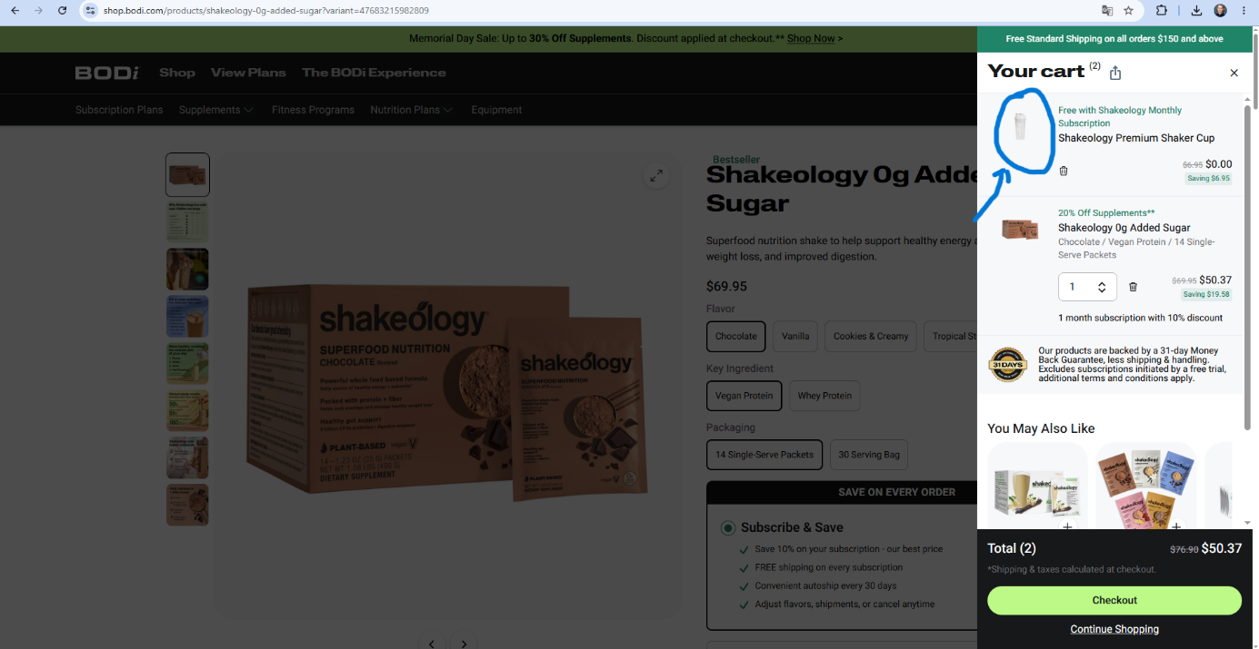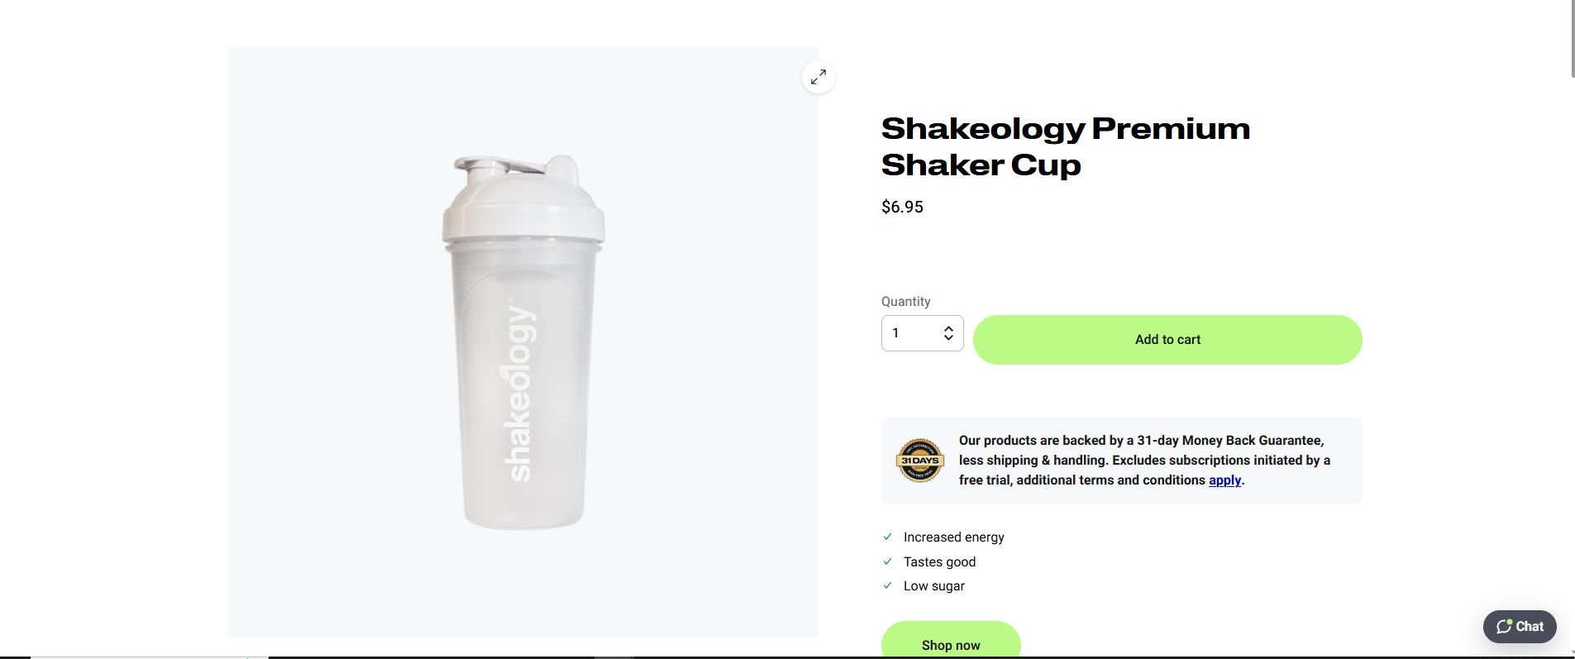

Expected result:
Test page should not be reachable

────────────────────────────────────────────
Notes:
The issue is not actual in Production
The issue is actual in all locales
The issue is actual only in desktop
────────────────────────────────────────────

Prepared by:
Albert Lalazaryan

Year:
2025

────────────────────────────────────────────

