3) a) I'm a new student in data analytics explaining to me what regression is in simple terms with examples.
b) 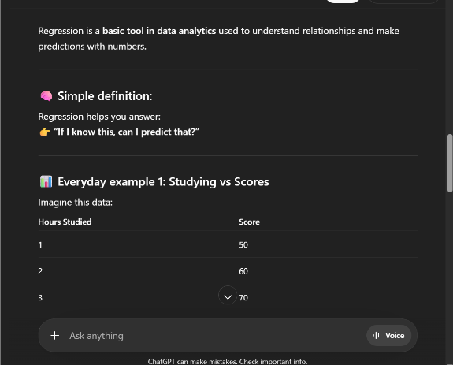
c) I added context that I’m new to learning this information. I want simple terms and examples to help me understand.

- I'm a student learning data. Explain in simple terms what SQL is
- 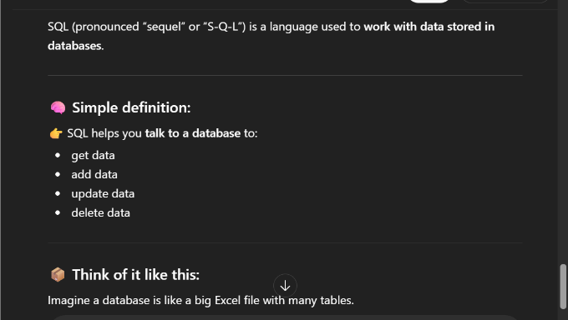
- My revised prompt is stronger due to adding information that I’m just now learning SQL.

- Generate a dataset with 5 rows showing yearly sales for beginners in excel.
- 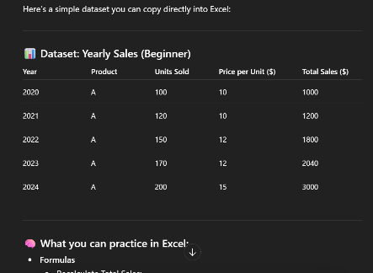
- I revised my prompt to add details about what kind of dataset I wanted.
I wanted to be more specific that it was needed for a beginner.

