**CSC542B WEB TECHNOLOGY PROJECT**

**TURF MANAGEMENT SYSTEM**

**OUTPUT:**

**HOME PAGE:**



**ABOUT US:**

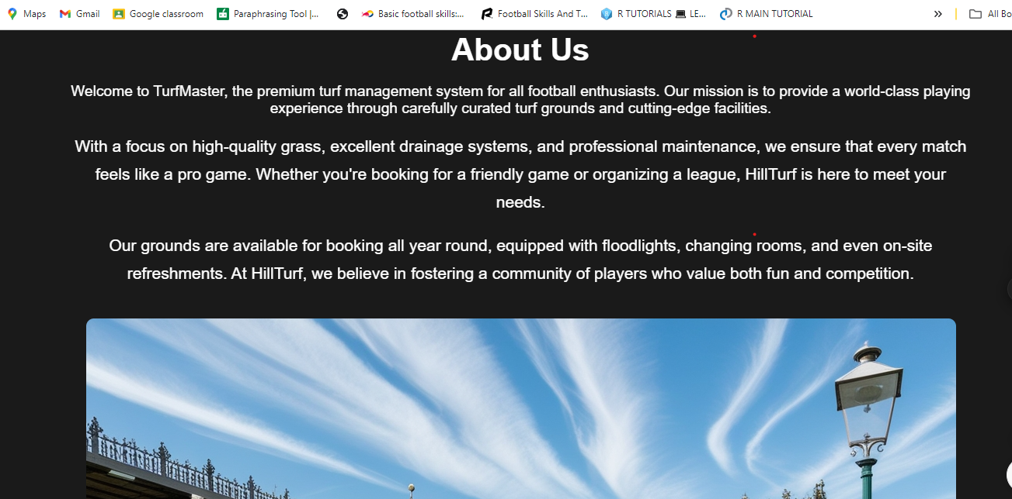

**PRICING:**

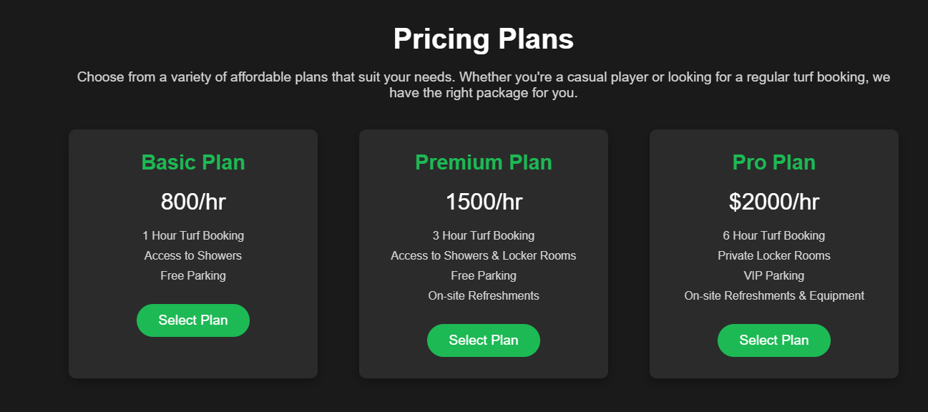

**FACILITIES:**

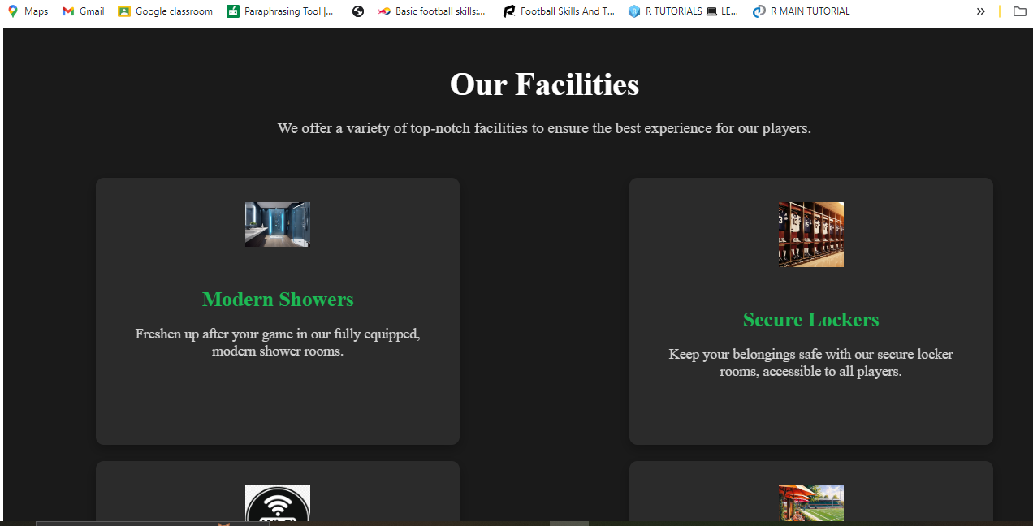

**BOOK NOW:**

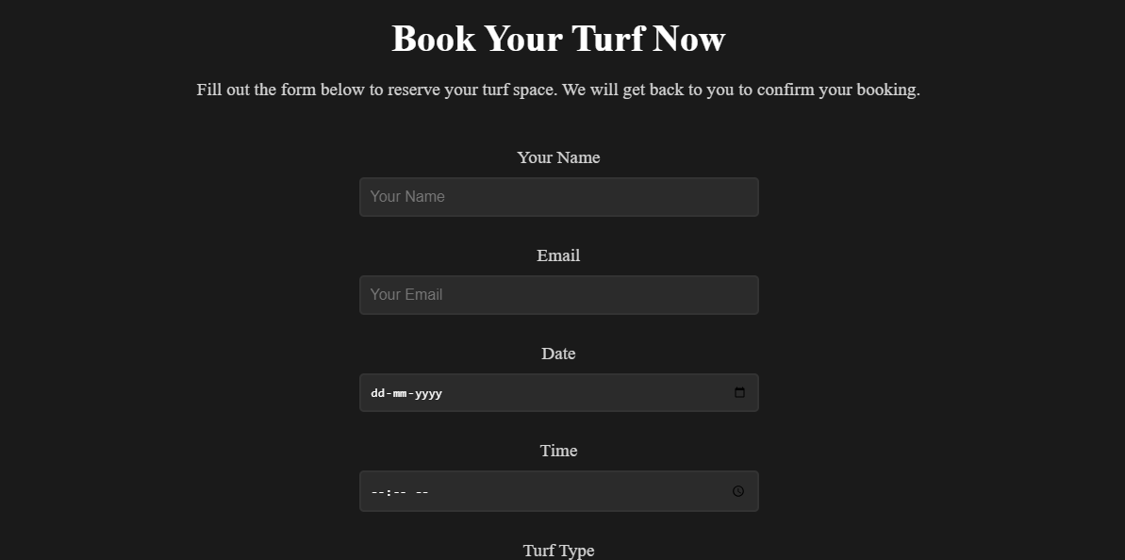

**CONTACT US:**

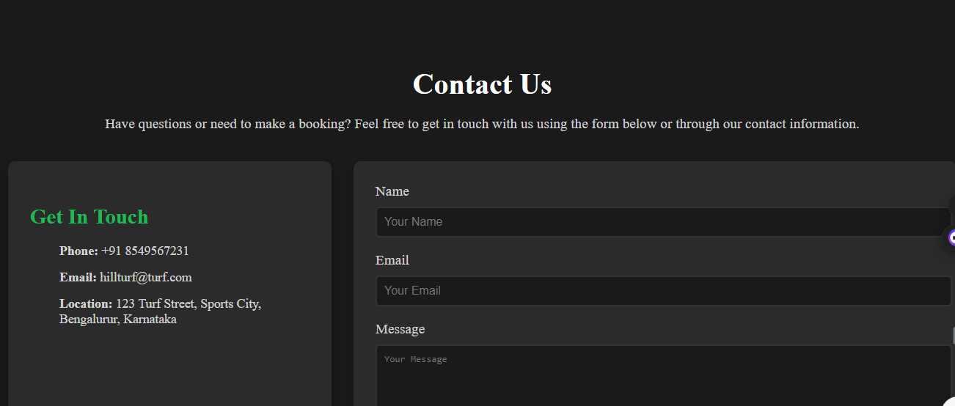

**LOGIN:**

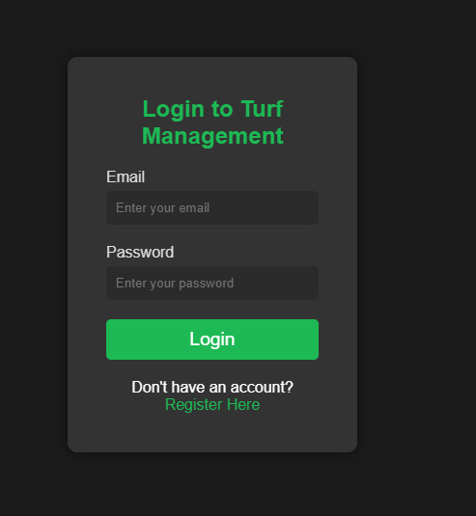

**REGISTER:**

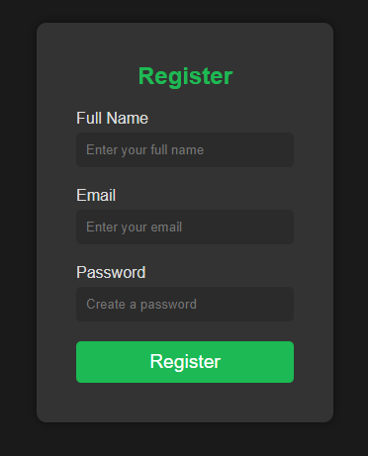

**SQL CODE:**

CREATE database hillturf;

USE hillturf;

#USERS DETAILS

CREATE TABLE userss (

id INT(11) AUTO_INCREMENT PRIMARY KEY,

username VARCHAR(100) NOT NULL,

email VARCHAR(100) NOT NULL,

password VARCHAR(255) NOT NULL

);

select * from userss;

#USER CONTACTS

CREATE TABLE IF NOT EXISTS contacts (

id INT(11) AUTO_INCREMENT PRIMARY KEY,

name VARCHAR(255) NOT NULL,

email VARCHAR(255) NOT NULL,

message TEXT NOT NULL,

submitted_at TIMESTAMP DEFAULT CURRENT_TIMESTAMP

);

SELECT * FROM contacts;

#USER SELECT PLAN

CREATE TABLE IF NOT EXISTS user_plans (

id INT(11) AUTO_INCREMENT PRIMARY KEY,

name VARCHAR(255) NOT NULL,

email VARCHAR(255) NOT NULL UNIQUE,

selected_plan VARCHAR(255) NOT NULL,

registered_at TIMESTAMP DEFAULT CURRENT_TIMESTAMP

);

SELECT * FROM user_plans;

#SQL for Creating bookings Table:

CREATE TABLE IF NOT EXISTS bookingsss (

id INT(11) AUTO_INCREMENT PRIMARY KEY,

name VARCHAR(255) NOT NULL,

email VARCHAR(255) NOT NULL,

`date` DATE NOT NULL, -- Ensure the 'date' column is included and correctly named

`time` TIME NOT NULL,

turf_type VARCHAR(255) NOT NULL,

duration INT NOT NULL,

total_price DECIMAL(10, 2) NOT NULL,

created_at TIMESTAMP DEFAULT CURRENT_TIMESTAMP

);

SELECT * FROM bookingsss;

#SQL Table for Turf Rates:

#You can use this table to store different turf rates.

CREATE TABLE IF NOT EXISTS turf_types (

id INT(11) AUTO_INCREMENT PRIMARY KEY,

turf_type VARCHAR(50) NOT NULL,

rate_per_hour INT(11) NOT NULL

);

SELECT * FROM turf_types;