**Assignment -1**

Write a JSON equivalent for the following xml structure:

<employees>

<employee>

<name>John</name>

<designation>Manager</designation>

<department>Finance</department>

</employee>

<employee>

<name>Kumar</namae>

<designation>Sales Person</designation>

<department>Marketing</department>

</employee>

</employees>

**Output-**

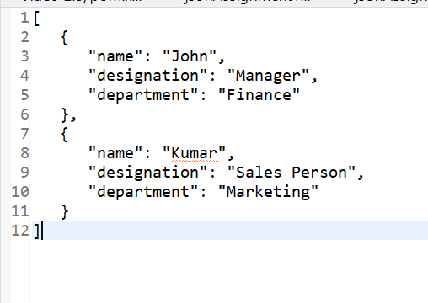

* Create a simple maven project, with json-api and glassfish dependencies in pom.xml, Write a method to read some json file with some array of objects, using JsonParser, parse the document and list all the JSON-P events, List all the keys corresponding the events, and list all the values.
* To the same above program create a method for json generator for the below scenario:

{

“name”:”Praveen”,

“desg”:”Manager”,

Mobiles:[

{

“type”:businesss”,

} “number”:”9948121217”

]

}

**Pom.xml file-**

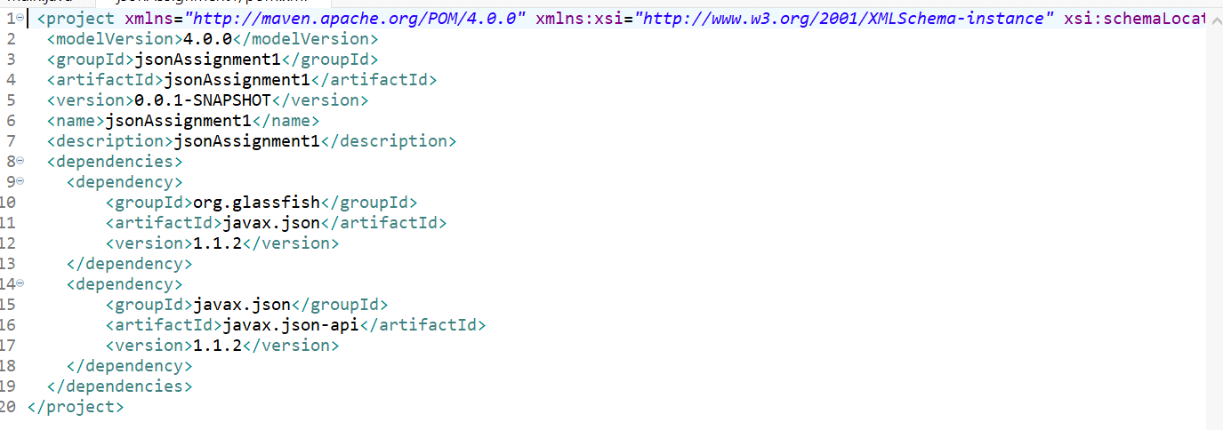

**Code-**

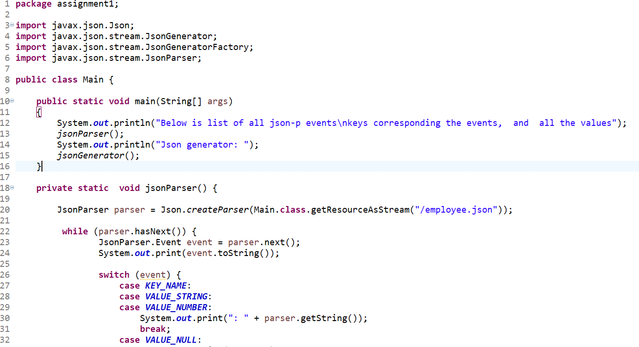

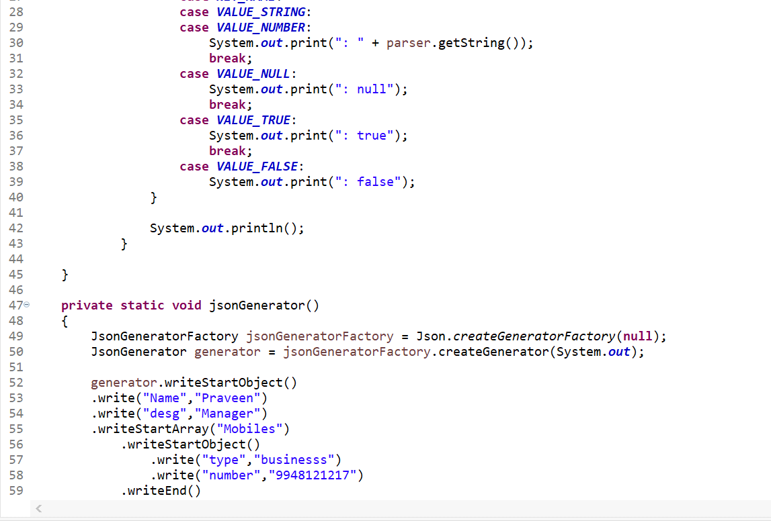

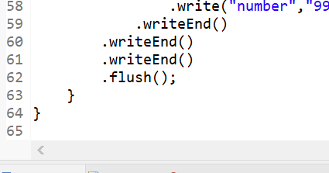

**Output-**

