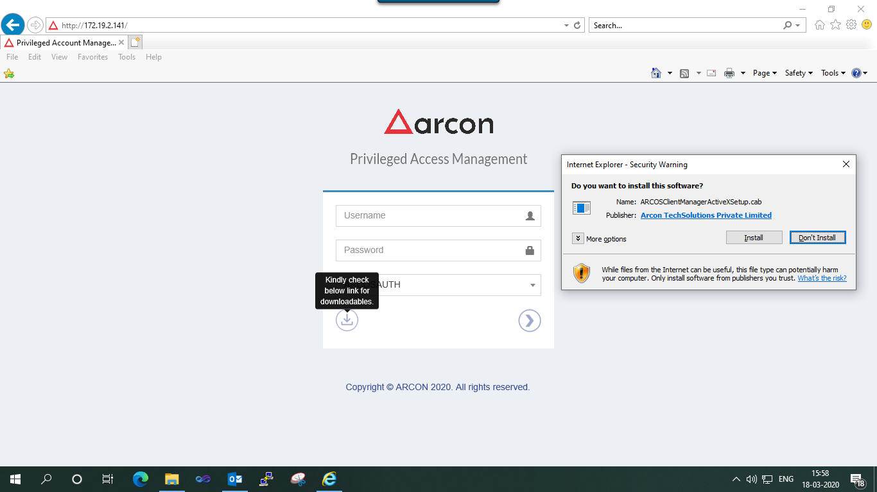

Click “ Don’t Install “

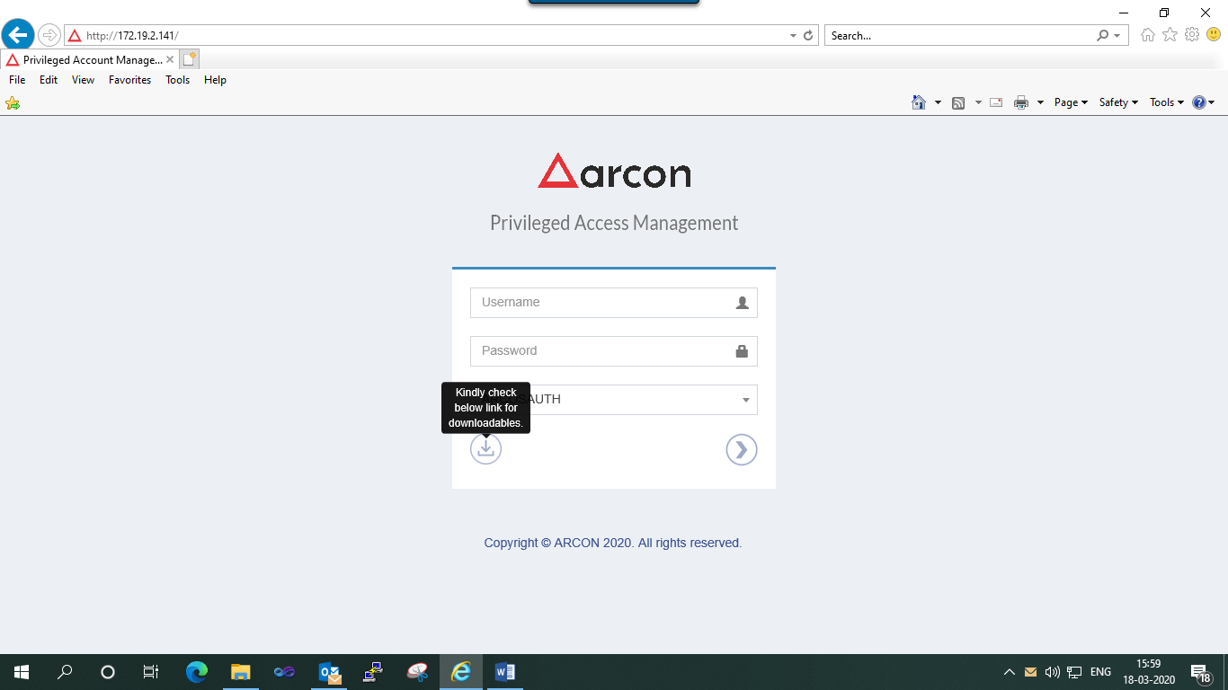

Select “ Kindly check below link for downloadables “

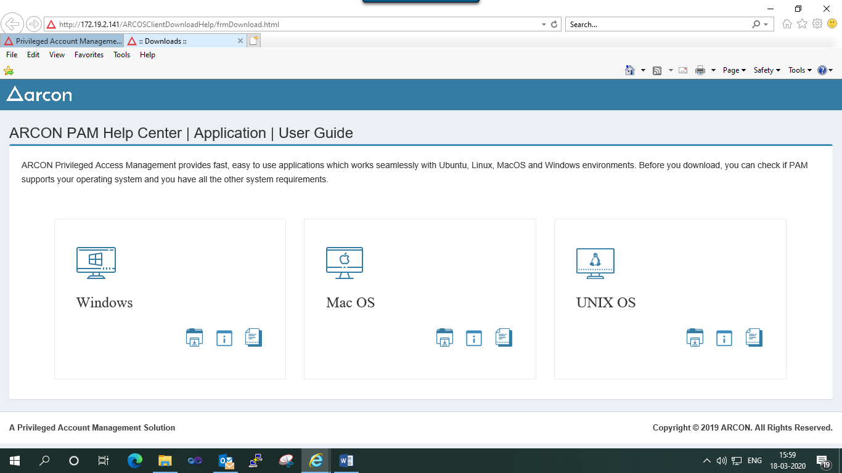

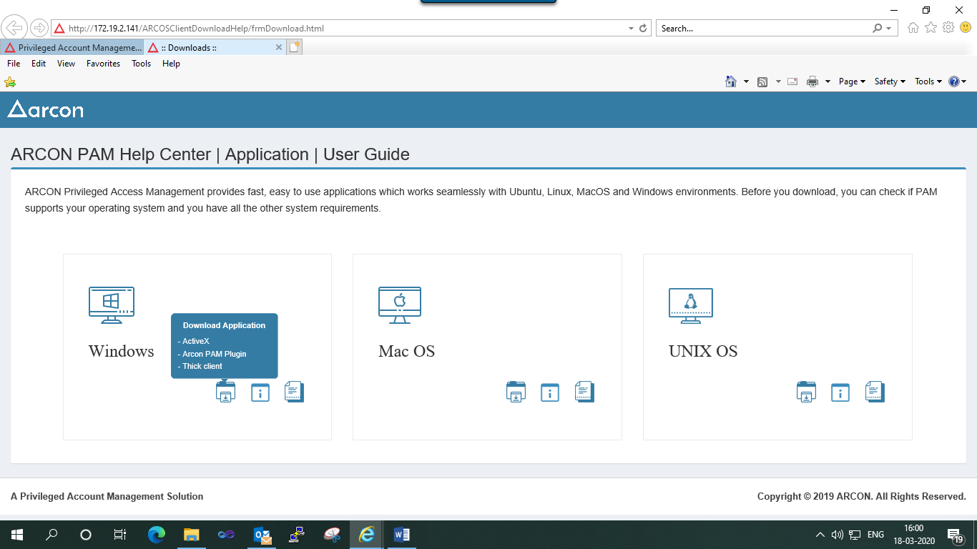

Select “ Thick Client “

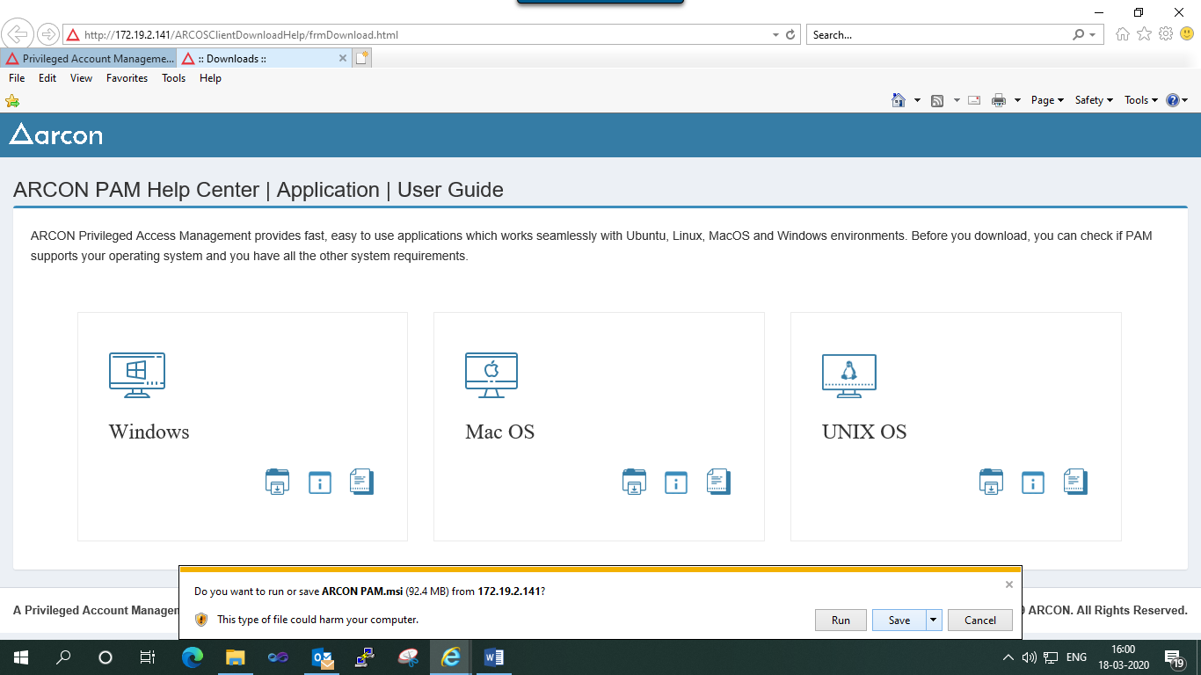

Select “ Save “

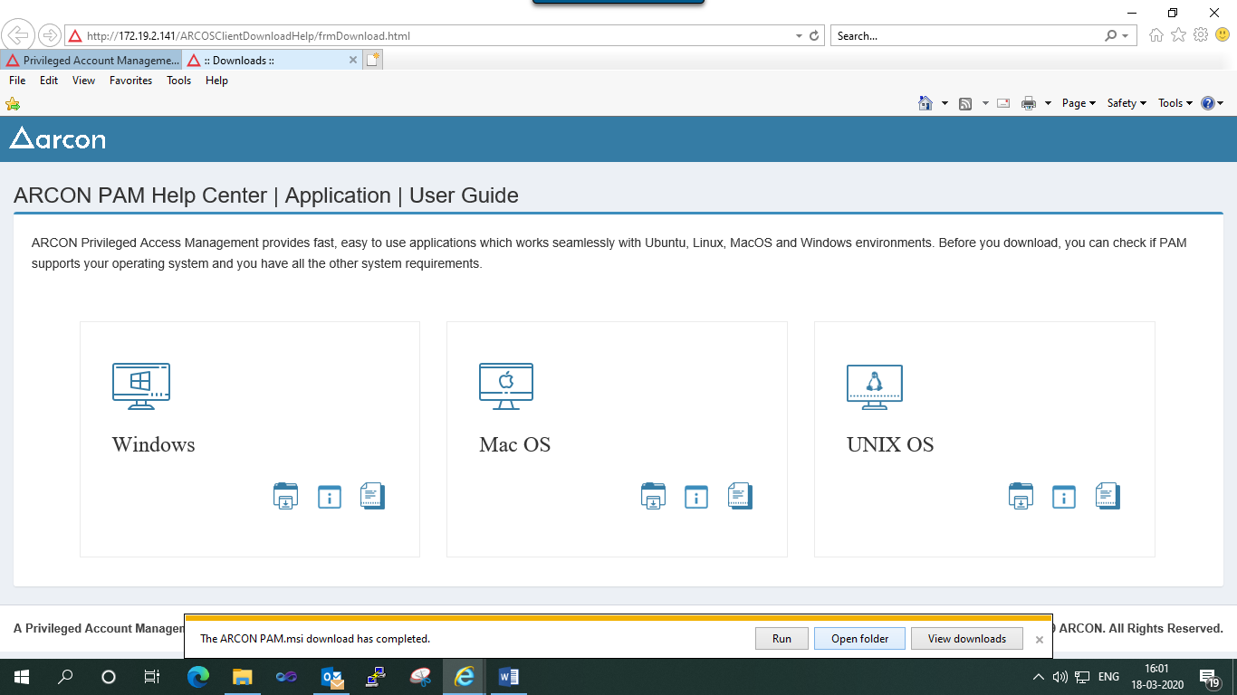



Double click “ ARCON PAN.msi “

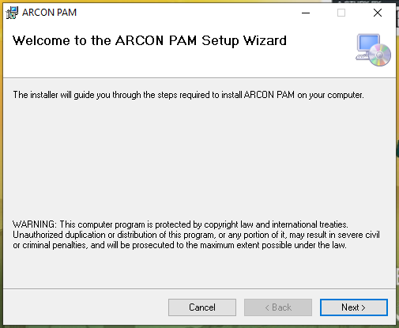

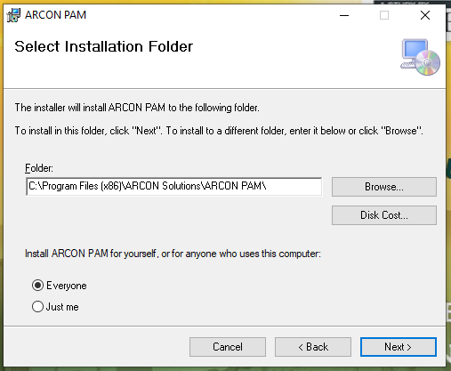

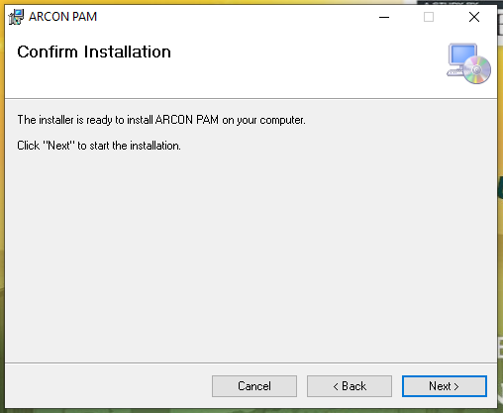

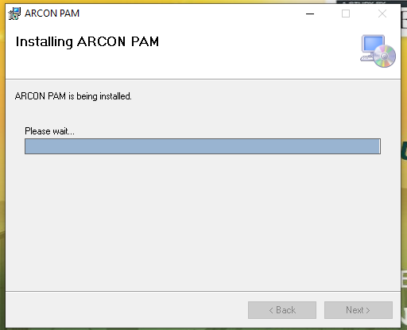

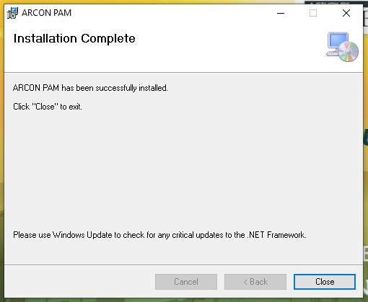

In START menu, Select “ ARCON PAM “

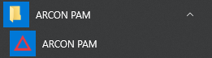

Enter the URL “ “

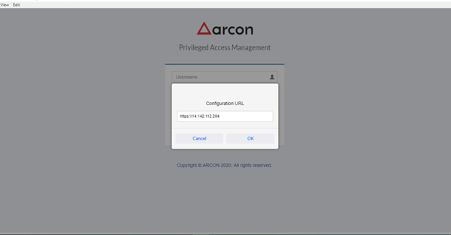

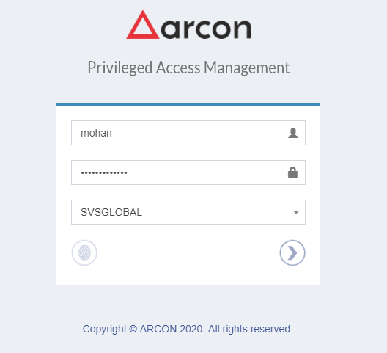

After entering the AD credentials, kindly enter the OTP shown in your validator screen on the Mobile ARCON authenticator app.

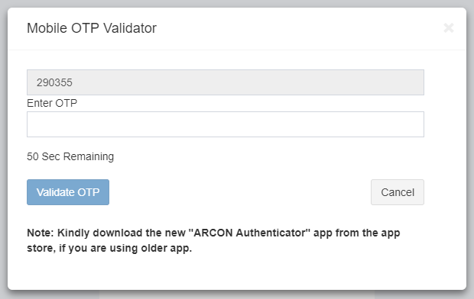

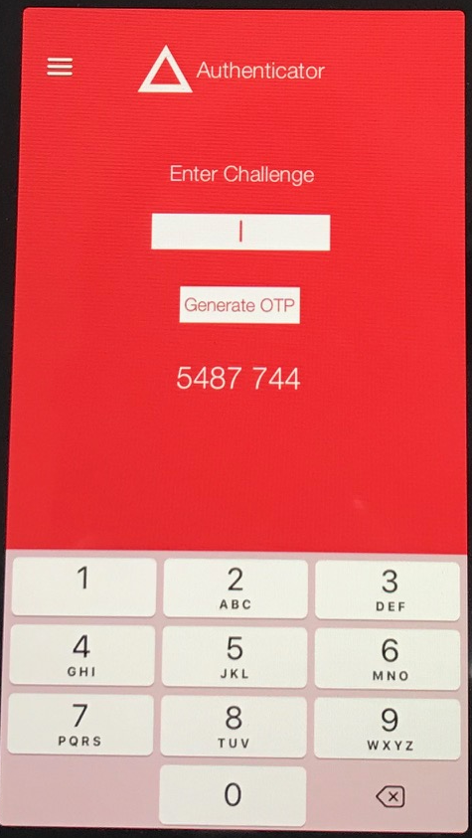

Now enter the OTP shown in your Mobile ARCON authenticator app to your validator screen.

Now you will be directed to your ARCON dashboard from which you can select WFH from the LOB drop down.

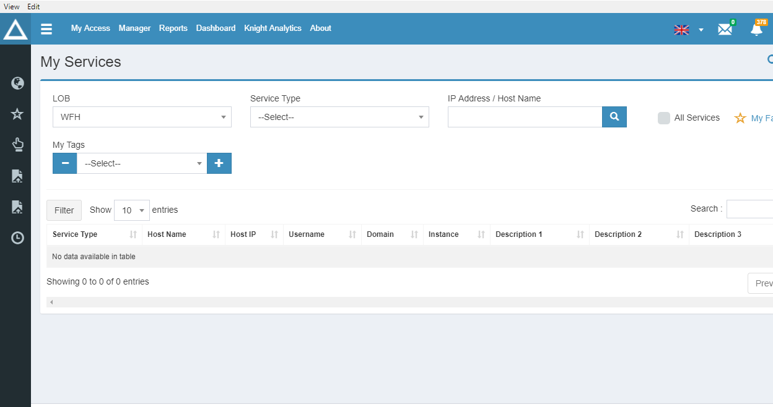

Select Windows RDP option from Select Type drop down.

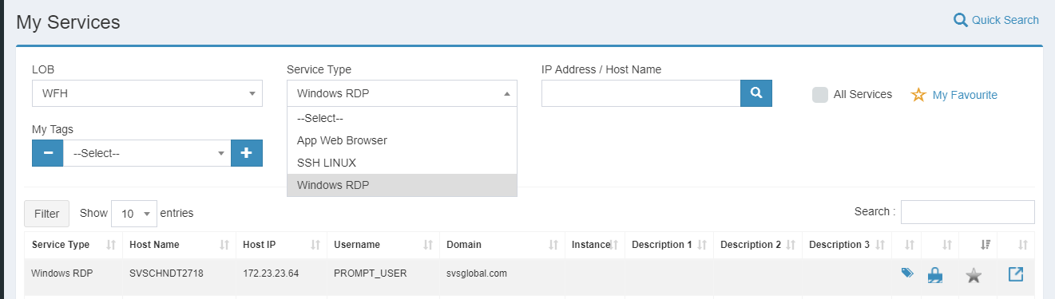

Now select your system IP which is displayed below.



Now click the “ Open “ icon.

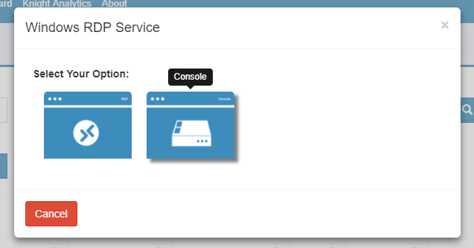

Select “ Console “ from the pop-up window.

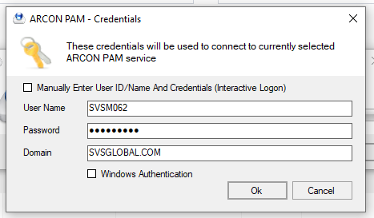

Enter your AD credentials to login to your desktop.