AUTHORS

Agnieszka Wierzbicka12, Katarzyna Kordecka1, Jarosław Żygierewicz2, Wioletta Waleszczyk1

1 Nencki Institute of Experimental Biology PAS, Warsaw, Poland

2 University of Warsaw, Faculty of Physics, Warsaw, Poland

TITLE

Analytical approaches for estimation of temporal frequency preference from visual evoked potentials.

ABSTRACT

There are various ways to study neuronal processing of information about temporal frequency content of visual stimuli. The two most fundamental methods are 1) direct measurement of response amplitude, e.g. an amplitude of averaged visual evoked potential, and 2) assessment of response magnitude after transformation of electrophysiological signal from time to frequency domain. In our study we found it impossible to use the same paradigm to analyze the whole spectrum of temporal frequencies in local field potentials recorded during visual electrophysiology experiments performed on anesthetized rats. Visual responses were recorded from all layers of primary visual cortex in response to flashing light with temporal frequency in the range of 0.5 – 15 Hz. We found that for frequencies lower than 2 Hz it is difficult to draw conclusions based on power spectrum alone, while for high frequencies (>2Hz) the evoked potential in time domain could not be observed. We discuss possible physiological reasons of these difficulties and the advantages of the Welch method instead of the periodogram to analyze signals in the frequency domain.

INTRODUCTION

Processing of the temporal frequency in visual cortex is an interesting research subject.

As it was observed over 80 years ago.

The form of presented stimuli must be chosen in respect on what kind of analysis is to applied. Examples:

Clapp et al. showed that visual stimulation at a frequency of 9 Hz induces long-term potentiation so they used very slow stimuli to prove that. (Clapp et al., 2006). On the other hand Todorov et al. focused on high frequency (up to 25 Hz) visual stimuli but since they observed only gamma-range (70-200 Hz) they could had filtered data.

…

MATERIAL AND METHODS

**Subjects**

All experimental procedures were conducted in accordance with the ARVO Statement for the Use of Animals in Ophthalmic and Vision Research and the EC Directive 86/609/EEC for animal experiments using protocols and methods accepted by the First Warsaw Local Ethical Commission for Animal Experimentation. For electrophysiological experiments presented in the articule, we used 2 adult male Wistar rats (250-300g) obtained from the Mossakowski Medical Research Center. All animals were housed with free access to food and water and maintained on a 12 h light/dark cycle.

**Surgical procedures**

Animals were under deep urethane anesthesia (1.5 g/kg, Sigma-Aldrich, Germany, 30% aqueous solution, i.p) and placed in a stereotaxic apparatus. Additional doses of urethane (0.15 g/kg) were administered if it was such a necessity. Body temperature was maintained between 36 and 38°C using an automatically controlled electric heating blanket. Every hour fluid requirements were fulfilled by subcutaneous injections of 0.9% NaCl (1ml/hour) and eyes were humidified with Vidisic (Polfa Warszawa S.A., Poland) to prevent cornea from drying. The skin on the head was disinfected with iodine and local anesthetic of 1% lidocaine hydrochloride (0.5 ml, Polfa Warszawa S.A., Poland) was injected over the scalp. The skull was opened to expose areas of the binocular primary VCx (7.5 mm posterior to bregma, 5.0 mm lateral) in both hemispheres. Coordinates were chosen based on the rat brain atlas of Paxinos and Watson (Paxinos and Watson, 2007).

**Electrophysiology recording**

LFPs were collected using linear electrodes made of 25 μm tungsten microwire in HML insulation (California Fine Wire, US). The reference electrode (Ag/AgCl wire) was positioned in the neck muscles. The cortical electrode consisted of 12 wires with a vertical recording site separation of approximately 150 - 200 μm and lowered to 1.8 mm (tip) from the cortical surface. The signal was recorded with multichannel data acquisition interface and software (USB-ME64-System, Multichannel Systems, Germany), amplified 100 times (USB-ME-PGA, Multichannel Systems, Germany), filtered at 0.1Hz – 500Hz, digitized (1 kHz sampling rate). Visual stimulation was provided by Spike2 software (Cambridge Electronic Design, UK). Stimulation marks were recorded along with the electrophysiological signals in the same data file. Matlab software (The MathWorks Inc., Natic, MA) was used for offline analysis. ECoG recordings were filtered using three Butterworth filters: low pass, I order cut off 100 Hz., band pass, I order, range 45-55 Hz and high pass, II order cut off 0.1 Hz.

**Stimulation paradigms**

In our experiments we presented the whole spectrum of frequencies (0,5-15Hz) of stimuli and we noticed that we should split out analysis into low and high frequencies. 1 Hz and 7 Hz was used to show main differences. Stimulus was a led flash 2 ms long at 1V amplitude. Both frequencies was presented in two ways: a one series of continuous stimuli and in 5s long parts with random pause between as is shown on the Figure 1.

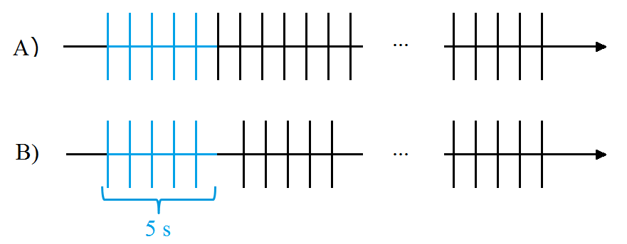

Figure 1. Visual stimulation was presented at the same frequency. Number of flashes was the same. A) Continuous, B) divided into 5 s long fragments with random pause between.

DATA ANALYSIS

1. Averaging
2. Periodogram of full length of signal
3. Periodogram of average
4. Welch of full length
5. Welch of average

RESULTS

**Analysis of low frequency example (1Hz)**

First approach is to average signal. Here is what we can see after averaging.

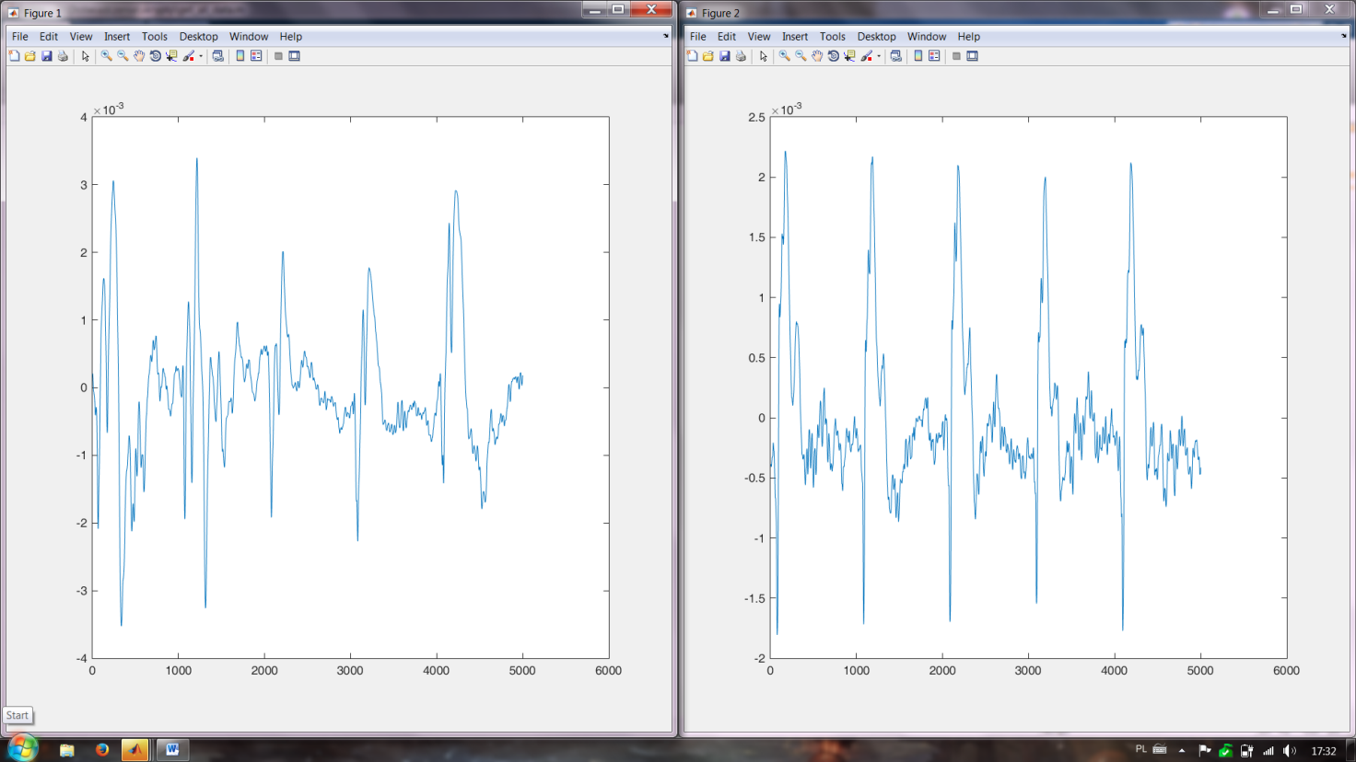

Figure 2: Left: stimulus in fragments Right: continuous

For continuous stimulus we can observe the same pattern of response and for fragments: the two first VEPs are different than 3 others.

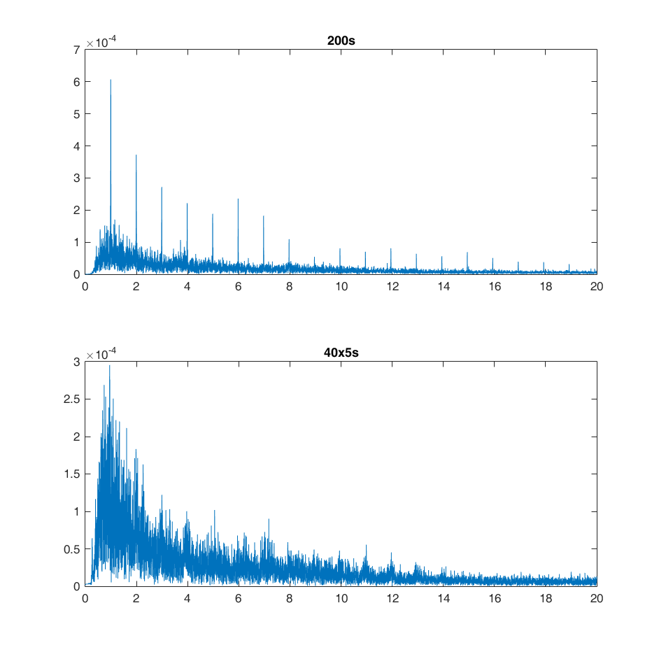Figure 3:

In periodogram continuous stimuli is clearly visible and is not in fragments. But noise may be a huge problem. Resolution in this case it’s not a problem:

Resolution = 2* Nyquist frequency/length of signal = 0.0017 Hz

Nyquist = Sampling frequency/2 (here 500), length of signal ~ 300000

In Welch 30s window and 20s of overlap for the whole signal.

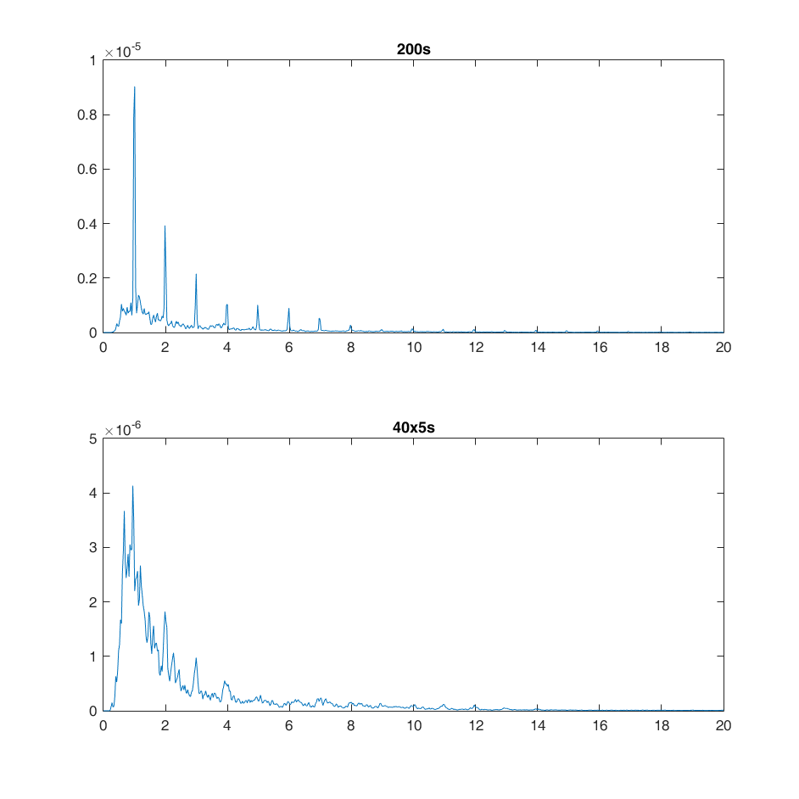

Figure 4:

Again first type of stimuli looks better and we don’t have so much noise. That’s why even in second stimuli we can see a response.

In both cases continuous looks better: response looks like 1 sinus of freq 1Hz and it’s easy to detect in one window. When sinus is divided into pieces with different phases.

Averaging signal (from figure 2) :

Periodogram:

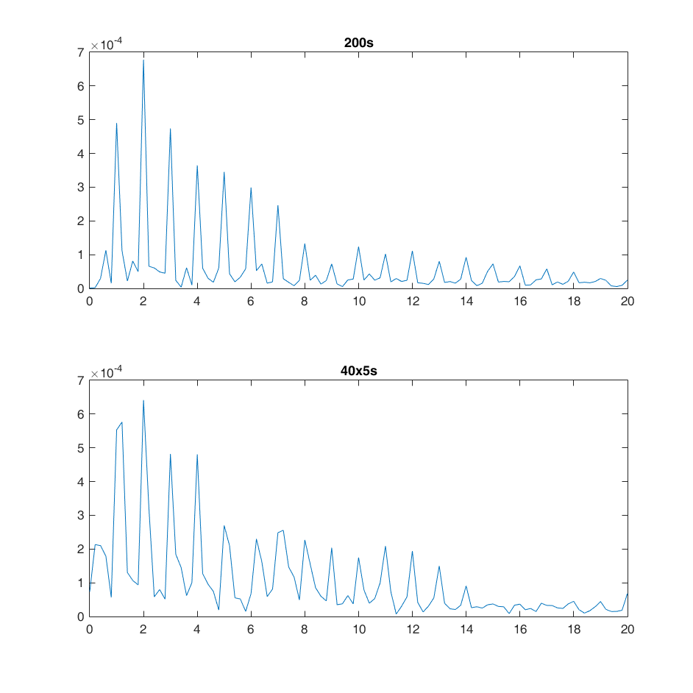

Welch 3 s window 2 s overlap:

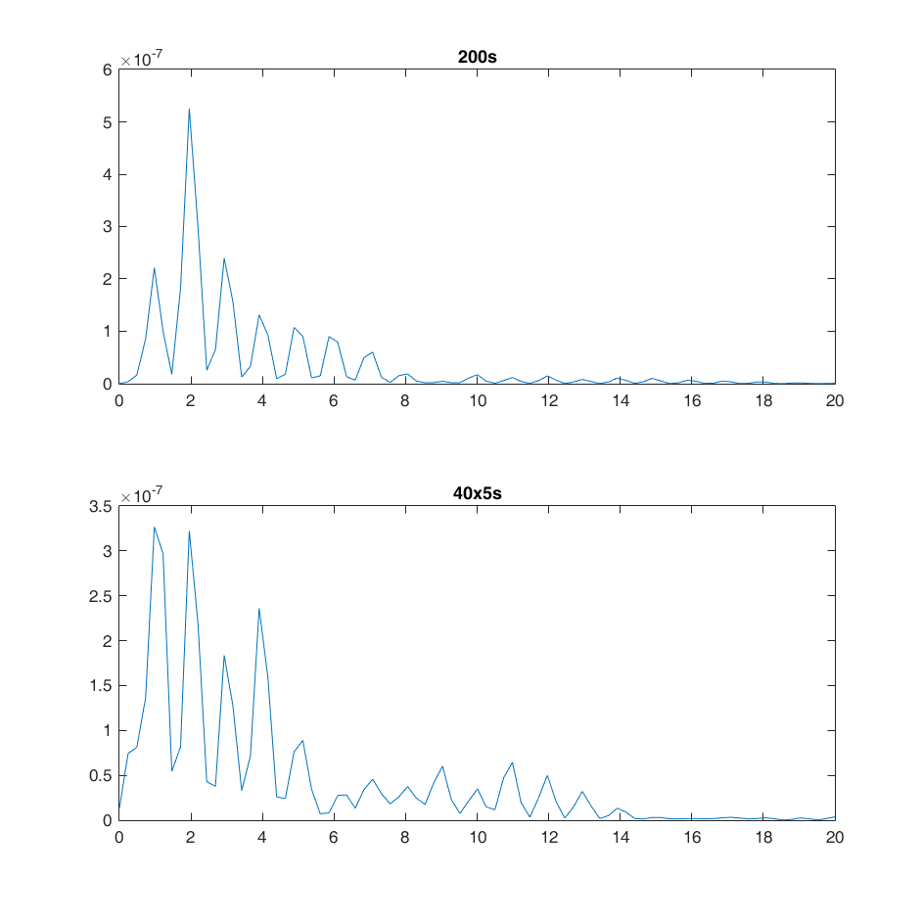

Cause: too low resolution.

Resolution = 2* Nyquist frequency/length of signal =0.1 Hz

Nyquist = Sampling frequency/2 (here 500), length of signal ~ 5000

**Analysis of high frequency example (7Hz)**

Average response: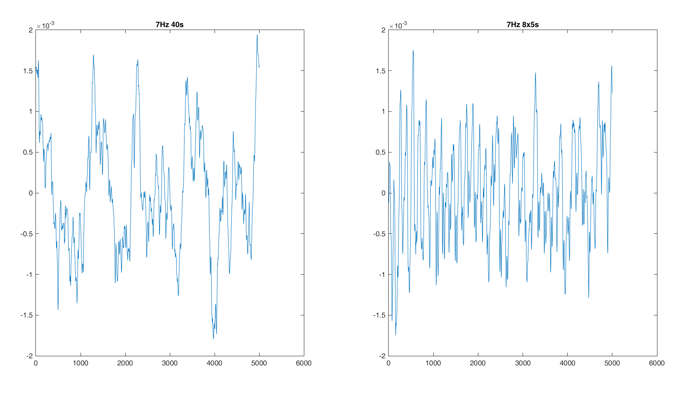

Stimulus too often, let’s focus on frequency domain.

Periodogram: 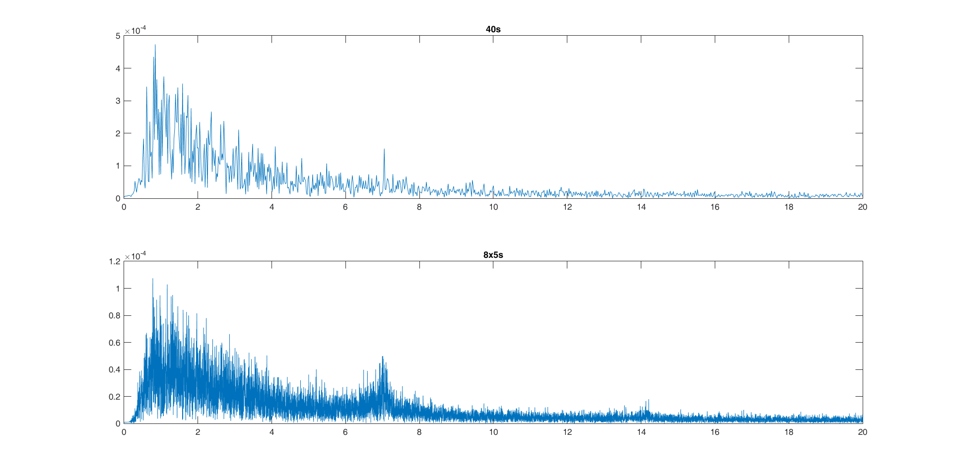

Welch 30s window, 20s overlap:

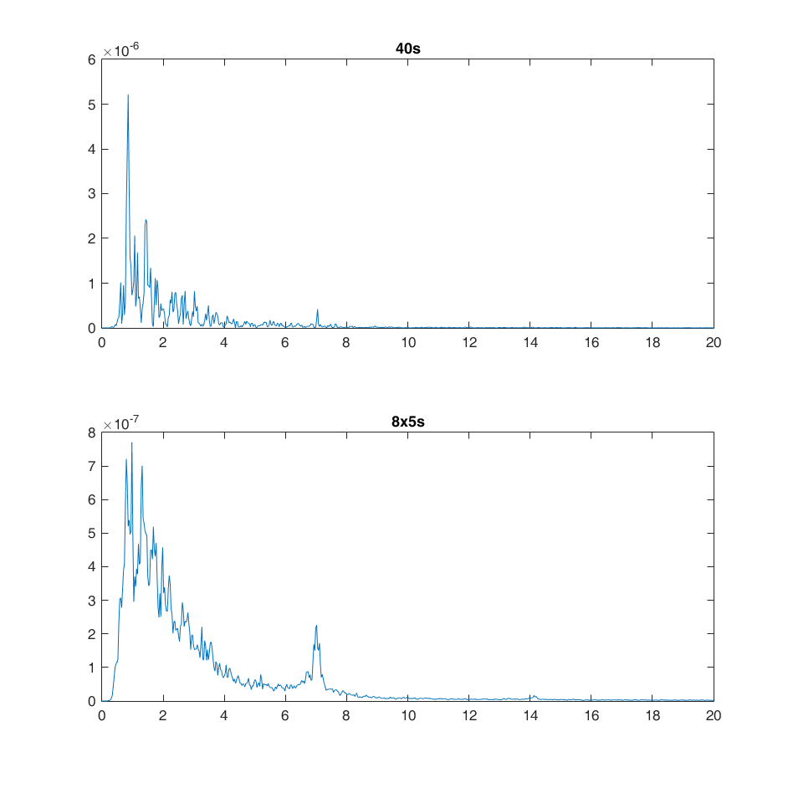

Averaged signal:

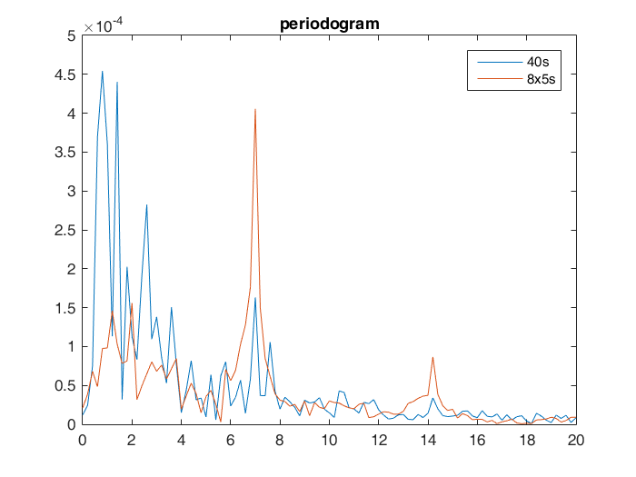

Welch (3s window 2s overlap):

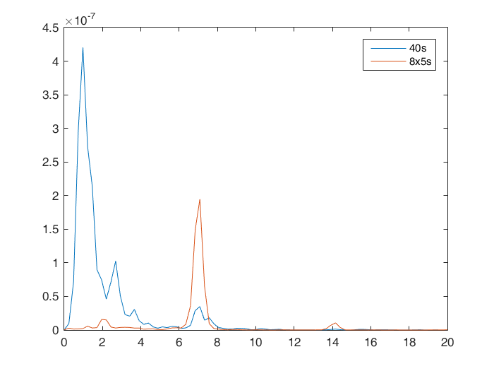

DISCUSSION

ACKNOWLEDGMENTS

The work was supported by Polish National Science Centre grant 2013/08/W/NZ4/00691.

REFERENCES

Clapp, WC, Eckert, MJ, Teyler, TJ, Abraham, WC **(2006)**. Rapid visual stimulation induces N-methyl-D-aspartate receptor-dependent sensory long-term potentiation in the rat cortex. Neuroreport, 17, 5:511-5.

Todorov, MI, Kékesi, KA, Borhegyi, Z, Galambos, R, Juhász, G, Hudetz, AG **(2016)**. Retino-cortical stimulus frequency-dependent gamma coupling: evidence and functional implications of oscillatory potentials. Physiol Rep, 4, 19