netsh http add urlacl url="http://+:50201/" user=everyone

Ejecutandolo como administrador, para reservar y agregar la url

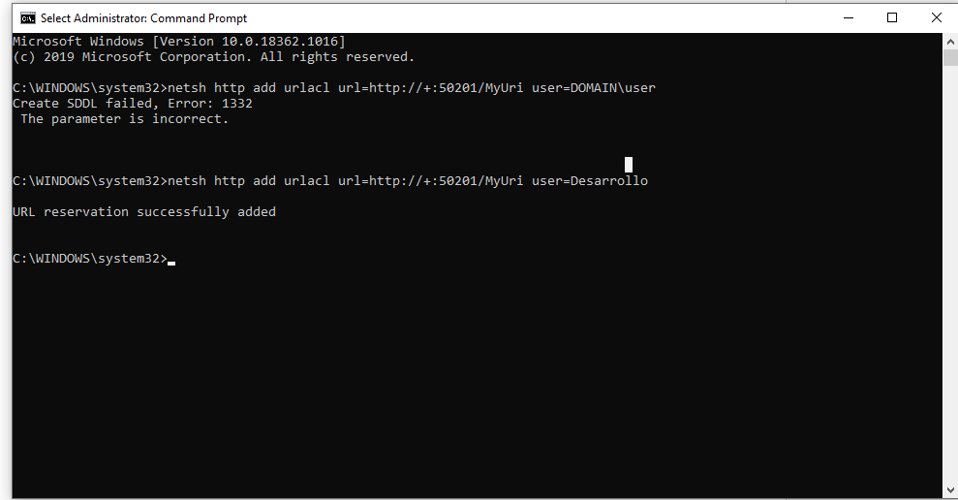

<https://docs.microsoft.com/en-us/dotnet/framework/wcf/feature-details/configuring-http-and-https?redirectedfrom=MSDN>

netsh http add urlacl url=http://+:80/MyUri user=DOMAIN\user