NRL Curriculum
Design, build, and program a competition robot with the NRL platform
Complete consolidated edition — Mechanical, Electronics & Programming Curricula
Generated 2026-09-21

Table of Contents

How to Use This Book
Welcome. This is the full NRL curriculum — everything you need to design, build, and program a competition robot using the NRL platform (the HEXA Command Hub), even if you've never touched CAD or written a line of code before.
It's split into three curricula that sit side by side in the sidebar, in the order a new team typically needs them:
• 1. Mechanical Curriculum — gears, forces, simple machines, CAD in Onshape, mechanism design, manufacturing processes, and hands-on DIY practice.
• 2. Electronics Curriculum — the hardware of the NRL robot: the Command Hub, the Controller, power, motors, sensors, wiring, and the wireless link between them.
• 3. Programming Curriculum — installing the software, understanding the hardware, and writing driver-controlled and fully autonomous robot programs.
You don't have to do them in order relative to each other — a mechanical lead, an electronics lead, and a programming lead on the same team might work through their curriculum in parallel. Within each curriculum, though, it's built as a path: each phase assumes you've read the ones before it. If you're brand new, read a curriculum front to back. If you already know the basics, skim ahead to where you actually need help.

1. Mechanical Curriculum
Phase | What it covers
Phase 1 — Mechanical Fundamentals | Gears and gear ratio, load/payload/forces, and a review of simple machines — levers and the wheel and axle.
Phase 2 — CAD with Onshape | Learning Onshape's interface, sketching, 3D features, and assemblies.
Phase 3 — Mechanism Design & Assembly | Spur vs. helical gears, building them in Onshape, four-bar linkages, and gear meshing assemblies.
Phase 4 — Manufacturing Processes | FDM 3D printing, laser cutting, CNC machining, injection moulding, and hand tools — how robot parts actually get made.
Phase 5 — DIY (Do It Yourself) | Dimensioned drawing sheets you model yourself in Onshape, with solution videos to check your work against.

2. Electronics Curriculum
Phase | What it covers
Phase 1 — Foundations | What electricity is, and how to "read" your robot — just enough theory to understand everything that follows.
Phase 2 — Your Hardware | A guided tour of the two boards — the Command Hub and the Controller — and the safety rules that protect you and them.
Phase 3 — Power | The battery, its two chargers, the battery checker, the main switch, and the voltage rails — how energy flows through the robot, and what happens when it doesn't.
Phase 4 — Motion & Sensing | One short module per building block: motors, servos, the motor driver, signals, buses, the IMU, and the line sensor.
Phase 5 — Wiring, Wireless & the Whole Robot | Connecting everything with the harness, the wireless link and antenna, reading the robot's lights and screens, troubleshooting, and inspection — plus a reference and glossary.

3. Programming Curriculum
Phase | What it covers
Phase 1 — Foundations | Plain C++ from scratch — no robot, no NRL framework — everything you need to read every code example in this book.
Phase 2 — Getting Started | What the robot is, then installing the tools, understanding your hardware, creating a project, pairing, flashing, and your first working program.
Phase 3 — Programming the Robot | One short module per building block: motors, driving, servos, the gamepad, the IMU, telemetry, the LED, the OLED, and power.
Phase 4 — Autonomous & Advanced | Robots that drive themselves: the action system, closed-loop turns, and a gentle look at the control ideas underneath.
Phase 5 — Reference | Worked examples, a troubleshooting guide, an API cheat-sheet, and a glossary.

The boxes you will see
Note
Extra background or a definition. Helpful, but you can keep going without it.

Tip
A shortcut or good habit that will make your life easier.

Warning: Watch Out
A common mistake or a real hazard. Read these — they save you hours of debugging.

Key Idea
A concept that the rest of the book builds on. Make sure it clicks before moving on.

What you need
• A Windows, macOS, or Linux computer with a free USB port and internet access (Onshape runs in the browser).
• A free Onshape account, for the Mechanical Curriculum.
• An NRL kit: a Robot board (Command Hub) and a handheld Controller board (both are ESP32-S3 microcontrollers), a battery and chargers, a wiring harness, motors, servos, and sensors, for the Electronics and Programming Curricula.
• Curiosity. No prior CAD or programming experience is required.

1. Mechanical Curriculum

Phase 1: Mechanical Fundamentals

Module 1.1: Gears & Gear Ratio

What is a Gear?
A gear is a rotating mechanical component with specially shaped teeth cut around its outer edge. When two gears mesh, the teeth lock together and transfer motion and power without slipping. Gears are used in automobiles, bicycles, clocks, robots, industrial machines, and household appliances.

Parts of a Gear
Teeth: Transfer motion, prevent slipping, ensure smooth rotation, determine gear ratio.
More teeth → larger gear, lower speed, higher torque. Fewer teeth → smaller gear, higher speed, lower torque.

How Do Gears Rotate?
When two gears touch, one rotates clockwise while the other rotates counter-clockwise. Every pair of meshing gears rotates in opposite directions. Adding another gear reverses the direction again.
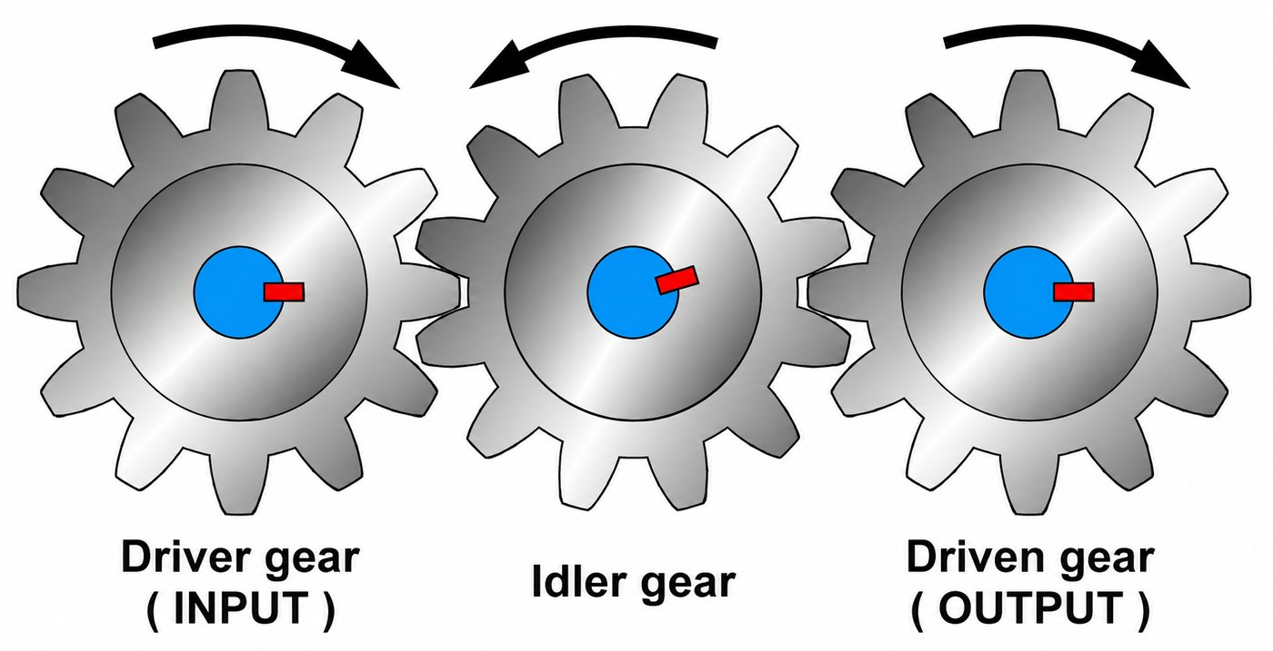
Two meshing gears rotating in opposite directions.

Driver Gear and Driven Gear
Driver Gear: Connected directly to the motor, engine, pedals, or hand crank. It supplies the input power.
Driven Gear: Receives power from the driver gear and delivers it to the output.
Motor → Driver Gear → Driven Gear → Output
Note: Real-Life Example
A robot motor drives a 12-tooth gear that meshes with a 36-tooth gear attached to the wheel. The 12T gear is the driver and the 36T gear is the driven gear.

Basic Working Principle
When two gears mesh, the teeth contact each other at the pitch point. The rotational motion of the driving gear causes its teeth to push against the teeth of the driven gear.
For two gears:
• Driver gear → receives power from the motor
• Driven gear → receives motion and torque from the driver
The fundamental relationship is:
N₁ × T₁ = N₂ × T₂
where:
• N = rotational speed
• T = number of teeth
Therefore:
N₁ ÷ N₂ = T₂ ÷ T₁
Key Idea: The ratio of teeth controls the ratio of speeds
This means that the speed ratio is controlled by the ratio of the number of teeth.

What is Gear Ratio?
Gear ratio tells us how many times the driver gear must rotate for the driven gear to rotate once.
Formula: Gear Ratio = Number of Teeth on Driven Gear ÷ Number of Teeth on Driver Gear
• Example 1: 10T → 40T = 4:1
• Example 2: 20T → 20T = 1:1
• Example 3: 40T → 10T = 1:4 (speed increase)
Gear ratio is one of the most important concepts when designing a drivetrain or mechanism.
For a simple gear pair:
Gear Ratio = T(driver) ÷ T(driven)
Suppose a motor drives a 20-tooth gear, which meshes with a 60-tooth gear.
Gear Ratio = 20 ÷ 60 = 3:1 — this is a 3:1 reduction.
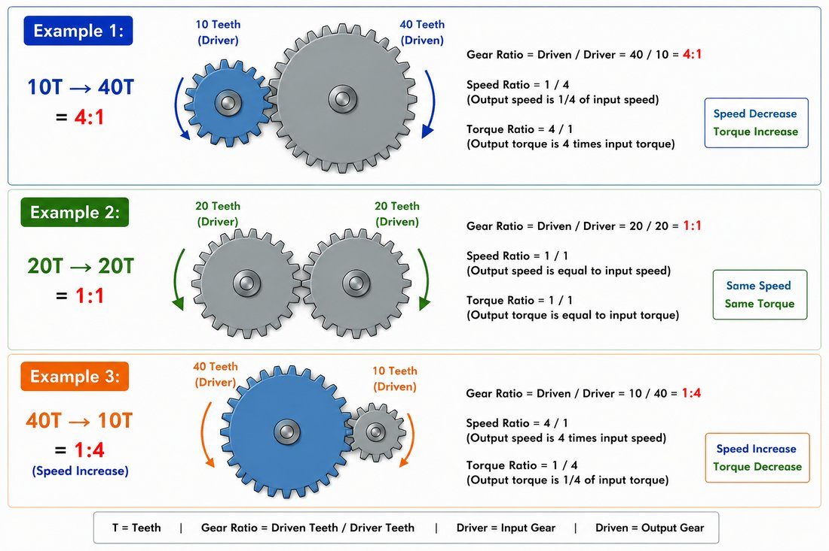
Working through a 3:1 gear ratio example: a 20-tooth driver meshing with a 60-tooth driven gear.
If the motor rotates at 3000 RPM:
N(out) = 3000 × (20 ÷ 60) = 1000 RPM
So the output speed decreases by three times. Ideally, torque increases by approximately three times: T(out) ≈ 3 × T(in).
Note: Real gearboxes aren't perfectly ideal
In a real gearbox, torque will be slightly lower than the ideal ratio predicts, because of friction and other losses.

Relationship Between Teeth and Speed
• Small driver + large driven = lower speed, higher torque.
• Large driver + small driven = higher speed, lower torque.
• Same size gears = same speed and torque.

Speed and Torque
Speed is measured in RPM (Revolutions Per Minute). Torque is the turning force. Increasing torque generally decreases speed and vice versa.
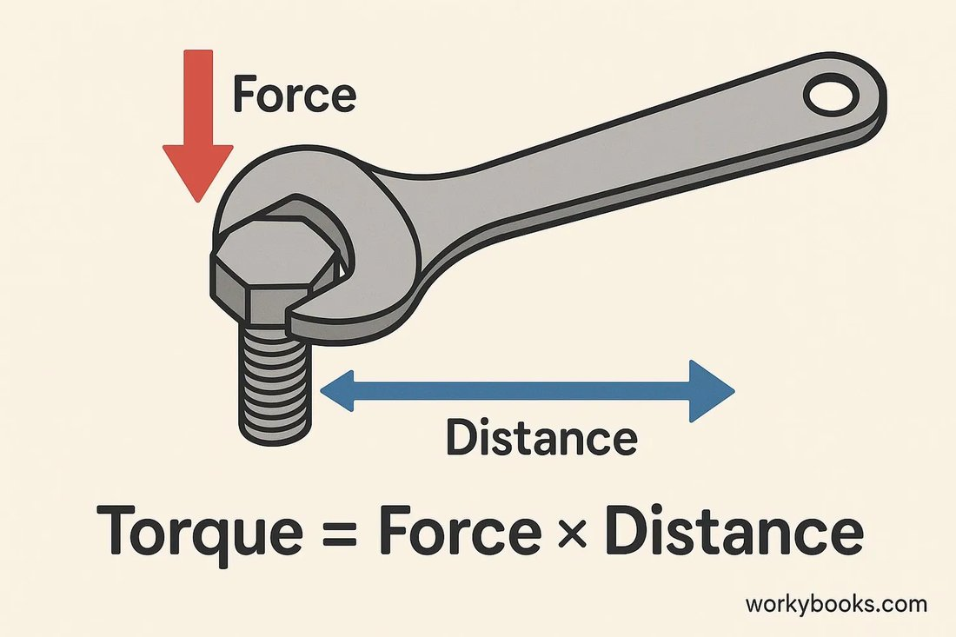
The speed-torque trade-off: gearing down increases torque at the cost of speed.

Types of Gears

Spur Gear
Spur gears have straight teeth parallel to the shaft axis. They are used for parallel shafts, simple gearboxes, robotics, and low-to-moderate speed applications.
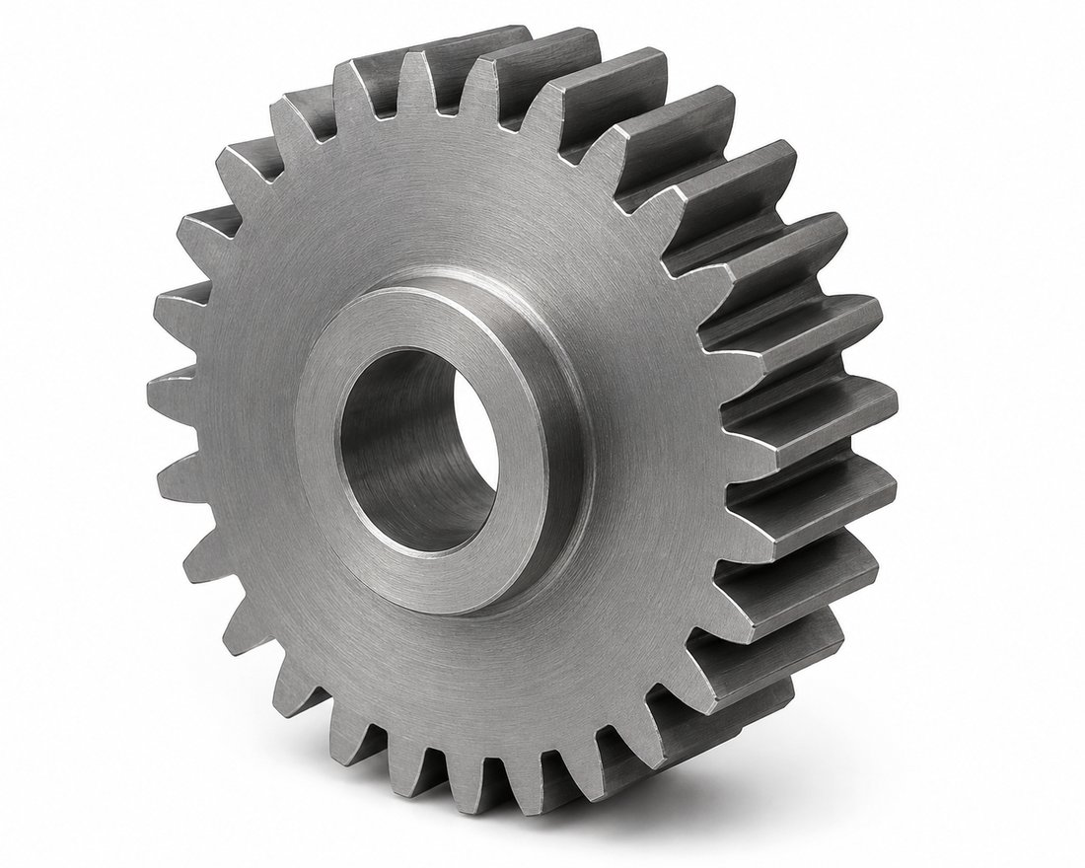
A spur gear, with straight teeth parallel to the shaft.
Advantages: Simple manufacturing, high efficiency, easy to design, low cost.
Limitation: The teeth engage suddenly across their width, which can produce noise and vibration at higher speeds.

Helical Gear
Helical gears have teeth cut at an angle to the shaft axis. The angled teeth allow gradual tooth engagement, producing smoother operation, lower noise, higher load-carrying capability, and better performance at high speed. However, helical gears produce an axial thrust force, so the shaft and bearing arrangement must account for this.
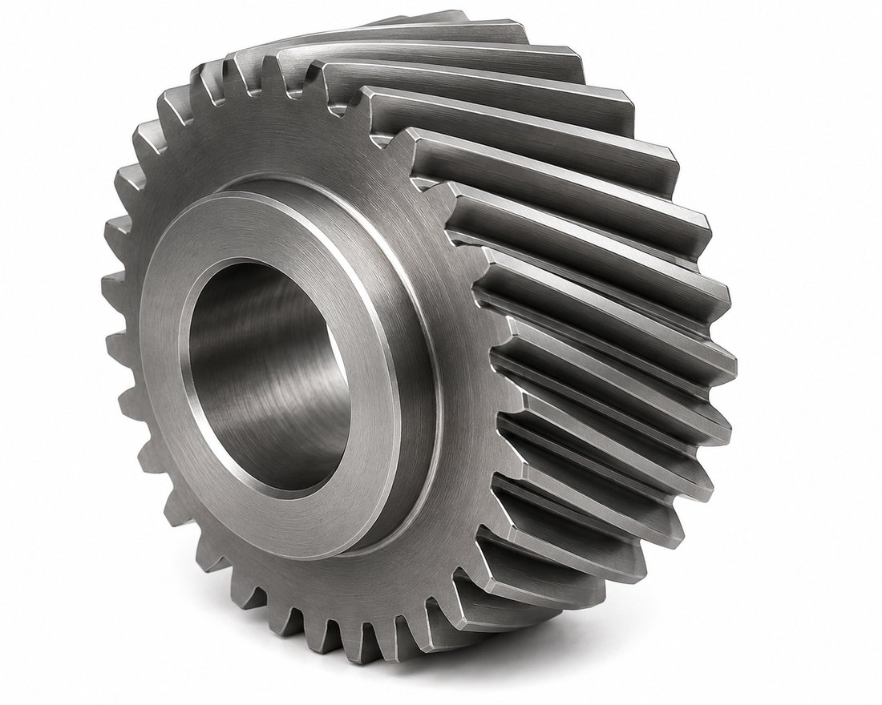
A helical gear, with teeth cut at an angle to the shaft axis.

Bevel Gear
Bevel gears are generally used when the shafts intersect, commonly at 90°. They can change the direction of rotational motion. Applications include differential systems, right-angle drives, machinery, and automotive systems.
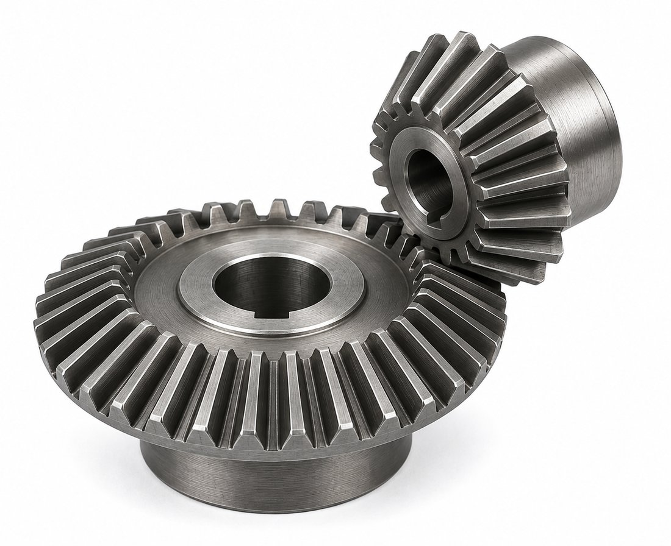
A bevel gear pair, used where shafts intersect.

Worm Gear
A worm gear system consists of a worm and a worm wheel. It is commonly used for large speed reduction.
Advantages: High reduction ratio, compact arrangement, ability to change rotational direction by 90°. Depending on geometry and friction conditions, some worm drives can also provide a degree of back-driving resistance.
Applications include lifting mechanisms, actuators, steering systems, and positioning mechanisms.
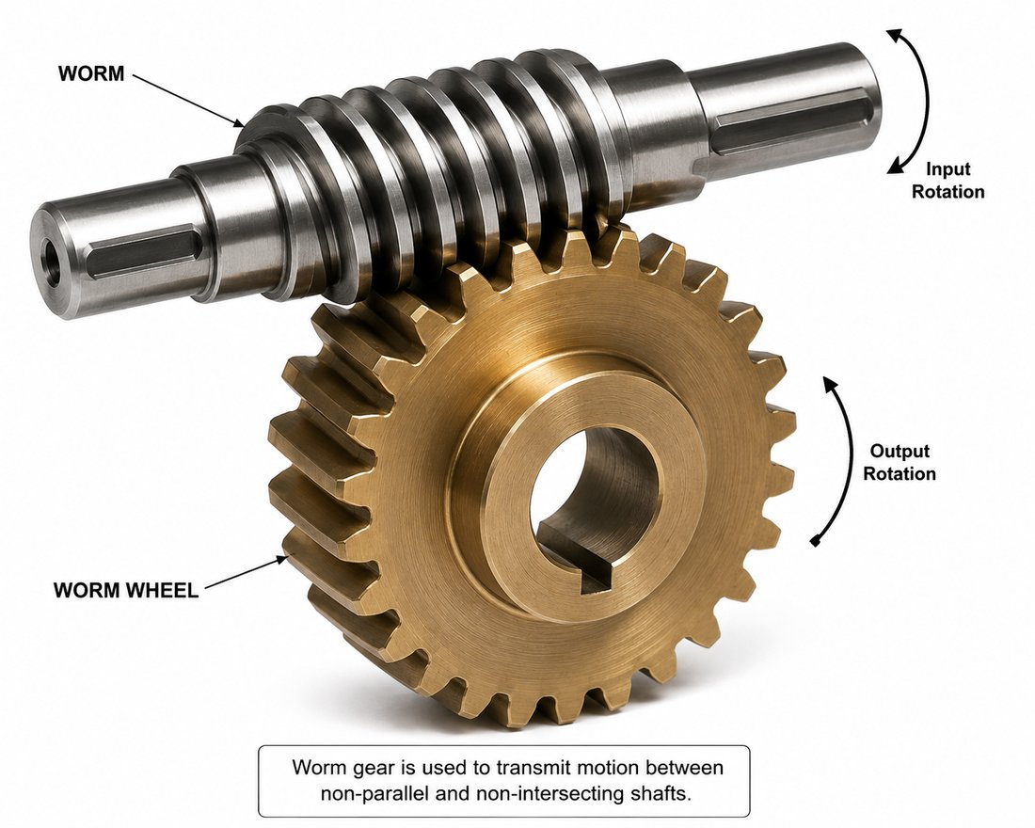
A worm gear system: a worm meshing with a worm wheel.

Rack and Pinion
A rack and pinion converts rotary motion into linear motion. The pinion is a circular gear, while the rack is a straight toothed component. A major application is automotive steering, where rotation of the steering input is converted into linear movement of the steering rack.
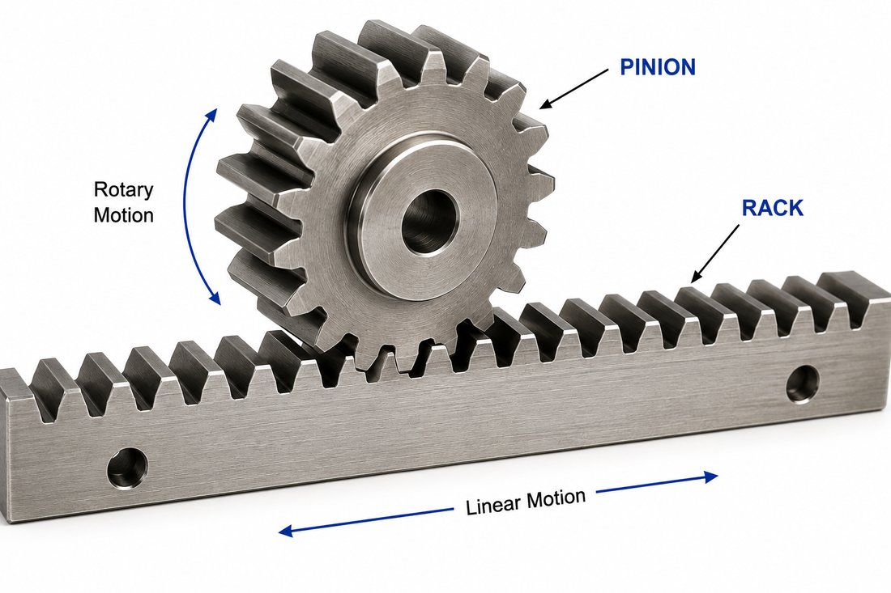
A rack and pinion, converting rotary motion into linear motion.

Idler Gear
An idler gear is placed between the driver and driven gears. Its primary purpose is generally to change the direction or spacing of the output without changing the overall gear ratio.
For example: 20T → 40T → 20T. The middle gear changes the rotational direction relationship but does not necessarily change the overall speed ratio between the first and last gears.
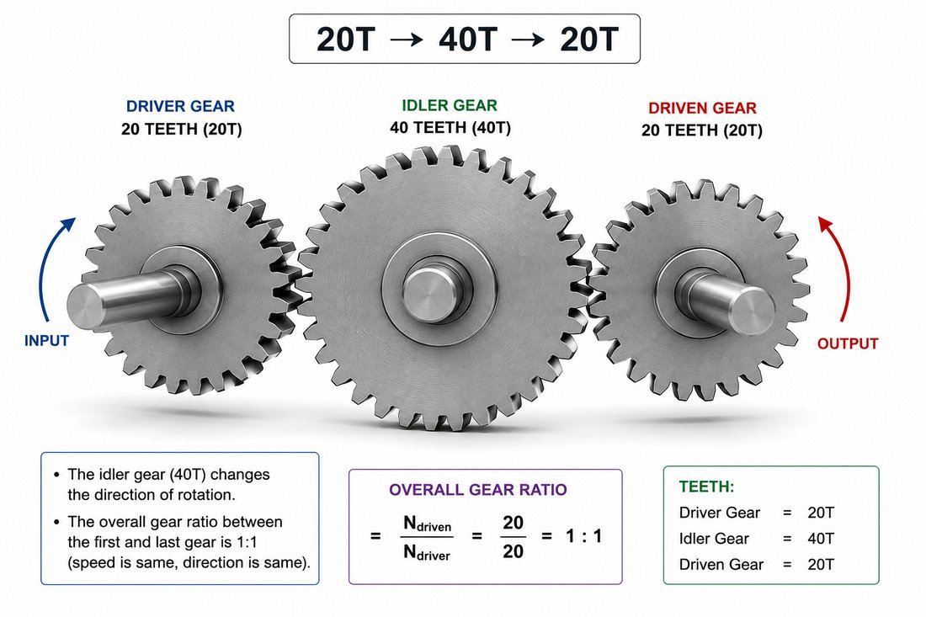
An idler gear placed between the driver and driven gears.

Gear Backlash
Backlash is the small amount of clearance between mating gear teeth.
Some backlash is necessary because perfectly tight teeth would cause increased friction, heat generation, binding, manufacturing problems, and failure due to thermal expansion.
However, excessive backlash can cause positioning errors, impact loading, noise, vibration, and reduced motion accuracy — this is particularly important in robotics and precision mechanisms.
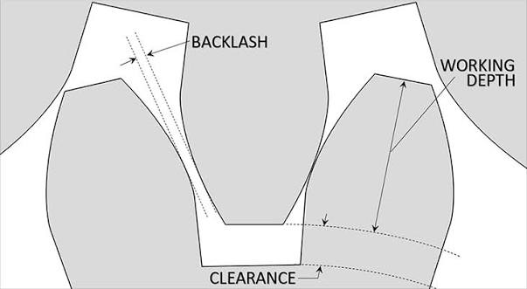
Gear backlash: the small clearance between mating teeth.

Applications
• Bicycle: Low gears help climb hills; high gears increase speed.
• Cars: Different gear ratios for starting, climbing, cruising.
• Robots: High torque for lifting; high speed for racing.
• Clocks: Different gears rotate at different speeds.

Advantages
No slipping, accurate motion, high efficiency, long life, precise speed control, can change direction, can increase torque or speed.

Disadvantages
Require lubrication, can be noisy, need accurate alignment, costlier than belt drives.

Module 1.2: Load, Payload & Forces

What is Force?
Force is a push or pull that can change the motion or shape of an object.
Formula: F = m × a SI Unit: Newton (N)
Example: A 5 kg robot accelerating at 2 m/s² requires 10 N of force.
Types of force: Push, Pull, Gravity, Friction, Magnetic, Spring, Air Resistance.
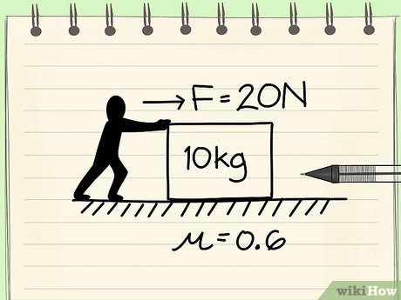
A push or pull force acting on an object.

What is Load?
Load is anything the robot must move, carry, lift, pull, or push against.
Formula: L = m × g SI Unit: Newton (N)
• Dead Load: Permanent parts.
• Live Load: Temporary objects.
• Static Load: Weight that does not move (robot sitting on a ramp).
• Dynamic Load: Extra force during motion, braking, impacts, or acceleration.

What is Payload?
Payload is the maximum safe weight a robot can carry or lift.
Example: Robot = 12 kg, maximum object = 4 kg, payload = 4 kg.
Warning: Exceeding payload
Exceeding payload can overload motors, gears and batteries.

Centre of Gravity
The center of gravity is the theoretical point where the entire weight of an object or body is considered to act.
Tall, narrow robots are easier to tip. Wide, low robots are more stable. Lower the CoG by placing heavy components low and widening the wheelbase.
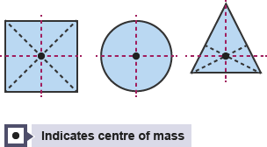
The center of gravity affects how stable a robot is.

Safety Factor
Formula: Safety Factor = Maximum Safe Load ÷ Expected Load.
Example: Expected load = 5 kg, designed for 15 kg, Safety Factor = 3.
Tip
Robots commonly use a safety factor of 2–3.

Module 1.3: Simple Machines Review

1.1 Lever Mechanism

What is a Lever?
A lever is one of the six simple machines. It is a rigid bar that rotates around a fixed point called the fulcrum. It helps lift or move loads using less effort. Common examples include scissors, pliers, seesaws, bottle openers, wheelbarrows, and robot arms.

Parts of a Lever
• Fulcrum: Pivot point.
• Effort: Applied force.
• Load: Object being moved.
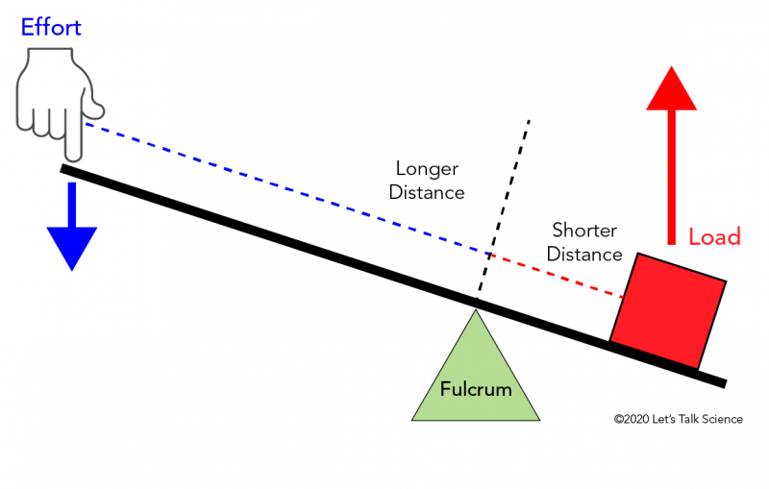
The three parts of a lever: fulcrum, effort, and load.

How a Lever Works
Applying effort on one side of the fulcrum creates a turning effect that moves the load. A longer effort arm reduces the force required.

Mechanical Advantage
Formula: MA = Load ÷ Effort. Example: Load = 60 N, Effort = 20 N, MA = 3.

Principle of Moments
Effort × Effort Arm = Load × Load Arm. Example: 40 N load at 10 cm balanced by 20 N effort at 20 cm.

Class 1 Lever
Fulcrum in the middle. Examples: Seesaw, Scissors, Crowbar, Pliers. Robot Example: Pivoted gripper.

Class 2 Lever
Load in the middle. Examples: Wheelbarrow, Bottle opener, Nutcracker. Robot Example: Lifting platform.

Class 3 Lever
Effort in the middle. Examples: Human arm, Tweezers, Fishing rod. Robot Example: High-speed robot arm.
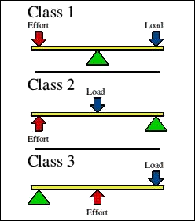
The three lever classes, distinguished by where the fulcrum, load, and effort sit.

Advantages
Reduces effort, can increase force or speed, simple, reliable, widely used.

Disadvantages
Requires space, incorrect fulcrum reduces efficiency, pivot friction, can bend under overload.

Applications
Construction, robotics, automobiles, cranes, industrial machinery, hand tools.

1.2 Wheel and Axle

What is a Wheel and Axle?
A wheel and axle is one of the six simple machines. It consists of a large wheel rigidly connected to a smaller axle so both rotate together. It helps reduce effort, increase torque, or increase speed depending on its design.
Definition: A wheel and axle is a simple machine made of a large wheel connected to a smaller axle that rotate together to transmit force, motion, and torque.

Parts of a Wheel and Axle
Wheel: Larger circular part that provides leverage. Functions: Reduces effort, increases distance traveled, improves efficiency.
Axle: Smaller shaft connected to the wheel. Functions: Supports the wheel, transfers rotational motion, delivers torque.
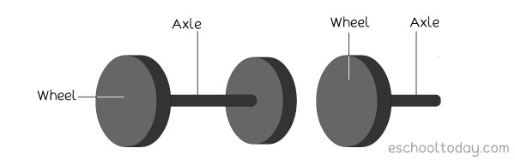
The wheel and axle, rigidly connected so both rotate together.

How It Works
When force is applied to the wheel, torque is created. Because the wheel and axle are fixed together, the axle rotates. A large wheel allows a small effort to create a larger turning force on the axle.

Torque
Formula: Torque = Force × Radius Example: Force = 20 N, Radius = 0.25 m, Torque = 20 × 0.25 = 5 N·m

Mechanical Advantage
Formula: MA = Wheel Radius ÷ Axle Radius (or Wheel Diameter ÷ Axle Diameter). Example: Wheel diameter = 40 cm, Axle diameter = 10 cm, MA = 4.

Robotics Applications
Robot drivetrain, gears (wheel-and-axle with teeth), intake rollers, conveyor systems, winches, and drive shafts all use the wheel-and-axle principle.

Advantages
• Reduces effort.
• Increases torque.
• Can increase speed.
• Smooth and efficient motion.
• Simple and reliable.

Disadvantages
• Bearing friction.
• Needs lubrication.
• Larger wheels require more space.
• Components wear over time.

Phase 2: CAD with Onshape

Module 2.1: Onshape Interface & Navigation
This module is taught through a video walkthrough rather than written notes here — follow along as you watch.
Start here: Signing in to Onshape (Google Drive) — a walkthrough of logging in and getting to your first Onshape workspace.
Once you're signed in, watch the video below to get comfortable with Onshape's interface before moving on to sketching.
▶ Watch: Onshape Interface and Navigation

Module 2.2: Sketch Fundamentals
This module is taught through Onshape's own interactive course rather than written notes here.
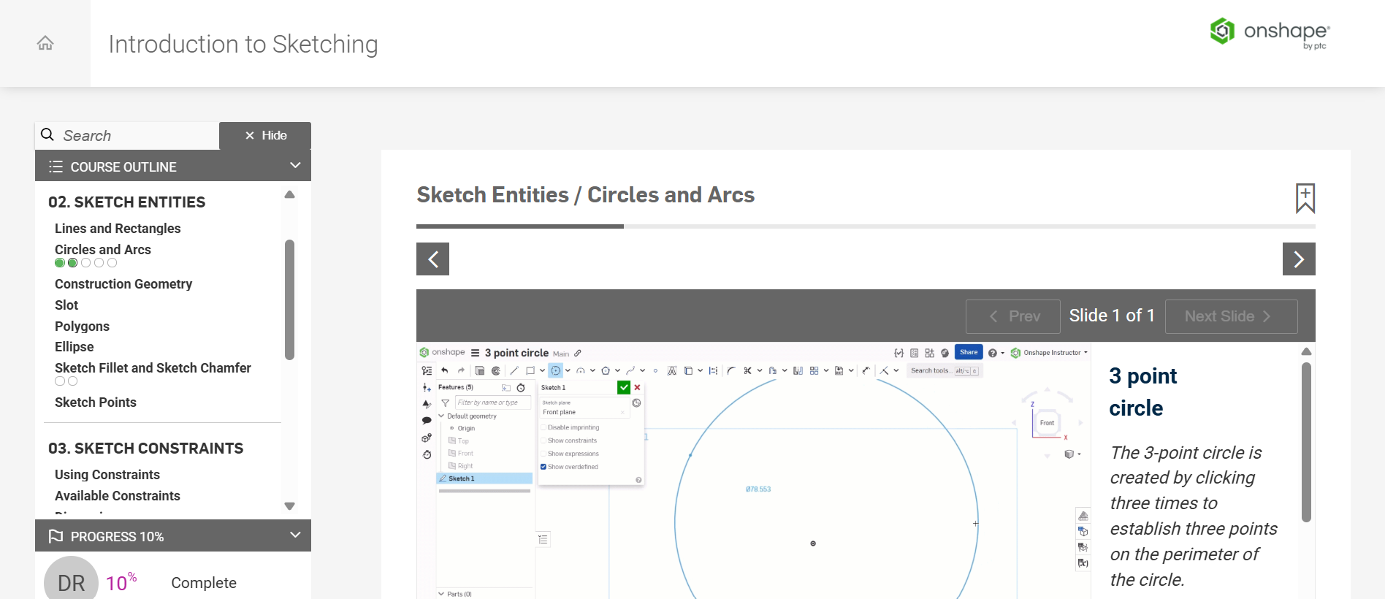
Onshape's "Fundamentals: Sketching" course, on the Sketch Entities / Circles and Arcs lesson.
Follow along here: Onshape Fundamentals: Sketching.

Module 2.3: 3D Features
This module is taught through Onshape's own interactive course rather than written notes here.
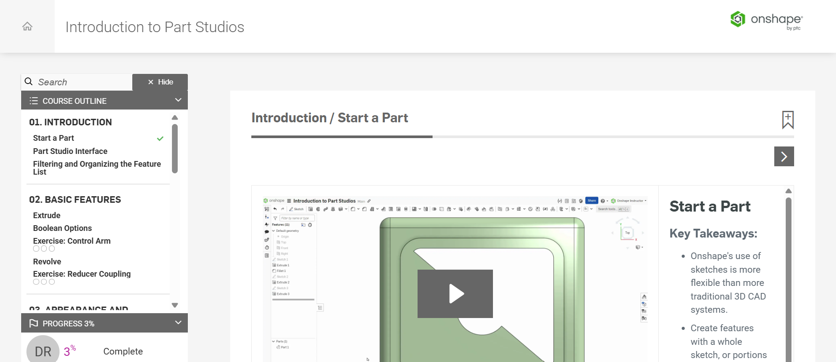
Onshape's "Introduction to Part Studios" course, on the Start a Part lesson.
Follow along here: Introduction to Part Studios.

Module 2.4: Assembly & Constraints (Mates)
This module is taught through Onshape's own interactive course and a video playlist rather than written notes here.
Start here: Creating an Assembly — Assembly Interface.
Then work through the full playlist below, covering assemblies and mates in Onshape:
▶ Watch: Assemblies in Onshape

Phase 3: Mechanism Design & Assembly

Module 3.1: Spur Gear vs. Helical Gear

Introduction
Gears transmit power and rotational motion between shafts. The two most common cylindrical gears are spur gears and helical gears.

Spur Gear
• Straight teeth parallel to the shaft.
• Entire tooth engages at once.
• High efficiency (97–99%).
• Simple, inexpensive and easy to manufacture.
• Produces more noise and vibration at high speed.
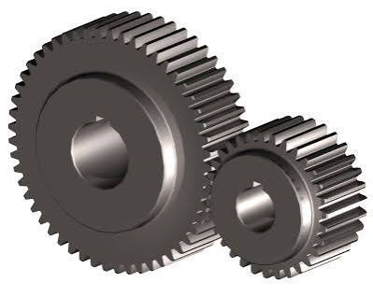
A spur gear, with straight teeth parallel to the shaft.

Helical Gear
• Teeth are cut at an angle (helix angle).
• Teeth engage gradually, making operation smoother and quieter.
• Higher load carrying capacity.
• Longer service life due to better load distribution.
• Generates axial thrust that must be supported by bearings.
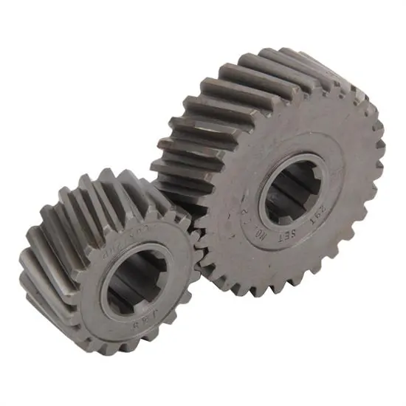
A helical gear, with teeth cut at an angle.

Axial Thrust Force
The angled teeth create a force along the shaft in addition to the tangential force. This axial thrust is managed using thrust bearings, angular contact bearings, tapered roller bearings, or double-helical gears.

Spur vs Helical Gear
Feature | Spur | Helical
Teeth | Straight | Angled
Engagement | Instant | Gradual
Noise | High | Low
Vibration | High | Low
Load Capacity | Moderate | High
Axial Thrust | None | Present
Cost | Lower | Higher
Applications | Low/Medium speed | Medium/High speed

Important Gear Parameters

1. Module (m)
Defines tooth size. Formula: m = d / z Larger module means larger, stronger but heavier teeth.

2. Number of Teeth (z)
Determines gear ratio, output speed and torque.

3. Pitch Diameter (d)
Effective rolling diameter of the gear. Formula: d = m × z

4. Helix Angle (ψ)
Typically 15°–30° for competition robots. Higher helix angles provide smoother engagement but increase axial thrust.

5. Face Width
Width of the gear tooth. A common guideline is 8–12 × module for good strength and load distribution.
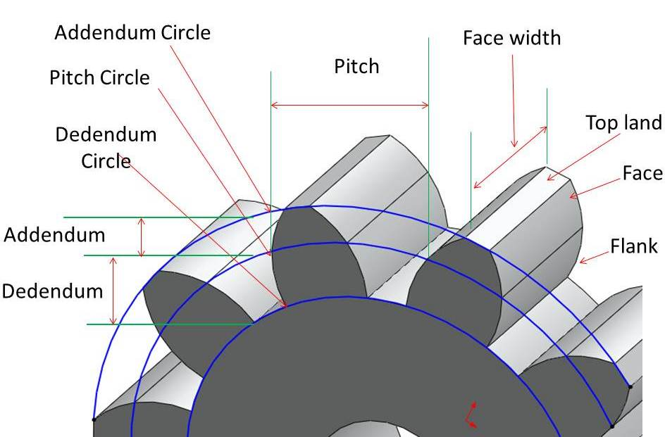
The key gear parameters: module, teeth, pitch diameter, helix angle, and face width.

Summary
Spur gears are simple, efficient and economical, while helical gears offer smoother, quieter operation and higher load capacity. The trade-off is axial thrust. Key parameters every student should understand are module, number of teeth, pitch diameter, helix angle and face width.

Module 3.2: Helical Gear — Step-by-Step Build in Onshape
This module is taught through a video walkthrough rather than written notes here — follow along as you watch.
Follow along in Onshape as you watch.
▶ Watch: Helical Gear: Step-by-Step Build in Onshape

Module 3.3: Four-Bar Linkage — Concept

Introduction to Linkages
A linkage is a mechanical system made of rigid bars (links) connected by pin joints (revolute joints). It transfers and transforms motion and force from one part of a machine to another.
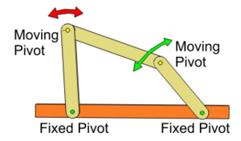
A simple linkage made of rigid links connected by pin joints.

What is a Link?
A link is a rigid member connecting two joints. The length of the link remains constant while it rotates or moves.

What is a Joint?
A joint connects two or more links. The most common joint is the pin (revolute) joint, which allows rotational motion.

Four-Bar Linkage
The four-bar linkage is the simplest closed-chain mechanism consisting of four rigid links connected by four pin joints.

Components
Ground Link: The fixed link that provides the reference frame.
Crank: The input link that can rotate continuously when geometry allows.
Coupler: Transfers motion between the crank and rocker.
Rocker: The output link that oscillates back and forth.

Working Principle
• The motor rotates the crank.
• The crank drives the coupler.
• The coupler transfers motion to the rocker.
• The rocker oscillates, converting rotary motion into useful output.

Importance in Robotics
• Converts rotary motor motion into oscillating or sweeping motion.
• Used in grippers, intake mechanisms, sweepers and walking robots.
• Simple, compact and reliable mechanism.

Grashof's Condition
Let s = shortest link, l = longest link, and p and q be the remaining two links.
Condition: s + l ≤ p + q
If the condition is satisfied, at least one link can rotate continuously. Otherwise, all moving links oscillate.

Advantages
• Simple construction
• Compact design
• Low cost
• Smooth motion
• High reliability
• Low maintenance

Limitations
• Motion depends on link lengths.
• Limited adjustment after manufacturing.
• Pin joints wear over time.
• Requires careful design.

Summary
A four-bar linkage consists of a ground link, crank, coupler and rocker. It converts rotary motion into oscillating motion and is widely used in robotics and machines. Grashof's condition helps determine whether continuous rotation is possible.

Simulator
Explore link lengths and Grashof's condition interactively: Four-Bar Linkage Simulator (third-party tool, not affiliated with NRL).

Module 3.4: Four-Bar Linkage — Step-by-Step Build
Note: Coming Soon
A screen-recorded, step-by-step build video for the four-bar linkage in Onshape is planned for this module but not yet available. In the meantime, review the Four-Bar Linkage: Concept module and try the linkage simulator to explore link geometry before building.

Module 3.5: Gear Meshing Assembly
This module is taught through a video walkthrough rather than written notes here — follow along as you watch.
Follow along in Onshape as you watch.
▶ Watch: Gear Meshing Assembly

Phase 4: Manufacturing Processes

Module 4.1: FDM (Fused Deposition Modeling) 3D Printing
Curriculum notes covering the working principle, materials, slicer settings, design rules, workflow, strengths and limitations.

Introduction
FDM is an additive manufacturing process in which thermoplastic filament is melted and deposited layer by layer to create a three-dimensional object.

How FDM Works
• Filament is fed into a heated nozzle.
• The nozzle melts the plastic.
• Molten plastic is deposited on the build plate.
• Each layer bonds to the previous one.
• The object grows upward until complete.
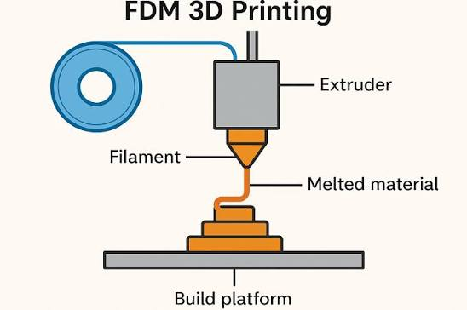
The FDM process: filament is melted and deposited layer by layer.

Common Materials
PLA: Easy to print, biodegradable under industrial composting conditions, ideal for prototypes.
PETG: Tough, slightly flexible, excellent for brackets and moderate-load gears.
ABS: Strong and heat resistant but prone to warping. Requires a heated bed and enclosed printer.

Key Slicer Settings
Layer Height (0.1–0.3 mm): Smaller layers improve finish but increase print time.
Infill (0–100%): 20% for light parts, 60–80% for structural parts.
Supports: Temporary structures for overhangs.
Print Speed: Slower speeds improve strength and layer bonding.
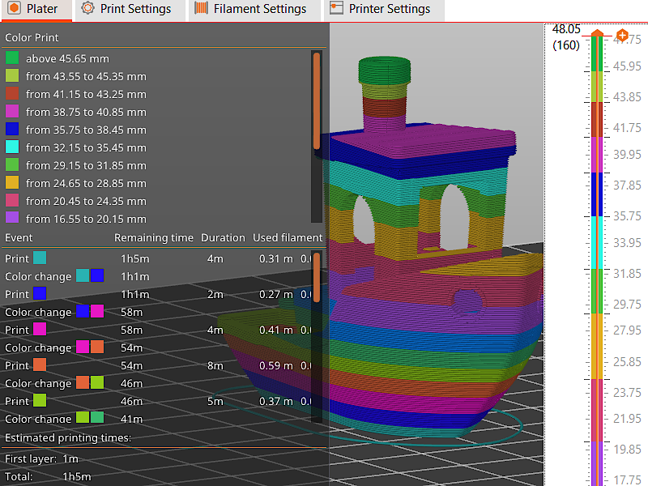
Key slicer settings that affect print quality and strength.

FDM Design Rules
• Minimum wall thickness: 1.2 mm (3 extrusion widths with a 0.4 mm nozzle).
• Overhangs up to 45° usually print without supports.
• Vertical holes print accurately.
• Horizontal holes may require compensation or chamfers.

Workflow
Onshape → Export STL → Import into Cura/PrusaSlicer → Configure settings → Slice to generate G-code → Send to the printer.

Strengths
• Low-cost filament
• Fast prototyping
• Easy to use
• Available in schools and maker spaces
• Excellent for rapid design iterations

Limitations
• Visible layer lines
• Weaker in the Z-direction
• Thin gears are unsuitable for high torque
• ABS can warp
• Supports may be required for complex overhangs

Summary
FDM is a low-cost and widely used manufacturing process. Understanding materials, slicer settings, design guidelines and workflow enables students to produce strong and reliable printed parts.

Module 4.2: Laser Cutting

What is Laser Cutting?
Laser cutting is a manufacturing process that uses a highly focused beam of light (laser) to cut or engrave materials with exceptional precision. The laser melts, burns, or vaporizes material along a programmed path to create clean and accurate cuts. It is widely used in robotics, engineering, product design, architecture, and manufacturing.

How Laser Cutting Works
1. Designing the Part — Create a 2D sketch in CAD software such as Onshape, SolidWorks, Fusion 360, or AutoCAD.
2. Exporting the Design — Export the sketch as a DXF or SVG file.
3. Importing into Laser Software — Import the file into software such as LightBurn or RDWorks. Set laser power, speed, and cutting/engraving operations.
4. Machine Setup — Place the material on the laser bed. Focus the laser and complete safety checks.
5. Cutting — The laser follows the programmed path, melting, burning, or vaporizing the material.
6. Removing the Parts — Remove finished parts and clean edges if necessary.
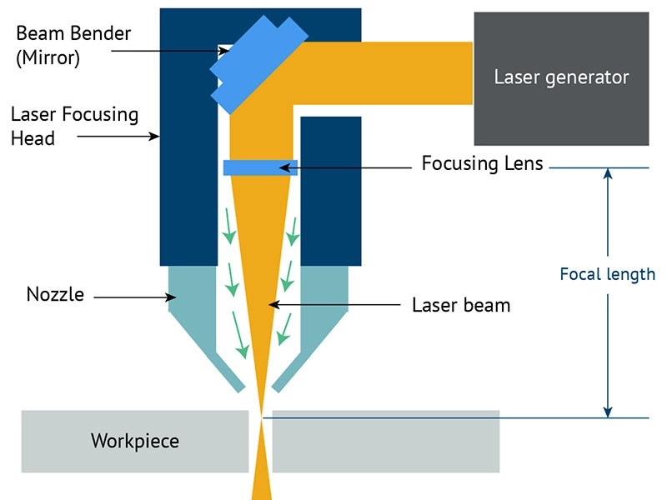
The laser cutting workflow, from design to finished parts.
Warning: Safety
Laser cutters involve high-power lasers and fumes from melted/burned material. Always complete machine-specific safety checks and never leave a cut running unattended.

Laser Cutting is a 2D Manufacturing Process
Laser cutters work with flat sheet materials only. Three-dimensional products are created by assembling multiple laser-cut parts.

Materials Commonly Used in Robotics
Plywood (3–6 mm): Strong, lightweight, inexpensive, and ideal for robot chassis, frames, and brackets.
Acrylic: Smooth, rigid, available in clear or colored sheets, and used for side panels, covers, and decorative parts.
Cardboard and Foam: Low-cost materials used for rapid prototyping, concept models, and classroom demonstrations.

Kerf
Kerf is the width of material removed by the laser beam during cutting. Typical kerf ranges from 0.1–0.3 mm depending on the material and machine settings.
Accounting for kerf is essential for accurate dimensions and properly fitting assemblies.
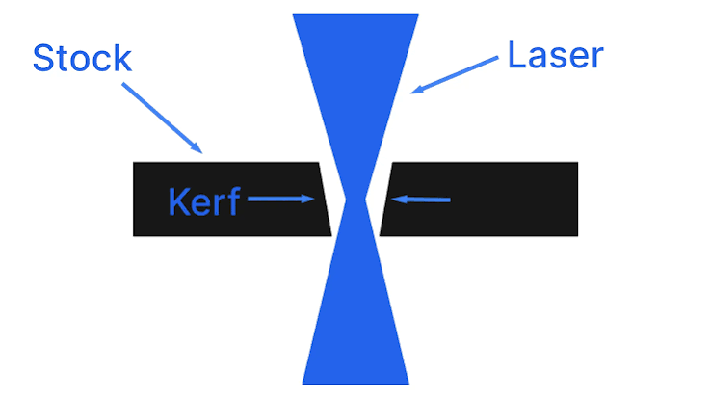
Kerf: the width of material removed by the laser beam.

Press-Fit (Tab-and-Slot) Joints
Press-fit joints use matching tabs and slots that snap together without glue or screws.
To compensate for kerf:
• Tabs are designed slightly wider.
• Slots are designed slightly narrower.
Applications include robot chassis, boxes, enclosures, and educational kits.
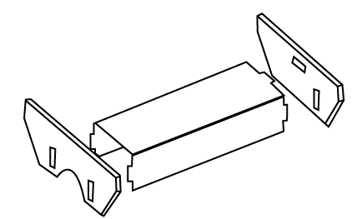
Press-fit tab-and-slot joints, compensated for kerf.

CAD Workflow
1. Create a 2D sketch in Onshape or another CAD program.
2. Export as DXF or SVG.
3. Import into LightBurn or RDWorks.
4. Set laser power, speed, and material thickness.
5. Preview the toolpath and begin cutting.

Engraving
By reducing laser power or increasing speed, the laser engraves the surface instead of cutting through it.
Applications: Labels, team logos, measurement scales, alignment marks, decorative graphics.

Advantages of Laser Cutting
Very fast cutting, excellent precision, clean edges, low material waste, easy design iteration, affordable materials, excellent for rapid prototyping.

Limitations of Laser Cutting
Limited to 2D sheet materials, requires assembly for 3D structures, wood edges may char, some plastics (e.g., PVC) cannot be laser cut due to harmful fumes, limited cutting thickness depending on machine power.

Applications in Robotics
Common laser-cut components include: robot chassis, motor mounts, gear plates, structural frames, sensor brackets, battery holders, protective covers, decorative panels, electronics mounting plates.

Module 4.3: CNC Machining

What is CNC?
CNC stands for Computer Numerical Control. It is a manufacturing process in which computers control the movement of cutting tools to remove material from a solid workpiece and create precise parts.
Instead of an operator manually guiding the cutting tool, a computer follows programmed instructions along the X, Y, and Z axes. CNC machining is widely used in automotive, aerospace, robotics, electronics, and medical manufacturing because it produces highly accurate and repeatable parts.

How CNC Machining Works
1. Designing the Part — Create a 2D drawing or 3D CAD model using software such as SolidWorks, Fusion 360, Onshape, or Inventor.
2. CAM Programming — Import the CAD model into CAM software. Select cutting tools, feed rates, spindle speeds, and machining operations.
3. Generating G-code — CAM software automatically generates G-code containing tool movements, cutting speeds, depths, and tool changes.
4. Machine Setup — Clamp the workpiece securely. Install the cutting tool. Set the machine reference point (zero). Perform safety checks.
5. Machining — The spindle rotates the cutter while motors move the tool or workpiece along programmed paths. Material is removed until the final shape is achieved.
6. Inspection — Measure dimensions, inspect surface finish, and remove burrs if necessary.
Warning: Safety
CNC machines involve fast-spinning cutting tools and flying debris. Secure fixturing, correct eye/ear protection, and trained supervision are required before operating any CNC machine.

CNC is a Subtractive Manufacturing Process
CNC machining removes material from a solid block called stock. Unlike 3D printing, which builds parts layer by layer, CNC cuts away unwanted material to produce the finished component.

Difference Between CNC Machining and 3D Printing
• CNC: Subtractive manufacturing, high strength, excellent accuracy, smooth finish.
• 3D Printing: Additive manufacturing, minimal waste, ideal for prototypes and complex shapes.

Common Types of CNC Machines
CNC Router: Cuts wood, foam, acrylic, HDPE, and plywood. Used for robot chassis, signs, and educational projects.
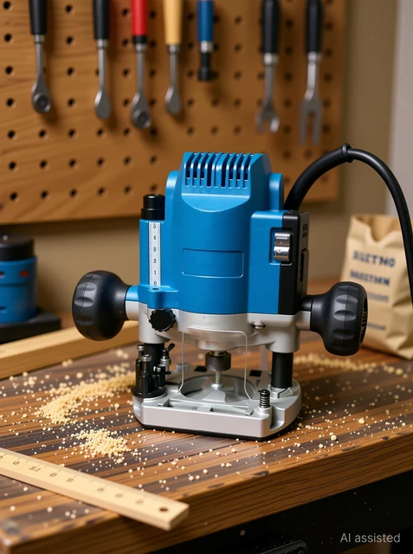
A CNC router, used for wood, foam, acrylic, HDPE, and plywood.
CNC Mill: Machines aluminium, brass, steel, and engineering plastics. Used for motor mounts, gearbox plates, and precision brackets.
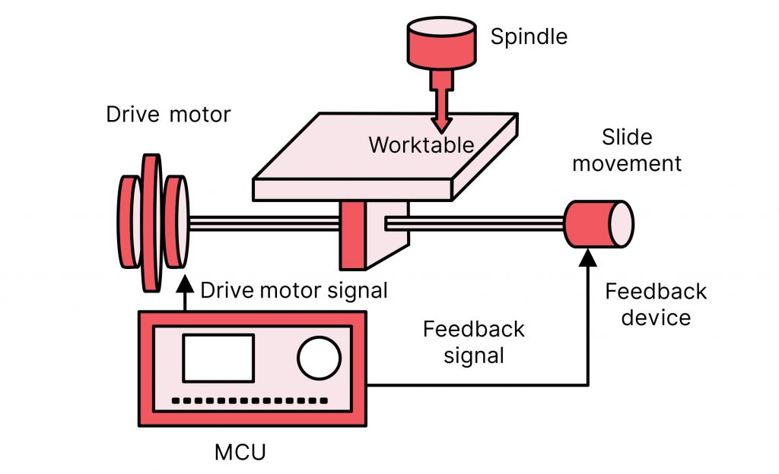
A CNC mill, used for aluminium, brass, steel, and engineering plastics.
CNC Lathe: Produces cylindrical parts by rotating the workpiece. Used for shafts, spacers, rollers, and bushings.
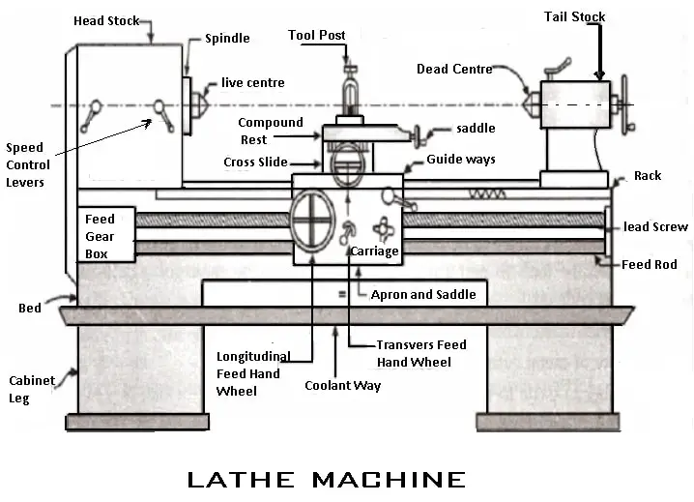
A CNC lathe, producing cylindrical parts by rotating the workpiece.

Materials Used in CNC Machining
Aluminium: Lightweight, strong, corrosion-resistant, and easy to machine. Used for robot chassis and structural components.
HDPE: Tough, lightweight engineering plastic. Used for side plates, guards, and brackets.
Hardwood: Used for furniture, prototypes, and educational projects.

G-code
G-code is the programming language that controls CNC machines. It tells the machine where to move, how fast to move, how deep to cut, and when to change tools or start the spindle.
Students usually do not write G-code manually. CAM software such as Autodesk Fusion 360 CAM, Mastercam, or SolidCAM automatically generates it from the CAD model.
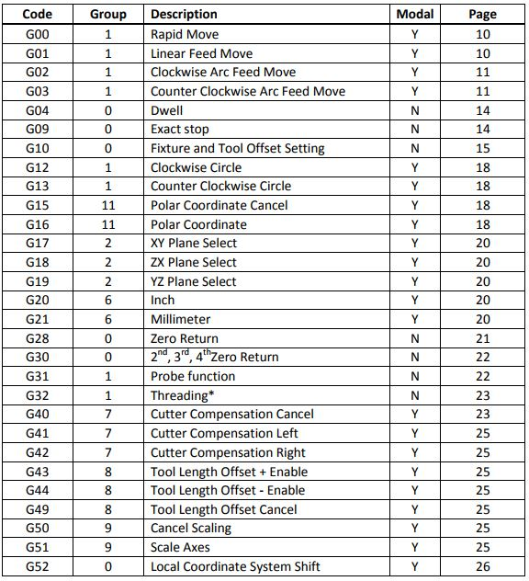
G-code drives every movement of a CNC machine.

Important CNC Design Rules
1. Inside Corners — Rotating cutters cannot produce perfectly sharp inside corners. Add a radius equal to the cutter radius.
2. Minimum Feature Size — Smallest feature depends on cutter diameter (typically 2–6 mm on school machines).
3. Fixturing — Clamp the workpiece securely. Poor fixturing causes vibration, inaccurate dimensions, poor finish, and possible tool breakage.

Advantages of CNC Machining
High precision and repeatability, excellent surface finish, machines strong materials such as aluminium and steel, suitable for professional mechanical components.

Limitations of CNC Machining
Expensive machines and tooling, longer setup than 3D printing, produces material waste, requires trained supervision and safety precautions.

Applications in Robotics
Common CNC-machined robot components include: motor mounts, aluminium chassis plates, drive shafts, wheel hubs, gearbox plates, bearing blocks, custom brackets, sensor mounts, structural frame members.

Module 4.4: Injection Moulding

What is Injection Moulding?
Injection moulding is one of the most common manufacturing processes used to produce plastic components in large quantities. It is used to manufacture everything from bottle caps and toys to automotive parts, medical devices, and robot kit components.
In this process, plastic pellets are heated until they melt. The molten plastic is then injected into a precision-machined steel mould under very high pressure. After the plastic cools and solidifies, the mould opens and ejector pins push the finished component out. The cycle is then repeated, allowing thousands or even millions of identical parts to be produced with excellent accuracy.
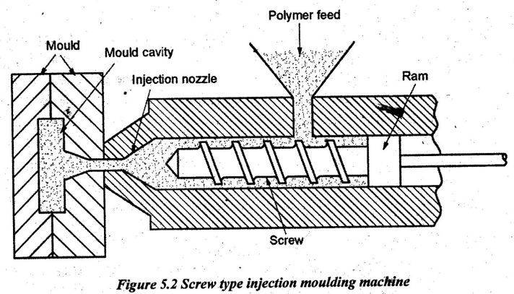
The injection moulding cycle: melt, inject, cool, eject.

How Injection Moulding Works

1. Feeding Plastic Pellets
• Small plastic pellets (ABS, Polypropylene, Polycarbonate, Nylon, etc.) are loaded into a hopper.
• The pellets fall into a heated barrel where they are transported by a rotating screw.

2. Melting the Plastic
• Heaters and friction melt the plastic.
• The molten plastic reaches approximately 180°C–300°C depending on the material.
• The screw builds pressure and measures the required shot size.

3. Injection
• The screw moves forward like a plunger.
• Molten plastic is injected into the mould cavity at pressures exceeding 100 MPa (14,500 psi).

4. Cooling
• Cooling channels circulate water to remove heat.
• Cooling accounts for approximately 50–70% of the total cycle time.

5. Ejection
• The mould opens and ejector pins remove the finished part.
• Typical cycle time ranges from 10–60 seconds.

Why Injection Moulding is Excellent for Mass Production
• One mould can produce thousands to millions of identical parts.
• Consistent dimensions and quality.
• High production speed with low labour.
• Very low cost per part at high production volumes.

Everyday Examples
LEGO bricks, plastic bottle caps, water bottles, robot competition kit components, plastic gears, computer mouse shells, keyboard keys, mobile phone covers, plastic cups, electrical switch housings, automotive interior panels, storage boxes, toys.

Important Design Rules

1. Draft Angles
Draft angles are small tapers (typically 1–3°) added to vertical walls to allow easy removal from the mould.
Benefits: Easier ejection, reduced mould wear, better surface finish, lower rejection rates.

2. Uniform Wall Thickness
Wall thickness should remain consistent throughout the part.
Uneven wall thickness can cause: Sink marks, warping, internal stresses.
Typical wall thickness is 1.5–3 mm for many consumer products.

3. Ribs
Ribs are thin reinforcing walls that increase stiffness without increasing wall thickness.
Typical design guidelines: Rib thickness 40–60% of wall thickness; rib height 2.5–3× wall thickness; include draft angles and fillets.

4. Weld Lines
Weld lines form where two plastic flow fronts meet. They are slightly weaker than surrounding material. Designers avoid placing highly loaded features such as screw holes on weld lines.

Cost Structure
• High initial mould cost (hundreds to many thousands of US dollars).
• Low production cost per part.
• Ideal for mass production but not economical for very small production runs.
Key Idea: Why Injection Moulding Matters for Robotics Students
Understanding injection moulding helps students:
• Recognise design features like ribs and draft angles.
• Avoid weakening moulded components while modifying them.
• Understand why commercial robot kit parts have their geometry.
• Design stronger, lighter, and more manufacturable plastic parts.

Module 4.5: Hand Tools
Hand tools are manually operated tools used for cutting, drilling, fastening, shaping, measuring, and assembling materials. They are commonly used in workshops for fabrication, maintenance, and basic mechanical work.
Examples: Allen key, file, screwdriver, hacksaw, hand drill, pliers, spanner, etc.

Allen Key
An Allen key is an L-shaped hexagonal tool used to tighten or loosen bolts and screws with a hexagonal socket.
Example: Used for tightening socket-head screws in robots and machinery.
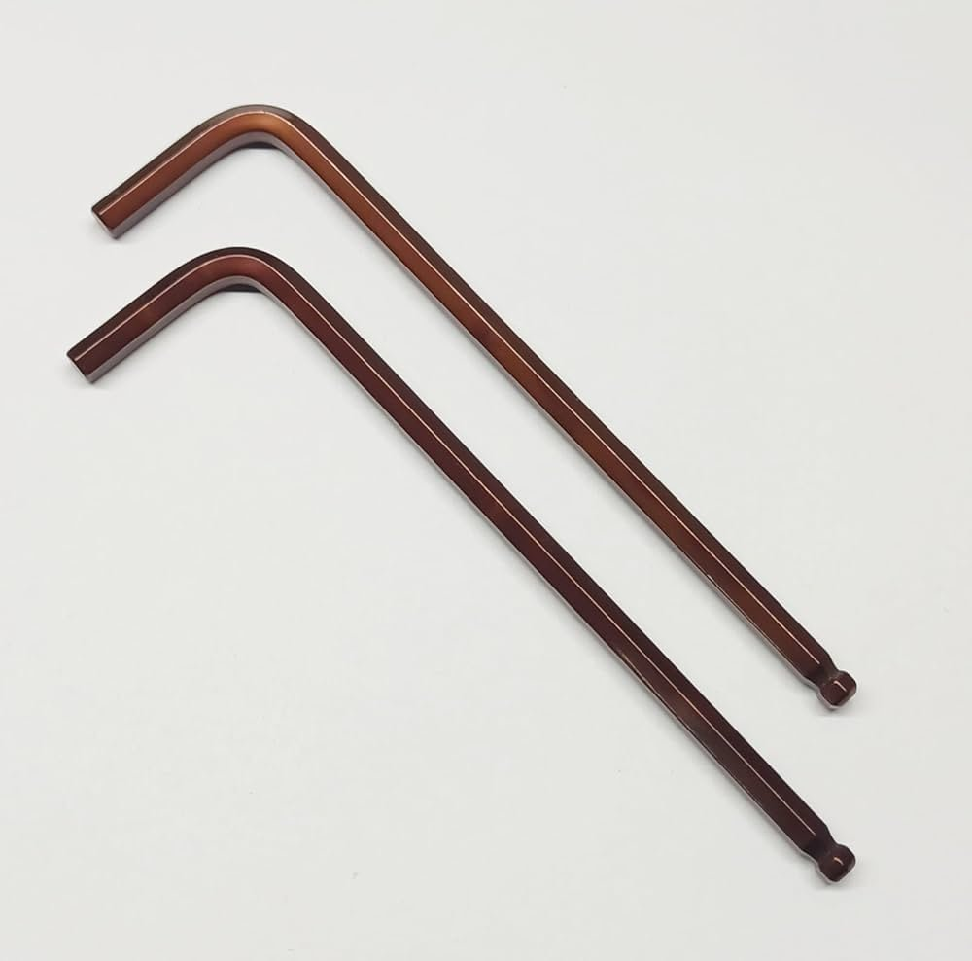
An Allen key, used to tighten and loosen hexagonal socket-head screws.

Files
A file is a hand tool with a rough, toothed surface used to remove small amounts of material and smooth or shape edges.
Example: Used for deburring and finishing metal or plastic parts.
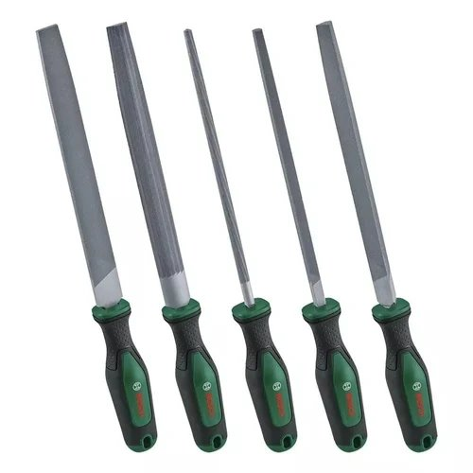
A set of files, used to smooth and shape material edges.

Screwdriver
A screwdriver is a hand tool used to tighten or loosen screws by applying rotational force.
Example: Flat-head and Phillips screwdrivers are commonly used in mechanical and electrical work.
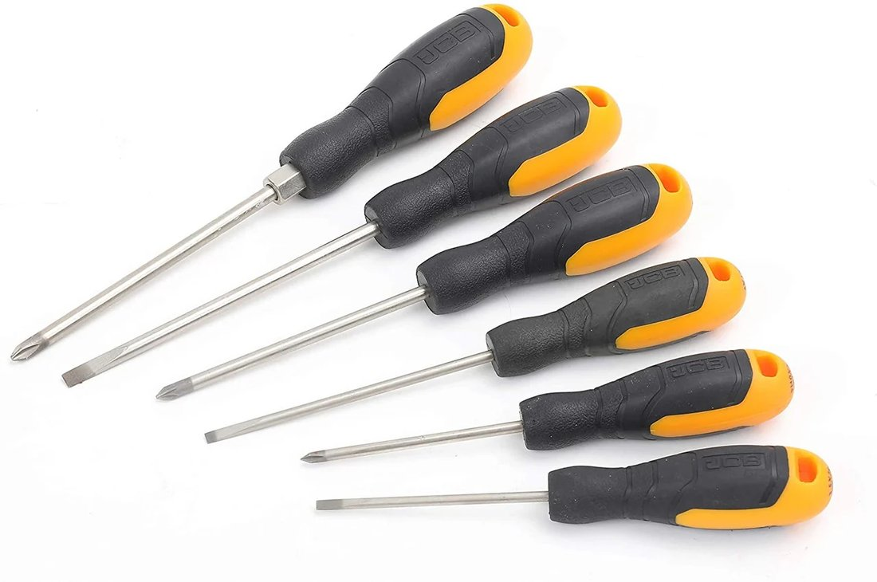
A screwdriver, used to tighten and loosen screws.

Hand Drill
A hand drill is a portable tool used to make holes in materials using a rotating drill bit.
Example: Used for drilling holes in wood, plastic, and metal sheets.
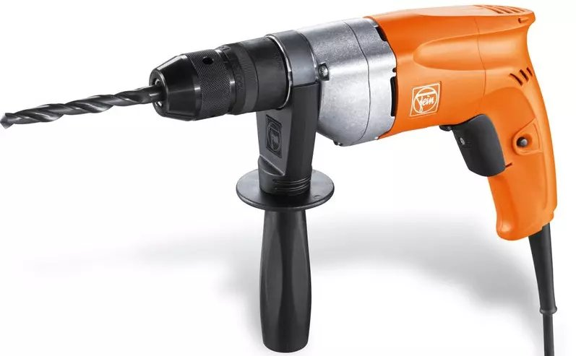
A hand drill, used to make holes with a rotating bit.

Tapping Machine
A tapping machine is a tool used to cut internal threads inside a pre-drilled hole using a tap.
Example: Used to create threads for bolts and screws in metal components.
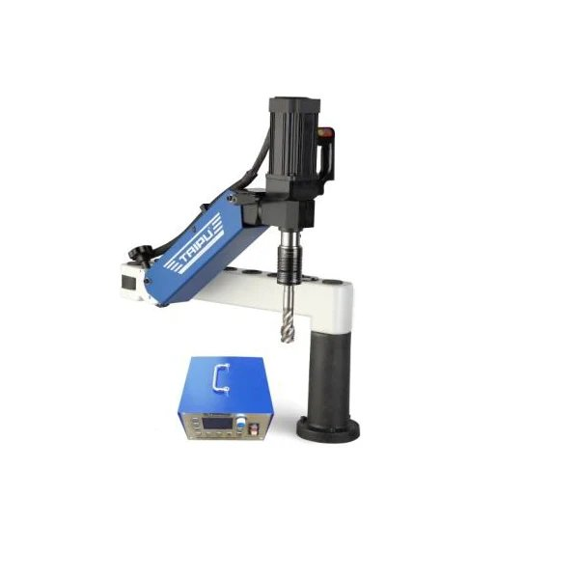
A tapping machine, used to cut internal threads.

Hacksaw
A hacksaw is a manual cutting tool with a fine-toothed metal blade used to cut materials such as metal, plastic, and pipes.
Example: Used to cut metal rods, bolts, and PVC pipes.
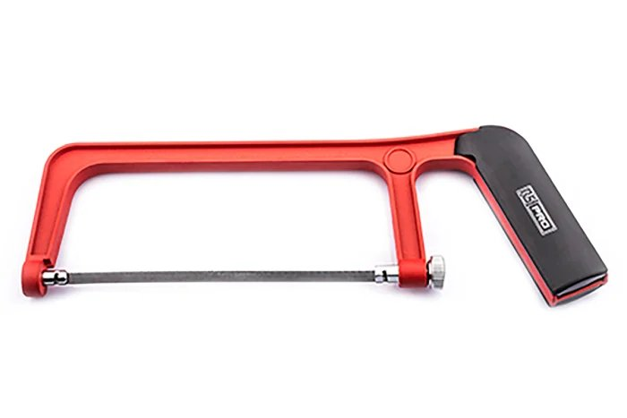
A hacksaw, used to cut metal, plastic, and pipes.

Phase 5: DIY (Do It Yourself)

Module 5.1: Arm Link
This is a DIY (Do It Yourself) exercise. There are no written modeling instructions here on purpose — the dimensioned drawing sheet below has everything you need: overall geometry, hole positions, fillet radii, and material thickness. Model the part in Onshape yourself before checking the solution.
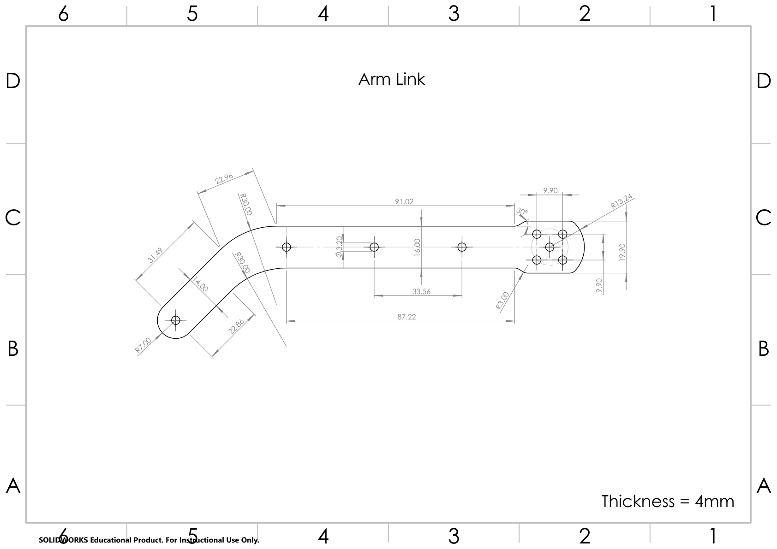
Arm Link dimensioned drawing sheet
Open full-resolution PDF: arm-link-drawing-sheet.pdf
Click the drawing sheet above to open the full PDF in a new tab, or [download it directly](/files/mechanical/arm-link-drawing-sheet.pdf).
Tip: Check your work
Once you've modeled the part yourself, compare your approach against the solution walkthrough: Arm Link — Solution Video (Google Drive).

Module 5.2: Back Plate
This is a DIY (Do It Yourself) exercise. There are no written modeling instructions here on purpose — the dimensioned drawing sheet below has everything you need: overall geometry, hole positions, fillet radii, and material thickness. Model the part in Onshape yourself.
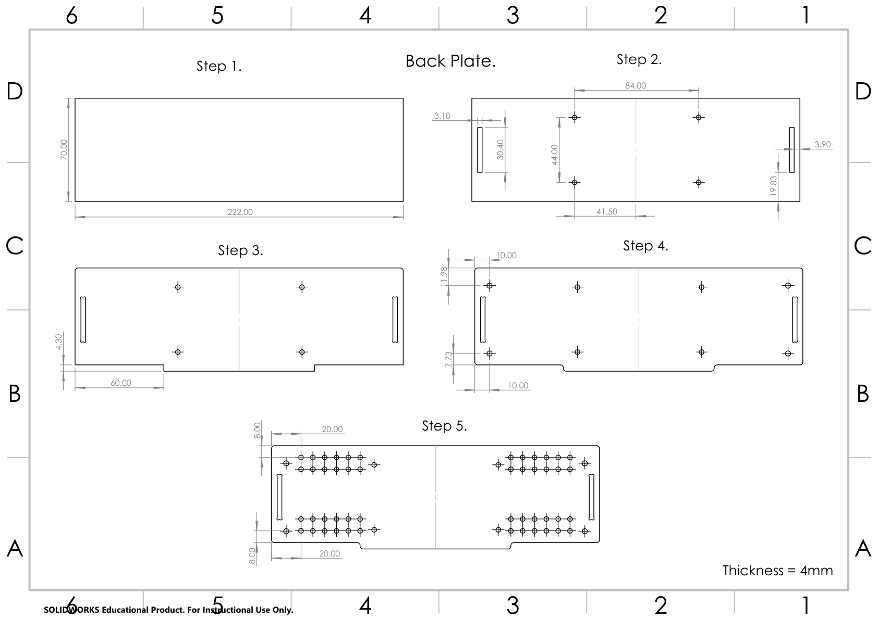
Back Plate dimensioned drawing sheet
Open full-resolution PDF: back-plate-drawing-sheet.pdf
Click the drawing sheet above to open the full PDF in a new tab, or [download it directly](/files/mechanical/back-plate-drawing-sheet.pdf).
Note
No solution video for this one — this part is pure DIY. Compare notes with a teammate or mentor if you get stuck.

Module 5.3: Side Plate
This is a DIY (Do It Yourself) exercise. There are no written modeling instructions here on purpose — the dimensioned drawing sheet below has everything you need: overall geometry, hole positions, fillet radii, and material thickness. Model the part in Onshape yourself before checking the solution.
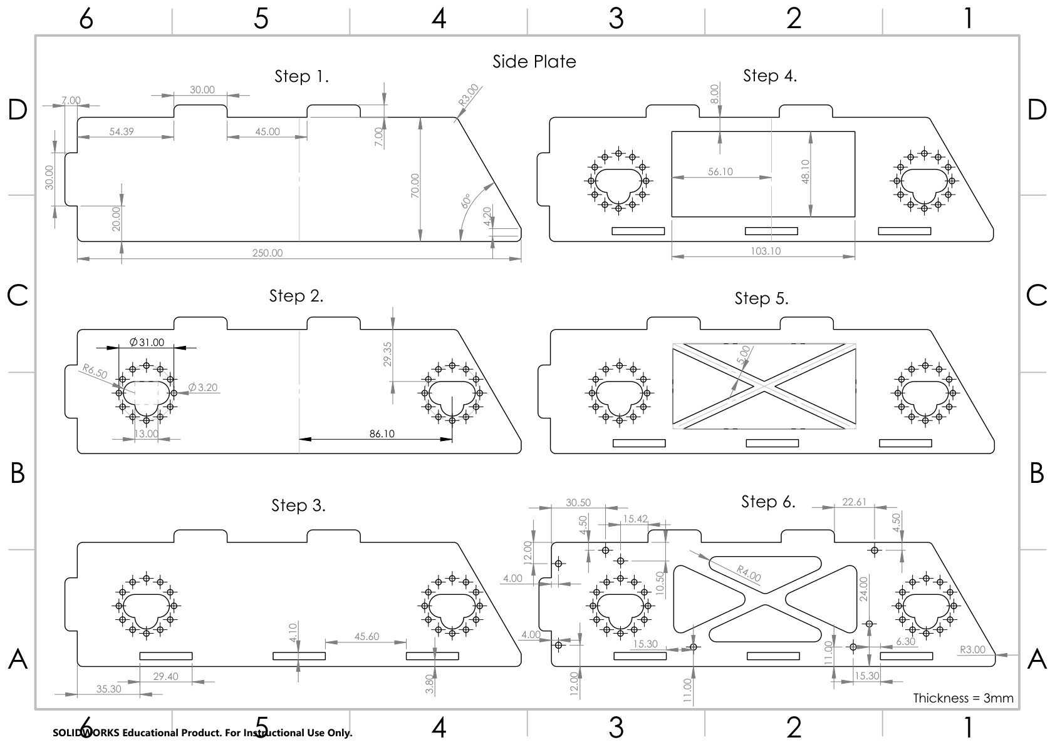
Side Plate dimensioned drawing sheet
Open full-resolution PDF: side-plate-drawing-sheet.pdf
Click the drawing sheet above to open the full PDF in a new tab, or [download it directly](/files/mechanical/side-plate-drawing-sheet.pdf).
Tip: Check your work
Once you've modeled the part yourself, compare your approach against the solution walkthrough: Side Plate — Solution Video (Google Drive).

Module 5.4: Top Plate
This is a DIY (Do It Yourself) exercise. There are no written modeling instructions here on purpose — the dimensioned drawing sheet below has everything you need: overall geometry, hole positions, fillet radii, and material thickness. Model the part in Onshape yourself.
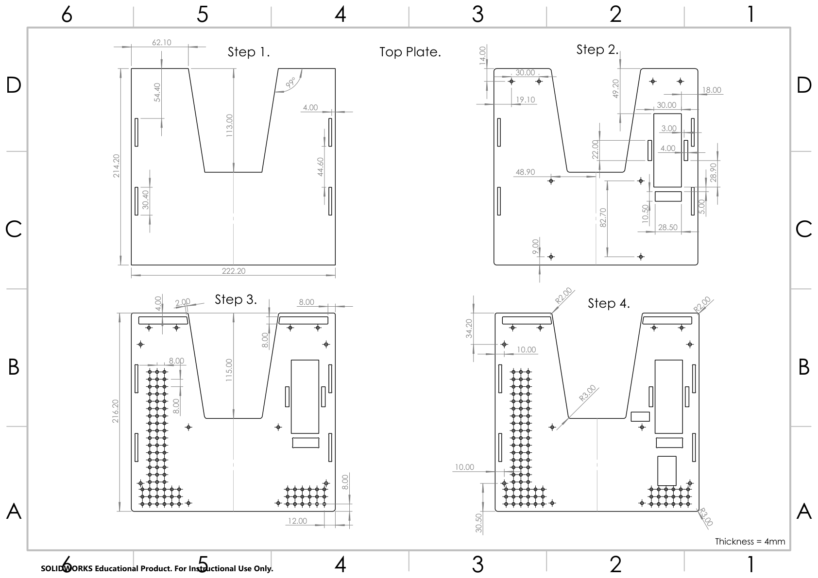
Top Plate dimensioned drawing sheet
Open full-resolution PDF: top-plate-drawing-sheet.pdf
Click the drawing sheet above to open the full PDF in a new tab, or [download it directly](/files/mechanical/top-plate-drawing-sheet.pdf).
Note
No solution video for this one — this part is pure DIY. Compare notes with a teammate or mentor if you get stuck.

Module 5.5: Base Plate
This is a DIY (Do It Yourself) exercise. There are no written modeling instructions here on purpose — the dimensioned drawing sheet below has everything you need: overall geometry, hole positions, fillet radii, and material thickness. Model the part in Onshape yourself before checking the solution.
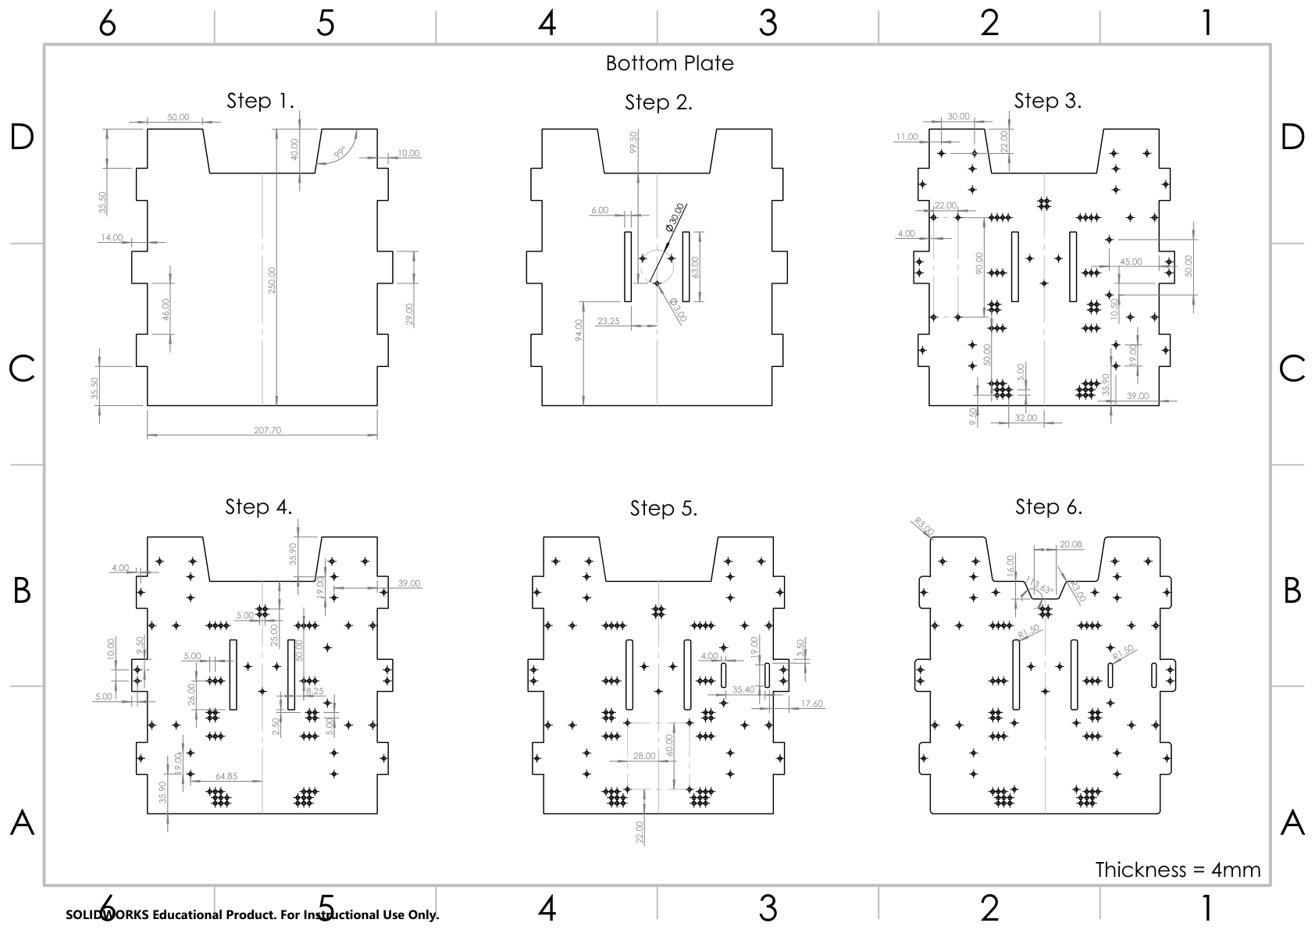
Base Plate dimensioned drawing sheet
Open full-resolution PDF: base-plate-drawing-sheet.pdf
Click the drawing sheet above to open the full PDF in a new tab, or [download it directly](/files/mechanical/base-plate-drawing-sheet.pdf).
Tip: Check your work
Once you've modeled the part yourself, compare your approach against the solution walkthrough: Base Plate — Solution Video (Google Drive).

2. Electronics Curriculum

Phase 1: Foundations

Module 1.1: Welcome to NRL Electronics
Meet the robot's body: two smart boards, a bundle of cables, and a battery — and the single chain of events that turns a joystick push into a spinning wheel.
This book is your guide to the hardware of the NRL robot — the boards, the wires, the motors, the sensors, and the battery that powers it all. It is the companion to the Programming Curriculum: that book teaches you to write the robot's brain; this one teaches you to understand and care for its body. You do not need to know any programming to read this book, and you do not need any electronics background. We start from zero.
The NRL platform is built around two small computers called ESP32-S3 microcontrollers:
• The HEXA Command Hub — the board bolted to your robot. It receives commands, drives the motors and servos, reads the sensors, and reports the robot's health.
• The HEXA Controller — the handheld unit with a colour screen, two joysticks, and buttons. It is how you select programs, start and stop a match, and drive.
The two boards talk wirelessly over a link we call Hexa Link. There is no WiFi router and nothing to configure — the Controller sends your joystick and button presses to the Hub many times per second, and the Hub sends live data back to the Controller's screen.
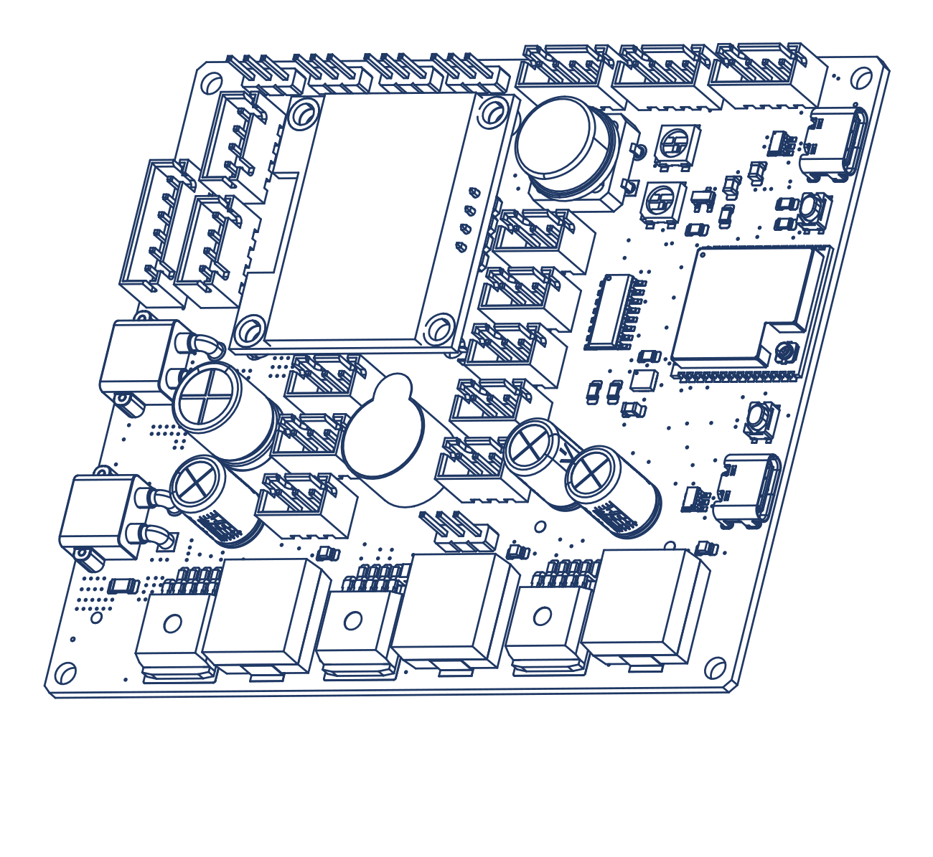
The HEXA Command Hub — the robot's brain. Every motor, servo, sensor, and the battery connects here.
The HEXA Command Hub — the robot's brain. Every motor, servo, sensor, and the battery connects here.
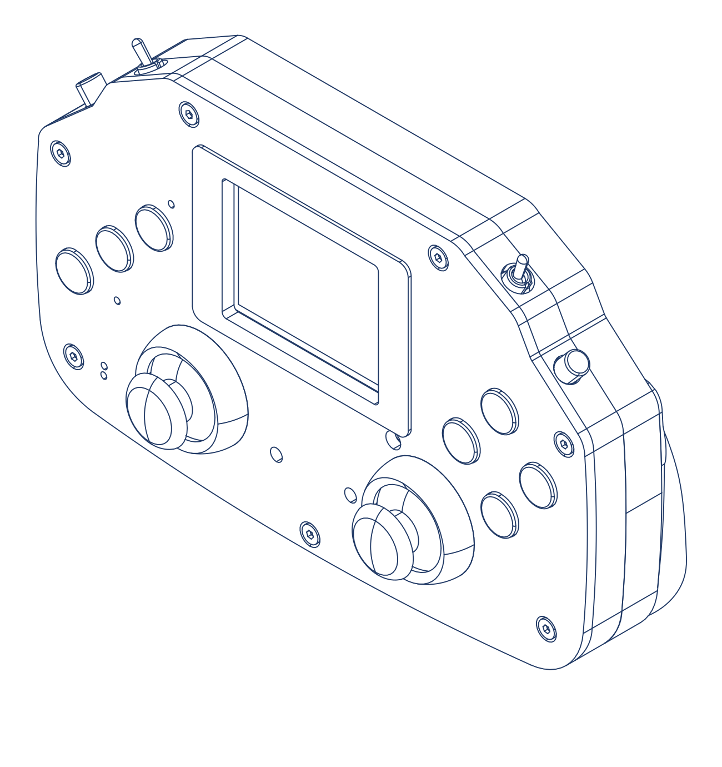
The HEXA Controller: a colour screen for menus and live data, two joysticks, and a set of buttons and toggles.
The HEXA Controller: a colour screen for menus and live data, two joysticks, and a set of buttons and toggles.
Key Idea: The signal chain
Everything in this book hangs on one chain of events:
Joystick → Controller → Hexa Link (wireless) → Command Hub → Motor Driver → Motor → Wheel.
When your robot misbehaves, the fault is always somewhere on this chain. By the end of this book you will be able to walk the chain link by link and find it.

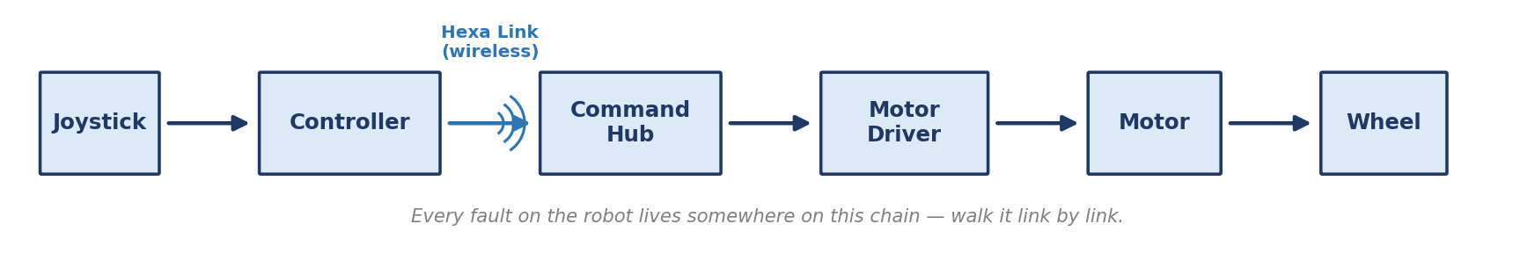
The signal chain — the backbone of this book.
The signal chain — the backbone of this book.

Your job on the team
The Programming curriculum teaches your teammates to write the robot's behaviour. Your job is everything the code depends on: a healthy battery, solid connections, correctly placed sensors, and a wiring job that survives a whole competition day. Programmers like to say "it's probably a hardware problem." After this book, you will know whether they are right — and how to fix it when they are.

What you will be able to do by the end
• Power the robot safely — charge, check, connect, and care for the battery like a professional.
• Connect every motor, servo, and sensor to the right port with the right cable, first try.
• Read the robot's lights, screens, and live telemetry to judge its health at a glance.
• Place the antenna and wiring so the wireless link stays rock solid in a noisy competition hall.
• Diagnose the most common electrical faults and pass a pre-match inspection with confidence.

Module 1.2: A Five-Minute Electricity Primer
Voltage, current, resistance, and power — the four words that explain every wire on your robot.
You do not need to master electrical engineering to use this book. You need four ideas, and every one of them shows up on your robot within the next three modules.

The water picture
Imagine electricity as water flowing through pipes. This picture is not perfect, but it is good enough to carry you through the whole season:
Electrical idea | Water picture | Unit | On your robot
Voltage (V) — the push | Water pressure in the pipe | volts (V) | The battery provides about 11.1 V of "push"
Current (I) — the flow | How much water is flowing | amps (A) | A driving motor might "drink" 1–2 A; a stalled one far more
Resistance (R) — the squeeze | How narrow the pipe is | ohms (Ω) | Every component resists current a little; that's what limits the flow
Power (P) — the work | Pressure × flow = work done | watts (W) | Power is what spins wheels — and what makes things warm

The two little laws
Two tiny equations connect the four ideas. You will not do heavy math in this book, but knowing what these mean lets you reason about the robot:
• Ohm's Law: V = I × R. For a given push (voltage), a narrower pipe (more resistance) means less flow (less current). This is why a healthy motor draws a modest current, but a short circuit — nearly zero resistance — draws a huge, dangerous one.
• Power: P = V × I. Push times flow. A motor working hard at 11 V and 2 A is converting about 22 W into motion (and some heat). More load → more current → more power → more heat.
Key Idea: The load decides the current
A common fear: "our battery can deliver 22 amps — won't that fry my little sensor?" No. The battery offers a push (voltage); each device draws only the current its own resistance allows. A sensor sips milliamps from the same battery that a motor gulps amps from.
What does damage devices is the wrong voltage — too much push. That is why this book repeats one rule again and again: check the voltage a device expects before you connect it.

Series and parallel — two ways to connect
There are only two basic ways to connect electrical things, and your robot uses both:
• Series — end to end, like train cars. Voltages add up. Your battery pack is three 3.7 V cells in series: 3.7 + 3.7 + 3.7 = 11.1 V. That is what "3S" on the battery label means.
• Parallel — side by side, like lanes on a highway. Every device gets the same voltage, and each draws its own current. All the robot's loads — motors, servos, logic — sit in parallel on the power system.

Capacity — what "2200 mAh" means
Your battery is labelled 2200 mAh (milliamp-hours). That is not power — it is a fuel tank. It means the pack can supply roughly 2.2 A for one hour, or 1.1 A for two hours, before it runs empty. Drive harder, and the tank drains faster. Module 3.2 turns these numbers into practical match planning.
Note: Your instruments
Many electronics courses hand you a multimeter on day one. On this team you have something better: the robot measures itself — the Command Hub continuously senses its own battery voltage and currents and shows them on its screens and telemetry (Module 3.4) — plus one pocket instrument, the battery checker (Module 3.2), which reads any pack's voltage the moment you plug it in.

Module 1.3: Reading the Robot
Block diagrams, silkscreen labels, and status lights — the three languages your hardware speaks.
Good electronics people are, above all, good readers. Before you plug in a single cable, learn to read the three things the robot is always telling you.

Block diagrams
A block diagram shows the robot as boxes and arrows: each box is a subsystem (battery, regulator, motor driver), each arrow is power or a signal flowing between them. It hides the tiny details so you can see the story. Every module of this book opens with the relevant slice of the HEXA block diagram — by the end, you will hold the whole map in your head.
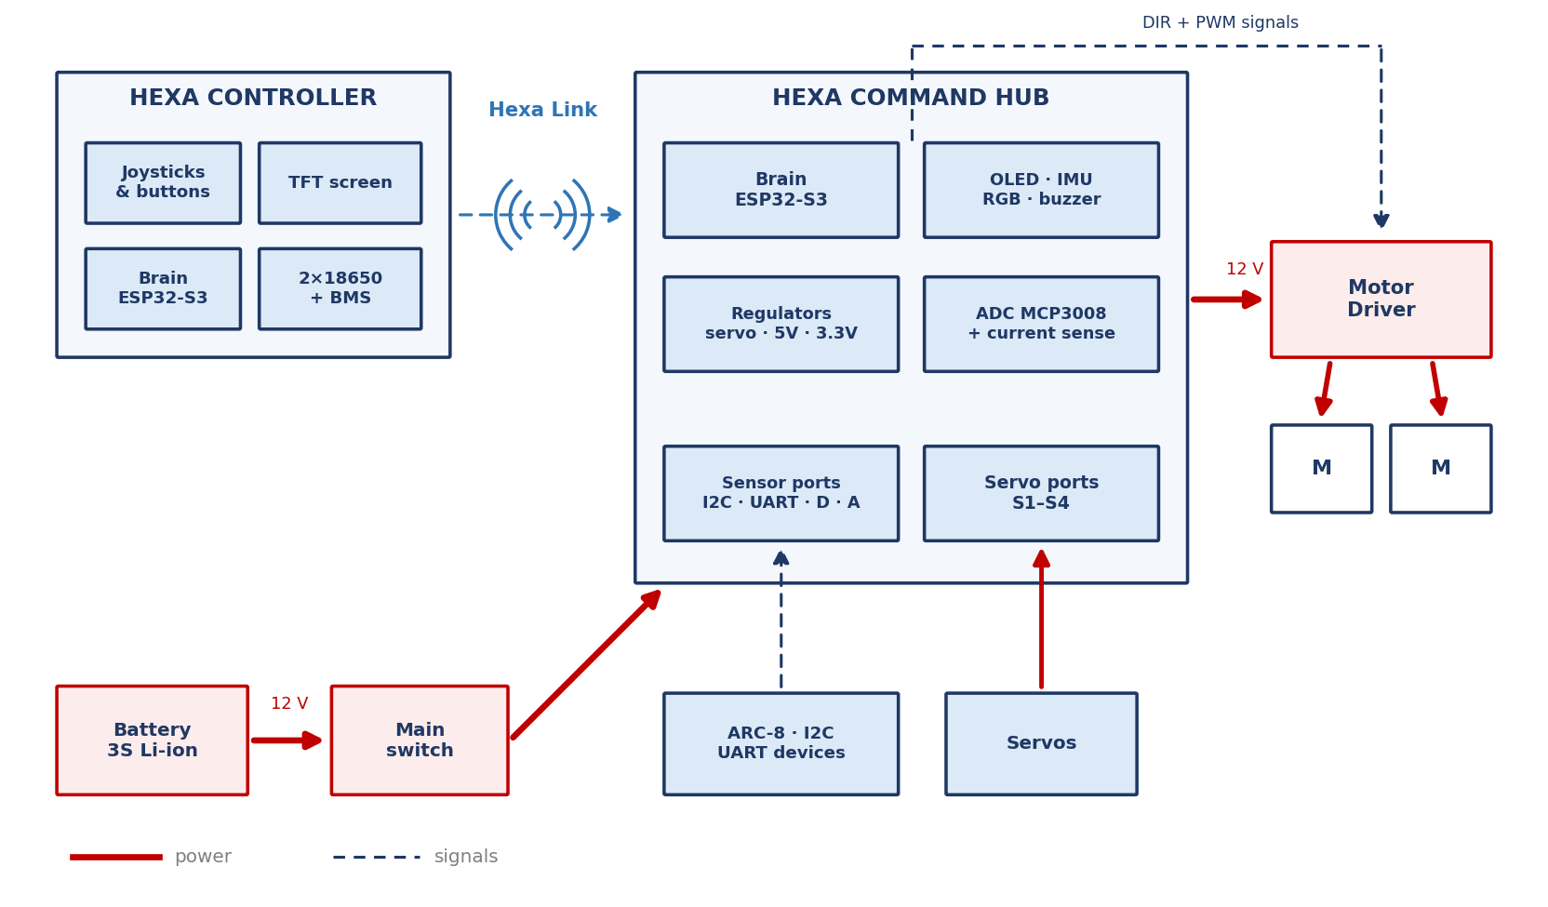
The whole robot in one picture. Red arrows are power; dashed arrows are signals. We will zoom into every box in this diagram over the coming modules.
The whole robot in one picture. Red arrows are power; dashed arrows are signals. We will zoom into every box in this diagram over the coming modules.

Silkscreen — the writing on the board
The white printing on a circuit board is called the silkscreen. It names every port (MOTOR DRIVER, SERVO_PORTS, I2C_0, UART, DIGITAL PORTS, ANALOG PORTS), marks pin order and polarity, and often tells you a voltage. Rule of thumb: the board's own label outranks your memory. When in doubt, read the silk.
Note: Photo coming soon
Close-up of Command Hub port rows with silkscreen labels visible. Every port is named, and every connector is keyed — if you can read this, you can wire the robot.

Lights and screens — the robot talking back
The Hub and Controller carry status LEDs, an RGB indicator, a buzzer, and screens. Together they answer the four questions you will ask most often: Is it powered? Is it charged? Is it connected? Is it happy? Module 5.4 gives you the full decoder table; for now, just know that a silent, dark robot is telling you something too.
Tip: Photograph everything
Before you unplug anything, take a phone photo. After you finish wiring, take another. When something stops working three weeks later, those photos are the fastest route back to "known good." Great teams keep a shared album of their robot's wiring history.

Phase 2: Your Hardware

Module 2.1: The Command Hub, Up Close
One board runs the whole robot. Here is every port, light, and button on it — and what each one is for.
The HEXA Command Hub is the robot's brain. At its centre sits an ESP32-S3-WROOM-1U (N8R8) microcontroller module — a small computer with built-in 2.4 GHz radio that uses an external antenna (Module 5.3). Around that module, the Hub provides power regulation, motor and servo control, sensor ports, and self-monitoring.
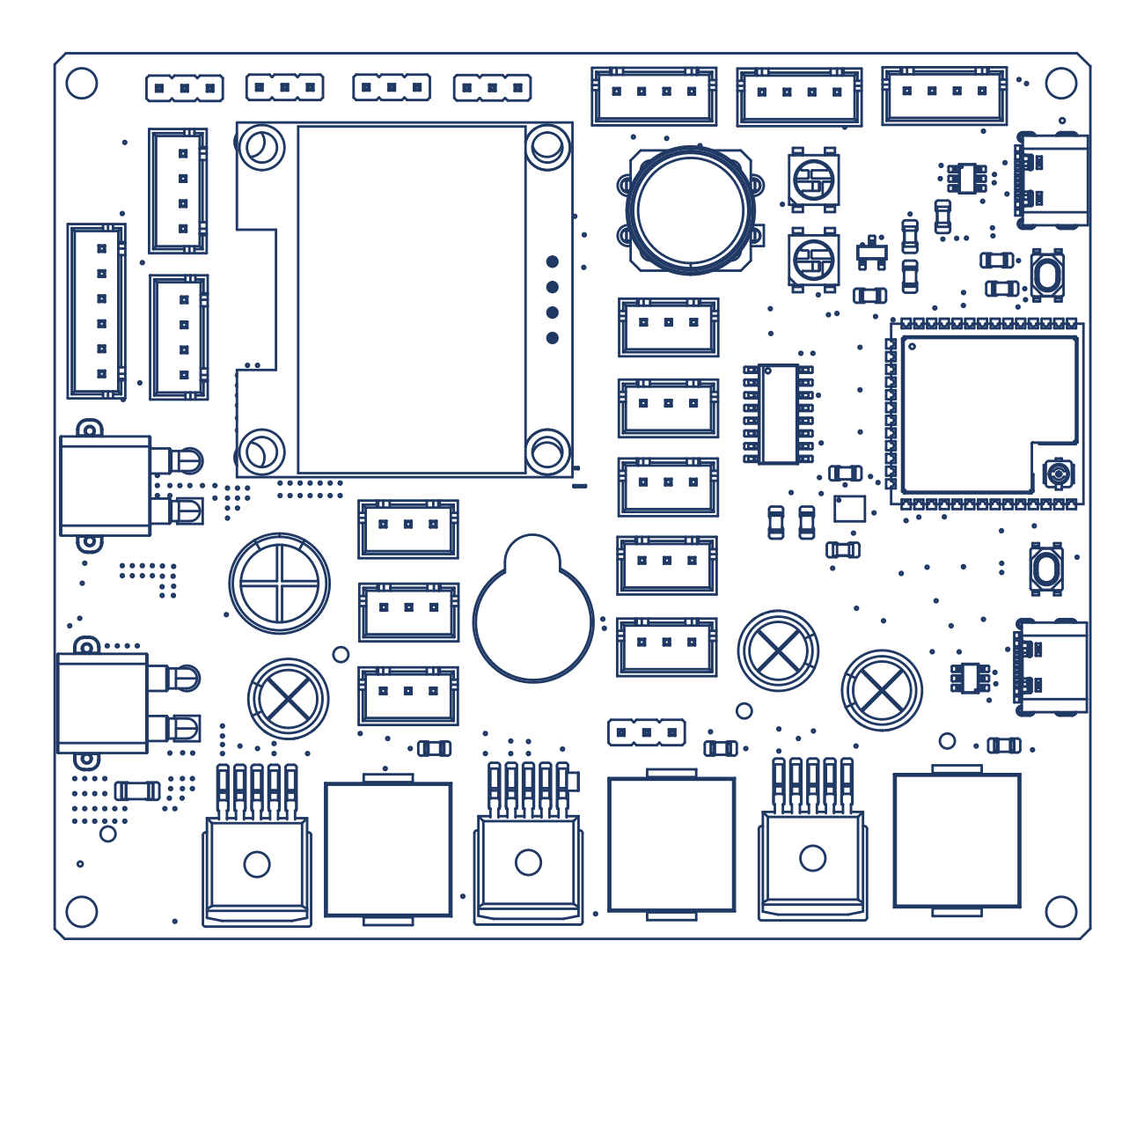
Your map of the Hub, top view. Every port in the tables below is here — match each one against the white silkscreen labels printed on your real board, which always have the final word.
Your map of the Hub, top view. Every port in the tables below is here — match each one against the white silkscreen labels printed on your real board, which always have the final word.

The power section
Element | What it does
XT30 Power IN | Where the 12 V battery connects, through the main switch cable. Yellow, keyed, impossible to reverse.
XT30 Power OUT | A direct 12 V passthrough that feeds the motor driver.
Voltage regulators | Create clean, steady supplies from the battery: a dedicated servo power rail, a 5 V rail, and a 3.3 V rail for the brain and sensors.
Current & voltage sensing | Two onboard current sensors and battery-voltage sensing let the Hub watch its own power health (Module 3.4).

The control ports
Port | Connector | What plugs in
Motor Driver | 6-pin JST-XH (DIR1 | GND | PWM1 | DIR2 | GND | PWM2) | The signal cable to the motor driver — direction + speed for two motors
Servo 1–4 (S1–S4) | 3-pin headers (GND | S+ | SIG) | Up to four servos, powered from the dedicated servo rail
Digital Ports × 3 | 3-pin JST-XH (GND | Dx | 5V) | Simple on/off sensors: touch switches, limit switches
Extra Digital IO Port 1–2 | 4-pin JST-XH (3.3V | GND | two signal pins) | Expansion digital devices — used to connect the ARC-8 IR sensor (Module 4.8)
Analog Ports × 5 (A3–A7) | 3-pin JST-XH (GND | Ax | 5V) | Sensors that answer with a varying voltage, read by the onboard ADC (Module 4.5)
I2C0 × 1, I2C1 × 1 | 4-pin JST-XH (SDA | SCL | GND | 3.3V) | Smart sensors that share a bus: distance, colour, and more (Module 4.6)
UART | 4-pin JST-XH (RX | TX | GND | 3.3V) | One smart serial device: a HuskyLens camera, a Raspberry Pi, etc.

Onboard peripherals
• 1.3″ OLED display — the robot's own status screen: team name, pairing state, battery, and live values.
• 6-axis IMU — a motion sensor that feels tilt and rotation (Module 4.7).
• RGB status LED — one bright, programmable light that shows the robot's mode at a glance.
• Buzzer — beeps for alerts you can hear without looking.
• User button — used to pair the Hub with the Controller (enabling Hexa Link).
• Two USB-C ports — one for programming, one for live data to a computer. They are not interchangeable; the silkscreen tells them apart.
• Boot & Reset buttons — used during flashing (the Programming book) and to restart the board.
Note: Photo coming soon
Close-up: OLED display showing pairing screen; RGB LED lit. The Hub's OLED and status LED — your first stop when checking robot health.

Module 2.2: The Controller, Up Close
It looks like a game controller. It is actually a complete embedded computer — with its own battery, screen, and radio.
The HEXA Controller is not a simple remote. It carries the same family of brain as the Hub — an ESP32-S3-WROOM-1U (N8R8) — plus its own battery system, a colour TFT display, an onboard IMU, and a full set of driver inputs. Treat it with the same respect as the robot itself.
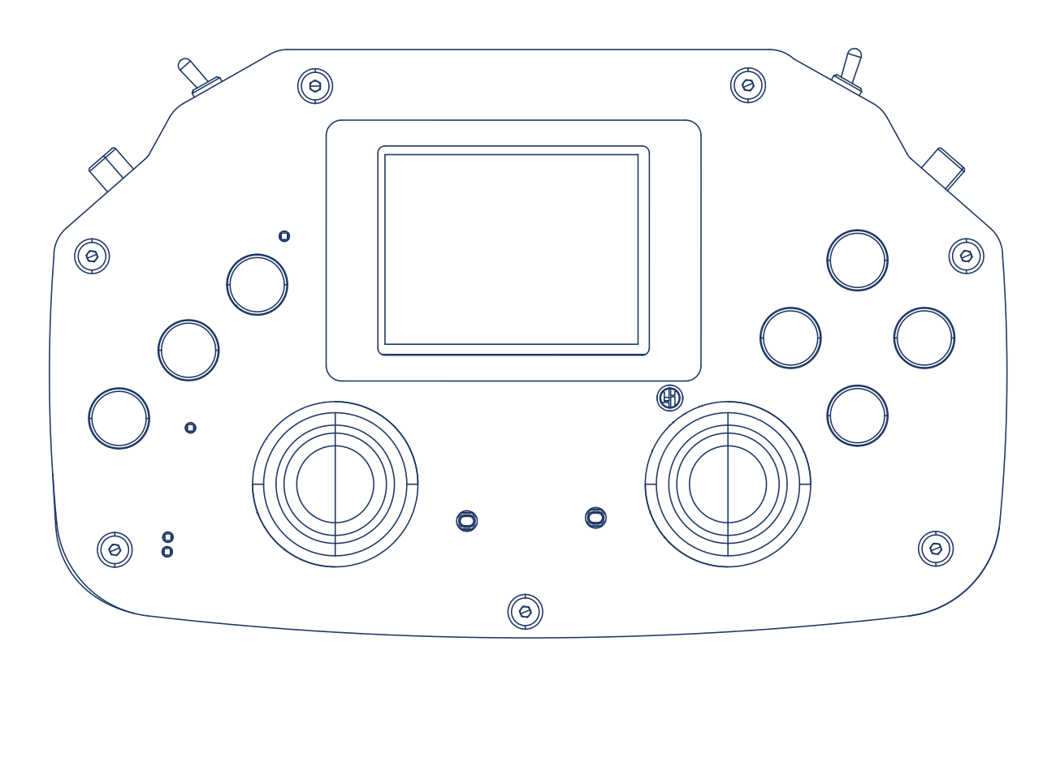
The Controller, face on: TFT screen top-centre, two joysticks, buttons left and right, toggles on the shoulders.
The Controller, face on: TFT screen top-centre, two joysticks, buttons left and right, toggles on the shoulders.
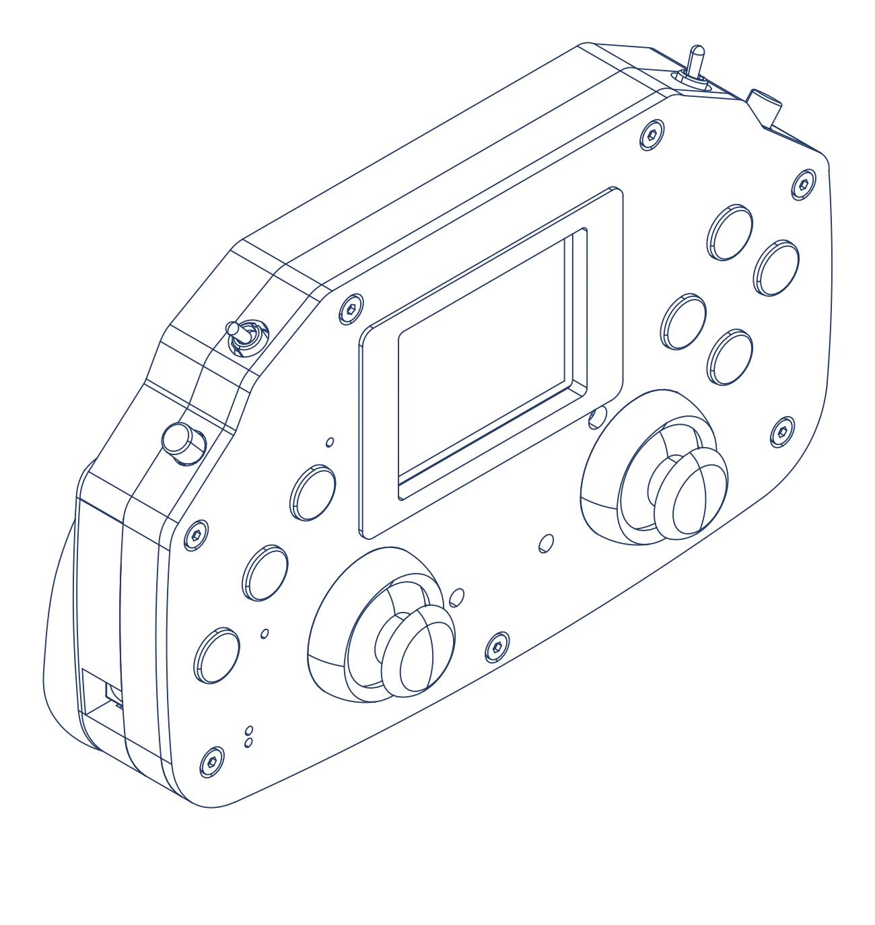
From the side: shoulder buttons at 90° for trigger-style control, with the power switch, charging jack, and USB-C along the top edge.
From the side: shoulder buttons at 90° for trigger-style control, with the power switch, charging jack, and USB-C along the top edge.

Driver inputs
• Two analog joysticks — each stick gives two smooth analog axes for precise driving.
• Seven tactile buttons plus two toggle switches for modes, and two shoulder buttons mounted at 90° for trigger-style control.

Feedback to the driver
• 2.4″ colour TFT display — the driver's dashboard: program menu, match state, and live telemetry streamed from the robot.
• RGB status LED and buzzer — connection and alert signals you can catch without looking down.

Under the shell
Inside are two 18650 Li-ion cells with their own battery-management system (BMS), and an onboard IMU — the same motion sensor family as the Hub's (Module 4.7). The Controller charges through its DC jack using the 12 V 1 A controller charger, switches on with a real power switch, and monitors its own battery voltage — so the screen can warn you before a dead controller ends your match. Every battery rule you learn in Phase 3 applies to the Controller too.
Tip: Charge both, always
Teams obsess over the robot battery and forget the Controller. Make it one habit: when the robot pack goes on charge after practice, the Controller goes on its own charger beside it — and the lanyard goes on your neck before the Controller leaves the table.

Module 2.3: Using & Caring for Your Boards — Dos and Don'ts
The Command Hub and Controller are the two most valuable items in your kit. Here is how to keep them alive for the whole season — and beyond.
Motors can be replaced in minutes and cables live in the spares box — but if the Command Hub or Controller dies, your robot is finished until a new board arrives. These two boards deserve their own set of habits. None of them is difficult; all of them matter.

Why these boards deserve respect
Each board is a complete computer with dozens of delicate components — a radio, regulators, sensors, and hundreds of solder joints smaller than a grain of rice. They are built to survive robot life, but they are not indestructible: their enemies are impact, liquids, static, heat, and wrong voltages. Every rule below guards against one of those five.

The Dos
• Do mount the Hub properly — bolted flat through its mounting holes onto the chassis, where it is protected from impacts and falling tools.
• Do hold boards by the edges, and carry them in their anti-static bags whenever they are off the robot.
• Do keep the Controller's lanyard around your neck while driving — nearly every broken Controller in team robotics is a dropped Controller.
• Do power down before connecting or disconnecting anything — ports, cables, sensors, everything.
• Do keep the boards clean and dry — a dry brush or dry cloth only; dust off gently before competitions.
• Do use the silkscreen — read the label before you plug. The right cable in the wrong port is how good boards die.

The Don'ts
• Don't let water — or any liquid — anywhere near the boards. No drinks on the electronics bench, ever. A wet board must be powered off immediately and handed to a mentor; powering a wet board destroys it.
• Don't place boards on metal surfaces, and don't let loose screws, tools, or wire offcuts sit on or under a powered board — one stray screw can short a dozen connections at once.
• Don't force any connector. If it doesn't slide in with gentle pressure, it is the wrong connector, the wrong way, or the wrong port. Stop and look.
• Don't touch component pins or press on parts — the shiny metal legs and small chips are not handles.
• Don't leave boards in a hot car or in direct sun — heat ages electronics and warps plastic connectors.
• Don't "test" anything by improvising wiring that this book doesn't describe. If you're not sure, that is exactly what mentors are for.
Key Idea: The board's best protection is a habit, not a case
Notice that every rule above costs seconds and no money. Teams that finish the season with healthy boards aren't lucky — they simply do these small things every single time.

Module 2.4: Safety First
Nothing in this kit can hurt you if you follow a few rules. Here they are — learn them before Phase 3, because that is where the battery comes out.

Li-ion battery rules
Li-ion cells store serious energy in a small package. Respected, they are safe and reliable. The rules:
1. Charge only with the matched charger — 15 V 1 A for the robot battery, 12 V 1 A for the Controller — only in the designated charging area, and never unattended.
2. Never short the battery's connector — keep it away from loose tools, metal rulers, and paperclips.
3. Never puncture, crush, drop-test, or disassemble a pack.
4. A pack that is swollen, hot, or damaged goes straight to a mentor — it does not go back on the robot, and it does not go in a bag.
5. For breaks longer than a week, store packs around half charge, not full (Module 3.2 explains why).

The power-on protocol
One habit prevents almost every burnt component in team robotics: no robot is powered until a second person — a teammate or a mentor — has checked the wiring. Before the switch flips, they walk the connections: battery seated, connectors clicked, nothing pinched, nothing loose on the bench. It takes thirty seconds. Make it a ritual.

Everyday bench discipline
• Hold bare boards by the edges; boards travel in anti-static bags (Module 2.3).
• No food or drinks on the electronics bench. One spilled drink can end a robot.
• Never plug or unplug the battery cable while the system is on — and never plug or unplug the motor driver's power while the system is on. Switch off first, every time.
• Route cables before powering, not after.
Warning: The one-second rule
If you smell something odd, hear a new buzz, or see smoke or a flash: switch off first, investigate second. The main switch exists so that your first move is always the same, and always fast.

Phase 3: Power

Module 3.1: The Battery & the BMS
Eleven point one volts of stored sunshine — what the numbers on the label really mean.
Your robot runs on a 3S Li-ion battery pack: three cells in series, 11.1 V nominal, 2200 mAh, rated 10C, with a built-in protection board (BMS), an XT30 power connector, and a DC jack for charging. Every one of those words matters. Let's decode the pack:
On the pack | What it means | Why you care
3S | Three Li-ion cells in series | 3 × 3.7 V = 11.1 V nominal — the robot's "12 V" system
11.1 V nominal | The average working voltage | Fully charged it reads about 12.6 V; near-empty, about 9 V. Voltage is your fuel gauge.
2200 mAh | The fuel tank (capacity) | Roughly 2.2 A for one hour. Hard driving drains it in well under an hour.
10C | Maximum safe discharge rate | 10 × 2.2 A = up to 22 A available — headroom for motors accelerating and stalling
BMS | Battery Management System | A tiny guardian board inside the pack that protects against over-charge, over-discharge, and shorts — and performs cell balancing, keeping all three cells evenly charged
XT30 (yellow) | The power output connector | Connects to the robot through the main switch cable. Keyed — cannot go in backwards.
DC jack (black) | The power in connector | Where the charger plugs in to charge the pack (Module 3.2)

Note: Photo coming soon
The 3S battery pack showing XT30 output, DC charging jack, and label. Two connectors, two jobs: yellow XT30 sends power out to the robot; the black DC jack takes charging power in.

Key Idea: Voltage is the fuel gauge
A Li-ion pack's voltage falls as it empties: ~12.6 V full → ~11.1 V mid → ~10 V getting low. Your robot displays battery voltage live on the Controller's screen, and the battery checker (Module 3.2) reads it directly from the pack. Learn to glance at it the way a driver glances at a fuel gauge.

Note: Why the BMS is not an excuse
The BMS is a last line of defence, like a seatbelt. It will cut power in a crisis — but a pack that gets rescued by its BMS has still been abused. Your habits (Module 3.2) are the real protection.

Module 3.2: Charging, Checking & Battery Care
Two chargers, one pocket-sized checker, and the habits that make packs last seasons.

Two chargers — never swap them
Your kit contains two different chargers, and they are not interchangeable:
Charger | Output | Charges | How to recognise it
Robot battery charger | 15 V 1 A | The robot's 3S pack, via the pack's DC jack | Read the output printed on the charger body: "Output: 15V"
Controller charger | 12 V 1 A | The Controller, via its DC jack | Output label reads "12V"

Tip: Label them on day one
The two chargers look similar and their plugs may even fit each other's jacks — the output label is the only reliable difference. On the day you unbox the kit, wrap a piece of coloured tape around each charger and write ROBOT and CONTROLLER on them. Ten seconds of tape prevents a season of doubt.

Charging, step by step
1. Inspect the pack first: no swelling, no damage, connectors clean.
2. Pick the correct charger — check its output label, not its shape.
3. Plug the charger into the pack's DC jack (or the Controller's), then into the wall. Charge in the designated area, with someone present, on a non-flammable surface.
4. When the charger signals complete, disconnect. Do not leave packs sitting on chargers overnight.
5. Log it: date, pack number, and anything unusual. Your future self will thank you at the competition.

The battery checker — your pocket instrument
Your kit includes a small battery checker with an XT30 connector. Plug the pack's XT30 into it and it instantly displays the pack's voltage — no robot needed. It is the fastest answer to the three questions you will ask most often:
• "Is this pack charged?" — check before strapping a pack onto the robot; ~12.4 V or higher means match-ready.
• "Is this pack empty or is the robot broken?" — when a robot won't power up, checking the pack takes five seconds and cuts the mystery in half (Module 5.5).
• "Which of these packs should we use?" — check all packs at the start of a match day and line them up from fullest to emptiest.
Note: Photo coming soon
Battery checker connected to a pack's XT30, display showing voltage. Five seconds, no tools, no doubt: the battery checker turns "I think it's charged" into a number.

Storage and health
• Match days: charge fully. Long breaks: store around half charge — Li-ion cells age fastest when parked at 100%.
• Health check: watch the robot's live battery-voltage telemetry while driving. A healthy pack dips a little under hard acceleration and recovers. A tired pack's voltage sags deeply under the same load.
• Retirement signs: noticeably shorter run time, deep sag, any swelling, or getting unusually warm while charging. When in doubt, show a mentor and take it out of rotation.
Tip: Number your packs
Give every pack a big written number and rotate them evenly — the battery checker makes the rotation honest.

Module 3.3: The Power Path
Follow the energy: battery → switch → clean rails and one raw one.
Flip the main switch and energy begins a well-planned journey. Walk it with your finger on the real robot:
1. The battery connects through its XT30 into the main switch harness — the robot's master ON/OFF and your emergency stop.
2. From the switch, power enters the Hub's XT30 Power IN.
3. One branch leaves straight back out of the XT30 Power OUT as raw ~12 V to the motor driver. Motors are strong and thirsty — they get battery power directly.
4. The other branch feeds the voltage regulators, which manufacture clean, steady supplies: the dedicated servo power rail, the 5 V rail, and the 3.3 V rail that powers the brain and most sensors.
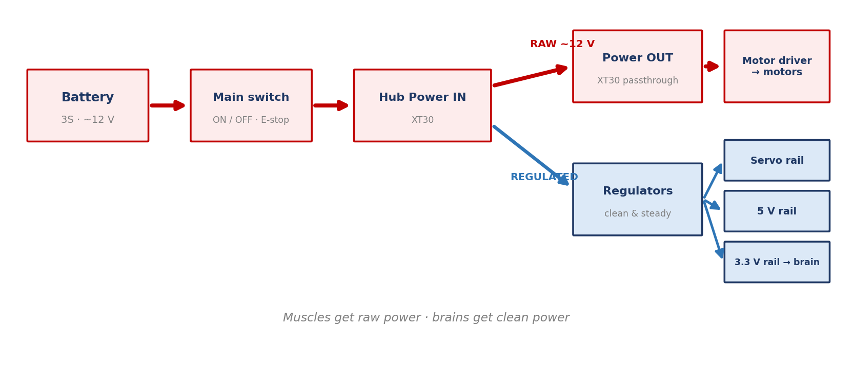
The whole power story in one picture. Raw power goes to muscles; regulated power goes to brains.
The whole power story in one picture. Raw power goes to muscles; regulated power goes to brains.
Key Idea: Muscles get raw power; brains get clean power
Motors tolerate the battery's rough, sagging voltage — sensors and microcontrollers do not. That is the entire reason regulators exist, and it explains a dozen design choices you will meet later: separate servo power, sensor voltage rules, even why brownouts (Module 3.4) hurt the brain before the muscles.

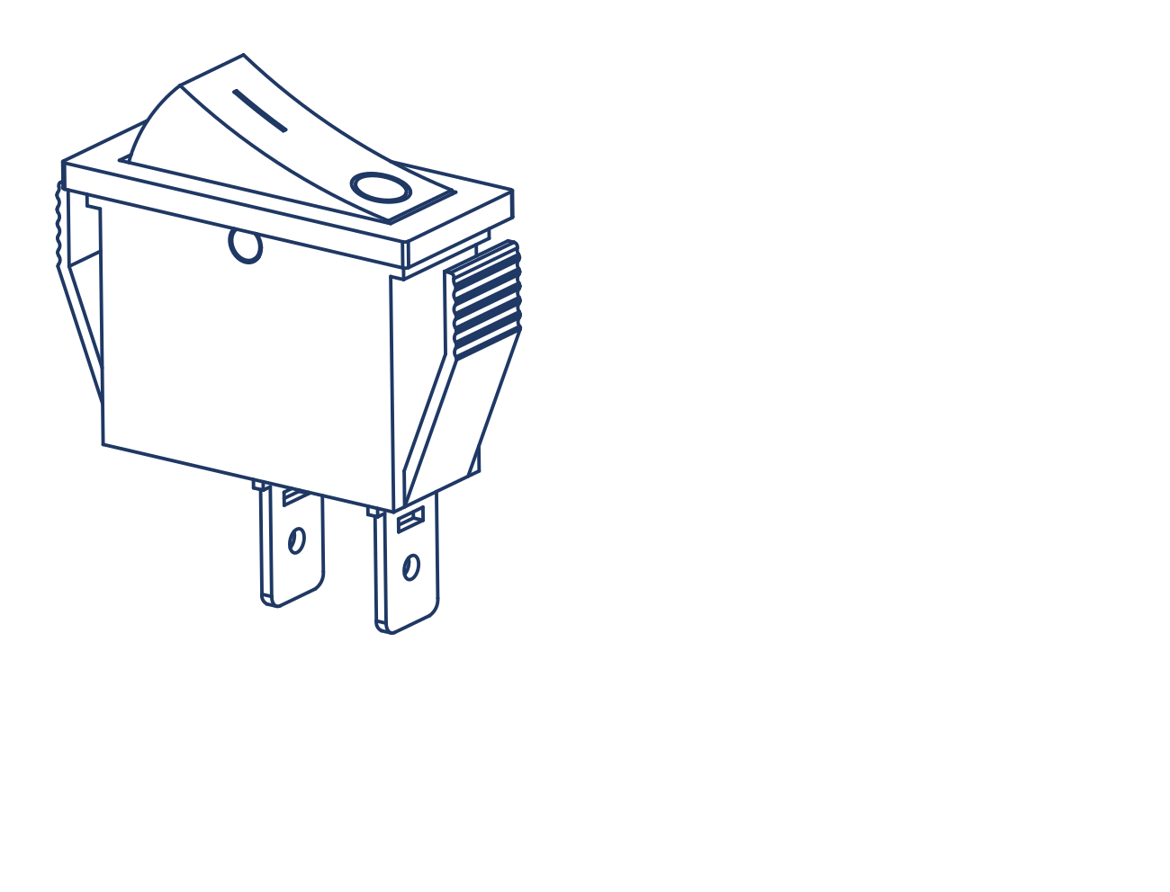
The main rocker switch — the robot's master ON/OFF and your emergency stop. Mount it where anyone can hit it in one second.
The main rocker switch — the robot's master ON/OFF and your emergency stop. Mount it where anyone can hit it in one second.
Warning: The main switch is the safety system
With no user-serviceable fuse in the path, the protection order is: the BMS inside the pack guards against shorts and abuse, and the main switch is your instant hand-operated cut-off. Keep the switch mounted where any team member can reach it in one second — that placement is a safety feature, not a convenience.

Module 3.4: Brownouts & Power Monitoring
Why robots reboot mid-match — and how yours warns you before it happens.

What a brownout is
Ask several motors to accelerate at once and they gulp current. Every gulp drags the battery voltage down for a moment — that dip is called sag. If the voltage sags low enough, the regulators can no longer hold up the 3.3 V rail, and the brain resets: screen blanks, link drops, robot freezes for a few seconds, then wakes up confused. That is a brownout — and to a driver it looks exactly like "the code crashed."
The usual suspects, in order: a tired or under-charged battery, a loose or half-seated XT30, and motors stalling against an obstacle while the driver keeps pushing.

How the Hub watches its own power
The Hub carries real measuring instruments, wired into its own analog system. Here is the actual arrangement — worth knowing, because it explains what the telemetry numbers are and where they come from:
• Two ACS712 current sensors. One measures the current flowing on the 12 V battery input (everything the robot draws); the other measures the current on the servo power rail (what your servos are drawing). An ACS712 senses current by the tiny magnetic field it creates and outputs a voltage proportional to the flow.
• Battery voltage sensing. The battery's ~12 V is far above what the measuring circuit accepts, so a voltage divider — two resistors that scale a voltage down by a fixed ratio — shrinks it to a safe, measurable level. The brain multiplies back up to display the true pack voltage.
• One ADC chip reads them all. The two current sensors and the voltage divider connect to channels 1, 2, and 3 of the Hub's MCP3008 analog-to-digital converter (Module 4.5). The remaining five channels are yours — they are the Analog Ports A3–A7 on the board's edge.
• The Controller monitors itself differently: it uses an INA219 power-monitor chip that reports its battery's voltage and current digitally over I2C (Module 4.6).
Your programmers can stream all of it to the Controller screen as telemetry, which turns you into a pit engineer:
What you watch | Healthy looks like | Trouble looks like
Battery voltage at rest | ~12 V or higher, steady | Below ~11 V before you even drive — charge or swap the pack
Voltage while driving | Small dips that recover instantly | Deep sag on every acceleration — tired pack or a loose power connector
Battery current, robot idle | Small and steady | A large constant draw at rest — something is stalled, jammed, or shorted
Servo rail current | Brief rises as servos move | Pinned high with a buzzing servo — a servo is straining against a stop (Module 4.2)

Warning: "The code keeps crashing"
When a robot resets only during hard driving, suspect power before programming. Check the battery voltage telemetry, the XT30 seating, and the pack on the battery checker — in team robotics, the mysterious mid-match reboot is a brownout until proven otherwise.

Phase 4: Motion & Sensing

Module 4.1: DC Motors & Gearboxes
The robot's muscles: simple, strong, and honest — they always tell you how hard they're working, if you know how to listen.
Your drive wheels are turned by 12 V brushed DC geared motors (the "Johnson" motors in your kit, geared to 300 RPM). Two ideas explain everything about them:
• How they spin: current through coils creates a magnetic push against fixed magnets; a rotating switch called a commutator keeps flipping the current so the push continues. More voltage → faster spin; more load → more current drawn.
• The gearbox trade: the bare motor spins very fast with little strength. The gearbox trades speed for torque (turning force) — dropping to 300 RPM while multiplying the twist that reaches the wheel. Speed and torque are two ends of one see-saw; your Mechanical teammates live on that see-saw.
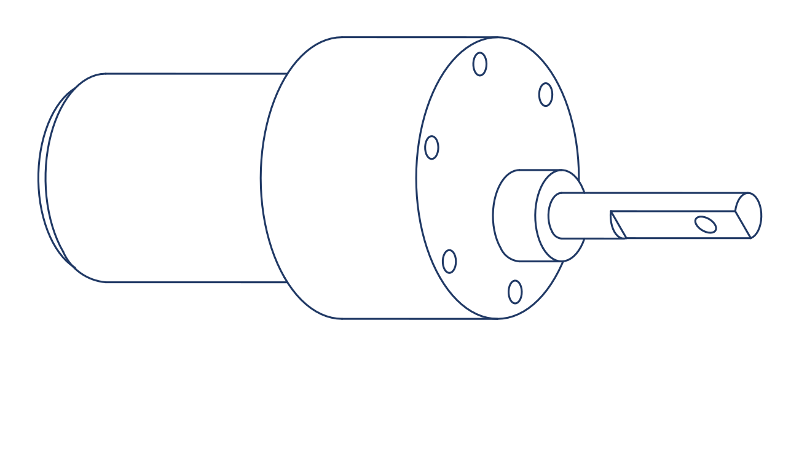
The geared motor: cylindrical motor body behind, gearbox and output shaft in front. Two power wires ending in a 2-pin JST-VH connector, no electronics inside — the direction it spins is simply the direction current flows through it.
The geared motor: cylindrical motor body behind, gearbox and output shaft in front. Two power wires ending in a 2-pin JST-VH connector, no electronics inside — the direction it spins is simply the direction current flows through it.

The two currents that matter
State | What's happening | Current
Free run | Spinning with no load | Small — a fraction of an amp
Working | Driving the robot | Moderate — rises with effort, watch it on telemetry
Stall | Shaft forced to a stop while powered | Maximum — several amps of pure heat. Seconds of stall cook motors and drain packs.

Warning: Stall is the enemy
A stalled motor converts every watt into heat, right inside the windings. If the robot is pushing against a wall and not moving, ease off. Drivers who hold full throttle against an immovable object are slow-roasting their own motors — and the current telemetry shows it happening in real time.

Tip: The touch test
After a practice run, rest a finger on each motor body. Comfortably warm is honest work. Too hot to hold means stalling, binding, or a mechanical problem — tell your Mechanical teammates what you found and which motor it was.

Module 4.2: Servos
Motors that go where they're told: dial an angle, and the servo holds it.
A servo is a complete position-control system in a plastic case: a small motor, a gearbox, a position sensor, and a control board that constantly compares "where am I?" against "where was I told to be?" and corrects the difference. Your kit's servos are high-torque 20 kg·cm units — strong enough for arms and grippers.
• Three wires only: plugged straight onto the Hub's servo headers (GND \| S+ \| SIG). The position command travels on the signal wire as a timed pulse — a form of the PWM signalling you will meet properly in Module 4.4.
• 20 kg·cm decoded: at 1 cm from the shaft the servo can hold about 20 kg; at 10 cm, about 2 kg. Leverage matters — share this number with your Mechanical teammates when designing arms.
• Their own power rail: all four servo ports are fed by the Hub's dedicated servo power rail, with extra energy-storage capacitors at each port — because servos twitching together draw sharp bursts that would rattle a shared supply.
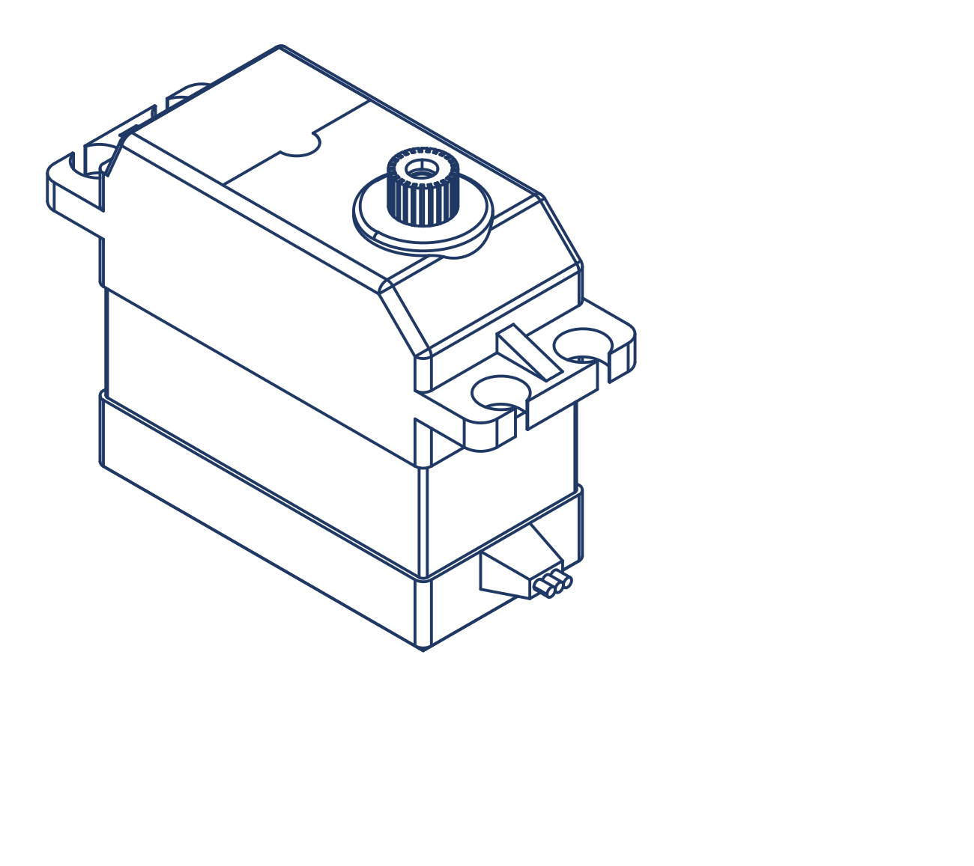
The 20 kg·cm servo with its mounting tabs and output spline. Its 3-pin lead is friction-fit — note the wire colours and the silkscreen (GND | S+ | SIG) before plugging, because unlike JST connectors, it can physically go on backwards.
The 20 kg·cm servo with its mounting tabs and output spline. Its 3-pin lead is friction-fit — note the wire colours and the silkscreen (GND | S+ | SIG) before plugging, because unlike JST connectors, it can physically go on backwards.
Warning: Two ways to hurt a servo
Forcing the horn by hand while powered — you are fighting the gearbox and it loses teeth. Commanding it against a hard stop — the servo will strain at full current forever, getting hot (watch the servo rail current climb on telemetry). If a servo buzzes continuously and feels warm, its target position is unreachable; ask the programmers to back it off a few degrees.

Module 4.3: The Motor Driver
The translator between the Hub's whisper and the motors' shout.
The Hub's brain speaks in tiny 3.3 V signals — far too weak to move a motor. Motors want raw battery power in controlled doses. Between them sits the motor driver: your kit's is a custom-built NRL dual-channel driver, controlling both drive motors.

The idea inside: the H-bridge
Each channel contains an H-bridge — four electronic switches arranged like the letter H with the motor as the crossbar. Close one diagonal pair and current flows through the motor left-to-right: forward. Close the other diagonal: reverse. Switch the power on and off very fast and the motor sees an average power — that is speed control, and the fast switching signal is called PWM (Module 4.4 is all about it). So each motor needs exactly two commands from the Hub: DIR (which diagonal) and PWM (how much).
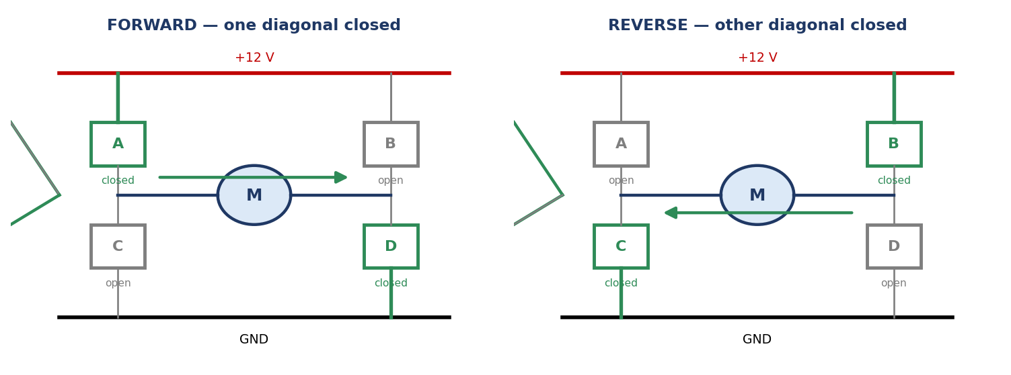
The H-bridge: same four switches, two diagonals — current flows through the motor one way for forward, the other way for reverse. PWM the closed pair and you get speed control too.
The H-bridge: same four switches, two diagonals — current flows through the motor one way for forward, the other way for reverse. PWM the closed pair and you get speed control too.

The three connections
Connector | Type | Carries
Power IN | XT30 | Raw ~12 V from the Hub's Power OUT passthrough — the muscle supply
Motor A / Motor B OUT | 2-pin JST-VH, one per motor | Full-power output to each drive motor
Signal IN | 6-pin JST-XH | The control cable from the Hub's Motor Driver port: DIR1 | GND | PWM1 | DIR2 | GND | PWM2

Note: Photo coming soon
The NRL motor driver board, connectors labelled: XT30 in, two JST-VH motor outputs, 6-pin JST-XH signal. The driver's three families of connectors: one power in, two motor out, one signal in. Keyed connectors make miswiring nearly impossible — nearly.

Key Idea: Power and signal never mix
Notice the pattern: thick wires and big connectors carry power; the thin six-wire cable carries signals. The driver is where the two worlds meet — which is why its wiring deserves your neatest work and why Module 5.2 routes power and signal cables apart from each other.

Warning: If one side of the robot won't drive
Don't reach for a replacement driver — a genuinely dead channel is rare. Check, in order: the dead motor's JST-VH power cable seated at both the driver and the motor; the 6-pin signal cable fully clicked at the Hub and the driver; then swap the silent motor onto the working channel to learn whether the problem travels with the motor or stays with the wiring. Module 5.5 walks the full method.

Module 4.4: PWM — Controlling Power with Pulses
How a computer that only knows ON and OFF creates any speed, any brightness, any angle — by switching faster than anything can notice.
Here is a puzzle. The Hub's brain is digital — its pins can only be fully ON or fully OFF (Module 4.5). Yet your robot drives at half speed, dims LEDs, and holds a servo at exactly 90°. How does an ON/OFF machine produce "halfway"?
The answer is PWM — Pulse-Width Modulation — and it is one of the most useful tricks in all of electronics: switch ON and OFF so fast that the device only feels the average.

Duty cycle — the one number that matters
A PWM signal repeats a simple cycle: ON for a while, OFF for a while, thousands of times per second. The duty cycle is the percentage of each cycle spent ON — and it directly sets the average power delivered:
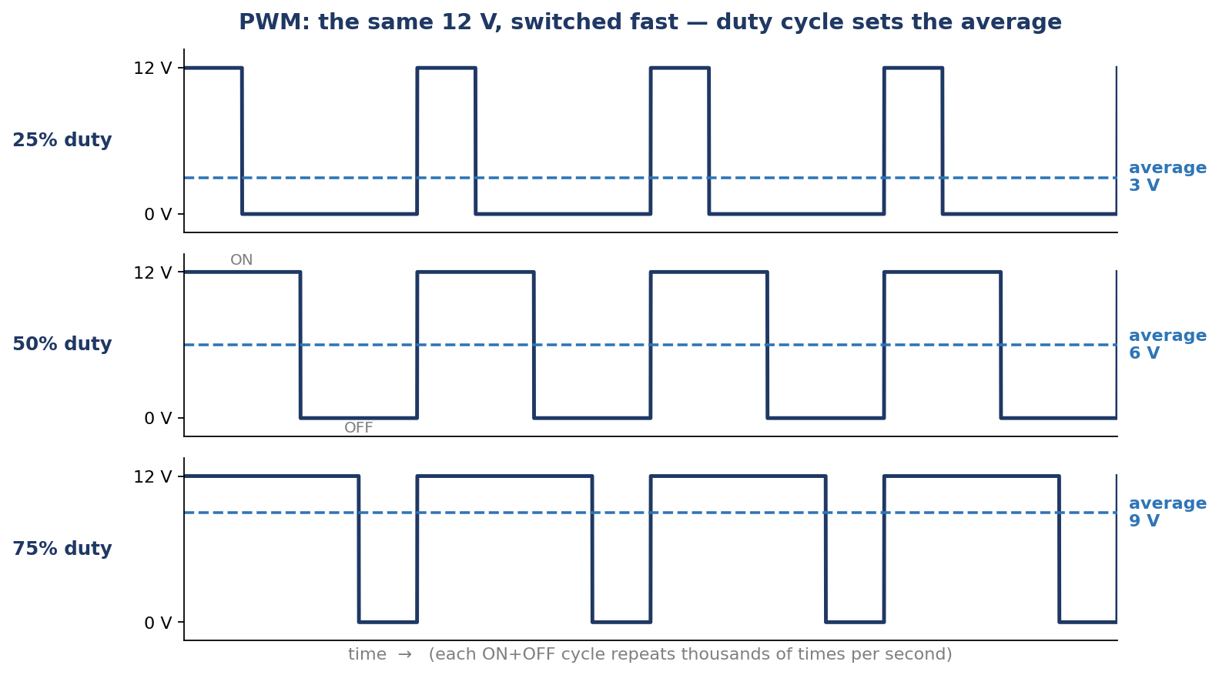
Three PWM signals switching the same 12 V supply. Nothing about the voltage changes — only the fraction of time it is ON. The dashed line is what the motor "feels."
Three PWM signals switching the same 12 V supply. Nothing about the voltage changes — only the fraction of time it is ON. The dashed line is what the motor "feels."
Duty cycle | Signal looks like | Average of a 12 V supply | Motor result
0% | Always OFF | 0 V | Stopped
25% | Short ON, long OFF | 3 V | Slow
50% | Half ON, half OFF | 6 V | Medium
75% | Long ON, short OFF | 9 V | Fast
100% | Always ON | 12 V | Full speed

The switching is far too fast to see or hear as pulses — the motor's own spinning mass smooths thousands of tiny pushes per second into steady motion, exactly the way a movie's still frames blur into smooth video.

Why not just lower the voltage?
You could slow a motor by putting a resistor in its path — but the resistor would burn the unwanted energy as heat, wasting battery and cooking itself. PWM wastes almost nothing: the switch is either fully ON (little resistance, little heat) or fully OFF (no current, no heat). That efficiency is why PWM runs everything from robot motors to phone screen brightness.

Where PWM lives on your robot
• DC motor speed: the Hub sends a PWM signal to each motor driver channel (the PWM1/PWM2 wires in the 6-pin cable); the driver's H-bridge switches the full 12 V to match. Joystick position → duty cycle → speed.
• Servo position: servos use a special dialect of pulse signalling — the width of a repeating pulse tells the servo which angle to hold (Module 4.2). Same idea, different message: motors read the average, servos read the pulse width.
• Lights and sounds: the RGB status LED's colours and brightness come from PWM-dimming its red, green, and blue elements, and the buzzer's tones come from switching at audible frequencies.
Key Idea: PWM in one sentence
PWM delivers any fraction of full power by switching ON and OFF very fast — the duty cycle (% of time ON) is the throttle.

Note: Who sets the duty cycle?
Your programmers do, in code — mapping joystick values to duty cycles is one of the Programming book's early victories. Your side of the deal is hardware that lets the pulses arrive clean: seated signal cables, and power wiring routed away from signal wiring (Module 5.2).

Module 4.5: Analog & Digital Signals
Every wire on the robot carries one of two kinds of message. Learn both and no port will ever confuse you again.
• Digital signals have two states — ON or OFF. Buttons, limit switches, touch sensors. The Hub's three Digital Ports (3-pin: GND \| Dx \| 5V supply) and two 4-pin Extra Digital IO Ports read these.
• Analog signals vary smoothly across a range — a joystick axis mid-travel, a reflectance reading, a battery voltage. The Hub's five Analog Ports (A3–A7) read these.

How a smooth voltage becomes a number
Brains only understand numbers, so an ADC (analog-to-digital converter) measures the voltage on an analog pin and reports it as a count. The Hub uses a dedicated ADC chip — the MCP3008 — with 10-bit resolution: it splits its measuring range into 1024 steps (0–1023). Zero volts reads ~0; full scale reads ~1023; halfway reads ~512. When your programmers print "raw sensor value: 680," you now know exactly what that number is — a voltage, translated.
The MCP3008 has eight channels, and Module 3.4 already introduced three of them: channels 1–2 read the current sensors and channel 3 reads the battery voltage divider. The other five are brought out as the Analog Ports A3–A7 on the board's edge — those are yours.
Warning: Check the voltage before you connect — every time
Different ports live in different voltage worlds. The 3-pin sensor ports offer a 5 V supply pin to power sensors; the 4-pin Extra Digital IO ports supply 3.3 V; and any signal wired to the brain's own pins (digital, I2C, UART) must never exceed 3.3 V. The Analog Ports measure signals from 0 up to 5 V (the ADC's full scale) — but on the digital ports and buses, never connect a sensor whose output exceeds 3.3 V: it can permanently damage the brain's input pins. Before connecting anything new, find its supply and output voltages in its datasheet or ask a mentor.

Note: Signal vs. supply
A sensor port has supply pins (which power the sensor) and a signal pin (which carries its answer). Some sensors are powered from 5 V yet politely answer in 3.3 V — the datasheet always tells you which voltages live on which pins.

Module 4.6: Buses — I2C, UART & SPI
Smart sensors don't send a voltage — they hold a conversation. Buses are the languages they speak.
Simple sensors answer with one voltage on one wire. Smart devices — distance sensors, colour sensors, cameras, display screens — have too much to say, so they talk over shared digital "party lines" called buses. You don't need to speak these languages, but knowing a few words of each tells you which port hosts which conversation — and why.

I2C — the conference call
I2C ("I-squared-C", Inter-Integrated Circuit) lets many devices share just two signal wires. Its port has four pins: SDA (Serial Data — the wire the actual information travels on, in both directions), SCL (Serial Clock — a steady tick from the Hub that keeps every device reading the data at the same rhythm), plus 3.3V and GND. Every device on the bus has its own address, like houses on a street — the Hub calls an address, and only that device answers. In principle over a hundred devices can share one I2C bus; in practice you will connect a handful, and each needs a different address.
• On the Command Hub: the onboard IMU already lives on the I2C0 bus — the external I2C0 port shares its street. The onboard OLED display lives on I2C1, sharing that port's street.
• On the Controller: its onboard IMU likewise sits on its I2C0 bus.
• Practical rule: two different sensors can share one port's bus (different addresses). Two identical sensors usually clash (same address) — put one on I2C0 and one on I2C1.

UART — the private phone line
UART (Universal Asynchronous Receiver-Transmitter) connects exactly two parties, each talking on its own wire: TX (transmit — the wire a device talks out of) and RX (receive — the wire it listens on). The Hub's TX must connect to the other device's RX, and vice versa — like two people each holding a phone to the correct ear. There are no addresses because there is nobody else on the line; the two sides simply agree on a talking speed and stream bytes both ways at once. The Hub's 4-pin UART port (RX \| TX \| GND \| 3.3V) hosts one smart guest: a HuskyLens camera, a Raspberry Pi, or another microcontroller.

SPI — the fast internal expressway
SPI (Serial Peripheral Interface) is the fastest of the three, used where lots of data must move quickly. It needs more wires: MOSI (Master Out, Slave In — data from the Hub to the device), MISO (Master In, Slave Out — data back), SCLK (the clock tick), and a CS (chip-select) line per device — the Hub "taps the shoulder" of whichever chip it wants, so several can share the data wires. Plus power and ground, that's the six-wire family. You won't wire SPI yourself — the Hub uses it internally to talk to the MCP3008 ADC, and the Controller uses it to drive its TFT screen fast enough for smooth graphics.
Bus | Wires (signals) | Devices | On your robot
I2C | 2 — SDA + SCL | Many, by address | IMU (I2C0), OLED (I2C1), your add-on sensors
UART | 2 — TX + RX crossed | Exactly two | The UART port: HuskyLens, R-Pi
SPI | 4+ — MOSI, MISO, SCLK, CS | Several, by chip-select | Internal: ADC chip; Controller's TFT

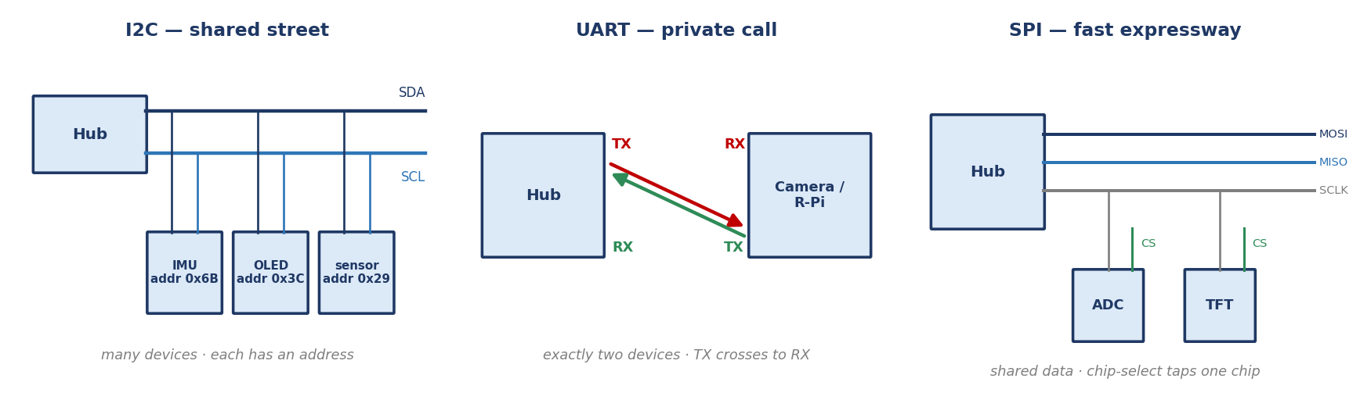
Three buses, three shapes of conversation: I2C's shared street with addresses, UART's crossed private pair, SPI's shared expressway with a chip-select per device.
Three buses, three shapes of conversation: I2C's shared street with addresses, UART's crossed private pair, SPI's shared expressway with a chip-select per device.
Note: When a smart sensor "isn't found"
Programmers will sometimes report an I2C device "not detected." Nine times out of ten it is hardware: cable half-seated, plugged into the wrong port, or an address clash with the onboard IMU or OLED sharing that bus. Your two-minute check — right port, firm click at both ends, correct cable — solves it before anyone reads a line of code.

Module 4.7: The IMU — The Robot's Inner Ear
Built into both boards is a sensor that feels every tilt and turn — no wiring required.
The Hub carries an onboard 6-axis IMU (inertial measurement unit) — the same kind of chip that tells your phone which way is up. Six axes means two sensors in one package:
• Accelerometer (3 axes): feels acceleration — including gravity, which is how it knows tilt. Robot climbing a ramp? The IMU feels the slope.
• Gyroscope (3 axes): feels rotation speed around each axis — which, tracked over time, gives the robot its heading: which way it is facing.
The exact chip is the LSM6DSOXTR, a precision 6-axis IMU whose accelerometer can measure up to ±16 g and whose gyroscope tracks rotation up to 2000° per second — far beyond anything your robot will ever do, which is exactly what you want from an instrument. Two facts about it matter to you as the hardware person:
• It is an I2C device, internally connected to the I2C0 bus — on the Command Hub and on the Controller, which carries the same IMU. That is why Module 4.6 warned about address clashes on I2C0.
• It measures the board's motion, not the robot's intentions — so how the Hub is mounted matters.
Heading is the star. It is what lets an autonomous robot make a true 90° turn and drive genuinely straight — the Programming book builds whole chapters on it.
Tip: Mount flat, mount firm
Bolt the Hub flat and square on the chassis, through proper mounts — not on foam tape, not at a jaunty angle. A tilted Hub gives tilted readings; a vibrating Hub gives noisy ones. If autonomous turns drift, mention the Hub's mounting before anyone blames the code — and let programmers run their IMU calibration with the robot perfectly still.

Note: Photo coming soon
Hands tilting the Hub while the OLED / telemetry shows roll, pitch, yaw values changing. Try it: with a mentor's demo program running, tilt the Hub and watch roll, pitch, and yaw respond live. Thirty seconds of play beats a page of definitions.

Module 4.8: The ARC-8 Line Sensor
Eight infrared eyes staring at the floor — the hardware behind every line-following robot.
The ARC-8 is a bar of eight infrared reflectance sensors. Each one shines invisible IR light at the floor and measures how much bounces back: a white surface reflects strongly, a black line barely at all. Eight readings in a row tell the robot not just that the line is there, but where under the bar it is — which is exactly what a line-following program steers by.
The ARC-8 connects to the Hub through its dedicated Y-shaped harness cable: a 6-pin JST plug at the sensor's end that splits into two 4-pin JST plugs, one into each of the Hub's two Extra Digital IO Ports (Module 2.1). The ports supply the sensor's 3.3 V power and carry its readings to the brain. Two pins of one 4-pin plug are intentionally unused — that is by design, not a fault.
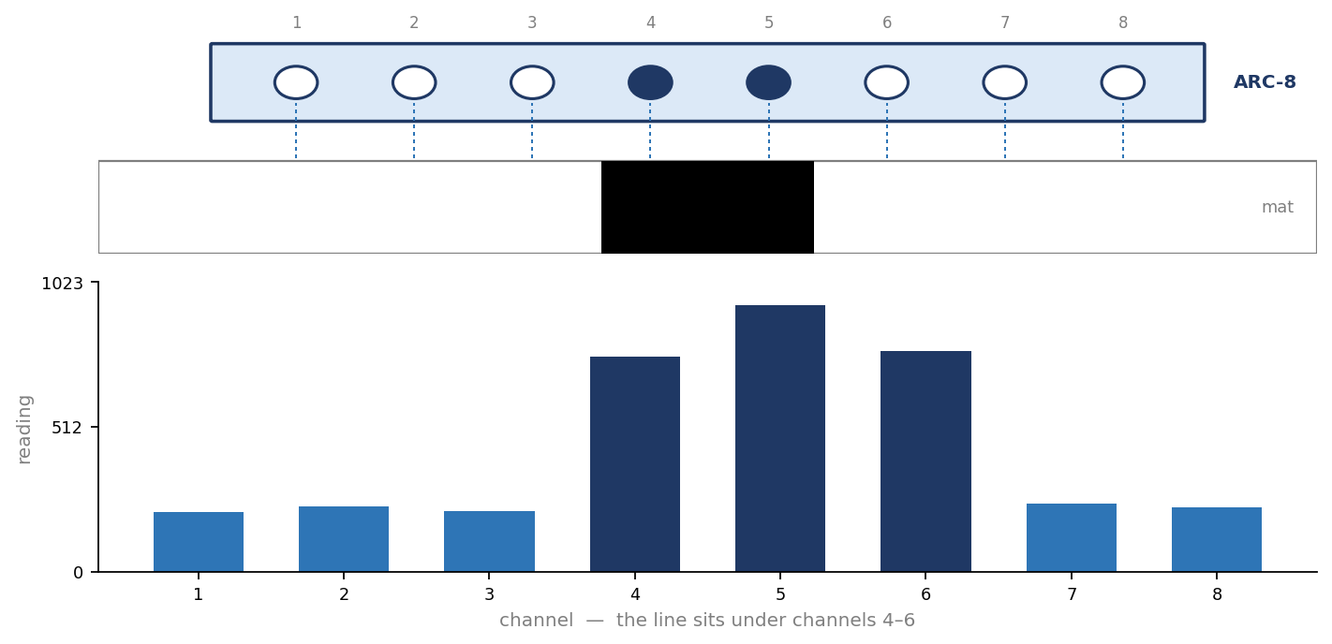
What the robot sees: eight channels stare at the mat; the channels over the black line read high while the rest read low — and the pattern's position is the line's position.
What the robot sees: eight channels stare at the mat; the channels over the black line read high while the rest read low — and the pattern's position is the line's position.
Note: Photo coming soon
ARC-8 array underside showing the 8 sensor pairs; mounted at the front of a robot over a black line on white mat. The ARC-8 mounted low at the robot's front edge — close enough to see sharply, high enough not to scrape.

Warning: 3.3 volts. Only. Ever.
The ARC-8 must be powered from 3.3 V — which is exactly what its port provides. Never improvise its wiring onto a 5 V supply: on 5 V its outputs slam past what the Hub's inputs tolerate, white and black become indistinguishable, and you risk damaging the board. If the ARC-8 ever reads "all maxed out," check its wiring and supply first.

Getting good readings — your three jobs
• Height: mount the bar a few millimetres off the floor, level across its width — too high and the picture blurs, too low and it scrapes on mat seams.
• Light: strong sunlight and some hall lighting contain IR that pollutes readings. If a robot that behaved indoors goes strange near a window, shade the sensor and look again.
• Cleanliness: dust on the sensor face dims every reading. A gentle wipe before matches is a real, professional maintenance step.
Note: Why programmers "calibrate"
No two channels, mats, or venues read identically, so before each event programmers sweep the robot across the line while software records each channel's own white and black values. That is calibration. Your part of the bargain: once calibrated, don't change the sensor's height or angle — a re-mounted sensor needs a re-calibration.

Phase 5: Wiring, Wireless & the Whole Robot

Module 5.1: Connectors & the Wiring Harness
Your kit ships with professionally made cables for every connection. Your superpower is knowing each one by sight — and seating it right.
You will not build cables on this team — the pre-made NRL wiring harness covers every connection with the correct wire, length, and connector. What you own is using them well: picking the right cable, seating it fully, and spotting a damaged one before it costs a match.

Meet the connector families
Connector | Looks like | Used for | Personality
XT30 | Small yellow block, two fat pins | Battery power, main switch harness, motor driver power | Keyed — cannot go in backwards. Needs a firm push; seats with authority.
JST-XH | Small white shell, 3/4/6 thin pins | All signal cables: motor driver signal, sensors, I2C, UART | Latched — listen for the tiny click. Remove by the shell, never the wires.
JST-VH | Larger white shell, 2 sturdy pins | Motor power, driver to each motor | Power's little brother — same firm-click rules as XT30.
Servo header | Bare 3-pin friction fit | Servos onto the Hub's servo ports | Not keyed — the one connector you can physically reverse. Read the silkscreen every time.
DC jack | Round barrel plug | Chargers into the battery pack and Controller | Simple and sturdy — but only ever mates with its matched charger (Module 3.2).

Note: Photo coming soon
All harness cable types laid out and labelled on a white background. The full harness family — main switch harness, motor driver power (XT30 F-F), 6-pin driver signal, sensor cables, servo leads. Print this photo for the pit wall.

The colour code
Every harness cable follows one colour law: red is positive power (VCC — whether that rail is 3.3 V or 5 V), black is ground (GND) — and the remaining colours identify signals. When a cable and a port meet, red meets the + marking, black meets GND, and the world stays orderly.

The seating ritual
1. Look — right connector, right port, silkscreen agrees, pins straight.
2. Seat — push straight in until it clicks or bottoms out firmly. No click on a latched connector = not connected, however connected it looks.
3. Tug — a gentle pull on the shell (never the wires). A seated connector shrugs it off.
Tip: Retiring a wounded cable
A cable with a cracked shell, a backed-out pin, or wires pulling from the housing is a time bomb of intermittent faults — the worst kind. Mark it with tape, swap in a spare, and hand it to a mentor. Spare cables exist precisely so you never have to nurse a bad one.

Module 5.2: Wiring the Robot
The difference between a robot that survives a competition day and one that doesn't is usually visible from a metre away.
With the harness in hand and every port known, wiring the robot is assembly, not electronics. The craft is in the layout — and it follows five rules:
1. Plan before you plug. Dry-run the layout: battery reachable for swaps, main switch reachable in a hurry, every cable arriving at its port without stretching or doubling back.
2. Power and signal travel apart. Route the thick power cables (battery, driver, motors) along one path and the thin signal cables along another. Motor power switching at high speed is electrically noisy, and signal wires bundled against it pick up that noise as sensor glitches.
3. Stay clear of everything that moves or heats. Wheels, gears, arm pivots, and motor bodies all destroy cables. Route around, tie back, and check the full range of every mechanism by hand, unpowered before first power-on.
4. Strain-relieve and leave service loops. Anchor cables near each connector so a snag pulls on the tie, not the pins — but leave gentle slack. A drum-tight harness fails at the connectors from pure vibration.
5. Tie it down, and label if it helps. Zip ties every few centimetres, snug but not crushing. On a symmetric robot, a flag of tape marking LEFT/RIGHT on the motor cables pays for itself all season.
Note: Photo coming soon
Well-wired robot chassis: separated power/signal runs, zip ties, service loops, labelled cables. What good looks like. You can trace every cable with your eyes — which means you can troubleshoot it in a hurry.

The wiring QC checklist
Before the second-person power-on check (Module 2.4), run your own inspection:
• Every connector: look, seat, tug (Module 5.1).
• Battery held by its strap — a shifting pack yanks its own power cable.
• Full mechanism sweep by hand — nothing rubs, nothing pinches at any position.
• No cable within reach of a wheel or gear, even under vibration.
• Antenna clear and positioned (Module 5.3).
• Phone photo of the finished layout for the team album.
Key Idea: Neat is fast
Tidy wiring is not for style points. In the pit, with three minutes before a match, the team that can see its wiring finds the loose connector; the team with spaghetti does not. Every rule in this module is really about speed when it matters.

Module 5.3: Hexa Link & the Antenna
Your commands fly through the air on invisible waves — and one small antenna decides how reliably they arrive.

The crowded airwaves
Hexa Link lives on the 2.4 GHz radio band — the same public band as WiFi routers, Bluetooth headphones, and (yes) microwave ovens. A competition hall is a storm of 2.4 GHz chatter, which is why every hardware detail in this module exists: your link must stay crisp in a noisy room.
Over that band, the HEXA system speaks three protocols, each with its own job: ESP-NOW — an ultra-quick, direct board-to-board protocol — carries the driving commands, because a driver can feel even a few milliseconds of lag; WiFi carries bigger data when needed; and Bluetooth LE handles low-power companion roles. Setting them up is the Programming book's business; making the radio's hardware excellent is yours.

The antenna
Both boards use an external antenna — the small flexible strip supplied already fitted to the Hub and the Controller. It connects to the board through a tiny snap-on socket called a U.FL connector, and that thumbnail-sized part is the most delicate component on your robot. Three rules keep it alive:
• Leave it connected. U.FL sockets survive only a limited number of connect/disconnect cycles — the antenna comes fitted; there is almost never a reason to remove it.
• If it must be re-seated: press the round plug straight down onto the socket until it snaps — never at an angle, never with a twist. To remove, lift straight up from under the metal plug with a plastic tool. Never pull the cable.
• Strain-relieve the cable — a small piece of tape near the plug means a snagged antenna tears the tape, not the socket.
Note: Photo coming soon
Macro shot: U.FL connector being pressed on correctly; FPC antenna mounted on the polycarbonate panel. Left: pressing the U.FL straight down. Right: the antenna mounted high on the polycarbonate plate, cable strain-relieved.

Placement — where the antenna lives
• High and clear — top of the robot, with open air around it.
• Never against metal. A metal plate behind an antenna is a mirror and a shield at once; mount it on the polycarbonate plate.
• Away from the battery and motor power cables — both are electrically loud neighbours.
• Flat and secured, not dangling — a flapping antenna changes performance corner to corner.
Warning: "The robot lags in matches but not at home"
Classic antenna story: at home, one robot in a quiet room — any placement works. At an event, dozens of 2.4 GHz devices roar at once, and the badly placed antenna finally matters.

Tip: A quieter channel
The 2.4 GHz band is divided into numbered channels, and Hexa Link can be moved to a different one through the Controller's settings menu. If the hall is badly congested, switching the robot-and-controller pair to a quieter channel — with a mentor's guidance — often cures stutters that no amount of antenna adjustment can.

Module 5.4: Lights, Screens & Telemetry
The robot never stops talking about its own health. This module teaches you its language.

The instrument panel
Instrument | Where | It tells you
RGB status LED | Hub | Robot mode and connection state, in colour, across the field
1.3″ OLED | Hub | Team name, pairing status, and live values at the robot
2.4″ TFT screen | Controller | Menus, match state, link status, and streamed telemetry from the robot
RGB LED | Controller | Connection and alert states at a glance
Buzzers | Both | Alerts you can hear with your eyes on the field

Note: Photo coming soon
Controller TFT showing a telemetry screen: battery voltage, currents, link status. A telemetry dashboard: the robot's vital signs, streamed live over Hexa Link. Ask your programmers to keep battery voltage and current readings on it — those numbers are Modules 3.1–4.3 come to life.

Clean presses — a hardware aside
When you press any button on the Controller, its metal contacts actually bounce — connecting and disconnecting several times in a few milliseconds before settling. The brain is fast enough to mistake one press for five. So every HEXA button carries a small debounce circuit — a resistor and capacitor that smooth the flurry into one clean press. You get crisp inputs; your programmers get clean signals; nobody has to think about it. That is good hardware design.

The 60-second health read
Before every practice run, read the panel in order: (1) boards power up, screens alive → (2) Hub OLED shows paired → (3) Controller TFT shows the link healthy → (4) telemetry battery voltage ≥ healthy → (5) idle current small and steady → (6) brief joystick wiggle moves the right wheels the right way. Sixty seconds, no tools, and you have verified most of this book. Module 5.6 grows this habit into the formal inspection.

Module 5.5: Troubleshooting — The Debug Guide
Robots fail. Calm, methodical people fix them fast — using eyes, lights, telemetry, the battery checker, and smart swaps.

The golden rules
1. Power first. Whatever the symptom, check the power story before anything else: main switch, battery seating, the pack on the battery checker, voltage on telemetry. Half of all faults die here.
2. Change one thing at a time. Swap one cable, re-seat one connector, then re-test. Change three things and you learn nothing even when it works.
3. Halve the problem. Robot dead? Does the Hub power up with the driver's power unplugged (switch OFF first)? Yes → the fault is downstream. Cut the mystery in half with every test.
4. Swap toward the truth. Suspected bad motor? Swap it to the other driver channel. Fault follows the motor → it's the motor. Fault stays with the channel → wiring. Spares turn guesses into proofs.
5. Log the fix. One line in the team log — symptom, cause, fix. A season of lines becomes the team's private repair manual.

The fault table
Symptom | Check first | Then | Usual culprit
Robot completely dead | Main switch; battery XT30 fully clicked | Pack on the battery checker | Unseated XT30 or empty pack
Resets when driving hard | Battery voltage telemetry while driving (deep sag?) | XT30 seating; pack on the checker after a rest | Brownout — tired battery (Module 3.4)
One motor dead | Its JST-VH power cable seating at driver and motor | Swap that motor to the other channel | Unseated cable; occasionally the motor
Servo buzzing and hot | Is it commanded against a hard stop? | Linkage jam by hand (power OFF); servo rail current on telemetry | Unreachable target position (Module 4.2)
Sensor reads garbage / all max | Supply voltage — the right port, the right volts (Module 4.5, Module 4.8) | Cable seating; correct port type | Wrong supply or wrong port
I2C device "not found" | Cable clicked at both ends; correct I2C port | Address clash with onboard IMU/OLED — try the other bus | Seating, wrong port, or address clash (Module 4.6)
Link stutters at the event only | Antenna placement vs. Module 5.3 rules; U.FL fully snapped | Controller battery; switch Hexa Link to a quieter channel (Module 5.3) | Antenna against metal / band congestion

Key Idea: Intermittent = mechanical
A fault that comes and goes with bumps, turns, or arm movement is almost always a connection, not a component: a half-seated connector, a cracked cable, a wire flexing at a pinch point. Components fail honestly — all the way, and they stay failed. Wiggle-test the cables along that mechanism's path.

Tip: When to call the mentor
Call immediately for: any smell of burning, a hot or swollen battery, liquid on a board, or visible board damage. Everything else — try the table first. The team's best troubleshooter is made, not born, and every fault you chase builds that skill.

Module 5.6: The Pre-Match Electrical Inspection
Champions are not lucky. They check.
Everything this book teaches compresses into one printed page: the inspection you run before every match. Two people, three minutes, out loud — one reads, one checks and answers. Laminate it. Live by it.
# | Check | Pass looks like
1 | Battery charged | Pack reads ~12.4 V+ on the battery checker; Controller charged too
2 | Battery secured | Strap tight; XT30 clicked; cable strain-relieved
3 | Full connector patrol | Every connector: look · seat · tug (Module 5.1)
4 | Harness survey | No new pinches, rubs, or loose ties since last match (Module 5.2)
5 | Antenna | High, clear, on the polycarbonate plate, cable secured (Module 5.3)
6 | Power-up & pairing | Screens alive; OLED paired; TFT link healthy (Module 5.4)
7 | Idle telemetry | Voltage healthy and steady; idle current small (Module 3.4)
8 | Motion test | Brief joystick check: correct wheels, correct directions; servos sweep freely
9 | Sensor sanity | ARC-8 over the mat shows sensible values; IMU steady (Module 4.7, Module 4.8)
10 | Fault log reviewed | Yesterday's gremlins confirmed fixed, not merely forgotten

Tip: Own the clipboard
Make one electronics student the inspector of record each match day — rotating the role builds the whole team. The inspector signs the sheet. It feels official because it is: this is exactly how real engineering teams operate.

Module 5.7: Quick Reference
The whole book at a glance — for the pit wall.

Hub ports at a glance
Port | Connector | Pins | Connects
Power IN | XT30 | + / − | Battery via main switch harness
Power OUT | XT30 | + / − | Motor driver power (XT30 F-F cable)
Motor Driver | JST-XH 6-pin | DIR1 · GND · PWM1 · DIR2 · GND · PWM2 | Motor driver signal
Servo S1–S4 | 3-pin header | GND · S+ · SIG | Servos (dedicated servo rail)
Digital Ports × 3 | JST-XH 3-pin | GND · Dx · 5V | Switches, simple sensors
Extra Digital IO 1–2 | JST-XH 4-pin | 3.3V · GND · 2 signals | ARC-8 IR sensor, expansion devices
Analog A3–A7 | JST-XH 3-pin | GND · Ax · 5V | Analog sensors → MCP3008 ADC
I2C0 × 1 / I2C1 × 1 | JST-XH 4-pin | SDA · SCL · GND · 3.3V | Smart sensors (IMU shares I2C0, OLED shares I2C1)
UART | JST-XH 4-pin | RX · TX · GND · 3.3V | HuskyLens, R-Pi, co-processor

Battery card
Item | Value
Robot pack | 3S Li-ion, 2200 mAh, 10C, BMS with cell balancing; XT30 out, DC jack in
Full / nominal / low | ~12.6 V / 11.1 V / ~10 V — swap or charge below the healthy zone
Robot pack charger | 15 V 1 A, via the pack's DC jack — attended, in the charging area
Controller charger | 12 V 1 A, via the Controller's DC jack — label both chargers!
Battery checker | Plugs onto the pack's XT30; instant voltage readout — check every pack, every match day
Storage | ~half charge for breaks over a week

The five reflexes
1. Voltage is the fuel gauge — glance at it constantly.
2. Check every device's voltage before connecting — ports live in different voltage worlds.
3. Look · Seat · Tug on every connector.
4. Power first when anything misbehaves — and the battery checker answers in five seconds.
5. Intermittent means a connection, not a component.

Module 5.8: Glossary
Every term this book leans on, in one place.
Term | Meaning
ADC | Analog-to-digital converter — turns a voltage into a number the brain can use; the Hub's is the 10-bit MCP3008 (Module 4.5)
Analog / Digital | Smoothly varying signal / two-state (ON-OFF) signal (Module 4.5)
Battery checker | Pocket instrument that reads a pack's voltage through its XT30 (Module 3.2)
BMS | Battery Management System — the protection and cell-balancing board inside the pack (Module 3.1)
Brownout | A reset caused by battery voltage sagging under load (Module 3.4)
Bus (I2C, UART, SPI) | A shared digital "conversation line" for smart devices (Module 4.6)
Cell balancing | The BMS keeping all cells in a pack evenly charged (Module 3.1)
Current (A) | The flow of electricity, in amps — drawn by the load (Module 1.2)
Debounce | Smoothing a button's electrical bounce into one clean press (Module 5.4)
DIR / PWM lines | The two commands per motor channel: direction, and the speed-setting pulse signal (Module 4.3–4.4)
Duty cycle | The percentage of each PWM cycle spent ON — the throttle setting (Module 4.4)
ESP-NOW | The fast, direct wireless protocol carrying driving commands over Hexa Link (Module 5.3)
H-bridge | Four switches that let one motor run both directions at any speed (Module 4.3)
Heading | The direction the robot faces, tracked by the IMU's gyroscope (Module 4.7)
Hexa Link | The 2.4 GHz wireless link between Controller and Command Hub (Module 1.1, 5.3)
IMU | Inertial measurement unit — accelerometer + gyroscope; the LSM6DSOXTR on both boards (Module 4.7)
MISO / MOSI / SCLK / CS | The SPI bus wires: data in, data out, clock, and chip-select (Module 4.6)
PWM | Pulse-Width Modulation — delivering partial power by fast ON/OFF switching (Module 4.4)
Rail | One regulated supply voltage distributed across the board (servo rail, 5 V, 3.3 V) (Module 3.3)
Regulator | A circuit that turns rough battery voltage into a clean, steady rail (Module 3.3)
Sag | The temporary drop in battery voltage under heavy load (Module 3.2, 3.4)
SDA / SCL | The I2C bus wires: serial data and serial clock (Module 4.6)
Series / Parallel | End-to-end (voltages add) / side-by-side (same voltage, own currents) (Module 1.2)
Silkscreen | The printed labels on a circuit board — always worth reading (Module 1.3)
Stall | A powered motor forced to a stop — maximum current, pure heat (Module 4.1)
Telemetry | Live robot data streamed to the Controller's screen (Module 5.4)
Torque | Turning force — what gearboxes trade speed to get (Module 4.1)
TX / RX | The UART wires: transmit and receive — always connected crosswise (Module 4.6)
U.FL | The tiny snap-on antenna connector — delicate, limited cycles (Module 5.3)
Voltage (V) | The electrical "push," in volts — and your battery fuel gauge (Module 1.2, 3.1)
Voltage divider | Two resistors that scale a big voltage down to a measurable one (Module 3.4)
XT30 / JST-XH / JST-VH | The kit's power and signal connector families (Module 5.1)

Module 5.9: Conclusion & Next Steps
You started with two mystery boards. You finish as the person your team trusts with them.
Walk the chain one last time — joystick → Controller → Hexa Link → Command Hub → motor driver → motor → wheel — and notice that every link now has a module, a set of habits, and a place in your hands. You can power a robot safely, care for the boards that run it, wire it cleanly, read its health at a glance, keep its radio honest in a loud hall, and hunt a fault with nothing but method and a battery checker.

Where to grow from here
• Team up with the Programming book. Sit with your programmers as they run the sensor and telemetry chapters — you own the same hardware from two sides, and the best NRL teams blur that line.
• Become the inspector. Own the Module 5.6 checklist at your next event. Nothing teaches faster than being the last set of eyes before a match.
• Keep the fault log. By season's end it will be the most valuable document your team owns — and you will have written it.
• Stay curious. Every topic here — batteries, radio, control, sensing — opens into a real engineering field. The robot in front of you is a genuine, working introduction to all of them.
See you in the pits. — The NRL Electronics Team

3. Programming Curriculum

Phase 1: Foundations

Module 1.1: Introduction to C++
This is where the C++ section of the book starts — five modules covering plain C++, with no robot or NRL framework code at all. Everything you learn here works in any C++ program, anywhere, on any computer.

How to follow along
You do not need to install anything yet. Open any free online C++ compiler in your browser — an online GDB compiler works well — and type each example yourself. Don't just read them: type them, then change one thing and see what happens. That's the whole job.

What is C++?
C++ is a language you write in English-ish text that gets turned into instructions a machine runs, in three steps:
1. You write main.cpp — text you can read.
2. The compiler translates it into machine code.
3. The machine runs it — the program does the thing.
Key Idea: The one rule that trips everyone up
The compiler does exactly what you wrote — not what you meant. A missing semicolon or a stray bracket stops the whole build. That feels harsh at first. It's also why C++ programs can be trusted to run fast and predictably.

A few things follow from this:
• Compiled, not interpreted — errors are caught before the program ever runs.
• Fast and close to the hardware — why phones, games, cars, and robots use it.
• Strict about types — you must say what kind of value each thing holds.

Anatomy of a C++ program
Every program you write starts from this shape:
#include <iostream>

int main() {
std::cout << "Hello, robot!";
return 0;
}

Reading it line by line:
• #include <iostream> brings in the ability to print.
• int main() { ... } is where the program starts. Every program has exactly one.
• { } braces group the lines that belong together.
• ; ends every statement. Forgetting it is the #1 beginner error.
• return 0; tells the system "finished, no problems."

Printing output
std::cout sends text to the screen. The << arrows point the way the data flows.
std::cout << "Line one" << std::endl;
std::cout << "Line two\n";
std::cout << "Sum: " << 3 + 4 << "\n";

Line one
Line two
Sum: 7

Note: endl or \n?
Both end the line. \n is simply a character inside the text; std::endl also forces the text out immediately. Use \n unless you have a reason not to.

You can chain as much as you like — keep adding << to print text and numbers in one statement.

Comments
Notes for humans. The compiler ignores them completely.
// This is a single-line comment

/* This comment
spans several lines. */

int speed = 120; // trailing comment

• // ignores the rest of that line.
• /* */ ignores everything in between, across lines.
Tip: A comment is also an off switch
Putting // in front of a line disables it without deleting it — the fastest way to test "what if this line weren't here?"

Write why, not what. "add 1 to speed" is useless — the code already says that. "slow ramp to protect the gears" is worth writing.
Next up: putting values in named boxes, in Module 1.2.

Module 1.2: Variables & Data Types
Naming boxes that hold values.

Variables
A named box that holds a value you can read back and change later.
int count = 0; // declare + initialize
float speed = 1.5f;

count = 10; // assign a new value
count = count + 5; // now 15

Three things to declare one:
• A type — what kind of value (int)
• A name — how you refer to it (count)
• A value — what goes in it (0)
Key Idea: = means "put into," not "is equal to"
count = count + 5 is not maths nonsense. It reads: take what is in count, add 5, put the result back into count.

Naming rules:
• Letters, digits, and _ only — no spaces.
• Cannot start with a digit.
• Case matters: count and Count differ.
• Name it for what it holds, not x2 or temp.

Reading input
std::cin takes what the user types and puts it into a variable.
int age;
std::cout << "Enter your age: ";
std::cin >> age;
std::cout << "You are " << age << "\n";

• cout << — data goes out to the screen.
• cin >> — data comes in to your variable.
Point the arrows at where the data is going.
Warning: Always prompt first
Without the cout line, the program just sits there with a blank screen and the user has no idea it's waiting for them.

Type still matters. age is an int, so cin expects a whole number. Type "hello" and the read fails and age keeps its old value.

int and float
The two number types you'll use constantly.
int ticks = 42;
float ratio = 0.75f;
float half = 1.0f / 2.0f; // 0.5
int whole = 7 / 2; // 3, not 3.5

`int` — whole numbers only: -3, 0, 42. No fractional part, ever. Use for counts, indexes, steps.
`float` — numbers with a decimal: 0.75, -1.5. Use for measurements and ratios. Write 0.75f, not 0.75.
Note: Why the f suffix?
Plain 0.75 is a double (a bigger, slower decimal type). Writing 0.75f says "this is a float." It costs one keystroke and avoids a silent conversion.

bool — true or false
The type behind every decision a program makes.
bool isReady = true;
bool isRunning = false;

isReady = !isReady; // now false
std::cout << isReady; // prints 0

• true prints as 1
• false prints as 0
• ! flips it — read as "not." !isReady means "the opposite of isReady." Assigning it back to itself is the standard way to toggle something on and off.
Tip: Name bools as a question
isReady, hasPower, doneCalibrating. Then if (isReady) reads like a sentence. A bool called flag or b tells the next reader nothing.

char, double and string
Three more types you'll meet early.
char grade = 'A'; // single quotes
std::string name = "NRL"; // double quotes
double precise = 3.14159265358979;

std::cout << name << " got " << grade << "\n";

• `char` — one single character: 'A', 'z', '7'.
• `std::string` — text of any length: "Rushabh".
• `double` — like float, more decimal places: 3.14159265.
Warning: Quotes are not decoration
'A' with single quotes is one char. "A" with double quotes is a string. They are different types. Mixing them up is a common first error.

float or double? double holds far more decimal digits but uses more memory and time. On small computers and microcontrollers, prefer float.

const — values that must not change
Say it out loud and the compiler will enforce it for you.
const int MAX_SPEED = 255;
const float PI = 3.14159f;

// MAX_SPEED = 300; // error: cannot assign to a const

What you get:
• The compiler blocks any accidental change.
• One place to edit when the number changes.
• A name explains what 255 actually means.
Note: The real cost of a bare number
If 255 appears in nine places, changing it means finding all nine and not missing one. With a const, you change one line.

Constants are usually written in CAPITALS_WITH_UNDERSCORES so they stand out from ordinary variables.

Common mistakes: numbers
1. Integer division throws away the remainder.
int a = 7 / 2; // 3 both are ints -> int division
float b = 7 / 2; // 3.0 divided as ints first
float c = 7.0f / 2; // 3.5 correct

If both sides of / are whole numbers, C++ does whole-number division and drops the rest. Making just one side a float fixes it.
2. An uninitialized variable holds garbage.
// wrong
int d;
std::cout << d; // unpredictable

// right
int d = 0;
std::cout << d; // 0, always

Your turn
Work these out on paper first — then run them and see if you were right.
Q1. What prints?
int x = 9;
int y = 2;
std::cout << x / y
<< " "
<< x % y;

Reveal the Answer
4 1 — 9 / 2 is integer division, so 4. Then 9 % 2 is the remainder left over, which is 1.

Q2. What prints?
bool done = false;
std::cout << !done;

Reveal the Answer
1 — done is false, so !done is true, and true prints as 1.

Q3. Spot the bug — expected 2.5:
float temp = 5 / 2;
std::cout << temp;

Reveal the Answer
Prints 2. 5 / 2 is computed as ints before the answer is stored in a float. Fix: write 5.0f / 2.

Tip: Stuck? Trace it like the computer does
Read one line at a time and write down what every variable holds after that line. By the time you reach the cout you already have the answer.

Module 1.3: Operators
Maths, plus a few operators you've probably never used before.

Arithmetic operators
int a = 17, b = 5;

std::cout << a + b << "\n"; // 22
std::cout << a - b << "\n"; // 12
std::cout << a * b << "\n"; // 85
std::cout << a / b << "\n"; // 3 integer division
std::cout << a % b << "\n"; // 2 remainder

% is the remainder: 17 ÷ 5 = 3, with 2 left over. 17 / 5 gives you the 3. 17 % 5 gives you the 2. It only works on whole numbers.
Tip: Where % earns its keep
n % 2 == 0 tests for an even number. n % 5 == 0 fires once every five steps.

Assignment operators
Shorthand for the very common "change a variable using its own value."
int score = 10;

score += 5; // 15
score -= 3; // 12
score *= 2; // 24
score++; // 25
score--; // 24

Same thing, written twice:
Shorthand | Longhand
score += 5; | score = score + 5;
score++; | score = score + 1;

Note: ++ is everywhere
Adding exactly 1 is so common in counting and loops that it gets its own operator. You will see it on almost every for loop you ever read.

Relational operators
Comparisons. Every one of them answers true or false.
int a = 5, b = 8;

std::cout << (a < b) << "\n"; // 1 true
std::cout << (a > b) << "\n"; // 0 false
std::cout << (a == b) << "\n"; // 0
std::cout << (a != b) << "\n"; // 1
std::cout << (a <= 5) << "\n"; // 1

Operator | Means
> | greater than
< | less than
>= | greater or equal
<= | less or equal
== | equal to
!= | not equal to

Key Idea: = vs ==
One = puts a value in. Two == asks a question. This single character causes more beginner bugs than anything else in C++.

Logical operators
Combine several true/false answers into one.
bool hasPower = true;
bool isArmed = false;

std::cout << (hasPower && isArmed) << "\n"; // 0
std::cout << (hasPower || isArmed) << "\n"; // 1
std::cout << (!isArmed) << "\n"; // 1

• && is AND — true only when BOTH sides are true.
• || is OR — true when AT LEAST ONE side is true.
• ! is NOT — flips true to false and back.
A | B | A && B | A || B | !A
true | true | true | true | false
true | false | false | true | false
false | true | false | true | true
false | false | false | false | true

Tip
&& is strict, || is generous. If you can say the condition out loud in English, you've written it correctly.

Putting operators together
Real conditions mix comparison and logic in one line.
int score = 12;
bool gameOver = false;

if (score > 10 && !gameOver) {
std::cout << "Keep going!\n";
}

"If the score is above ten AND the game is not over, keep going." The code and the sentence match one to one.
When in doubt, add brackets. C++ has precedence rules that decide what happens first — you don't have to memorise them, since brackets make the order explicit and easier to read. For reference, from highest to lowest precedence:
1. ( )
2. !
3. * / %
4. + -
5. < > <= >=
6. == !=
7. && then ||

Common mistakes: operators
1. Using `=` where you meant `==`.
// wrong — assigns 3 to x, then treats 3 as true -> ALWAYS runs
if (x = 3) { }

// right — asks whether x is 3
if (x == 3) { }

2. Comparing floats with `==`.
float f = 0.1f + 0.2f;

if (f == 0.3f) { } // may be false!
if (std::fabs(f - 0.3f) < 0.001f) { } // safer

Decimals are stored as approximations, so 0.1 + 0.2 may not land exactly on 0.3. Ask "are these close enough" instead.

Your turn
Predict the output before you run anything.
Q1. What prints?
int a = 4, b = 4;
std::cout << (a >= b)
<< (a != b);

Reveal the Answer
10 — 4 >= 4 is true, so 1. 4 != 4 is false, so 0. Printed side by side that reads 10.

Q2. What prints?
bool p = true;
bool q = false;
std::cout << (!p || q);

Reveal the Answer
0 — !p is false and q is false. || needs at least one true side, so the whole thing is false.

Q3. Spot the bug:
int temperature = 20;

if (temperature = 100) {
std::cout << "Hot!";
}

Reveal the Answer
Always prints "Hot!" — = assigns 100 to temperature, and 100 counts as true. Fix: use == to compare.

Note: Remember
true prints as 1 and false prints as 0. Two of them printed one after the other run together with no space in between.

Module 1.4: Conditionals & Loops
Making decisions and repeating work.

if
Run a block of code only when something is true.
int battery = 15;

if (battery < 20) {
std::cout << "Battery low!\n";
}

if (condition) {
// runs only when
// condition is true
}

The condition is just a bool — anything that evaluates to true or false works here: a comparison, a bool variable, or several joined with && and ||.
Warning: No semicolon after the )
Writing if (x < 5); creates an empty if, and the block below it then runs every time. The compiler will not warn you.

if / else
Exactly one of the two blocks runs. Never both, never neither.
int battery = 55;

if (battery < 20) {
std::cout << "Battery low\n";
} else {
std::cout << "Battery OK\n";
}

Battery OK

else is the catch-all: "in every other case." It doesn't get its own ( ) — if you want to test something else, you need else if.
Tip
Change 55 to 10 and run it again. Watching the other branch fire is worth more than reading three paragraphs about it.

else if chains
Test several conditions in order. The first one that is true wins.
int score = 78;

if (score >= 90) {
std::cout << "Grade A\n";
} else if (score >= 75) {
std::cout << "Grade B\n";
} else if (score >= 60) {
std::cout << "Grade C\n";
} else {
std::cout << "Grade F\n";
}

Grade B

78 fails the first test, passes the second, and C++ stops there. The third test is never even looked at.
Key Idea: Order matters enormously
Put >= 60 first and every passing score becomes a C, because it matches before the higher tests get a chance. Go strictest first.

switch
A cleaner way to branch when you're comparing one value against fixed options.
int mode = 2;

switch (mode) {
case 1:
std::cout << "Manual\n";
break;
case 2:
std::cout << "Auto\n";
break;
default:
std::cout << "Unknown\n";
}

Three parts:
• case — one specific value to match
• break — stop here, leave the switch
• default — none of the above
Warning: Forget break and it falls through
Execution keeps running into the next case instead of stopping. It prints Auto AND Unknown. Occasionally useful, usually a bug.

The ?: shortcut
An if/else squeezed into one line that produces a value.
int battery = 15;

std::string status = (battery < 20) ? "LOW" : "OK";
std::cout << status << "\n"; // LOW

Read it as: condition ? A : B → "if condition then A, otherwise B."
Note: Never nest them
a ? b : c ? d : e is legal and nobody can read it. Use if/else the moment there are three outcomes. You'll read ?: more than you write it — it's everywhere in real code, so you need to recognise it, but a plain if/else is easier to read. Reach for ?: only when it genuinely shortens things.

while
Keep repeating a block for as long as a condition stays true.
int count = 0;

while (count < 3) {
std::cout << count << " ";
count++;
}
// prints: 0 1 2

Every while needs three things:
1. A starting value (count = 0)
2. A condition to test (count < 3)
3. Something that moves it towards false (count++)
Warning: Drop the third and it never ends
Leave out count++ and the condition stays true forever. The program hangs and you have to kill it.

for
The same three parts as a while, gathered onto one line where you cannot forget them.
for (int i = 0; i < 5; i++) {
std::cout << i << " ";
}
// prints: 0 1 2 3 4

• int i = 0 — Start: runs once, before anything else.
• i < 5 — Test: checked before every pass; stop when false.
• i++ — Step: runs after every pass.
Use for when you know how many times — "do this 5 times." Use while when you don't — "keep going until the user quits." Counting from 0 looks odd at first but it's the C++ convention. Get used to reading i < 5 as "five times."

do / while
Same as while, except the body always runs at least once.
int n = 10;

do {
std::cout << n << " ";
n++;
} while (n < 3);

// prints: 10

The condition is tested at the bottom, so the body has already run once by the time C++ discovers 10 < 3 is false.
Tip: When you want it
Menus and prompts: show the menu first, then decide whether to show it again.

Note: Note the semicolon
do/while is the one loop that ends with a ; after the closing while ( ).

break and continue
Two ways to change a loop's normal flow mid-pass.
for (int i = 0; i < 6; i++) {
if (i == 2) continue; // skip just this one
if (i == 4) break; // stop the loop entirely
std::cout << i << " ";
}
// prints: 0 1 3

• `continue` — abandon this pass, jump straight to the next one. The loop carries on.
• `break` — leave the loop right now. Nothing after it in the loop ever runs.
Trace it: 0 and 1 print. At 2, continue skips the print. 3 prints. At 4, break ends the loop, so 4 and 5 never appear.

Common mistakes: loops
The infinite loop.
int i = 0;
while (i < 5) {
std::cout << i;
// forgot i++
}

Nothing changes i, so the condition is true forever. The program freezes.
The stray semicolon.
for (int j = 0; j < 5; j++);
{
std::cout << j;
}

The ; ends the loop immediately. The block below is not the loop body and j does not exist there.
Off by one.
for (int i = 0; i <= 5; i++)
// runs 6 times: 0,1,2,3,4,5

for (int i = 0; i < 5; i++)
// runs 5 times: 0,1,2,3,4

< and <= differ by exactly one pass. Decide which you meant.

Your turn
Trace each loop on paper, one pass at a time.
Q1. What prints?
for (int i = 1; i <= 3; i++) {
std::cout << i * i << " ";
}

Reveal the Answer
1 4 9 — i takes 1, 2 and 3, and i * i gives 1, 4 and 9. Note <= 3 means it does run for 3.

Q2. How many times?
int n = 0;
do {
std::cout << "run ";
} while (n > 5);

Reveal the Answer
Once — the condition is tested at the bottom. 0 > 5 is false, but the body has already run.

Q3. What prints?
int score = 60;

if (score >= 90) {
std::cout << "A";
} else if (score >= 60) {
std::cout << "C";
} else {
std::cout << "F";
}

Reveal the Answer
C — 90 fails, 60 >= 60 passes, so the chain stops there. The else is never reached.

Tip: How to trace a loop on paper
Draw two columns: pass number and variable value. Add one row per pass until the condition fails. The rows are your output.

Module 1.5: Functions & Scope
Naming a chunk of work and reusing it.

Why functions?
A function gives a name to a piece of work so you can do it again without repeating yourself.
// without
std::cout << "====\n";
std::cout << " MENU\n";
std::cout << "====\n";
// ... later ...
std::cout << "====\n";
std::cout << " MENU\n";
std::cout << "====\n";

// with
void showMenu() {
std::cout << "====\n";
std::cout << " MENU\n";
std::cout << "====\n";
}

showMenu();
// ... later ...
showMenu();

• Change it once — fix the menu in one place, not in nine.
• Read it faster — showMenu() says what happens. Three cout lines make you work it out.
• Test it alone — a small named piece is far easier to check than a giant main().

Defining and calling
Write it once above main. Then use its name as many times as you like.
#include <iostream>

void greet() {
std::cout << "Hello!\n";
}

int main() {
greet();
greet();
return 0;
}

Anatomy of void greet() { }: void (returns nothing) — greet (name) — () (no inputs) — { } (body).
Note: Defining is not running
The body sits there doing nothing until something calls greet(). Output here is "Hello!" twice — once per call.

Parameters
Pass values in so the same function can do the job on different data.
void greet(std::string name) {
std::cout << "Hello, " << name << "!\n";
}

int main() {
greet("Aarav");
greet("Priya");
return 0;
}

Hello, Aarav!
Hello, Priya!

You can take more than one: void move(int x, int y), called as move(10, 4);.
Tip: Parameter vs argument
name is the parameter — the placeholder in the definition. "Aarav" is the argument — the actual value you hand over at the call.

Return values
A function can hand a value back to whoever called it.
int add(int a, int b) {
return a + b;
}

int main() {
int total = add(3, 4); // total is 7
std::cout << total;
return 0;
}

int add(...) promises to hand back an int. If you promise a value you must actually return one.
• `void` means no promise — a void function hands nothing back. You can still write a bare return; to leave it early.
• `return` ends the function immediately — any lines after it never run. That's a feature: return early on bad input instead of nesting deeper ifs.

Declare before you use
C++ reads your file top to bottom and will not call something it hasn't seen yet.
#include <iostream>

void greet(); // declaration (prototype)

int main() {
greet(); // OK: compiler already knows it
return 0;
}

void greet() { // definition, further down
std::cout << "Hi\n";
}

Two ways to be safe: define every function above main, or declare it above and define it below.
Note: A prototype is the signature only
Return type, name, parameter types, then a semicolon — no body. It tells the compiler what to expect.

Scope — where a variable lives
A variable exists only inside the braces it was declared in.
int outer = 1;
{
int inner = 2;
std::cout << outer << inner; // both visible
}
// std::cout << inner; // error: inner is gone

The rule: created at its declaration, destroyed at the closing brace, visible to inner blocks, never to outer ones.
Key Idea: This is why loop counters vanish
int i declared inside for ( ) belongs to the loop. After the closing brace it no longer exists — which is exactly what you want.

Functions cannot see each other's variables. A variable inside main() is invisible inside greet(). That's what parameters are for.

Global variables
Declared outside every function, so every function can see them.
#include <iostream>

int matchCount = 0; // global: seen everywhere

void recordMatch() {
matchCount++; // no parameter needed
}

int main() {
recordMatch();
recordMatch();
std::cout << matchCount; // 2
return 0;
}

Handy: no need to pass the value into every function that touches it.
Warning: Use sparingly
Any function can change a global, so when the value is wrong you have to check the whole program to find out who did it. Prefer parameters and return values.

Your turn
Last set. Trace the calls carefully.
Q1. What prints?
int twice(int n) {
return n * 2;
}

std::cout << twice(twice(3));

Reveal the Answer
12 — the inner call runs first: twice(3) is 6. That 6 is then passed out to twice again, giving 12.

Q2. Spot the bug:
int square(int n) {
int result = n * n;
}

Reveal the Answer
No return — it promises an int but never returns one, so the value you get back is undefined. Fix: add return result;

Q3. What prints?
void tick() {
int x = 0;
x++;
std::cout << x;
}

tick();
tick();

Reveal the Answer
11 — x is local to tick(), so it's created fresh at 0 on every call. It never carries over. Two calls, two 1s.

Note: Remember
A local variable is created fresh every time the function is called and destroyed when it returns. Nothing carries over between calls.

Recap
Everything across these four modules is plain C++. It works in any C++ program, anywhere.
Module | Covers
1.2 — Variables & Types | int, float, bool, char, string, const. Say what a thing is before you use it.
1.3 — Operators | + - * / %, the six comparisons, and && || ! to join them.
1.4 — Conditionals & Loops | if / else if / else, switch, while, for, do-while, break, continue.
1.5 — Functions & Scope | Name a piece of work, pass values in, hand a value back. Braces decide what's visible.

Tip
Redo every example on this page and the previous three from memory before moving on to the rest of the book — that's the fastest way to make it stick.

Phase 2: Getting Started

Module 2.1: Welcome to NRL
The NRL platform is a plug-and-play robotics kit designed for competition teams and classrooms. It is built around two small computers called ESP32-S3 microcontrollers:
• The Robot — the board bolted to your robot. It drives the motors, moves the servos, reads the sensors, and runs your program.
• The Controller — a handheld unit with a color screen, joysticks, and buttons. You use it to pick which program to run, to start and stop a match, and to drive the robot.
The two boards talk to each other wirelessly over a protocol called ESP-NOW. There is no WiFi router involved and nothing to configure on a network — the Controller sends your joystick and button presses to the Robot many times per second, and the Robot sends data back to show on the Controller's screen.
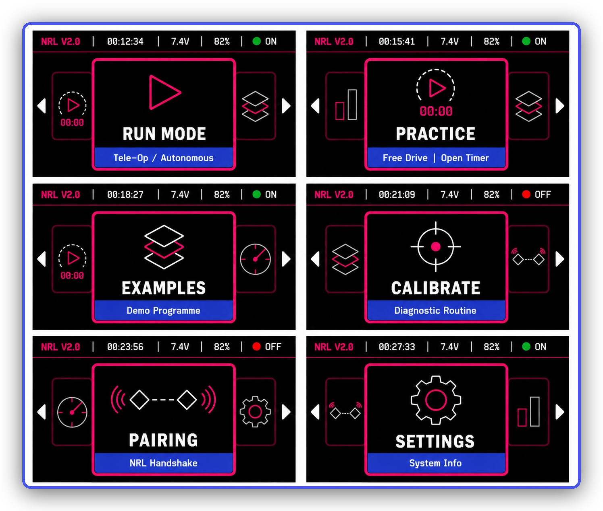
The handheld Controller: a color screen for menus and live data, two joysticks, and a set of face and shoulder buttons.
The handheld Controller: a color screen for menus and live data, two joysticks, and a set of face and shoulder buttons.
Key Idea: The one idea that matters most: the OpMode
You never write the low-level code that talks to motors over wires, or that manages the wireless link, or that draws menus. The framework (a big library that ships with the kit) already does all of that.
Your job is to write a small class called an OpMode — short for Operation Mode. An OpMode is one complete robot behavior: "drive around with the joysticks," or "automatically drive forward and turn." You write the game logic; the framework runs it.

If you have heard of FTC or WPILib (the software used in the FIRST Robotics competitions), NRL is deliberately modeled on the same idea. An NRL OpMode plays the same role as an FTC OpMode: it is the unit of code a student writes and the robot runs.

The shape of every OpMode
Every program you write will have the same three parts. Don't worry about the exact syntax yet — just notice the shape:
class MyProgram : public NRLOpMode {
public:
void init() override {
// Runs ONCE, when you press INIT. Get hardware ready here.
}

void loop() override {
// Runs OVER AND OVER, many times a second, during the match.
// Read the gamepad, drive motors, react. This is where the action is.
}

void stop() override {
// Runs ONCE, when the match ends. Turn the motors off here.
}
};

REGISTER_OPMODE(MyProgram, "My Program", TELEOP); // makes it show up on the Controller

That last line — REGISTER_OPMODE(...) — is what makes your program appear in the menu on the Controller so you can select and run it. We will unpack every piece of this in Module 3.1.

Two kinds of OpMode
Type | What it is | How loop() behaves
TELEOP | Teleoperated — a human drives with the Controller. | Runs continuously until you press STOP.
AUTO | Autonomous — the robot runs by itself, no driver. | Runs, then automatically ends at a time deadline.

What you will have built by the end
• A TeleOp program that drives your robot with the joysticks and works an arm and gripper on the shoulder buttons.
• An Autonomous program that drives forward and makes a precise 90° turn using the robot's motion sensor.
• Programs that read sensors, light up an LED, draw on a small screen, and stream live data back to the Controller.

Module 2.2: Installing the Software
You need exactly two free programs on your computer. That's it — everything else installs itself the first time you build a project.
1. Visual Studio Code (VS Code) — a free code editor from Microsoft. Download it from code.visualstudio.com and install it like any normal app.
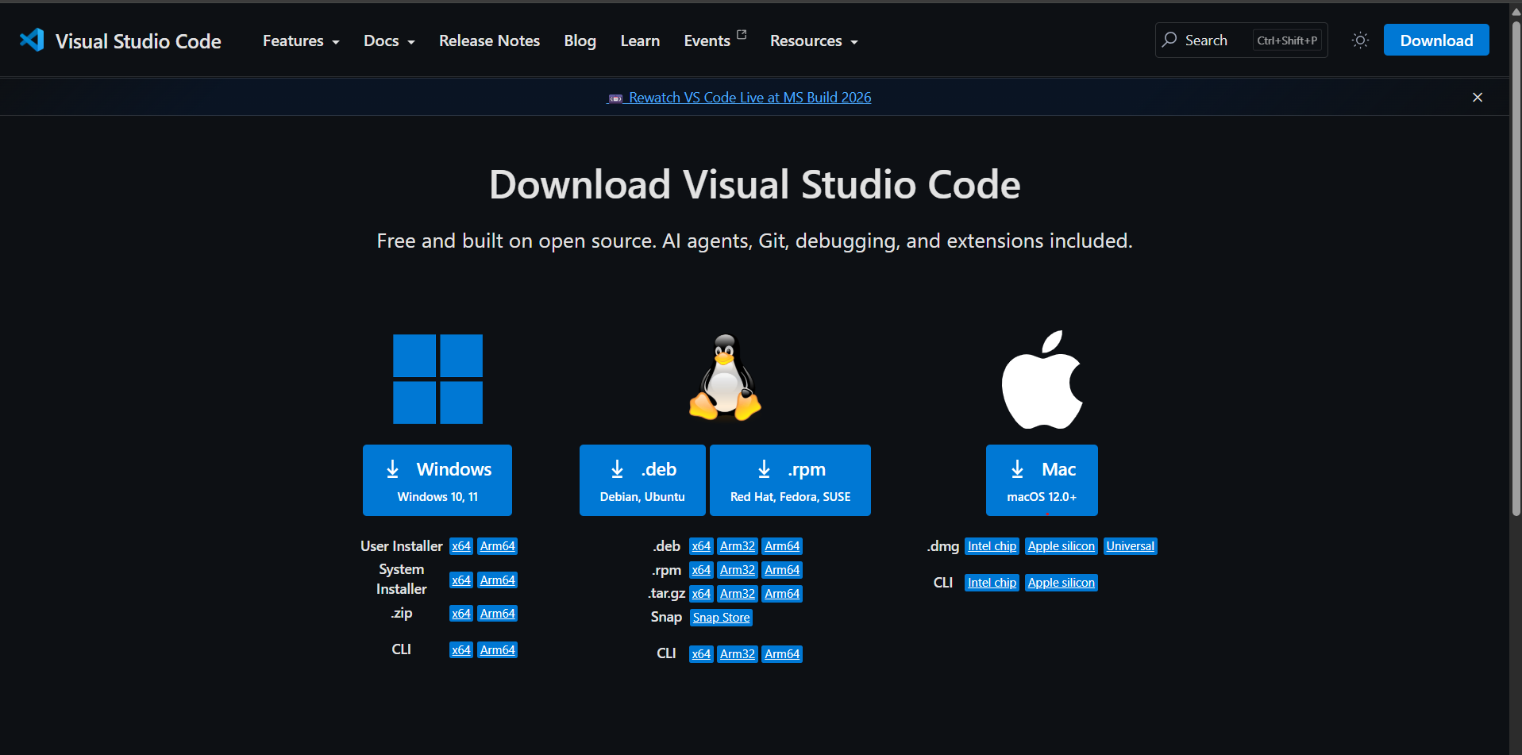
The VS Code download page — pick the installer for your operating system (Windows, macOS, or Linux).
The VS Code download page — pick the installer for your operating system (Windows, macOS, or Linux).
2. The PlatformIO IDE extension — this is the piece that compiles your code and uploads it to the robot. Open VS Code, click the Extensions icon in the left sidebar (the four-squares icon), search for "PlatformIO IDE", and click Install.
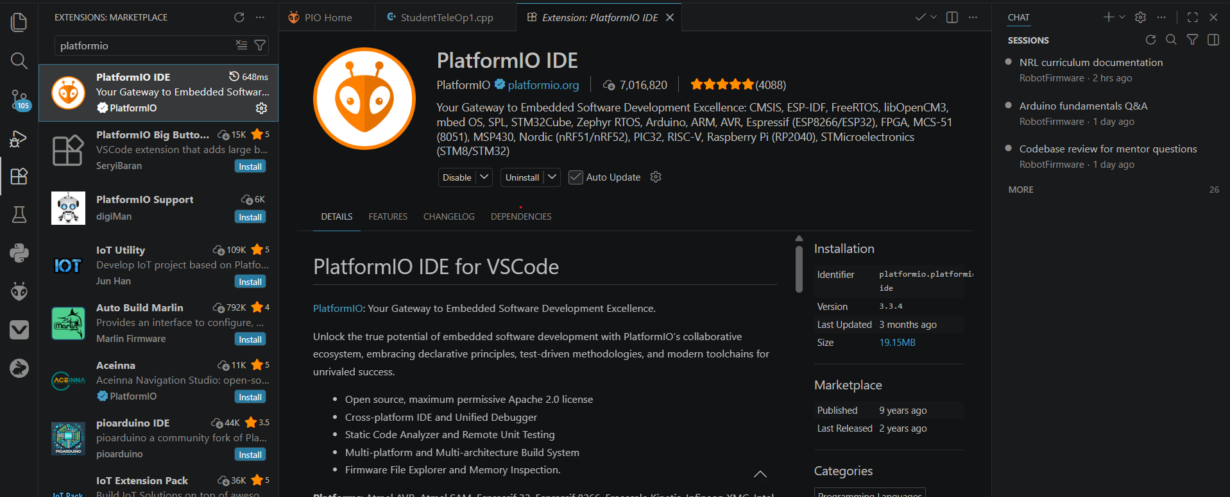
Searching for "PlatformIO IDE" in the VS Code Extensions marketplace. Install the one published by PlatformIO.
Searching for "PlatformIO IDE" in the VS Code Extensions marketplace. Install the one published by PlatformIO.
Note: What is PlatformIO?
PlatformIO is a build system for microcontrollers. When you press Build, it turns your C++ into a binary the ESP32-S3 can run; when you press Upload, it sends that binary to the board over USB. It also downloads any code libraries your project needs — automatically, the first time you build.

Module 2.3: Creating Your Own Project (HexaSDK)
Rather than editing the shared template directly, each team makes its own copy of the project, stamped with the team's number and name. NRL includes a wizard called HexaSDK to do exactly this — it is the NRL equivalent of WPILib's "Create a new project." Now that VS Code and PlatformIO are installed, here is the complete walkthrough, start to finish.

Step 1 — Get the project files
Go to the NRL kit's GitHub repository: github.com/NationalRoboticsLeague-NRL/NRL-NationalRoboticsLeague.
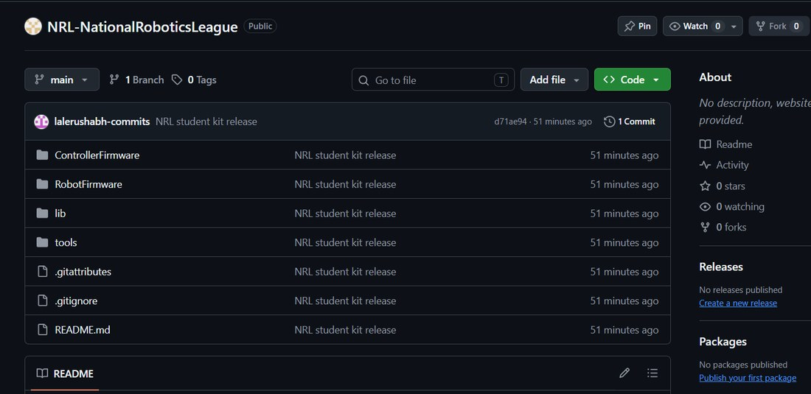
The NRL kit repository on GitHub.
The NRL kit repository on GitHub.

Step 2 — Download the ZIP
Click the green `<> Code` button and select Download ZIP.
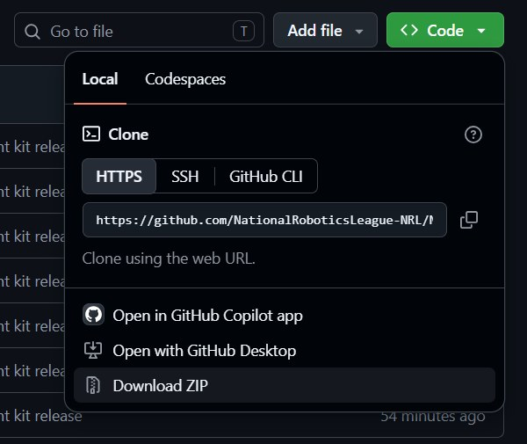
Click the green Code button, then Download ZIP.
Click the green Code button, then Download ZIP.

Step 3 — Extract the ZIP
Once it has downloaded, right-click the ZIP file and select Extract All.
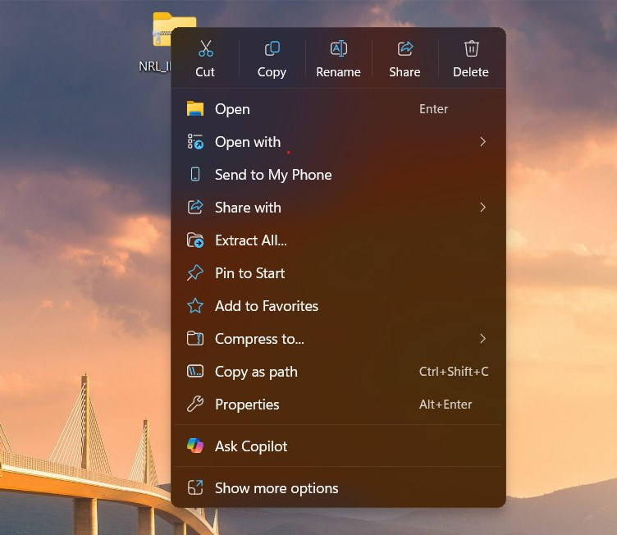
Right-click the downloaded ZIP and choose Extract All.
Right-click the downloaded ZIP and choose Extract All.

Step 4 — Open the tools folder
Inside the extracted folder, double-click into `tools`.
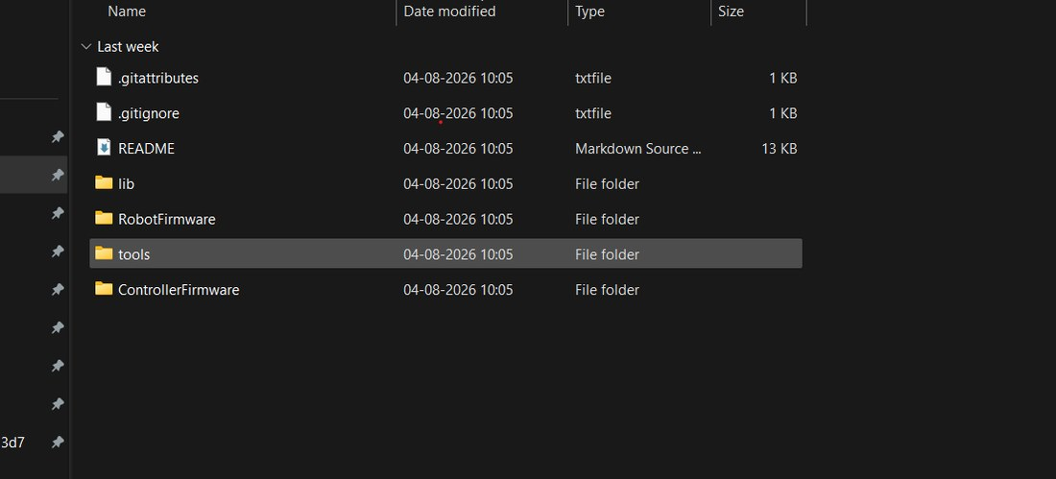
Inside the extracted folder, open the tools folder.
Inside the extracted folder, open the tools folder.

Step 5 — Run the launcher
Double-click `new-nrl-project` (the Windows Batch File) — this is the launcher/project generator.
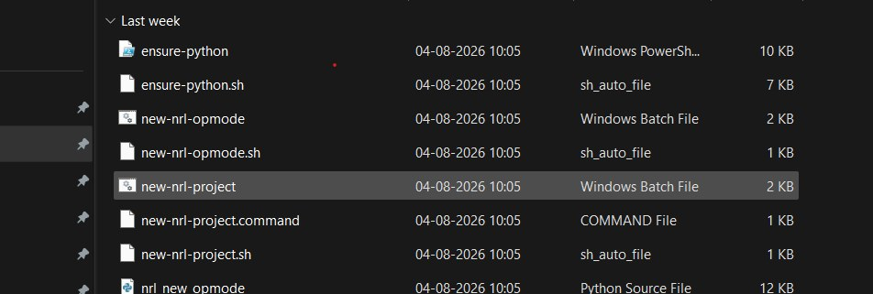
Double-click new-nrl-project (Windows Batch File) to start the wizard.
Double-click new-nrl-project (Windows Batch File) to start the wizard.
Note: Windows only, for now
NRL currently supports Windows. macOS and Linux are not yet compatible.

Step 6 — Confirm the security prompt
A Windows "publisher could not be verified" warning pops up — click Run. This is expected: the script isn't digitally signed, but it's the same launcher from the kit you just downloaded.
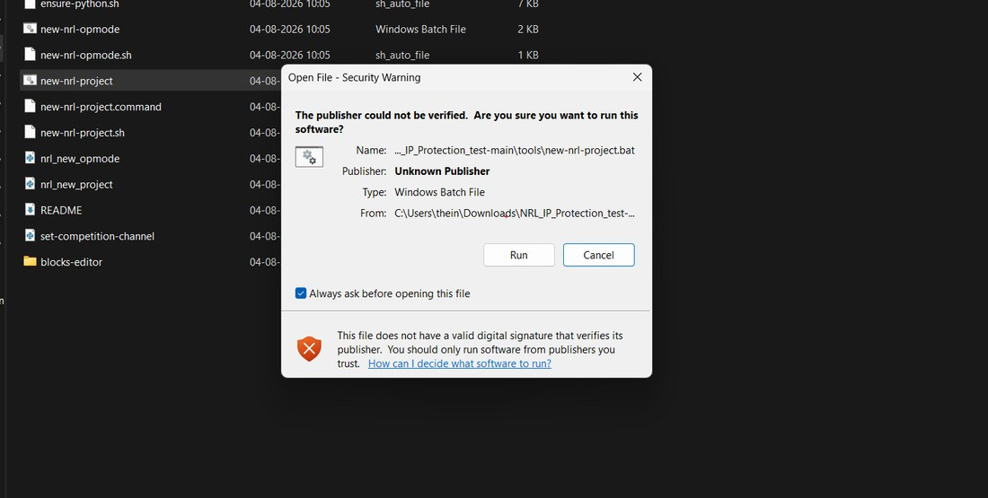
Windows shows a security warning because the script is unsigned — click Run to continue.
Windows shows a security warning because the script is unsigned — click Run to continue.
Note: First-time Python
The wizard is a small Python program. If your computer has no suitable Python installed, the double-click launchers install one for you the first time (a one-time step). You don't have to set anything up by hand.

Step 7 — Fill in your team details
A terminal window opens and asks for your project name, team number, and team name.
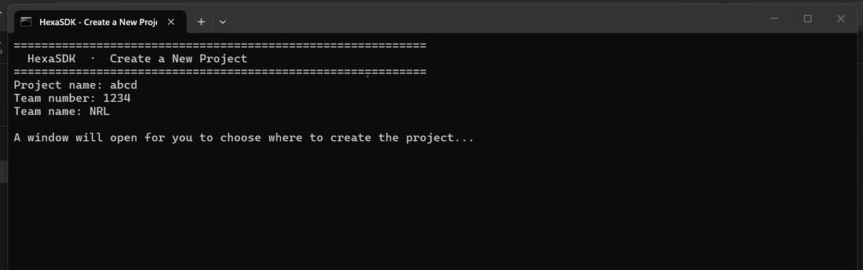
Enter the project name, team number, and team name in the terminal wizard.
Enter the project name, team number, and team name in the terminal wizard.

Step 8 — Choose where to save it
A Windows Explorer window opens automatically — pick the folder where you want the project saved.
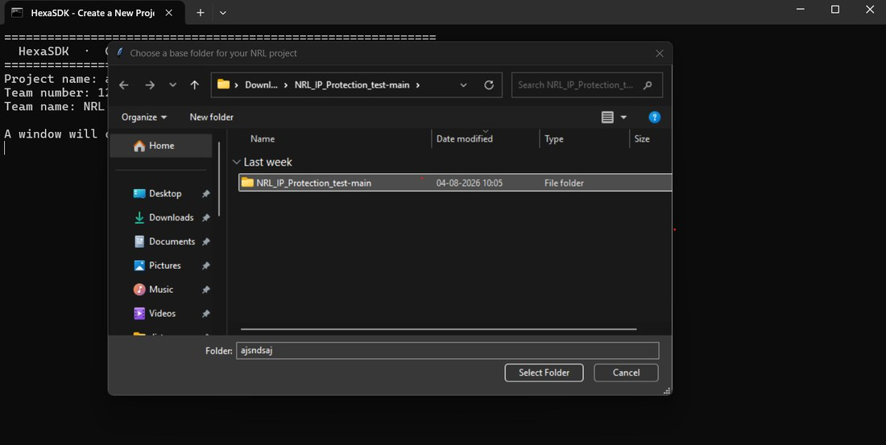
A file explorer window opens for you to choose the save location.
A file explorer window opens for you to choose the save location.

Step 9 — Confirm and generate
The wizard fills in the details and shows the ESP-NOW channel it derived for your team, plus the save location. Note that channel down — you'll want it for pairing later. Press Y to generate the project.
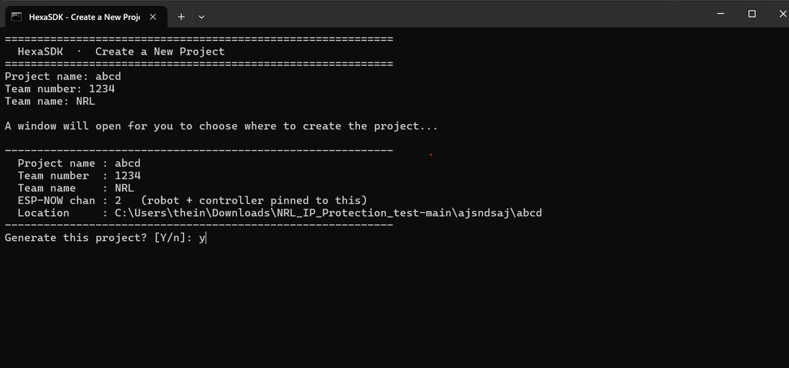
The wizard confirms your details, including the ESP-NOW channel — press Y to generate.
The wizard confirms your details, including the ESP-NOW channel — press Y to generate.

Step 10 — Project created
Once generation finishes, you'll see a confirmation like this.
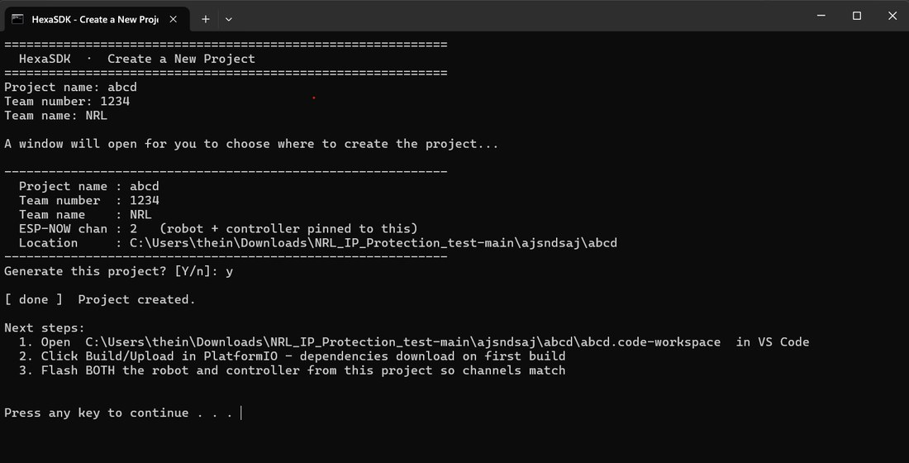
The wizard reports the project was generated successfully.
The wizard reports the project was generated successfully.

Step 11 — VS Code opens automatically
VS Code launches with your new project already loaded. The first setup takes about 10–15 minutes, because PlatformIO needs to initialize and download dependencies — let it finish before you start building.
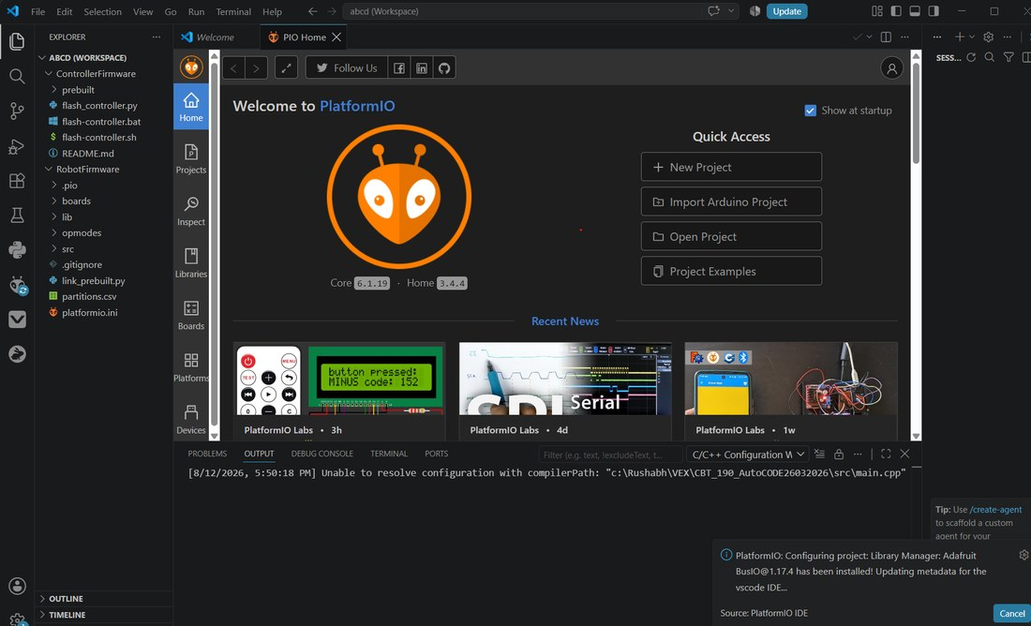
VS Code opens automatically with the new project. First-time PlatformIO setup takes 10–15 minutes.
VS Code opens automatically with the new project. First-time PlatformIO setup takes 10–15 minutes.

Step 12 — Always reopen via the workspace file
An NRL project contains two firmware folders — one for the Robot, one for the Controller. To let VS Code and PlatformIO see both at once, always open the project through its workspace file, never the bare folder.
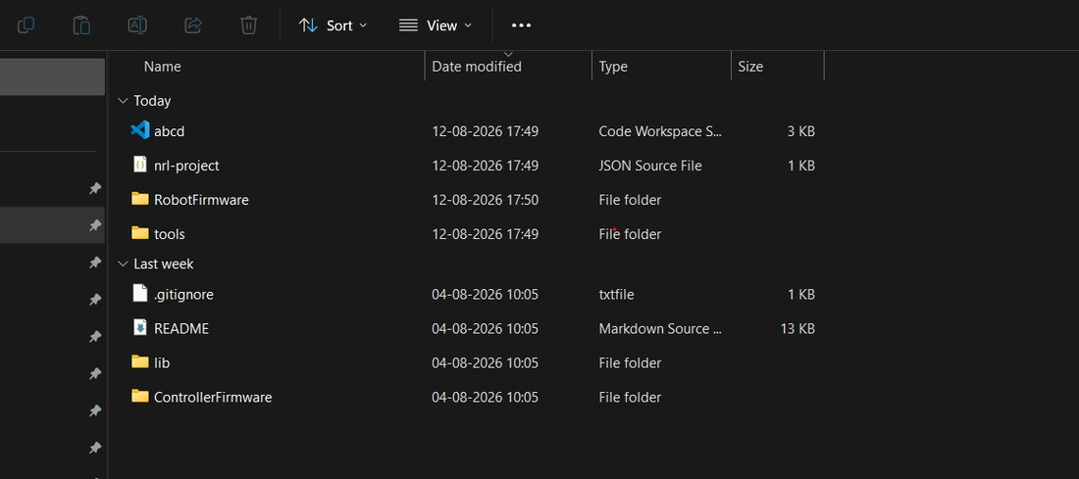
Always reopen the project through its .code-workspace file.
Always reopen the project through its .code-workspace file.
If you close VS Code, remember where you saved the project, then:
1. In VS Code choose File → Open Workspace from File...
2. Select the file ending in `.code-workspace` (named after the project name you entered in Step 7).
3. If PlatformIO needs to re-download anything, let it finish before you start building.
Warning: Don't open the bare folder
If you open the plain folder instead of the .code-workspace file, PlatformIO only sees one firmware at a time and IntelliSense (code auto-complete) may show phantom errors. Always open the workspace file.

What the team number does
Your team number is baked into both the Robot and Controller firmware when the project is generated, and it's what keeps your kit's wireless channel separate from every other kit's in the room.
Warning: Flash both boards from the SAME project
The Robot and Controller must be built from the same generated project. If they're not, they'll be on different channels — they either won't pair at all, or the connection will be unstable even if they do.

What you get
The wizard produces a self-contained project folder with RobotFirmware/, ControllerFirmware/, the shared lib/ drivers, a renamed .code-workspace file, and a small nrl-project.json recording your team details. Build artifacts and tooling are left out. Dependencies download on your first build, exactly as before.
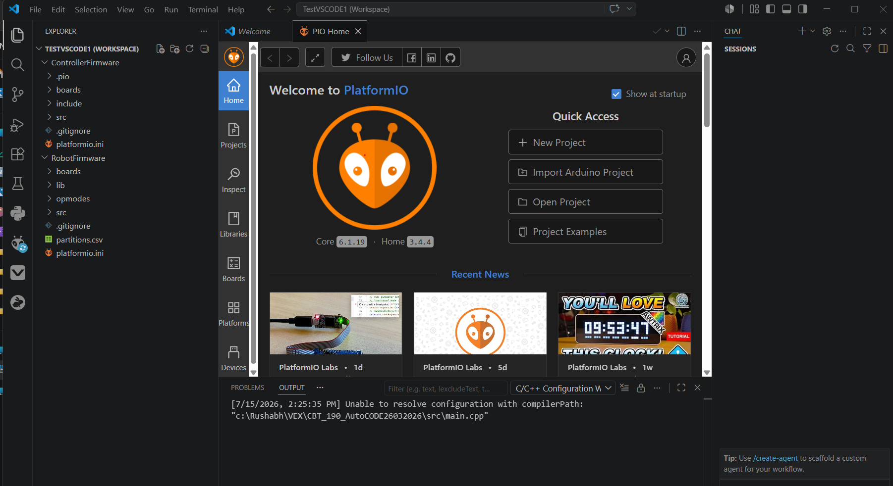
The generated project opens automatically in VS Code: both RobotFirmware and ControllerFirmware are in the Explorer, ready to build and flash.
The generated project opens automatically in VS Code: both RobotFirmware and ControllerFirmware are in the Explorer, ready to build and flash.

Module 2.4: Understanding Your Hardware
You do not need to be an electronics expert, but knowing what plugs in where — and the names the code uses for each connector — makes writing programs much easier. Every pin has a friendly constant defined in a file called BoardPins.h, and you use those names in your code instead of raw numbers.

The two boards
Board | Role
Robot | Runs your OpMode; drives the robot.
Controller | Human interface; sends input wirelessly.

Note: Want the hardware details?
What's actually on each board — ports, sensors, screens, power regulation — is covered in the Electronics Curriculum. This module only covers what your code needs to know.

Key connectors on the Robot board
These are the names you will type in your programs. Keep this table handy for Phase 3.
Constant (name in code) | Connector | Used for
MOTOR_L_DIR, MOTOR_L_PWM | Left drive motor | The two wires that set the left motor's direction and speed.
MOTOR_R_DIR, MOTOR_R_PWM | Right drive motor | Same, for the right motor.
SERVO_1 ... SERVO_4 | Four servo ports | Signal pin for each servo (arms, grippers, etc.).
I2C_SDA, I2C_SCL | Motion-sensor bus | Connects the onboard IMU (LSM6DSOX).
OLED_SDA, OLED_SCL | Display bus | Connects the small OLED status screen.
LED_STATUS_PIN | Status LED | The onboard NeoPixel indicator.
BUZZER_PIN | Buzzer | A passive buzzer for beeps.
BUTTON_PIN | Button | The tactile button used for pairing.
ADC_EXT_1 ... ADC_EXT_5 | External analog ports | Read extra analog sensors through the power ADC.

Power and current sensing
The Robot board can measure its own battery voltage and how much current the motors and servos are drawing, through an onboard analog-to-digital converter (an MCP3008 chip). You read these through a ready-made object called power — no setup required. We cover it in Module 3.9.
Note: One current sensor per rail — not per motor
The board has one current sensor on the motor rail and derives the servo rail from the total. So power.getMotorCurrent() is the current for all motors together, not any single motor. There is deliberately no per-motor current reading.

Module 2.5: Flashing and Pairing
With a project created, it's time to put firmware on both boards and connect them to each other. The Controller and the Robot are flashed differently — start with the Controller.

Step 1 — Install the Python extension
The Controller ships with a prebuilt firmware image, flashed through a small Python script rather than a normal PlatformIO build. Make sure the Python extension is installed in VS Code (Extensions icon in the Activity Bar → search "Python" → Install), and let PlatformIO finish initializing first — check its status from the Activity Bar and wait if the status bar still shows "PlatformIO: Loading Tasks."
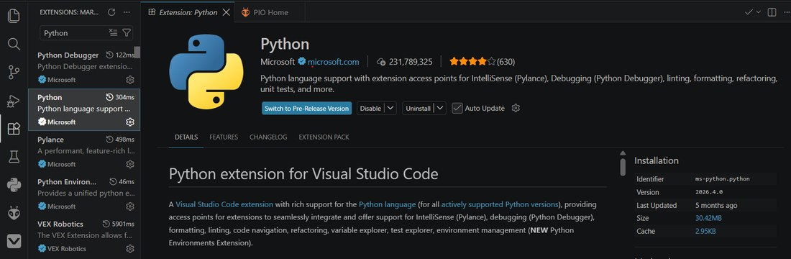
Installing the Python extension in VS Code.
Installing the Python extension in VS Code.

Step 2 — Run flash_controller.py
Open `flash_controller.py` under ControllerFirmware, plug the Controller in over USB, then click the dropdown arrow next to the Run button (top-right) and choose Run Python File.
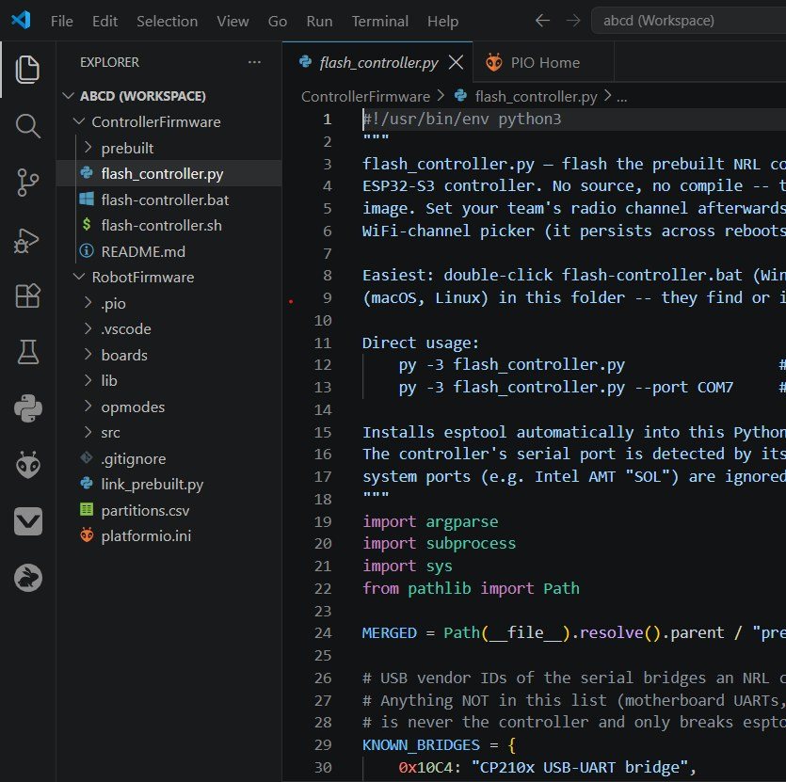
flash_controller.py under ControllerFirmware.
flash_controller.py under ControllerFirmware.
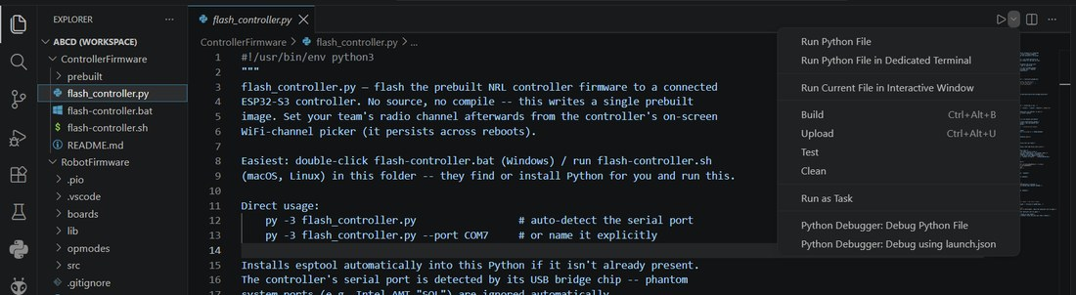
Click the dropdown next to Run and choose "Run Python File" — not the usual PlatformIO Upload.
Click the dropdown next to Run and choose "Run Python File" — not the usual PlatformIO Upload.
Note: First-time Python
The wizard is a small Python program. If your computer has no suitable Python installed, the double-click launchers install one for you the first time (a one-time step). You don't have to set anything up by hand.

Step 3 — Confirm the flash succeeded
Wait for the terminal to report success.
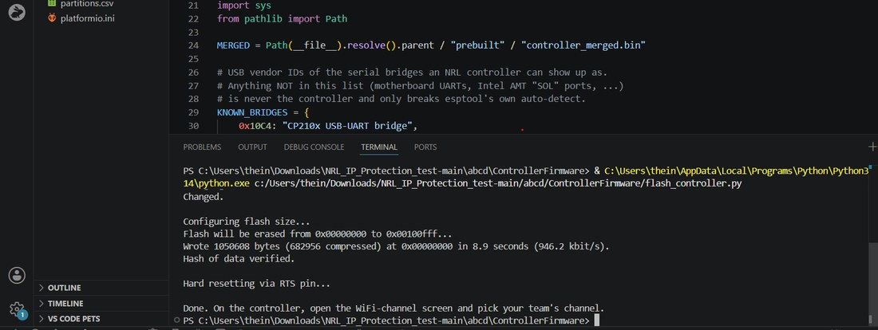
The terminal confirms the flash succeeded and reminds you to pick your team's WiFi channel on the Controller.
The terminal confirms the flash succeeded and reminds you to pick your team's WiFi channel on the Controller.

Step 4 — Flash the Robot
Switch to the RobotFirmware environment in the bottom status bar, connect the Robot board, open RobotMain.ino (or an OpMode .cpp file), and click Upload on the PlatformIO toolbar (or the arrow in the status bar).
Tip: Upload = Build + Send
Upload automatically builds first, so you don't need a separate Build step. If Upload fails to find the board, check the USB cable (some are charge-only) and that no other program is using the serial port.

Step 5 — Check the Robot's OLED
Once the Robot is flashed, its OLED screen shows your team's details.
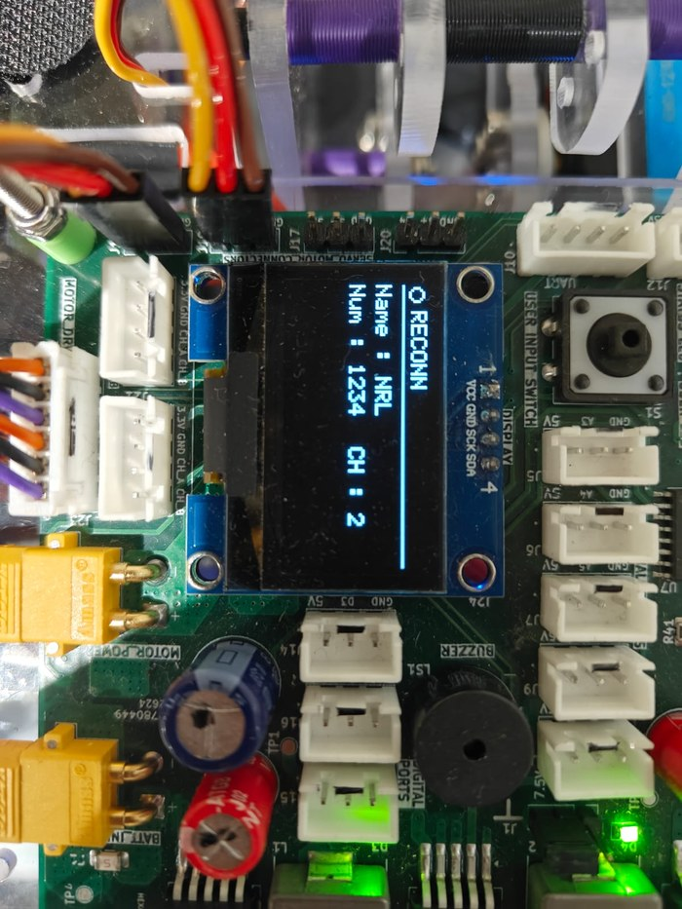
The Robot's OLED shows your team details after a successful flash.
The Robot's OLED shows your team details after a successful flash.

Step 6 — Match the WiFi channel
The Robot and Controller should be on the same channel before pairing — you can see your WiFi channel of the Robot on the OLED screen. You can change the WiFi channel of both bot and controller under SETTING → WIFI CHANNEL.
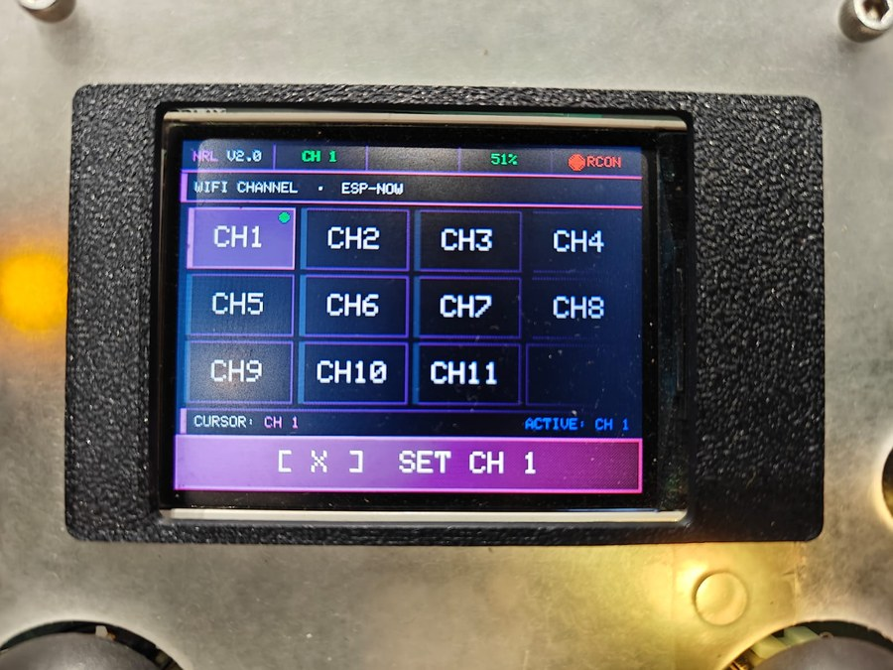
Each kit is pinned to a radio channel derived from its team number, so multiple robots can run in the same room.
Each kit is pinned to a radio channel derived from its team number, so multiple robots can run in the same room.

Step 7 — Pair the boards
The bot must be paired so they only talk to each other, even in a room full of other kits. Pairing uses the Robot's button and a short code shown on the Controller.
Press the tactile button on the Robot for 3 seconds. Then, under the pairing menu, press and hold the left bumper and right bumper on the Controller. This generates a 4-digit random number on the Controller. Check that you see the same number on the Robot's OLED. If you do, press the same button on the Robot for 1 second until it shows "paired."
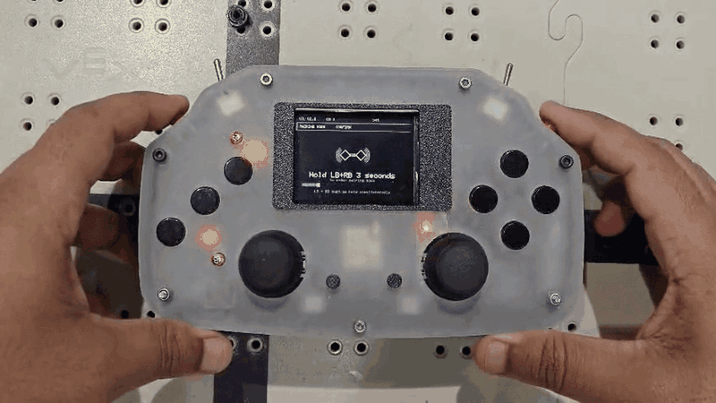
Holding the left and right bumpers on the Controller during pairing. (representative frame from an animated demo)
Holding the left and right bumpers on the Controller during pairing.
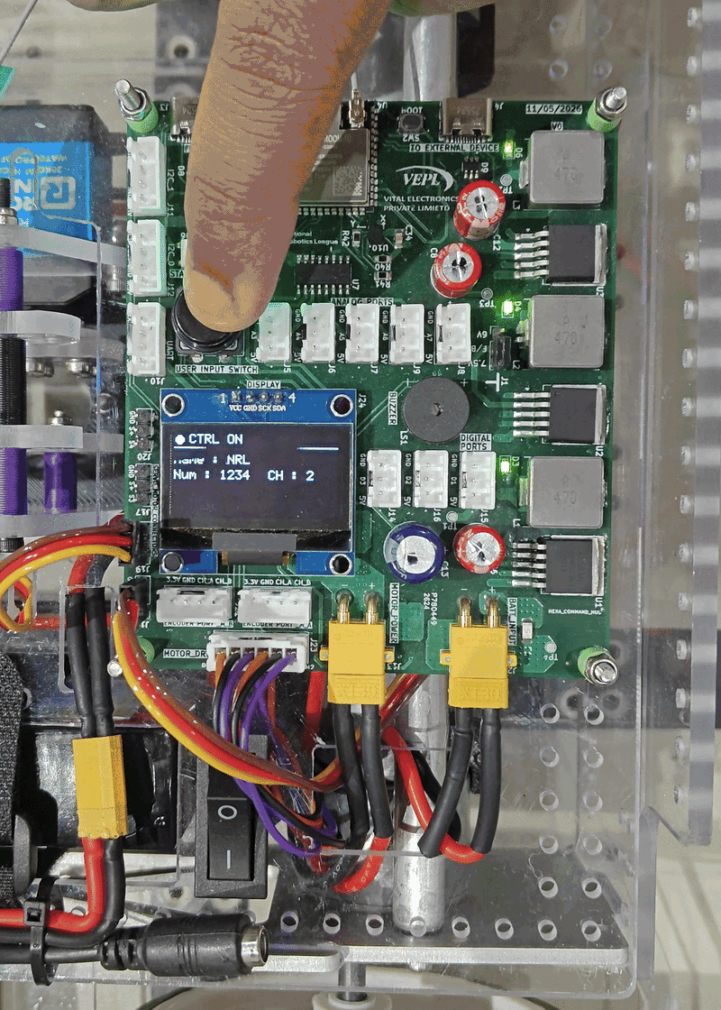
Pressing the tactile button on the Robot (Command Hub) during pairing. (representative frame from an animated demo)
Pressing the tactile button on the Robot (Command Hub) during pairing.
Once paired, the link is remembered (saved in the board's non-volatile memory), so you only pair once. The Controller's header shows the connection status and the Robot's battery voltage.

The Controller, at a glance
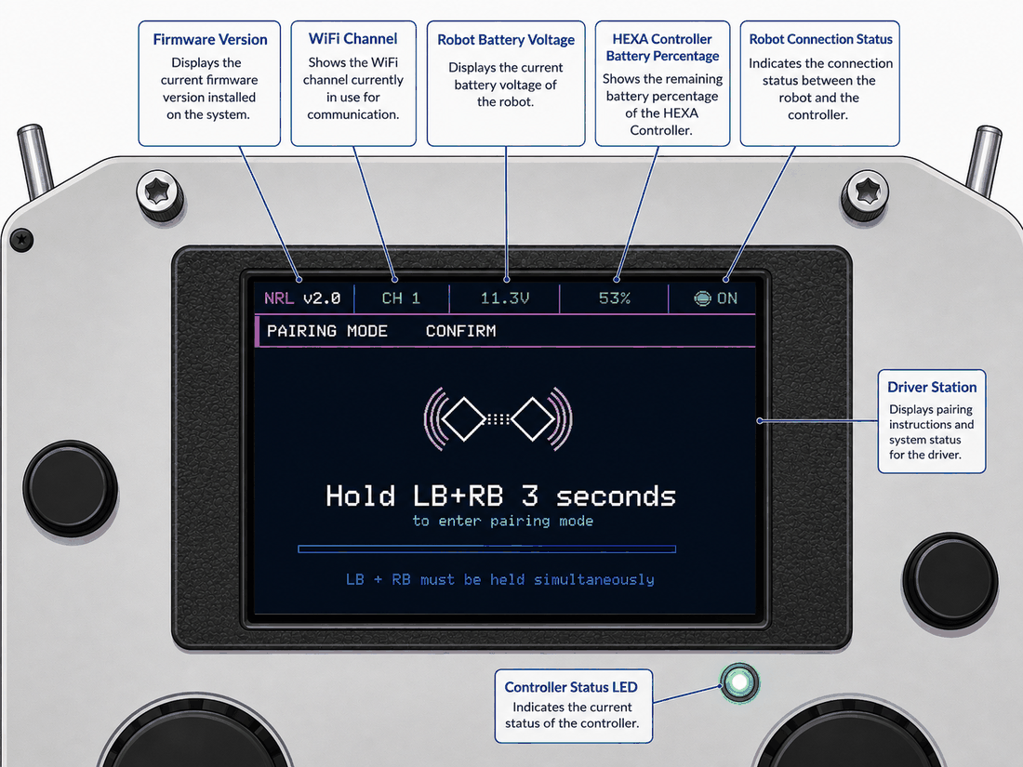
The Controller's header at a glance: firmware version, WiFi channel, robot battery voltage, controller battery percentage, robot connection status, the driver station screen, and the controller status LED.
The Controller's header at a glance: firmware version, WiFi channel, robot battery voltage, controller battery percentage, robot connection status, the driver station screen, and the controller status LED.
You drive the whole match from the Controller. Here is the button map you'll use constantly:
Control | In the menu | During a match
D-pad Up / Down | Scroll the OpMode list. | Free for your program to use.
D-pad Left / Right | Move across the MENU carousel. | Free for your program to use.
X button | Select / confirm. | Free for your program to use.
Y button | Go back. | Free for your program to use.
INIT / START / STOP | Run controls for the selected OpMode. | START begins the match; STOP ends it.

Step 8 — Wait for the first-time load
Once your project is generated, the VS Code window opens with both the Controller and Robot firmware loaded. The first time it opens you'll see the loading screen below — indexing and initializing the whole firmware takes about 10 minutes, so let it finish before you start.
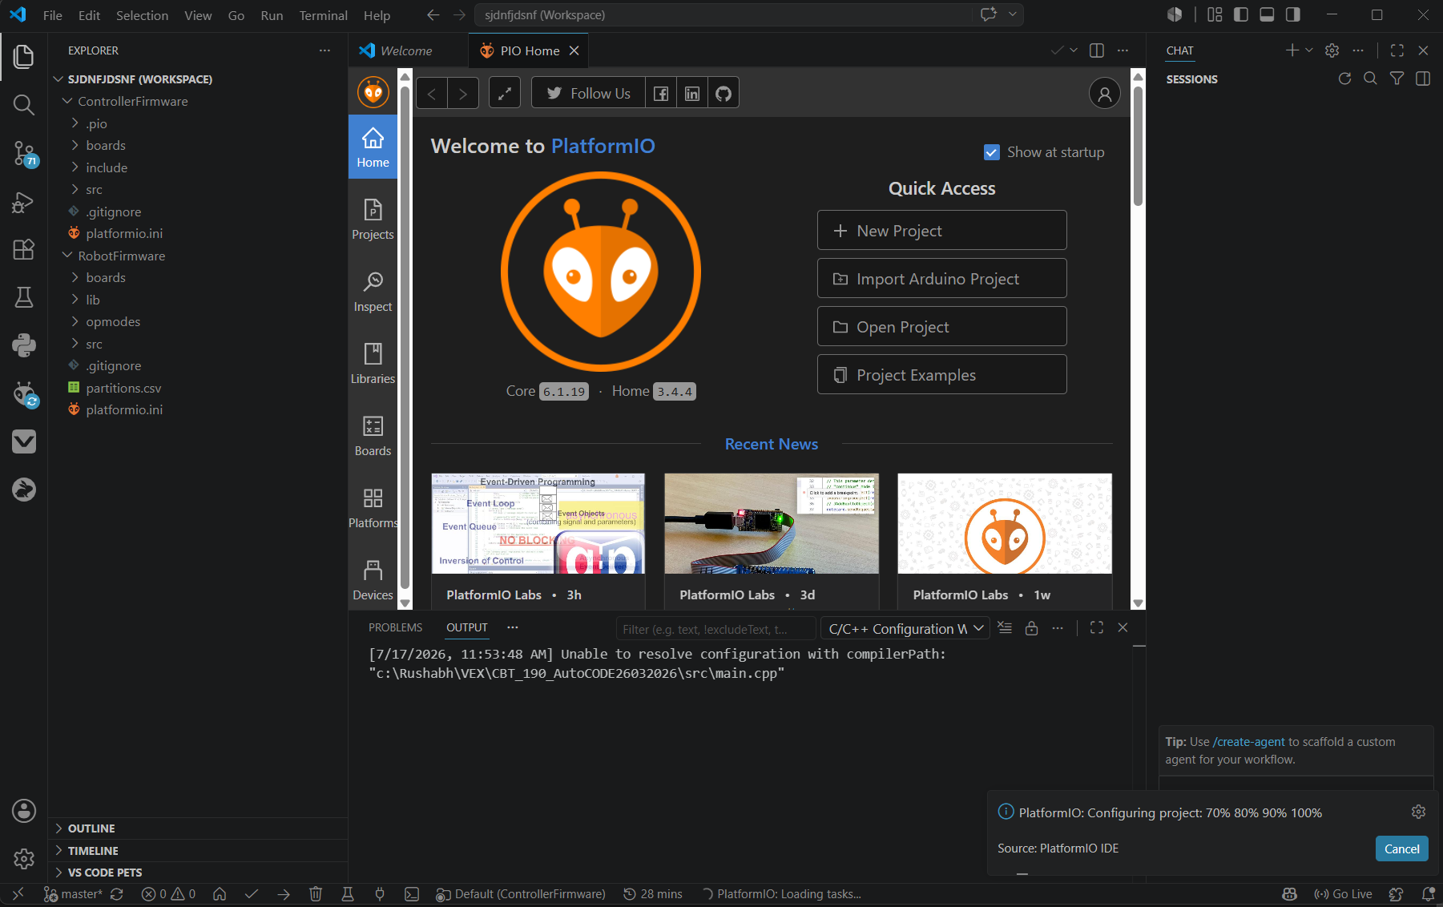
VS Code indexing and initializing the whole firmware for the first time.

Step 9 — Open the OpMode creation task
Once the project has finished loading, follow this same sequence each time you want to create a new OpMode. Open the command palette with Ctrl + Shift + P and select Tasks: Run Task.
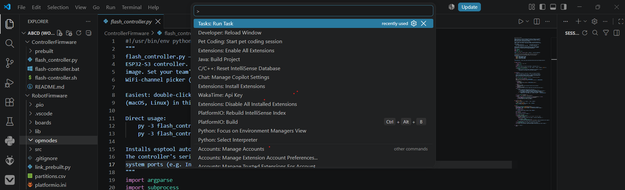
Opening the command palette and selecting "Tasks: Run Task".
Opening the command palette and selecting "Tasks: Run Task".

Step 10 — Fill in the wizard
From the task list, select NRL: New OpMode — "Create a new robot OpMode (TeleOp or Auto) from a minimal template."
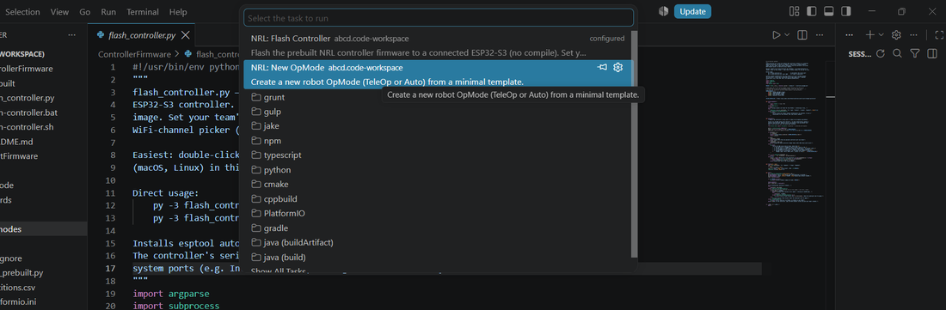
Selecting "NRL: New OpMode" from the task list.
Selecting "NRL: New OpMode" from the task list.
The wizard then runs in the terminal. Enter your details when prompted — here's a full example:
============================================================
NRL · Create a New OpMode
============================================================
OpMode name (e.g. DriveStraight): TemplateTest1 # the .cpp file name
Type (teleop/auto) [teleop]: teleop # teleop or auto, as needed
Controller display name [TemplateTest1]: templatetest1 # name shown on the Controller
------------------------------------------------------------
OpMode name : TemplateTest1
Type : TELEOP
Display name : templatetest1 (shown on the Controller)
File : C:\Rushabh\ARDUINO_Libs\NRL\NRL_Update_1\RobotFirmware\opmodes\TemplateTest1.cpp
------------------------------------------------------------
Create this OpMode? (y/n) [y]: y

Step 11 — Your new OpMode is ready
The new OpMode is generated from a template — ready for you to fill in with your own code.
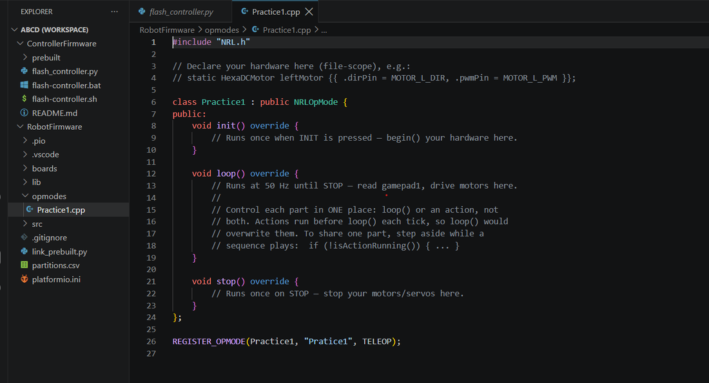
The new OpMode file generated from the template, ready for you to fill in with your own code.
The new OpMode file generated from the template, ready for you to fill in with your own code.

Phase 3: Programming the Robot

Module 3.1: Motors
A DC motor is what spins your wheels. The HexaDCMotor class controls one motor's direction and speed through a driver on the board.

Declaring a motor
static HexaDCMotor leftMotor{{ .dirPin = MOTOR_L_DIR, .pwmPin = MOTOR_L_PWM }};

The double braces hold the motor's configuration. Each motor needs two pins — a direction pin and a speed (PWM) pin — and you name them with the BoardPins.h constants. An optional .flipped = true reverses the motor in software, which is handy when a motor is mounted backwards on the frame.

The methods
Member | Purpose
begin() | Initializes the motor. Call once in init().
setSpeed(int speed) | Sets speed from -255 (full reverse) to +255 (full forward). 0 = coast. Values outside the range are clamped.
getSpeed() | Returns the last speed you commanded.
stop() | Stops the motor (same as setSpeed(0)).
setFlipped(bool) | Reverses direction in software, effective immediately.

Note: Why -255 to 255?
The speed is an 8-bit value: 255 distinct steps in each direction. Negative means reverse, positive means forward, and the magnitude is how hard it drives. A tiny deadband near zero is applied automatically so noise doesn't make the motor stutter.

A complete motor OpMode
This program ramps both motors smoothly up to speed and back down — a good pattern that avoids the current spike (and wheel slip) of slamming from 0 to full.
#include "NRL.h"

static HexaDCMotor leftMotor{{ .dirPin = MOTOR_L_DIR, .pwmPin = MOTOR_L_PWM }};
static HexaDCMotor rightMotor{{ .dirPin = MOTOR_R_DIR, .pwmPin = MOTOR_R_PWM, .flipped = true }};

class MotorRamp : public NRLOpMode {
int _speed = 0;

public:
void init() override {
leftMotor.begin();
rightMotor.begin();
}

void loop() override {
if (_speed < 220) _speed += 5; // creep up 5 units each pass
leftMotor.setSpeed(_speed);
rightMotor.setSpeed(_speed);
telemetry.addData("speed", (float)_speed);
}

void stop() override {
leftMotor.setSpeed(0);
rightMotor.setSpeed(0);
}
};

REGISTER_OPMODE(MotorRamp, "Motor Ramp", TELEOP);

Warning: Common motor mistakes
Forgetting `begin()` in init() — the motor will silently do nothing.
Forgetting to stop in stop() — the robot keeps rolling after the match ends.

Module 3.2: Driving with TankDrive
Controlling two motors by hand to drive straight and turn is fiddly. TankDrive does the math for you: you give it a forward amount and a turn amount, and it works out the correct speed for each side.

Declaring the drive
TankDrive is built from two motors you've already declared, so it comes after them:
static HexaDCMotor leftMotor{{ .dirPin = MOTOR_L_DIR, .pwmPin = MOTOR_L_PWM, .flipped = true }};
static HexaDCMotor rightMotor{{ .dirPin = MOTOR_R_DIR, .pwmPin = MOTOR_R_PWM }};
static TankDrive drive(leftMotor, rightMotor);

The methods
Member | Purpose
drive(float forward, float turn) | The main call. forward and turn each range -1.0 to +1.0. Positive forward drives ahead; positive turn steers right.
stop() | Stops both motors. Call in stop().
setScale(float 0..1) | Overall speed limit — great for a "slow / precision" mode toggle.
setRampRate(float) | How fast the output is allowed to change. Lower = smoother and gentler on the battery.

Note: You still begin() the motors
TankDrive uses the motors you declared, so you still call leftMotor.begin() and rightMotor.begin() in init(). TankDrive itself needs no begin().

The everyday driving OpMode
This is the pattern you'll start almost every TeleOp with. The left joystick's up/down drives; the right joystick's left/right turns:
void loop() override {
drive.drive(gamepad1.leftY(), gamepad1.rightX());
}

Want a precision mode? Scale the whole drive down while a button is held:
void loop() override {
drive.setScale(gamepad1.pressed(BTN_LB) ? 0.35f : 1.0f); // slow while LB held
drive.drive(gamepad1.leftY(), gamepad1.rightX());
}

Tip: Motor mounted backwards?
If the robot turns the wrong way or one wheel fights the other, flip one motor with .flipped = true in its declaration instead of re-wiring. It's a one-word fix.

Module 3.3: Servos
A servo motor moves to a specific angle and holds it — perfect for arms, grippers, and claws. The HexaServo class drives one servo, in degrees from 0 to 180.

Declaring a servo
static HexaServo arm{{ .signalPin = SERVO_1, .startAngle = 90.0f, .settleMs = 0 }};

Member | Purpose
.signalPin | Which servo port: SERVO_1 ... SERVO_4.
.startAngle | Where the servo moves to when begin() runs. Default 90° (center).
.settleMs | 0 (default) = hold the angle forever. A positive value auto-releases the servo after that many idle milliseconds.
.offsetDeg | A calibration nudge if the servo horn is slightly misaligned.
.minAngle / .maxAngle | Software travel limits, if you need to protect a mechanism.

The methods
Member | Purpose
begin() | Initializes the servo and moves it to startAngle. Call in init().
setPosition(float deg) | Moves to an absolute angle, 0-180°.
moveBy(float deg) | Moves relative to the current angle.
getPosition() | Returns the current angle.
setRampRate(float degPerSec) | Limits how fast the servo swings. Call before the first setPosition().
detach() / attach() | Release / re-engage the servo (a detached servo goes limp).

Note: settleMs = 0 means "hold"
With .settleMs = 0, the servo keeps its signal and firmly holds its commanded angle — which is what you usually want for an arm. This relies on a clean servo power supply; if a servo buzzes at rest on a weak battery, that's a power issue (see Module 5.2), not a code bug.

A complete servo OpMode
This sweeps an arm servo between two poses on a button, using edge detection so one press = one toggle (the pattern is explained fully in Module 3.4).
#include "NRL.h"

static HexaServo arm{{ .signalPin = SERVO_1, .startAngle = 90.0f, .settleMs = 0 }};

class ArmToggle : public NRLOpMode {
public:
void init() override {
arm.begin();
}

void loop() override {
arm.setPosition(90);
telemetry.addData("arm", arm.getPosition());
}

void stop() override {
arm.detach(); // let the servo relax
}
};

REGISTER_OPMODE(ArmToggle, "Arm Toggle", TELEOP);

Warning: Servo watch-outs
Angles are 0-180. Asking for 200° just clamps to 180.
Call `begin()` in `init()`, or the servo won't move.

Module 3.4: The Gamepad
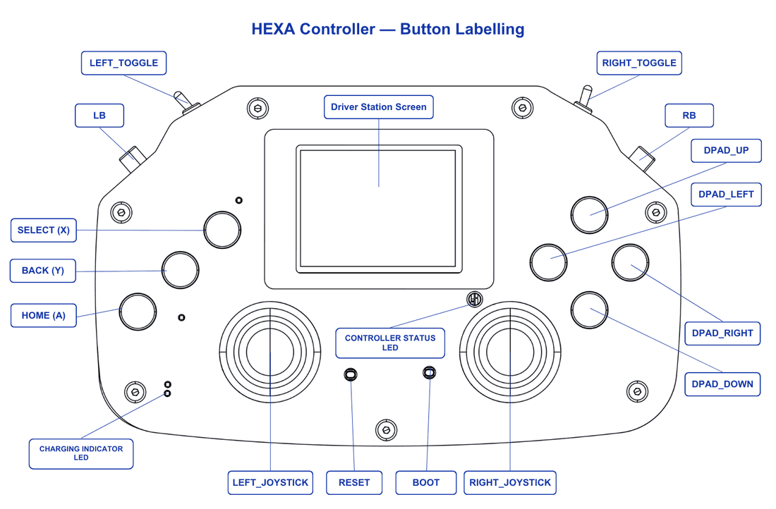
The HEXA Controller, with every button, joystick, and status LED labelled.
The HEXA Controller, with every button, joystick, and status LED labelled.
Everything the driver does on the Controller reaches your program through one ready-made object: `gamepad1`. You don't declare it — it's always there, refreshed automatically at the start of every loop().

Reading the joysticks
Each joystick axis returns a float from -1.0 to +1.0:
Member | Purpose
gamepad1.leftY() | Left stick up/down. Up is positive — the usual "forward."
gamepad1.leftX() | Left stick left/right.
gamepad1.rightX() | Right stick left/right — the usual "turn."
gamepad1.rightY() | Right stick up/down.

Reading the buttons
There are three ways to ask about a button, and choosing the right one matters:
Member | Purpose
pressed(BTN_X) | True while the button is held down right now. Use for continuous actions (drive faster while held).
justPressed(BTN_X) | True for the one pass the button went down. Use for one-shot actions (toggle, fire a sequence).
justReleased(BTN_X) | True for the one pass the button went up. Use for acting on release.

The button names
Constant | Button | Constant | Button
BTN_X | X face button | BTN_DPAD_UP | D-pad up
BTN_A | A face button | BTN_DPAD_DOWN | D-pad down
BTN_Y | Y face button | BTN_DPAD_LEFT | D-pad left
BTN_LB / BTN_RB | left / right bumper | BTN_DPAD_RIGHT | D-pad right
 |  | BTN_LT / BTN_RT | left / right trigger toggle

Note: Seven buttons, and there is no B
The Controller has seven buttons: X, A, Y and the four D-pad directions, plus the bumpers and trigger toggles. There is no B button on the board, so there is no BTN_B constant — using one is a compile error.
BTN_Y is yours to use while your program runs. (In the menus it acts as BACK, and it dismisses the TeleOp exit-confirm popup — so if that popup is showing, one press does both.) Leaving a running OpMode is done with the left trigger toggle, not with Y.

The edge-detection toggle pattern
A very common need: press a button once to toggle something (open/close a gripper). If you check pressed() in loop(), it's true for every pass the button is held — dozens of times — so the gripper flickers. The fix is justPressed(), which is true for exactly one pass per press:
bool _open = false;

void loop() override {
if (gamepad1.justPressed(BTN_RB)) { // exactly one toggle per press
_open = !_open;
gripper.setPosition(_open ? 0 : 40);
}
}

Optional: button bindings
For simple "when pressed, do this" actions, you can register a callback once in init() instead of checking every pass:
void init() override {
gamepad1.onPress(BTN_A, []{ arm.setPosition(120); });
gamepad1.onPress(BTN_Y, []{ arm.setPosition(30); });
}

Tip: Which to use?
Use justPressed() in loop() for most things — it keeps all your logic in one place. Reach for onPress() bindings when you have a lot of independent one-shot buttons and want to keep loop() tidy. For multi-step sequences, use Actions (Module 4.2).

Module 3.5: The Motion Sensor (IMU) & Heading
The robot carries an IMU (Inertial Measurement Unit) — a chip that senses acceleration and rotation. Its most useful output for us is heading: which way the robot is pointing, in degrees. Heading is what makes precise autonomous turns possible (Module 4.3).

Two ways to use it
For autonomous turns, you usually don't touch the IMU class directly at all — the framework already tracks heading for you, and you read it through NRLComms:
float hdg = NRLComms::getHeading(); // current heading in degrees
NRLComms::zeroHeading(); // call this "0 degrees, starting now"
bool ready = NRLComms::isHeadingReady(); // has calibration finished?

For reading raw motion (acceleration, rotation rate, temperature) yourself — say to build a tilt-controlled program or a live dashboard — declare your own HexaIMU:
static HexaIMU imu{ hexaImuConfig() }; // uses the onboard IMU by default

// in init(): imu.begin();
// in loop():
imu.tick(millis());
imu.read();
// float az = imu.getAccelZ();
// float gz = imu.getGyroZ();

The methods you'll use
Member | Purpose
begin() | Starts the IMU. Safe to call in init().
tick(millis()) | Call every loop() — drives the non-blocking heading calibration and integration.
read() | Grabs a fresh snapshot; call before the get... methods.
getAccelX/Y/Z() | Acceleration in m/s² (Z ≈ 9.81 when flat).
getGyroX/Y/Z() | Rotation rate in rad/s.
getHeading() / isHeadingReady() | Integrated heading in degrees, and whether calibration is done.
zeroHeading() | Resets the heading angle to 0 (keeps the calibration).

Warning: Never calibrate by blocking in init()
The IMU needs about half a second of the robot held still to learn its zero point. Do not try to do this with a delay() inside init() — init() runs in a time-sensitive part of the framework, and blocking it can make your OpMode abort right after INIT.
Instead, call imu.tick(millis()) every pass of loop(). Calibration spreads itself painlessly across the first ~50 passes. Just keep the robot still for the first half-second after START.

Note: Heading drift
An IMU-only heading slowly drifts over time (there's no compass to correct it). That's fine for the short, sharp turns in a match. Zero it right before a turn for best accuracy.

Module 3.6: Telemetry
Telemetry is how your robot sends numbers and text back to the Controller's screen while it runs — your window into what the code is thinking. It is the single most useful debugging tool you have. Every OpMode already has a telemetry object built in.

Sending data
Inside loop(), call telemetry.addData(key, value) with a short label and either a number or a piece of text:
void loop() override {
telemetry.addData("heading", NRLComms::getHeading()); // a number
telemetry.addData("speed", drive.getScale()); // a number
telemetry.addData("status", _open ? "OPEN" : "SHUT"); // text
}

Each unique key becomes one line on the Controller. Sending the same key again updates that line instead of adding a new one, so a value like heading shows a single live-updating number.

The rules
Limit | Value
Maximum number of keys | 64
Maximum key length | 11 characters
Maximum value length | 15 characters
When it sends | Automatically, once per loop() pass — you don't call anything extra.

Warning: Use telemetry.addData — nothing lower-level
Always send data through telemetry.addData(...). It batches and de-duplicates efficiently so it never floods the wireless link. Do not dig for lower-level send functions — the buffered telemetry object is the supported, safe way, and it clears itself automatically when the OpMode stops.

Tip: Telemetry is your debugger
There's no console on a robot. When something misbehaves, add a telemetry.addData(...) for the value you suspect and watch it live on the Controller. It's faster than guessing.

Module 3.7: The Status LED
The Robot has an onboard NeoPixel LED you can drive for your own signals — a green flash when a task finishes, red when the battery is low, and so on.
You control it through a ready-made object called `userLed`.

The methods
Member | Purpose
userLed.setSolid(r, g, b) | Steady color. Each of r, g, b is 0-255.
userLed.setBlink(r, g, b, periodMs) | Blinks on/off at the given period (default 500 ms).
userLed.setPulse(r, g, b, periodMs) | Smoothly breathes in and out (default 1000 ms).
userLed.setOff() | Turns it off.

Note: userLed vs. the system LED
There are two LED "pixels" on the same part. One (botLed) is owned by the framework to show pairing/run status — leave it alone. The other, `userLed`, is yours. Just call its methods; you don't declare or begin() it.

Example: battery warning light
void loop() override {
if (power.isBatteryLow()) userLed.setBlink(255, 0, 0, 250); // fast red blink
else userLed.setSolid(0, 60, 0); // dim green
}

Module 3.8: The OLED Display
The Robot can carry a small OLED screen for on-robot readouts. The HexaOLED class gives you a simple drawing surface — text, lines, rectangles, and circles. This is optional; most programs send data via telemetry (Module 3.6) instead, but an on-robot display is great for pit debugging.

Declaring and drawing
Declare your own display object, begin() it, then draw. The golden rule: you draw into a buffer, and nothing appears until you call `display()`.
#include "NRL.h"
#include <HexaOLED.h>

// hexaImuConfig() / hexaOledConfig() (from RobotConfig.h via NRL.h) pin each
// device to its correct board bus — no magic pin numbers, no wrong-bus mistakes.
static HexaIMU imu{ hexaImuConfig() };

class OledHello : public NRLOpMode {
HexaOLED _oled{ hexaOledConfig() };
bool _oledOk = false;

public:
void init() override {
_oledOk = _oled.begin(); // capture success — don't ignore it
// telemetry.addData("oled ok", _oledOk ? 1.0f : 0.0f);
imu.begin();
}

void loop() override {
// Drive the heading engine EVERY loop: the first ~50 ticks (~0.5s, hold
// the robot still) estimate the gyro bias, then each tick integrates
// gyro-Z into the heading. Without this call getHeading() stays 0.
imu.tick(millis());

if (!_oledOk) return; // nothing to draw if the OLED didn't start

_oled.clearDisplay(); // wipe the buffer
_oled.setTextSize(1);
_oled.setTextColor(HexaOLED::WHITE);
_oled.setCursor(0, 0);
_oled.print("HEADING:");
_oled.setCursor(0, 12);

if (!imu.isHeadingReady()) {
_oled.print("calib..."); // hold still until bias calibration finishes
} else {
// send heading to telemetry and also print the numeric value to the OLED
telemetry.addData("heading", imu.getHeading());
_oled.print(imu.getHeading(), 1); // 1 decimal place
}

_oled.display(); // push buffer to the screen
}
};

REGISTER_OPMODE(OledHello, "OLED Hello", TELEOP);

The drawing toolbox
Member | Purpose
clearDisplay() | Blanks the buffer (call first each frame).
setCursor(x, y) / setTextSize(n) | Text position and scale (1 or 2).
print(text) / print(number) | Writes text or a number at the cursor.
drawLine / drawRect / fillRect | Lines and rectangles.
drawCircle / fillCircle | Circles.
display() | Pushes everything you drew to the physical screen.

Tip: Nothing showing?
The number-one OLED mistake is forgetting display() — you drew a perfect frame into memory and never sent it. Also remember clearDisplay() at the top of each frame, or new text piles on top of the old.

Module 3.9: Power & Battery
The Robot measures its own battery voltage and current draw through an onboard analog-to-digital converter. You read all of it through a ready-made object called `power` — no declaration, no begin().

The readings
Member | Purpose
power.getBatteryVoltage() | Battery pack voltage, in volts.
power.isBatteryLow() | true when the pack is below the low-battery threshold.
power.getMainCurrent() | Total current from the battery, in amps.
power.getMotorCurrent() | Current on the motor rail (all motors together).
power.getServoCurrent() | Current on the servo rail (derived: main - motor).
power.readChannelVoltage(ADC_EXT_1) | Voltage on an external analog port — for your own sensors.

Example: show battery health on the LED and telemetry
void loop() override {
float v = power.getBatteryVoltage();
telemetry.addData("battery", v);
telemetry.addData("motor A", power.getMotorCurrent());
userLed.setSolid(v < 10.5f ? 255 : 0, v < 10.5f ? 0 : 60, 0);
}

Warning: Trust volts more than amps at first
The voltage reading is well-calibrated out of the box. The current readings depend on per-board sensor calibration — treat them as a relative health signal (rising = working harder) unless your kit has been calibrated against a meter.

Phase 4: Autonomous & Advanced

Module 4.1: Writing an Autonomous OpMode
An Autonomous (AUTO) OpMode runs with no driver. You register it with AUTO instead of TELEOP:
REGISTER_OPMODE(MyAuto, "My Auto", AUTO);

An AUTO OpMode's loop() runs until an automatic time deadline and then ends on its own, mirroring a real match's timed autonomous period. You don't manage that timer; the framework does.

The four hooks
AUTO uses one more hook than you've seen so far — start(). The four hooks are:
• `init()` — once, when INIT is pressed. Claim your hardware with begin(). The robot is still being lined up on the field, so nothing should move here.
• `start()` — once, the moment the match begins. This is where an AUTO routine goes.
• `loop()` — many times a second, until the deadline. In AUTO, use it to WATCH sensors, not to drive the routine.
• `stop()` — once, on STOP or when the period ends. Motors do NOT stop by themselves, so always stop them here.
The important one is start(). A routine has to be kicked off exactly once, and start() runs exactly once — so the problem solves itself:
class MyAuto : public NRLOpMode {
public:
void init() override {
leftMotor.begin();
rightMotor.begin();
}

void start() override { // runs ONCE, when the match starts
runAction(driveActions.turn(90));
}

void loop() override { // runs many times a second — just watch
telemetry.addData("heading", NRLComms::getHeading());
}

void stop() override {
drive.stop();
}
};

Key Idea: start() runs once, loop() runs constantly
runAction(...) hands the framework a routine (an Action) to advance one small step on each loop() pass, without ever blocking. Your loop() stays fast and responsive.
Put that queueing in start() and "once" is guaranteed by the framework — no flag to declare, reset, or forget.

Warning: Never queue a routine in loop()
loop() runs many times a second. Queue a routine there and you throw it away and restart it every few milliseconds — the robot twitches in place and never reaches step two. Queue it in start() instead. isActionRunning() is for REPEATING work: guarding a one-time move with it restarts the move the instant it finishes, so the robot would turn 90°, finish, and immediately turn another 90°, forever.

Curious: what if you don't use Actions?
Actions are the recommended way to write a routine, and you can skip this section entirely. But it's worth seeing once what they're doing for you, because there's no magic in it.
You can't use delay() (it freezes STOP and the wireless link). What you can do is start a stopwatch and check it every pass. millis() gives you the number of milliseconds since the robot booted:
uint32_t startedAt = 0;

void start() override {
startedAt = millis(); // start the stopwatch
}

void loop() override {
uint32_t t = millis() - startedAt; // ms since the match began

if (t < 300) gripper.setPosition(102); // grip
else if (t < 2300) drive.drive(0.6f, 0.0f); // drive forward
else if (t < 2800) { drive.stop(); arm.setPosition(95); }
else drive.stop(); // hold still
}

One variable, one subtraction, and an if/else if chain. It reads down the page like a timeline, and it needs nothing you haven't already met.
Two things make it work:
• Re-commanding every pass is fine. drive.drive() sets a command the robot holds, and setting a servo to the angle it's already at does nothing. So it doesn't matter that loop() runs the same line hundreds of times.
• Use `millis()`, not a count of loop passes. Counting passes assumes you know how fast loop() runs; millis() is real time, so it can't drift out of step with it.

When the timeline gets awkward: a step counter
Look at the times above: 300, 2300, 2800. They're cumulative — each is measured from the start of the match, not from the end of the previous step. Decide the drive should last 3 seconds instead of 2, and you have to bump every number below it by 1000.
The fix is to remember which step you're on and restart the stopwatch each time you move on. That's all switch adds here — one case per step:
int step = 0; // which step we are on
uint32_t stepStart = 0; // when this step started

void start() override { step = 0; stepStart = millis(); }
void next() { step++; stepStart = millis(); } // go to next step

void loop() override {
uint32_t t = millis() - stepStart; // time spent in THIS step

switch (step) {
case 0: gripper.setPosition(102); if (t > 300) next(); break;
case 1: drive.drive(0.6f, 0.0f); if (t > 2000) next(); break;
case 2: drive.stop();
arm.setPosition(95); if (t > 500) next(); break;
default: drive.stop(); break; // finished
}
}

Now each duration stands on its own — change 2000 to 3000 and nothing else moves. next() is the only new idea: it bumps the step and restarts the stopwatch in one go. default: catches everything after the last step, so the robot holds still instead of running off the end.
Tip: Why Actions exist
Compare the three ways of writing the same routine, by what you have to manage:
• One stopwatch, `if`/`else` — cumulative times: edit one, edit them all.
• `switch` + step counter — independent times, but you maintain step, stepStart, and next().
• Actions — nothing. You just list the steps.
runAction(sequential({
instant([]{ gripper.setPosition(102); }),
sleep_ms(300),
instant([]{ drive.drive(0.6f, 0.0f); }),
sleep_ms(2000), // change this one freely
instant([]{ drive.stop(); }),
}));

sleep_ms() gives you independent durations without the step bookkeeping — it's the switch version's benefit with the stopwatch version's simplicity. That's the whole reason the Action system exists, so reach for Actions on real routines and keep these patterns for short autos or for when you want to see exactly what's happening.

Module 4.2: The Action System
Real routines have steps: drive forward, wait, raise the arm, turn. The obvious way to write "wait" is delay(1000) — but on a robot that is a serious mistake. delay() freezes the entire robot: the wireless link stalls, the emergency STOP stops responding, sensors go unread. NRL forbids it.
Warning: Never use delay()
delay() blocks everything, including the STOP button and the wireless link. Anywhere you're tempted to "wait," use an Action (sleep_ms) instead. This is one of the most important rules in the framework.

Actions: steps that span time without blocking
An Action is a unit of work that can take several loop() passes to finish, checked a little at a time. You build routines by combining small Action "factories":
Member | Purpose
instant([]{ ... }) | Run a bit of code once, immediately (set a motor, move a servo).
sleep_ms(500) | Wait 500 ms — without freezing anything.
wait_until([]{ return cond; }) | Wait until a condition becomes true (e.g. a sensor reading).
sequential({ a, b, c }) | Do a, then b, then c — one after another.
parallel({ a, b, c }) | Do a, b, and c at the same time; finish when all are done.
repeat(action) | Loop an action until the AUTO deadline or STOP.

Building a sequence
Here's a routine that drives forward for two seconds, then stops — written as a sequence of steps. Notice the []{ ... } bits: those are little inline functions (called lambdas) holding the code to run at each step.
void start() override { // AUTO: queue it once, in start()
runAction(sequential({
instant([]{ drive.drive(0.6f, 0.0f); }), // start driving forward
sleep_ms(2000), // wait 2 s (non-blocking)
instant([]{ drive.stop(); }), // stop
}));
}

Want the arm to rise while the robot keeps driving? Use parallel:
runAction(parallel({
sequential({ // step the drive path
instant([]{ drive.drive(0.6f, 0.0f); }),
sleep_ms(1500),
instant([]{ drive.stop(); }),
}),
instant([]{ arm.setPosition(120); }), // raise the arm at the same time
}));

runAction vs. runBlocking
Member | Purpose
runAction(a) | Queues the routine; advances one step per loop() pass. Non-blocking.  Use in: start() for AUTO, a button press for TeleOp
runBlocking(a) | Runs the routine to completion before returning (still checks STOP and the deadline).  Use in: rare — only when you deliberately want to wait it out.

Tip: Prefer runAction
In almost every case you want runAction() — it keeps the robot alive and responsive while the routine plays out. Reach for runBlocking() only when you truly want the routine to finish before the next line runs.

Module 4.3: Precise Motion with DriveActions
Turning "about 90 degrees" by spinning the motors for a guessed number of milliseconds is unreliable — battery level, floor friction, and wear all change the result. `DriveActions` solves this by using the IMU: it turns until the robot has actually rotated the requested angle. This is called closed-loop control (the sensor closes the loop between command and result).

Declaring DriveActions
It builds on your TankDrive, so it comes after it:
static HexaDCMotor leftMotor{{ .dirPin = MOTOR_L_DIR, .pwmPin = MOTOR_L_PWM }};
static HexaDCMotor rightMotor{{ .dirPin = MOTOR_R_DIR, .pwmPin = MOTOR_R_PWM, .flipped = true }};
static TankDrive drive(leftMotor, rightMotor);
static DriveActions driveActions(drive);

The motion primitives
Each of these returns an Action you hand to runAction():
Member | Purpose
driveActions.turn(90) | Turn 90° right, relative to now (negative = left). Closed-loop on the IMU.
driveActions.turnTo(180) | Turn to an absolute heading of 180° in the current frame.
driveActions.driveInches(24) | Drive ~24 inches forward (negative = reverse), fusing the IMU and a timed model.
driveActions.driveForMs(1500) | Drive forward for 1.5 s — pure open-loop time.
driveActions.waitForHeadingReady() | Wait for IMU calibration to finish before moving.
driveActions.stopAll() | Stop the drive.

Chaining a whole routine
For a multi-step auto, the fluent builder reads like a sentence — each step runs after the previous one finishes:
void start() override { // queue the whole thing once, when the match begins
runAction(driveActions.auto_()
.waitForHeadingReady() // let the gyro finish calibrating (hold still)
.driveInches(24) // forward 24 inches
.turn(90) // precise 90-degree right turn
.driveInches(12) // forward 12 inches
.turn(-90) // precise 90-degree left turn
.stopAll() // done
.build());
}

Note: Turns are precise; straight lines are estimated
This robot has no wheel encoders, so straight-line distance is open-loop: it drives at a speed for a computed time (helped by the IMU). Tune it per robot if distances come up short or long.
Turns are closed-loop on the IMU heading and are far more repeatable — always prefer a turn() over a timed spin.

Warning: Keep the robot still at the start of AUTO
The IMU spends about the first half-second learning its zero point. Put waitForHeadingReady() first in your routine and don't nudge the robot during that window, or every later turn inherits a calibration error.

Module 4.4: A Gentle Look Under the Hood
You don't need control theory to use DriveActions — but understanding why it behaves the way it does will make you a better roboticist. Three ideas do most of the work.

Deadband: ignoring the noise near zero
Sensors and joysticks are never perfectly still — they wobble slightly around zero. If a motor obeyed every tiny wobble, it would buzz and jitter. A deadband simply treats small values as zero. The motor driver applies one automatically, which is why a barely-touched joystick doesn't creep.

Ramping: easing into motion
Slamming a motor from 0 to full pulls a big surge of current that can sag the battery and even reset the board (a "brownout"). Ramping spreads a speed change over a short time. TankDrive ramps by default; setRampRate() tunes how gentle it is. Lower is smoother and kinder to the battery; higher is snappier.
Note: Why the robot sometimes resets
A hard 0→full motor command can brown out the ESP32, which looks like the robot suddenly disconnecting ("BOT NOT CONNECTED"). Ramping is the first defense; a healthy battery and good wiring are the rest.

Closing the loop: correcting toward a target
An open-loop command says "spin for 400 ms" and hopes. A closed-loop command says "spin until the heading reads 90°, then stop." It measures the result and reacts. DriveActions::turn() does exactly this: it watches the IMU heading, eases off as it nears the target so it doesn't overshoot, and gives a tiny reverse nudge to cancel leftover momentum. That's the essence of feedback control — and why closed-loop turns land so much more reliably than timed ones.

Phase 5: Examples, Troubleshooting & Reference

Module 5.1: Worked Examples
Your kit ships with several complete example OpModes you can select from the Controller and read as reference. Here's what each one teaches.
Example (menu name) | Type | What it demonstrates
Servo Sweep | TELEOP | Sweeping a servo through a set of angles on a timer; streaming positions to telemetry.
Motor Ramp | TELEOP | Smoothly ramping motor speed up, holding, and ramping down — the anti-brownout pattern.
OLED Live | TELEOP | A live IMU dashboard on the OLED (acceleration, rotation, heading), refreshed at 5 Hz.
AUTO Live | AUTO | A full self-driving routine: calibrate, drive, pause, and a closed-loop IMU turn.

Read it as three regions you already know: hardware declared at file scope, `init()` calling begin() on everything, and `loop()` doing the driving plus two edge-detected toggles. Change the servo angles, swap the buttons, and re-upload — that fast edit-and-run cycle is how you'll learn.

Module 5.2: Common Mistakes & Troubleshooting
Almost every problem beginners hit is on this list. Scan the symptom column.
Symptom | Likely cause | Fix
Robot keeps moving after STOP | Motors not stopped in stop(). | Call drive.stop() (and any motor.stop()) in stop().
Motor/servo does nothing | begin() not called in init(). | Call begin() on every hardware object in init().
OpMode aborts right after INIT | Blocking (e.g. delay()) in init(). | Keep init() fast; move sensor bring-up/calibration into loop() via tick().
Robot freezes / STOP unresponsive | A delay() somewhere. | Replace it with sleep_ms(...) inside an Action.
Gripper flickers on one press | Using pressed() for a toggle. | Use justPressed() for one action per press.
Motors/servos dead after several runs | LEDC channels exhausted over many runs. | Reboot the Robot; it's a known limit the framework resets on OpMode end.
Robot won't connect to Controller | Different radio channels or not paired. | Flash both boards from the same project; re-pair.
Robot resets under load | Motor inrush browning out the board. | Ramp motors (setRampRate), use a good battery, add bulk capacitance.
Autonomous turn is inaccurate | Robot moved during IMU calibration. | Hold still ~0.5 s after START; put waitForHeadingReady() first.
OpMode missing from the menu | Missing/typo'd REGISTER_OPMODE, or not uploaded. | Fix the register line; re-Upload and watch for SUCCESS.

Module 5.3: API Quick Reference
A one-page cheat-sheet for everything covered in Phase 3 and Phase 4. See each module for full explanations and worked examples.

OpMode skeleton
class Name : public NRLOpMode {
void init() override { /* begin() hardware — nothing moves yet */ }
void start() override { /* once, when the match starts — AUTO routines go here */ }
void loop() override { /* every pass */ }
void stop() override { /* stop motors */ }
};

REGISTER_OPMODE(Name, "Menu Label", TELEOP); // or AUTO

start() is optional — TeleOp usually doesn't need it. AUTO almost always does.

Motors — HexaDCMotor
Member | Purpose
{{ .dirPin=, .pwmPin=, .flipped= }} | Declaration config.
begin() | Init (in init()).
setSpeed(-255..255) | Set speed; 0 = coast.
getSpeed() / stop() | Read speed / stop.

Drive — TankDrive
Member | Purpose
TankDrive(left, right) | Build from two motors.
drive(forward, turn) | Each -1.0..+1.0.
stop() | Stop both.
setScale(0..1) / setRampRate(x) | Speed cap / smoothing.

Servo — HexaServo
Member | Purpose
{{ .signalPin=, .startAngle=, .settleMs= }} | Declaration config.
begin() | Init + go to start angle.
setPosition(0..180) / moveBy(d) | Absolute / relative angle.
getPosition() | Read angle.
detach() / attach() | Release / re-engage.

Gamepad — gamepad1
Member | Purpose
leftY() leftX() rightX() rightY() | Axes, -1.0..+1.0.
pressed(BTN_...) | Held right now.
justPressed(BTN_...) / justReleased(BTN_...) | Edge events.
onPress(BTN_..., cb) | Bind a callback (in init()).
Buttons | BTN_X A Y · BTN_DPAD_UP/DOWN/LEFT/RIGHT · BTN_LB RB LT RT · (no B button on this board)

Heading & IMU
Member | Purpose
NRLComms::getHeading() | Heading in degrees.
NRLComms::zeroHeading() | Call current heading 0.
NRLComms::isHeadingReady() | Calibration done?
HexaIMU + tick() / read() / getAccel* / getGyro* | Raw motion access.

Telemetry, LED, Power
Member | Purpose
telemetry.addData(key, value) | Send a number or text to the Controller.
userLed.setSolid / setBlink / setPulse / setOff | Drive the status LED.
power.getBatteryVoltage() / isBatteryLow() | Battery state.
power.getMotorCurrent() / getServoCurrent() / getMainCurrent() | Rail currents.

Actions & DriveActions
Member | Purpose
runAction(a) | Add a routine to the queue (start() for AUTO, a button press for TeleOp). Adds — does not cancel what is running.
isActionRunning() / cancelActions() | Is anything queued / drop everything (does NOT stop hardware — stop it yourself).
instant, sleep_ms, wait_until, sequential, parallel, repeat | Action factories.
driveActions.turn(deg) / turnTo(h) | Closed-loop IMU turns.
driveActions.driveInches(in) / driveForMs(ms) | Straight moves.
driveActions.auto_()...build() | Chain a whole routine.

Module 5.4: Glossary
Term | Meaning
OpMode | One robot program — a class extending NRLOpMode with init/loop/stop.
TeleOp | A driver-controlled OpMode.
Autonomous (AUTO) | A self-driving OpMode that ends on a time deadline.
Framework | The library that runs your OpMode and hides the low-level hardware, comms, and timing.
ESP-NOW | The wireless protocol linking the Robot and Controller — no router needed.
Firmware | The compiled program running on a board.
Flash / Upload | Sending compiled firmware to a board over USB.
Pairing | Linking a specific Robot and Controller so they only talk to each other.
IMU | Inertial Measurement Unit — the motion sensor that provides heading.
Heading | The direction the robot points, in degrees, from the IMU.
Telemetry | Live data sent from the Robot to the Controller's screen.
Action | A non-blocking unit of work that can span multiple loop() passes.
Deadband | A small range near zero treated as zero to ignore sensor/stick noise.
Ramping | Easing a motor's speed change over time to avoid current spikes.
Open-loop | A command with no feedback (e.g. "spin for 400 ms").
Closed-loop | A command that measures the result and corrects (e.g. "turn until heading = 90°").
Brownout | A board reset caused by the battery voltage sagging under sudden load.
LEDC | The ESP32's hardware PWM system used to drive motors and servos.

Module 5.5: Conclusion & Next Steps
You've gone from never having coded to writing driver-controlled and autonomous robot programs, reading sensors, and driving precise motion with feedback. That's the whole core of competition robotics software.

Where to go next
• Build a full match routine. Combine an AUTO that scores in the autonomous period with a polished TeleOp for driver control.
• Tune your robot. Adjust setRampRate, servo poses, and the drive-distance timing until the robot feels exactly right.
• Add subsystems. Factor arms, intakes, and lifts into their own helper methods so your loop() reads cleanly.
• Read the shipping examples. AutoLiveDemo and the Student* files are excellent references — open them and change things.
• Help your teammates. Teaching the OpMode pattern to a new member is the fastest way to master it yourself.
Tip: The loop that matters most
Write a little, upload, watch the robot, read the telemetry, adjust. That fast cycle — not any single clever line of code — is what turns a beginner into a roboticist. Now go build something.

