EECE 5554 Robotics Sensing and Navigation

**LAB 4 – Report**

1. To calibrate the magnetometer, first I checked the data that was collected during the car travelling in circles. If the magnetometer data does not represent a perfect circle, then it shows that there are distortions present in it. So, to calibrate it I found the offset values to map the distorted values back into a sphere. The distortions may fall into two categories, hard iron distortion caused by a speaker or magnet which leads to a shift in the center of the circle and soft iron distortion caused by deflections or alterations in the existing magnetic field distort and warp the data unlike just shifting them. I know these distortions may present because the car is equipped with speakers and other metallic parts which may act as magnets and the travelling car may lead to change in magnetic fields.

Figure

Figure

Figure

1. A complementary filter can be used to combine the outputs of multiple sensors to provide a more accurate estimate of a desired quantity. For Yaw estimation the complimentary filter is used to combine the output of gyroscope and magnetometer to obtain a more accurate estimate of the vehicles heading. The complementary filter first uses the gyroscope data to calculate a short-term estimate of the yaw angle. This estimate is then combined with the longer-term estimate provided by the magnetometer data using a weighted sum. In the code I used the gyroscope data passed after passing through a high pass filter which removes the lower frequency components making a long-term estimate and magnetometer data after passing through low pass filter which removes the higher frequency components. The weights used in the combination depend on the confidence in each sensor's estimate at any given time. Since I believe that gyroscopes data to be more accurate, I assigned it the highest weight of 0.6 and 0.4 to magnetometer. Cut-off frequency for high pass filter was 0.01 Hz and low pass filter was 0.001 Hz.

Figure

Figure

Figure

Figure

1. I trust the complimentary filter’s estimate of Yaw more because I think it provides me a trustworthy estimate of Yaw since it takes measurement from two sensors that is magnetometer and gyroscope into consideration. We know that no sensor is perfect and there may exist sources of error or bias. Hence by fusing two estimates into one would provide us with more accurate data or data that is closer to the actual value without errors.
2. We can estimate forward velocity by integrating linear acceleration from accelerometer readings. But by doing so we are integrating the bias of accelerometer over time. This causes distortion in the estimation as we can observe a linear trend in velocity over time and this is not the case. Hence, we need to eliminate the bias. We can eliminate this bias instance by looking at the values when we know that the car was stationary. Subtracting that bias value from present and future entries will eliminate the bias. This will bring the forward velocity estimate closer to accuracy.

Figure

Figure

Figure

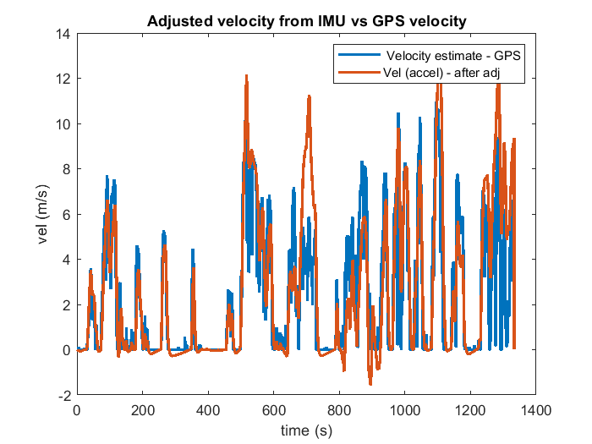

Figure

1. We can see that from the plot the discrepancies in velocity estimate between accel and GPS are seen in peaks and troughs. This may be due to error in accelerometer reading or calibration, due to bias or Cross-axis sensitivity that is when accelerations in one axis affect the output of another axis caused by misalignment of the sensor, that is the accelerometer registered some value when the car was stationary (mostly negative as we can see) and it overestimated velocity at peaks.

Figure

Figure

Figure

I think the plots mostly agree with each other. But there are some places that do not match completely. This may be caused due to the fact actual acceleration in Y – axis from accelerometer data contains bias and acceleration we compute (i.e., w*x’) uses the velocity values computed from data where bias is eliminated.

1. Trajectory of the vehicle - Plots

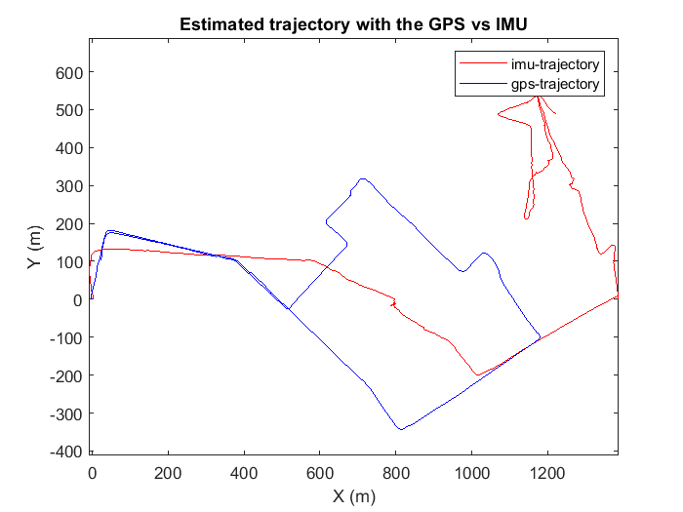

Figure

Added constants to Xe and Xn vectors to eliminate the offset from the plot

Xe = Xe + 1220;

Xn = Xn + 490;

1. In Fig 15 we can observe that there is an offset between the imu trajectory and gps trajectory plots.

Because the straight distance calculated using the IMU can be observed to be not reliable. This error in distance estimation shows up between all the turns resulting in the final location not matching the GPS trajectory. And we can see that as time goes the error in position increases. Thus, without a position fix, we cannot expect it to be able to navigate reliably. I think a position fix using GPS should be provided every 10 minutes for reliable navigation. This can vary based on application and the accuracy and availability of other sensors or information sources used in conjunction with the VectorNav

**Other Plots**

Figure