The following instructions may go under revision in the future.

If the android program you’re running is running correctly and you want to test it outside of an emulated environment, it may be time to test on a physical machine. Some models have shortcuts or built in drivers and tools to accelerate their individual download process, but the following guide is acceptable on all android platforms.

The following instructions are for Android 4.3, aka “Jellybean”, but should be similar instructions for all builds of Android.

Setting up an android device to work as a developer.

The first part of developing directly on an android phone or tablet is ensuring that your android device is capable of running and debugging non-authenticated applications (anything NOT from the Google Play Store, or in the event that the name has changed since this writing, the store Android distributes apps from). Go into “Security” and select the option “Unknown sources”. This will allow the Android device to run “Third Party” applications.

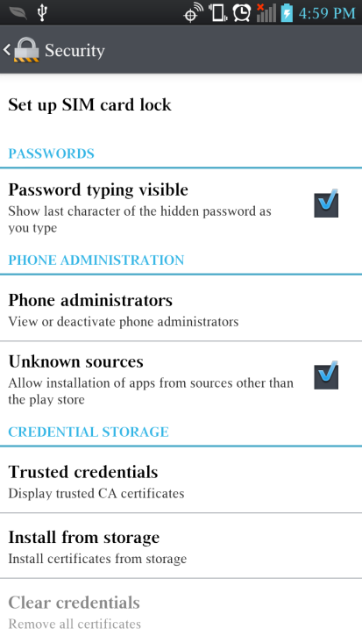

Next, you will want to ensure that the developer settings available to you are useful for the purpose of your application. Under “Settings”, find and open “Developer options”. You may want to view the list and tailor the options to the purposes of your app, but the settings you may want to start with are “USB Debugging” and “Stay awake”. Also make note of “Select Debug app”, as that will be how you apply the debugger to your application once installed.

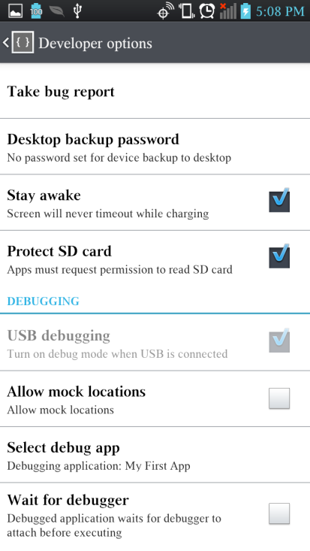

Next up is getting the application installer onto your android device. After every successful run of the program through Eclipse, a .apk file is generated and updated. If you haven’t seen .apk files before, they are what Android devices use to install programs onto your phone or tablet. If you haven’t changed it’s build location, they will more than likely be int the project folder’s bin, under <ProjectLocation>/bin/<ProjectName>.apk

To transfer it onto an android device,there are a few options, but the one you may want is to plug the Android phone or Tablet into your computer’s USB port, and directly copy the file onto your Android device. The actual location on the phone to save is unimportant, but it is important you remember where, and recommended that you keep it consistent for all manual .apk downloads. If there is no .apk file associated with your app, it means that there has not been a successful run of your app on the Android emulator through Eclipse.

Install and running the application on your phone or tablet

At this point, the .apk file should be accessible to your Android device. Using your preferred file system on the Android device, locate the .apk file for your application, and select it. If given the option, select the standard Package Installer. The install time can vary based on the size of the app, as well as anything else your phone may be doing, but once complete, you will be given the option to run your app. You can choose to do so if you wish, but you may wish to enable the debugger for your app first.

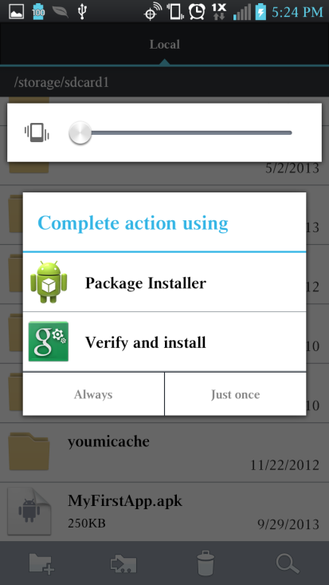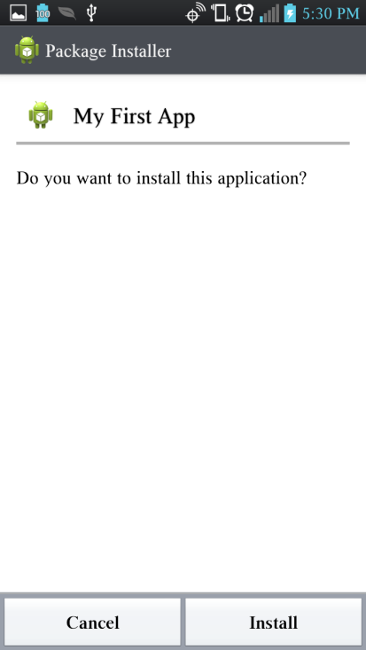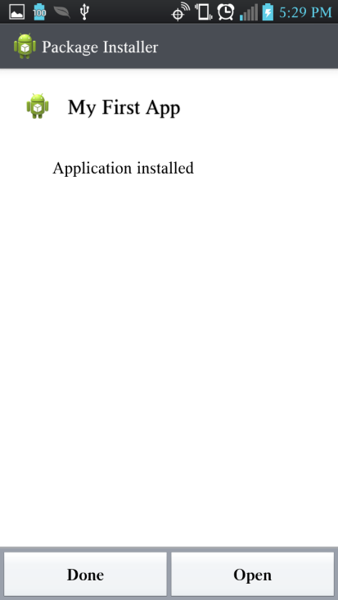

Return to the “Settings>Developer options” menu, and find and select “Select debug app”. A menu will pop up showing a list of all apps with debugging enabled (may include purchased apps). Only one at a time can be selected, so choose the app you are developing.



We’re almost done. All that’s left is to find and run your newly installed app. Simply go to your list of apps, find your newly installed app’s icon, and select it. If it runs, great! You can now test your app on physical hardware. And if it does not run, you can check the debugging settings and try some new setting combinations to see what went wrong.