***************************************************************************
Ex.no: 1 (b) Name: Lalima.R
Registration Form
Date: Rollno:25MCA013
***************************************************************************Aim:
To design a webpaged student administration registration form using HTML forms controls (Lables, Text box, List box, Radio buttons, Check box, Command button, Etc.,).
Procedure:
- Document Setup: Initialize the webpage using the <!DOCTYPE html> declaration and set the language to English (lang="en") within the <html> tag.
- Define Global Document Structure: Use a <center> tag to wrap the entire content for alignment, then place a <main> container and a thematic <section> to group the form elements.
- Add Header and Instructions: Create a <header> for the title and use the <details> and <summary> tags to provide collapsible instructions to the user.
- Set Up Interactive Form Logic: Initialize a <form> element with an oninput event attribute. This is the "brain" of the form that automatically updates the live preview by mapping input values (like fullname.value) to output names (like outName.value) as the user types.
- Organize Inputs with a Table: Use a <table> inside the form to align labels on the left and input fields on the right for a clean registration layout.
- Configure Specific Data Controls:
- Text & Datalist: Link a text input to a <datalist> to provide autocomplete suggestions for common names.
- Dropdown Categories: Use <optgroup> within a <select> element to group related departments like "Engineering".
- Visual Elements: Wrap the profile photo in a <figure> and use <figcaption> for the caption.
- Implement Progress and Metrics:
- Use the <progress> tag to show how much of the form is complete (e.g., 50%).
- Use the <meter> tag to display a scalar measurement for "Skill Level .
- Create the Live Preview: Outside the table but inside the form, add a <fieldset> containing <output> tags. These tags will dynamically display the user’s input data based on the logic.
- Finalize with Actions and Footer: Place "Submit" and "Reset" buttons at the end of the form, and add a <footer> with a small-print link for terms and conditions.
Coding:
<center>
<main><!-- 1. Main -->
<section style="font-family: Lucida; max-width: 650px; background-color: #f7f7f7; padding: 20px; border: 1px solid #ddd;">
<header><!-- 2. Header -->
<h2>Student Administration Registration</h2>
<details><!-- 3. Details -->
<summary>Click for instructions</summary><!-- 4. Summary -->
<p>Please fill out all <abbr title="Required">REQ</abbr> fields.</p><!-- 5. Abbr -->
</details>
</header>

<form oninput="outName.value=fullname.value; outEmail.value=email.value; outDept.value=dept.value; outGender.value=gender.value">
<table cellpadding="10" style="width: 100%; background: white; border-radius: 8px;">
<tr>
<td align="right"><label for="fullname">Full Name:</label></td>
<td>
<input type="text" id="fullname" name="fullname" list="name-suggestions" required>
<datalist id="name-suggestions"><!-- 6. Datalist -->
<option value="John Doe">
<option value="Jane Smith">
</datalist>
</td>
</tr>
<tr>
<td align="right">Profile Photo:</td>
<td>
<figure><!-- 7. Figure -->
<img src="https://via.placeholder.com" alt="Avatar">
<figcaption>Preview</figcaption><!-- 8. Figcaption -->
</figure>
</td>
</tr>
<tr>
<td align="right"><label for="dob">Date of Birth:</label></td>
<td><time datetime="2000-01-01"></time><input type="date" id="dob"></td><!-- 9. Time -->
</tr>
<tr>
<td align="right">Dept:</td>
<td>
<select id="dept" name="dept">
<optgroup label="Engineering"><!-- 10. Optgroup -->
<option value="Computer Science">Computer Science</option>
<option value="Electrical Engineering">Electrical Engineering</option>
</optgroup>
</select>
</td>
</tr>
<tr>
<td align="right">Bio:</td>
<td><textarea name="bio" placeholder="Tell us about yourself..."></textarea></td><!-- 11. Textarea -->
</tr>
<tr>
<td align="right">Skill Level:</td>
<td><meter value="0.6">60%</meter></td><!-- 12. Meter -->
</tr>
<tr>
<td align="right">Form Progress:</td>
<td><progress value="50" max="100"></progress></td><!-- 13. Progress -->
</tr>
<tr>
<td></td>
<td>
<button type="submit">Register Student</button>
<button type="reset">Clear Form</button>
</td>
</tr>
</table>

<fieldset style="margin-top: 20px; text-align: left; border: 2px solid #007bff;">
<legend><b>Live Preview</b></legend>
<p><strong>Name:</strong> <output name="outName">...</output></p>
<p><strong>Email:</strong> <output name="outEmail">...</output></p>
<p><strong>Dept:</strong> <output name="outDept">Computer Science</output></p>
</fieldset>
</form>

<footer style="margin-top:15px;"><!-- 14. Footer -->
<small>By registering, you agree to our <a href="#">Terms</a></small><!-- 15. a (Anchor) -->
</footer>
</section>
</main>
</center>

Output:

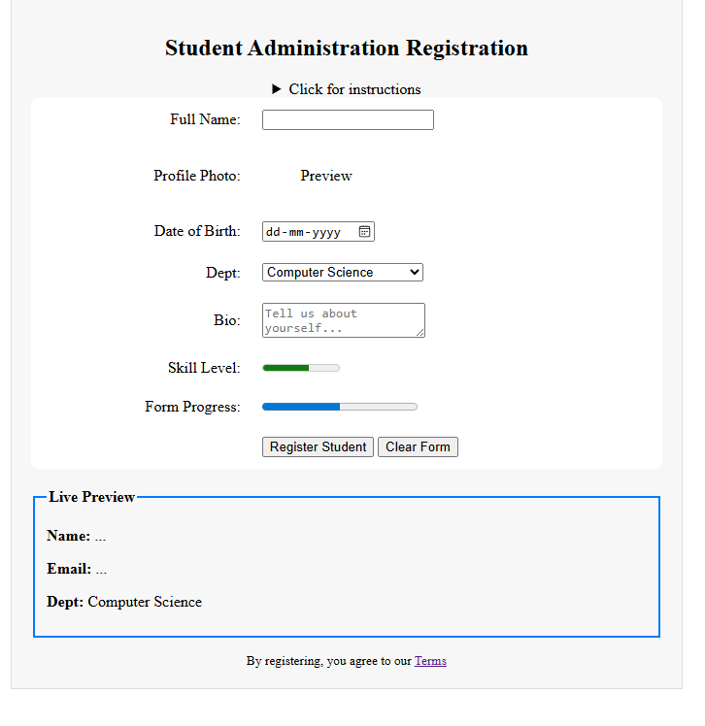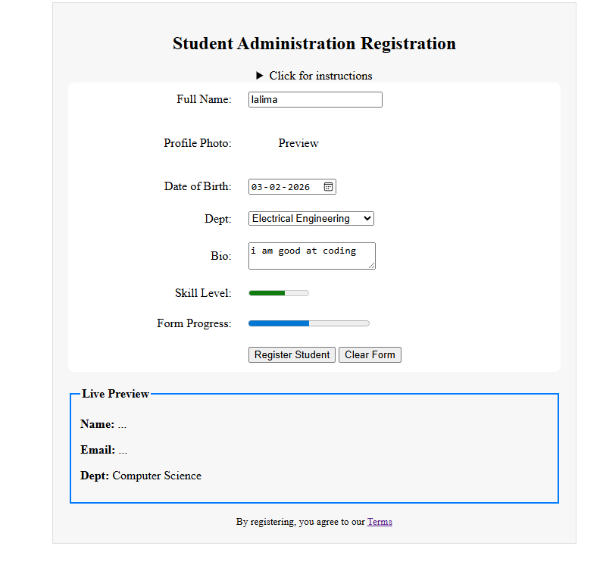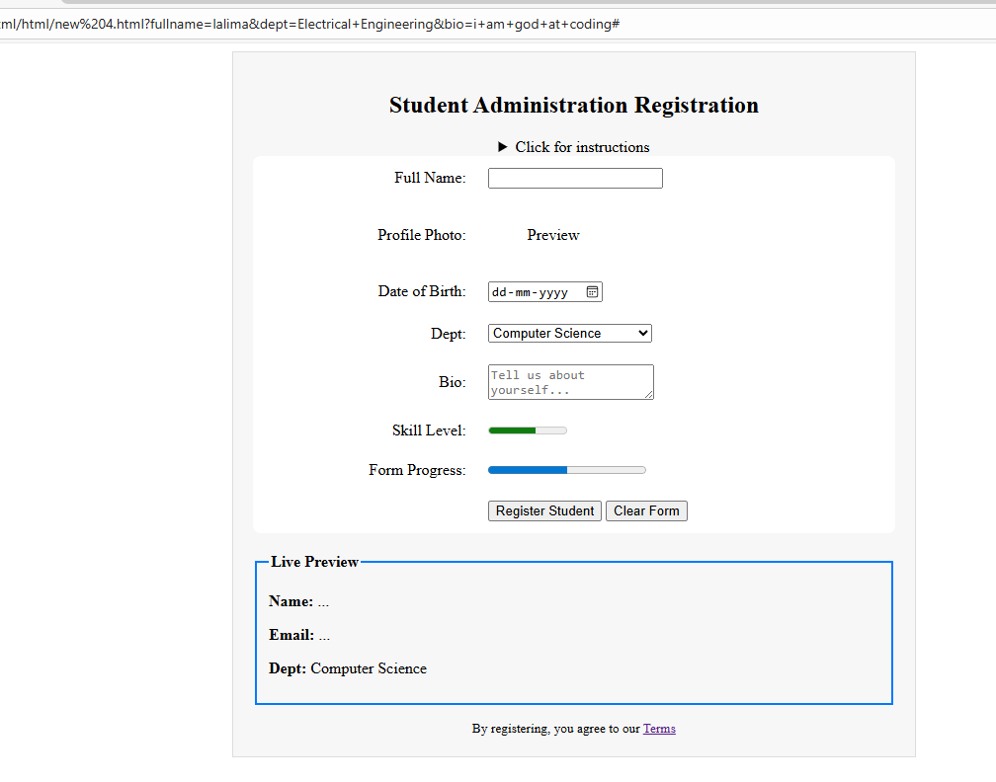

Result:
Thus, the Resume and Registration form using various html tags and controls was performed successfully and output was verified.

