***************************************************************************
Ex.no: 4 Name:Lalima.R
Implementing Star rating using JQuery
Date: Roll no:25MCA013
***************************************************************************
Aim:
To design and develop an interactive web-based quiz application using HTML, CSS, and JavaScript that displays multiple-choice questions, includes a timer and progress bar, and shows the final score in the form of a star rating.
Procedure:
- Create the basic structure of the webpage using HTML.
- Add a container (quiz-box) to display the quiz.
- Include elements for:
- Question
- Options
- Timer
- Progress bar
- Next button
- Design the user interface using CSS.
- Apply light theme styling.
- Style buttons, options, progress bar, and timer.
- Add hover effects and color changes for correct and wrong answers.
- Declare the quiz questions in JavaScript using an array of objects.
- Each object contains:
- Question
- Options
- Correct answer
- Create a function loadQuestion() to:
- Display the current question
- Dynamically generate options
- Reset the timer
- Update the progress bar
- Implement a timer using setInterval() to:
- Count down from 10 seconds
- Automatically move to the next question if time expires
- Add click event listeners to options to:
- Check whether the selected answer is correct
- Highlight correct answer in green
- Highlight wrong answer in red
- Increase score if correct
- Create a showResult() function to:
- Calculate total score
- Convert score into star rating (⭐)
- Display final result with restart button
- Test the application in a web browser to ensure:
- Questions load correctly
- Timer works
- Score updates properly
- Star rating displays correctly
Coding:
<!DOCTYPE html>
<html lang="en">
<head>
<meta charset="UTF-8">
<meta name="viewport" content="width=device-width, initial-scale=1.0">
<title>jQuery Coding Quiz</title>
<!-- jQuery CDN -->
<script src="https://code.jquery.com"></script>
<style>
:root {
--primary: #4a90e2;
--success: #2ecc71;
--error: #e74c3c;
--bg: #f4f7f6;
}
body { font-family: 'Segoe UI', sans-serif; background: var(--bg); display: flex; justify-content: center; align-items: center; height: 100vh; margin: 0; }
.quiz-box { background: white; width: 400px; padding: 25px; border-radius: 12px; box-shadow: 0 10px 25px rgba(0,0,0,0.1); text-align: center; }
.progress-container { background: #eee; height: 8px; border-radius: 4px; margin-bottom: 20px; overflow: hidden; }
#progress { background: var(--primary); height: 100%; width: 0%; transition: 0.3s; }
#timer { font-weight: bold; color: var(--error); margin-bottom: 15px; }
.option { background: #f8f9fa; border: 2px solid #ddd; padding: 12px; margin: 8px 0; border-radius: 8px; cursor: pointer; transition: 0.2s; }
.option:hover { background: #eef2f7; border-color: var(--primary); }
.correct { background: var(--success) !important; color: white; border-color: var(--success); }
.wrong { background: var(--error) !important; color: white; border-color: var(--error); }
button { background: var(--primary); color: white; border: none; padding: 10px 25px; border-radius: 6px; cursor: pointer; font-size: 16px; margin-top: 15px; }
button:hover { opacity: 0.9; }
</style>
</head>
<body>

<div class="quiz-box">
<div class="progress-container"><div id="progress"></div></div>
<div id="timer">Time Left: 10</div>
<h2 id="question">Loading...</h2>
<div id="options"></div>
<button id="nextBtn" style="display: none;">Next Question</button>
</div>

<script>
$(document).ready(function() {
var questions = [
{ question: "1. Which language is used for styling web pages?", options: ["HTML", "CSS", "Python", "C++"], answer: "CSS" },
{ question: "2. jQuery uses which symbol?", options: ["$", "#", "&", "@"], answer: "$" },
{ question: "3. Which tag is used for JavaScript?", options: ["<script>", "<js>", "<javascript>", "<code>"], answer: "<script>" },
{ question: "4. Who developed jQuery?", options: ["Google", "John Resig", "Microsoft", "Meta"], answer: "John Resig" },
{ question: "5. CSS stands for?", options: ["Cascading Style Sheets", "Creative Style Sheets", "Computer Style Sheets", "Colorful Style Sheets"], answer: "Cascading Style Sheets" }
];

var current = 0, score = 0, timer, timeLeft = 10;

function loadQuestion() {
timeLeft = 10;
$("#timer").text("Time Left: " + timeLeft);
$("#nextBtn").hide();

let q = questions[current];
$("#question").text(q.question);
$("#options").empty();

q.options.forEach(option => {
$("<div>").addClass("option").text(option).click(selectOption).appendTo("#options");
});

updateProgress();
startTimer();
}

function updateProgress() {
let percent = (current / questions.length) * 100;
$("#progress").css("width", percent + "%");
}

function startTimer() {
clearInterval(timer);
timer = setInterval(() => {
timeLeft--;
$("#timer").text("Time Left: " + timeLeft);
if(timeLeft <= 0) {
clearInterval(timer);
$("#nextBtn").show().trigger('click');
}
}, 1000);
}

function selectOption() {
clearInterval(timer);
let selected = $(this).text();
let correct = questions[current].answer;

$(".option").each(function() {
if ($(this).text() === correct) $(this).addClass("correct");
$(this).off("click"); // Disable clicking other options
});

if (selected !== correct) $(this).addClass("wrong");
else score++;

$("#nextBtn").fadeIn();
}

$("#nextBtn").click(function() {
current++;
if(current < questions.length) loadQuestion();
else showResult();
});

function showResult() {
let stars = "⭐".repeat(score) + "☆".repeat(5 - score);
$(".quiz-box").fadeOut(300, function() {
$(this).html(`
<h2>Quiz Completed!</h2>
<h1 style="color: gold; font-size: 50px;">${stars}</h1>
<p>You scored <strong>${score}</strong> out of ${questions.length}</p>
<button onclick="location.reload()">Restart Quiz</button>
`).fadeIn();
});
}

loadQuestion();
});
</script>

</body>
</html>

Output:

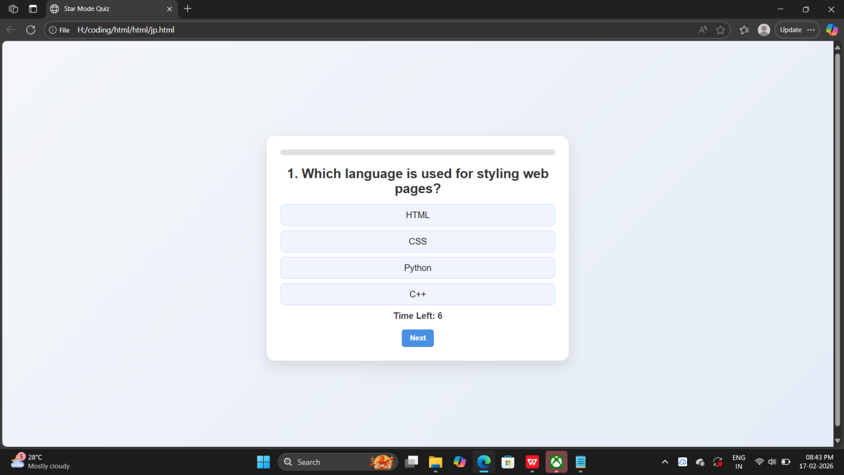

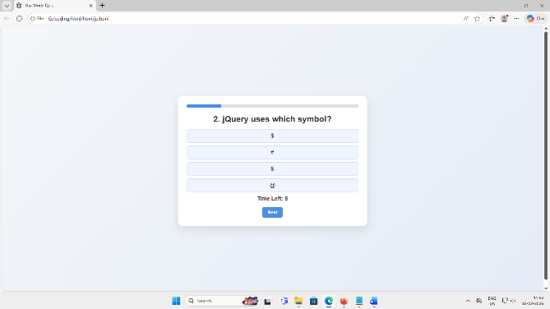

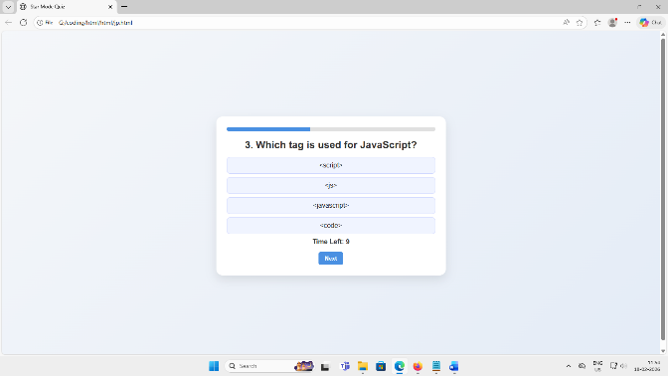
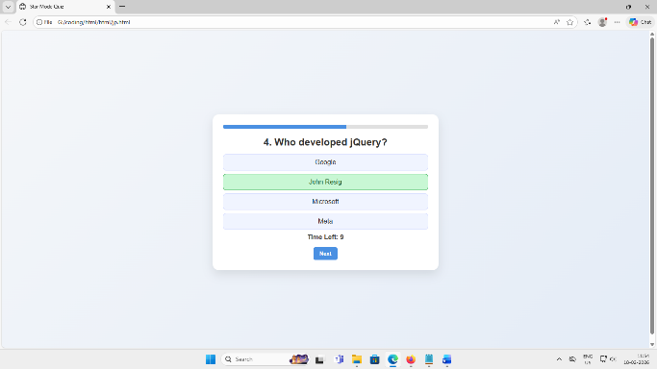

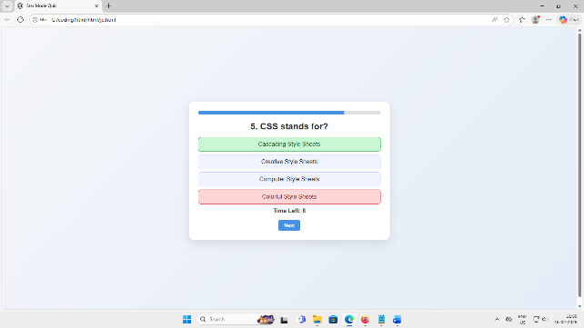

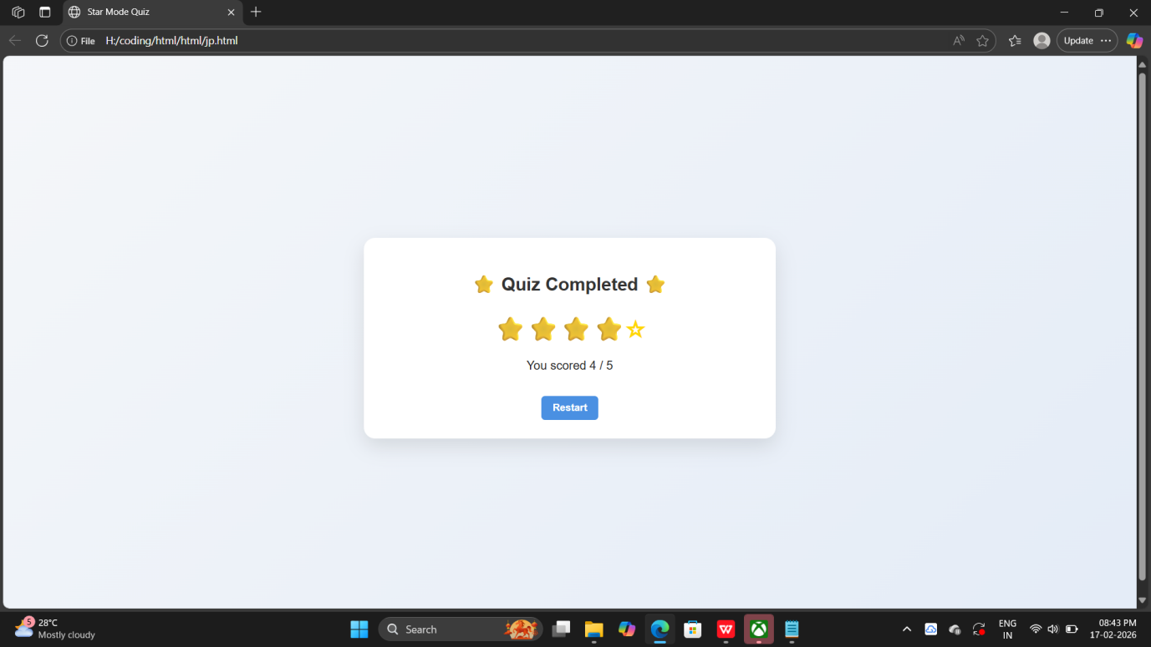

Result:
Thus, The Star Mode Quiz Web Application was successfully developed and verified.
The application displays questions with multiple options, includes a countdown timer, tracks progress, and shows the final score in the form of a star rating system. The quiz works interactively and resets properly after completion.

