***************************************************************************
Ex.no: 3b) Name:Lalima.R
Data Structure and Its Operations
Date: Roll no:25MCA013
***************************************************************************
Aim:
To implement a Singly Linked List using JavaScript and perform the following operations:Insertion at Beginning, Insertion at Middle, Insertion at End, Deletion at Beginning, Deletion at Middle, Deletion at End, Traversal (Display) of the Linked List, Apply a user-defined size limit to control the number of node.
Procedure:
- Start the program and design the user interface using HTML and CSS.
- Create a class Node with two attributes:
- data to store the value
- next to store the reference of the next node
- Initialize the head pointer as null to indicate an empty list.
- Accept the maximum size from the user and store it in a variable MAX_LIMIT.
- Before inserting a node, check whether the list has reached the maximum limit using the isFull() function.
- For Insertion at Beginning:
- Create a new node.
- Make its next point to the current head.
- Update head to the new node.
- For Insertion at End:
- Traverse the list until the last node.
- Make the last node’s next point to the new node.
- For Insertion at Middle:
- Use two pointers (slow and fast).
- Move fast pointer two steps and slow pointer one step.
- Insert the new node at the middle position.
- For Deletion at Beginning:
- Move head to head.next.

- For Deletion at End:
- Traverse to the second-last node.
- Set its next to null.
- For Deletion at Middle:
- Use slow and fast pointers to find the middle.
- Adjust links to remove the middle node.
- Traverse the list and display each node followed by NULL.
- Display the current size and maximum size to the user.
- End the program.
窗体底端
Coding:
<!DOCTYPE html>
<html>
<head>
<style>
body {
font-family: 'Segoe UI', Tahoma, Geneva, Verdana, sans-serif;
background-color: #f4f7f6;
display: flex;
flex-direction: column;
align-items: center;
padding-top: 50px;
}
.container {
background: white;
padding: 2rem;
border-radius: 12px;
box-shadow: 0 4px 6px rgba(0,0,0,0.1);
text-align: center;
margin-bottom: 20px;
}
input {
padding: 10px;
border: 2px solid #ddd;
border-radius: 6px;
margin: 5px;
outline: none;
}
button {
padding: 10px 20px;
margin: 5px;
border: none;
border-radius: 6px;
cursor: pointer;
font-weight: bold;
}
.btn-insert { background-color: #2ecc71; color: white; }
.btn-delete { background-color: #e74c3c; color: white; }
.btn-display { background-color: #3498db; color: white; }
button:hover { opacity: 0.8; }

#output {
margin-top: 30px;
display: flex;
flex-wrap: wrap;
justify-content: center;
align-items: center;
gap: 10px;
}
.node {
background: #34495e;
color: white;
padding: 15px 20px;
border-radius: 8px;
font-family: monospace;
}
.arrow { color: #7f8c8d; font-size: 24px; }
.null-node { color: #95a5a6; font-style: italic; }

#sizeInfo {
margin-top: 10px;
font-weight: bold;
color: #555;
}
</style>
</head>

<body>

<div class="container">
<h2>Singly Linked List (With Limit)</h2>

<!-- Limit Section -->
<input type="number" id="val" placeholder="Enter max size">
<button onclick="setLimit()">Set Limit</button>

<div id="sizeInfo">Size: 0 / Not Set</div>

<hr>

<!-- Value Section -->
<input type="number" id="value" placeholder="Enter value">
<br>

<button class="btn-insert" onclick="insertbegin()">Insert Begin</button>
<button class="btn-insert" onclick="insertmiddle()">Insert Middle</button>
<button class="btn-insert" onclick="insertend()">Insert End</button>
<br>
<button class="btn-delete" onclick="deletebegin()">Delete Begin</button>
<button class="btn-delete" onclick="deletemiddle()">Delete Middle</button>
<button class="btn-delete" onclick="deleteLast()">Delete End</button>
<br>
<button class="btn-display" onclick="displayList()">Display</button>

<div id="output"></div>
</div>

<script>
class Node {
constructor(data) {
this.data = data;
this.next = null;
}
}

let head = null;
let MAX_LIMIT = 0;
function setLimit() {
let sizeInput = document.getElementById("val");
let size = parseInt(sizeInput.value);

if (isNaN(size) || size <= 0) {
alert("Please enter a valid size!");
return;
}

MAX_LIMIT = size;
updateSizeInfo();
alert("Maximum size set to " + MAX_LIMIT);
}
function getSize() {
let count = 0;
let temp = head;
while (temp !== null) {
count++;
temp = temp.next;
}
return count;
}

function isFull() {
if (MAX_LIMIT === 0) {
alert("Please set the size first!");
return true;
}
return getSize() >= MAX_LIMIT;
}

function updateSizeInfo() {
let sizeInfo = document.getElementById("sizeInfo");
let currentSize = getSize();

if (MAX_LIMIT === 0) {
sizeInfo.innerText = "Size: 0 / Not Set";
} else {
sizeInfo.innerText = "Size: " + currentSize + " / " + MAX_LIMIT;
}
}
function insertbegin() {
let input = document.getElementById("value");
let val = input.value;

if (val === "") return;
if (isFull()) return;

let newNode = new Node(val);
newNode.next = head;
head = newNode;

input.value = "";
displayList();
}

function insertend() {
let input = document.getElementById("value");
let val = input.value;

if (val === "") return;
if (isFull()) return;

let newNode = new Node(val);

if (head === null) {
head = newNode;
} else {
let temp = head;
while (temp.next !== null) {
temp = temp.next;
}
temp.next = newNode;
}
input.value = "";
displayList();
}

function insertmiddle() {
let input = document.getElementById("value");
let val = input.value;

if (val === "") return;
if (isFull()) return;

let newNode = new Node(val);

if (head === null) {
head = newNode;
} else if (head.next === null) {
head.next = newNode;
} else {
let slow = head;
let fast = head;
let prev = null;

while (fast !== null && fast.next !== null) {
fast = fast.next.next;
prev = slow;
slow = slow.next;
}

newNode.next = slow;
prev.next = newNode;
}

input.value = "";
displayList();
}
function deletebegin() {
if (head === null) return;

head = head.next;
displayList();
}

function deleteLast() {
if (head === null) return;

if (head.next === null) {
head = null;
} else {
let temp = head;
while (temp.next.next !== null) {
temp = temp.next;
}
temp.next = null;
}

displayList();
}

function deletemiddle() {
if (head === null) return;

if (head.next === null) {
head = null;
} else {
let slow = head;
let fast = head;
let prev = null;

while (fast !== null && fast.next !== null) {
fast = fast.next.next;
prev = slow;
slow = slow.next;
}

prev.next = slow.next;
}

displayList();
}
function displayList() {
const output = document.getElementById("output");
output.innerHTML = "";

if (head === null) {
output.innerHTML = "<p style='color:#95a5a6;'>List is currently empty</p>";
updateSizeInfo();
return;
}
let temp = head;
while (temp !== null) {
let nodeDiv = document.createElement("div");
nodeDiv.className = "node";
nodeDiv.innerText = temp.data;
output.appendChild(nodeDiv);

let arrow = document.createElement("span");
arrow.className = "arrow";
arrow.innerText = "→";
output.appendChild(arrow);
temp = temp.next;
}
let nullLabel = document.createElement("span");
nullLabel.className = "null-node";
nullLabel.innerText = "NULL";
output.appendChild(nullLabel);
updateSizeInfo();
}
displayList();
</script>
</body>
</html>
Output:

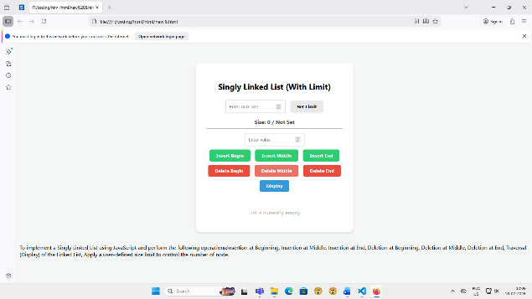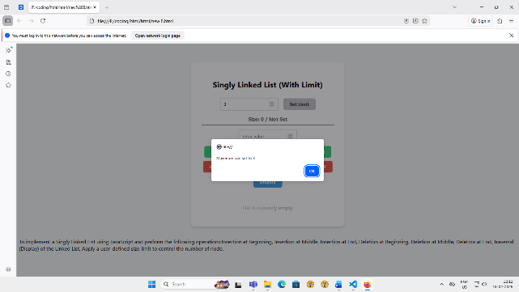

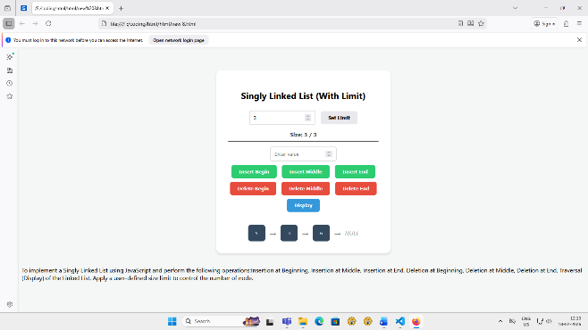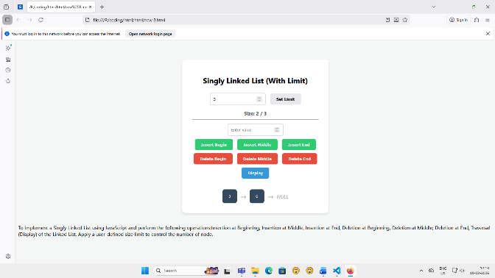

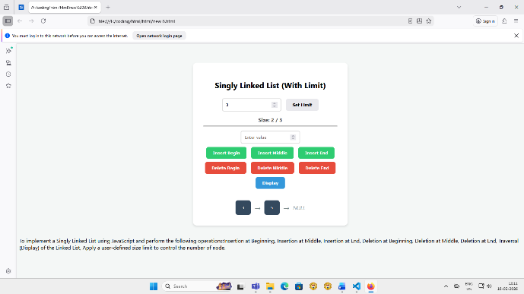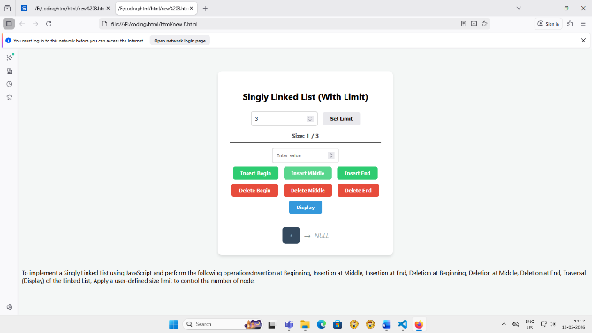

Result:
Thus, The calculator and data structures (Singly linked list) was successfully developed and verified.The application Insertion at Beginning, Insertion at Middle, Insertion at End, Deletion at Beginning, Deletion at Middle, Deletion at End, Traversal (Display) of the Linked List, Apply a user-defined size limit to control the number of node.

