Driver Installation steps

SPD Driver
- Select SPD_Driver_R4.20.4201 folder.
- Go to SPD_Driver_R4.20.4201>Win10>DriverSetup
- Install the Driver.
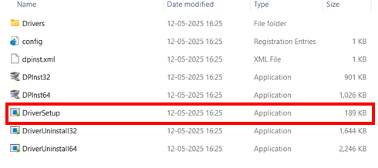
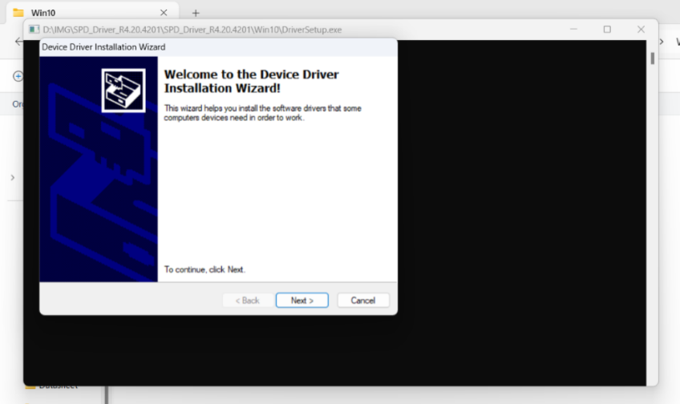
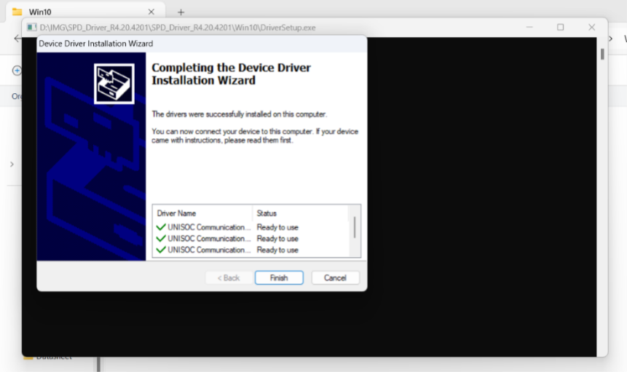

N58 Signed Driver
- Connect the N58 USB in your device.
- Open Device Manager.
- Select N58 General Serial Port (it will have error icon)
- Select “Change Setting” option.
- Upgrade the Driver by choosing manual path.
- Insert Path:
D:\IMG_JIG_450_NOS\Prerequisites\Drivers\Neoway_N58_Signed Drivers\Windows10

J-Link Driver
While installing J-link software, check the driver box as shown below:
