**Normalization**

**Definition :**

Normalization is a systematic approach of decomposing tables to eliminate data redundancy (repetition) and undesirable characteristics like insertion, update and delete anomalies (errors). It is a multi-Step process that puts data into tabular form by removing duplicated data from the relation tables.

* Normalization is the process of organizing the data in the database.
* Normalization is used to minimize the redundancy from a relation or set of relations. It is also used to eliminate undesirable characteristics like Insertion, Update, and Deletion Anomalies.
* Normalization divides the larger table into smaller and links them using relationships.
* The normal form is used to reduce redundancy from the database table.

**Types of normal form**

**First Normal Form(1NF) :** A relation will be 1NF if it contains an atomic value and distinct (unique) values.

**Second Normal Form(2NF) :** In the second normal form, all non-key attributes are fully functional dependent on the primary key.

**Third Normal Form(3NF) :** In 3NF there is no transitive dependency for non-prime attributes.

**Examples**

**1.First Normal Form(1NF) :** First normal form is a property of a relation in a relational database. A relation is in first normal form if and only if no attribute domain has relations as elements. Or more informally, that no table column can have tables as values.

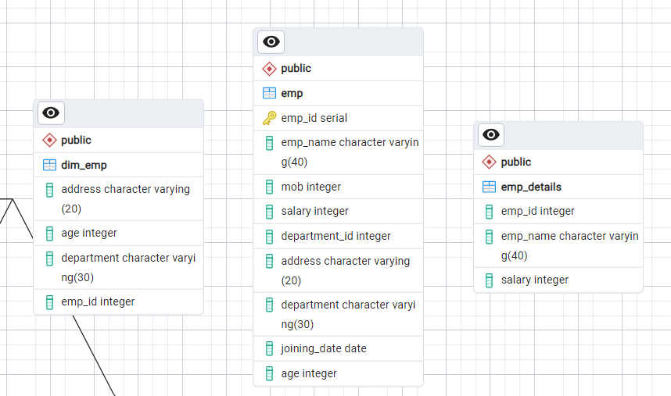

**2.Second Normal Form(2NF) :** The second Normal Form applies to relations with composite keys, that is, relations with a primary key composed of two or more attributes. A relation with a single-attribute primary key is automatically in at least 2NF. A relation that is not in 2NF may suffer from the update anomalies. To be in the second normal form, a relation must be in the first normal form and the relation must not contain any partial dependency. A relation is in 2NF if it has No Partial Dependency, i.e., no non-prime attribute (attributes that are not part of any candidate key) is dependent on any proper subset of any candidate key of the table.

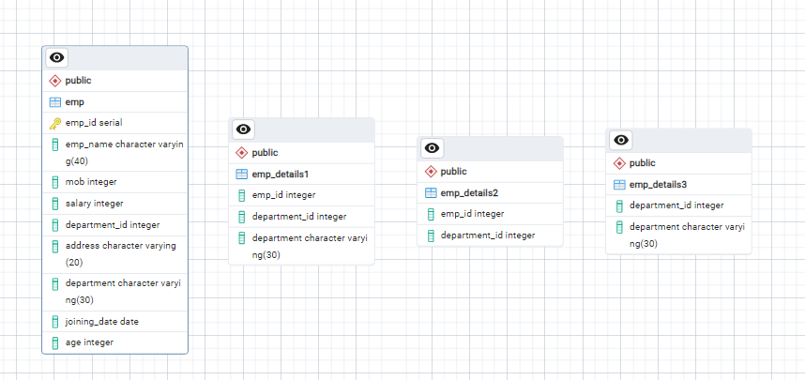

**3. Third Normal Form(3NF) :** A relation is in the third normal form, if there is no transitive dependency for non-prime attributes as well as it is in the second normal form. A relation is in 3NF if at least one of the following conditions holds inery non-trivial function dependency X -> Y.

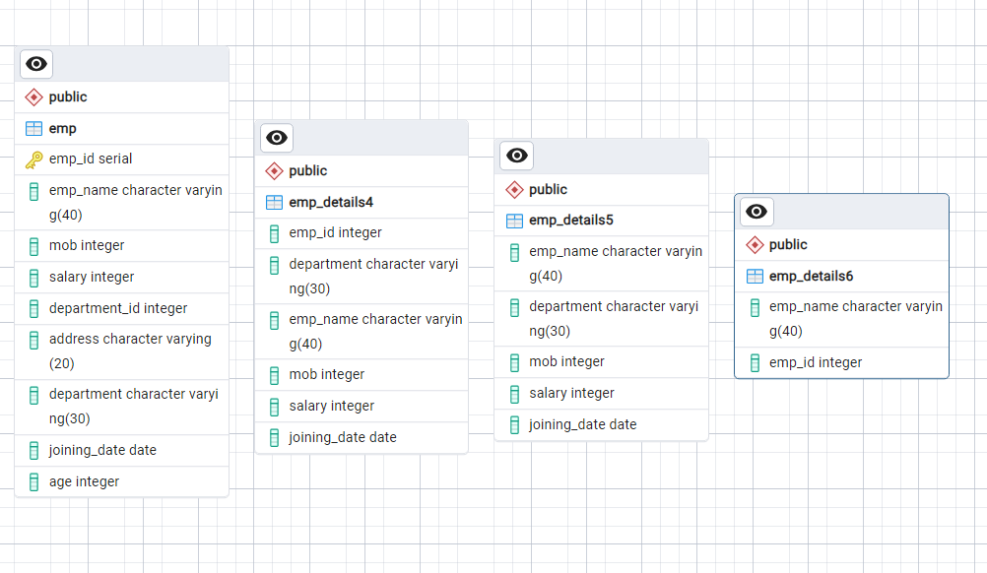

* X