

**Introduction:**

**InteGrids** is a hardware automation software that provides features to communicate with any hardware, automate a combination of hardware to work together by using custom logics via **InteGrids** **Tools**.

**Main Window (Landing screen):**

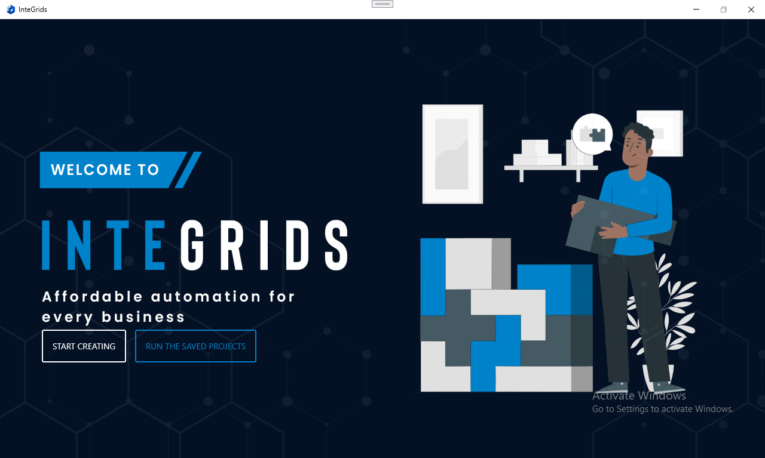

**START CREATING:** Click here to create your own custom logics (Projects) and save the projects to use later.

Image 1.0

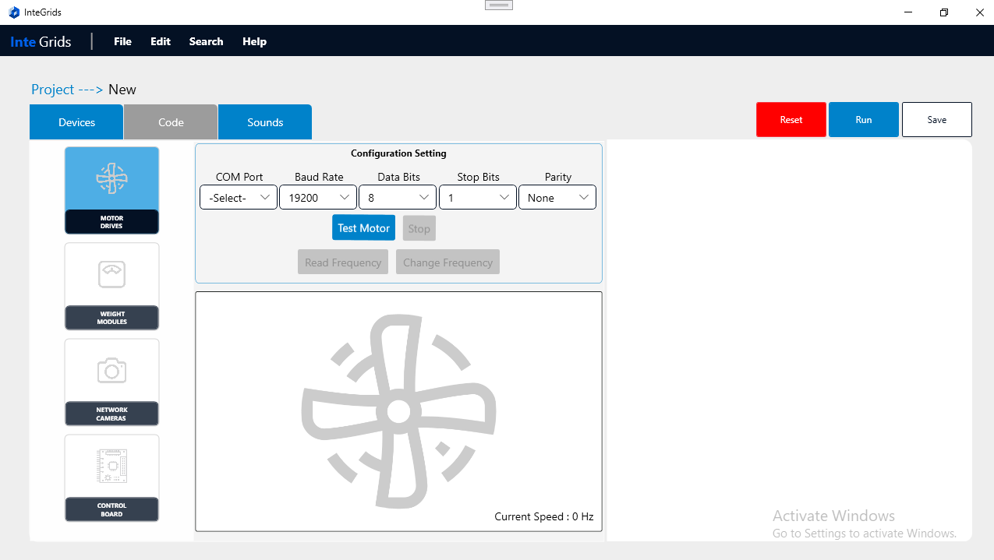  
  
Once clicked **START CREATING** button that user will be redirected a new screen (Design Mode) as you can see in the image 1.0.

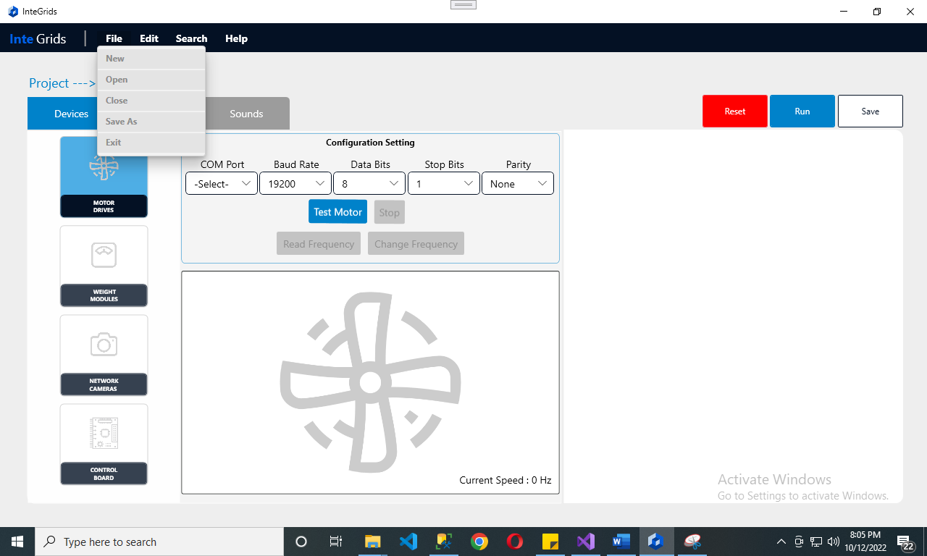

Image 1.1  
  
Here, we have a basic menu function as shown in image 1.1 and the description is given below:  
  
**File:**  
  
**NEW:** After clicking on this, application will reset all you work with new window.

OPEN: After clicking on this, a pop-up window will appear with a list of already saved project templates. User can click on any of them to open the templates.

Save As: After clicking on this, User will be able to save a template created with a name.

Close: This is used to close the designing mode and go back to main screen.

Exit: It can be used to completely exit from the application.

**Edit, Search, Help are under development.**

Image 1.2

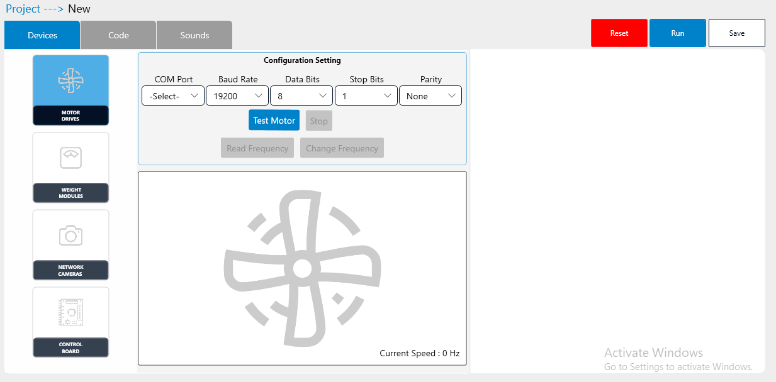

As you can see in the image 1.2, This is design mode having 3 tabs such as Devices, Code, Sounds.  
  
**Devices:** Devices area currently has test area to test communication and response of 4 specific devices, for i.e., Motor Drive, Weight, Network Camera’s, Control Card.

User can test Motor drive, Weighing Device, Control board using configuration settings of each Module as shown in the image given below:

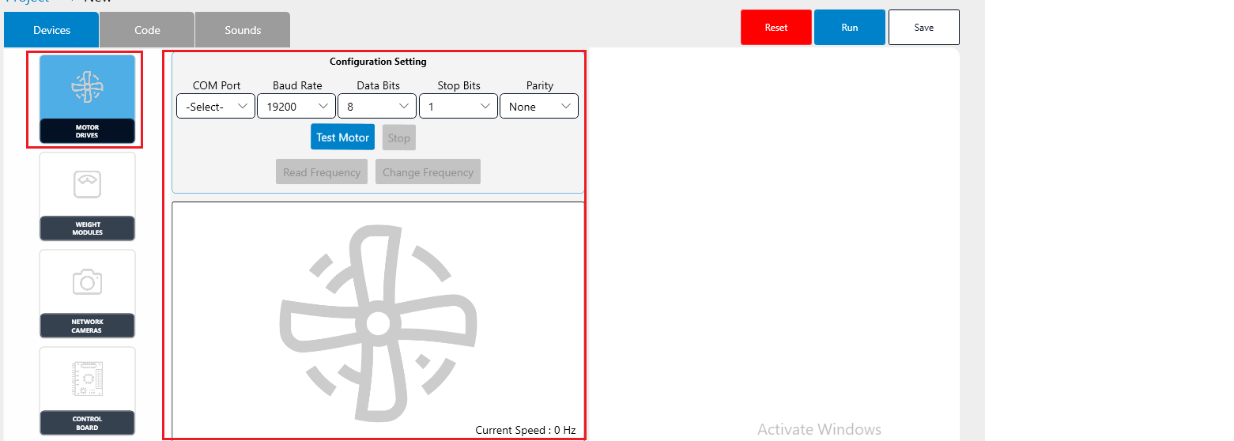

Image 1.3

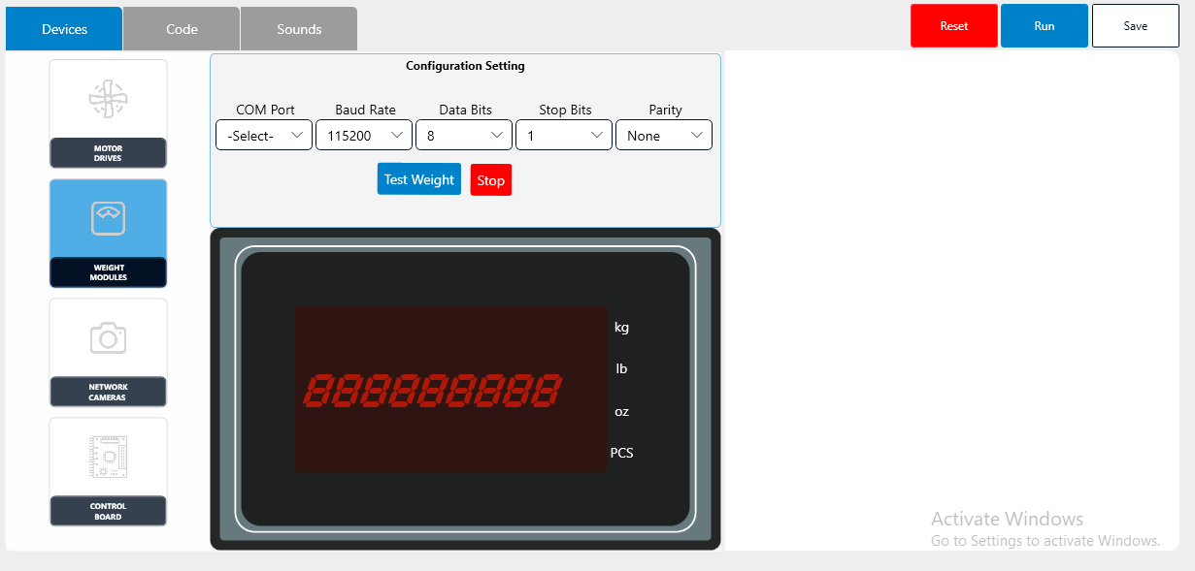

Image 1.4

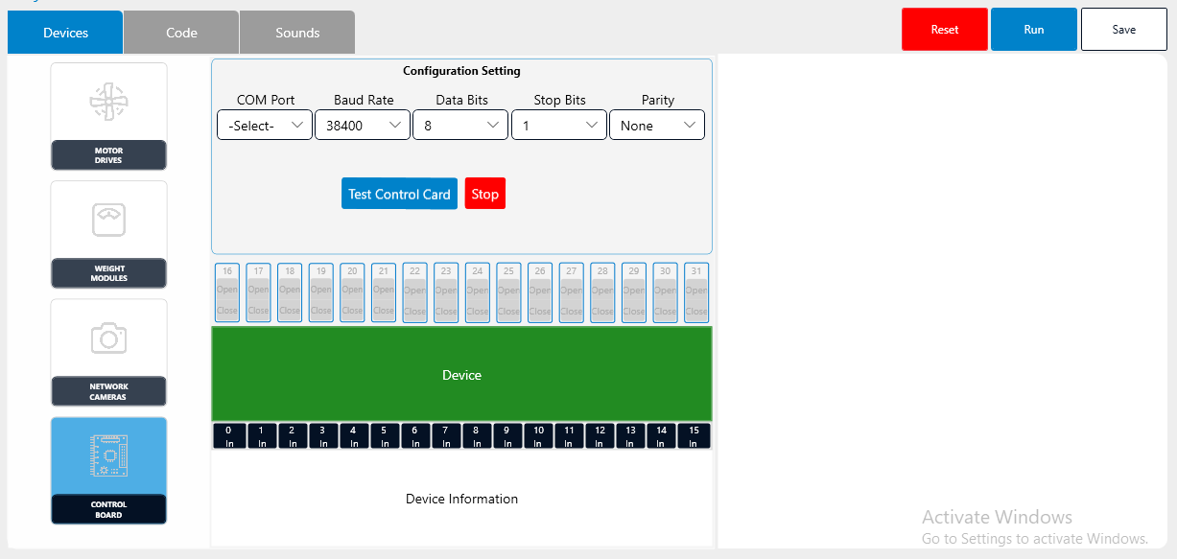

Image 1.5

In Network Camera Area, user can discover network camera/usb camera and test.  
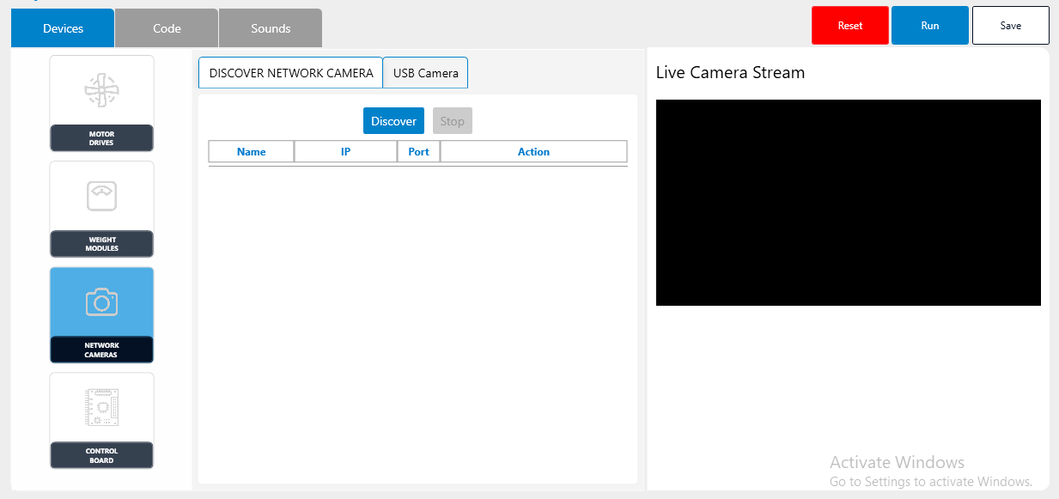

Image 1.6

**Code**: In this section, user can create logics using the controls on the left side to connect/send/receive data with hardware devices (MODBUS, URT) or can turn on/off camera recording as shown in image below:  
  
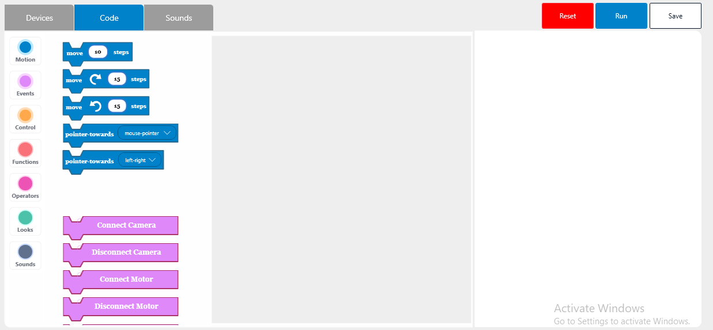

Image 1.7

Notes: Motion Controls are under development so can not be used for now.  
  
**Event controls**: These controls (Pink color) can be used to instantiate communication between devices/Camera.  
  
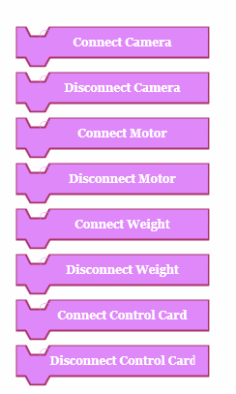Image 1.8  
  
**Controls**: Orange color controls can be used set conditional logic and scope of the logics.  
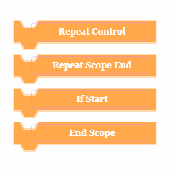

**Function Controls**: These controls can be used read response received from any connected device or send command to devices.  
  
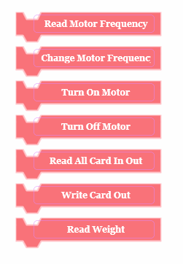

1. Read Motor Frequency: This is used to read motor frequency of a connected motor.
2. Change Motor Frequency: This is used to modify motor frequency.
3. Turn On Motor: Under development.
4. Turn Off Motor: Under development.
5. Read All Card In Out: This is used to read all the I/O register status.
6. Write Card Out: This is used to write a register.

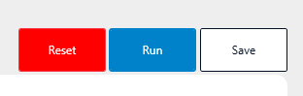

Reset button is used to reset the logic area.

Save is used to save the logics created as a template to re-user.

Run button is used to run the logic created in the code section. Once click then it will activate the HMI Mode with the existing used logics.  
  
**HMI Mode**:  
  
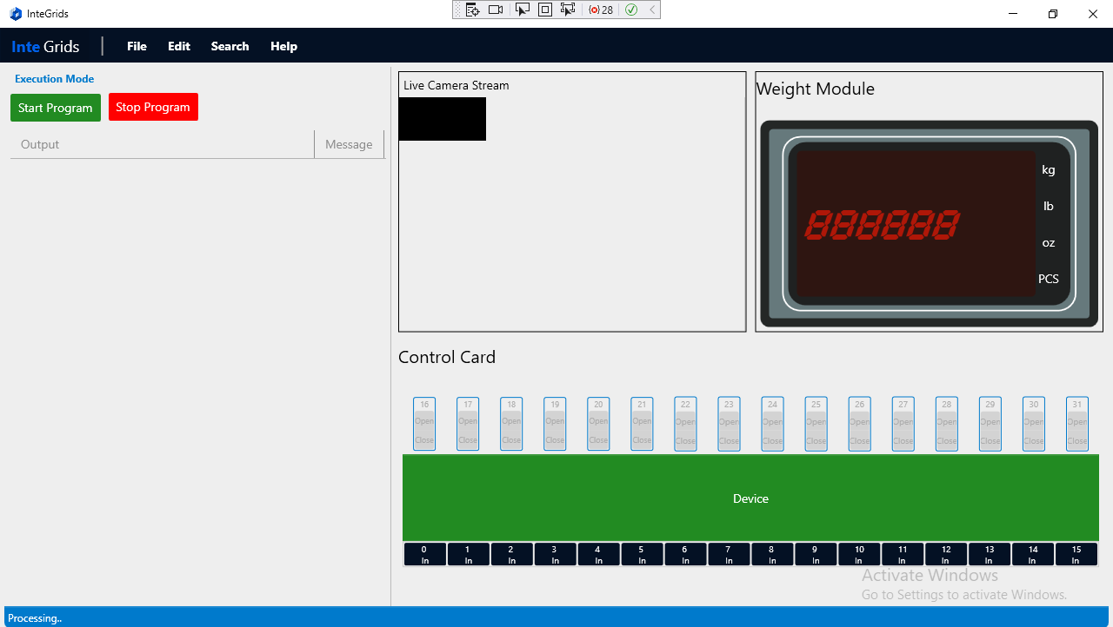

On HMI Mode, User can see all the devices that he has added using the Event Controls and can start/stop executing the logics created.

**RUN THE SAVED PROJECTS:** Click here If you already have saved projects to run.