1. **Create a API that can show the list of students from the same major and only the login’s user can call this API.**

**Request Message**

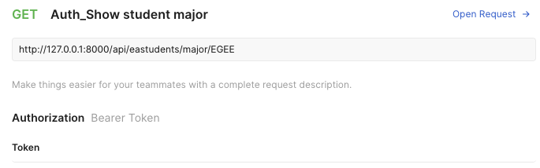

**Response Message**

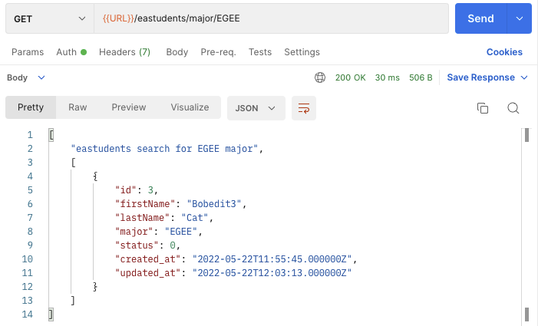

**Validation: The size of {major} parameter must be equal to 4 characters**

**Response Message: {major} < 4**

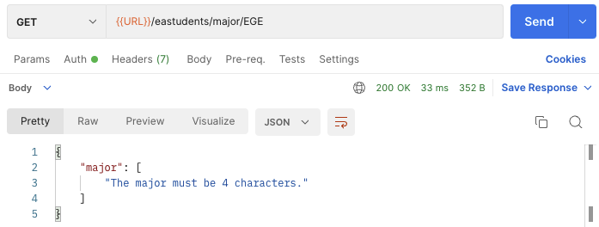

**Response Message: : {major} > 4**

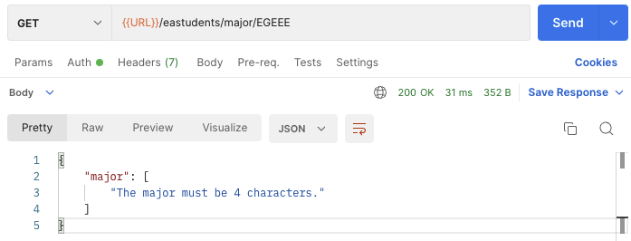

1. **Create a API that can show the list of students from the same faculty and only the login’s user can call this API.**

**Request Message**

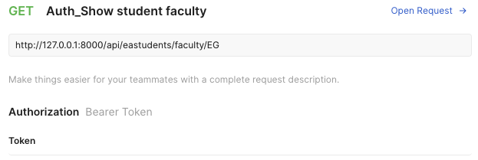

**Response Message**

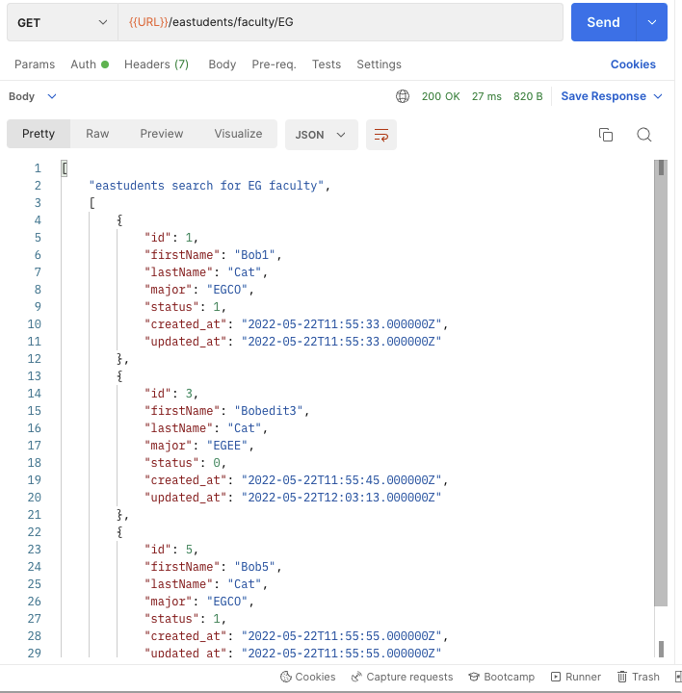

**Validation: The size of {faculty} parameter must be equal to 2 characters.**

**Response Message: {faculty} < 2**

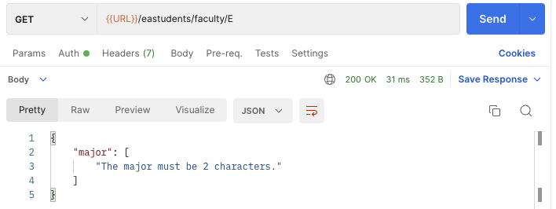

**Response Message: : {major} > 2**

