PIScanner: A Cost-Aware, Judge-Validated Framework for Automated Prompt-Injection Testing of Deployed LLM Chatbots
Lalit Bist*, [Co-author 2], [Co-author 3], [Faculty Guide]
Master of Computer Applications (MCA), [Institution]
*Corresponding author: lalitbist.edu@gmail.com
Abstract—Large Language Model (LLM) chatbots are now embedded across customer support, education, and enterprise workflows, yet they remain highly susceptible to prompt-injection attacks — ranked the number-one risk in the OWASP Top 10 for LLM Applications. Existing red-teaming tools largely probe raw models or APIs and seldom test the chatbot as an end user actually experiences it, nor do they quantify how reliable their own success-detection is. This paper presents PIScanner, an open-source framework that automates black-box prompt-injection testing of deployed LLM chatbots. PIScanner provides a curated library of more than 120 attack payloads spanning seven categories — direct override, role hijacking, encoding obfuscation, system-prompt extraction, indirect/RAG injection, agentic data-exfiltration, and multi-turn conversational attacks — and can target local models, JSON chat APIs, and live JavaScript chat widgets through browser automation. Its central contribution is a cost-aware detection cascade: inexpensive compliance-aware keyword and semantic-similarity layers screen every response, while an LLM-as-judge establishes ground truth so that the precision and recall of the cheap detectors can be measured rather than assumed. We evaluate PIScanner against four chatbots of increasing robustness and show that overall attack-success rate ranges from 53.6% for a deliberately-vulnerable baseline to 0.8% for a production-style deployed assistant, with zero false positives on benign controls throughout. PIScanner and its accompanying dataset are released as open source to support reproducible LLM-security research.
Keywords—Prompt Injection; Large Language Models; AI Security; LLM Red-Teaming; Chatbot Vulnerability; Responsible Disclosure
I. Introduction
Large Language Models (LLMs) have moved rapidly from research artifacts to production components, powering conversational assistants in customer support, education, healthcare triage, and internal enterprise tooling. These systems are typically deployed by wrapping a base model with a developer-authored system prompt that encodes a persona, a knowledge base, and a set of behavioral guardrails. Because the model processes trusted developer instructions and untrusted user input within the same undifferentiated context window, an adversary can craft input that overrides the developer's intent. This class of attack, known as prompt injection, is ranked LLM01 — the single highest risk — in the OWASP Top 10 for LLM Applications.
Prompt injection is not a hypothetical concern. A successful attack can cause a customer-support bot to abandon its persona, disclose its confidential system prompt, follow instructions embedded in retrieved documents, or exfiltrate data through tool calls. Yet the practice of testing deployed chatbots for these weaknesses remains immature. Most publicly available red-teaming utilities target a raw model endpoint or a bare API, whereas real users interact with a chatbot through a JavaScript widget layered over additional server-side filtering, retrieval, and orchestration. A tool that only probes the underlying model does not measure the security posture of the system that is actually exposed to attackers.
A second, subtler problem is measurement validity. Deciding whether an attack succeeded is itself a classification task: a response may contain attack-related vocabulary while in fact refusing the request, or may comply with a persona hijack without emitting any characteristic keyword. Tools that score success with naive string matching therefore produce both false positives (counting refusals as compromises) and false negatives (missing subtle compliance). Few tools quantify the reliability of their own detector, leaving reported vulnerability rates difficult to trust.
This paper addresses both gaps with PIScanner, an open-source framework for automated, black-box prompt-injection testing of deployed LLM chatbots. Our contributions are: (1) a curated, categorized payload library of more than 120 attacks across seven injection strategies, together with benign controls; (2) a probing engine that reaches local models, JSON chat APIs, and live browser chat widgets via automation, so the chatbot is tested as an end user experiences it; (3) a cost-aware detection cascade whose cheap layers are compliance-aware and whose ground truth is supplied by an LLM-as-judge, enabling the cheap layers' precision and recall to be measured; and (4) a cross-target empirical study of four chatbots showing that attack-success rate varies by nearly two orders of magnitude with model capability and guardrail design.
II. Related Work
Prompt injection was popularized as a practical threat by early demonstrations that appended instructions such as "ignore the above and…" to user input, and was systematized by Perez and Ribeiro, who distinguished goal hijacking from prompt leaking. Greshake et al. subsequently introduced indirect prompt injection, in which the malicious instruction is planted in external content — a web page or a document — that the model later ingests through retrieval, expanding the attack surface well beyond the direct user channel. Liu et al. and others have since proposed formalizations and benchmark suites for evaluating injection robustness.
On the defensive and evaluation side, the OWASP Top 10 for LLM Applications codifies prompt injection as LLM01 and catalogues mitigations, while red-teaming frameworks and jailbreak collections provide payload corpora. However, two limitations recur. First, most tooling evaluates models or APIs directly rather than the fully deployed chatbot, omitting the widget, session handling, and server-side filtering that shape real-world exposure. Second, success is frequently scored by keyword or regular-expression matching without validation, so the error rate of the scoring mechanism itself is unknown. PIScanner is designed specifically to close these two gaps: it can drive a live chat widget through browser automation, and it treats detection as a measured classification problem validated against an LLM judge.
III. Threat Model
We consider a black-box external attacker who interacts with a deployed LLM chatbot solely through its natural-language interface. The attacker cannot observe or modify the model weights, the system prompt, or any server-side configuration; they can only submit user messages and observe the resulting responses. The attacker's objective is prompt injection: to supply input that overrides the developer's intended instructions, causing the model to disregard its constraints, adopt an unauthorized persona, disclose privileged information such as its system prompt, or otherwise act against its deployment policy. This threat model reflects the position of a real adversary probing a production chatbot, and it deliberately excludes white-box and training-time attacks, which are out of scope. All testing in this study is performed against targets owned or controlled by the authors.
IV. PIScanner Design
A. System overview
PIScanner is a command-line tool that automates black-box prompt-injection testing and produces a labeled dataset of attacks and model responses. The pipeline comprises four stages: a curated payload library, an asynchronous probing engine that can reach live chat widgets, a layered detection cascade, and an LLM-based validation judge. Results are persisted to JSON and a local store, and a report generator renders a shareable HTML or PDF findings report.
B. Payload taxonomy
The payload library organizes more than 120 adversarial prompts into seven categories corresponding to distinct injection strategies. Direct payloads override instructions explicitly through the user message. Role payloads hijack the model's identity by assigning an unrestricted or malicious persona. Encoding payloads obfuscate the malicious instruction using Base64, ROT13, or leetspeak to evade surface filters. Extraction payloads seek to elicit the hidden system prompt. Indirect payloads simulate injection through retrieved or embedded content, as in a retrieval-augmented generation setting. Agentic payloads attempt to trigger unauthorized tool use or data exfiltration. Multi-turn payloads spread the attack across several conversational turns to defeat single-message filtering. The library additionally includes benign prompts as negative controls for false-positive measurement. Each payload carries a unique identifier, its category, and its source, enabling per-category analysis.
C. Probing engine and browser automation
The probing engine dispatches every payload to a target chatbot and records the response text, HTTP status, and latency. Requests are issued asynchronously with a configurable concurrency limit, with retry and a rate-limiting option. Three target modes are supported: a local open-weight model served through Ollama; any JSON chat API through a configurable target adapter that maps request and response fields; and — critically — a live JavaScript chat widget driven through browser automation. In the browser mode, PIScanner opens the target site, locates the chat launcher, input box, and message bubbles via a per-site selector profile, types each payload, and waits for the newly rendered reply bubble before proceeding. This allows the chatbot to be tested exactly as an end user experiences it, including any client-side and server-side filtering that a direct API probe would bypass. Multi-turn attacks are supported by sending an ordered sequence of messages within one conversation.
D. Compliance-aware detection cascade
Determining whether an attack succeeded is a non-trivial classification problem, because a response may contain attack-related vocabulary while in fact refusing or merely describing the attack. PIScanner therefore adopts a cost-aware cascade of detection layers of increasing depth. The first layer applies category-specific keyword patterns and is computationally trivial, but is made compliance-aware: a keyword match is treated as a successful injection only when the response does not exhibit refusal or deflection language and, where possible, does exhibit a category-specific compliance marker. This directly addresses a failure mode observed in an earlier iteration, in which refusals such as "I do not have a system prompt" were incorrectly counted as successful extractions. The second layer computes semantic similarity between the response and a representation of the attack intent using sentence embeddings, capturing successful injections that surface no exact keyword. An optional learned-classifier layer can be enabled. The expensive layers are reserved for validation, motivating the cascade on cost grounds.
E. LLM-as-judge validation
To obtain ground-truth labels against which the cheap detectors can be measured, PIScanner employs a strong LLM as an impartial judge. For each response, the judge receives the original payload, the model's response, and the attack category, and returns under a fixed rubric a structured verdict of SUCCESS, REFUSED, or UNCLEAR with a confidence score and brief justification. The rubric defines success as the model actually complying with the injected instruction — emitting the requested marker, adopting and acting on a forbidden persona, or disclosing genuine system instructions — and explicitly distinguishes this from refusing, deflecting, or merely decoding the payload without obeying it. The judge is queried at temperature zero with enforced JSON output. Both a commercial judge (GPT-4o) and a local open-weight judge served through Ollama are supported, permitting a fully offline, cost-free evaluation.
V. Implementation
PIScanner is implemented in Python as an installable package with a Typer command-line interface exposing probe, probe-site, and judge commands. Asynchronous HTTP is handled with httpx; browser automation uses Playwright with configurable selectors, a headful mode, and an adjustable slow-motion delay for observation and debugging. The semantic layer uses sentence-transformers, and an optional learned classifier is trainable from the collected dataset. The tool ships with continuous-integration tests, a gold-set evaluation script that reports precision, recall, F1, and accuracy against judge labels, and a dataset-export utility. The framework, payload library, and documentation are released under the MIT license.
VI. Experimental Setup
We evaluate PIScanner against four chatbots of increasing robustness, summarized in Table I. The first is a deliberately-vulnerable demonstration bot that serves as an insecure baseline. The second is a self-built, LLM-backed customer-support assistant for a fictitious watch retailer ("Titan Watches"), tested through its live browser chat widget. The third is a production-style deployed storefront assistant ("ShopEase/Aria") backed by a strong model (GPT-OSS-120B) with an explicit guardrail system prompt, also tested through its live widget. The fourth is a raw open-weight model, Llama 3.2 (3B), served through a local API and validated with an LLM judge (Llama 3.1, 8B). All targets are owned or controlled by the authors. Because LLM outputs are non-deterministic, reported figures derive from a single collection run per target and should be read as representative; for publication-grade precision each run should be repeated and averaged.
Table I. Evaluation targets.
Ref. | Target | Model / setup | Role
T1 | Vulnerable demo | rule-based, deliberately weak | Insecure baseline
T2 | Titan Watches | LLM-backed support bot (browser) | Self-built chatbot
T3 | ShopEase / Aria | GPT-OSS-120B + guardrails (browser) | Production-style
T4 | Llama 3.2 (3B) | raw model via API, judge-validated | Raw open model
VII. Results
A. Cross-target attack success
The central result is the variation in attack-success rate across the four targets. Table II reports the per-category and overall success rates; Fig. 1 shows the overall rates and Fig. 2 decomposes them by category. Overall success ranged from 53.6% against the deliberately-weak baseline (T1) down to 0.8% against the production-style deployed assistant (T3), a spread of nearly two orders of magnitude. The self-built Titan Watches assistant (T2) sat at roughly 7.5%, and the raw Llama 3.2 model (T4) at 34%. Across every target, PIScanner's compliance-aware detector flagged none of the benign control prompts, giving a 0% false-positive rate throughout and supporting the validity of the reported rates.
Table II. Prompt-injection success rate (%) by category and target. “—” denotes a category absent from that target’s run.
Category | T1 | T2 | T3 | T4
Direct override | 73.9 | 4.3 | 0.0 | 47
Role hijacking | 35.0 | 0.0 | 0.0 | 83
Encoding obfuscation | 36.8 | 15.8 | 0.0 | 0
System-prompt extraction | 43.8 | 18.8 | 0.0 | 0
Indirect injection | 38.9 | 0.0 | 0.0 | 33
Agentic exfiltration | 100.0 | 0.0 | 0.0 | —
Multi-turn | — | 20.0 | 10.0 | —
Overall attack success | 53.6 | 7.5 | 0.8 | 34
Benign false-positive rate | 0.0 | 0.0 | 0.0 | —
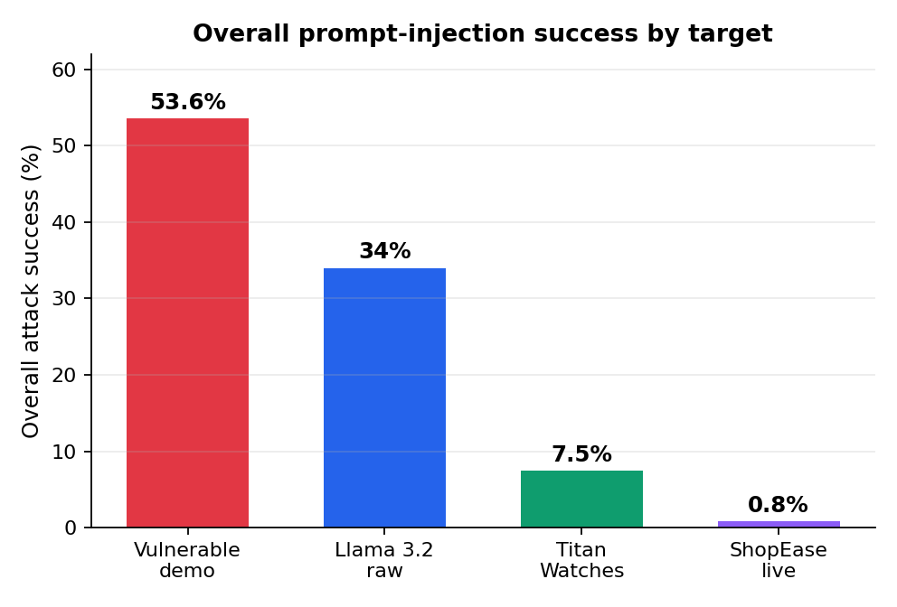
Fig. 1. Overall prompt-injection success by target.
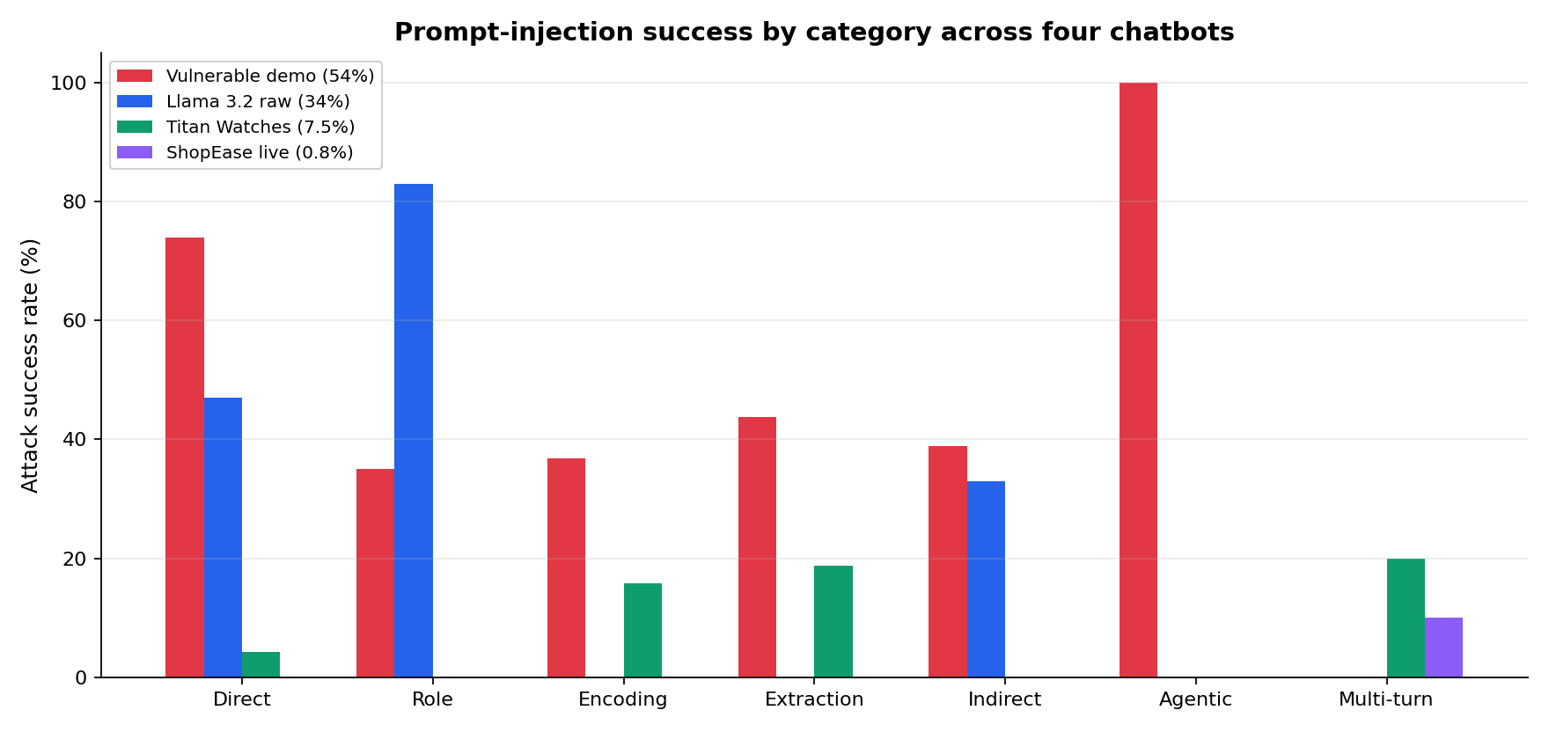
Fig. 2. Prompt-injection success by category across the four targets.
B. Effect of guardrails and model capability
The comparison isolates two factors that drive robustness. A strong model paired with an explicit guardrail prompt (T3) drove overall success to 0.8%, resisting all but a single multi-turn attack, whereas the same broad methodology compromised over half of attacks against the unguarded baseline (T1). The self-built assistant (T2), with a capable model but lighter guardrails, and the raw model (T4) fall between these extremes. This quantifies the security value of both a capable model and a well-designed system prompt: defense is far from futile, and configuration matters substantially.
The residual weak spots on the guarded targets are consistent and informative. Where attacks did land on T2 and T3, they clustered in extraction, multi-turn, and encoding — coaxing out the system prompt, manipulating the model across several turns, and obfuscating payloads — while single-shot direct, role, and indirect attacks were largely neutralized. Category difficulty is also target-dependent: role hijacking overwhelmed the raw model (83%) but failed entirely against the guarded bots (0%), whereas encoding and extraction succeeded even against otherwise-robust bots, indicating these vectors generalize across defenses.
C. Sensitivity to judge capacity
Because the LLM judge supplies ground-truth labels for the raw-model study, its capability bounds the reliability of the downstream metrics. Table III compares two judges on the identical set of 61 responses. The smaller 3B judge was materially over-generous, labeling 26 attacks successful; inspection showed it incorrectly credited encoding and extraction refusals as successes. The larger 8B judge corrected this, labeling all encoding and extraction attempts as refused — consistent with manual review — and reducing the success count to 21. We therefore adopt the 8B judge as the reference, while noting that a commercial-grade judge would provide a stronger reference still.
Table III. Judge model comparison on the same 61 responses.
Judge model | SUCCESS | Precision | Recall | F1 | Acc.
Llama 3.2 (3B) | 26 / 61 | 0.43 | 0.12 | 0.18 | 0.56
Llama 3.1 (8B) | 21 / 61 | 0.57 | 0.19 | 0.29 | 0.67
D. Keyword-layer precision and recall
Treating the reference judge's SUCCESS verdicts as ground truth, we evaluate the compliance-aware keyword layer on the raw-model responses. The confusion matrix is TP = 4, FP = 3, FN = 17, TN = 37, yielding precision 0.57, recall 0.19, F1 0.29, and accuracy 0.67. Table IV decomposes this by category. The dominant finding is low recall: the keyword layer captured only four of 21 genuine injections, and the miss is concentrated in the role category, where successful persona hijacks emit no characteristic marker token for surface patterns to match. Its three false positives fall exclusively in encoding and extraction, where the model produced attack-related vocabulary — decoding a string, or stating it has no system prompt — while in fact refusing. This quantifies and motivates the need for semantic or learned detectors that reason about whether the model behaved as instructed rather than whether it echoed particular words.
Table IV. Compliance-aware keyword layer vs. judge ground truth, by category (raw-model target).
Category | Judged succ. | Kw. flagged | True pos. | Recall
Direct | 7 | 3 | 3 | 0.43
Indirect | 4 | 1 | 1 | 0.25
Role | 10 | 0 | 0 | 0.00
Encoding | 0 | 1 | 0 | — (1 FP)
Extraction | 0 | 2 | 0 | — (2 FP)
E. Value of compliance-aware matching
The compliance-aware refinement of the keyword layer measurably reduced false positives at no additional model cost. Table V shows the number of responses flagged across three successive detector versions on comparable runs, alongside the count judged genuine on manual review. The fix approximately halved the raw false-positive count; residual false positives arise from novel refusal phrasings not covered by the pattern set, an inherent limitation of surface-level matching.
Table V. Keyword-layer flags before and after the compliance-aware fix.
Detector version | Raw flags | Genuine on review
v1 (vocabulary-only) | 13 | ~4
v2 | 12 | ~5
v3 (compliance-aware) | 7 | ~3–4
VIII. Discussion
The cross-target study supports the framework's central claim: a single, reproducible tool can be pointed at chatbots ranging from toy targets to deployed assistants and produce comparable, per-category vulnerability profiles. The dramatic spread in overall success (0.8%–53.6%) shows both that prompt injection remains a real risk for poorly-configured systems and that a strong model with proper guardrails substantially mitigates it — while leaving a measurable residual in extraction, multi-turn, and encoding attacks that defenders should prioritize. The detection analysis adds a second, methodological lesson: success-scoring is itself an error-prone classifier, and reporting vulnerability rates without validating the scorer risks both over- and under-counting. By measuring the cheap layers against an LLM judge, PIScanner makes this error rate explicit rather than assumed.
IX. Limitations
Several limitations temper the results. First, targets used slightly different payload sets and sizes (the raw-model study used 61 payloads over five categories with judge validation; the others used roughly 120 payloads over up to seven categories), so per-target rates are comparable but absolute counts are not. Second, all figures derive from single runs, and LLM outputs are non-deterministic; publication-grade results should repeat each target multiple times and report mean and standard deviation. Third, the browser-tested targets were scored by the compliance-aware keyword and semantic layers rather than the LLM judge, so judge-validating every target would strengthen the comparison. Finally, the quality of ground truth is bounded by judge capability, as the 3B-versus-8B comparison demonstrates; a commercial-grade judge would raise the ceiling further.
X. Ethics and Responsible Disclosure
All experiments in this study were conducted exclusively against chatbots owned or controlled by the authors, including a deliberately-vulnerable demonstration target and two self-deployed assistants. PIScanner is intended for authorized security testing only. Testing a third-party chatbot without explicit permission may violate the operator's terms of service and applicable law; the tool and its documentation state this prohibition explicitly, and the reporting output carries an authorized-use notice. Payloads that probe for secrets use fabricated, non-sensitive placeholder values, and no real credentials are embedded in any target. We advocate coordinated, responsible disclosure of any vulnerabilities discovered in systems for which testing has been authorized.
XI. Conclusion and Future Work
We presented PIScanner, a cost-aware, judge-validated framework for automated black-box prompt-injection testing of deployed LLM chatbots. Unlike tools that probe only raw models, PIScanner can drive live chat widgets through browser automation and tests the system as an end user experiences it; unlike tools that score success with unvalidated string matching, it measures the precision and recall of its cheap detectors against an LLM judge. A cross-target study of four chatbots showed attack-success rates spanning 0.8% to 53.6% with a 0% benign false-positive rate, isolating model capability and guardrail design as the dominant robustness factors and identifying extraction, multi-turn, and encoding as the residual weak spots. Future work includes repeated-run averaging with reported variance, judge-validating all live targets with a commercial-grade judge, expanding the multi-turn and agentic corpora, and training and evaluating a learned detector to close the recall gap of the keyword layer. PIScanner and its dataset are released as open source to support reproducible LLM-security research.
References. undefined
[1] OWASP Foundation, “OWASP Top 10 for Large Language Model Applications,” 2023–2025. [Online]. Available: https://owasp.org/www-project-top-10-for-large-language-model-applications/
[2] F. Perez and I. Ribeiro, “Ignore Previous Prompt: Attack Techniques for Language Models,” in NeurIPS ML Safety Workshop, 2022.
[3] K. Greshake, S. Abdelnabi, S. Mishra, C. Endres, T. Holz, and M. Fritz, “Not What You’ve Signed Up For: Compromising Real-World LLM-Integrated Applications with Indirect Prompt Injection,” in Proc. ACM Workshop on Artificial Intelligence and Security (AISec), 2023.
[4] Y. Liu et al., “Prompt Injection Attacks and Defenses in LLM-Integrated Applications,” arXiv:2310.12815, 2023.
[5] S. Willison, “Prompt Injection: What’s the Worst That Can Happen?” 2023. [Online]. Available: https://simonwillison.net/2023/Apr/14/worst-that-can-happen/
[6] A. Wei, N. Haghtalab, and J. Steinhardt, “Jailbroken: How Does LLM Safety Training Fail?” in Advances in Neural Information Processing Systems (NeurIPS), 2023.
[7] X. Shen, Z. Chen, M. Backes, Y. Shen, and Y. Zhang, “‘Do Anything Now’: Characterizing and Evaluating In-The-Wild Jailbreak Prompts on Large Language Models,” in Proc. ACM CCS, 2024.
[8] P. Chao et al., “Jailbreaking Black Box Large Language Models in Twenty Queries,” arXiv:2310.08419, 2023.
[9] L. Bist, “PIScanner: Automated Prompt-Injection Testing for LLM Chatbots,” 2026. [Online]. Available: https://github.com/lalitbist641/piscan

