FJS APP

1 - Notifications

* Sales rep needs to be alerted that he has been sent a lead

2 - Quote

* Select Customer shows same customer multiple times - see below
* Need search bar for ease if finding a customer

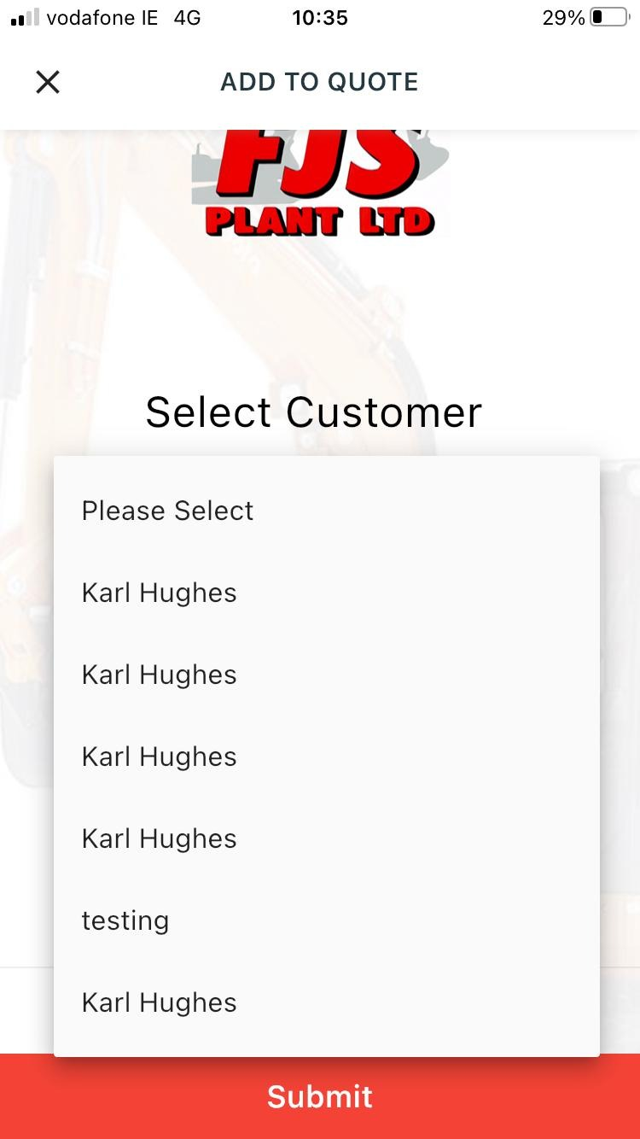

3 - Dealerships

* Need to be able to add machines even if not in stock - sales order will be made and when machine comes into stock assign to earliest customer looking for the machines

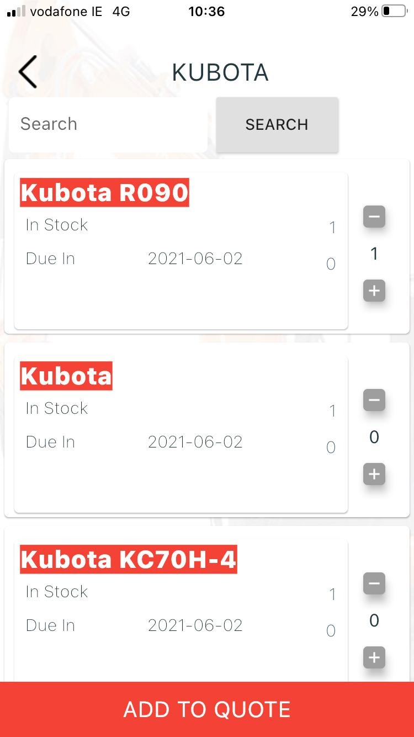

4 - Add to Quote

* Select Lead shows same customer multiple times, should only show the customer once
* Also we need a search bar as there's 2K+ customers
* 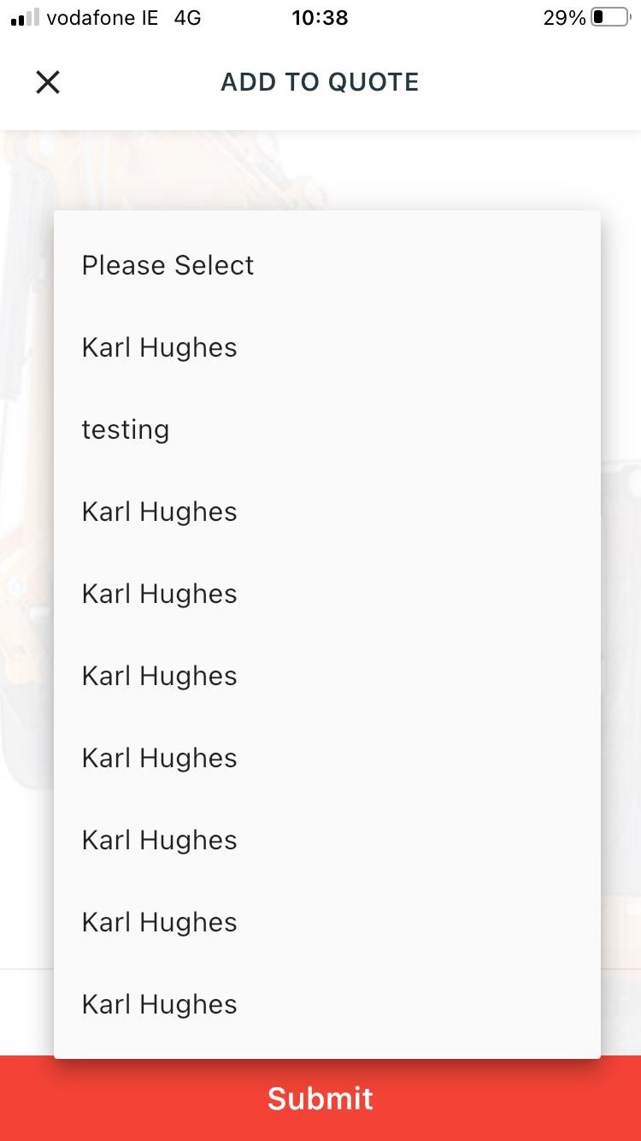

5 - Sales Calls

* Need to have most recent sales lead go to the top not the bottom
* Need to be able to mark sales calls as done and then they remove from phone

5 - Quotes

* Preview quote email needs to be sent before the quote is sent to customer
* So will go as follows

1 - create quote

2 - add machines

3 - send preview quote (sends to reps email)

4 - send quote

6 - Sales Orders

* Edit page is not opening - <http://fjsplant.ie/admin/sales_order/edit/17>
* Missing fields sent in previous email - see below of fields need on sales order page

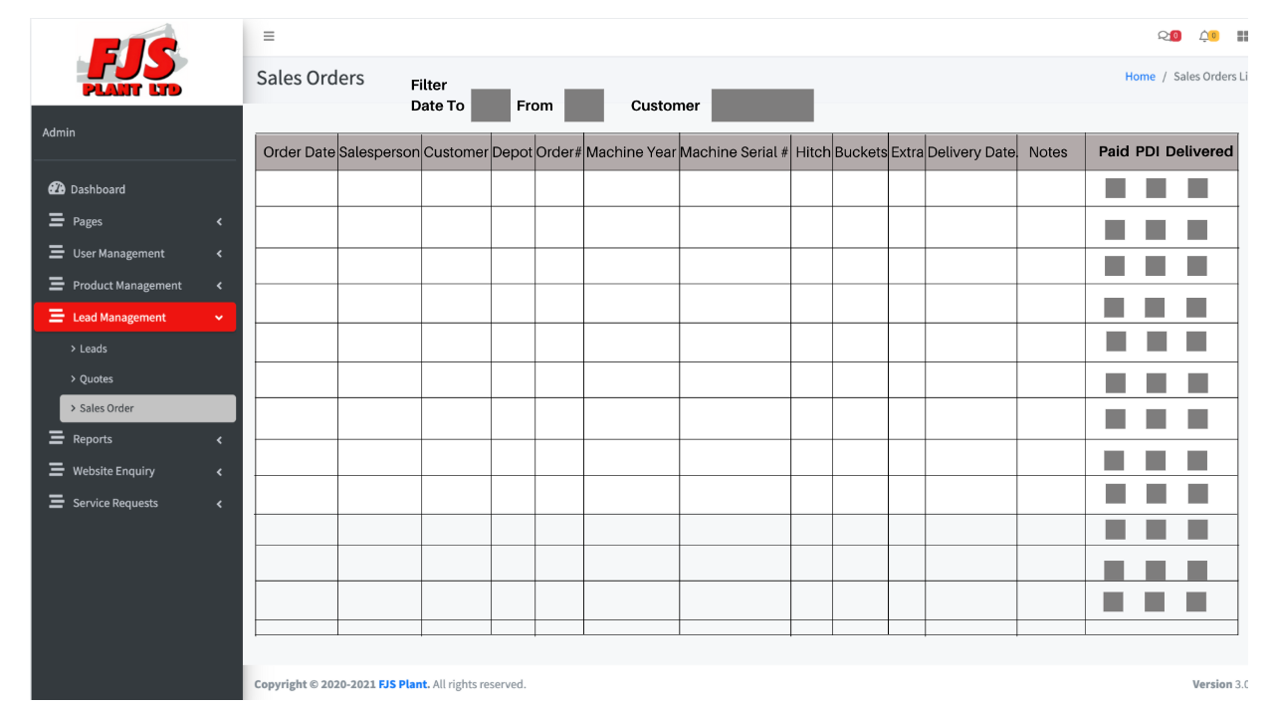

7 - Quotation

* Needs to look more like the image i sent
* Rep email/ number and name needs to be on it where you can see on this, still has frank Smyth on Qoute

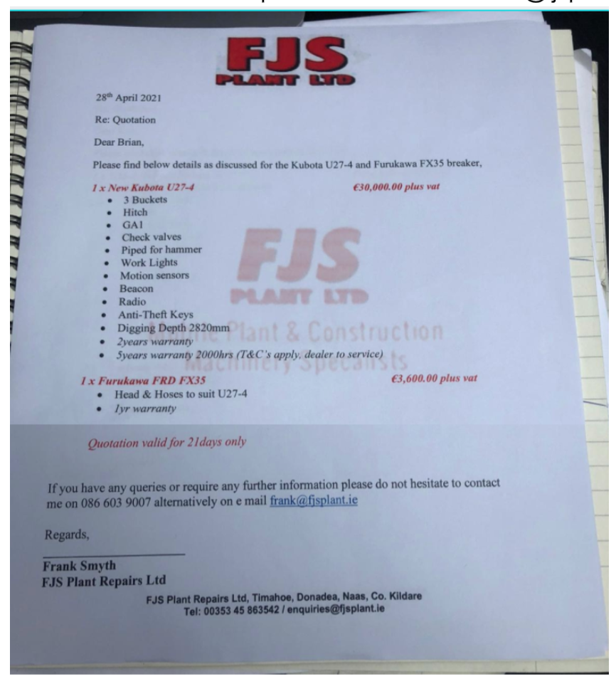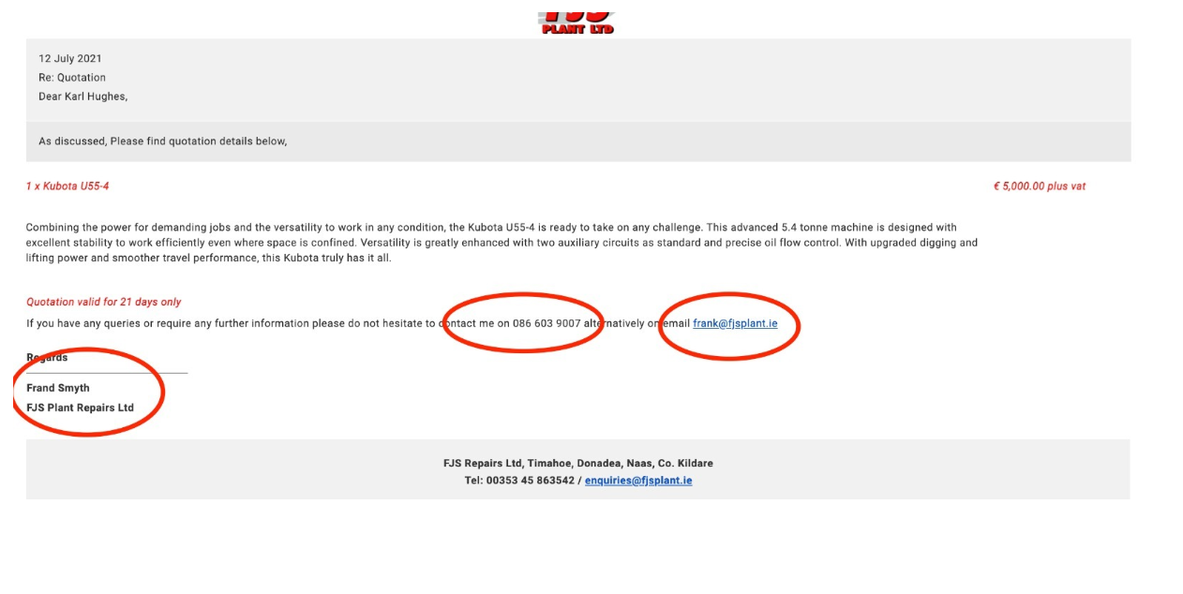

8 - Trade in options not on mobile