**Online Food Ordering and Delivery System.**

**1. SCOPE:**

**1) Who is your end user?**

End User: The end-users of the system will be customers who want to order food online.

**2) What is your Objective?**

Objective: The objective of the project is to provide a user-friendly platform for customers to order food online from various restaurants.

**3) What are project limitations?**

Project Limitations: The project will have the following limitations:

1) Only online payments will be accepted.

2) Delivery will be limited to a specific geographical area.

**4) List down your own ideas**

Ideas: Some ideas that can be included in the project are:

A rating and review system that allows customers to rate the restaurant and leave feedback.

An option to customize the food order according to the customer's preferences.

Then accordingly decide roles and functionalities for your project.

**Roles and functionalities:**

Admin: The admin will have access to the back-end of the system and will be responsible for adding new restaurants, managing orders, managing Delivery Personnel.

Customers: The customers will have access to the front-end of the system and will be able to search for restaurants, place orders and make online payments.

Restaurants: The restaurants will have access to a separate portal where they can manage their menu, view orders, and update their information.

Delivery Personnel: The delivery personnel will be responsible for delivering the orders to the customers. They will have access to a separate portal where they can view the delivery details and update the status of the delivery.

Overall, the scope of the online food ordering system project will be to create a user-friendly platform that connects customers with restaurants and provides a seamless online ordering experience.

**2.User Case Diagram:**

**User:**

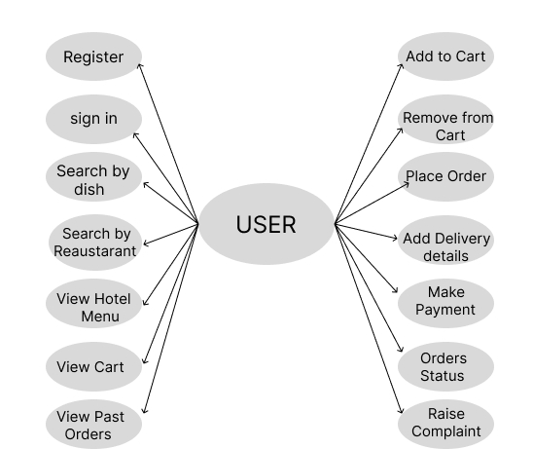

**Admin:**

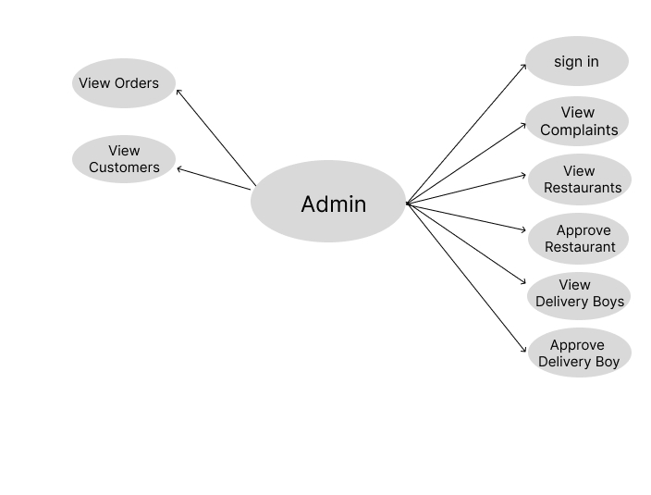

**Restaurant Manager:**

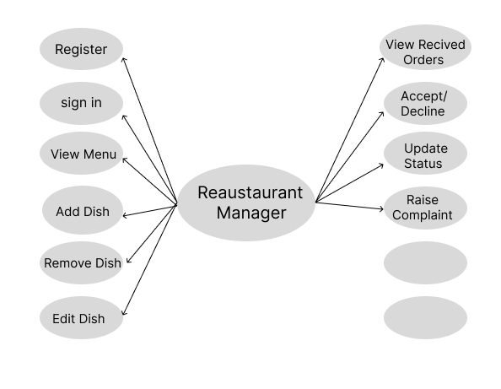

**Delivery Person:**

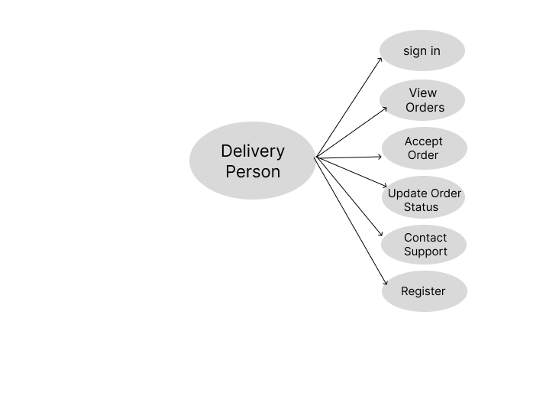

**3.Data Flow Diagram:**

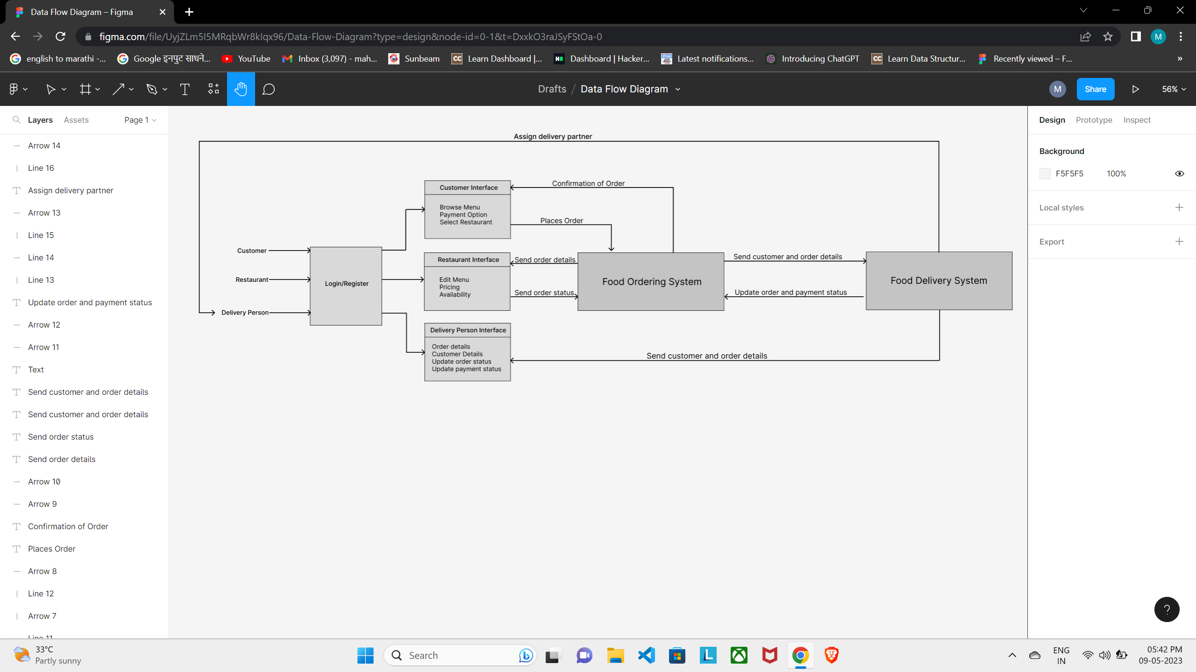

**4.ER Diagram:**

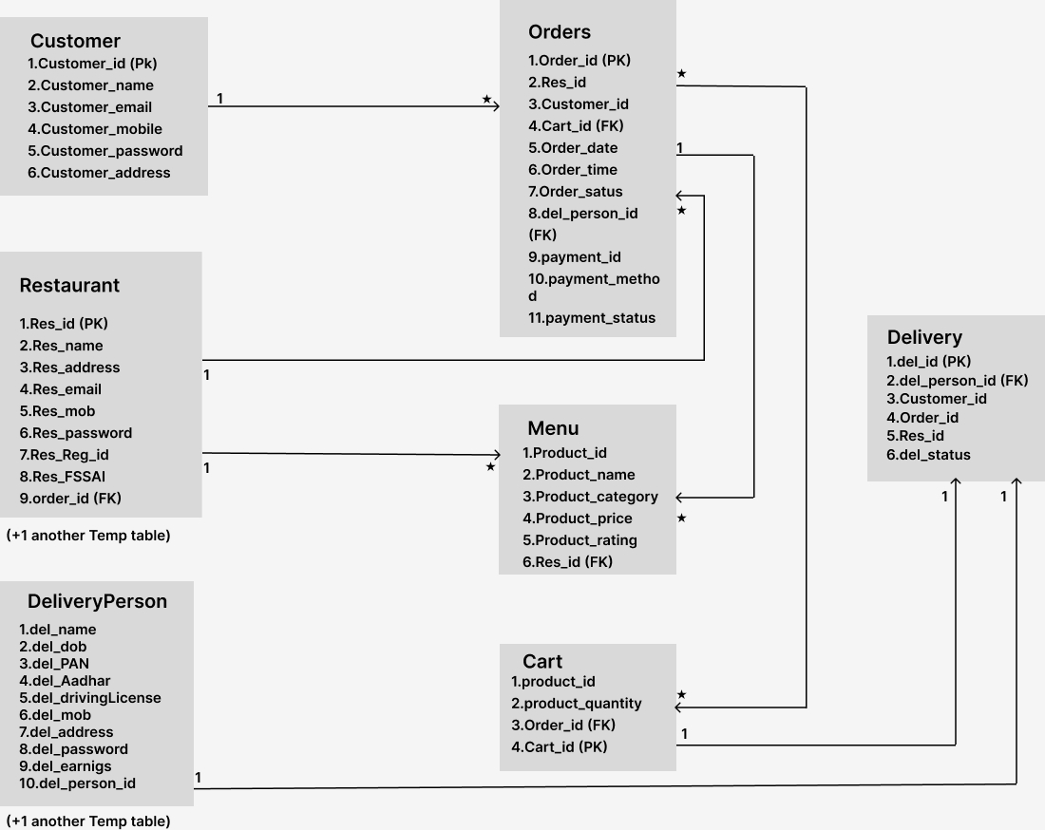

1

1

**5. UI Diagram:**

**Customer:**

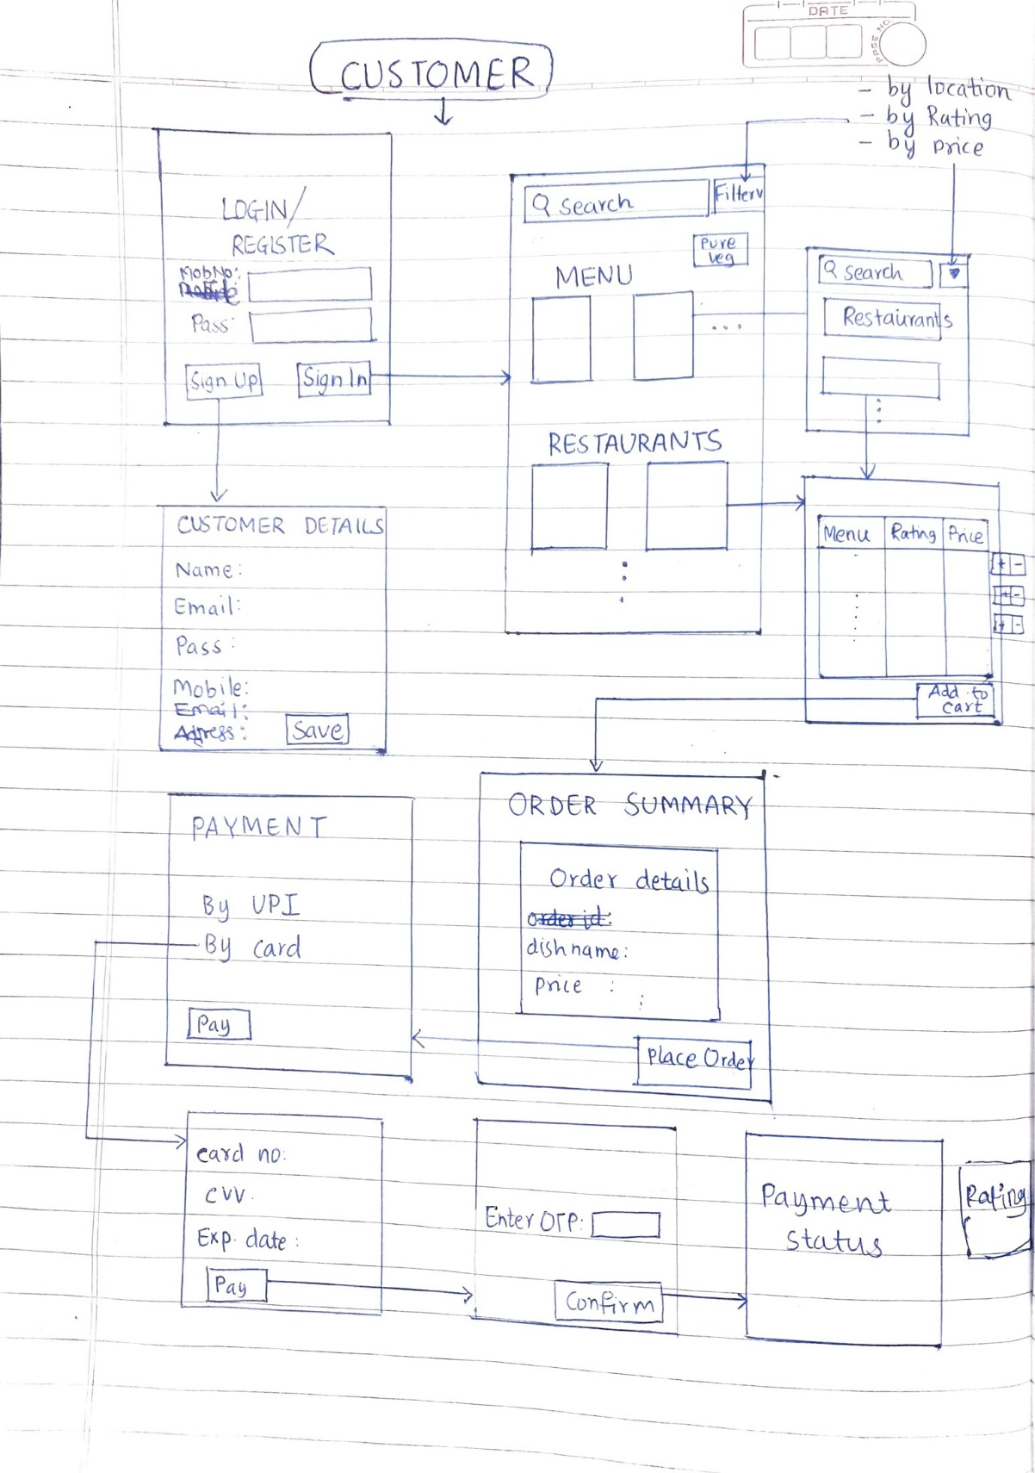

**Restaurant:**

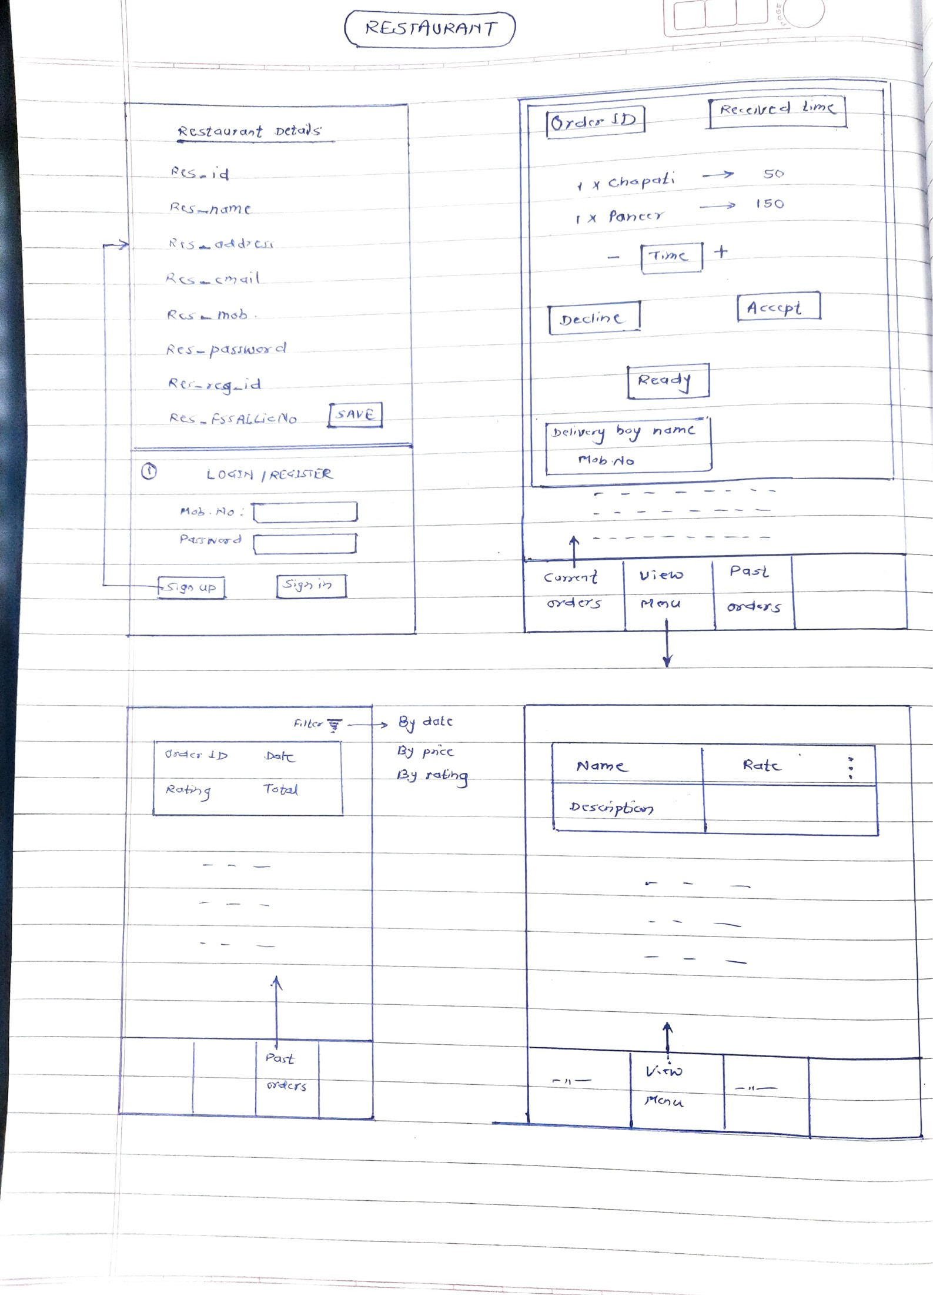

**Admin:**

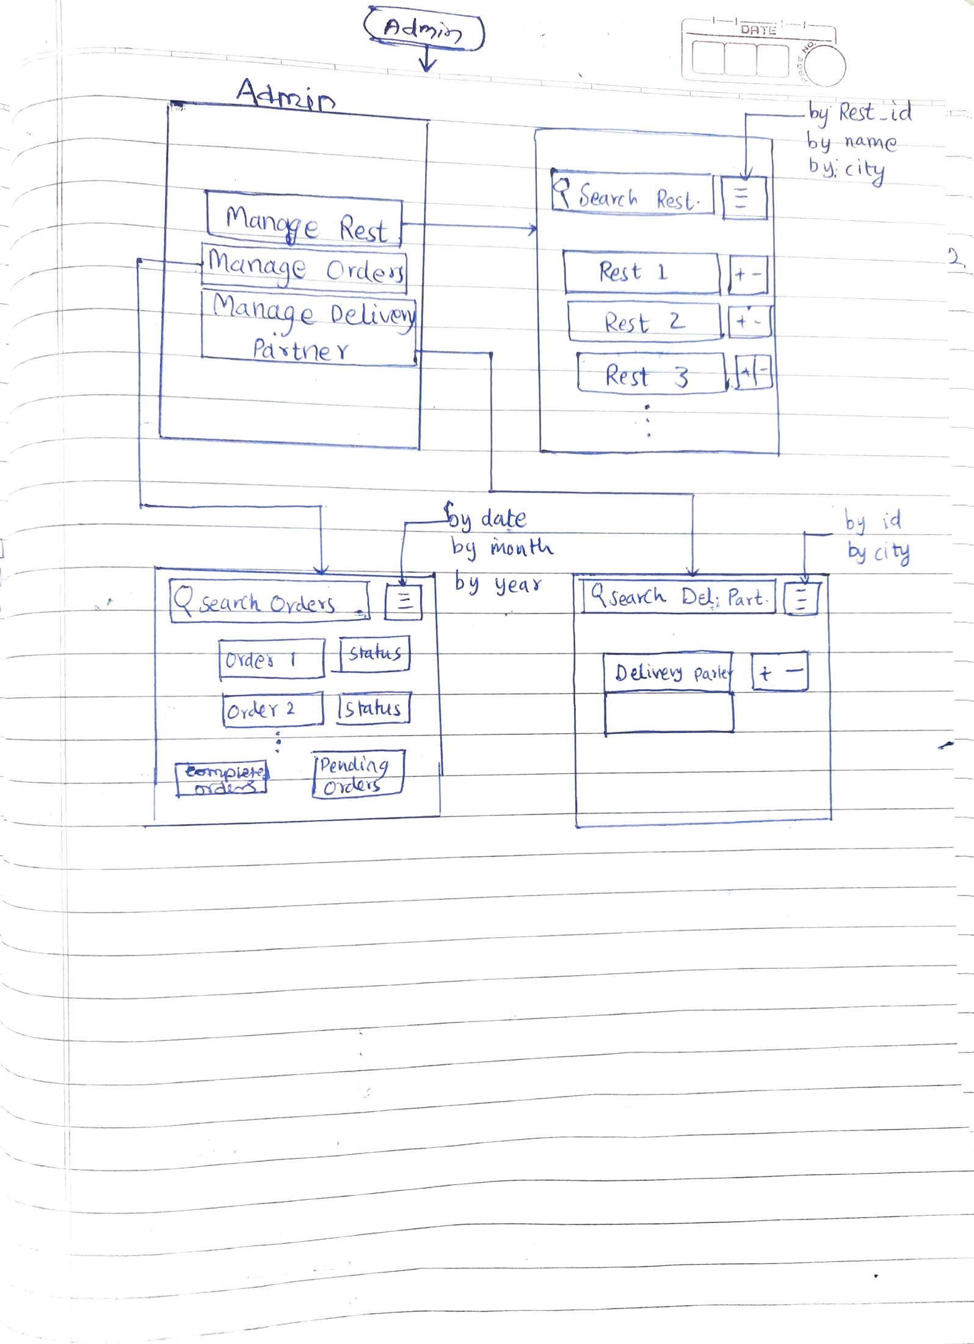

**Delivery Partner:**

