Software Architecture and Design Specification
Project: Insurance Workflow Automation Software (IWAS)
Version: 1.0
Authors: Bitbees
Date: 05-10-2025
Status: Draft

1. Introduction

1.1 Purpose
This document specifies the architecture and design of the Insurance Workflow Automation Software (IWAS). It details the system’s components, integration points, workflow orchestration, and interfaces, based on the SRS. It serves as a guide for developers, testers, and integrators implementing the solution.

1.2 Scope
IWAS automates end-to-end insurance business processes such as new policy issuance, underwriting, renewals, claims, billing, endorsements, and compliance reporting. It uses modular web components, workflow orchestration, and API-driven integration.

1.3 Audience
Developers, QA engineers, security auditors, instructors, project evaluators, and maintenance teams.

1.4 Definitions
- IWAS: Insurance Workflow Automation Software
- U/W: Underwriting
- STP: Straight Through Processing
- FNOL: First Notice of Loss
- DMS: Document Management System
- SLA: Service Level Agreement
- PII/PHI: Personal/Health Identifiable Information

2. Document Overview

2.1 How to use this document
This document provides:
- Architectural components and relationships
- UML component and sequence diagrams
- Technology stack and deployment overview
- Security model and traceability

2.2 Related Documents
- Software Requirements Specification (SRS)
- System Test Plan (STP)
- Requirements Traceability Matrix (RTM)

3. Architecture

3.1 Goals & Constraints
Goals:
- Automate policy and claims workflows end-to-end
- Provide scalable and modular architecture
- Maintain high availability (≥99.9%)
- Support secure data management (encryption, RBAC, GDPR/IRDAI compliance)
Constraints:
- Integration with legacy systems (PAS, CRM, DMS)
- Regulatory retention and audit logging
- Zero-downtime deployment

3.2 Stakeholders & Concerns
Stakeholder | Concern
Customers | Simplicity, transparency, and timely notifications
Agents/Brokers | Workflow efficiency, commission tracking
Underwriters/Claims Adjusters | Rule-based task assignment and SLA monitoring
Managers | Reporting, audit trails, workload visibility
System Admins | Integration, configuration, access control
Regulators | Compliance and data retention

3.3 Component (UML) Diagram

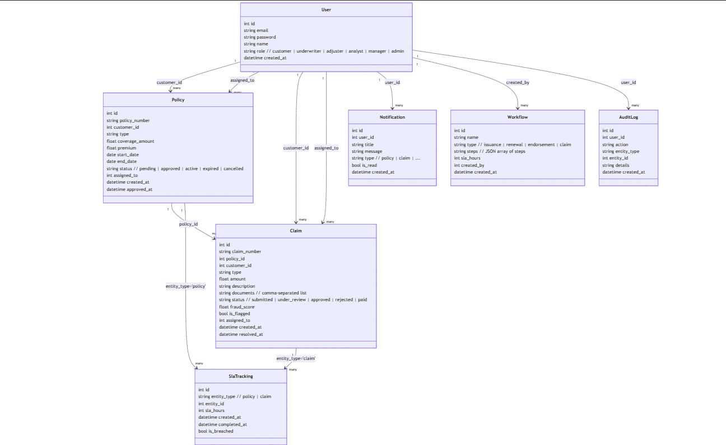

Diagram: Insurance Workflow Management System – Component Diagram
Main Layers:
- User Interfaces (UI Layer):
  - Customer Portal
  - Agent Portal
  - Underwriter Workbench
  - Claims Adjuster Portal
  - Manager Dashboard
- Orchestration Layer:
  - Workflow Orchestration Engine
  - Business Rules Engine
  - Process Engine
  - Event Handler
  - Workflow Repository
  - Queue Manager
- Workflow Components:
  - Policy Lifecycle Automation
  - Claims Workflow Automation
  - Task Automation & Escalation
  - Communication & Notifications
  - Reporting & Compliance
- Infrastructure Layer:
  - Workflow Database
  - Integration Layer (API Gateway, Message Queue)
  - Security & Data Management
- External Systems:
  - Payment Gateway
  - CRM
  - Fraud Detection
  - Email/SMS Providers
  - Regulatory Systems

3.4 Component Descriptions
Component | Description
User Interfaces | Provides portals and dashboards for role-specific access.
Workflow Orchestration Engine | Central control unit coordinating workflow execution and task routing.
Business Rules Engine | Evaluates decision tables, approval logic, and validations for automation.
Process Engine | Manages workflow instances, versioning, and state transitions.
Queue Manager | Handles task queuing, load balancing, and retries for failed workflows.
Workflow Repository | Stores workflow definitions, process templates, and version history.
Workflow Database | Central data store for policies, claims, tasks, and audit logs.
Integration Layer | Facilitates communication with external APIs (payments, CRM, DMS).
Security & Data Management | Manages authentication, authorization, encryption, and compliance.

3.5 Chosen Architecture Pattern and Rationale
A modular layered architecture with an API-first orchestration core is chosen to separate user interfaces, business rules, workflow automation, and infrastructure concerns.
- Advantages: Maintainability, scalability, and easy integration.
- Rejected: Monolithic or microservice over-fragmentation, which adds unnecessary complexity for the project scale.

3.6 Technology Stack & Data Stores
Category | Technology / Choice
Backend | Node.js (TypeScript) with Next.js API Routes / Express.js
Frontend | React.js with Next.js (Responsive SPA/SSR web UI)
Database | PostgreSQL (primary OLTP database)
Caching | Redis (session caching, frequently accessed data)
Workflow & Messaging | Apache Kafka / AWS SQS (async workflows, event-driven processing)
File / Object Storage | AWS S3 / Azure Blob Storage
Authentication | OAuth 2.0 / OpenID Connect, JWT-based sessions, MFA support
Authorization | Role-Based Access Control (RBAC) per user role
Logging & Monitoring | ELK / CloudWatch / Azure Monitor, Prometheus + Grafana dashboards
Hosting & Orchestration | Kubernetes (Linux nodes), Docker containerized services
CI/CD | GitHub Actions / GitLab CI / Azure DevOps pipelines

3.7 Risks & Mitigations
Risk | Mitigation
Workflow engine downtime | Redundant cluster deployment
Integration API failure | Circuit breakers and retry logic
Data breach | End-to-end encryption and RBAC
SLA violations | Real-time monitoring and alerting

3.8 Traceability to Requirements
Requirement | Component
FR-1 to FR-5 | Workflow Orchestration & Core Engine
· Definition and execution of workflows
· SLA tracking for policies and claims
· Audit logging for all workflow steps
FR-6 to FR-9 | Policy Lifecycle Automation
· Policy creation, underwriting, approval, renewal
· Policy status transitions (pending, active, expired, cancelled)
· Auto-assignment to underwriters
· Policy-related SLA tracking
FR-10 to FR-15 | Claims Workflow Automation
· Claim submission, validation and decisioning
· Fraud scoring and flagging of high-risk claims
· Auto-assignment to adjusters / analysts
· Claim status transitions (submitted, under_review, approved, rejected, paid)
· Claim-related SLA tracking
FR-16 to FR-19 | Task Automation & Escalation
· Automatic task creation from workflow steps
· Escalation rules based on SLA breaches or near-breach
· Reassignment / workload balancing
· Notifications to responsible users on escalations
FR-20 to FR-23 | Communication & Notifications
· In-app notifications for policies and claims
· Configurable templates for alerts and updates
· Multi-channel extensions (email / SMS) in future
· User-level preferences for notification types
FR-24 to FR-27 | Reporting, Analytics & Compliance
· Operational dashboards (policies, claims, SLAs, fraud flags)
· Compliance and audit reports (workflows, approvals, overrides)
· Export of reports (CSV / PDF) for regulators
· Monitoring of error rates and system health
FR-28 to FR-31 | Security, Access Control & Data Management
· Authentication (OAuth 2.0 / JWT / MFA-ready)
· Role-Based Access Control (customers, underwriters, adjusters, analysts, managers, admins)
· Data encryption in transit and at rest
· No PII or secrets in logs; proper retention and backup policies

3.9 Security Architecture
Threat Modeling (STRIDE):
Threat | Mitigation
Spoofing | OAuth 2.0 / JWT verification
Tampering | Encrypted workflow data and audit logs
Repudiation | Immutable audit trails
Information Disclosure | TLS 1.3 + AES-256 at rest
Denial of Service | Load balancing and auto-scaling
Elevation of Privilege | RBAC and MFA enforcement

4. Design

4.1 Design Overview
IWAS uses a layered modular design:
- UI Layer: Front-end portals for all roles.
- Business Layer: Workflow orchestration, rules evaluation, and process management.
- Integration Layer: External systems communication via REST APIs.
- Data Layer: Workflow, audit, and document storage.

4.2 UML Sequence Diagrams

4.2.1 User authentication
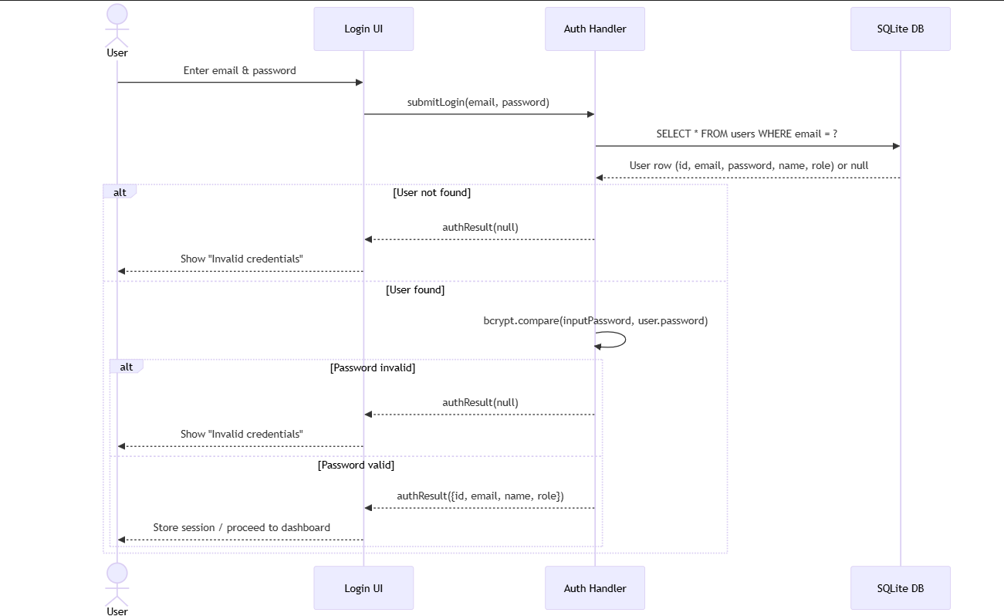
Covers the flow from customer policy submission → underwriting → policy issuance.

4.2.2 Policy creation & approval

Create policy
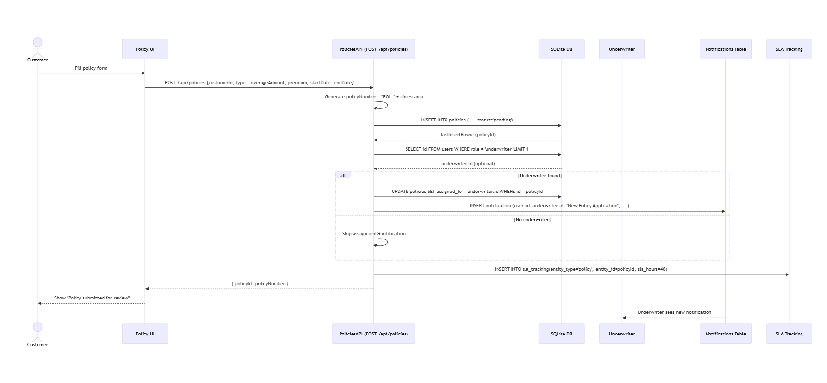
Approve / update policy
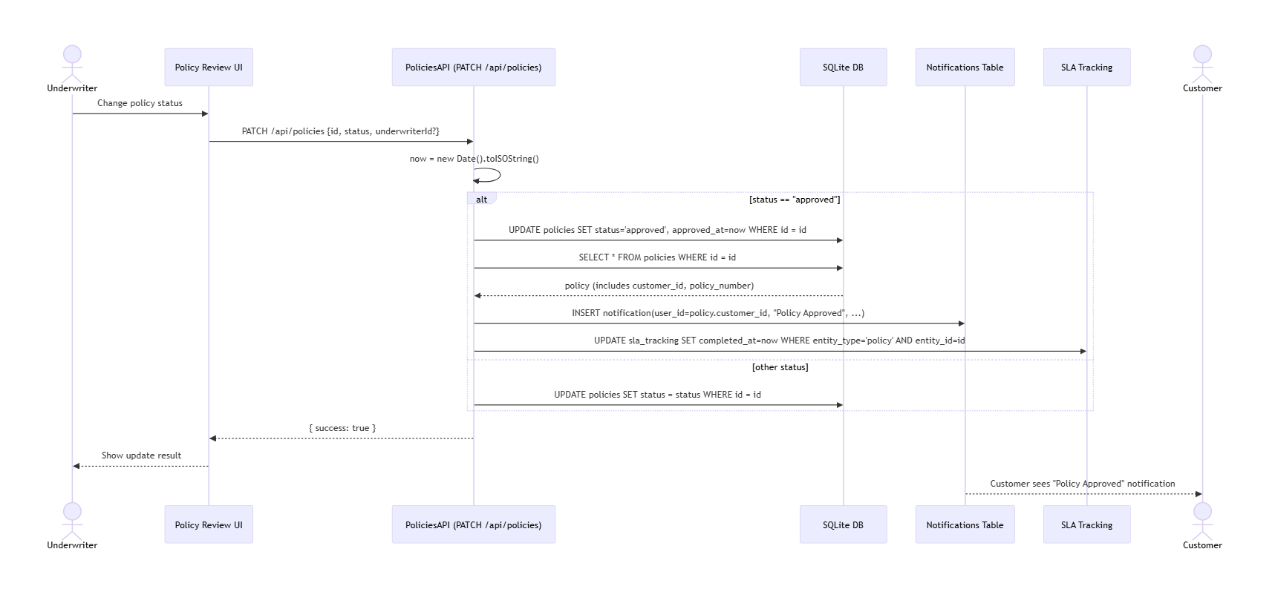
Covers the claim submission → eligibility → fraud detection → approval/rejection process.

4.3 API Design

Endpoint 1: /api/v1/policies
· Method: POST
· Description: Creates a new policy for a customer, optionally attaches documents, auto-assigns an underwriter (if available), creates a notification for the underwriter, and starts SLA tracking.

· Request:
{
customerId,
policyDetails: {
type,
coverageAmount,
premium,
startDate,
endDate
},
documents
}

· Request field details:
- customerId: number, required
- policyDetails.type: string, required
- policyDetails.coverageAmount: number, required
- policyDetails.premium: number, required
- policyDetails.startDate: string (date, ISO format), required
- policyDetails.endDate: string (date, ISO format), required
- documents: list of strings (optional, e.g., file names or references)

· Response (success – 201 Created):
{
policyId,
policyNumber,
status,
message
}

- policyId: number (generated unique identifier)
- policyNumber: string (e.g., "POL-<timestamp>")
- status: string (typically "pending" at creation)
- message: string (confirmation message, e.g., "Policy created and submitted for underwriting.")

· Errors:
- 400 Invalid Data
{ error: "Invalid policy data." }

- 403 Unauthorized
{ error: "Unauthorized." }

- 500 Workflow Error (internal workflow / database failure)
{ error: "Workflow error while creating policy." }

Endpoint 2: /api/v1/claims
· Method: POST
· Description: Submits a claim for an existing policy, performs eligibility and fraud checks, auto-assigns the claim to an adjuster or analyst, creates a notification, and starts SLA tracking.

· Request:
{
policyId,
claimDetails: {
type,
amount,
description
},
documents
}

· Request field details:
- policyId: number, required
- claimDetails.type: string, required (e.g., "hospitalization", "theft")
- claimDetails.amount: number, required
- claimDetails.description: string, required
- documents: list of strings (optional, e.g., file names or references)

· Response (success – 201 Created):
{
claimId,
claimNumber,
status,
settlementAmount,
fraudScore,
isFlagged
}

- claimId: number (generated unique identifier)
- claimNumber: string (e.g., "CLM-<timestamp>")
- status: string (e.g., "submitted" or "under_review")
- settlementAmount: number or null (null at submission; filled when claim is settled)
- fraudScore: number (calculated risk score)
- isFlagged: boolean (true if fraudScore is above threshold)

· Errors:
- 404 Policy Not Found
{ error: "Policy not active or not found." }

- 422 Invalid Claim
Examples:
{ error: "Claim amount exceeds coverage." }
{ error: "Duplicate claim detected." }

- 500 Internal Error
{ error: "Internal error while submitting claim." }
4.4 Error Handling, Logging & Monitoring
· Centralized structured logging (e.g., ELK stack / CloudWatch / Azure Monitor) for all backend services
· No PII (Personally Identifiable Information), passwords or secrets written to logs
· Correlation IDs to trace end‑to‑end API requests, background jobs and workflows
· Standardized error codes and messages returned from all APIs (client‑safe messages, server‑side details in logs)
· Graceful error handling and user‑friendly error pages/messages on the UI
· Workflow retries with exponential backoff for transient errors (DB timeouts, network failures, third‑party API issues)
· SLA tracking for key entities (policies and claims) across creation, review, approval, settlement/closure
· Real‑time dashboards for:
– Error rates, failed jobs and failed workflows
– SLA breaches and near‑breach alerts for policies and claims
– Fraud‑flagged claims and other high‑risk activities
· Alerting and notifications for critical incidents (e.g., repeated failures, database unavailability, abnormal error spikes)
· Periodic review of logs and dashboards by operations and security teams

4.5 UX Design
· Responsive web UI optimized for desktop, tablet, and mobile devices
· Clear, step‑by‑step flows for policy creation, policy review, claim submission and claim decisioning
· Role‑based dashboards:
– Customer: view policies, claims, notifications, SLA status and important alerts
– Underwriter: queue of pending policies, risk indicators, workload and SLAs
– Adjuster / Analyst: assigned claims, fraud flags, prioritization by SLA and risk
– Manager / Admin: high‑level KPIs, SLAs, compliance and audit logs overview
· Consistent design system (colors, typography, components) reused across the portal
· Multilingual support (English by default, extensible to additional regional languages)
· Accessibility support aligned with WCAG guidelines:
– High‑contrast themes and scalable fonts
– Keyboard‑only navigation for all critical flows
– Screen‑reader‑friendly labels, headings and ARIA attributes
· Clear user feedback throughout journeys (success states, inline validation errors, loading/progress indicators, empty‑state messages)
· Simple, intuitive navigation with minimal steps to complete core tasks (buy policy, file claim, track status)

4.6 Open Issues & Next Steps
· Integrate advanced AI‑driven fraud scoring using historical policy and claim data
· Add chat‑based claim and policy support (virtual assistant with escalation to human agents)
· Automate regulatory, compliance and management report generation (scheduled and on‑demand)
· Implement more fine‑grained audit trails for all critical user actions (view, create, update, approve, reject, override)
· Further harden security (rate limiting, IP allow‑listing where applicable, enhanced authentication and MFA rollout)
· Expand notification channels (email / SMS / in‑app / push) with configurable user preferences
· Introduce self‑service configuration for SLAs, workflows and notification rules
· Perform performance tuning, capacity planning and load testing for peak usage periods (e.g., renewal seasons, catastrophe events)

5. Appendices

5.1 Glossary
Term | Definition
IWAS | Insurance Workflow Automation Software
SLA | Service Level Agreement
DMS | Document Management System
KYC | Know Your Customer

5.2 References
IEEE 42010, OWASP ASVS, NIST SP 800-160, IRDAI guidelines

5.3 Tools
draw.io, PlantUML, Swagger, Kubernetes Dashboard, Grafana

