S U R V E Y R E P O R T
Low-Code Development in 2026
A Survey of the Platform Landscape and a Hands-On Study of Zoho Creator
Market growth, platform categories, the rise of AI inside the builder, and what governance has to catch up with
Prepared by
Lalitha B
Roll Number: 241401045
B.Tech Computer Science and Business Systems
Rajalakshmi Engineering College, Chennai
3 August 2026

Table of Contents

1. Summary of Findings 3
2. Introduction 3
3. What Counts as Low-Code 4
4. How Big the Market Actually Is 4
5. The Shape of the Platform Landscape 5
6. Zoho Creator: A Closer Look 7
7. Trend: AI Has Moved Inside the Builder 9
8. Trend: Who Builds the Software Has Changed 9
9. Trend: Governance Is Catching Up 10
10. Trend: Platforms Are Specialising by Industry 11
11. Trend: Openness Versus Lock-In 11
12. Where Each Trend Stands 11
13. What Tends to Go Wrong 12
14. The Next Three Years 12
15. Conclusion 13
16. References 13

1. Summary of Findings
Low-code tools used to be something a team reached for when it wanted an internal form built quickly. That is no longer a fair description of the category. Enterprises now use these platforms for applications that carry real operational weight, and the analysts who track the market have started calling low-code infrastructure rather than a productivity trick.
The numbers behind that claim are less tidy than they look in vendor marketing. Depending on who is counting and what they include, the 2026 market is somewhere between USD 26 billion and USD 49 billion. What every forecast agrees on is the slope: growth in the twenty to thirty percent range, year after year, with no sign of flattening yet.
This report covers three things. It maps the platform landscape and explains why lumping OutSystems and Bubble into one market is misleading. It then examines Zoho Creator in detail, using a trial account I set up and worked through module by module. Finally it looks at five shifts reshaping the category, the largest of which is that AI has moved out of the finished application and into the act of building it.
One theme runs through all of it. Low-code keeps solving the speed problem and keeps creating a control problem in the process, and most of the interesting work in the category right now is about the second half of that sentence.

2. Introduction
Every organisation of a reasonable size has a queue of software it wants and cannot get. Someone in operations needs a way to track vendor onboarding. Someone in HR wants leave requests to stop living in email. None of these are hard problems technically, but they all sit behind a development team that is already committed to work with a bigger budget attached, and so they wait. Some of them wait for years, and in the meantime the work gets done in a spreadsheet that only one person understands.
Low-code platforms exist because that queue exists. They let an application be assembled mostly through configuration, with code written only where configuration cannot express the logic. The effect is that the person who understands the process can often build the tool for it, without going through the queue at all.
That is the promise, anyway. The reason the category is worth surveying in 2026 rather than treating as settled is that the promise has been largely delivered on and the consequences are now arriving. Organisations have hundreds of these applications. Many were built by people who have since moved teams. Some of them touch customer data. The questions being asked at enterprise level have shifted from whether low-code works to what it means to run a few hundred applications nobody has formally reviewed.

2.1 Aim of the Survey
The aim here is to give an honest picture of the category rather than a promotional one, covering the market, the platforms, and the direction of travel, with enough hands-on detail about one platform to make the general claims concrete.

2.2 Sources and Approach
Three kinds of source went into this. Market figures come from published summaries by Gartner, Grand View Research, Mordor Intelligence and Fortune Business Insights. Product detail comes from vendor documentation, which is reliable about what a product does and unreliable about how well it does it, so I have tried to read it accordingly. The Zoho Creator section comes from a trial account I created in July 2026 and worked through directly.
Where market figures appear I have given ranges instead of single numbers. Analyst definitions of low-code vary enough that quoting one figure would suggest a precision that does not exist.

3. What Counts as Low-Code
The distinction between low-code and no-code gets more attention than it deserves. In theory, no-code means the platform never requires you to write anything, and low-code means it gives you a visual surface but lets you drop into code when the visual surface runs out. In practice almost every serious platform does both, because a tool that genuinely cannot be extended hits a wall on its first non-trivial requirement.
A more useful way to think about it is to ask what the platform gives you for free. Most low-code products provide four things without being asked: a database that appears when you define a form, a user interface generated from that definition, an authentication and permissions system, and hosting. Building those four things by hand is where a large fraction of the effort in a small business application actually goes, and removing that effort is the whole value proposition.
What you give up is control over the parts you did not build. The database schema follows the platform's conventions. The interface looks like the platform. Performance characteristics are whatever the vendor has decided they are. For an internal approval tool this hardly matters. For a customer-facing product with a distinctive interface it matters a great deal, which is why the choice of platform depends far more on the kind of application than on any general ranking of quality.

3.1 Why the Category Grew When It Did
Three pressures explain the timing. The shortage of experienced software engineers has been sustained rather than cyclical, so organisations stopped expecting to hire their way out of the backlog. Cloud delivery made it practical for a vendor to host thousands of small customer applications cheaply. And the pandemic years forced a lot of processes online quickly, which taught non-technical staff that they could build things and left behind a generation of business users who now expect to.

4. How Big the Market Actually Is
Ask four research houses for the size of the low-code market and you get four different answers, sometimes differing by a factor of two. This is not sloppiness. Some analysts count only application platforms; others fold in workflow automation, no-code website builders and integration tooling. The chart below shows the spread rather than hiding it.
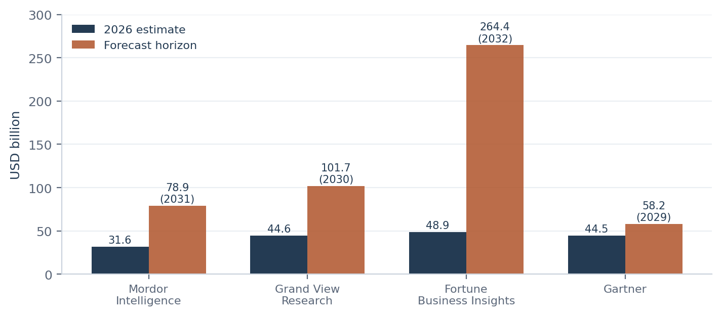
Figure 1: 2026 market estimates and forecast horizons across four research houses (USD billion).
Fortune Business Insights sits at the top of the range with USD 48.9 billion for 2026 and a long forecast running to USD 376.9 billion by 2034. Mordor Intelligence is the most conservative, putting 2026 at USD 31.6 billion. Grand View Research lands in between at USD 44.6 billion, reaching USD 101.7 billion by 2030. Gartner's figure of USD 44.5 billion for 2026 is close to Grand View's, though its forecast horizon is shorter and more restrained.
Two details underneath the headline figures are more informative than the figures themselves. Services revenue, meaning implementation and integration work, is growing faster than licence revenue in several forecasts. That tells you low-code is being deployed into complicated environments where it has to connect to things, not into greenfield isolation. Separately, Asia-Pacific is the fastest-growing region, which matters for an Indian audience: a lot of the demand driving these numbers is local.

70-75%  of new enterprise apps expected to involve low-code by 2026 | ~80%  of people building them sit outside IT | 20-29%  annual growth across published forecasts | $67-102B  projected market size by 2030
Blended from Gartner, Grand View Research, Mordor Intelligence and Fortune Business Insights, 2026.

5. The Shape of the Platform Landscape
Treating low-code as one market makes the comparison table meaningless. A platform built for a bank's claims system and a platform built for a startup's landing page are not competitors, whatever the category label says. The five groups below are separated by the problem each is built to solve.
Group | Examples | Built for | Who buys it
Enterprise platforms | Microsoft Power Apps, OutSystems, Mendix, ServiceNow, Appian, Salesforce | Large, long-lived, business-critical systems | Enterprise IT
Business low-code | Zoho Creator, Kissflow, Quickbase, Bubble | Departmental workflow apps and operational tools | Department heads, SMBs
Internal-tool builders | Retool, ToolJet, Budibase | Admin panels and dashboards over an existing database | Engineering teams
AI app generators | Prompt-to-app and agent-style scaffolding tools | First drafts and rapid prototypes | Individual developers
Automation layers | Power Automate, Zapier, n8n | Connecting systems that already exist | Operations teams
Table 1: Five groups within the low-code category, 2026.
Gartner's enterprise evaluations for 2025 and 2026 have consistently placed Microsoft Power Apps, Mendix, OutSystems, ServiceNow, Appian and Salesforce in the Leaders quadrant, with AI capability emerging as a major differentiator. That list is accurate for enterprise procurement and close to useless for a small team choosing a tool this month, since none of those products is priced for one. The comparison below covers both ends.
Platform | How you extend it | Strongest at | Where it struggles
Microsoft Power Apps | Power Fx, custom connectors, Azure functions | Anything already inside the Microsoft estate | Licensing is genuinely hard to predict
OutSystems | Full-stack, C# and Java extensions | Large applications meant to last years | Expensive; not a citizen developer tool
Mendix | Java actions, model-driven SDK | Business and IT modelling together | Setup overhead is significant for small teams
Appian | Expression rules and plug-ins | Process-heavy work and case management | The process model does not suit every problem
Zoho Creator | Deluge scripting, REST APIs, Zia AI tasks | Capable applications at a very low price point | Deluge is proprietary; UI customisation has limits
Bubble | Visual logic, plugin ecosystem | Consumer-facing web apps without code | Cost and performance once traffic grows
Retool, ToolJet | JavaScript throughout, direct database access | Internal tools over data you already have | Assumes developers, not business users
n8n, Zapier | JavaScript nodes and webhooks | Gluing systems together, agentic chains | No real interface layer; not app platforms
Table 2: Representative platforms compared, 2026.
If you read across that table looking for the deciding factor, it is not capability. Almost all of these tools can build the application you have in mind. The factor that actually differs is what leaving costs. A platform that stores your logic in its own language on its own infrastructure is expensive to leave, and that cost is invisible when you sign up and very visible three years later when pricing changes.

6. Zoho Creator: A Closer Look
I picked Zoho Creator for detailed study for two reasons. It sits in the middle of the market, so it shows the compromises a platform makes when it is trying to be cheap enough for a small team and structured enough for a large one. And it is easy to examine honestly, because a fifteen-day trial gives you a full organisation with the entire admin console unlocked.

6.1 What You Get on Day One
Signing up creates an organisation, makes you its super admin, and drops you on an Applications screen with a Create Application button. That is more or less the whole onboarding. There is no environment to configure and no database to provision, which is the point.

6.2 The Four Building Blocks
An application in Creator is made of four things. Forms capture data, and this is where the platform's central trick lives: adding a field to a form adds a column to the underlying table, so you never model the database separately. Reports display what has been stored, as lists, grids, calendars, kanban boards or maps, with filters and access rules attached to each. Pages combine reports and charts into dashboards. Workflows attach logic to events, whether that is a record being created, a field changing, a scheduled time arriving, or a user pressing a button.
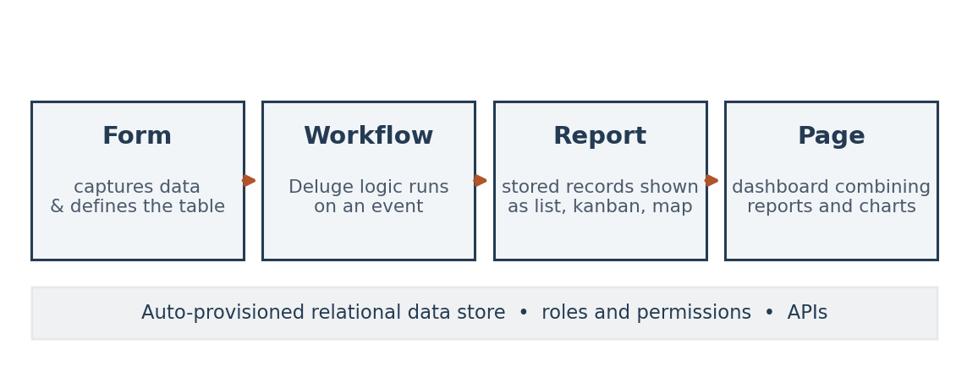
Figure 2: How the four building blocks of a Zoho Creator application relate to each other.
Blueprint sits slightly apart from the rest. It is a visual state machine for processes where a record moves through defined stages with a different owner at each one, such as an approval chain or a service request. In practice it is the feature that separates an application that stores data from an application that runs a process.

6.3 Deluge
Deluge is Zoho's scripting language and it is what makes Creator low-code rather than no-code. It reads close to plain English, which lowers the barrier considerably for someone who has never written code, and it handles validation, record manipulation, custom functions and outbound API calls through invokeUrl.
The tradeoff is obvious and worth stating plainly. Deluge exists only inside Zoho. Every hour spent writing it produces logic that cannot be moved anywhere else, and a developer who becomes expert in it has acquired a skill with exactly one employer's worth of demand behind it. That is the standard bargain in this tier of the market, but it is a bargain, not a free lunch.

6.4 The Admin Console
Creator splits its administrative functions into three groups, and the split itself tells you which concerns Zoho treats as genuinely separate.
Group | Modules | What it covers
Develop | Applications, Microservices | Building the app and the reusable services it calls
Deploy | Environments, Mobile, Portal | Releasing through Development, Stage and Production; mobile delivery; external user access
Manage | Users, Organization, Governance, Metrics, Operations, Billing | Access control, identity, security policy, usage analytics, operational tooling, subscription
Table 3: How the Zoho Creator admin console is organised.
Of these, Environments is the one I would point to if asked what separates a governed platform from an ungoverned one. It gives you Development, Stage and Production as distinct copies, with an explicit publish step between them and a version history you can roll back from. Without that, every change a citizen developer makes is a change to a live system, and that single fact accounts for a large share of low-code's reputation for fragility.
Operations gathers the account-level tools: backup, audit trail, logs, API management, email configuration, domain restriction, payment gateways, Databridge for syncing with outside databases, and the settings for Zia. Governance handles security policies, custom authentication, Active Directory sync and custom domains. Between them these two modules are Zoho's answer to the governance problem described in Section 9, and they are more complete than the price point would lead you to expect.

6.5 What AI Does Here
Zia, Zoho's assistant, now appears at several points in the build process rather than only in the finished application. You can generate an application or a form from a description. You can ask it to write, annotate or optimise a Deluge block. And the Zia task in Deluge exposes a language model directly to your workflow, so summarising text, classifying a support request or pulling structured fields out of an uploaded document becomes an ordinary step rather than an integration project.
Two things about the implementation are worth noticing. Zia can run on Zoho's own models or on an external provider such as OpenAI, Gemini or Anthropic, configured per organisation, which matters for anyone with data residency constraints. And the configuration lives under Operations rather than inside the app builder, meaning an administrator decides what AI is available rather than each developer deciding for themselves. That is a governance choice dressed up as a menu location.

6.6 What It Costs
Creator is licensed per user across three published tiers, Standard, Professional and Enterprise, with a custom Flex tier above them and a fifteen-day trial that defaults to Professional. Published rates put Standard around USD 8 to 12 per user per month on annual billing, Professional around USD 20 to 25, and Enterprise around USD 25 to 37. Monthly billing costs meaningfully more. Higher tiers unlock custom domains, wider Zia capability and larger limits on environments and integrations.
The commercially decisive fact is not the list price. Zoho One bundles Creator at Professional tier alongside the rest of the Zoho suite, so for any organisation already standardised on Zoho, Creator is effectively free. Microsoft does the same thing with Power Apps and Microsoft 365. A good deal of both products' market position comes from that bundling rather than from anything a feature comparison would reveal.

6.7 An Honest Assessment
What works well | What to be aware of
Very low cost to start, and effectively free inside Zoho One | Deluge does not port anywhere, so exit is expensive
Real governance tooling: environments, audit trail, security policies, directory sync | Interface customisation runs out before the logic does
Deluge makes genuine logic accessible without a programming background | Documentation quality is patchy on the more advanced modules
AI is available at build time and inside workflows, not just as a chat panel | Some AI assistance still expects an external model provider
Mobile access and external portals are included rather than sold separately | Applications at heavy scale or with bespoke interfaces will hit ceilings
Table 4: Assessment of Zoho Creator based on the trial account walkthrough.

7. Trend: AI Has Moved Inside the Builder
The biggest change in this category over the past two years is easy to state. AI used to be a feature you added to an application you had built. Now it builds the application. You describe what you want, and the platform produces a data model, a set of forms and a first pass at the logic, which you then correct.
The important line is between assistance and agency. Assistive AI finishes a line of code or suggests a field type while you remain the author. Agentic AI takes an objective and works through a plan to reach it, calling tools and making decisions along the way without checking in at each step. Everyone ships the first kind now. The competition is over the second, and so is the risk, because an agent that misunderstands what you asked for can produce a great deal of confident, wrong work very quickly.
Three consequences are visible already. Platforms are building human review checkpoints in as proper workflow steps rather than bolting them on. Retrieval and vector storage are becoming standard services so AI features can work against the organisation's own data. And review capacity is quietly becoming the real limit on delivery speed, because once generating something costs almost nothing, the expensive part is checking it.
- Application scaffolding from a natural-language description, compressing the first draft from days to minutes.
- Code assistance inside the scripting layer, generating and explaining logic from intent.
- Model calls as ordinary workflow steps, turning classification and extraction into configuration.
- Agentic execution of multi-step tasks with explicit review points before anything reaches production.

8. Trend: Who Builds the Software Has Changed
Roughly four in five people building applications on low-code platforms do not work in IT. That figure gets quoted a lot and it is softer than it sounds, since it depends heavily on what counts as an application, but the direction is not in dispute.
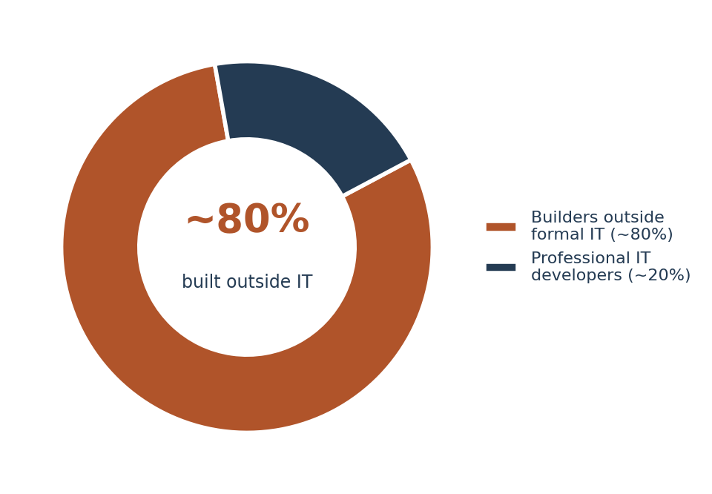
Figure 3: Share of low-code application building happening outside formal IT departments.
The more interesting development is structural. The unit that seems to work is the fusion team, meaning a small group combining someone who understands the process with someone who understands the architecture. The domain expert builds most of it. The developer handles integration, performance and anything that must not break. This arrangement fixes the failure mode of unstructured citizen development, where a business-critical application turns out to have been built by one person who has since changed roles and left no documentation.
Citizen development and shadow IT describe the same activity. The difference is entirely governance: whether the building is sanctioned, bounded and visible, or none of those. Three questions decide which one an organisation ends up with. Who is allowed to build? What data can they reach? What does an application have to satisfy before it carries real work? Organisations that answer those in advance get citizen development. Organisations that do not get shadow IT, and usually find out during an audit.

9. Trend: Governance Is Catching Up
Security remains the single largest brake on enterprise low-code adoption, and the worry is legitimate. A platform that makes building easy makes ungoverned building equally easy, and someone unfamiliar with data classification can move regulated information into an unmonitored store without meaning any harm at all.
The response taking hold is governance-by-design. Instead of reviewing each application after the fact, the controls sit in the platform so everything built on it inherits a baseline. Encryption, activity logging, role-based access, environment separation and restrictions on which data sources are reachable get configured once and apply to everyone, including the people who were not thinking about security when they started.
Delivering that at scale usually means a federated model. A central team sets standards and configures the guardrails. Trained champions inside each business unit review applications in their own area. Only things touching sensitive data or heading for production scale go to central review. It spreads the work without lowering the bar.
The most useful idea to come out of this trend is that the cure for shadow IT is substitution, not prohibition. People go around IT because the official route is slow. Blocking the alternatives without fixing the speed simply moves the activity somewhere you cannot see it.

61%  of IT leaders name shadow IT a top concern | 73%  of adopters have no formal governance rules | 47%  worry about scalability limits | 39%  cite security as a direct barrier
Figure 4: Governance and risk concerns reported by enterprise IT leaders, 2026 survey composites.

10. Trend: Platforms Are Specialising by Industry
General-purpose platforms are being joined by products built for one industry, most visibly healthcare, financial services and the public sector. These arrive with compliance controls already configured, industry-standard data models and templates for the workflows that sector actually runs. You can configure a general platform to meet healthcare privacy requirements. A vertical platform shows up already meeting them, with the audit documentation written.
This is a familiar pattern in enterprise software. Once everyone's core capability is roughly comparable, the competition moves to depth of fit for a specific regulatory context. The likely outcome over the next few years is consolidation, with two or three dominant players per industry and general platforms keeping the long tail of cases too small to justify specialised tooling.

11. Trend: Openness Versus Lock-In
Vendor lock-in has become a top-tier purchasing concern, and it is starting to shape what vendors build. Buyers increasingly want standard connectors, logic they can export, API-first design and something that fits into the DevOps pipeline they already run, rather than an environment that owns everything it touches.
This also enables the hybrid arrangement most organisations are drifting toward anyway. Low-code and conventional engineering are not two answers to one question. They suit different problems. A low-code platform handles the operational tool that needs to exist next month and will probably be replaced in three years. Conventional engineering handles the system that has to run for a decade. What decides whether the result is a coherent estate or just a pile of adjacent things is the connective tissue between them: shared identity, common data contracts, APIs that actually work.
There is a contradiction here that nobody in the industry says out loud. The openness trend runs directly against the bundling economics described in Section 6.6, where platforms win by being deeply woven into an ecosystem the customer already owns. Deep integration is exactly what makes a platform hard to leave. Buyers say they value portability and then choose convenience, which is a reasonable choice as long as it is made knowingly.

12. Where Each Trend Stands
Positioning the five trends by maturity and likely trajectory gives the following picture. AI capability is the least mature and carries the most impact. Citizen development is already normal. Governance is moving fastest from optional to expected.
Trend | What is driving it | Maturity in 2026 | Where it goes next
AI inside the builder | Model-generated schema, interfaces and logic | Emerging | Becomes a baseline feature, stops differentiating
Agentic execution | Autonomous multi-step task completion | Early | Fast uptake; review capacity becomes the bottleneck
Citizen development | Developer shortage and the IT backlog | Maturing | Standard operating model in large organisations
Governance-by-design | Shadow IT and regulatory exposure | Early to growing | A purchasing requirement, not a selling point
Vertical platforms | Compliance depth and domain templates | Growing | Consolidation to a few leaders per industry
Open architecture | Fear of lock-in | Growing | A differentiator, but bundling pulls the other way
Table 5: Maturity and outlook for the five surveyed trends.

13. What Tends to Go Wrong
None of the growth has removed the problems that come with spreading software creation more widely. Five failure patterns show up repeatedly.
- Applications outgrow the platform. Something built for twelve people in one department behaves badly when four hundred use it. The failure is rarely dramatic. It is usually a slow degradation that becomes obvious only after the application has become important and the person who built it has moved on.
- Leaving turns out to be expensive. Proprietary languages and hosted data make migration costly, and the cost only becomes visible when pricing or product direction changes, which is precisely when leverage is lowest.
- Sensitive data ends up in the wrong place. Someone building a tracker copies customer records into it without realising what that means under GDPR, HIPAA or India's DPDP Act. This is almost always inadvertent, which is exactly why platform-level controls work better than training.
- The estate fragments. Applications built in isolation duplicate data and processes instead of simplifying them, and the organisation ends up with fifty tools that are individually convenient and collectively incoherent.
- AI output goes unreviewed. When generating something costs nothing, more of it reaches production without anyone reading it carefully. Generated logic that is subtly wrong is much harder to catch than logic that simply fails.
None of these are arguments against adopting low-code. They are arguments for putting the governance described in Section 9 in place before the estate grows, because retrofitting it onto three hundred undocumented applications is a far worse job than setting it up on the first ten.

14. The Next Three Years
The trends in this report look more likely to merge than to compete. AI generation and agentic execution will become things every platform has, at which point they stop separating vendors and start separating the organisations that review output well from the ones that do not. Governance-by-design will finish becoming a procurement checkbox, and platforms without environment separation, audit trails and policy controls will get filtered out before anyone evaluates their features.
Vertical platforms will consolidate. Open architecture will keep gaining ground in what buyers say while bundling keeps winning in what they do, and the resolution will probably be partial: lock-in accepted for peripheral applications, portability insisted on for core ones.
The question I find most interesting concerns the developer role. If a platform can produce a working application from a paragraph of description, then construction is no longer the scarce skill. What remains scarce is knowing what should be built, judging whether the generated thing is right, and keeping a fast-growing estate of applications coherent. That is a change in what expertise means. It is not a reduction in how much of it you need.

15. Conclusion
Low-code has finished the crossing from interesting technology to ordinary infrastructure. The market is growing at twenty to thirty percent a year, most new enterprise applications are expected to involve it, and the landscape has separated into tiers that serve genuinely different problems rather than one undifferentiated market.
Working through Zoho Creator directly made the general claims concrete. It is a capable platform at a price that makes it accessible to a student or a small team, with governance tooling that is better than the price suggests, and one clear structural weakness in Deluge, which is a language you can only use in one place. That weakness is shared by most of its tier, and it is exactly what the openness trend is reacting against.
The five trends surveyed are not separate developments. They are parts of one movement. Software creation is being opened up, sped up by AI, and, because of the first two, re-governed at the same time. Organisations that treat these as one coordinated change get the productivity gains. Organisations that pursue speed and defer governance end up with an estate they cannot account for, which is a slower and more expensive problem than the backlog they set out to fix.

16. References
Gartner. Magic Quadrant for Enterprise Low-Code Application Platforms, 2026.
Gartner. Forecast: Low-Code Development Technologies Market, 2026.
Grand View Research. Low-Code Application Development Platform Market Size, Share & Trends Report, 2024-2030.
Mordor Intelligence. Low-Code Development Platform Market - Growth, Trends and Forecasts (2026-2031).
Fortune Business Insights. Low-Code Development Platform Market Size, Share and Industry Analysis, 2026-2034.
Forrester Research. Enterprise Low-Code Adoption and Security Survey, 2026.
Kissflow. Low-Code Trends and Statistics Shaping Enterprise IT in 2026.
ToolJet. Low-Code Development Platforms: Statistics and Trends, 2026.
Persistence Market Research. Low-Code Development Platform Market Share and Forecast, 2026-2033.
Zoho Corporation. Zoho Creator Product Documentation and Release Notes, 2026.
Zoho Corporation. Zoho Deluge Help - Zia Task and AI Tasks Reference, 2026.
Zoho Corporation. Zoho Creator Pricing Plans and FAQs, 2026.
Zoho Corporation. Zoho Adds Advanced AI Capabilities to its Low-Code Development Platform (press release).
Microsoft. Power Platform Governance Documentation, 2026.
Primary observation: Zoho Creator trial account, admin console walkthrough, July 2026.

