DATE: 28/07/2026 CB23F35 EXPERIMENT – 2
EXPLORING THE ZOHO CREATOR LOW-CODE DEVELOPMENT PLATFORM

1. Aim
To explore the Zoho Creator low-code application development platform, to study the structure of its administrator dashboard, and to understand the purpose of every module available under its three functional categories — Develop, Deploy and Manage.

2. Objectives
- To create a Zoho Creator account and a sample application on the platform.
- To navigate the admin dashboard and identify the modules grouped under Develop, Deploy and Manage.
- To document the function of each module with supporting screenshots.
- To understand how a low-code platform separates application building, deployment and administration.

3. Requirements
Item | Details
Platform | Zoho Creator (creator.zoho.in) — 15-day trial account
Browser | Google Chrome
Operating System | Windows 11
Account Type | Super Admin (single-user organisation)
Sample Application | “My first Creator app”

4. Theory
Zoho Creator is a low-code application development platform that allows users to build custom business applications with minimal hand-written code. Instead of writing an application from scratch, the developer designs forms to capture data, reports to display it, and pages to present dashboards, while the platform automatically provisions the underlying database, user interface and hosting. Business logic that cannot be expressed through the visual builder is written in Deluge, Zoho’s proprietary scripting language.
The administrator dashboard of Zoho Creator is organised into three logical categories that follow the life cycle of an application. The Develop category contains the tools used to build application logic. The Deploy category contains the tools used to release the application to different audiences and devices. The Manage category contains the administrative controls that govern who uses the application, how securely it runs, and what it costs. This separation makes the platform easier to operate in a team environment, because building, releasing and administering are handled through distinct interfaces.

5. Procedure
- Signed up for a Zoho Creator account and logged in to creator.zoho.in.
- Created a sample application named “My first Creator app” from the Applications section.
- Opened the admin dashboard and observed the left navigation pane containing the three categories.
- Visited each module in the order Develop → Deploy → Manage.
- Captured a screenshot of every module and recorded its purpose.
- Compiled the observations into the report given below.

6. Observations
The left navigation pane of the admin dashboard groups eleven modules under three headings, as summarised below.
Category | Modules
DEVELOP | Applications, Microservices
DEPLOY | Environments, Mobile, Portal
MANAGE | Users, Organization, Governance, Metrics, Operations, Billing

A. DEVELOP
The Develop category holds everything required to build the application itself — the app and its reusable back-end services.

A.1 Applications
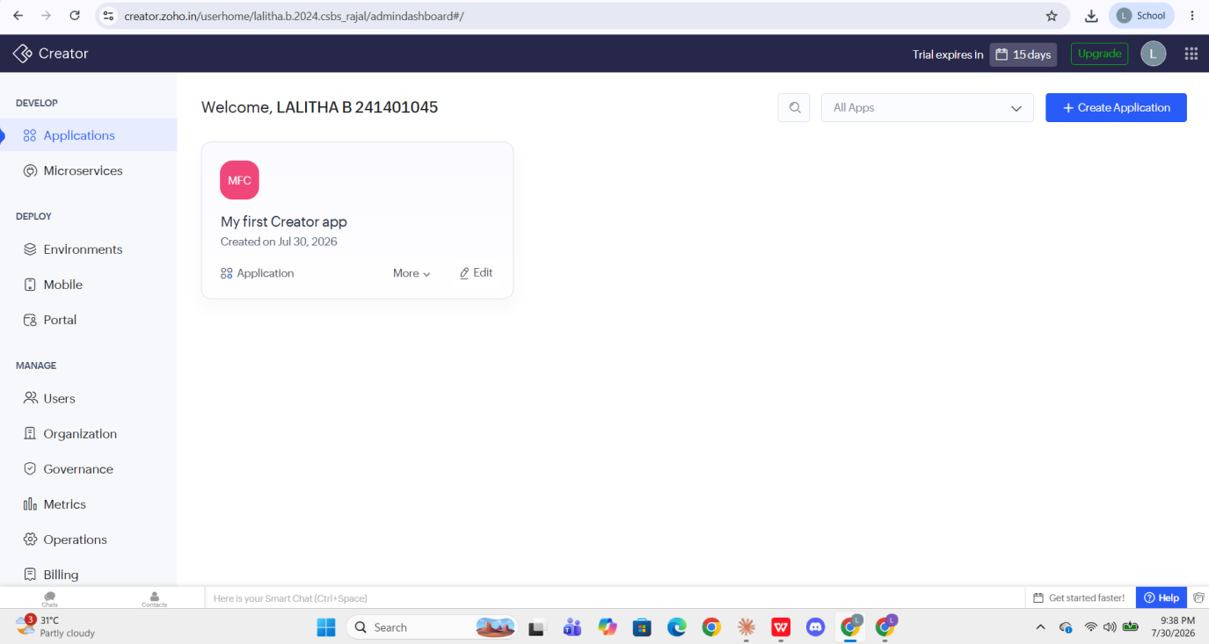
Fig. 1 — Applications module showing the created sample application
Applications is the home screen and the primary workspace of Zoho Creator. Every application built under the account is listed here as a card showing its name, icon and creation date. In the screenshot, a single application named “My first Creator app”, created on 30 July 2026, is visible.
- Create Application — starts a new app, either from scratch, from a pre-built template in the marketplace, or by importing a spreadsheet file.
- Edit — opens the application builder where forms, reports, pages and Deluge workflows are designed.
- More — provides options such as rename, duplicate, share, export and delete for the selected application.
- All Apps filter and search — used to locate a specific application when many applications exist in the account.

A.2 Microservices
Microservices allows independent, reusable back-end services to be written and hosted inside the Creator environment. Instead of duplicating the same logic in several applications, a piece of functionality — for example a tax calculation, a validation routine, or an integration with an external API — is written once as a microservice and then called by any application in the account through an endpoint. This promotes modularity and keeps individual applications lightweight. (No configuration was performed in this module during the experiment, so no screenshot is included.)

B. DEPLOY
The Deploy category controls how a finished application reaches its users — through staged releases, mobile devices, or an external self-service gateway.

B.1 Environments
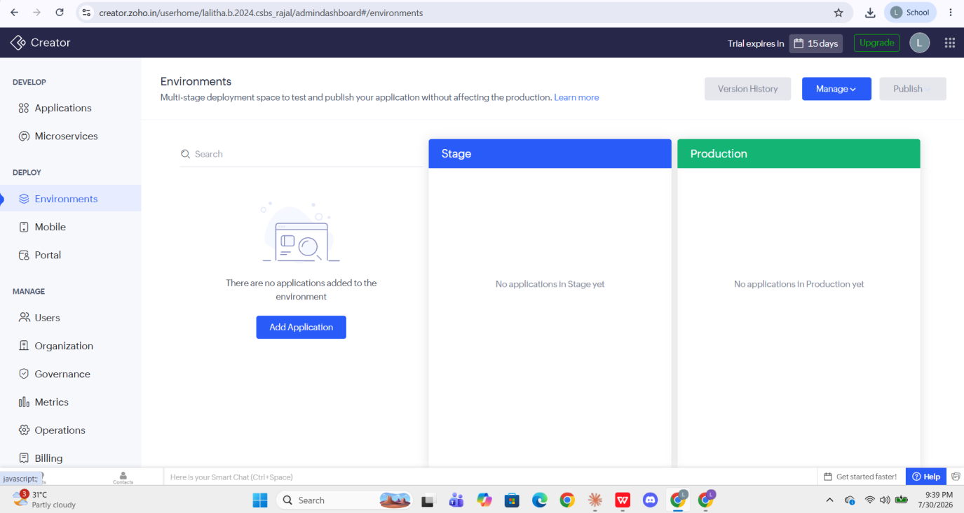
Fig. 2 — Environments module with Development, Stage and Production columns
Environments provides a multi-stage deployment space so that an application can be tested and released without disturbing the version that live users are working on. The screen is divided into three columns representing the three stages of the release pipeline.
Stage | Purpose
Development | The working copy where the developer makes changes. Applications are brought into the pipeline using the Add Application button.
Stage | A testing copy that mirrors production. Changes are verified here before release.
Production | The live version used by real end users.

- Publish — promotes an application from one stage to the next.
- Version History — lists previous published versions and allows a rollback if a release introduces a defect.
- Manage — used to configure the environments and control which applications participate in the pipeline.
In the screenshot all three columns are empty, since the sample application had not yet been added to the deployment pipeline.

B.2 Mobile
The Mobile module manages how the application behaves on smartphones and tablets. Zoho Creator applications are automatically available through the Zoho Creator mobile app, and this module is used to configure that mobile experience — controlling the layout shown on small screens, enabling offline data capture that synchronises when connectivity returns, and generating a branded native app for Android and iOS on higher plans. (This module was not configured during the experiment, so no screenshot is included.)

B.3 Portal
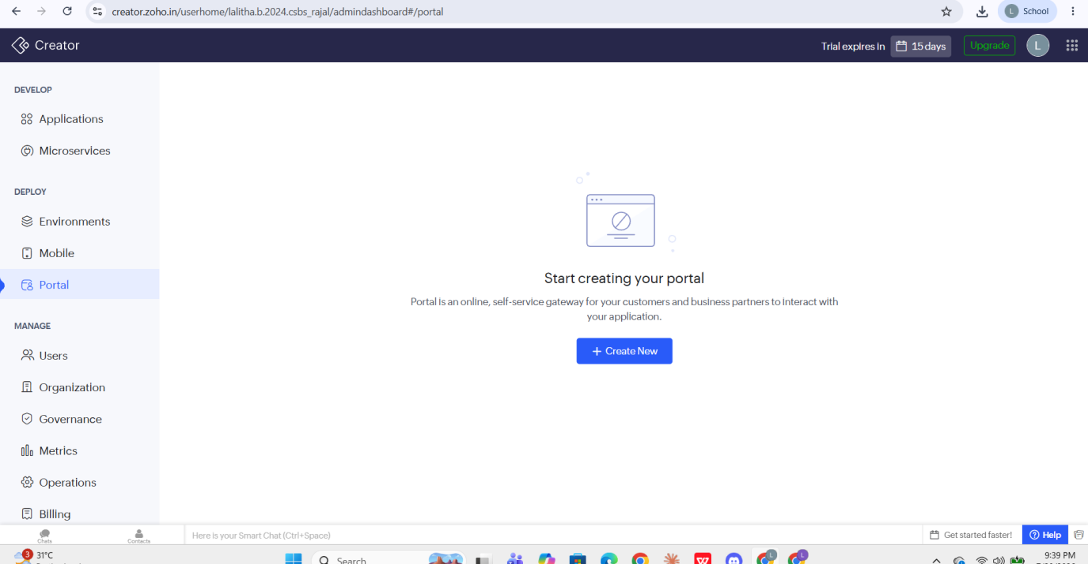
Fig. 3 — Portal module before a portal has been created
A Portal is an online, self-service gateway that lets customers and business partners interact with the application without being licensed users of the Creator account. A typical use is a customer who logs in to submit a request, check the status of an order, or upload a document, while internal staff continue to use the full application. Because portal users are external, they are counted and priced separately from internal users.
As no portal had been created at the time of the experiment, the screen displays the empty state with a Create New button.

C. MANAGE
The Manage category contains the administrative controls of the account — who the users are, how the organisation is identified, how security is enforced, how the system is monitored, and how the subscription is paid for.

C.1 Users
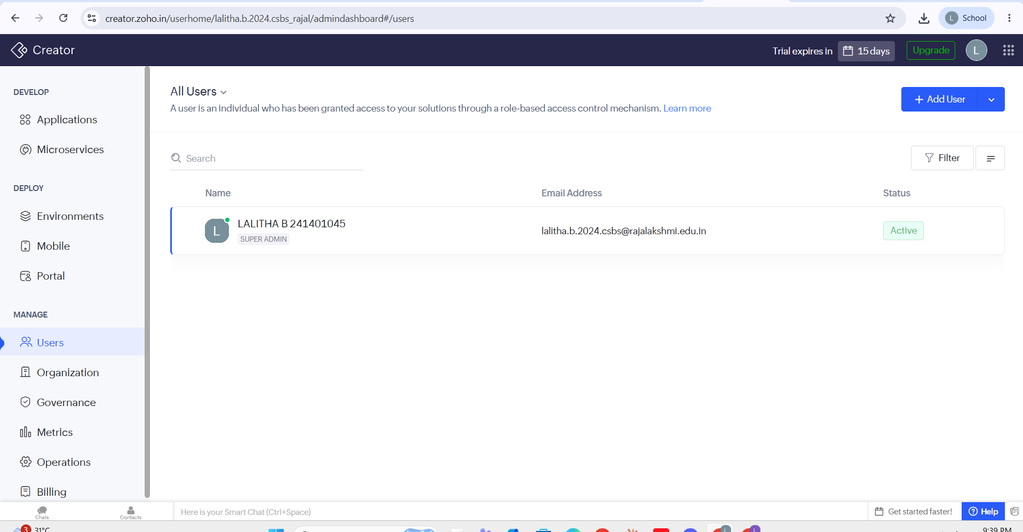
Fig. 4 — Users module listing the Super Admin of the account
The Users module manages every individual who has been granted access to the applications through a role-based access control mechanism. Each user is listed with a name, an email address and a status. In the screenshot a single user is present, marked SUPER ADMIN with the status Active — the account owner who created the organisation.
- Add User — invites a new member by email and assigns a role that determines what that member can see and do.
- Status — indicates whether an invited user is Active, or still pending confirmation of the invitation.
- Filter and Search — used to locate users by role, status or name in a large organisation.
Role-based access control means permissions are attached to a role rather than to an individual, so a person receives the correct level of access simply by being assigned the appropriate role.

C.2 Organization
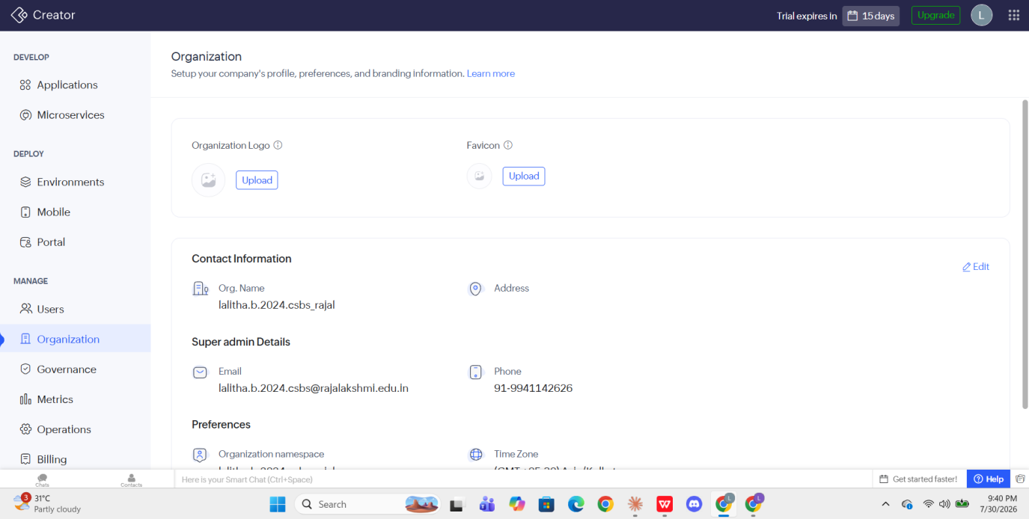
Fig. 5 — Organization module showing profile, admin details and preferences
The Organization module stores the identity, branding and default preferences of the account. It is the single place where information common to all applications in the account is defined.
Setting | Purpose
Organization Logo and Favicon | Branding images applied across the applications and portals so that the interface carries the organisation’s identity.
Contact Information | The organisation name and registered address.
Super Admin Details | The email address and phone number of the account owner, used for critical notifications and account recovery.
Organization namespace | A unique identifier that forms part of the application URLs of the account.
Time Zone | The default time zone applied to timestamps and scheduled workflows — set to (GMT +05:30) Asia/Kolkata in this account.

C.3 Governance
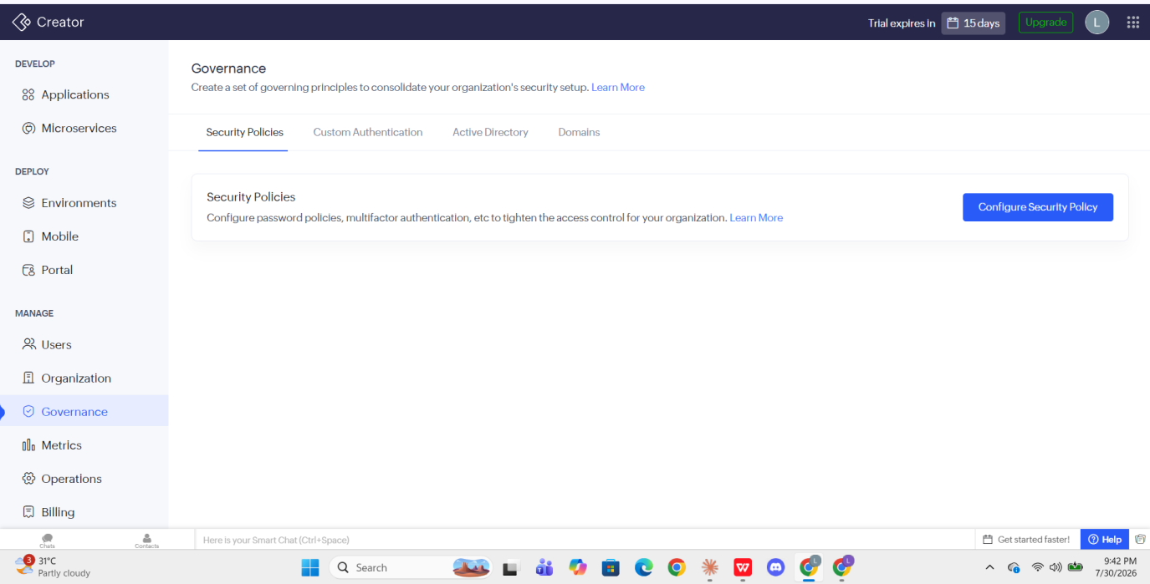
Fig. 6 — Governance module with its four configuration tabs
Governance is used to create a set of governing principles that consolidate the security setup of the organisation. It is organised into four tabs.
Tab | Function
Security Policies | Configures password strength rules, password expiry and multi-factor authentication to tighten access control.
Custom Authentication | Allows users to sign in through an external identity provider such as a single sign-on service instead of a Zoho account.
Active Directory | Synchronises users and groups from a corporate Active Directory so that access follows the existing organisational directory.
Domains | Registers and verifies custom domains so applications can be hosted on the organisation’s own web address rather than a default Zoho URL.

C.4 Metrics
The Metrics module presents usage analytics for the account — the number of records stored, the volume of API calls consumed, the number of active users, and the storage occupied. These figures are compared against the limits of the current plan, which helps the administrator detect when the account is approaching a threshold and needs an upgrade. (This module was not opened during the experiment, so no screenshot is included.)

C.5 Operations
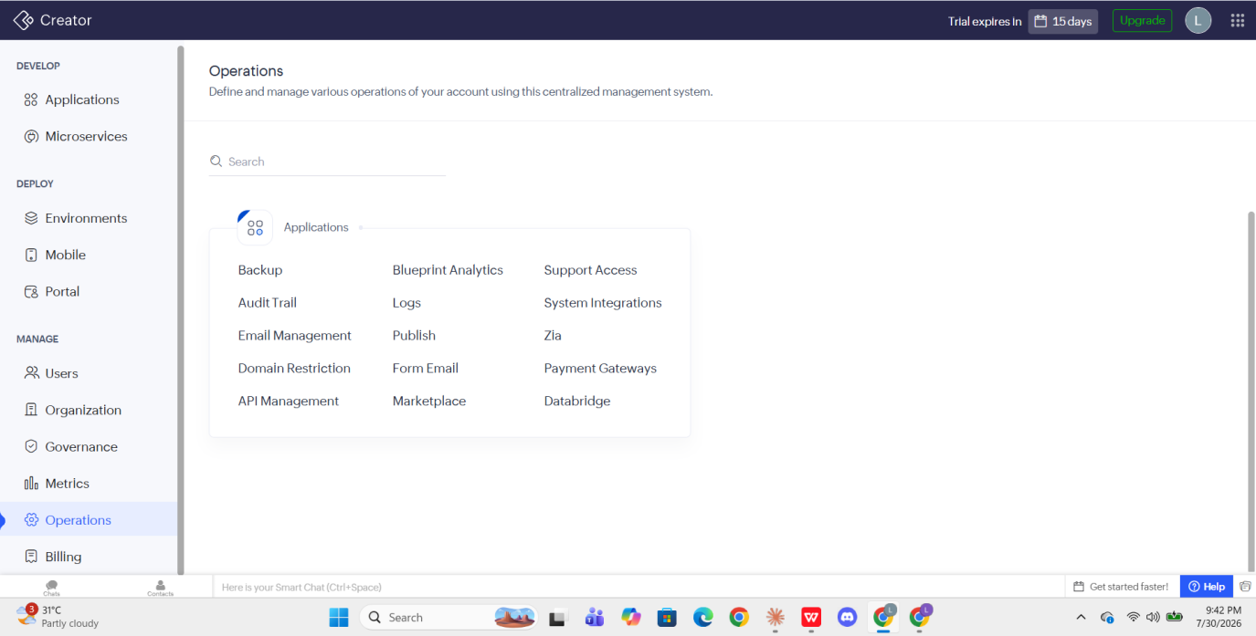
Fig. 7 — Operations module listing the account-level operational tools
Operations is a centralised management system through which the various day-to-day operations of the account are defined and managed. All the tools are grouped under an Applications panel and can be located using the search box. The individual tools are described below.
Tool | Function
Backup | Takes a copy of application data and schema so that it can be restored after accidental loss or corruption.
Audit Trail | Records who performed which action and when, providing accountability and a trail for compliance checks.
Email Management | Configures the email addresses and templates that the applications use to send notifications.
Domain Restriction | Limits access so that only users with email addresses from approved domains can sign in.
API Management | Generates and controls the API keys and endpoints through which external systems talk to the applications.
Blueprint Analytics | Reports on the performance of Blueprints — the visual business-process flows — highlighting stages where records get stuck.
Logs | Displays system and script execution logs, used to trace errors and debug workflows.
Publish | Controls how applications and individual components are made publicly available.
Form Email | Allows records to be created in the application from incoming email messages.
Marketplace | Provides ready-made application templates and extensions that can be installed into the account.
Support Access | Temporarily grants the Zoho support team permission to view the account while troubleshooting an issue.
System Integrations | Connects Creator with other Zoho services and third-party applications.
Zia | Zoho’s artificial-intelligence assistant, offering prediction, data enrichment and conversational access to application data.
Payment Gateways | Configures payment providers so that applications can collect payments through their forms.
Databridge | Synchronises data between Creator and an on-premises or external database.

C.6 Billing
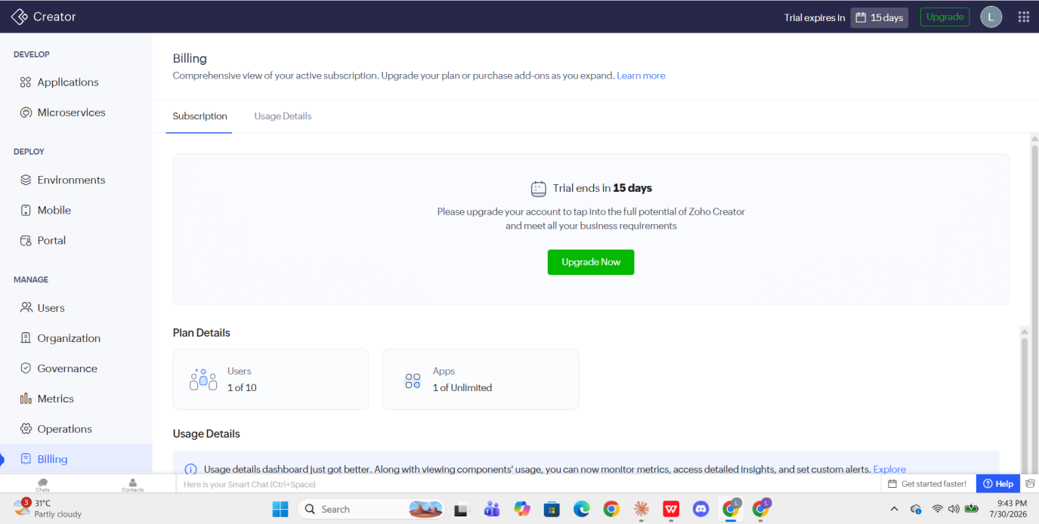
Fig. 8 — Billing module showing trial status, plan details and usage
The Billing module gives a comprehensive view of the active subscription and is where the plan is upgraded or add-ons are purchased. It is divided into a Subscription tab and a Usage Details tab.
- Trial status — the banner reports that the trial ends in 15 days, with an Upgrade Now button to convert the trial into a paid subscription.
- Plan Details — shows consumption against the entitlement of the plan. In this account, 1 of 10 users and 1 of unlimited applications are in use.
- Usage Details — monitors component-level usage, provides detailed insights, and allows custom alerts to be set so the administrator is warned before a limit is reached.

7. Result
The Zoho Creator platform was explored successfully. A sample application was created, the admin dashboard was navigated, and the function of each module under the Develop, Deploy and Manage categories was identified and documented with supporting screenshots.

8. Conclusion
From this experiment it is understood that Zoho Creator organises the complete application life cycle into three clearly separated categories. Develop provides the building tools — Applications for the app itself and Microservices for reusable back-end logic. Deploy provides the release tools — Environments for a staged Development-to-Production pipeline, Mobile for delivery on handheld devices, and Portal for controlled access by external customers and partners. Manage provides the administrative tools — Users for role-based access, Organization for identity and branding, Governance for security policy, Metrics for usage analytics, Operations for backups, logs, integrations and other day-to-day controls, and Billing for the subscription.
This structure demonstrates the central advantage of a low-code platform: the developer concentrates on business logic while the platform supplies the database, hosting, access control, deployment pipeline and monitoring as configurable services rather than as code that must be written and maintained.

