**AUTO IMMUNE LAB TRACKER**

URL: https://labservices.nimhans.ac.in

Enter the username and to login.

Example:

Username: Apollo

Password: xyz

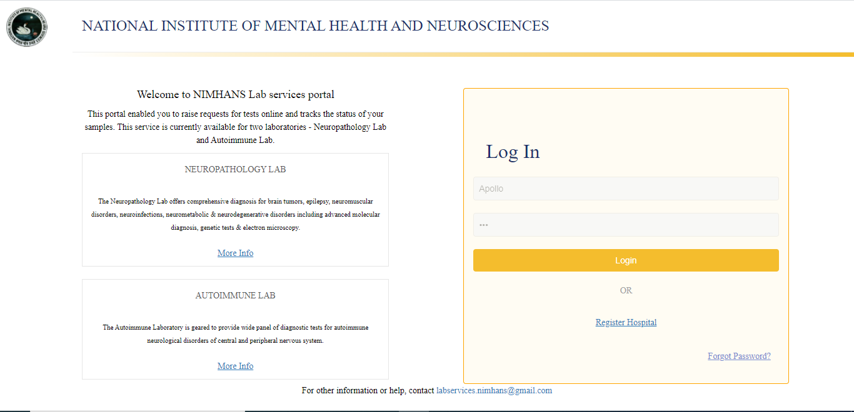

Image1: Laboratory Services Portal Login Page

After clicking login button, if the login credentials are valid, user is directed to the landing page with 2 with 2 boxes: “Neuropathology Laboratory” and “Autoimmune Laboratory”. Clicking on “Autoimmune Laboratory” directs to the home page of Autoimmune lab. Clicking on “Information on how to send samples”, “Charges for tests” ad “Help?” opens corresponding documents for the user.

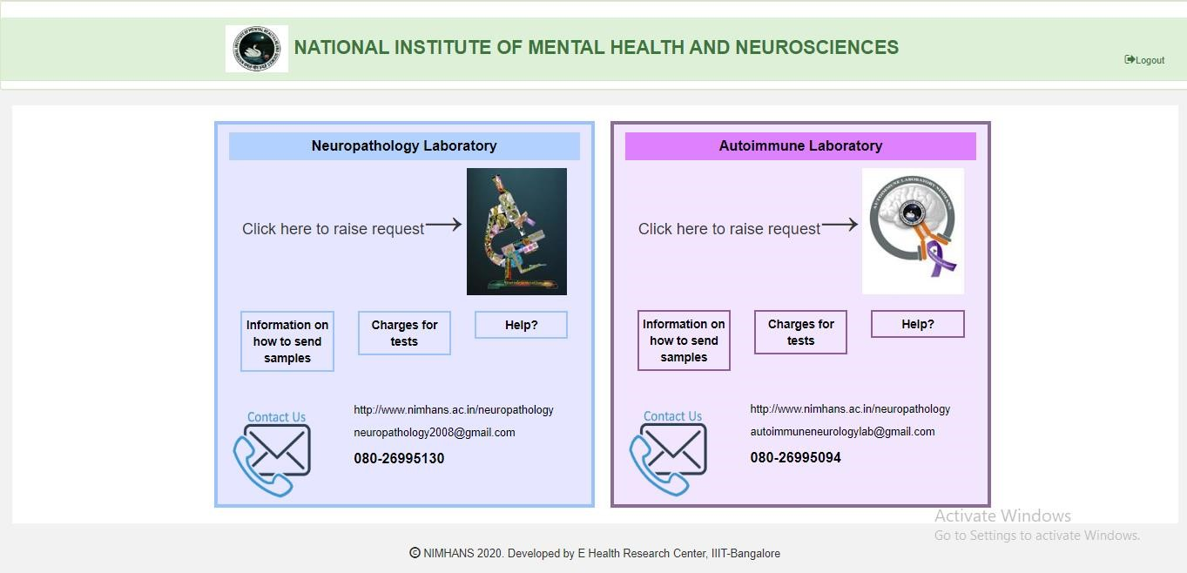

Image2: Landing Page

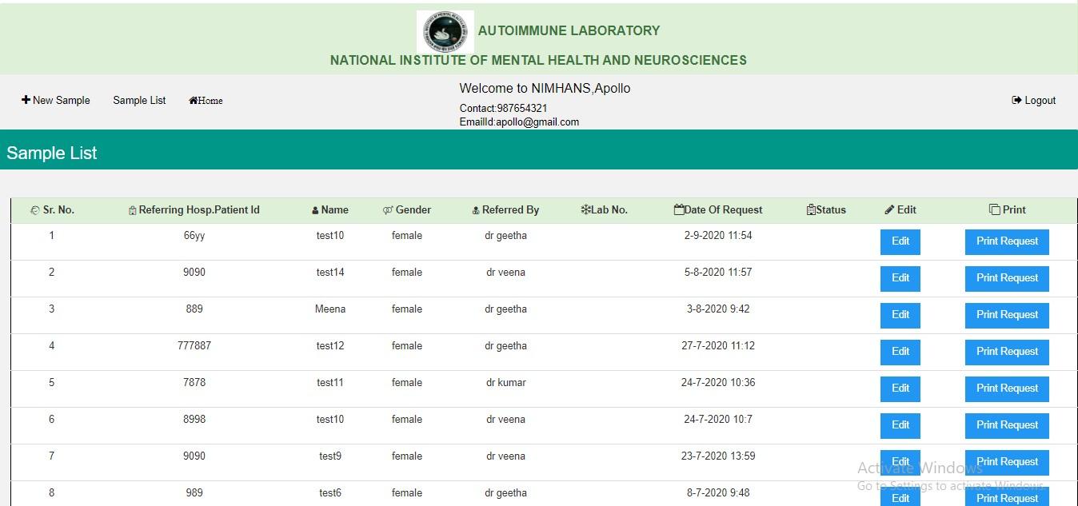

Image3: AU LAB Home Page

At the left top part of the home page, there is a button called “+ New Sample” for adding new external samples, which upon clicking directs to the page “Patient Registration”. Here all fields are mandatory. Mandatory fields are marked in red color asterisk. For payment, user has to select either DD or Online Transaction and fill in the corresponding fields. Only if all the mandatory fields are filled, the “Add Sample” button at the bottom is enabled. Otherwise it will be disabled.

To add test details for the sample, user has to select options under “Tests Required”. For tests 1, 2, 5,6,7,8, there is option “Serum”, for tests 3 and 4, there are “Serum” and “CSF”. User can select either one or both. Amount for the tests is displayed in the “Amount” field automatically based on the test.

If the user clicks on the “Back” button to go back to the sample list page, without submitting this data in this page, then the entered data will be lost(A warning is displayed)

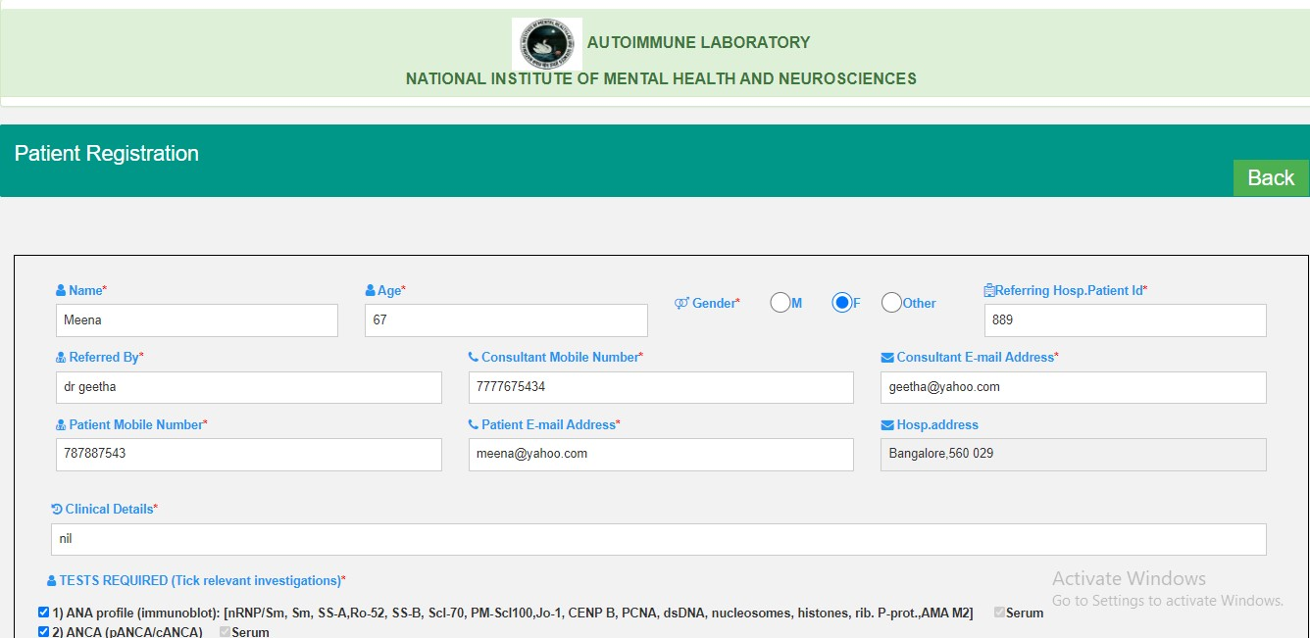

Image7: Add New Sample Page (Top)

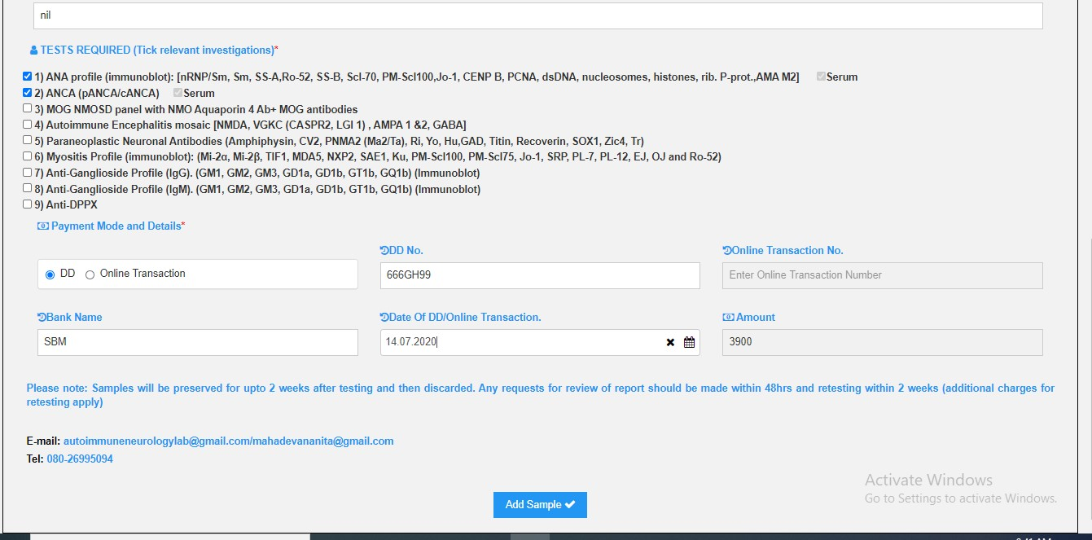

Image9: Add New Sample Page (Bottom)

In the home page, the user can see the list of external samples (LATEST FIRST order) with various details. The button “Edit” is for editing the sample details. There is another button called “Print Request” in the sample list table for displaying the added sample details in the preview page. From the preview page, user can download the page.

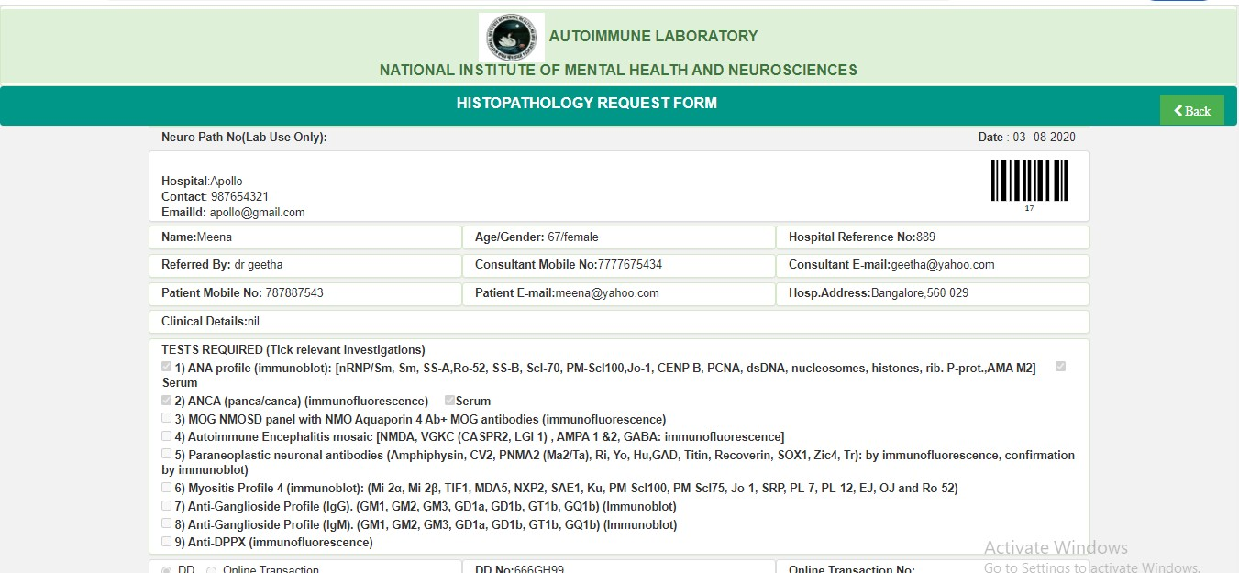

Image4: Print Request Page (Top)

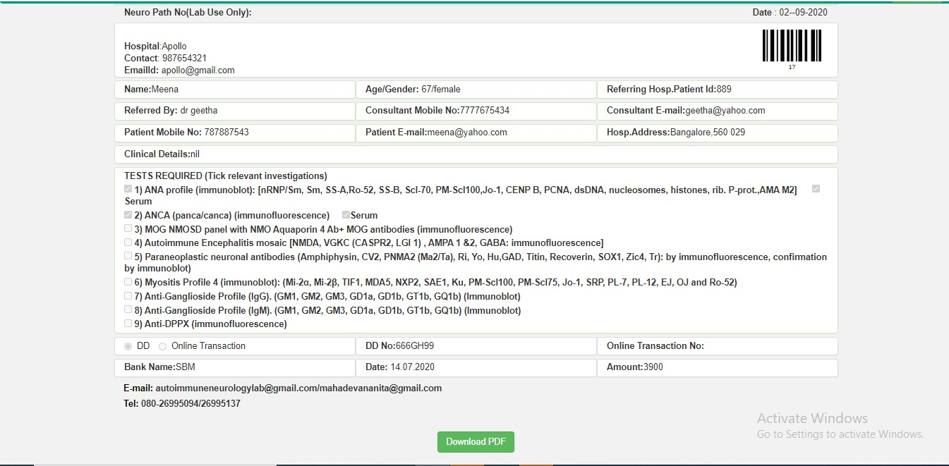

Image5: Print Request Page (Bottom)

=====================================================================================