Week 1: Strategic Planning and Data Exploration
Project title: Logistics Delivery Performance Analytics
Internship: YuvaIntern – Logistics Data Analyst Internship
Week: Week 1 – Strategic Planning and Data Exploration
Prepared by: Lalitha Pottelu

- Project Overview
This project focuses on analysing food delivery operations to understand the factors that influence delivery performance and delivery time. The analysis will use a public food delivery dataset containing information about delivery personnel, order timing, weather conditions, road traffic, vehicle characteristics, multiple deliveries, festivals, city categories, geographic locations, and delivery time.
The project follows an end-to-end data analytics approach, beginning with strategic planning and data exploration, followed by data cleaning, preprocessing, exploratory data analysis, visualization, and predictive modelling. Key operational indicators will be examined to identify patterns and factors associated with longer delivery times.
The overall objective is to transform raw logistics data into meaningful insights that can support delivery planning, operational monitoring, and data-driven decision-making. The project will also explore how predictive analytics can be applied to estimate delivery time and identify areas where logistics operations could potentially be improved.

- Business Problem Statement
Food delivery operations involve multiple factors that can affect the time required to complete an order. Traffic conditions, weather, delivery distance, vehicle characteristics, order timing, multiple deliveries, and other operational factors may contribute to variations in delivery performance.
The key business problem addressed in this project is to understand which operational and environmental factors are associated with delivery time and how these factors can be analyzed to support better logistics planning. The project will examine historical delivery data to identify patterns, measure delivery performance, and develop a foundation for predictive analysis.
The analysis is intended to answer the following central question:
“How can food delivery data be used to understand delivery performance, identify factors associated with longer delivery times, and support better operational planning?”

- Project Objectives
The main objectives of this project are:
- To understand the structure and characteristics of the food delivery dataset and identify the key variables relevant to delivery performance.
- To establish meaningful logistics Key Performance Indicators (KPIs) for monitoring delivery operations.
- To identify and address data-quality issues such as missing values, inconsistent formats, duplicate records, and potential outliers during the preprocessing stage.
- To perform exploratory data analysis and investigate relationships between delivery time and operational factors such as distance, traffic, weather, vehicle type, and order timing.
- To create meaningful features from the available raw data, including delivery distance, preparation time, day of the week, and time-of-day categories where appropriate.
- To develop a predictive model for estimating delivery time using relevant features from the cleaned dataset.
- To translate analytical and predictive findings into practical insights that could support delivery planning, operational monitoring, and resource allocation.

- Logistics Scenario
The project is based on a food delivery platform that manages orders from restaurants to customers across different urban areas. The platform coordinates delivery personnel, restaurants, vehicles, and customer locations while operating under changing traffic and weather conditions.
As order volumes vary throughout the day, delivery performance can be affected by factors such as the distance between restaurants and customers, road traffic density, weather conditions, vehicle type and condition, preparation and pickup timing, and whether a delivery person is handling multiple orders.
From an operational perspective, the platform needs to monitor delivery performance and understand the factors associated with longer delivery times. Data analytics can help transform historical delivery records into operational insights, while predictive modelling can provide estimates of expected delivery time.
In this project, the food delivery dataset will be treated as historical operational data for analytical purposes. The analysis will focus on identifying measurable patterns and relationships in the data rather than representing the operations of any specific real-world company.

- Key Performance Indicators (KPIs)
To evaluate delivery performance, the project will use the following Key Performance Indicators (KPIs):
5.1 Average Delivery Time
Definition: The average time taken to complete a delivery.
Purpose: Provides an overall measure of delivery performance and serves as the primary performance indicator for comparing different operational conditions.
Calculation: Total delivery time ÷ Number of completed deliveries.
5.2 Delivery Time Variability
Definition: The extent to which delivery times differ across orders.
Purpose: Helps identify whether delivery performance is consistent or whether certain operating conditions are associated with greater variation in delivery time.
Measurement: Standard deviation and distribution of delivery time.
5.3 Average Delivery Distance
Definition: The average geographic distance between the restaurant and the customer's delivery location.
Purpose: Helps evaluate the relationship between delivery distance and the time required to complete an order.
Measurement: Distance calculated from the restaurant and delivery-location coordinates.
5.4 Average Preparation/Pickup Time
Definition: The average time between the order being placed and the order being picked up by the delivery person.
Purpose: Helps distinguish potential preparation or pickup delays from the time spent travelling to the customer.
Measurement: Difference between the order time and pickup time.
KPI Usage
These KPIs will be analysed together rather than in isolation. Average delivery time will provide the primary performance measure, while delivery-time variability, distance, and preparation/pickup time will provide additional context for understanding operational performance.

- Dataset and Data Source
6.1 Data Source
The project uses a publicly available Food Delivery Dataset obtained from Kaggle. The dataset is provided in separate training and testing files. For this project, the train.csv file will be used as the primary dataset for data exploration, preprocessing, analysis, and predictive modelling.
The dataset will be treated as historical food delivery operational data for academic and analytical purposes. It does not represent data from any specific company in this project.
6.2 Dataset Characteristics
The training dataset contains information related to delivery personnel, restaurant and customer locations, order timing, environmental conditions, traffic, vehicle characteristics, order characteristics, and delivery duration.
Key variables include:
Category | Example Variables
Delivery personnel | Delivery person ID, age, rating
Location | Restaurant latitude/longitude, delivery location latitude/longitude
Timing | Order date, order time, pickup time
Environment | Weather conditions, road traffic density
Vehicle | Vehicle condition, vehicle type
Order | Type of order, multiple deliveries
Events & location | Festival, city category
Target variable | Time taken for delivery
The dataset provides a suitable foundation for investigating delivery performance and developing a predictive analysis workflow.
6.3 Data Usage Plan
The raw train.csv file will first be preserved without modification. Data quality issues will be examined during the preprocessing stage. Relevant features may then be created from existing variables, such as delivery distance, preparation/pickup duration, day of the week, and time-of-day categories.
The test.csv file will remain separate from the primary analysis dataset and will not be used to generate exploratory findings.

- Relevant Data Science Concepts
7.1 Regression
Regression is a supervised learning technique used to predict a numerical outcome based on one or more input variables.
In this project, regression can be used to predict delivery time in minutes. Potential input variables may include delivery distance, traffic conditions, weather, vehicle type, preparation time, multiple deliveries, and time-related features.
The predicted delivery time could help provide an estimate of the time required to complete a delivery and support operational planning.
7.2 Clustering
Clustering is an unsupervised learning technique used to group observations with similar characteristics without requiring a predefined target label.
In a logistics context, clustering could be used to identify groups of deliveries with similar characteristics, such as short-distance deliveries, high-traffic deliveries, or deliveries with longer preparation times.
These groups could help identify different operational patterns that may require different planning approaches.
7.3 Optimization
Optimization involves selecting the most suitable decision or allocation of resources while considering defined objectives and constraints.
In this project, optimization concepts could be applied to logistics planning. For example, delivery operations could potentially use analytical insights to improve resource allocation, prioritize deliveries, or manage delivery capacity under different traffic and demand conditions.
Optimization will be discussed as a potential decision-support approach rather than claiming that a specific optimization solution has already been implemented.
7.4 Relationship Between the Concepts
These concepts support different stages of the overall analytics process:
- Descriptive analysis → Understand what is happening in delivery operations.
- Regression → Estimate delivery time and investigate predictive relationships.
- Clustering → Identify groups of deliveries with similar operational characteristics.
- Optimization → Use analytical insights to support better operational decisions.

- Strategic Analytical Roadmap
The project will follow a structured end-to-end analytical roadmap. The objective is to move from raw operational data toward reliable insights and predictive decision support while maintaining data quality at every stage.
Stage 1 — Business Understanding
Define the logistics business problem, identify the main delivery-performance objective, and establish the key questions that the analysis should answer.
Key question:
What operational and environmental factors are associated with variations in delivery time?
Stage 2 — Data Collection and Understanding
Use the train.csv file from the publicly available Food Delivery Dataset as the primary analytical dataset. Examine the dataset structure, variables, data types, distributions, and relationships between the available fields.
Stage 3 — Data Quality Assessment
Inspect the raw data for:
- Missing values
- Duplicate records
- Incorrect or inconsistent data types
- Invalid or unusual values
- Inconsistent categorical labels
- Potential outliers
Data-quality issues will be documented before applying appropriate cleaning methods.
Stage 4 — Data Cleaning and Preprocessing
Prepare the dataset for analysis by handling missing values, correcting data types, standardizing categorical values, and addressing inappropriate or extreme observations were justified.
Time-related fields will be converted into suitable formats, and relevant numerical variables will be prepared for analysis and modelling.
Stage 5 — Feature Engineering
Create meaningful analytical features from the available raw variables.
Potential engineered features include:
- Delivery distance calculated from geographic coordinates
- Preparation/pickup duration calculated from order and pickup times
- Day of the week derived from the order date
- Time-of-day category derived from order time
- Other relevant variables identified during data exploration
Each engineered feature will be evaluated for its analytical relevance before being included in the final dataset.
Stage 6 — Exploratory Data Analysis
Analyse delivery performance using descriptive statistics and visualizations.
The analysis will examine relationships between delivery time and factors such as:
- Distance
- Traffic density
- Weather conditions
- Vehicle type and condition
- Preparation/pickup duration
- Multiple deliveries
- Time of day
- City category
- Festival status
The purpose is to identify patterns, variations, and potential operational bottlenecks.
Stage 7 — KPI Analysis
Calculate and monitor the defined logistics KPIs, including average delivery time, delivery-time variability, average delivery distance, and average preparation/pickup time.
KPIs will be compared across relevant operational categories to provide a structured view of delivery performance.
Stage 8 — Predictive Modelling
Develop a predictive model to estimate delivery time using relevant features from the cleaned dataset.
Candidate approaches may include:
- Linear Regression
- Decision Tree Regression
- Ensemble Regression methods
The final model will be selected based on its performance and suitability for the project rather than assuming a particular algorithm will perform best in advance.
Stage 9 — Model Evaluation
Evaluate the predictive model using appropriate regression metrics, including:
- Mean Absolute Error (MAE)
- Root Mean Squared Error (RMSE)
- R-squared (R²)
Where appropriate, cross-validation and hyperparameter tuning will be considered to improve model reliability and reduce the risk of overfitting.
Stage 10 — Operational Insights and Optimization
Translate the analytical and predictive findings into practical logistics insights.
Potential decision-support areas include:
- Delivery resource allocation
- Planning for high-traffic periods
- Identifying conditions associated with longer delivery times
- Managing delivery capacity
- Supporting route and operational planning
Any recommendations will be based on the actual findings obtained from the analysis rather than assumptions made before analysing the data.
Stage 11 — Business Decision Support
The final stage will communicate the major findings through clear visualizations, KPI summaries, predictive results, and actionable recommendations.
The overall objective is to create a repeatable analytics workflow that helps transform historical delivery data into information that can support operational planning and data-driven decision-making.
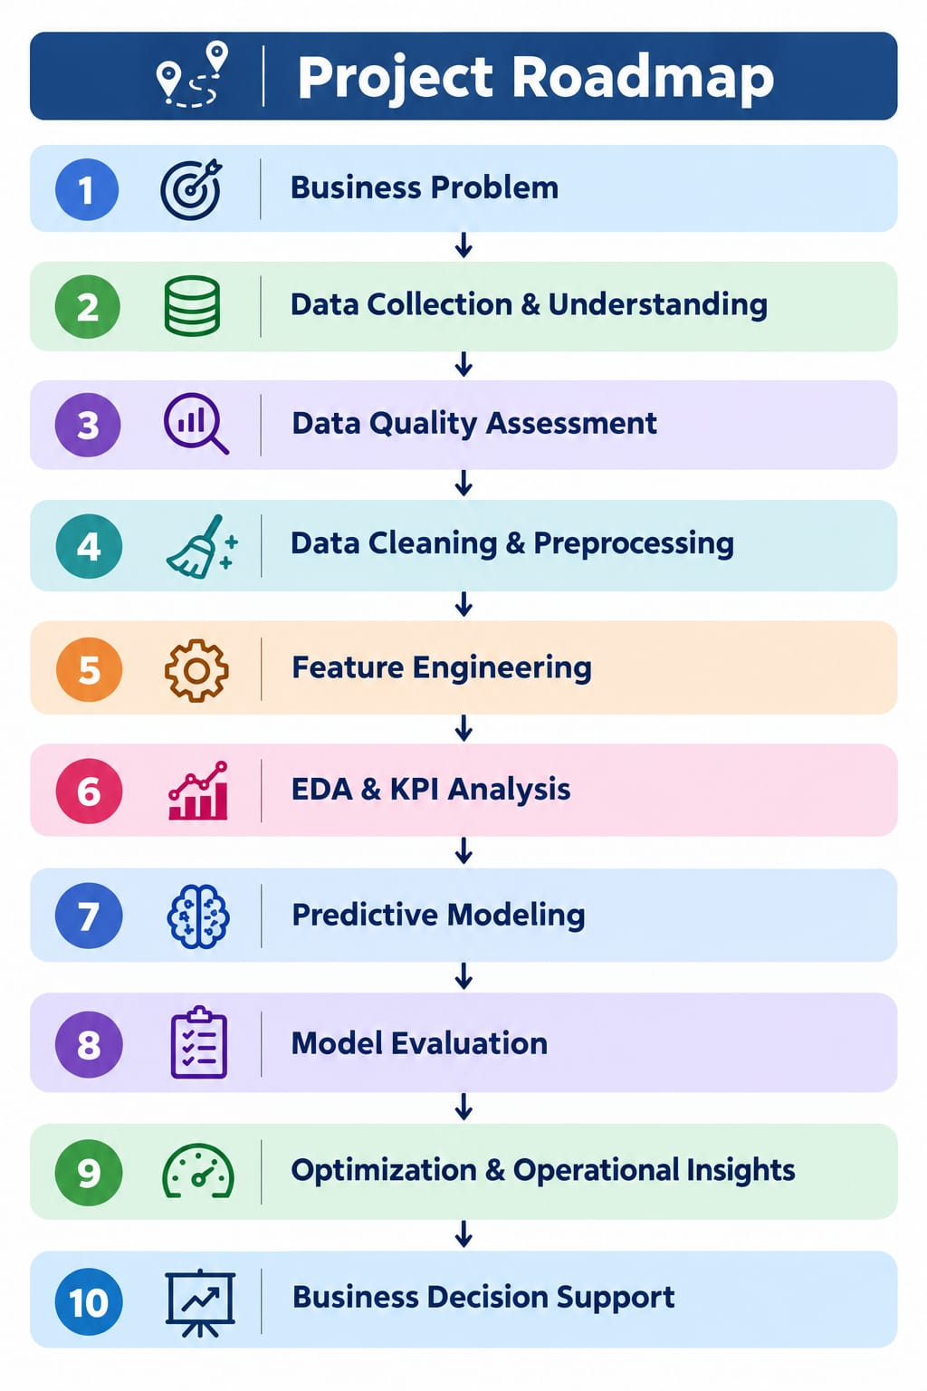

- Python Implementation Plan
Python will be used throughout the project for data inspection, cleaning, feature engineering, exploratory analysis, visualization, and predictive modelling. The implementation will use Pandas and NumPy for data processing, Matplotlib and Seaborn for visualization, and Scikit-learn for predictive modelling.
9.1 Dataset Loading and Initial Inspection
The raw train.csv file will be loaded without modifying the original dataset. Initial inspection will be performed to understand the dataset structure, column names, data types, missing values, and duplicate records.
import pandas as pd
import numpy as np
df = pd.read_csv("train.csv")
print(df.shape)
print(df.head())
print(df.info())
print(df.isnull().sum())
print(df.duplicated().sum())
The dataset contains 45,593 records and 20 variables. The initial inspection will be used to identify data-quality issues that need to be addressed during the preprocessing stage.
9.2 Data Cleaning and Preprocessing
Several fields require conversion or standardization before analysis. For example, delivery age, ratings, multiple deliveries, and delivery time are stored as text values in the raw dataset.
A simplified preprocessing approach will be:
df["Delivery_person_Age"] = pd.to_numeric(
df["Delivery_person_Age"], errors="coerce"
)
df["Delivery_person_Ratings"] = pd.to_numeric(
df["Delivery_person_Ratings"], errors="coerce"
)
df["Time_taken(min)"] = (
df["Time_taken(min)"]
.astype(str)
.str.extract(r"(\d+\.?\d*)")[0]
.astype(float)
)
Date and time fields will also be standardized so that they can be used for feature engineering and analysis.
9.3 Feature Engineering
Additional analytical variables will be created from the available raw fields. These may include:
- Distance_km — geographic distance between the restaurant and delivery location.
- Preparation_Time_min — time between order placement and order pickup.
- Day_of_Week — day derived from the order date.
- Time_of_Day — category based on the order time.
The geographic distance can be estimated using the latitude and longitude coordinates:
from math import radians, sin, cos, sqrt, atan2
def calculate_distance(lat1, lon1, lat2, lon2):
R = 6371
dlat = radians(lat2 - lat1)
dlon = radians(lon2 - lon1)
a = (
sin(dlat / 2) ** 2
+ cos(radians(lat1))
* cos(radians(lat2))
* sin(dlon / 2) ** 2
)
return 2 * R * atan2(sqrt(a), sqrt(1 - a))
The exact feature-engineering implementation will be refined during the preprocessing stage after validating the raw values and time formats.
9.4 Exploratory Data Analysis
After cleaning and feature engineering, Python will be used to examine delivery-time patterns and relationships with operational factors.
Examples include:
df["Time_taken(min)"].describe()
df.groupby("Road_traffic_density")["Time_taken(min)"].mean()
df.groupby("Weatherconditions")["Time_taken(min)"].mean()
df.groupby("Type_of_vehicle")["Time_taken(min)"].mean()
Visualizations will be created to investigate distributions, category-level differences, relationships, and potential operational bottlenecks.
9.5 Predictive Modelling
In the final stage, relevant cleaned features will be used to develop a regression model for estimating delivery time.
A simplified workflow will be:
from sklearn.model_selection import train_test_split
from sklearn.metrics import mean_absolute_error, mean_squared_error, r2_score
X_train, X_test, y_train, y_test = train_test_split(
X, y, test_size=0.20, random_state=42
)
model.fit(X_train, y_train)
predictions = model.predict(X_test)
mae = mean_absolute_error(y_test, predictions)
rmse = np.sqrt(mean_squared_error(y_test, predictions))
r2 = r2_score(y_test, predictions)
Candidate regression approaches will include Linear Regression, Decision Tree Regression, and an ensemble regression model. The final model will be selected based on appropriate evaluation metrics and suitability for the logistics problem.
9.6 Implementation Objective
The Python workflow is designed to create a repeatable analytical process:
Raw Dataset → Data Inspection → Data Cleaning → Feature Engineering → EDA & KPI Analysis → Predictive Modelling → Evaluation → Operational Insights
The implementation will be developed progressively with findings and model results based on the cleaned dataset rather than assumptions made during the initial planning stage.

- Conclusion and Expected Outcomes
10.1 Conclusion
This Week 1 strategic planning stage establishes a structured analytical approach for the Logistics Delivery Performance Analytics project. The selected food delivery dataset contains operational, geographic, environmental, vehicle, order, and delivery-time information that can be used to investigate factors associated with delivery performance.
The project will progress from data understanding and quality assessment to preprocessing, feature engineering, exploratory analysis, KPI measurement, predictive modelling, and operational interpretation. The analysis will focus on identifying measurable relationships between delivery time and factors such as traffic conditions, weather, delivery distance, preparation time, vehicle characteristics, multiple deliveries, and order timing.
The planned analytical workflow provides a foundation for transforming raw delivery records into meaningful information that can support logistics planning and operational decision-making. The findings in the later stages will be based on the cleaned and analysed dataset rather than assumptions made during the planning stage.
10.2 Expected Outcomes
The project is expected to produce the following outcomes:
- Improved understanding of delivery performance through relevant KPIs such as average delivery time, delivery-time variability, delivery distance, and preparation/pickup time.
- Identification of data-quality issues including missing values, inconsistent formats, invalid values, and other preprocessing requirements in the raw dataset.
- Creation of useful analytical features such as delivery distance, preparation time, day of the week, and time-of-day categories.
- Identification of delivery-time patterns and relationships across traffic conditions, weather, vehicle characteristics, multiple deliveries, order timing, and other operational factors.
- Development of a predictive model capable of estimating delivery time using relevant operational and environmental features.
- Model performance evaluation using appropriate metrics such as MAE, RMSE, and R² to understand prediction accuracy.
- Operational insights for logistics planning, including identification of conditions associated with longer delivery times and areas where resource allocation or operational planning may be improved.
- A repeatable data analytics workflow that demonstrates how raw logistics data can be transformed into analytical insights and predictive information for business decision support.
The final recommendations will be developed after completing the data cleaning, exploratory analysis, and predictive modelling stages. This ensures that operational decisions are supported by evidence obtained from the actual dataset.

- References and Data Source
Data Source
Kaggle. Food Delivery Dataset. Publicly available food delivery dataset containing delivery personnel, location, order timing, weather, traffic, vehicle, order, and delivery-time information.
Primary file used: train.csv
Technical References
- Pandas Documentation — Data manipulation and analysis using Python.
- NumPy Documentation — Numerical computing with Python.
- Matplotlib Documentation — Data visualization in Python.
- Seaborn Documentation — Statistical data visualization in Python.
- Scikit-learn Documentation — Machine learning and model evaluation.
These references provide the technical foundation for the data preprocessing, exploratory analysis, visualization, and predictive modelling stages of the project.

