Advanced Data Analysis and Visualization in Logistics

YuvaIntern – Logistics Data Analyst Internship
Week 3: Advanced Data Analysis and Visualization
Prepared by: Lalitha Pottelu

1. Introduction
Logistics performance analysis helps identify factors that affect delivery time and operational efficiency. This project uses Python to explore food delivery data, summarize delivery performance, visualize important patterns, and identify areas for potential improvement.
The analysis was performed using Pandas, NumPy, Matplotlib, and Seaborn in Google Colab.

2. Objectives
- Analyze delivery-time patterns using descriptive statistics.
- Examine relationships between delivery time and traffic, weather, vehicle condition, and other available variables.
- Create visualizations to communicate important findings.
- Identify potential operational improvements based on the results.
- Document the methodology, findings, and recommendations.

3. Dataset Description
The dataset contains food delivery records with information about delivery personnel, order characteristics, traffic density, weather conditions, vehicle condition, city, festival status, and delivery time.
The dataset used in this analysis contains 45,593 records and 20 columns.
The target measure for the analysis is Time_taken(min), which represents delivery time in minutes.
The dataset does not contain explicit transportation-cost or shipment-volume fields. Therefore, these two measures were not analyzed.

4. Tools and Technologies
- Python: Data analysis and processing.
- Pandas: Dataset loading, cleaning, grouping, and summarization.
- NumPy: Numerical operations and missing-value handling.
- Matplotlib: Charts and visualizations.
- Seaborn: Statistical visualizations.
- Google Colab: Execution of Python code and documentation of results.

5. Methodology
5.1 Data Loading and Validation
The cleaned dataset was loaded into a Pandas DataFrame. Its dimensions, column names, data types, descriptive statistics, and important variable values were examined.
5.2 Data Quality Checks
The dataset was checked for missing values, duplicate rows, and unusual numerical values. Text placeholders representing missing values were standardized, and selected categorical fields were assigned an Unknown category where appropriate.
5.3 Exploratory Data Analysis
Delivery time was analyzed using summary statistics and visualizations. Comparisons were performed across traffic density, weather conditions, vehicle condition, city, order type, vehicle type, multiple deliveries, festival status, and delivery-person ratings.
5.4 Correlation Analysis
Correlation analysis was used to examine numerical relationships between delivery time and selected numerical variables. Correlation indicates association and does not establish causation.

6. Key Performance Indicators
The main delivery-time statistics were:
- Total delivery records: 45,593
- Average delivery time: 26.29 minutes
- Median delivery time: 26 minutes
- Minimum delivery time: 10 minutes
- Maximum delivery time: 54 minutes
- Standard deviation: 9.38 minutes
- Average delivery-person rating: 4.64
These measures provide an overview of delivery performance and the variation in delivery times.

7. Analysis and Visualizations
This section presents the exploratory data analysis and visualizations performed on the logistics dataset using Python. Different charts were created using Matplotlib and Seaborn to examine delivery-time patterns and their relationships with traffic density, weather conditions, vehicle condition, city, order type, vehicle type, multiple deliveries, festival status, and delivery-person ratings. Each visualization is supported by a Python code excerpt and an interpretation of the results.
7.1 Delivery Time Distribution
Interpretation: The average delivery time was 26.29 minutes, and the median was 26 minutes. Delivery times ranged from 10 to 54 minutes, showing variation in the time required to complete deliveries.
Python Code:
plt.figure(figsize=(10, 5))
sns.histplot(data=df, x="Time_taken(min)", bins=30, kde=True)
plt.title("Distribution of Delivery Times")
plt.xlabel("Delivery Time (minutes)")
plt.ylabel("Number of Deliveries")
plt.tight_layout()
plt.show()

Output:
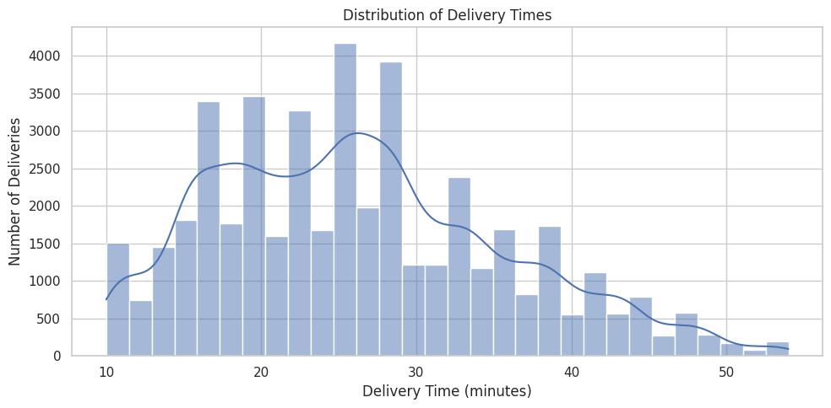

7.2 Delivery Time by Road Traffic Density
Interpretation: Deliveries during jam traffic had an average delivery time of 31.18 minutes, compared with 21.27 minutes under low traffic. This suggests that traffic conditions are associated with delivery delays.
Python Code:
traffic_summary = df.groupby("Road_traffic_density")["Time_taken(min)"].agg(
["count", "mean", "median", "min", "max"]
).round(2)
display(traffic_summary)
plt.figure(figsize=(10, 5))
sns.boxplot(data=df, x="Road_traffic_density", y="Time_taken(min)")
plt.title("Delivery Time by Road Traffic Density")
plt.xlabel("Road Traffic Density")
plt.ylabel("Delivery Time (minutes)")
plt.tight_layout()
plt.show()
Output:
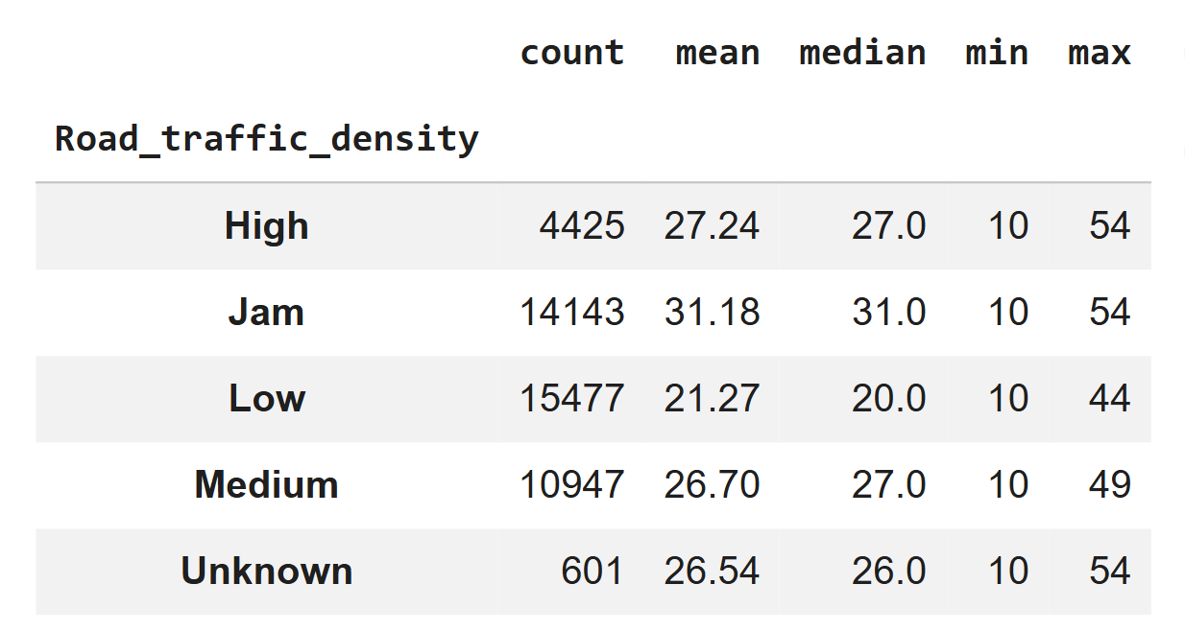
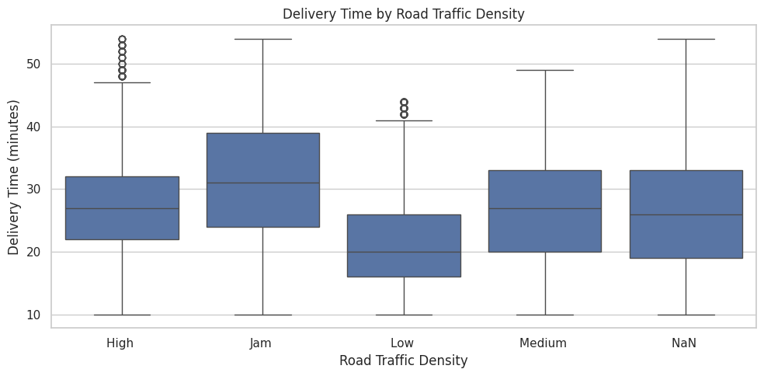

7.3 Delivery Time by Weather Conditions
Interpretation: Delivery times varied across weather categories. Cloudy and foggy conditions had average delivery times of approximately 28.92 minutes, while sunny conditions averaged approximately 21.86 minutes. These are observed differences and do not prove that weather alone caused the variation.
Python Code:
weather_summary = df.groupby("Weatherconditions")["Time_taken(min)"].agg(
["count", "mean", "median", "min", "max"]
).round(2)
display(weather_summary)
plt.figure(figsize=(10, 5))
sns.boxplot(data=df, x="Weatherconditions", y="Time_taken(min)")
plt.title("Delivery Time by Weather Conditions")
plt.xlabel("Weather Conditions")
plt.ylabel("Delivery Time (minutes)")
plt.xticks(rotation=30)
plt.tight_layout()
plt.show()

Output:
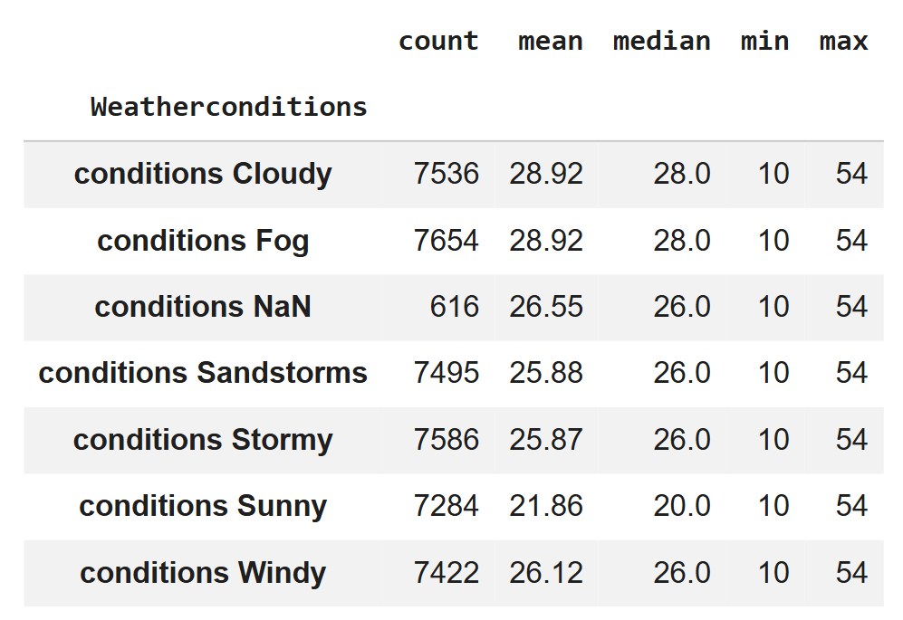
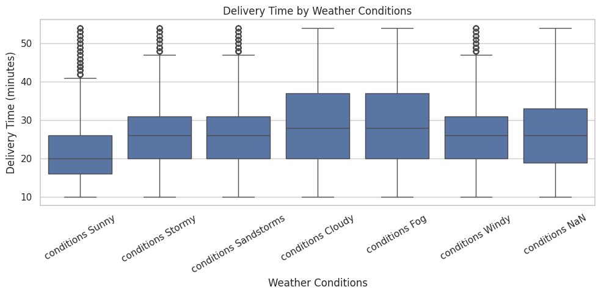

7.4 Delivery Time by Vehicle Condition
Interpretation: Average delivery time differed across the recorded vehicle-condition codes. The meaning of each code should be verified from the dataset documentation before drawing operational conclusions.
Python Code:
vehicle_summary = df.groupby("Vehicle_condition")["Time_taken(min)"].agg(
["count", "mean", "median", "min", "max"]
).round(2)
display(vehicle_summary)
plt.figure(figsize=(8, 5))
sns.boxplot(data=df, x="Vehicle_condition", y="Time_taken(min)")
plt.title("Delivery Time by Vehicle Condition")
plt.xlabel("Vehicle Condition")
plt.ylabel("Delivery Time (minutes)")
plt.tight_layout()
plt.show()

Output:
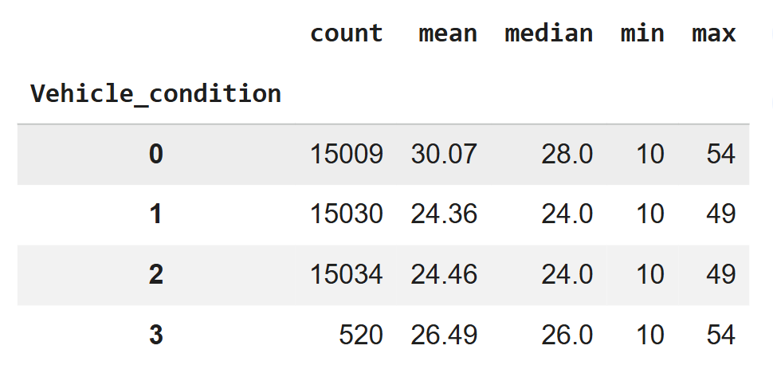

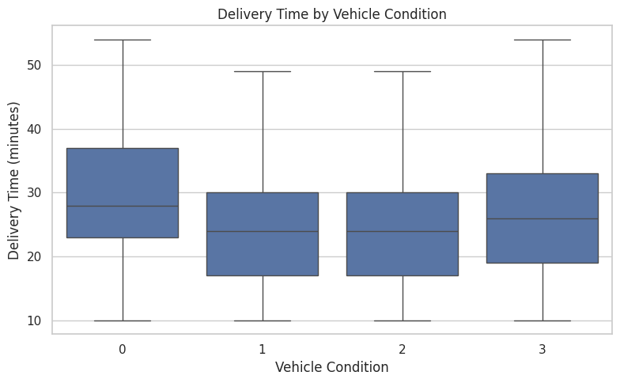

7.5 Delivery Time by City
Interpretation: The recorded city categories showed differences in average delivery time. The Semi-Urban category had a higher average, but its sample size was only 164 records. This result should be interpreted cautiously.
Python Code:
city_summary = df.groupby("City")["Time_taken(min)"].agg(
["count", "mean", "median", "min", "max"]
).round(2)
display(city_summary)
plt.figure(figsize=(8, 5))
sns.boxplot(data=df, x="City", y="Time_taken(min)")
plt.title("Delivery Time by City")
plt.xlabel("City")
plt.ylabel("Delivery Time (minutes)")
plt.tight_layout()
plt.show()

Output:
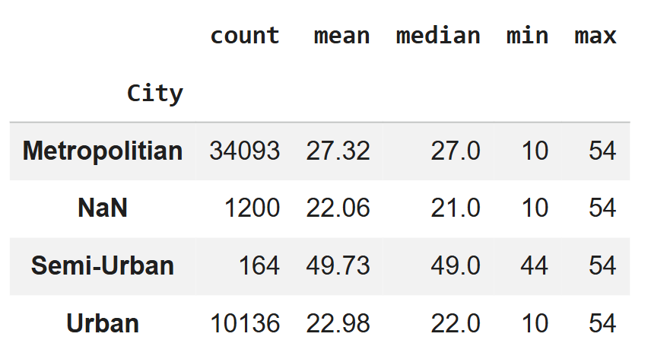

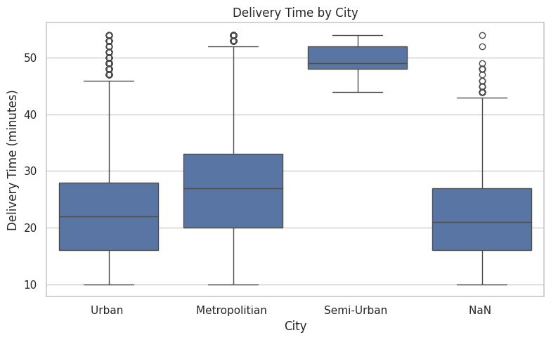

7.6 Delivery Time by Order Type and Vehicle Type
Interpretation: Average delivery times were similar across the four order types. Differences were observed across vehicle types, but the bicycle category contained only 68 records, so its average may be less representative.
Python Code:
order_summary = df.groupby("Type_of_order")["Time_taken(min)"].agg(
["count", "mean", "median", "min", "max"]
).round(2)
display(order_summary)
plt.figure(figsize=(8, 5))
sns.boxplot(data=df, x="Type_of_order", y="Time_taken(min)")
plt.title("Delivery Time by Type of Order")
plt.xlabel("Type of Order")
plt.ylabel("Delivery Time (minutes)")
plt.tight_layout()
plt.show()

Output:
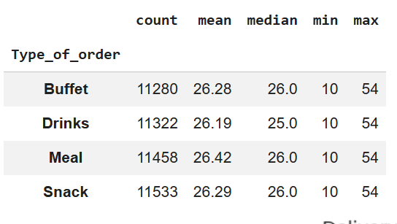

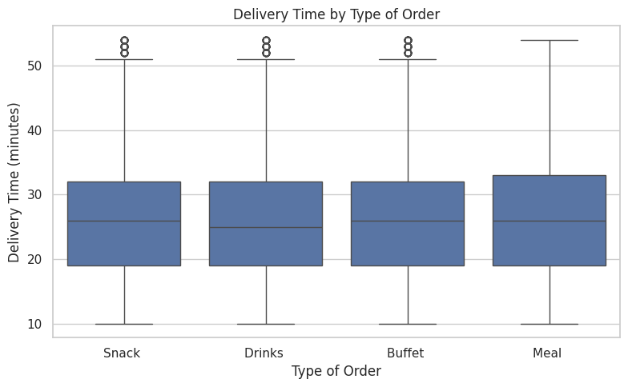
Python Code:
vehicle_type_summary = df.groupby("Type_of_vehicle")["Time_taken(min)"].agg(
["count", "mean", "median", "min", "max"]
).round(2)
display(vehicle_type_summary)
plt.figure(figsize=(8, 5))
sns.boxplot(data=df, x="Type_of_vehicle", y="Time_taken(min)")
plt.title("Delivery Time by Type of Vehicle")
plt.xlabel("Type of Vehicle")
plt.ylabel("Delivery Time (minutes)")
plt.tight_layout()
plt.show()
Output:
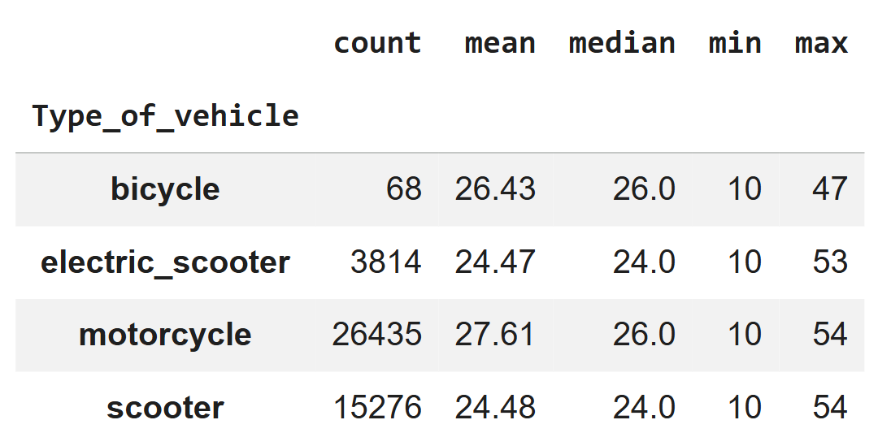
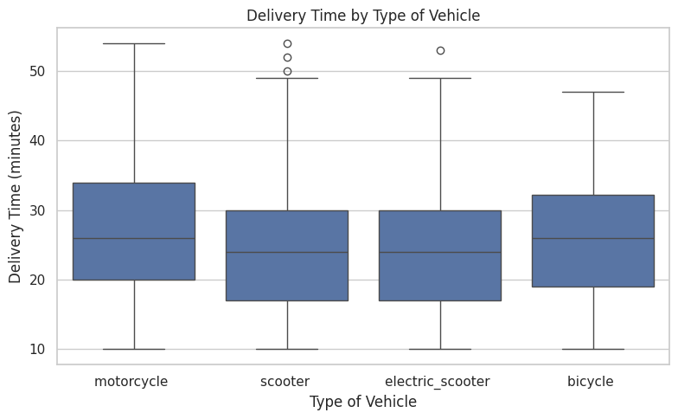
7.7 Delivery Time by Number of Multiple Deliveries
Interpretation: Average delivery time increased as the recorded number of multiple deliveries increased. Records with three multiple deliveries had an average delivery time of 47.82 minutes, compared with 22.88 minutes for the category recorded as zero. This relationship warrants further investigation.
Python Code:
multiple_delivery_summary = df.groupby("multiple_deliveries")["Time_taken(min)"].agg(
["count", "mean", "median", "min", "max"]
).round(2)
display(multiple_delivery_summary)
plt.figure(figsize=(8, 5))
sns.boxplot(data=df, x="multiple_deliveries", y="Time_taken(min)")
plt.title("Delivery Time by Number of Multiple Deliveries")
plt.xlabel("Number of Multiple Deliveries")
plt.ylabel("Delivery Time (minutes)")
plt.tight_layout()
plt.show()

Output:
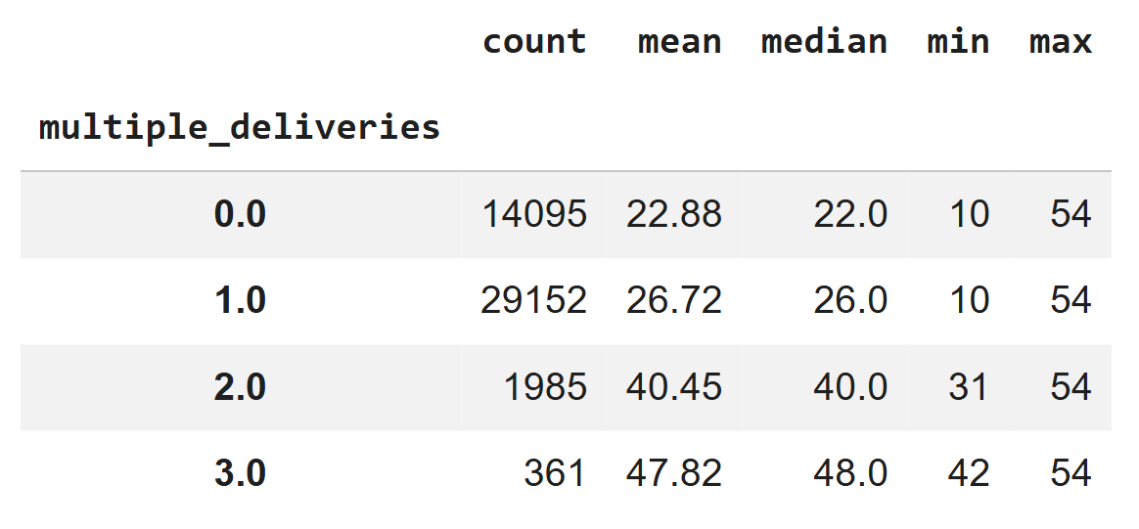

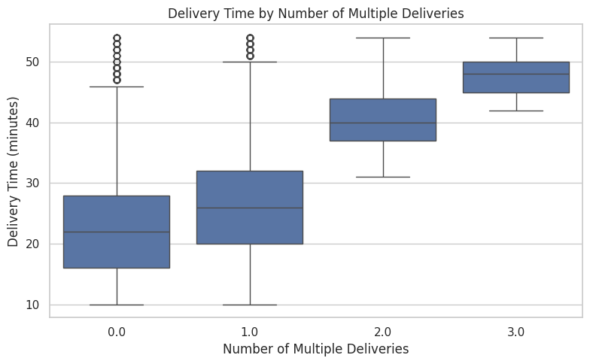
7.8 Delivery Time by Festival Status
Interpretation: Records marked as festival-related deliveries had an average delivery time of 45.52 minutes, compared with 25.98 minutes for records marked as non-festival deliveries. The Unknown category should not be interpreted as an actual festival condition.
Python Code:
festival_summary = df.groupby("Festival")["Time_taken(min)"].agg(
["count", "mean", "median", "min", "max"]
).round(2)
display(festival_summary)
plt.figure(figsize=(8, 5))
sns.boxplot(data=df, x="Festival", y="Time_taken(min)")
plt.title("Delivery Time by Festival Status")
plt.xlabel("Festival Status")
plt.ylabel("Delivery Time (minutes)")
plt.tight_layout()
plt.show()
Output:
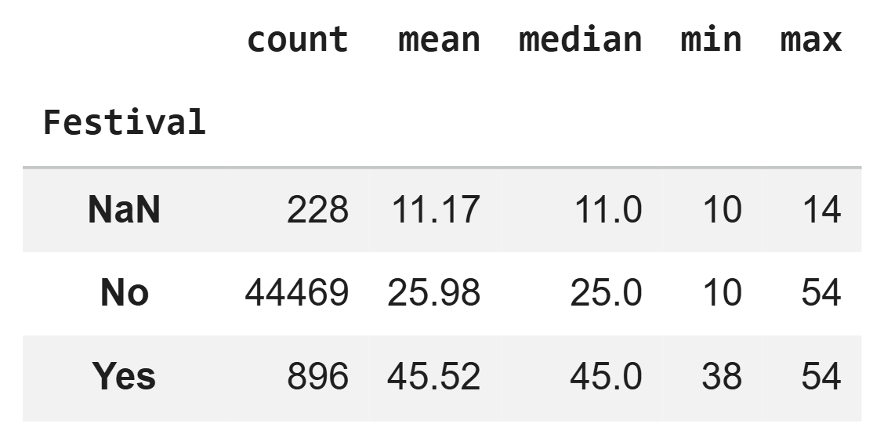
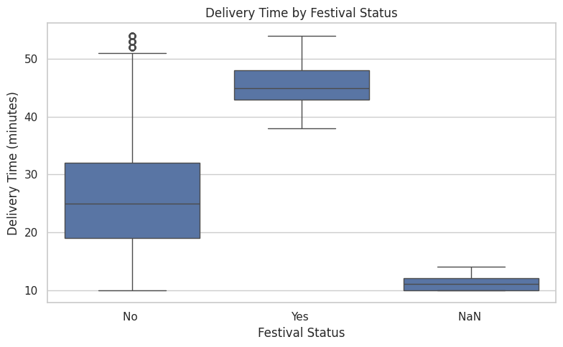
7.9 Delivery Time by Delivery-Person Ratings
Interpretation: Lower delivery-person ratings were generally associated with longer delivery times in the dataset. This relationship does not establish whether delivery time affects ratings or whether other factors influence both.
Python Code:
festival_summary = df.groupby("Festival")["Time_taken(min)"].agg(
["count", "mean", "median", "min", "max"]
).round(2)
display(festival_summary)
plt.figure(figsize=(8, 5))
sns.boxplot(data=df, x="Festival", y="Time_taken(min)")
plt.title("Delivery Time by Festival Status")
plt.xlabel("Festival Status")
plt.ylabel("Delivery Time (minutes)")
plt.tight_layout()
plt.show()

Output:

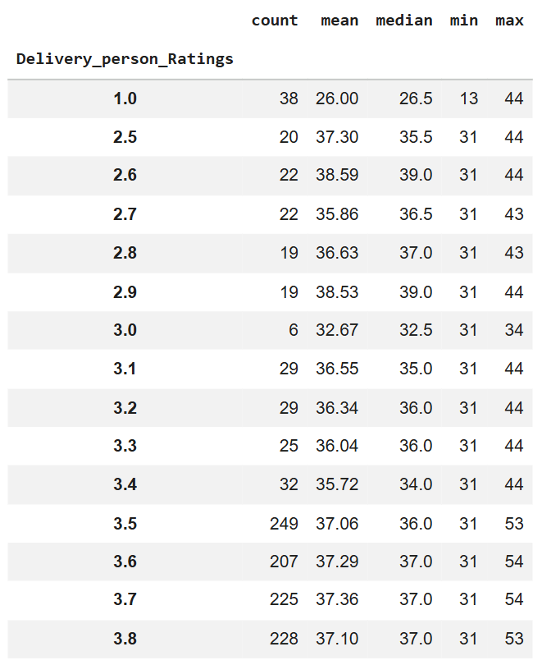
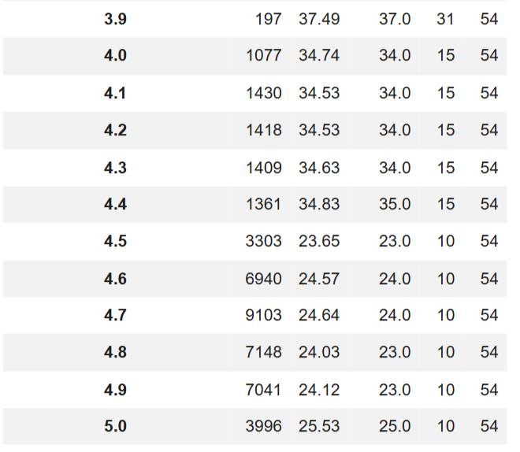
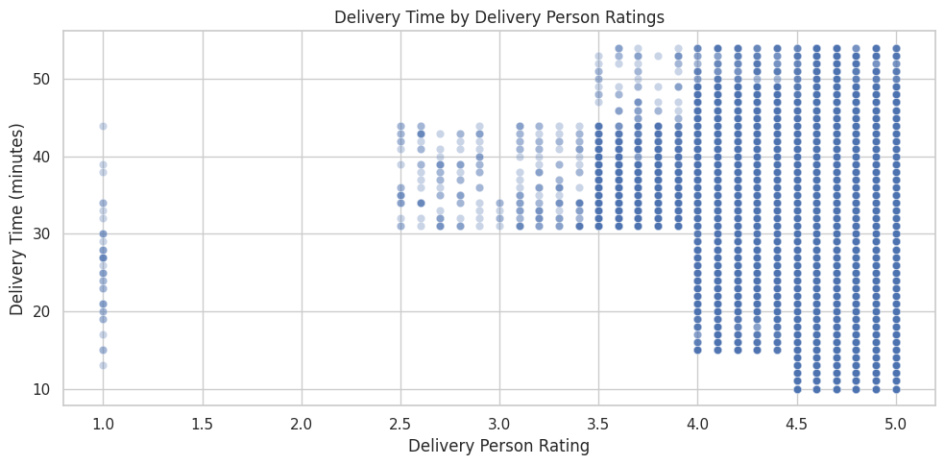
7.10 Correlation Analysis
Interpretation: The correlation analysis showed a positive relationship between multiple deliveries and delivery time (approximately 0.38), and a negative relationship between delivery-person ratings and delivery time (approximately -0.33). Delivery-person age had a positive correlation of approximately 0.29. These values indicate associations, not causal effects.
Python Code:
rating_summary = df.groupby("Delivery_person_Ratings")["Time_taken(min)"].agg(
["count", "mean", "median", "min", "max"]
).round(2)
display(rating_summary)
plt.figure(figsize=(10, 5))
sns.scatterplot(
data=df,
x="Delivery_person_Ratings",
y="Time_taken(min)",
alpha=0.3
)
plt.title("Delivery Time by Delivery Person Ratings")
plt.xlabel("Delivery Person Rating")
plt.ylabel("Delivery Time (minutes)")
plt.tight_layout()
plt.show()
Output:
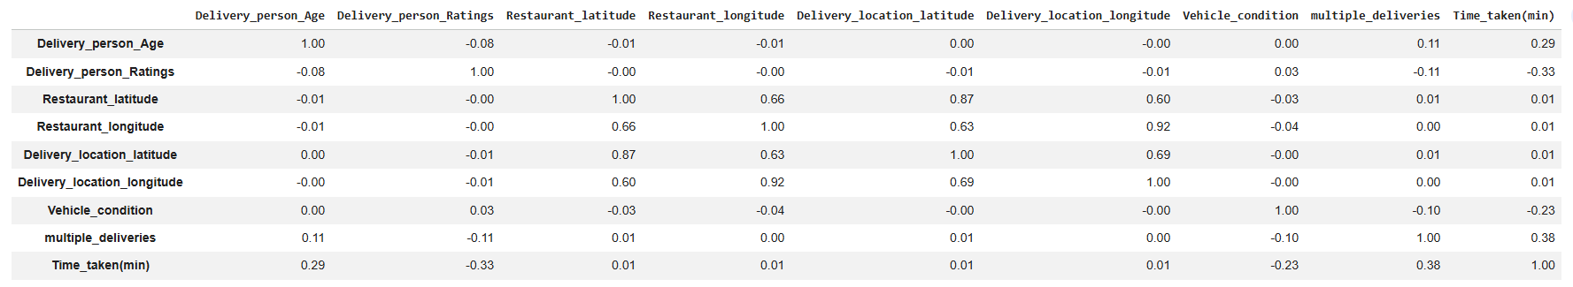
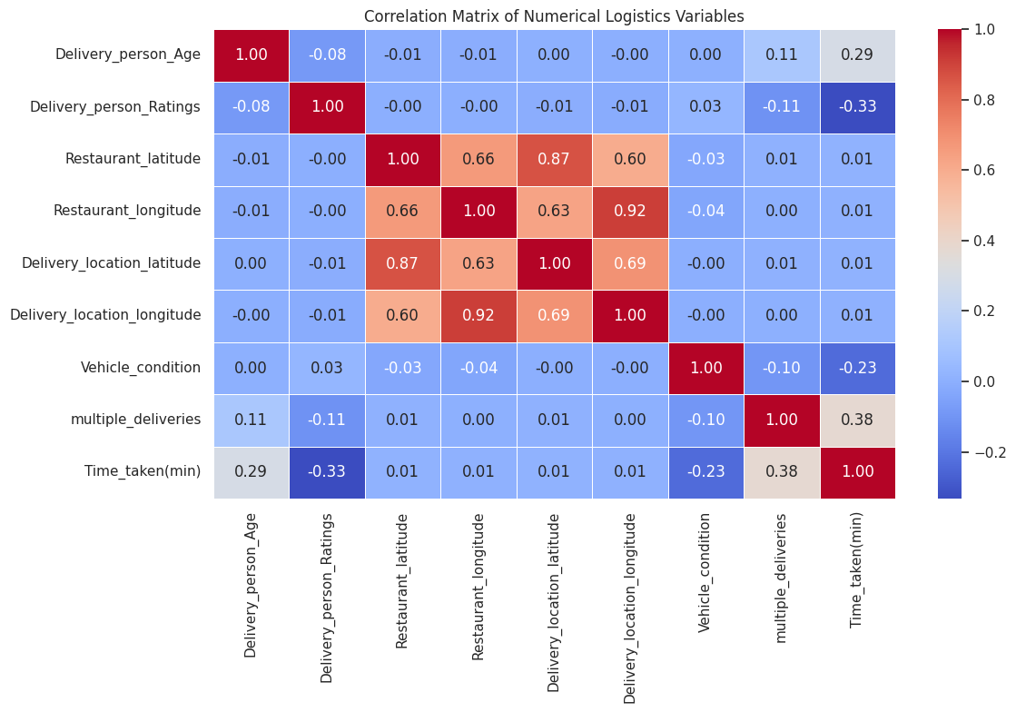
8. Key Findings
- The average delivery time was 26.29 minutes.
- Jam traffic was associated with longer average delivery times than low traffic.
- Records involving three multiple deliveries had an average delivery time of 47.82 minutes.
- Festival-marked records had a higher average delivery time than non-festival records.
- Delivery time varied across weather and vehicle categories.
- Some categories had small sample sizes or coded values that require further verification.
- Transportation costs and shipment volumes could not be evaluated because the required fields were not available.

9. Recommendations
- Traffic management: Consider traffic conditions when planning routes and estimating delivery times.
- Delivery batching: Review the sequencing and assignment of multiple orders to reduce avoidable delays.
- Festival planning: Review staffing and delivery capacity during festival periods.
- Weather monitoring: Track delivery performance across weather conditions to identify recurring operational challenges.
- Data quality: Confirm category definitions, investigate unusual values, and retain clear documentation of missing-value handling.
- Further analysis: Collect transportation costs, shipment volumes, distance, and additional operational data to support broader logistics performance analysis.

10. Limitations
This analysis identifies patterns and associations in the available food delivery dataset. It does not prove causation. Some categories have limited observations, and coded values should be verified against the dataset documentation. Transportation costs and shipment volumes were unavailable, preventing analysis of those measures.

11. Conclusion
The exploratory data analysis examined delivery-time patterns and their relationships with traffic density, weather conditions, vehicle condition, order type, multiple deliveries, and delivery-person ratings. The average delivery time was 26.29 minutes. Jam traffic and records involving multiple deliveries showed higher average delivery times.
The findings identify areas for further investigation, including traffic-aware routing, delivery batching, and festival-period planning. The analysis demonstrates how Python-based data analysis and visualization can support logistics decision-making while highlighting the importance of data quality and cautious interpretation.

