|  |
| --- |
| Illustration of bamboo in shades of light gray and dark red |

**PHASE 4:**

**DEVELOPMENT PART 2**

**STEP 1: FEATURE ENGINEERING**

**Data set link:** https://www.kaggle.com/datasets/prasoonkottarathil/microsoft-lifetime-stocks-dataset

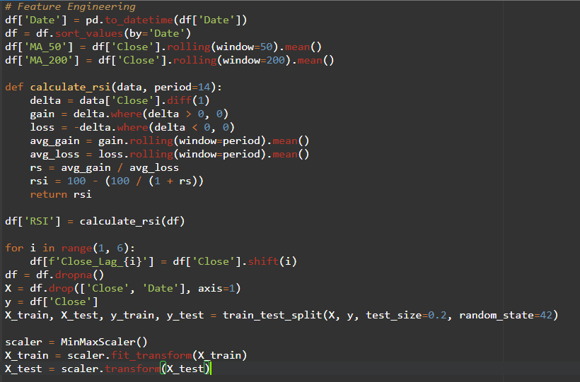

**EXPLANATION:**

**The code splits the dataset into training and testing sets and scales the features to a common range for model training and evaluation**

**STEP 2: MODEL TRAINING**

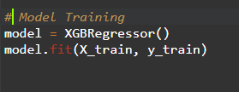

**EXPLANATION:**

**The code initializes an XGBoost Regressor model and trains it using the training data (X_train and y_train)**.

**STEP 3: MODEL EVALUATION**

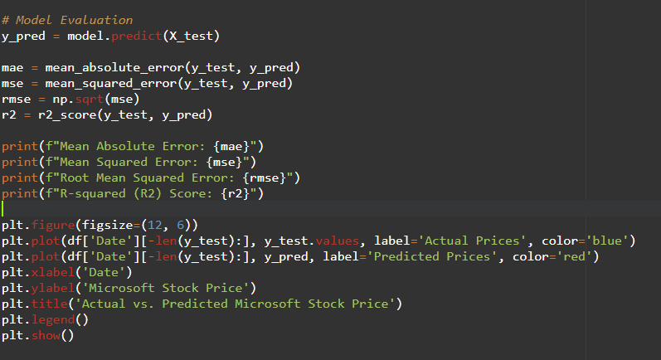

**EXPLANATION:**

**These lines calculate various regression metrics (MAE, MSE, RMSE, and R2) to assess the model's performance on the test data. It also generates a plot to visualize the actual vs. predicted stock prices for evaluation and interpretation.**

**OUTPUT:**

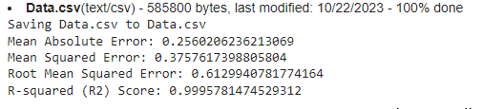

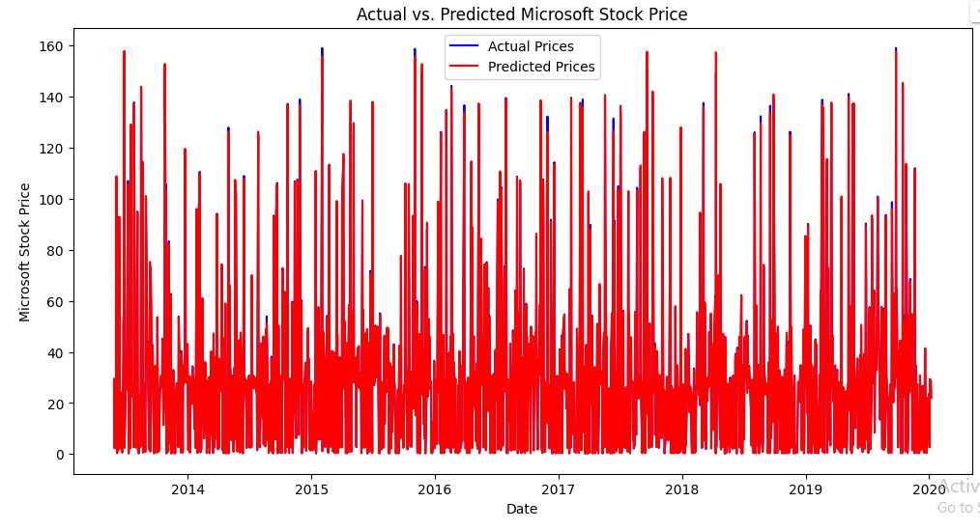

**CONCLUSION:**

**feature engineering enriches the dataset with technical indicators, XGBoost regression is used for model training, and model evaluation metrics are presented alongside a visual comparison of actual vs. predicted stock prices, providing a comprehensive assessment of the stock price prediction model's performance**