ls -ltr : Display the most recently modified file
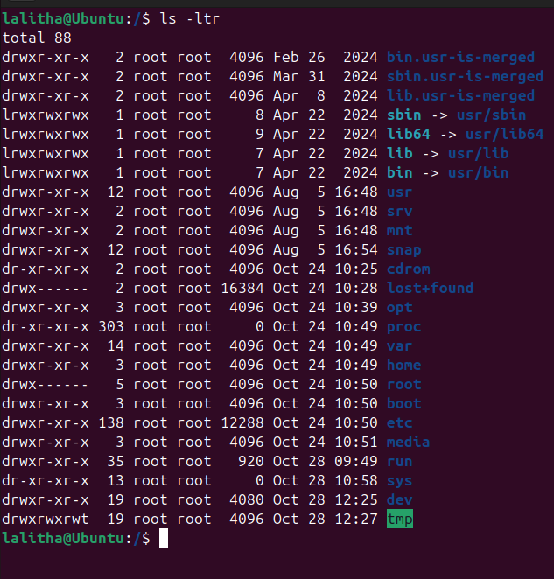
Mkdir -p d1/d2/d3 : create a path d1/d2/d3
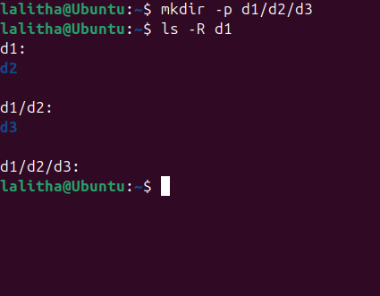
Chmod 755 :

