Step-1 : Inspect Unit Net price After Credits

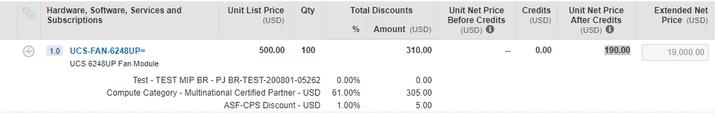

Elements Tab

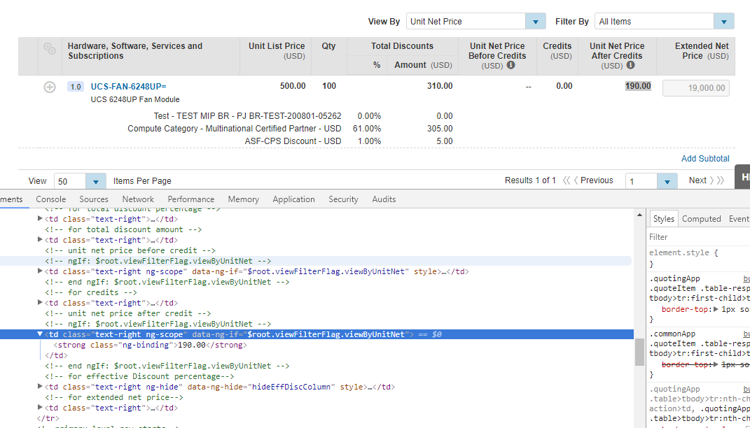

Step-2:select “$root.viewFilterFlag.viewByUnitNet”



Step 3: Goto Network tab

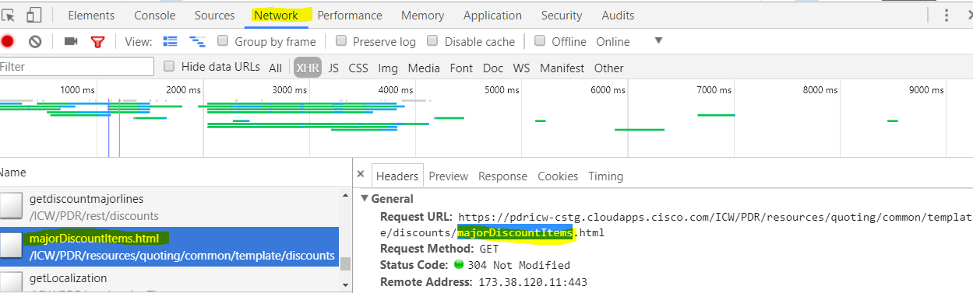

Step-4:search “$root.viewFilterFlag.viewByUnitNet” in the file called “majorDiscountItems.html”

And copy “unitNetPriceAfterCredits”

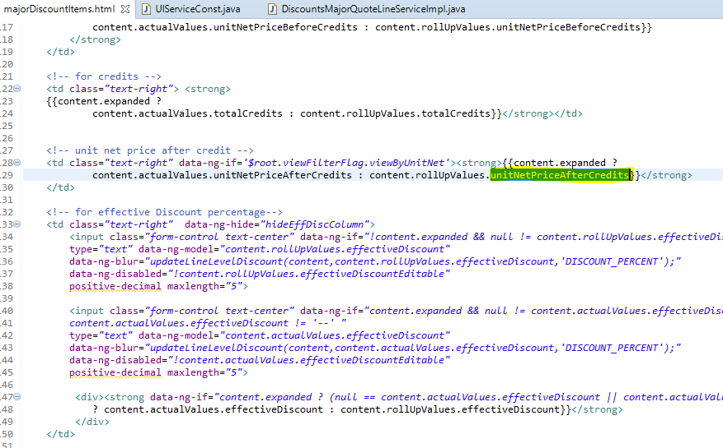

Step5: search “unitNetPriceAfterCredits” in inspect Element “getDiscountMajorLines”

Note:

Open “UIServiceConst.java”

In that search for “getDiscountMajorLines”

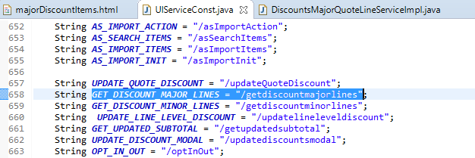

Now get the class “***GET_DISCOUNT_MAJOR_LINES.java” and findthat method “getdiscountmajorlines()”***

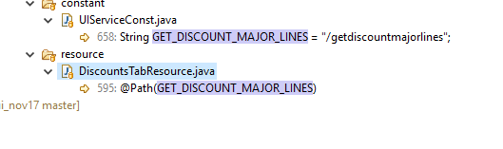

So goto “DiscountsTabResource.java” in resource folder as above and observe for “ @Path(GET_DISCOUNT_MAJOR_LINES)”

And goto “QuotingCoreService” line as below

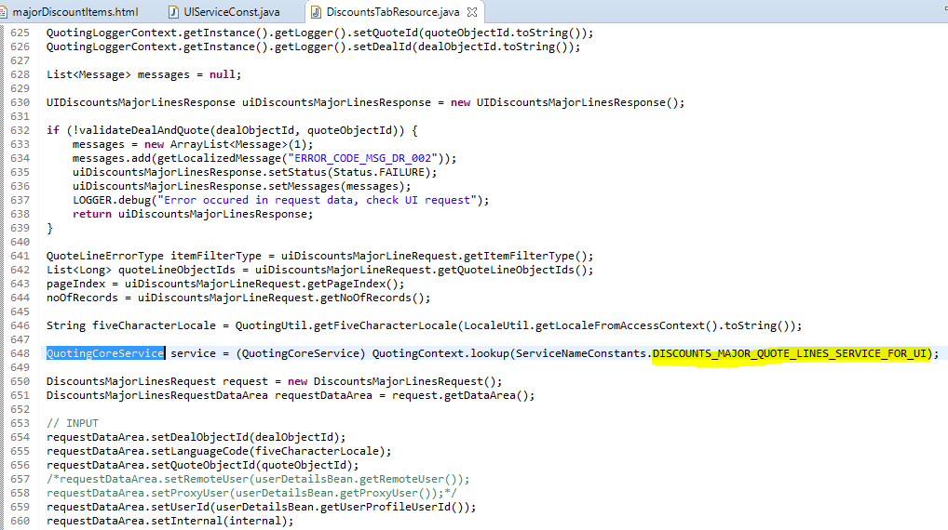

Search for “DISCOUNTS_MAJOR_QUOTE_LINES_SERVICE_FOR_UI.java” file in the CoreServices projet in eclipse

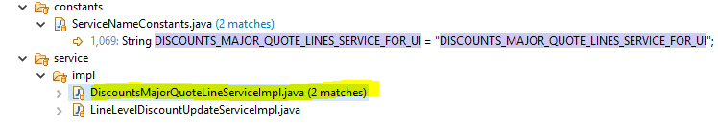

Now in this implementation class we can directly search for

unitNetPriceBeforeCredits

unitNetPriceAfterCredits

unitNetPriceBeforeCredits

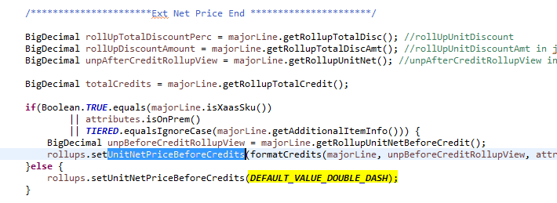

we added product not subscription that’s y condition 2 satisfied so that y it is double slash

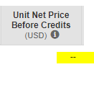

unitNetPriceAfterCredits

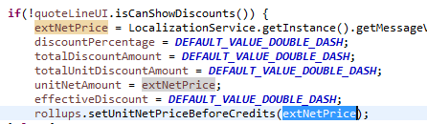

unitNetPriceAfterCredits will be extNetPrice and that is unitNetAmount

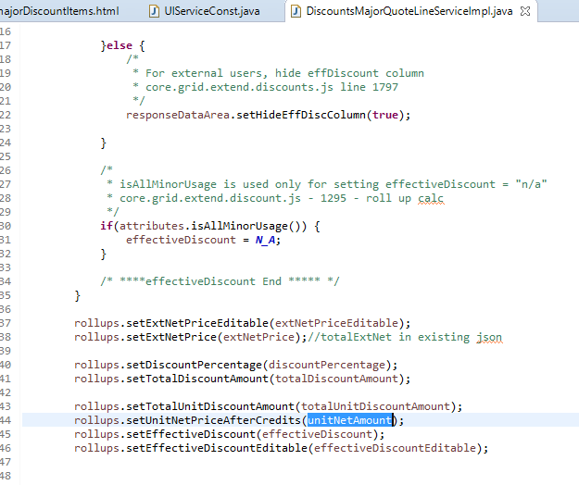

Search for the “uniNetAmount”

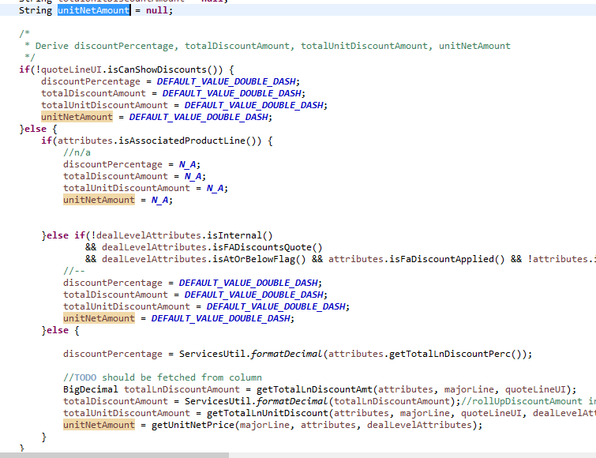

And there are if else conditions it will check all the conditions

Condition 1:will not satisfy bcoz we loged in as partners if we select as cisco buy method we will get discounts so it is false

Condition2:it is not isAssociatedProductLine it is regular product line,so it is also false

Condition3: says not internal so it is also false

Then it comes to

Condition 4:

unitNetAmount = getUnitNetPrice(majorLine, attributes, dealLevelAttributes);

now call the method “getUnitNetPrice()”

this method contains if else condition,here if condition says if it is XaasSKU(that means if it is subscription then if condition will work).

So ours is product so it will come out of if and goes to else condition

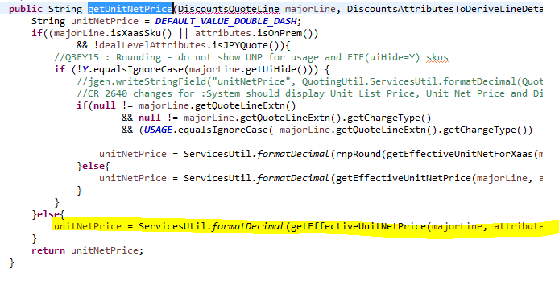

So now call getEffectiveUnitNetPrice() method

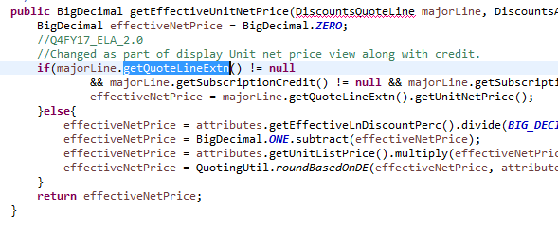

If we see this majorLine.getQuoteLineExtn() != **null** that means there are some rows in “cq_quote_line_extn”so let us check

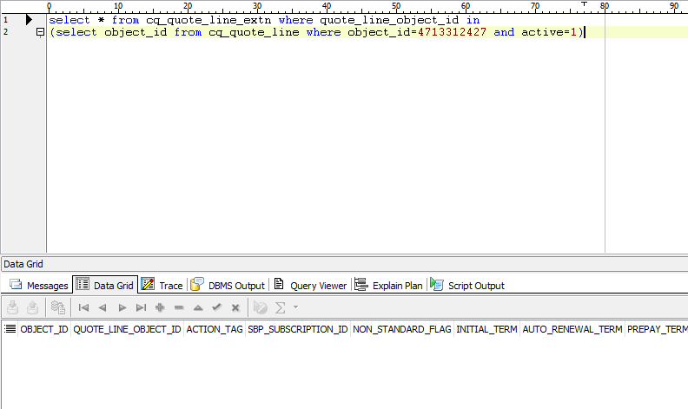

So there are no rows so it will come to next condition

effectiveNetPrice = attributes.getEffectiveLnDiscountPerc().divide(***BIG_DECIMAL_HUNDRED***, ***BIGDECIMAL_DIVIDE_SCALE***, RoundingMode.***HALF_UP***);

effectiveNetPrice = BigDecimal.***ONE***.subtract(effectiveNetPrice);

effectiveNetPrice = attributes.getUnitListPrice().multiply(effectiveNetPrice);effectiveNetPrice = QuotingUtil.*roundBasedOnDE*(effectiveNetPrice, attributes.getDecimalExpansionValue());

1.If we call “getEffectiveLnDiscountPerc” method ,it will return “effectiveLnDiscountPerc”

It is usually

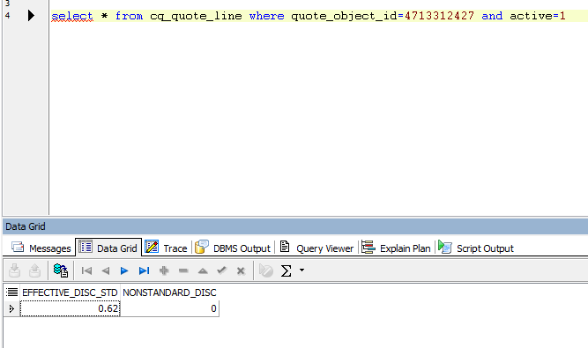

This EFFECTIVE_DISC_STD will be standard discount

And NONSTANDARD_DISC will be whatever Non standard discounts that we gave

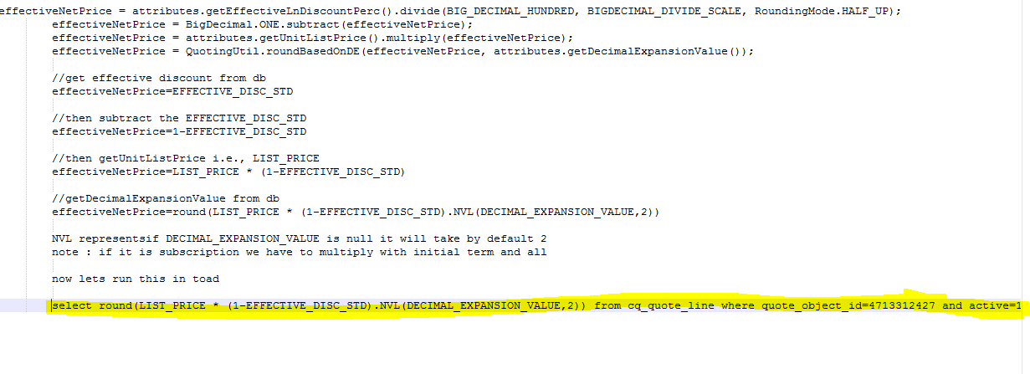

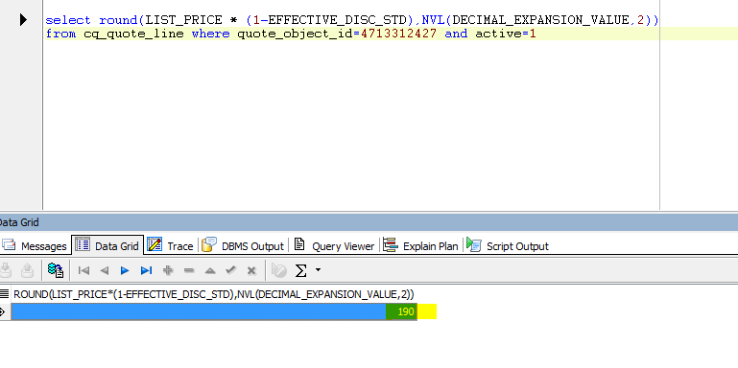

So we are considering it as “UNIT_NET_PRICE_AFTER_CREDIT”

So the query will be

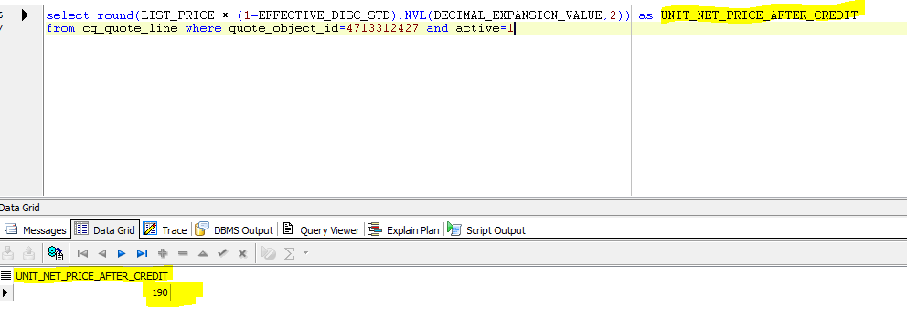

Flow Chart for **ForwardToDiscounts**

1.goto Quote🡪items🡪save and continue🡪Discounts and credits

2.goto Network🡪select ALL🡪select quoteConfigure_forwardToDiscounts

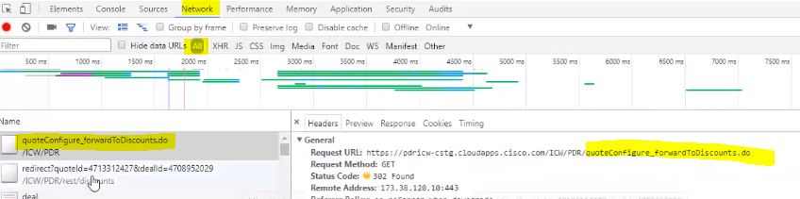

They are using “struts” for Navigation here

And if there are no validation errors and selected buy method in the product that we added then it will navigate to

