1. **INTRODUCTION**

***1.1 Scope of the work***

* It’s a web-enabled project.
* This project offers user to enter the data through simple and interactive forms. This is very helpful for the client to enter the desired information through so much simplicity.
* This is bound to be simple and very friendly as per the user is concerned.
* Easier and faster data transfer through latest technology associated with the computer and communication.
* Through these features it will increase the efficiency, accuracy and transparency.

***1.2 Usage Scenarios***

With a large number of institutions offering a variety of courses, making a decision as to what to pursue after completion of 10th or 12th becomes a big problem. A lot of sites on the internet provide information regarding various options available after 10th and 12th. But, these require manually browsing each of these sites one by one which is a very tedious task. Apart from this, not all houses have computers with internet connection. This becomes a limitation to those lacking these facilities.

These issues can be solved with the development of an application that can provide assistance to these students. The application will provide all the necessary information all at one place. Students who have completed their 10th or 12th belonging to any stream can use this application to get information about higher studies opportunities. Since all the information are present all at one place, the need to go through a large number of sites on the internet is eliminated.

The application is mainly intended for students who have completed their 10th or 12th and wants to pursue higher education in India itself. It gives the users the option to choose their current education as well as their preferred stream. Information relevant to the chosen stream is displayed to the user.

The following report deals with the initial stages like requirement analysis and application design which are involved in the development of any application. The report is divided into the following sections.

The second section is the SRS (Software Requirement Specification) of the application which in detail explains about the functional requirements, non-functional requirements, use case scenarios and limitations of the application being developed.

The third section is the SDS (Software Design Specification) of the application which provides description about the system architecture and design goals and detailed design methodologies.The fourth section gives a brief description about the results of the requirements analysis and design phase and the development environment chosen for the implementation of the project.

Finally the fifth section gives a brief description about the proposed work plan of the project.

1. **REQUIREMENT ANALYSIS**

***2.1 Functional Requirements***

The application provides the following functionalities –

**Customer Module:** There are two types of users. Visitors to the site and Tourists. The user module has the following sub divisions.

**1. Search:**All visitors to the system can search for tourist centers in India, as per specific location, district, category and season. They can get information about different recreational facilities available at each Tourist centers and information about facility providers, quality and cost.

**2. Registration:** The tourist who wishes to avail of the facilities provided by DTPC has to register with the system giving all the details. He / she have to provide a user id and password. The registration process, user login process, security checking regard to these is taken care of in this module.

**3. Online Booking**:In this module tourists can book online the following facilities: Home stay, travel agents, Health care centers (Indian System) and hotels / restaurants, one month in advance.

They can also make online payment of bills for booking. They can also cancel the booking and get the payment back after deduction booking charges.

**4. Feedback**:Options to give feedback by the users are coming under this sub module.

**Administrator Module:**This module has the following sub modules.

**1. Information Module** :In this module there provides data about different Tourist centers photos, clippings, audio and video gallery. Addition, deletion and modification of data is taken care of in this module. New centers with all information are added in the system.

**2. Client Module**:Recreational facilities and service providers at tourist centers are considered as clients of the system. They have to register first before doing operations. Therefore in this module online registration of clients, cancellation of a client permit, client login, and security checking are taken care of.

**3. Reports & Mail**:Generation of different reports, sending mails to clients and tourists, providing reports and data are considered here.

**4. Advertisements**:The clients can advertise here .The functionality is developed and executed in this module

***2.2 Non- Functional Requirements***

The following are the non-functional requirements:

**2.2.1 Security Requirements:**The application should not be able to access personal data of the user. It also ensures that its sensitive information is not revealed to the external world under any condition.

**2.2.2 Performance Requirements:** The response time of the application should be minimum. A user can undo his action any point of time.

**2.2.3 Availability:**All the information that the user requires will be readily available and accessible. The application is also independent of the user’s location. The application will be available to the users anytime they wish to use it irrespective of the time and location.

**2.2.4 Usability:** The application has a very simple and user friendly user interface. Any new user can easily use the application. Every screen has self-explanatory buttons and explanations that avoids any confusion for the user. The layout of the user interface is consistent throughout the application. The application supports English language.

**2.2.5 Documentation**: Software Requirements Specification is provided for the users as well as the developers and System Design Description is provided for the developers and the maintenance engineers.

* 1. ***Use Case Scenarios***

Yuml online tool has been used for constructing Use Case diagrams.

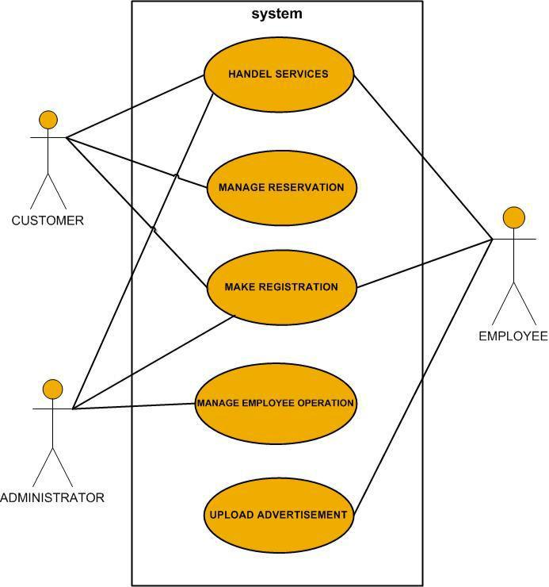

**Figure 1:** Use case diagram for TMS

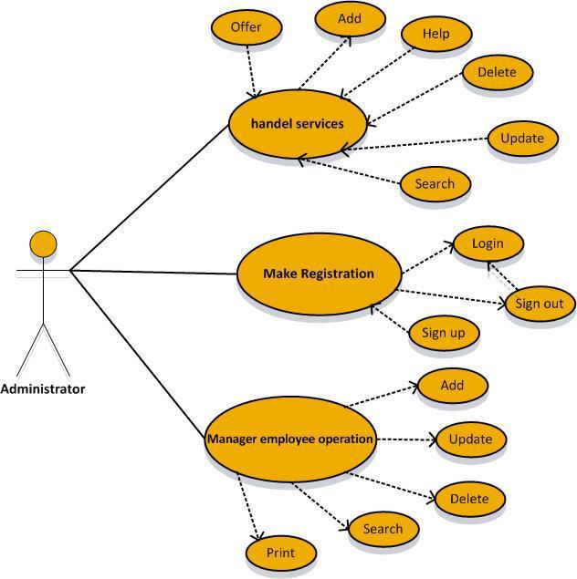

Figure 3: Use case diagram of the administrator.

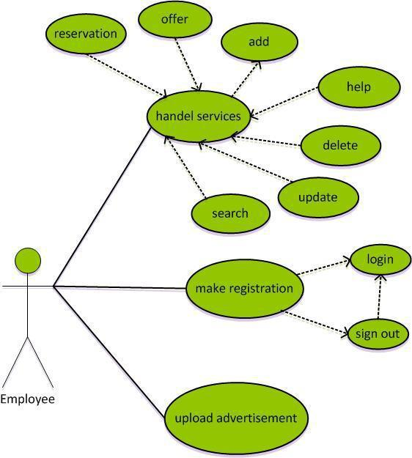

Figure 4: Use case diagram of the employee.

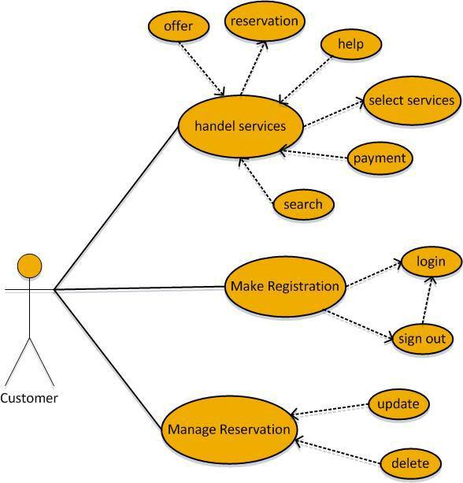

Figure 5:Use case diagram of the customer.

Activity diagrams are graphical representations of workflows of stepwise activities and actions with support for choice, iteration and concurrency. In the Unified Modeling Language, activity diagrams can be used to describe the business and operational step-by-step workflows of components in a system. An activity diagram shows the overall flow of control.

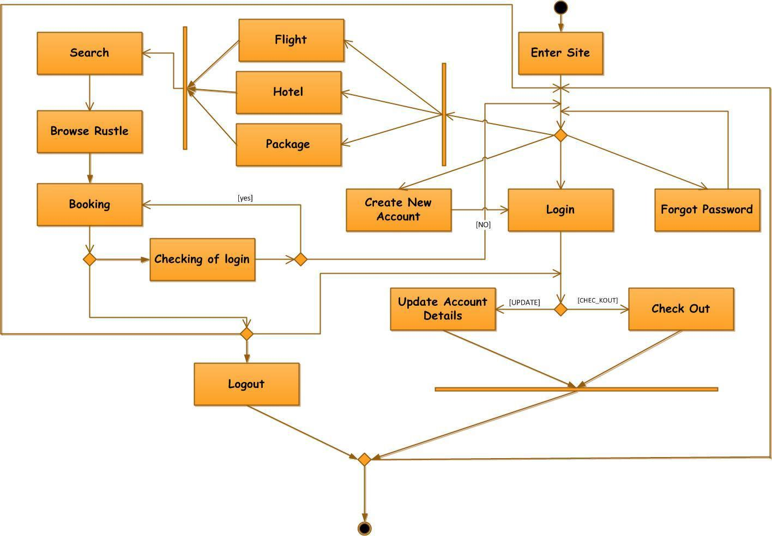

Figure 6:Activity Diagram For All System TPS

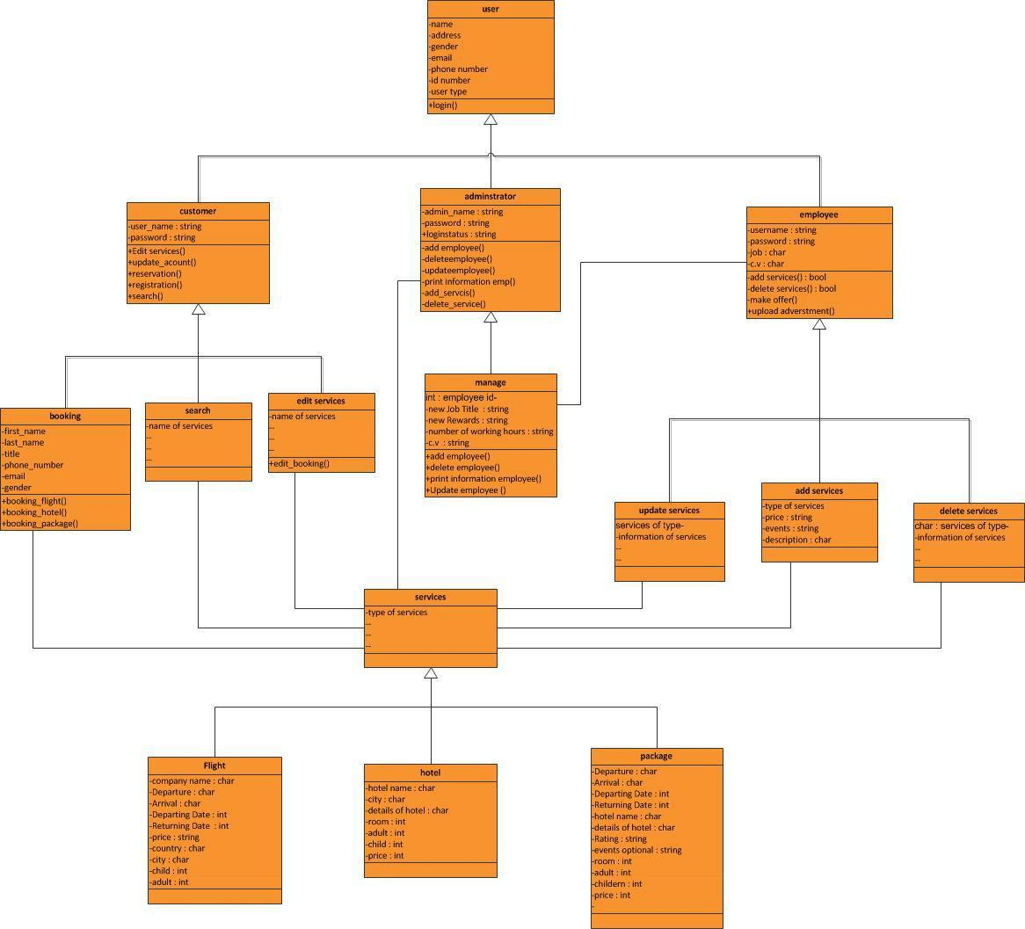

***3.3 Interaction Diagrams***

**Sequence Diagrams**

The sequence diagram is a representation for the use case diagram specified previously in The System Requirement Chapter Three. We will design the sequence diagram using the three tiers approach.

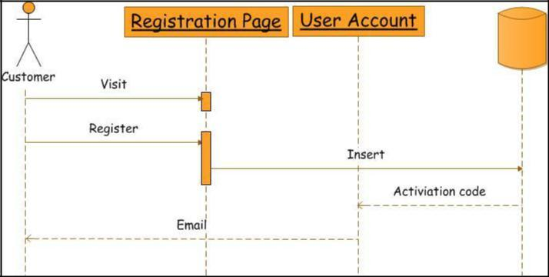

Figure 8: The Customer Registration in The system

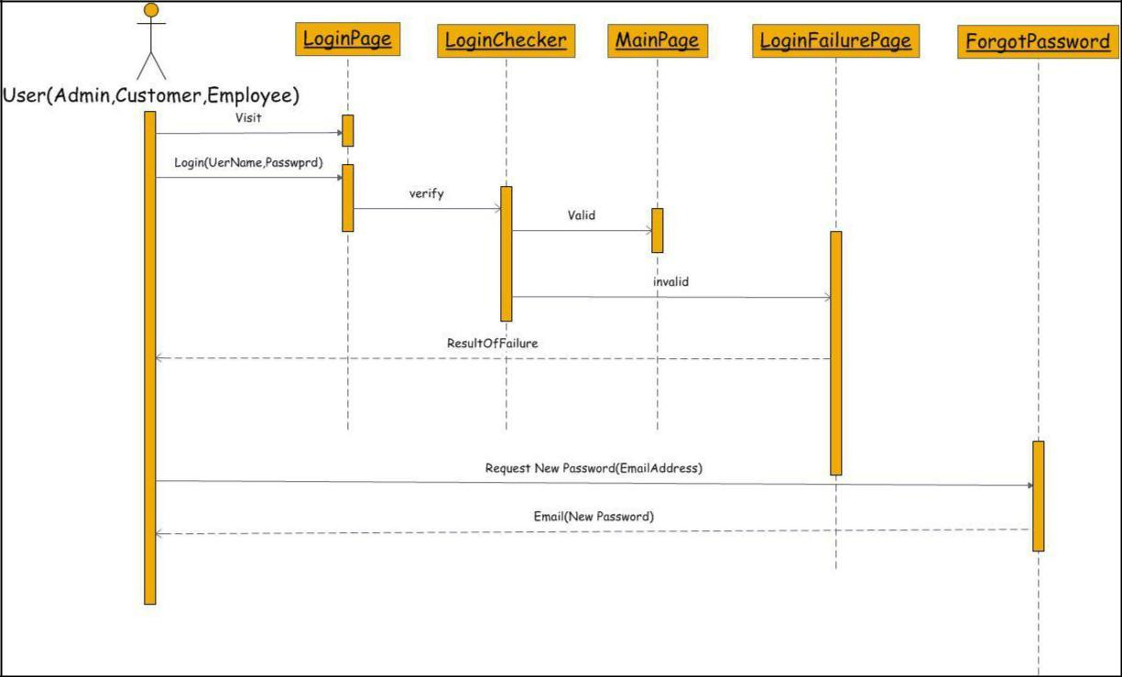

Figure 9: The login of all Users& Forgot Password

**E-R Diagram**

In this document we will specify the E-R diagram for the system proposed, showing every detail in the relations.

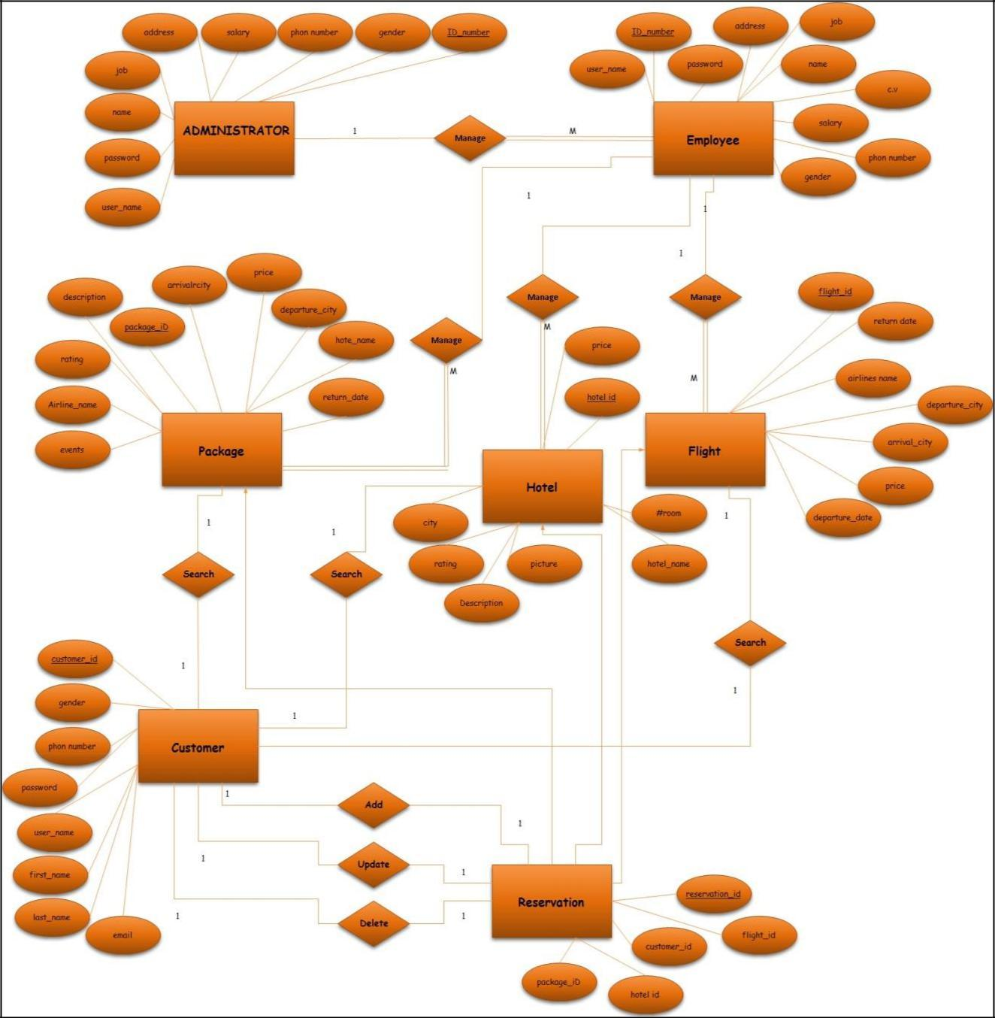

The E-R Diagram

The actor named customer is the user of the application and has every functionality control in its

hand.

1. **SYSTEM DESIGN**

***3.1 Design Goals***

The application comprises of many features and hence the system is divided into various components. The main objective of this section is to elaborate the system design and to give an overview of the various components of the application including their interfaces. It also provides information about the relationship between the various components and the different data elements used by each of the components. It also explains the overall system design. The application has a client-server architecture with the application running on the client side and the files residing on the server side with which the user interacts through the application. The following sections containsclass diagram, sequence diagram and activity diagrams representing the various components and their interactions and also the detailed description of each of the components.

***3.2 System Architecture***



Requesting info

HTML file



**Figure 6: The Client-Server Architecture**

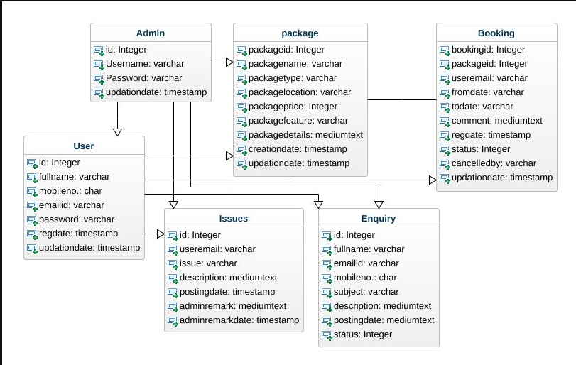

**Figure 7: Class Diagram**

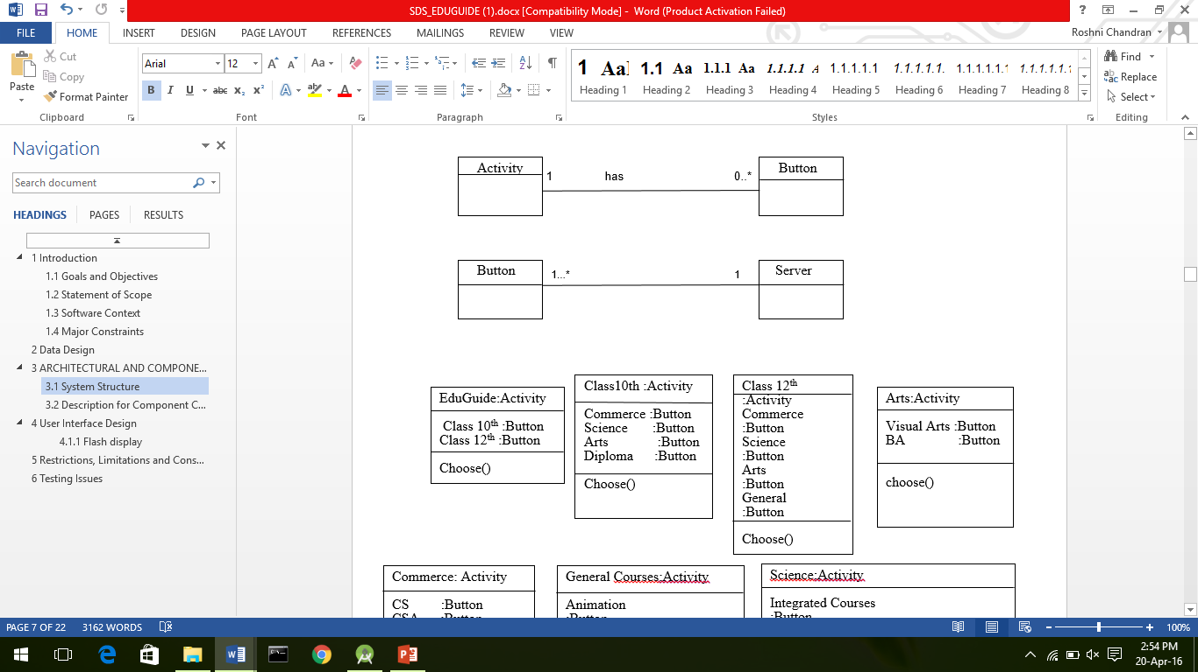

**Figure 8: Association between classes**

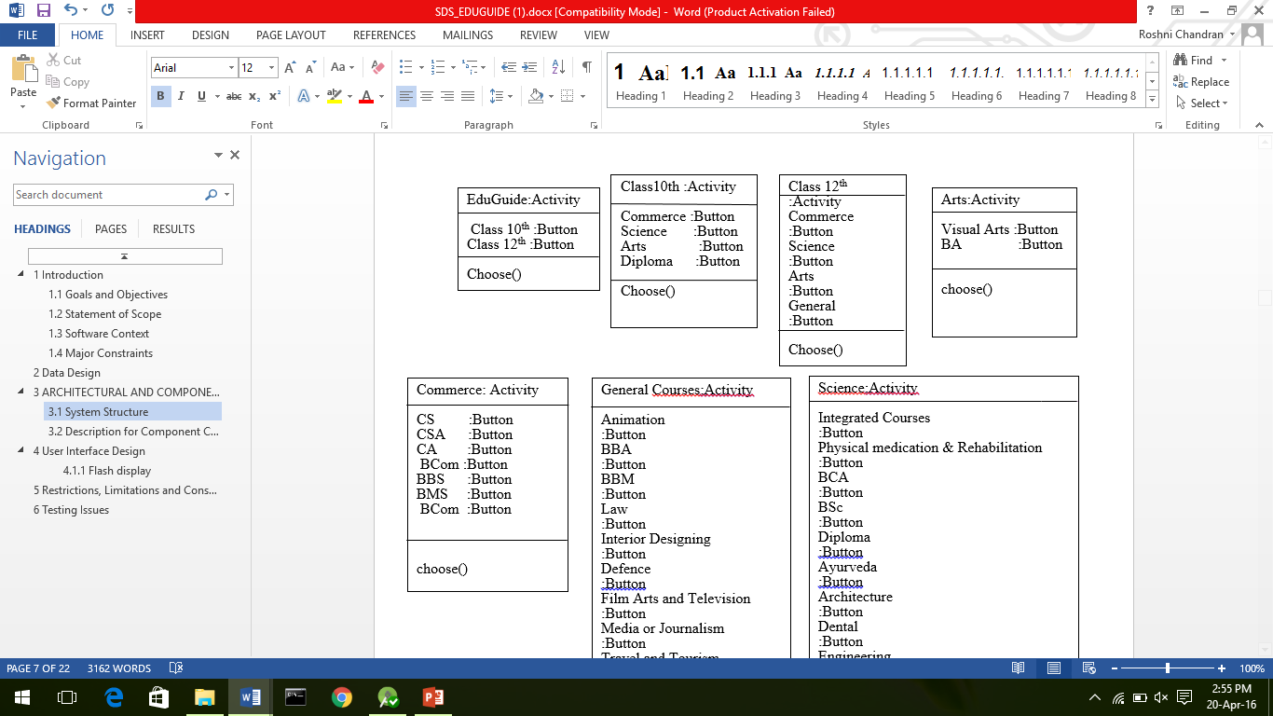

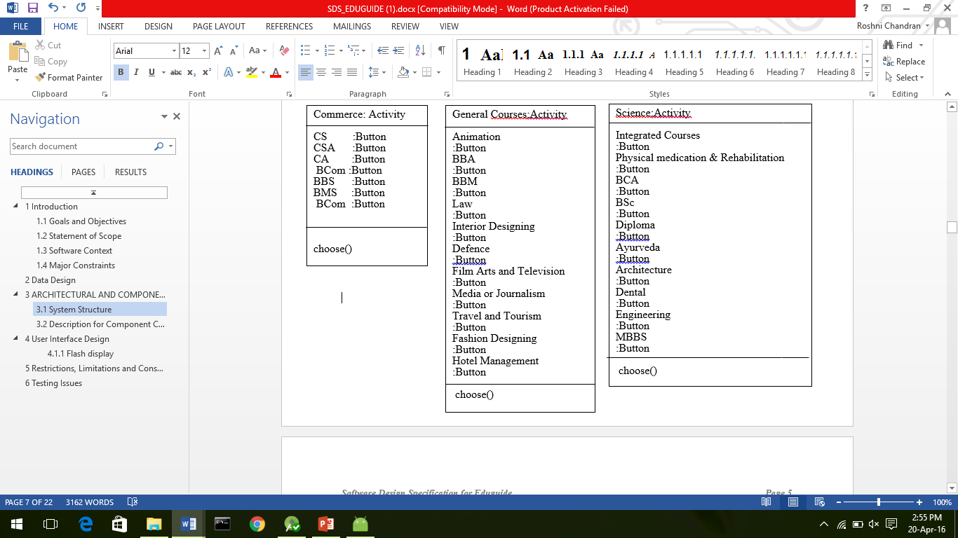

**Figure 9: Description of components**

Class Name: Activity

Attributes: Array of Buttons

Methods: choose() – upon clicking the button the user can choose his/her options

Display_info()- retrieves and displays information

Class Name: Button

Attributes: ID - String

Name – String

Methods: go_to_next_activity()- upon clicking, it directs to the next activity

Get__info() - retrieves information from the files

Class Name: Server

Atttributes: Array of files

Methods: send_info() - send the requested information stored in the files

***3.4 Detailed Design Methodologies***

**3.4.1 Detailed Description of the User Interface**

**3.4.1.1 Flash Display**

This screen is a flash screen displaying EDUGUIDE for 5 seconds.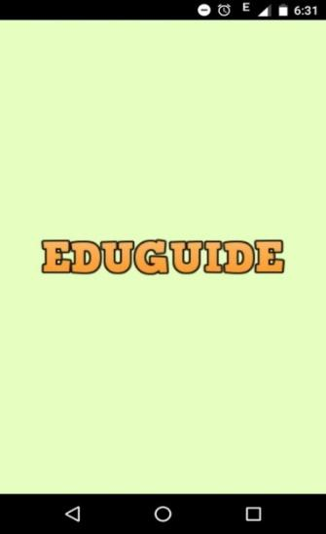

**Figure13: UI for splash screen**

**3.4.1.2 Home Screen**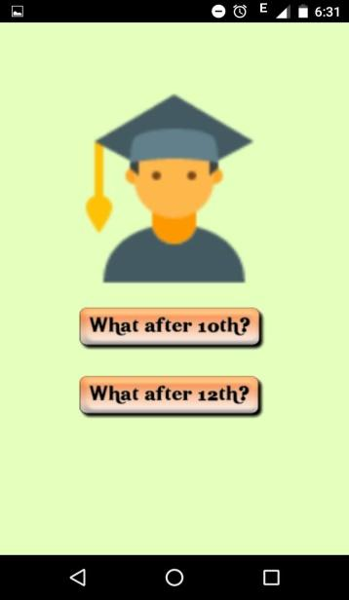

**Figure14: UI for home screen**

Objects and actions of home screen:

Objects:-

* After 10th
* After 12th

Actions:-

* Open 10th Main Screen
* Open 12th Main Screen

**3.4.1.3 After 10th main screen**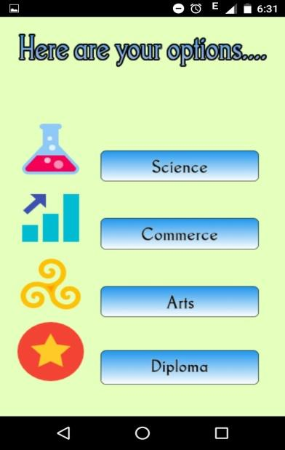

**Figure15: UI for 10th main screen**

This Screen gives options about the streams that can be taken after 10th .Objects and actions of this screen are:-

Objects:-

* Science
* Commerce
* Arts
* Diploma

Actions:-

* Description About Science stream
* Description About Commerce stream
* Description About Arts stream
* Description About Diploma

**3.4.1.4 After 12th main screen**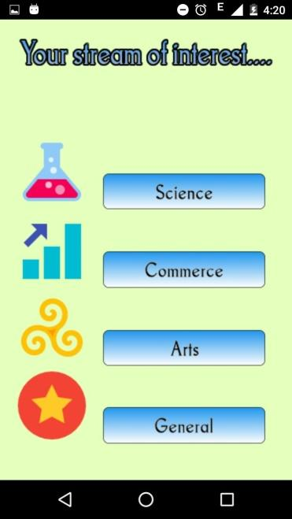

**Figure 16: UI for after 12th main screen**

Objects and Actions of this Screen are:

Objects:-

* Science
* Commerce
* Arts
* General

Actions:-

* Opens screen containing various courses that can be undertaken after 12th in science stream.
* Opens screen containing various courses that can be undertaken after 12th in Commerce.
* Opens screen containing various courses that can be undertaken after 12th in Arts.
* Opens screen containing various general courses that can be undertaken after 12th.

**3.4.1.5 Science Stream Screen**

: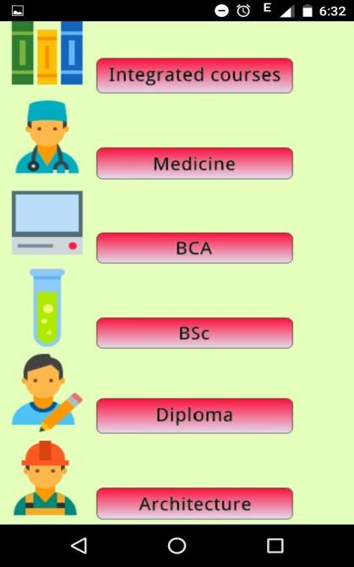

**Figure17:UI for science stream**

This screen contains various courses that can be undertaken after 12th in science field. Objects andActions of this field are:

Objects:-

* Integrated Courses
* Medicine
* BCA
* BSc
* Diploma
* Architecture

Actions:-

* Detailed Description about the integrated courses, career opportunities in this field and the colleges where these courses are offered.
* Detailed Description about the Medicine courses, career opportunities in this field and the colleges where these courses are offered.
* Detailed Description about the BCA courses, career opportunities in this field and the colleges where these courses are offered.
* Detailed Description about the BSc courses, career opportunities in this field and the colleges where these courses are offered.
* Detailed Description about the diploma courses available in science field.
* Description about the architectural courses, college offering this course and career opportunities in this field.

**3.4.1.6Commerce Stream Screen**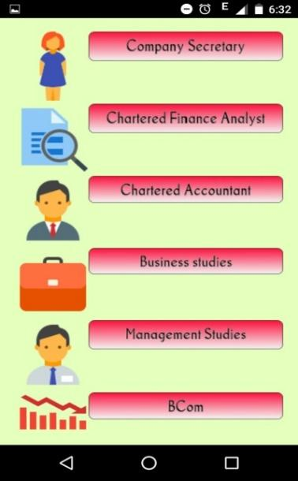

**Figure18: UI for commerce stream**

Objects and Actions of This Screen are:

Objects:-

* Company Secretary
* Charted Financial Analyst
* Charted Accountant
* Business Studies
* Management Studies
* B.Com

Actions:-

* Gives information about the work of Company Secretaries, how to apply for it, what are the qualifications required and other details.
* Charted Financial Analyst, Charted Accountant give detailed information about the work that needs to be done in these field , qualification required, employment conditions etc..
* Business Studies, Management Studies, B.Com give detailed information about the respective courses, colleges where they are offered and the career opportunities in this field.

**3.4.1.7 Arts Stream screen**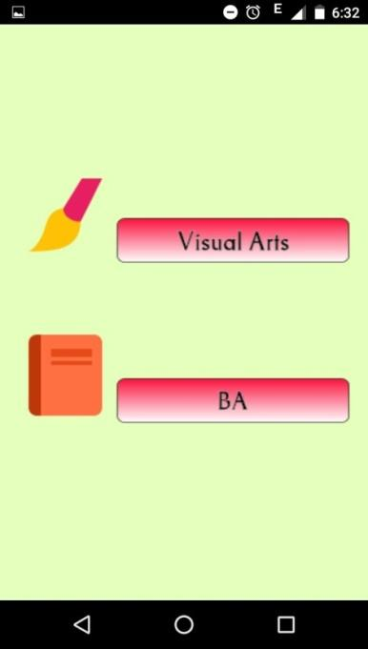

**Figure19: UI for arts stream**

Objects:-

* Visual Arts
* BA

Actions:-

* Provides information about the Visual Arts where they can showcase them and some other related information.
* Detailed description about BA course, colleges offering these course and career opportunities in this field.

**3.4.1.8 General Screen**

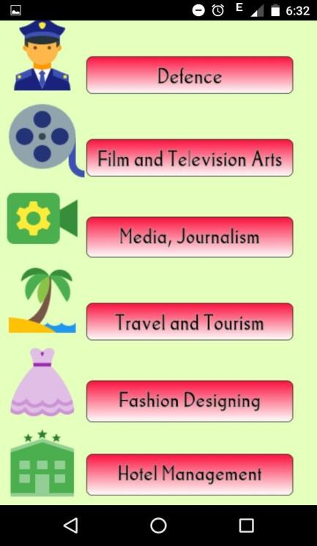

**Figure 20: UI for general screen**

Objects and actions of this screen are:

Objects:-

* Defence
* Film and Television Arts
* Media Journalism
* Travel and Tourism
* Fashion Designing
* Hotel Management

Actions:

* Detailed information about the defence field and the career opportunities in this field.
* Detailed information about the careers in Film and Television Arts.
* Description about Media Journalism and how to achieve a career goal in this field.
* Description about career opportunities in Travel and Tourism.
* Description about career opportunities in Fashion Designing, colleges offering courses in this field.
* Description about Hotel Management courses, colleges offering this course and the career opportunities in this field.

1. **WORK DONE**

**4.1 Development Environment**

The application being developed would be an Android App and would be called EduGuide. The application development process consists of three phases: 1.Developing a Web crawler in order to obtain links for gathering data. 2. Extracting, filtering and structuring data 3. Developing the front end and the backend for the app and establishing connection between the two.

**4.1.1 Web Crawler**

A web crawler has been developed which takes a URL as an input and gives URLs of similar links. The crawler has been developed in Android Studio IDE. The crawler once given an input crawls for a specified amount of time and displays similar URLs which have been used for extracting data about courses.

**4.1.2 Extracting, filtering, structuring data**

Once the links have been extracted, the data from the web pages have been extracted using Jsoup library. The Jsoup library extracts data from a given HTML document based on the specified tag name given. The extraction process has been performed in NetBeans IDE using JAVA. The data from each of the selected links is extracted and stored in files. The extracted data is then filtered, structured and stored as HTML files on a remote Web Server.

**4.1.3 Developing the app EduGuide**

The Android App has been developed using Android Studio IDE. The GUI is designed with animations using various interpolators to attract the users. Android widgets mainly self-explanatory buttons have been used for displaying the options of various courses to the users. The client application will connect to the server files using HTTP Protocol.

**4.2 Testing**

**4.2.1 Black Box Testing**

Test Case 1:

Input: What after 12th

Output: Display options after 12th (Science, Commerce, Arts, Diploma)



**Figure 21: Output of Test Case 1**

Input: Arts

Output: Display options for arts students who have passed 12th

On giving the input “Arts” if the application displays information related to non-arts courses, the application will fail the test.

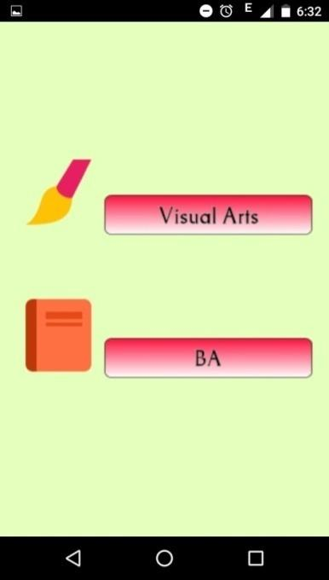

**Figure 22: Output of Test case 2**

**4.2.2 Unit Testing**

In unit testing individual units of source code is tested to check it’s working correctly. The goal of unit testing is to isolate each part of the program and show that the individual parts are correct.

For unit testing, each activity is considered as a single unit and tested. Each activity is expected to display the buttons pertaining itself only and not those belonging to other activities.

**4.2.3 Integration Testing**

For integration testing, the working of all the activities of the application is tested on the emulator. It involves checking if upon pressing a button in one activity directs to the next intended activity. Basically it checks if the application runs as expected with the correct sequence of activities.

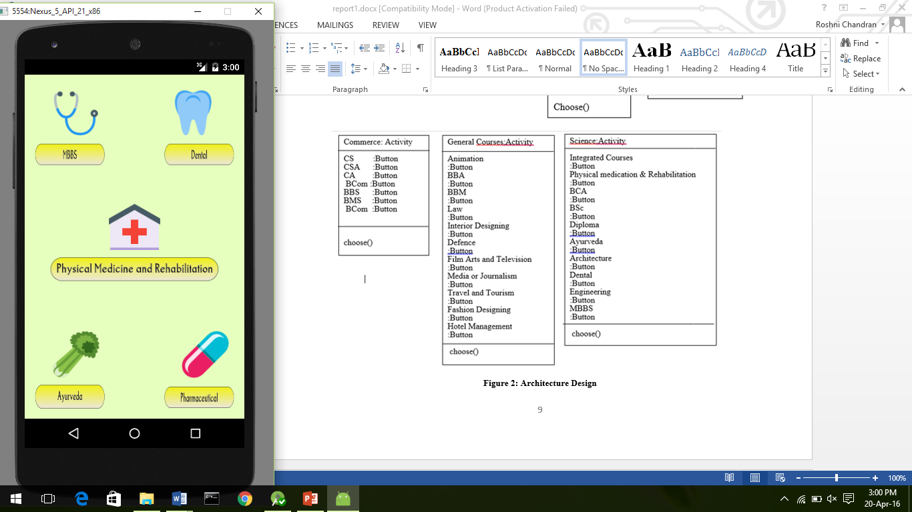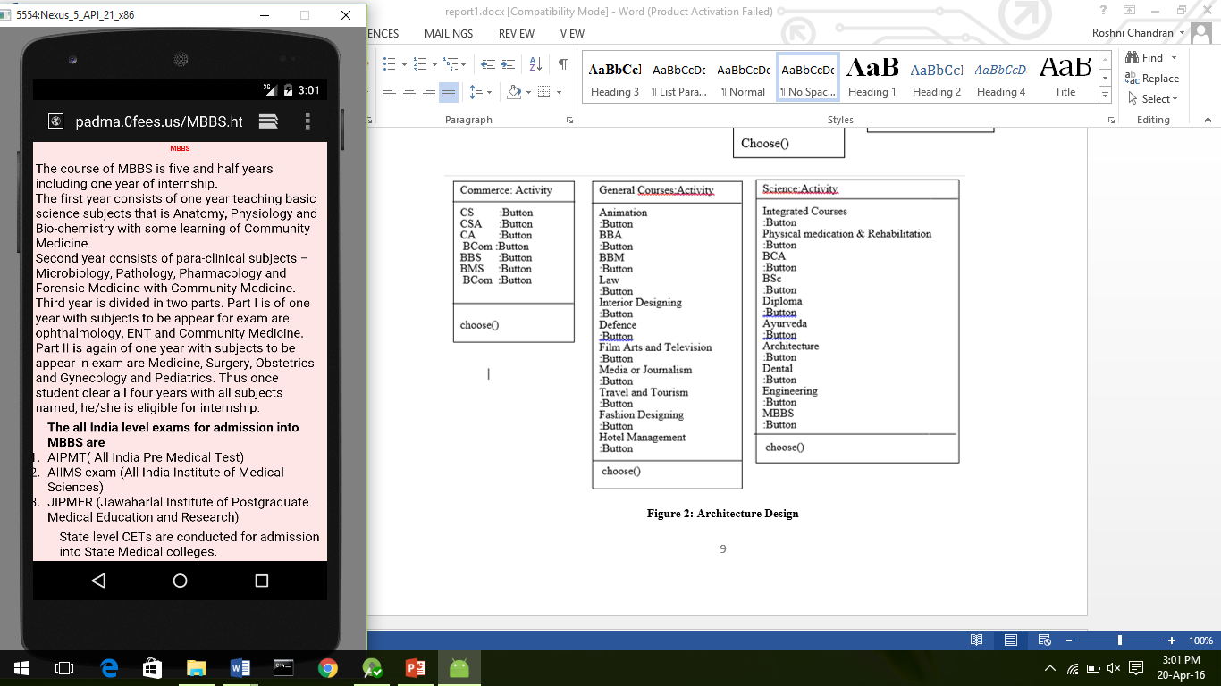

**Figure 23: Integration Testing**

**4.2.4 System Testing**

For system testing, the application is installed on actual android device and is tested.

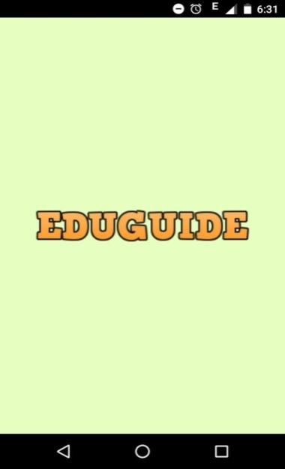

**Figure 24: System Testing Screen 1 Figure 25: System Testing Screen 2**



**Figure 26: System Testing Screen 3**

**Figure 27: System Testing screen 4** 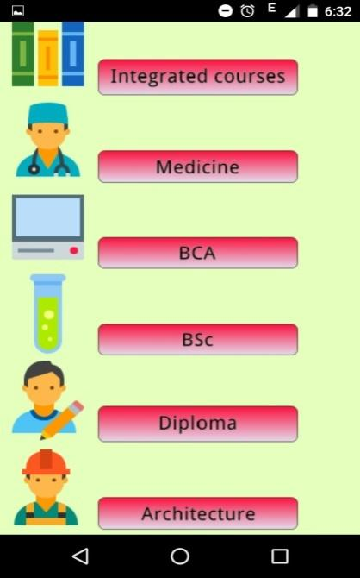

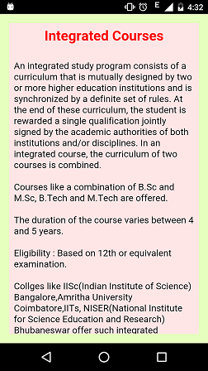

**Figure 28: System Testing screen 5**

**4.2.5 Stress Testing**

Stress Testing of the Android Application was performed using Monkey which is a program that generates pseudo-random streams of user events such as clicks, touches or gestures.

The command used for testing : adb shell monkey –p package_name –v event_number

The application was tested for various event numbers ranging from 500 to 5000. The application crashed at event 4837 when event range was 5000.

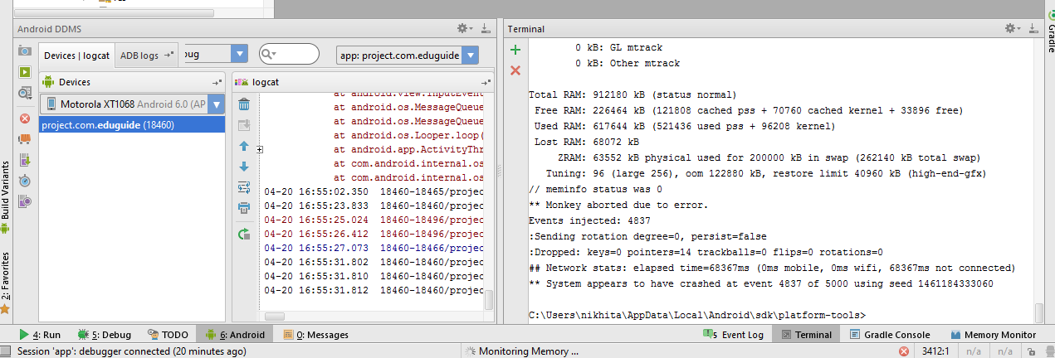

**Figure 29: Stress Testing of the app using Monkey**

**4.2.6 Expected Software Response**

The application is expected to display results to the user based on his/her choices. For example:

Test Case 1 (Positive testing):

Input: What after 12th

Output: Display options after 12th (Science, Commerce, Arts, Diploma)

Input: Science

Output: Display options for science students who have passed 12th

Test Case 2 (Positive Testing):

Input: What after 10th

Output: Display options after 10th (Science, Commerce, Arts, Diploma)

Input: Commerce

Output: Display commerce options for students who have passed 10th

TestCase 3 (Negative Testing):

Input: Integrated Course (without internet connection)

Output: Web Page not available. Check your Internet connection

**4.2.7 Debugging using Traceview**

Traceview is a graphical viewer for execution logs saved by the application. It has been used to debug the application and profile its performance.

**4.3 Performance of the App**

**4.3.1 Battery Consumption**

The app was tested on a real Android device and it was observed that the battery consumption of the app was minimal.

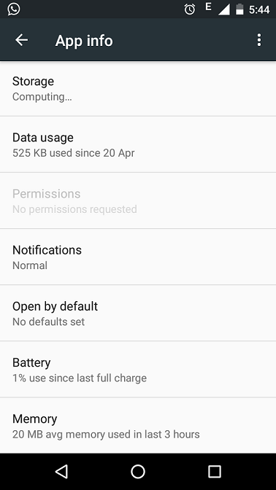 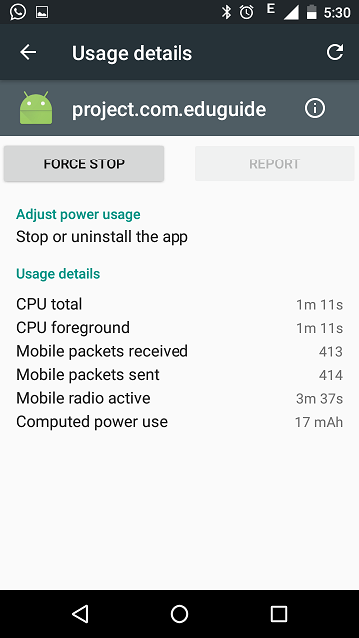

**Figure 30: Battery Consumption of the App**

**4.3.2 Internal Storage Usage**

The following was memory usage of the App when tested on an Android device.

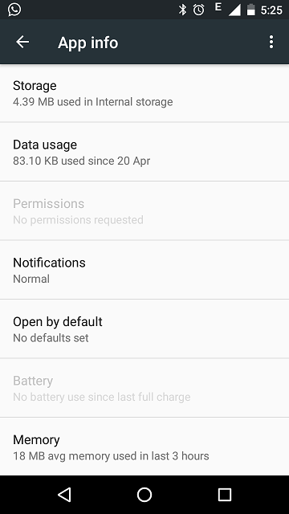

**Figure 31: Internal Storage of the App**

**4.3 Cost Estimation of the App**

Cost Estimation of the App has been performed using COCOMO model. COCOMO applies to three classes of software projects:

* Organic projects - "small" teams with "good" experience working with "less than rigid" requirements
* Semi-detached projects - "medium" teams with mixed experience working with a mix of rigid and less than rigid requirements
* Embedded projects - developed within a set of "tight" constraints. It is also combination of organic and semi-detached projects.(hardware, software, operational, ...)

KLOC : estimated number of delivered lines

For organic,

a = 2.4

b = 1.05

c = 2.5

d = 0.38

Effort Applied (E) = a(KLOC)^b (man months)

Development Time (D) = c(E)^d (months)

People required (P) = Effort Applied/Development Time (count)

3.746 (KLOC in thousands)

E = 9.604 = 10 man months

D = 5.9057 = 6 months

P = 2 people

1. **CONCLUSION AND FUTURE WORK**

With a large variety of education and career opportunities in today’s world, it has become a very difficult task to make a decision as to what to pursue after 10th or 12th. Institutions are springing up in every nook and corner of the country offering a large number of courses to students. Information about all such courses are available on the internet. But the main problem with this is that information is spread across various sites. This requires manual browsing of each and every site, which is a tedious task. What we need is a solution to these problems making the information easily accessible.

EduGuide was successfully developed meeting all the functional and non-functional requirements that were identified in the initial phase of development. All the features were implemented and effectively retrieves the required information and displays it to the user based on the choices made by him/her. All students who have completed their 10th or 12th and wish to pursue higher education in India can use this application to get information about the various courses available for them along with important information like the necessary competitive exams for a particular course etc. All these information for any streams are all easily accessible in a single place at one go.

As future work, the application can be extended to provide information about courses offered in foreign universities as well. A search option can be incorporated, so that users can directly search for a particular course they wish to know about. As and when new courses come up, the maintenance of the application is important to provide updated information.

**REFERENCES**

1. IEEE SRS template downloaded from *capstone.cs.ucsb.edu/cs189a/support/****SRS****-****template****.doc*
2. IEEE STANDARD 1016: Software Design Specification
3. <https://en.wikipedia.org/wiki/COCOMO>
4. http://developer.android.com/tools/help/monkey.html