Name: Lalitha S
Emp. ID : 19000570
2. In the header division , in the right corner,
add three icons [1. fb 2. twitter 3. instagram]
[Feature to be used - absolute positioning]
if mouse is hoverer over the images it should be scaled

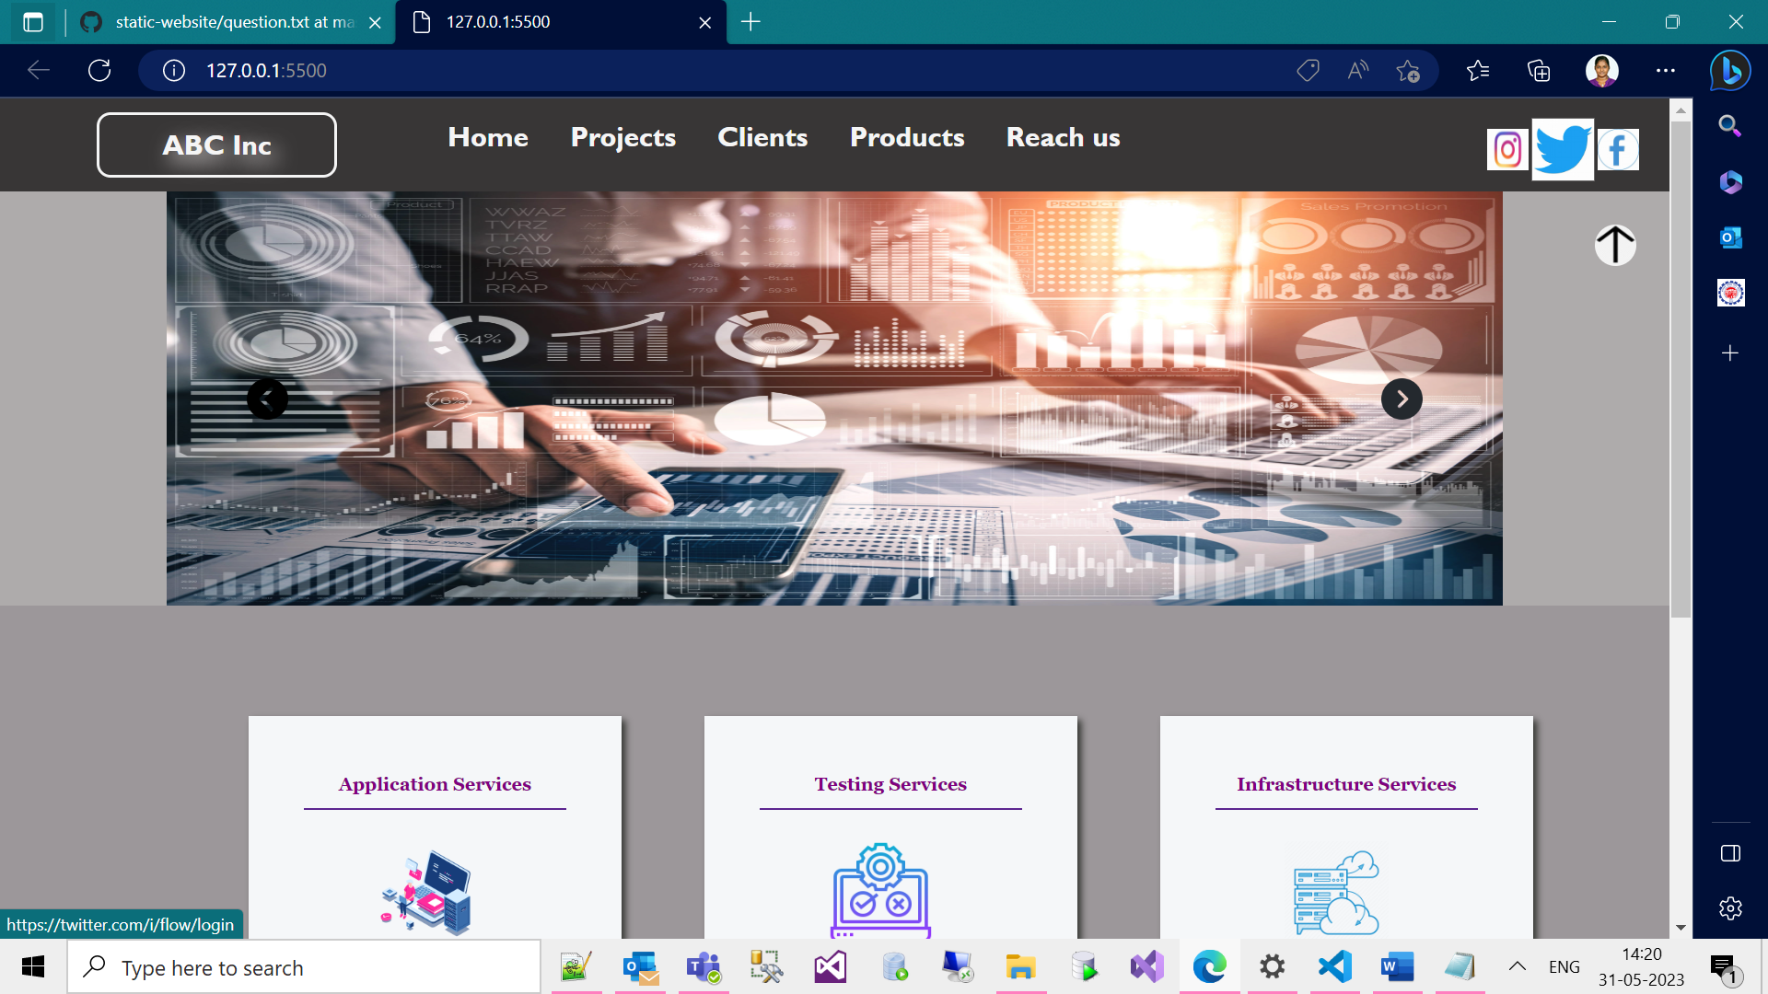

3. now in the service-box division , the features list
item is not showing clickable cursor/pointer
- make it show pointer and clickable
2. if clicked we must call a function and the function
should alert the content of current li (note: pass this as parameter
to functio]
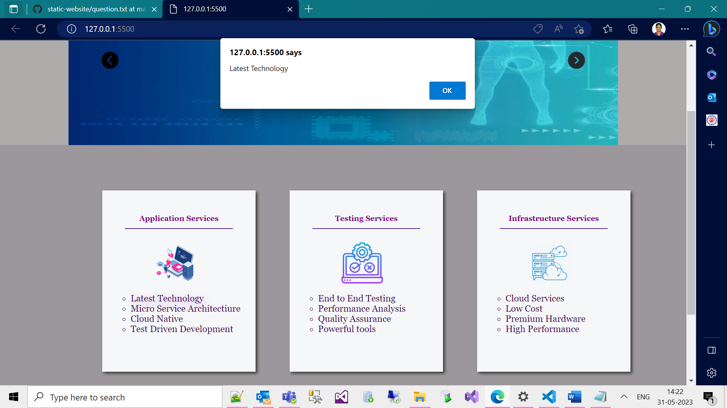

3. in the service-box image if you take mouse over it the image must
move rightside by 50px and when you take away mouse pointer it
should go back to original positioning
[note: explore transform : translate]
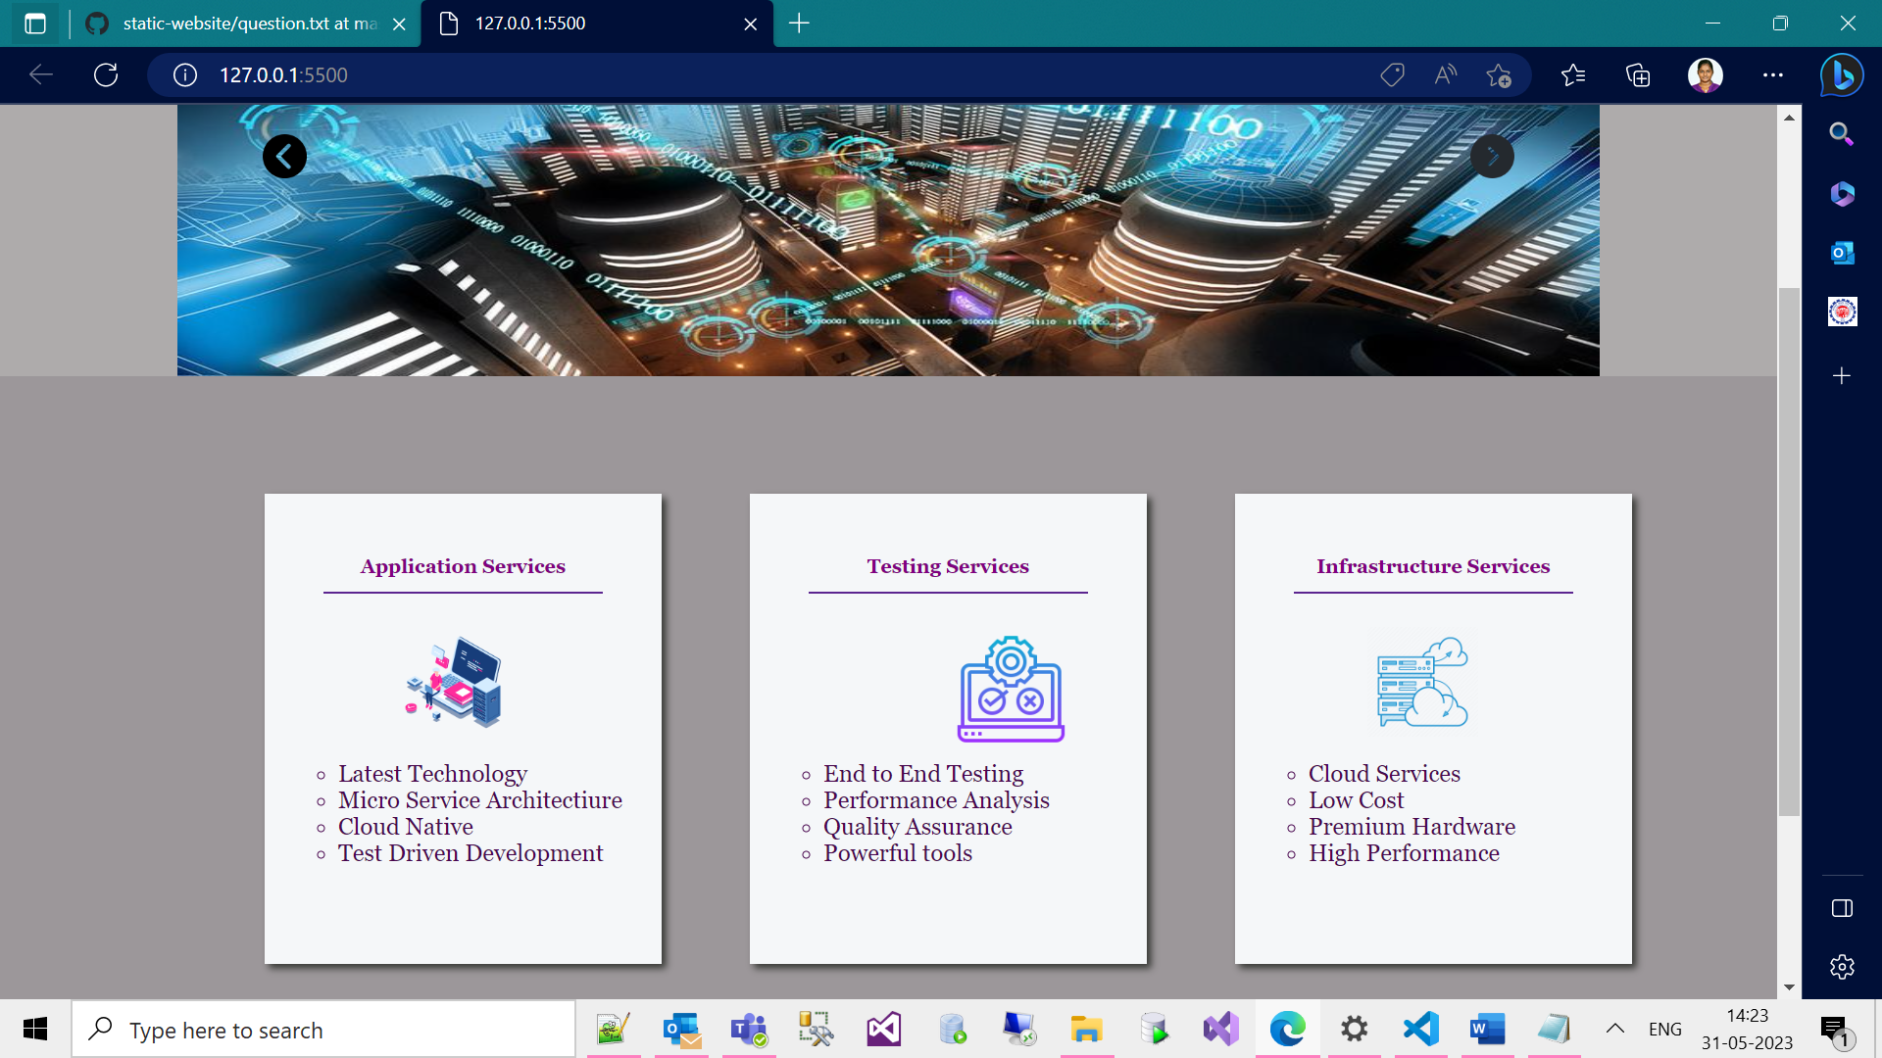
4. In the slide-area, top right corner put double up arrow
icon , if you click it the slide-show must be hidden and the
up arrow must be changed to down arrow
if down arrow is clicked again slide show must be visible and
down arrow should be converted to up arrow

