Task 2

Name: Lalitha S  
Emp_Id: 1900570  
  
required :

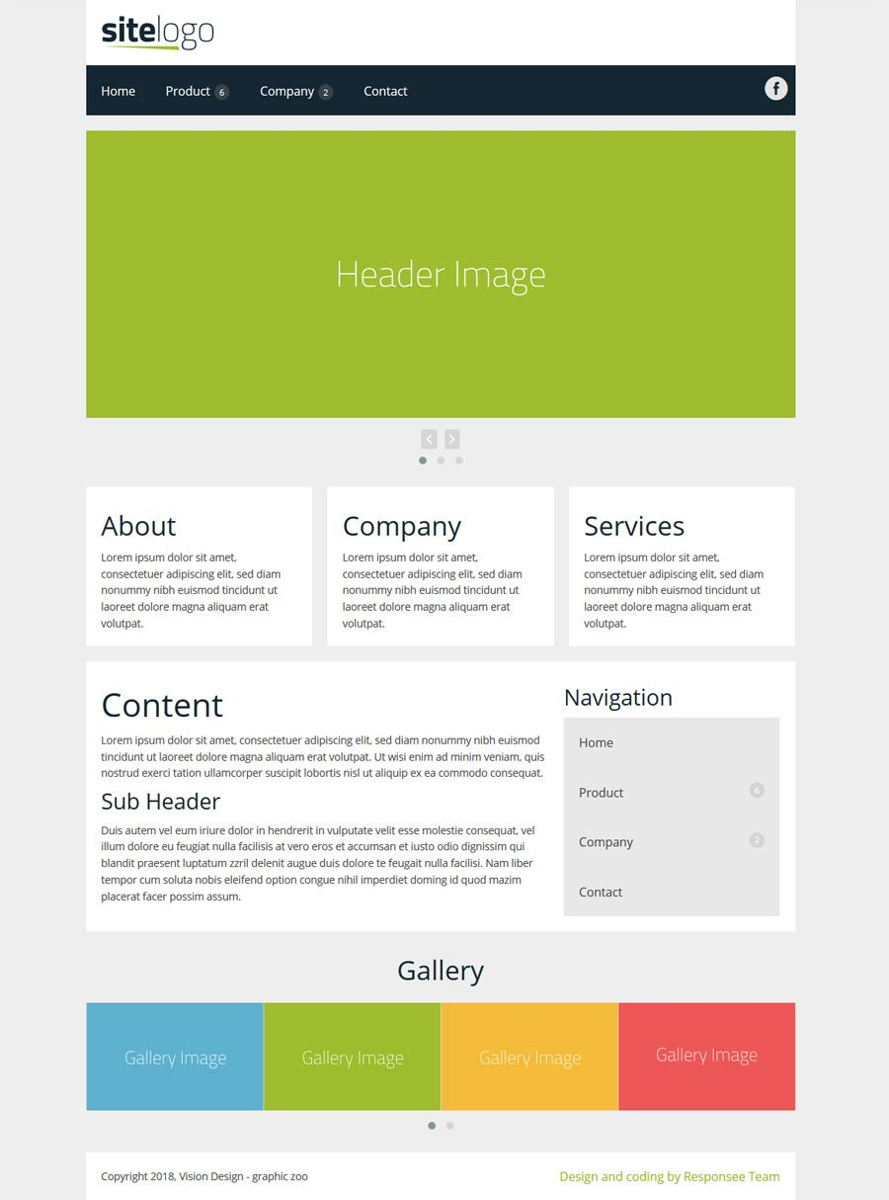

My Result:

