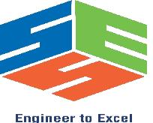

SIMATS ENGINEERING

Saveetha Institute of Medical and Technical Sciences
Chennai- 602105

Student Name:M.Lalitha Sri Regno: 192424072
Course Code: DSA0216 Slot: SLOT B
Course Name: Computer Vision with OpenCVfor Modern AI ​
Course Faculty: Dr. S. Senthilvadivu​ and Dr. T.Kumaragurubaran​
Project Title: ​AI-Based Smart Mirror for Real-Time Human Posture Detection and Correction
Module Photographs:
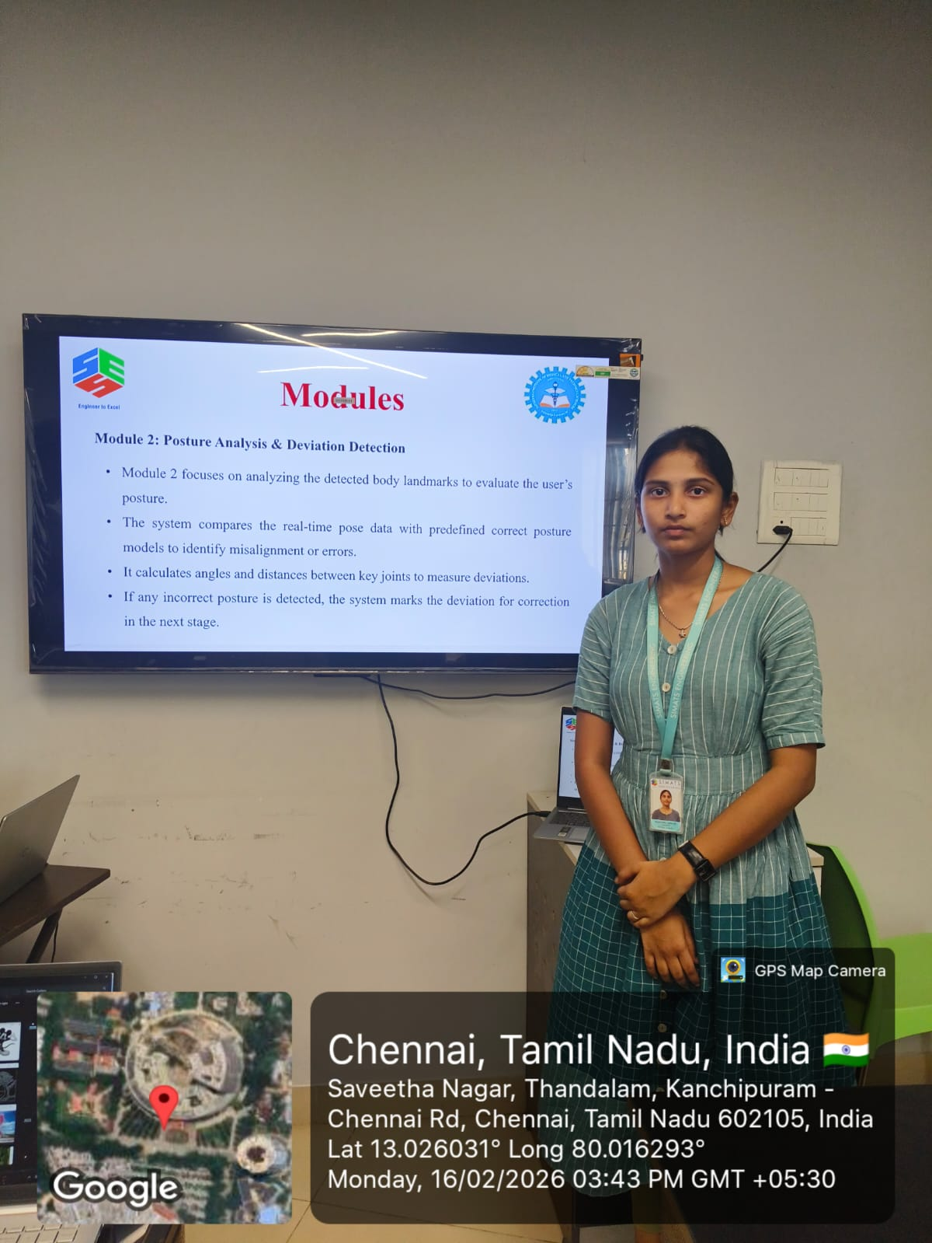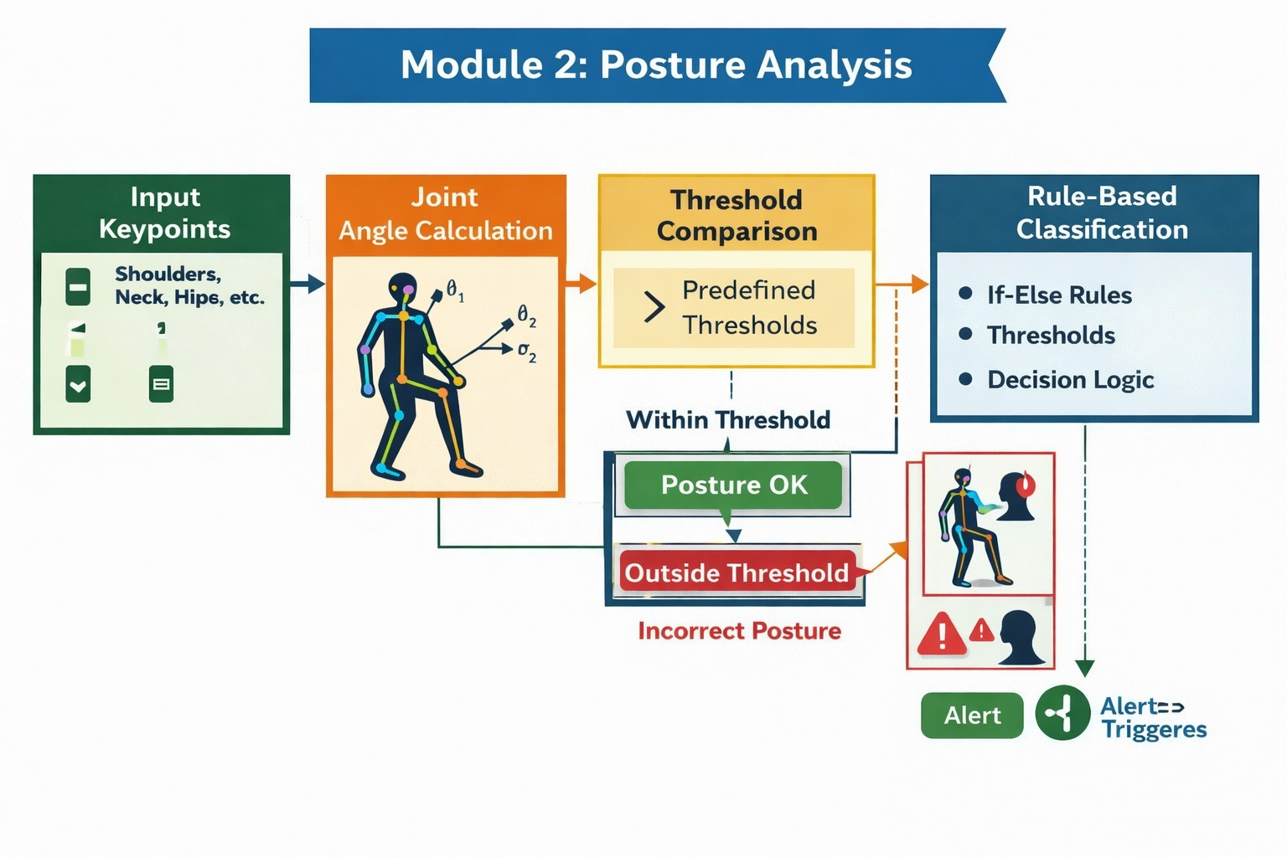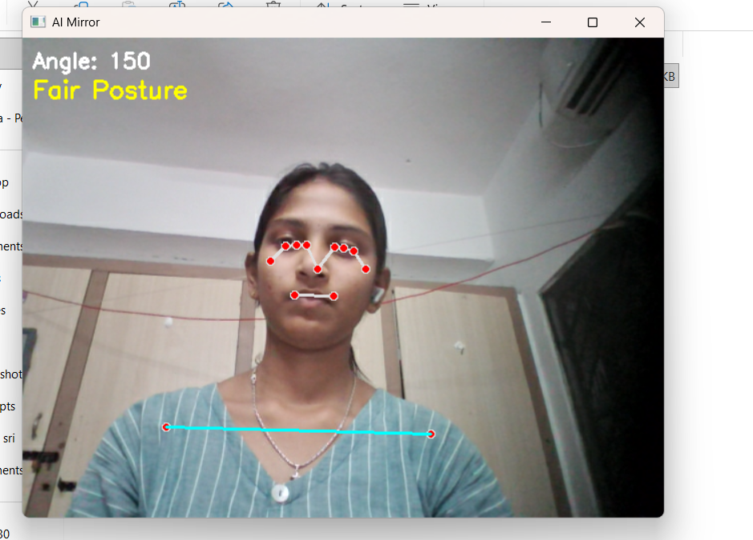
Project Description: MODULE 2 – Posture Analysis & Deviation Detection​
This module analyzes posture using real-time pose landmarks detected from the webcam. It calculates neck angle using ear, shoulder, and hip points and checks shoulder alignment using vertical difference. Based on predefined thresholds, posture is classified as Good, Fair, or Poor. I implemented angle calculation, shoulder analysis, smoothing, and posture classification logic for stable real-time monitoring.
Model Description
The module receives landmark coordinates, computes neck angle and shoulder difference, applies smoothing to reduce jitter, and classifies posture using threshold values. Poor posture detection is forwarded to the alert module for corrective feedback.
Outcomes
- Real-time posture analysis using geometric calculations.
- Stable Good/Fair/Poor posture classification.
- Improved detection accuracy using smoothing and threshold tuning.
- Provides continuous posture status for feedback and alerts.

Student Signature Guide Signature

