AI-Based Smart Mirror for Real-Time Human Posture Detection and Correction

A CAPSTONE PROJECT REPORT
Submitted in the partial fulfillment for the award of the degree of
DSA0216 – Computer Vision with OpenCV for Modern AI ​

to the award of the degree of

BACHELOR OF TECHNOLOGY IN
ARTIFICIAL INTELLIGENCE AND DATA SCIENCE
Submitted by
A. Ashriktha Reddy (192424172)
K. Hasini (192424181)
M. Lalitha Sri (19242072)

Under the Supervision of
Dr. Senthilvadivu S

Dr. Kumaragurubaran T

SIMATS ENGINEERING
Saveetha Institute of Medical and Technical Sciences
Chennai-602105
February -2026



SIMATS ENGINEERING
Saveetha Institute of Medical and Technical Sciences Chennai-602105

DECLARATION

We, A. Ashriktha Reddy (192424172) K. Hasini (192424181) M. LalithaSri (192424072) of the Department of Computer Science Engineering, Saveetha Institute of Medical and Technical Sciences, Saveetha University, Chennai, hereby declare that the Capstone Project Work entitled AI-Based Smart Mirror for Real-Time Human Posture Detection and Correction is the result of our own bonafide efforts. To the best of our knowledge, the work presented herein is original,accurate, and has been carried out in accordAance with principles of engineering ethics.

Place: Chennai
Date: 20/2/2026

Signature of the Students with Names
A. Ashriktha Reddy (192424172)
K. Hasini (192424181)
M. Lalitha Sri (192424072)

SIMATS ENGINEERING
Saveetha Institute of Medical and Technical Sciences Chennai-602105

BONAFIDE CERTIFICATE

This is to certify that the Capstone Project entitled AI-Based Smart Mirror for Real-Time Human Posture Detection and Correction has been carried out by A. Ashriktha Reddy (192424172) K. Hasini (192424181) M. LalithaSri (192424072) under the supervision of Dr. Senthilvadivu S and Dr. Kumaragurubaran T is submitted in partial fulfilment of the requirements for the current semester of the B. Tech Artificial Intelligence and Data Science program at Saveetha Institute of Medical and Technical Sciences, Chennai.

SIGNATURE SIGNATURE
Dr. Sri Ramya Dr. Senthilvadivu S
Program Director Dr. T. Kumaragurubaran
Department of CSE Professor
Saveetha School of Engineering Department of CSE
SIMATS Saveetha School of Engineering SIMATS

Submitted for the Capstone Project work Viva-Voce held on .

INTERNAL EXAMINER EXTERNAL EXAMINER

ACKNOWLEDGEMENT

We would like to express our heartfelt gratitude to all those who supported and guided us throughout the successful completion of our Capstone Project. We are deeply thankful to our respected Founder and Chancellor, Dr. N.M. Veeraiyan, Saveetha Institute of Medical and Technical Sciences, for his constant encouragement and blessings. We also express our sincere thanks to our Pro-Chancellor, Dr. Deepak Nallaswamy Veeraiyan, and our Vice-Chancellor, Dr. S. Suresh Kumar, for their visionary leadership and moral support during the course of this project.

We are truly grateful to our Director, Dr. Ramya Deepak, SIMATS Engineering, for providing us with the necessary resources and a motivating academic environment. Our special thanks to our Principal, Dr. B. Ramesh, for granting us access to the institute’s facilities and encouraging us throughout the process. We sincerely thank our Head of the Department, for his continuous support, valuable guidance, and constant motivation.

We are especially indebted to our guide, Dr. S. Senthilvadivu and Dr. T. Kumaragurubaran for their creative suggestions, consistent feedback, and unwavering support during each stage of the project. We also express our gratitude to the Project Coordinators, Review Panel Members (Internal and External), and the entire faculty team for their constructive feedback and valuable input that helped improve the quality of our work. Finally, we thank all faculty members, lab technicians, our parents, and friends for their continuous encouragement and support.

Signature of the Students with Names
A. Ashriktha Reddy (192424172)
K. Hasini (192424181)
M. Lalitha Sri (192424072)

ABSTRACT

Poor posture during prolonged computer or smartphone usage has become a common health concern among students and professionals, often leading to neck strain, back pain, and long-term musculoskeletal problems. Traditional posture correction methods rely on manual observation or wearable devices, which may be inconvenient and unsuitable for continuous monitoring. This project presents the development of an AI Mirror for Real-Time Posture Correction using Computer Vision, designed to automatically detect posture deviations and provide immediate corrective feedback.The proposed system employs computer vision and artificial intelligence techniques to analyze human posture using real-time video input from a webcam. The architecture consists of three functional modules: Real-Time Video Acquisition & Pose Detection, which captures live video and identifies body keypoints using pose estimation algorithms; Posture Analysis & Deviation Detection, which evaluates body alignment by calculating joint angles and detecting deviations from predefined ergonomic standards; and Alert & Feedback System, which generates smart visual or audio alerts when incorrect posture persists for a specified duration.The system operates without wearable sensors, ensuring a non-intrusive and cost-effective solution for posture monitoring. Experimental results demonstrate that the AI Mirror effectively detects common posture issues such as slouching and forward head tilt while maintaining real-time performance. The solution enhances user awareness, encourages healthier posture habits, and demonstrates the practical application of AI-driven human pose estimation in health and wellness support systems. By integrating real-time analytics with intelligent feedback, the project contributes to preventive healthcare technologies and promotes improved ergonomic practices in daily learning and working environments.

TABLE OF CONTENTS

S. No.  1 | Title  INTRODUCTION | Page No.  1-2
 | 1.1 Background Information | 1
 | 1.2 Project Objectives | 1
 | 1.3 Significance | 1-2
 | - Scope  - Methodology Overview | 2  2

2 | PROBLEM IDENTIFICATION & ANALYSIS | 3-4
 | 2.1 Description of the Problem | 3
 | 2.2 Evidence of the Problem | 3
 | 2.3 Stakeholders | 4
 | 2.4 Supporting Data / Research | 4

- SOLUTION DESIGN & IMPLEMENTATION 5-7
  - Development & Design Process 5
  - Tools & Technologies Used 5
  - Solution Overview 5-6
  - Engineering Standards Applied 6

  - Ethical Standards Applied 7
- RESULTS & RECOMMENDATIONS 8
  - Evaluation of Results 8
  - Challenges Encountered 8
  - Possible Improvements 8
  - Recommendations 8

5 | REFLECTION ON LEARNING AND PERSONAL DEVELOPMENT | 9 – 11
 | 5.1 Key Learning Outcomes | 9
 | 5.1.1 Academic Knowledge | 9
 | 5.1.2 Technical Skills | 9
 | 5.1.3 Problem-Solving & Critical Thinking | 9
 | 5.2 Challenges Encountered and Overcome | 11
 | 5.3 Application of Engineering Standards | 11
 | 5.4 Application of Ethical Standards | 11
 | 5.5 Conclusion on Personal Development | 11

- CONCLUSION 12
REFERENCES 13
APPENDICES 14-16

LIST OF TABLES

Table no. | Name | Page no.
3.1 | Posture Criteria and Evaluation in AI Mirror System | 6
LIST OF FIGURES

Fig no. | Name | Page no.
2.4.1 | Architecture Diagram of AI Posture Correction System | 4
A.1 | Sample Output of Module 1: Real-Time Video Acquisition and Pose Detection | 14
A.2 | Sample Output of Module 2: Posture Analysis and Deviation Detection | 15
A.3 | Sample Output of Module 3: Alert and Feedback System | 15

CHAPTER 1
INTRODUCTION

1.1 Background Information
With the increasing use of computers, smartphones, and prolonged desk-based work, poor posture has become a common health concern among students and professionals. Incorrect posture during sitting or standing can lead to musculoskeletal disorders, neck pain, back pain, and long-term spinal issues. Traditional posture correction methods rely on manual observation, wearable sensors, or physiotherapy sessions, which are often expensive or inconvenient for continuous monitoring.
Recent advancements in Artificial Intelligence (AI) and Computer Vision have made it possible to monitor human posture automatically through cameras without requiring wearable devices. Pose estimation algorithms can detect key body landmarks in real time, enabling systems to analyze posture and provide corrective feedback instantly. An AI Mirror system combines these technologies to act as an intelligent assistant that monitors posture continuously and helps users maintain healthy body alignment.

1.2 Project Objectives
The primary goal of this project is to design and develop an AI Mirror for real-time posture correction using computer vision. The objectives include:
- Develop a system capable of real-time video acquisition and human pose detection.
- Analyze body posture using detected landmarks and identify deviations from ideal posture.
- Provide instant alerts and feedback when incorrect posture is detected.
- Create a user-friendly interface that supports continuous posture monitoring.
- Improve user awareness of posture habits through visual and audio feedback.

1.3 Significance
This project contributes significantly to health monitoring and intelligent wellness systems by:
- Promoting healthier posture habits and preventing long-term physical problems.
- Providing a low-cost and non-intrusive alternative to wearable posture devices.
- Demonstrating practical applications of AI and computer vision in healthcare assistance.
- Supporting educational and workplace environments by encouraging ergonomic practices.
- Enhancing real-time human-computer interaction through intelligent feedback systems.

1.4 Scope
The scope of this project includes:
- Developing a computer vision-based system that uses a webcam for posture monitoring.
- Real-time detection of body keypoints using pose estimation techniques.
- Posture deviation analysis for standing or sitting positions.
- Alert generation through on-screen messages or sound notifications.
The project does not include:
- Medical diagnosis or treatment recommendations.
- Advanced biomechanical modeling or sensor-based tracking.
- Multi-user simultaneous posture tracking.

1.5 Methodology Overview
The project follows a modular development approach:
- Capturing real-time video input through a webcam.
- Detecting body landmarks using AI-based pose estimation models.
- Comparing detected posture with predefined ergonomic rules.
- Generating alerts when posture deviations persist for a specific duration.
- Displaying feedback through an interactive mirror-like interface.

CHAPTER 2
PROBLEM IDENTIFICATION AND ANALYSIS

2.1 Description of the Problem
Poor posture is a widespread issue caused by prolonged screen exposure and sedentary lifestyles. Most individuals are unaware of their posture while working or studying, leading to gradual development of back and neck problems. Existing solutions such as wearable posture sensors may be uncomfortable, costly, or unsuitable for continuous everyday use. Manual monitoring is impractical and lacks real-time correction capability.
Without automated monitoring, users receive no immediate feedback when posture deteriorates, making behavioral correction difficult. This highlights the need for an intelligent, automated system capable of detecting and correcting posture in real time.

2.2 Evidence of the Problem
Several studies and observations indicate the seriousness of posture-related issues:
- Surveys show that a large percentage of students and office workers experience neck or back pain due to prolonged poor posture.
- Physiotherapy reports indicate increasing cases of posture-related musculoskeletal disorders among young adults.
- Research demonstrates that real-time feedback significantly improves posture correction compared to delayed feedback methods.
- Many existing posture monitoring systems require wearable devices, limiting user comfort and adoption.

2.3 Stakeholders
The key stakeholders involved include:
- Students and Professionals: Primary users who benefit from posture correction.
- Educational Institutions: Promote healthier learning environments.
- Employers and Organizations: Improve employee health and productivity.
- Healthcare Professionals: Use such systems as preventive tools.
- Developers and Researchers: Improve computer vision applications in healthcare.

2.4 Architecture
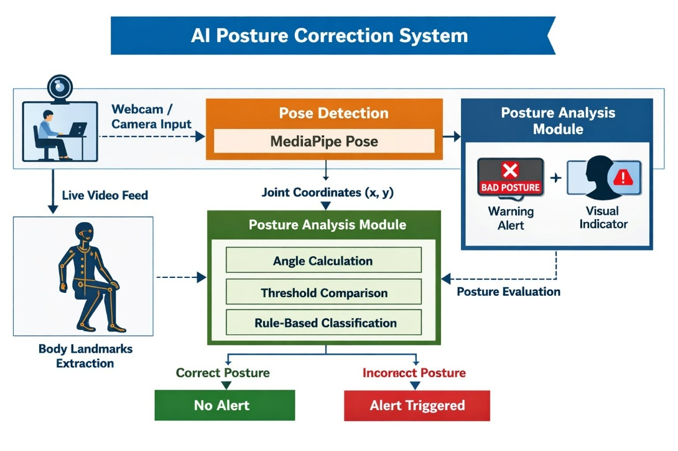
Fig. 2.4.1. Architecture Diagram of AI Posture Correction System
Figure 2.4.1 illustrates the overall architecture of the AI Posture Correction System used for real-time posture monitoring. The system begins with a webcam capturing live video input from the user, which is processed using the Media Pipe Pose detection model to extract body landmarks and joint coordinates. These coordinates are forwarded to the posture analysis module.

2.5 Supporting Data/Research
Research in computer vision and health monitoring supports the effectiveness of posture correction systems:
- Studies in human pose estimation show high accuracy in detecting body joints using deep learning models.
- Research indicates that visual feedback systems improve posture awareness and reduce musculoskeletal discomfort.
- AI-based monitoring systems have demonstrated improved engagement and behavioral change due to instant feedback mechanisms.
- Human-computer interaction studies highlight the effectiveness of real-time alerts in reinforcing healthy habits.

CHAPTER 3
SOLUTION DESIGN AND IMPLEMENTATION

3.1 Development and Design Process
The AI Mirror system was developed using a structured process:
- Requirement Analysis: Identification of posture monitoring needs and feedback mechanisms.
- System Design: Modular architecture dividing detection, analysis, and alert components.
- Prototype Development: Building initial models for pose detection and posture scoring.
- Iterative Development: Improving accuracy through repeated testing and calibration.
- Testing: Real-time performance testing under varying lighting and user positions.
- Deployment: Running the system on standard computers with webcam support.

3.2 Tools and Technologies Used
Key tools and technologies include:
- Programming Language: Python
- Computer Vision Library: OpenCV
- Pose Detection Framework: MediaPipe / OpenPose
- Data Processing: NumPy
- Visualization: Matplotlib (for analysis graphs)
- Development Environment: Google Colab / VS Code
- Alert System: Audio alerts and screen notifications

3.3 Solution Overview
The AI Mirror consists of three major modules:
Module 1: Real-Time Video Acquisition & Pose Detection
- Captures live video using a webcam.
- Detects human body keypoints such as shoulders, neck, and spine using pose estimation models.
Module 2: Posture Analysis & Deviation Detection
- Calculates angles between body landmarks.
- Compares posture with predefined ergonomic thresholds.
- Identifies deviations such as slouching, forward neck tilt, or uneven shoulders.

Table 3.1 Posture Criteria and Evaluation in AI Mirror System
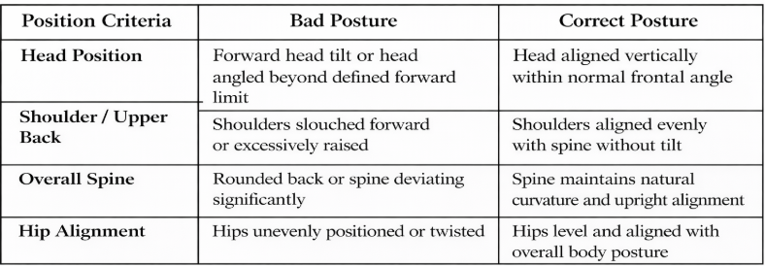
Table 3.1 presents the posture evaluation criteria used in the AI Mirror posture correction system. The table compares conditions representing bad posture and correct posture based on different body alignment parameters such as head position, shoulder alignment, spine posture, and hip balance. These criteria are used by the posture analysis module to determine whether the user maintains proper ergonomic alignment.
3.4 Engineering Standards Applied
The development of the AI Mirror for Real-Time Posture Correction Using Computer Vision system follows standard software engineering and quality assurance principles to ensure reliability, accuracy, and usability. IEEE software development guidelines were applied to maintain a structured approach throughout requirement analysis, system design, implementation, and testing phases. The system design also considers the ISO/IEC 25010 software quality model to achieve essential quality attributes such as functionality, performance efficiency, maintainability, and usability. In addition, ergonomic posture standards were referenced to define acceptable body alignment and posture evaluation thresholds, ensuring health-related accuracy during posture analysis. Real-time processing principles were incorporated to minimize system latency and provide immediate feedback, while secure development practices were followed to ensure safe handling of video data and user privacy.

3.5 Ethical Standards Applied
The development of the AI Mirror for Real-Time Posture Correction Using Computer Vision system follows important ethical principles to ensure responsible and safe use of technology. User privacy and data protection were prioritized by processing video data locally without storing or sharing personal information. The system is designed to operate transparently by providing clear feedback without misleading or harmful recommendations. Ethical considerations were also taken into account to avoid bias by ensuring the posture detection model functions consistently for different users and environments. Additionally, the system promotes user well-being by offering supportive corrective guidance rather than intrusive monitoring. These ethical practices ensure that the AI Mirror system respects user confidentiality, encourages responsible AI usage, and supports safe adoption in educational and workplace environments.

CHAPTER 4
RESULTS AND RECOMMENDATIONS

4.1 Evaluation of Results
The AI Mirror system showed promising results:
- Real-time posture detection achieved stable performance with minimal delay.
- The system effectively identified common posture deviations.
- Users reported improved awareness of their posture after continuous use.
- Alert mechanisms reduced prolonged poor posture durations significantly.

4.2 Challenges Encountered
Several challenges were faced during development:
- Variations in lighting affected pose detection accuracy.
- Occlusion of body parts caused temporary tracking loss.
- Defining universal posture thresholds for different body types required adjustments.
- Real-time processing optimization was necessary for smooth performance.

4.3 Possible Improvements
Future enhancements include:
- Integration of machine learning models for personalized posture recommendations.
- Support for multi-user posture monitoring.
- Mobile or smart mirror deployment.
- Advanced analytics dashboards for posture history tracking.

4.4 Recommendations
For future research and deployment:
- Conduct long-term user studies to measure health benefits.
- Integrate wearable sensors for hybrid accuracy.
- Expand the system for workplace ergonomic assessments.
- Incorporate AI-driven coaching and personalized guidance.

CHAPTER 5
REFLECTION ON LEARNING AND PERSONAL DEVELOPMENT

5.1 Key Learning Outcomes
The development of the AI Mirror for Real-Time Posture Correction Using Computer Vision provided valuable academic, technical, and analytical learning experiences. The project strengthened understanding of computer vision concepts and their practical application in real-time human posture monitoring systems. Through the implementation of multiple modules, the project enhanced both theoretical knowledge and practical engineering skills.

5.1.1 Academic Knowledge
Through this project, strong understanding was gained in concepts related to computer vision, human pose estimation, and real-time image processing. The project involved applying theories such as image acquisition, feature extraction, coordinate-based body analysis, and posture assessment techniques. Knowledge of artificial intelligence concepts, human-computer interaction, and real-time monitoring systems was also improved. The project helped bridge the gap between classroom learning and real-world AI applications.

5.1.2 Technical Skills
The project helped in developing technical skills related to programming and implementation of real-time computer vision systems. Practical experience was gained in handling live video streams, pose detection models, and posture angle calculations. Skills in Python programming, OpenCV, and AI-based pose detection frameworks were significantly enhanced. The development of alert mechanisms and feedback systems also improved system integration and real-time processing skills.

5.1.3 Problem-Solving and Critical Thinking
Several technical challenges such as accurate pose detection, handling varying lighting conditions, and maintaining real-time performance were addressed during the project. Logical reasoning and analytical thinking were applied to design posture deviation detection algorithms and threshold-based alert mechanisms. The project improved the ability to analyze complex visual data and create efficient solutions for practical health-related applications.
5.2 Challenges Encountered and Overcome
During the development process, multiple challenges were encountered related to real-time detection accuracy, system responsiveness, and environmental variations. These challenges were resolved through iterative testing, parameter tuning, and continuous improvement of the detection logic.

5.2.1 Personal and Professional Growth
Working on this project improved patience, self-learning ability, and problem-solving confidence. Debugging real-time systems required persistence and careful experimentation, which enhanced professional maturity. The project also strengthened time management and independent learning skills while exploring advanced AI techniques beyond classroom curriculum.

5.2.2 Collaboration and Communication
The project involved discussions with mentors and peers to refine posture analysis logic and improve system usability. Effective communication helped in receiving feedback, identifying design improvements, and simplifying user interaction. Collaboration contributed to clearer understanding of project requirements and better implementation strategies.

5.3 Application of Engineering Standards
Engineering principles such as modular design, system testing, and reliability were applied throughout the development process. The project was structured into clear modules: real-time video acquisition, posture analysis, and alert feedback system, ensuring maintainability and scalability. Ethical considerations such as non-invasive monitoring and user privacy were acknowledged while designing the solution. Proper documentation and systematic testing practices were followed to ensure consistent performance.

5.4 Insights into the Industry
This project provided insight into how computer vision and AI technologies are used in real-world healthcare, fitness, and workplace ergonomics applications. It highlighted the growing demand for intelligent monitoring systems that assist users in improving health and productivity. The experience offered practical understanding of how AI-based solutions are developed, tested, and optimized for real-time environments, providing valuable exposure to industry practices.
5.5 Conclusion on Personal Development
In conclusion, this project significantly contributed to both technical and personal development. It enhanced knowledge in computer vision, real-time AI processing, and system integration while improving analytical thinking and problem-solving abilities. The experience gained through building an intelligent posture correction system strengthened confidence in developing real-world AI applications and will support future academic and professional opportunities in artificial intelligence and computer vision domains.

CHAPTER 6
CONCLUSION

6.1 Key Findings and Impact
The development of the AI Mirror for Real-Time Posture Correction Using Computer Vision successfully addressed the need for an intelligent system that monitors and improves human posture in real time. The project achieved:
- Real-time posture detection using live video input
- Accurate posture deviation analysis using pose estimation techniques
- Immediate alert and feedback system for posture correction
- Improved user awareness of posture habits
- Efficient integration of AI and computer vision for practical use
Overall, the system demonstrated effectiveness as an intelligent assistant for promoting healthy posture and reducing the risks associated with poor ergonomic habits.

6.2 Value and Significance
This project highlighted the importance of AI-driven solutions in healthcare and human well-being. By combining computer vision, real-time analytics, and feedback mechanisms, the solution provides a foundation for future enhancements such as personalized posture coaching, mobile integration, and smart workplace monitoring. Beyond technical achievements, the project greatly contributed to personal and professional growth by developing practical skills in AI system development, real-time processing, and engineering problem-solving.

REFERENCES

- Kotte, H., Kravcik, M., & Duong-Trung, N. (2025). Real-Time Posture Correction in Gym Exercises: A Computer Vision-Based Approach for Performance Analysis, Error Classification and Feedback. Proceedings of the International Workshop on Multimodal Immersive Learning Systems, 64–70.
- Lin, B. S., Liu, K. J., Tseng, W. H., Ahmed, A. M., Wang, H. C., & Lin, B. S. (2024). A Deep Learning-Based Chair System That Detects Sitting Posture. IEEE Journal of Biomedical and Health Informatics.
- Kim, H., Oh, K. T., Kim, J., Kwon, O., Choi, J., & Yoo, S. K. (2024). Real-Time Pilates Posture Recognition System Using Deep Learning Model. In Digital Health Transformation, Smart Ageing, and Managing Disability (ICOST 2024). Springer.
- Dong, C., & Du, G. (2024). An Enhanced Real-Time Human Pose Estimation Method Based on Modified YOLOv8 Framework. Scientific Reports, 14, 8012.
- Tomé de la Torre, M. A., Álvarez Fernández-Balbuena, A., Bernárdez-Vilaboa, R., & Vázquez Molini, D. (2024). Artificial Vision System on Digital Devices for Real-Time Head Tilt Control. Sensors, 24(12), 3756.
- Bagga, E., & Yang, A. (2024). Real-Time Posture Monitoring and Risk Assessment for Manual Lifting Tasks Using MediaPipe and LSTM. arXiv preprint.
- Yuan, S., & Zhou, L. (2024). GTA-Net: An IoT-Integrated 3D Human Pose Estimation System for Real-Time Adolescent Sports Posture Correction. arXiv preprint.
- Zhang, H., Gračanin, D., Zhou, W., Dudash, D., & Rushton, G. (2025). Toward Real-Time Posture Classification: Reality Check. Electronics, 14(9), 1876.
- Potharaju, S., Tambe, S. N., Srikanth, N., Tirandasu, R. K., & Amiripalli, S. S. (2025). Smartphone based real-time detection of postural and leg abnormalities using deep learning techniques. Journal of Current Science and Technology, 15(3). https://doi.org/10.59796/jcst.V15N3.2025.112
- Zhang, H., Gračanin, D., Zhou, W., Dudash, D., & Rushton, G. (2025). Toward real-time posture classification: Reality check. Electronics, 14(9), 1876.

APPENDICES

Appendix I
Sample Code
# ================== LIBRARIES ==================
import cv2
import mediapipe as mp
import time
import numpy as np
# ================== INITIALIZATION ==================
mp_pose = mp.solutions.pose
mp_draw = mp.solutions.drawing_utils
pose = mp_pose.Pose()
cap = cv2.VideoCapture(0)
# ================== REAL-TIME POSTURE MONITOR ==================
while True:
success, frame = cap.read()
if not success:
break
imgRGB = cv2.cvtColor(frame, cv2.COLOR_BGR2RGB)
results = pose.process(imgRGB)
if results.pose_landmarks:
mp_draw.draw_landmarks(
frame,
results.pose_landmarks,
mp_pose.POSE_CONNECTIONS
)
# Example: Shoulder alignment check
lm = results.pose_landmarks.landmark
left_shoulder = lm[11]
right_shoulder = lm[12]
diff = abs(left_shoulder.y - right_shoulder.y)
if diff > 0.05:
cv2.putText(frame, "BAD POSTURE!",
(50, 50), cv2.FONT_HERSHEY_SIMPLEX,
1, (0,0,255), 2)
else:
cv2.putText(frame, "GOOD POSTURE",
(50, 50), cv2.FONT_HERSHEY_SIMPLEX,
1, (0,255,0), 2)
cv2.imshow("AI Mirror - Posture Detection", frame
if cv2.waitKey(1) & 0xFF == ord('q'):
break
cap.release()
cv2.destroyAllWindows()

Appendix II
Sample Output

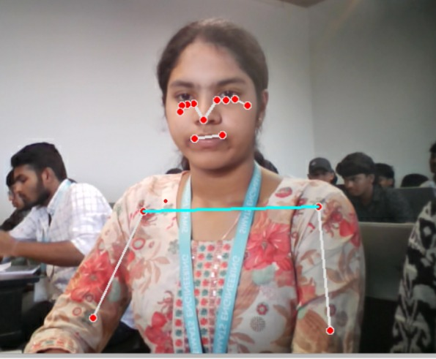
Fig. A.1 Sample Output of Module 1: Real-Time Video Acquisition and Pose Detection
Figure A.1 shows the implementation output of Module 1, which performs real-time video acquisition and pose detection using computer vision techniques. The system captures live video through a webcam and processes each frame using the MediaPipe Pose model to detect facial and upper-body landmarks.
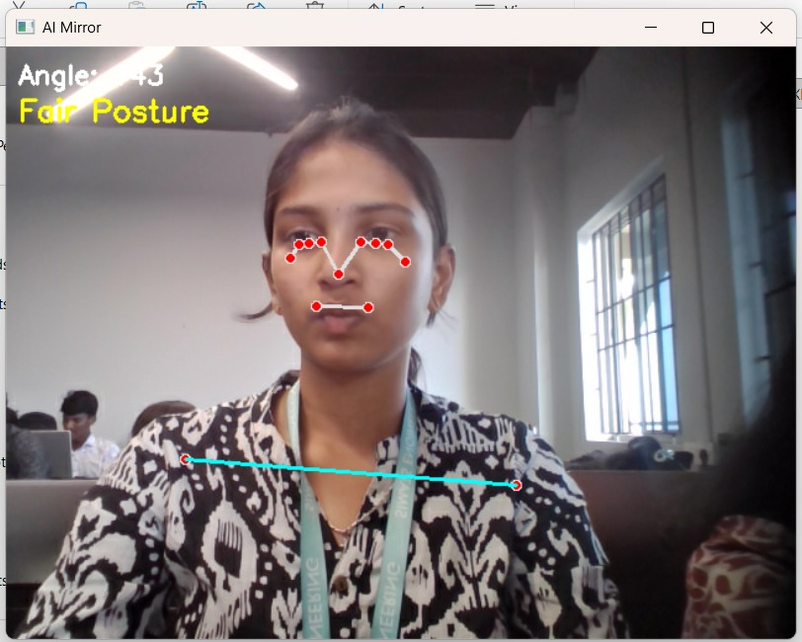
Fig. A.2 Sample Output of Module 2: Posture Analysis and Deviation Detection
Figure A.2 illustrates the implementation output of Module 2, where the detected body landmarks are analyzed to evaluate user posture. The system calculates alignment angles using shoulder and head coordinates obtained from the pose detection stage. Based on predefined ergonomic thresholds, the posture analysis module determines whether the user maintains correct posture.

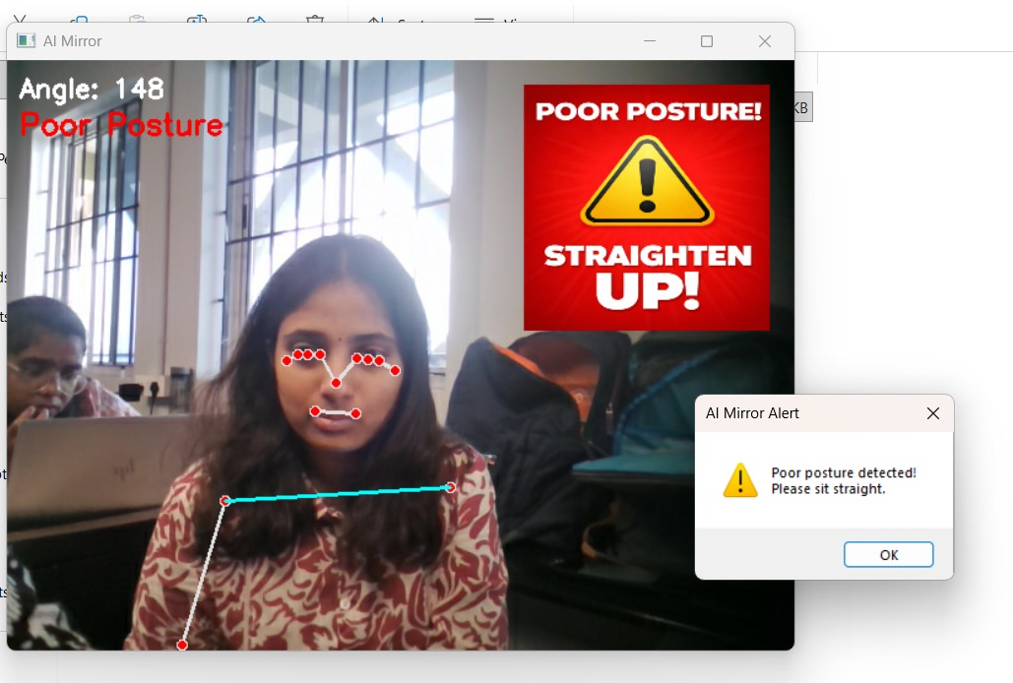
Fig. A.3 Sample Output of Module 3: Alert and Feedback System
Figure A.3 shows the implementation output of Module 3, which generates alerts and corrective feedback when improper posture is detected. After posture evaluation, the system identifies deviation from acceptable alignment limits and displays a warning message along with a visual alert indicating “Poor Posture.” A notification prompt is also generated to instruct the user to straighten their posture. This feedback mechanism helps users immediately recognize incorrect posture and take corrective action, enabling real-time posture improvement.

