LALITH ALPURI
AI INFRASTRUCTURE ENGINEER · MCP SERVERS · LOCAL AGENT MEMORY
Nashik, Maharashtra, India | lalithalpuri.worK@gmail.com | +91 63038 38238 | github.com/lalithbuilds | linkedin.com/in/lalith-alpuri

PROFILE
AI infrastructure engineer and applied AI strategist building local-first systems for coding agents and decision support. I work across Python, Java, MCP servers, SQLite memory, hybrid retrieval, multi-agent simulation, market intelligence, predictive analysis, and full-stack delivery. My public work includes EpisodAI, Episoda Core MCP, ALPURIS OS, and a personal Sentinel / UWOF local AI lab.

TECHNICAL STRENGTHS
AI systems | MCP servers, AI agents, multi-agent orchestration, local LLM workflows, RAG, hybrid retrieval, knowledge graphs, context engineering
Languages | Python, Java, JavaScript/ES6+, SQL, Bash, R
Backend | Spring Boot, Spring, JPA/Hibernate, REST APIs, Node.js, SQLite/FTS5, MySQL, MongoDB
Frontend | React, Next.js, HTML, CSS, WebGL visualization
Delivery | Docker, Kubernetes, Git/GitHub, GitHub Actions, Postman, Selenium automation, manual QA, HLD/LLD, DSA
Local AI | MLX, Ollama, OpenInterpreter, LoRA fine-tuning, Apple Silicon model tiers, Obsidian workflows

PROFESSIONAL EXPERIENCE

Ataraxia Pharma Pvt. Ltd. | Applied AI, Simulation & Analytics | 2026
• Developed AI-assisted research and scenario-analysis workflows for wellness product planning, combining structured market inputs, synthetic consumer cohorts, and comparative evidence reviews.
• Worked with a 1,000,000-row Monte Carlo simulation dataset in SQLite; analyzed pricing, channel commissions, landed costs, net selling price, and margin variables through feasibility and profitability filters.
• Produced a ranked 1,000-scenario CSV export and an HTML simulation explorer to support inspection of model assumptions, trade-offs, and shortlisted scenarios.
• Applied predictive scenario analysis to acquisition cost, ROAS, conversion, channel mix, and unit economics; distinguished synthetic outputs and forecast assumptions from observed commercial performance.
• Structured competitor comparisons and scientific-evidence audits into spreadsheets, dashboards, and technical briefs, documenting source evidence, limitations, and validation requirements.

PROJECTS

EpisodAI | Creator / maintainer | 2025–Present
• Built a local MCP memory engine with SQLite WAL, vector and trigram retrieval, knowledge-graph workflows, cognitive decay, and Obsidian ingestion.
• Hardened the threaded HTTP bridge for concurrent requests and documented reproduction commands instead of relying on unverified benchmark claims.

Episoda Core MCP | Creator / maintainer | 2025–Present
• Built a zero-dependency Python MCP server using SQLite FTS5/BM25 for offline, persistent recall by coding agents.
• Designed a small proof path—save, search, stats, and tests—to keep the system auditable and easy to adopt.

ALPURIS OS | Creator / maintainer | 2025–Present
• Built a local multi-agent city simulation with autonomous citizens, sector activity, civic governance, an economy, Python services, and a 3D WebGL voxel interface.
• Added repo-relative configuration, portable workspace/database overrides, Docker/Compose support, and a reproducible demo path.

Sentinel / UWOF local AI systems lab | Personal research project | 2025–Present
• Designed a local orchestration runner that routes between MLX model tiers, a web-scout path, and an OpenInterpreter/Ollama execution path.
• Maintains local model checkpoints and an MLX LoRA fine-tuning script for Apple Silicon experiments; runtime assumptions are documented in the source folder.

FULL-STACK ENGINEERING

Independent Full-Stack Developer | 2025–2026
• Built web applications with React/JavaScript frontends and Spring Boot backends, following SOLID principles and clear API boundaries.
• Designed SQL schemas and Hibernate/JPA mappings; built REST endpoints with global exception handling and Postman validation.
• Applied manual QA and Selenium automation to improve regression coverage and release confidence.

ORACLE CERTIFICATIONS
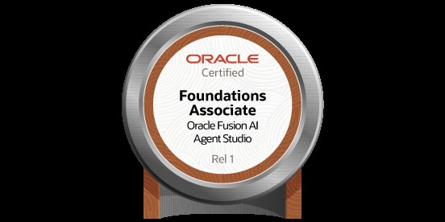 | Oracle Fusion AI Agent Studio Certified Foundations Associate - Rel 1  Oracle · Exam 1Z0-1145-1  Issued October 16, 2026  Verify Oracle credential
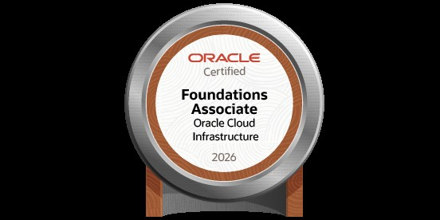 | Oracle Cloud Infrastructure Certified Foundations Associate  Oracle · Exam 1Z0-1085-26  Issued October 16, 2026 · Valid until October 16, 2028  Verify Oracle credential

EDUCATION & CERTIFICATION

Java Full Stack Development Certification | KodNest, Bengaluru
Java, Python, Spring Boot, JPA/Hibernate, React, SQL, MongoDB, REST APIs, DSA, manual QA, and Selenium automation.

Bachelor of Commerce in Computer Application | Rayalaseema University, Andhra Pradesh
Coursework included Python, Core Java, C/C++, R, DBMS, and enterprise application foundations.

SELECTED LINKS
GitHub: https://github.com/lalithbuilds · Project home: https://lalithbuilds.github.io/ · LinkedIn: https://www.linkedin.com/in/lalith-alpuri/

