Learning Roadmap
We'll treat this like a mini industry project.
Phase 1 — Understanding CMOS Inverter
Before opening Virtuoso, understand:
- NMOS operation
- PMOS operation
- Threshold voltage
- Cutoff
- Linear region
- Saturation
- CMOS switching
Goal:
Understand why CMOS consumes almost zero static power.

Phase 2 — Schematic Design
In Virtuoso:
Create
Library
↓
Cell
↓
View (schematic)
Then place
PMOS
NMOS
VDD
GND
Input
Output
Result
VDD
|
PMOS
|
OUT-----------
|
NMOS
|
GND
Input connected to both gates

Phase 3 — Symbol Creation
From the schematic create a symbol.
Design
→ Create Cellview
→ From Cellview
You'll obtain a reusable inverter block.

Phase 4 — Testbench
Create another schematic.
Library
↓
tb_inverter
Add
- inverter symbol
- VDD
- Pulse source
- Load capacitor
Pulse ---> Inverter ---> Output
|
VDD

Phase 5 — DC Analysis
Use ADE Explorer.
Run
Analysis
→ dc
Sweep
Vin
0 → VDD
Observe
Vout vs Vin
This is the Voltage Transfer Characteristic (VTC).
You'll learn:
- VOH
- VOL
- VIH
- VIL
- Switching threshold
- Noise margins
These are fundamental concepts in digital logic and analog device behavior.

Phase 6 — Transient Analysis
Apply a pulse input.
0
↓
VDD
↓
0
↓
VDD
Measure:
- Rise time
- Fall time
- Propagation delay
- Average power
This is how real digital circuits are evaluated.

Phase 7 — Parametric Analysis
Change transistor sizes.
Example:
NMOS W = 1 µm
PMOS W = 2 µm
Then try
PMOS = 3 µm
PMOS = 4 µm
PMOS = 5 µm
Observe:
- Delay
- Power
- Switching point
You'll understand why PMOS is often made about 2–3× wider than NMOS to balance drive strength.

Phase 8 — Layout
Create the physical layout.
You'll learn:
- Diffusion
- Poly
- Metal1
- Metal2
- Contacts
- Wells
This is where IC design becomes tangible.

Phase 9 — DRC
Run
Verify
→ DRC
Fix every design-rule violation.

Phase 10 — LVS
Run
Verify
→ LVS
Ensure
Layout == Schematic
If it passes, your layout correctly implements the intended circuit.

Phase 11 — Parasitic Extraction (PEX)
Extract
- Wire resistance
- Wire capacitance
- Coupling capacitance
These parasitics affect real-chip performance.

Phase 12 — Post-Layout Simulation
Simulate the extracted netlist.
Compare:
Metric | Pre-layout | Post-layout
Delay | ✓ | ✓
Power | ✓ | ✓
Rise time | ✓ | ✓
Fall time | ✓ | ✓
You'll see how layout-induced parasitics impact circuit behavior.

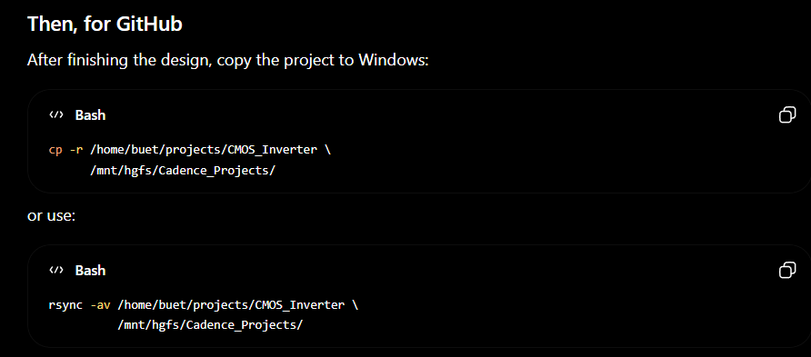

CADENCE cannot work on WINDOWS. It needs some open source OS
1. File -> New -> Library -> (Name), Attach to existy technology -> gpdk90
2. File -> New -> Cell Vie 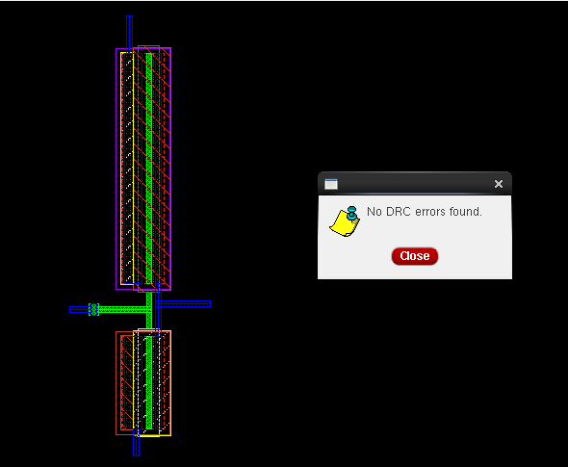 w-> (Name)

