Group 3
IT 372-B01
6/19/2026
Professor Azamy
Saukhya Shrestha, Richard Tindell, LK Kalidindi

Topic: Simple cybersecurity habits non-technical students make to help them stay safe.

Pitch: Making cybersecurity awareness simple to ensure non-technical users can stay safe online through practical digital habits which can be utilized every day.

Step 1
Reflection: Notebook LLM is an effective tool used to help visualize data. It took the sources along with our analysis and provided an efficient route of organization. The most useful tools within Notebook were the Mind Map feature and the Audio feature. As the entirety of Project 3 was a lot of information, the mind map helped to visualize the information by categorizing it into different cybersecurity concepts such as phishing awareness, password security, and multifactor authentication. Additionally, the Audio Overview made the research easier to understand as it provided a summary of key findings in a conversational format. These help simplify findings for non-technical college students to digest.

3 Real World Use Cases:
- Utilizing Mind Map feature when creating a presentation for cybersecurity defenses for non-technical students to understand because it quickly organizes major research into themes and easily followable paths.
- Audio overview can assist student associations to learn cybersecurity habits while multitasking and doing student association activities.
- Data tables can help students learn about the different habits and compare them before making their own educational presentation on cybersecurity habits as well as making decisions on which actions take priority.

Screenshots of Notebook
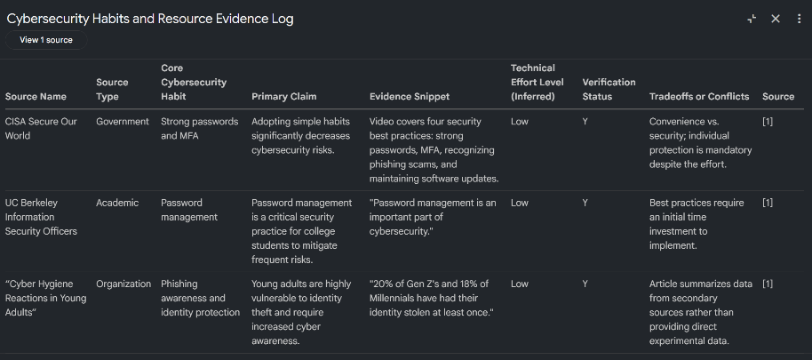
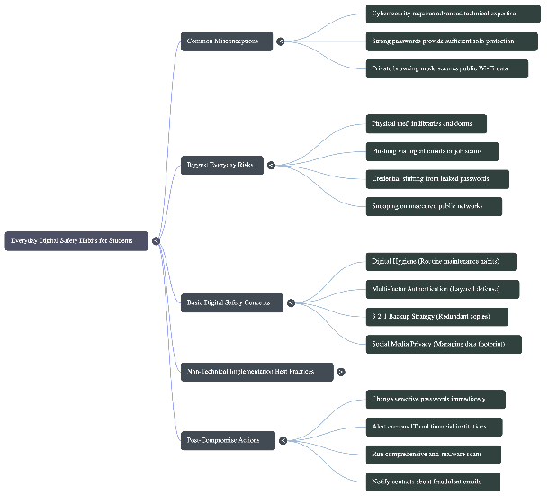
Mind map Data Table

Step 2
Slide decks created:
- Notebook LM: Group 3_NLM
- GenSpark: Group3_GenSpark
- Gamma: Group3_Gamma
Step 3
Metric / Field | NotebookLM | Gamma | GenSpark
Time to 1st Draft (min) | 6 min | 3:40 min | 2:50 min
# Edits | 0 | 2 | 0
# Fact Fixes | 0 | 0 | 0
Formatting Cleanup (min) | 0 | 4 min | 0
Relevance & Accuracy (1–5) | 4 | 4 | 5
Structure & Clarity (1–5) | 5 | 4 | 5
Visuals (1–5) | 5 | 4 | 5
Citation Quality (1–5) | 3 | 4 | 5
Customization Control (1–5) | 3 | 5 | 5
Export Quality (1–5) | 5 | 5 | 2
Overall Polish (1–5) | 4 | 4 | 5
Total Score (sum of 7 criteria) | 29 | 30 | 32
Reflection (1–3 sentences: when you’d choose this tool—e.g., speed vs. control vs. fidelity) | NLM made the presentation perfectly with everything we needed to add. However, it is not easily customizable as you need to redo the entire slide to fix errors, and it takes too long. This tool would be chosen when we have time and need to be through. | Gamma was quick and created the presentation well. However, the citation page was missing, and it initially created a presentation on the sources itself, not the overall topic. This tool would be used when we require less text for easy comprehension. | GenSpark was the fastest out of all 3 and provided a clean presentation. However, it did cost money for exports, which is something to consider, but the speed and accuracy are definitely positive. This tool would be used if it is an important project where the cost would be justifiable.

Winner and Justification
Comparing Notebook LM, Gamma and Genspark, we have a clear winner. All three LMs did a great job, but each had different features. Notebook LM took too long and was not easily customizable, which was not suitable for our needs, hence the lowest score of 29.

GenSpark was our second choice because it was quick but generated a slide show that was crowded with text and very few images. This is not a standard presentation that most people are expecting from a PowerPoint presentation. There is also a cost associated with using GenSpark effectively.

Gamma is the winner because it generated a PowerPoint presentation that was in a format that was expected by the audience, with images and text. There was no cost assonated to Gamma, which gave it the edge of GenSpark. To generate the citations, it required extra work, but it was worth the effort giving it a winning score of 32.

Step 4
GitHub Repo Links:
- Saukhya: https://github.com/sokhi-76/Summer2026_Group3_AI_Project
- Richard: https://github.com/jtindell/Summer2026_Group3_AI_Projects
- LK: https://github.com/lalithkalidindi/Summer2026_Group3_AI_Projects
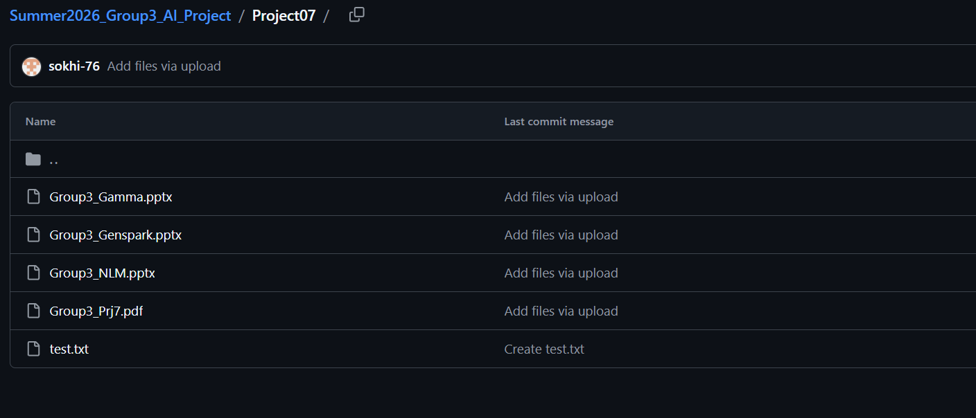

References

Citations
Cybersecurity and Infrastructure Security Agency (CISA). (n.d.). Secure Our World. U.S. Department of Homeland Security. https://www.cisa.gov/secure-our-world
Federal Trade Commission (FTC). (n.d.). Tips for using public Wi-Fi networks. https://consumer.ftc.gov/articles/how-safely-use-public-wi-fi-networks
Gamma. (n.d.). AI presentation generation platform. https://gamma.app
Genspark. (n.d.). AI-powered content and presentation generation platform. https://genspark.ai
Google. (2026). NotebookLM. https://notebooklm.google
UC Berkeley Information Security Office. (n.d.). Password management. https://security.berkeley.edu/education-awareness/password-management-lastpass
Microsoft. (n.d.). Computer software updates and security. https://www.microsoft.com/en-us/microsoft-365-life-hacks/privacy-and-safety/computer-software-update
CyberDegrees. (n.d.). Internet safety for college students. https://www.cyberdegrees.org/resources/internet-safety-for-college-students/

