**SUBJECT: SOFTWARE DEVELOPMENT PRACTICES**

**DEPARTMENT: INFORMATION TECHNOLOGY**

**SRS DOCUMENT FOR COVID-19 TRACKING WEBSITE**

**Team Members:**

**R Lalith Kumar *(reg no:111722203050)***

**Lohesh P *(reg no:111722203053)***

**Lokesh *(reg no:111722203054)***

**Porchelvan *(reg no:111722203075)***

COVID TRACKER APPLICARTION

# OBJECTIVES:

**The** **objective of the Website is:**

* ***Covid-19*** is a website to track covid cases.

# FUNCTIONAL REQUIRMENTS:

1. Build an application where public people can track the number of people ***affected by Covid-19 daily.***
2. Navigation icons must be placed on each side and must have their own contents.
3. The number of people ***vaccinated*** and ***non-vaccinated*** must also be mentioned with percentage.
4. The affected people of Covid-19 are differentiated by ***Confirmed, Active, Deceased, Recovered***.
5. The total number of ***people vaccinated*** doses are also administered.
6. A ***tabular column*** must be created that refers to the number of people affected by Covid-19 are differentiated by State wise and differentiated by Confirmed, Active, Deceased, Recovered.
7. A ***pictorial representation of India map*** must indicate the states with colored effects that mentions the Covid-19 affected and delivers contents of states.
8. The user must be able to ***create an account*** and ***login*** whenever needed and when they login the information about their location.

# Non-Functional Requirements:

## Security

• ***Secure connection*** for transmission of any data.

•Data must be secured so that no ***misinformation*** is delivered.

• User Credentials must be ***encrypted***.

## Performance

When there is more traffic.

• Home page < 3 seconds.

• Login page < 3 seconds.

### Availability

• 99.99% Availability

#### Standard Features

• The website must be responsive.

• Maintainability.

•Availability.

•Usability.

•Failover.

##### **Browser Compatible**

•The website must be compatible with all latest Browsers.

# Technology Stack

• Front End**:** HTML, CSS, Bootstrap.

• Back End**:** JavaScript, NodeJS, EJS.

• Server Side**:** Express.

• Database: MongoDB.

Key points to remember**:**

1. The frontend and backend mentioned in the SRS should not be modified at any cost. Failing to do may fail test cases.

2. Strictly adhere to the proper project Folder structure, coding conventions, method definitions and return types.

3. Adhere strictly to the endpoints given below.

## Application Assumptions:

• The user must be asked to ***login*** after 15 seconds of entering the website.

• The page must have a ***tabular*** ***column*** which represents the number of Covid-19 cases daily.

• The page must have an ***Indian map*** which displays the Indian map and must display the number of Covid-19 cases in ***each state and union territory***.

• The page must display the number of people ***vaccinated*** and ***non-vaccinated***.

### Project Tasks:

API Endpoints**:**

### USER

### Action URL Method of Response:

* GET Covid-19 cases data.

### ADMIN

### Action URL Method of Response:

• POST Covid-19 data.

• Edit the existing data.

## Frontend:

## User:

1. Design a page so that user can see Covid-19 cases data, the number of people Affected, Recovered, Deceased and Vaccinated.

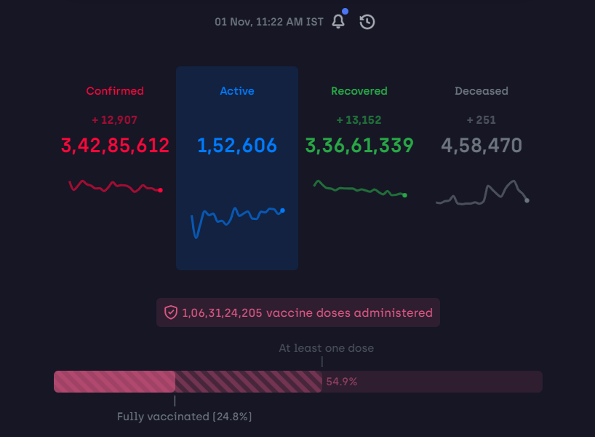

2. A search box is provided to search for a particular ***state or union territory***.

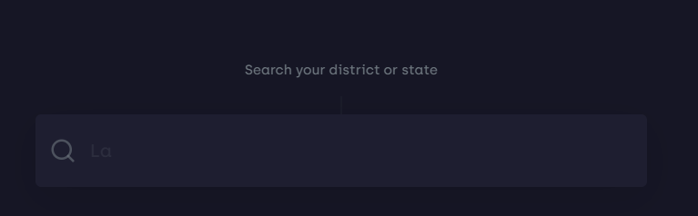

3. Data is requested from a database and displayed in the form of a ***tabular column***.

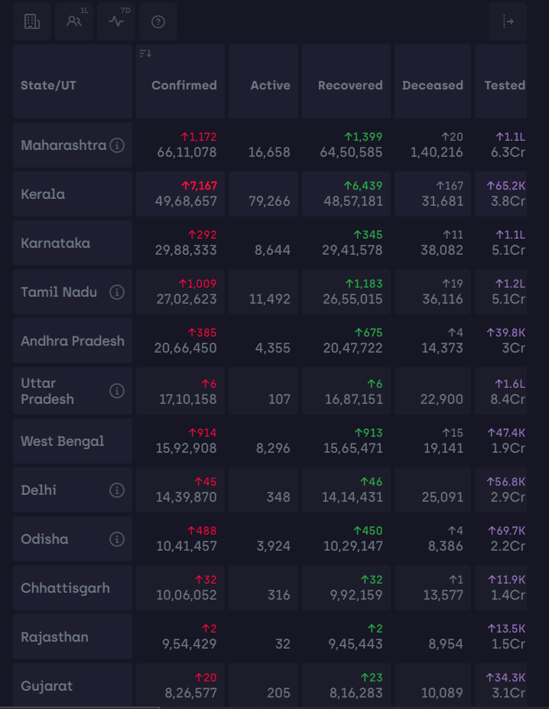

4. An image of the ***Indian map*** is also displayed and the covid cases in particular state can also be seen.

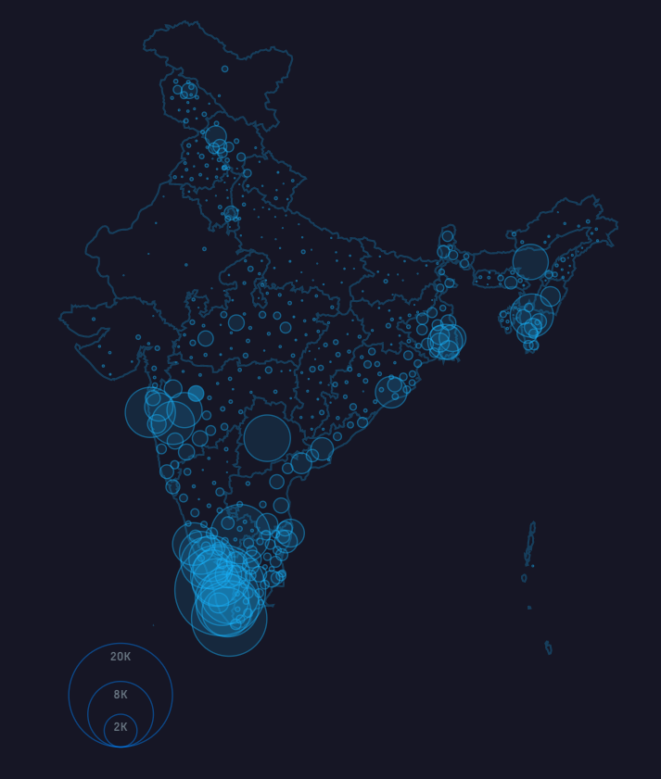

5. Users will be able to ***login*** to the website and have details about their ***location***.

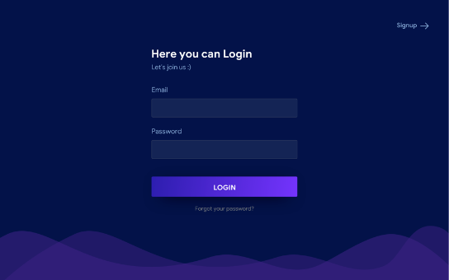

6. Users can also provide their ***feedback*** on the website.

## Admin:

1. The admin can ***update*** the data in the database.

2. The admin can ***read the feedback*** given by the user.

### Backend:

• When the webpage is opened the data from the ***MongoDB database*** is displayed in the webpage.

• A ***search box*** is placed at the top where users can search any state for covid cases. The input from the user is taken and the relevant state is displayed.