VEHICLE SERVICE MANAGEMENT PLATFORM

1.Introduction
The Vehicle Service Management System is a web-based application designed to automate and streamline vehicle servicing operations. Traditional service centers often rely on manual processes for booking appointments, maintaining service records, generating invoices, and communicating with customers, which can lead to inefficiencies and delays. This system provides a centralized digital platform that improves efficiency, ensures data consistency, and enhances transparency in managing all service-related activities.
The platform supports three main user roles: customers, technicians, and administrators. Customers can register vehicles, book service appointments, and track service status, while technicians manage repair details and update service records. Administrators oversee the entire system, including user management, service monitoring, and revenue tracking. This role-based access ensures secure and organized handling of system functionalities.
Technically, the system is built using the MERN stack, with MongoDB for database management, Express.js and Node.js for backend development, and React for the frontend. It follows the MVC architecture to ensure scalability and maintainability. Additional features such as JWT-based authentication, file uploads, and notification systems further enhance security, communication, and overall user experience, making the system an efficient solution for modern vehicle service management.

2 Scenario-Based Case Study
The functionality of the Vehicle Service Management System can be clearly understood through a real-world scenario involving multiple users. This case study demonstrates how the system efficiently manages the complete workflow of vehicle servicing, from appointment booking to service completion and billing.
Consider a customer named Rahul who owns a vehicle that requires servicing. Instead of physically visiting a service center, Rahul uses the online platform to handle the entire process in a convenient and efficient manner.

2.1 Customer Interaction
Rahul begins by accessing the system and performing the necessary steps to initiate the service process:
- Registers an account by providing basic personal details
- Logs into the system using secure authentication credentials
- Adds vehicle information such as vehicle number, model, fuel type, and purchase year
- Books a service appointment by selecting a preferred date and service type
- Once the appointment is successfully created, the system stores the request and sets its status to “Booked”, making it visible to the service team.

2.2 Technician Interaction
On the scheduled service date, the technician logs into the system to manage assigned tasks. The technician performs the following operations:
- Views the list of scheduled appointments
- Selects the assigned vehicle for servicing
- Updates repair details and service activities
- Modifies the service status at different stages:
- Booked → In Progress → Completed
- This ensures that the progress of the service is continuously updated and trackable within the system.

2.3 Invoice Generation and Notification
After the service process is completed, the system automatically manages billing and communication tasks:
- Generates an invoice based on the service details and cost calculations
- Sets the payment status initially to “Pending”
- Sends a notification to the customer regarding:
- Completion of service
- Availability of invoice details
- This automation reduces manual effort and enhances system efficiency.

2.4 Customer Post-Service Actions
After receiving the notification, Rahul can perform the following actions:
- Log into the system to access his dashboard
- View detailed service history of the vehicle
- Check the generated invoice
- Make the payment, updating the status to “Paid”
- All service and transaction records are securely maintained for future reference.

2.5 Administrator Interaction
The administrator is responsible for overseeing and managing the entire system. Key activities include:
- Monitoring users, vehicles, and appointments
- Tracking completed services and revenue generation
- Managing technician data and system operations
- Accessing analytics for performance evaluation and decision-making

2.6 Workflow Table
Step | Actor | Action Performed | System Response
1 | Customer | Registers and logs in | Account created and authenticated
2 | Customer | Adds vehicle details | Vehicle stored in database
3 | Customer | Books appointment | Status set to “Booked”
4 | Technician | Starts servicing | Status updated to “In Progress”
5 | Technician | Completes service | Status updated to “Completed”
6 | System | Generates invoice | Payment status set to “Pending”
7 | Customer | Makes payment | Payment status updated to “Paid”
8 | Administrator | Monitors system | Analytics and reports updated
This scenario demonstrates how the Vehicle Service Management System automates and streamlines the traditional vehicle servicing process. By integrating customer interaction, technician operations, automated billing, and administrative monitoring, the system ensures improved efficiency, transparency, and user satisfaction.

3. System Requirements
The system is a full-stack web application built using the MERN stack. It operates in a client-server environment where the backend handles business logic and database operations, while the frontend provides an interactive user interface. Therefore, both development and deployment environments must meet certain minimum specifications.

3.1 Software Requirements
The software requirements include all tools, frameworks, and environments necessary for developing and running the application.
- Development & Runtime Environment
  - Operating System: Windows, Linux, or macOS
  - Runtime Environment: Node.js (for executing backend JavaScript code)
  - Package Manager: npm (Node Package Manager)
- Backend Technologies
  - Framework: Express.js (for building RESTful APIs)
  - Database: MongoDB (NoSQL database for storing application data)
  - ODM Tool: Mongoose (for schema modeling and database interaction)
- Frontend Technologies
  - Framework: React.js (for building user interfaces)
  - Build Tool: Vite (for fast development and bundling)
  - Styling: Tailwind CSS (for responsive UI design)
- Additional Libraries & Tools
  - Authentication: JSON Web Tokens (JWT) for secure login sessions
  - Password Security: bcryptjs for hashing passwords
- File Upload Handling: Multer (for handling multipart/form-data)
- API Testing Tool: Postman (for testing backend endpoints)
- Version Control: Git

3.2 Hardware Requirements
The hardware requirements depend on whether the system is used for development or deployment. The following are the minimum and recommended specifications.
- Minimum Requirements
  - Processor: Intel i3 or equivalent
  - RAM: 4 GB
  - Storage: 500 MB free disk space
  - Internet Connection: Required for API communication and package installation
- Recommended Requirements
  - Processor: Intel i5 or higher
  - RAM: 8 GB or more
  - Storage: 1 GB or more free space
  - Internet Connection: High-speed broadband for better performance

3.3 System Environment Summary
Component | Requirement
Operating System | Windows / Linux / macOS
Backend Runtime | Node.js
Frontend Framework | React.js (with Vite)
Database | MongoDB
API Testing | Postman
Version Control | Git
RAM | Minimum 4 GB (8 GB recommended)
Storage | Minimum 500 MB

The above system requirements ensure that the Vehicle Service Management System can be developed, tested, and deployed efficiently. By using modern technologies and maintaining moderate hardware requirements, the system remains scalable, flexible, and accessible across different environments.

4. Project Architecture
The Vehicle Service Management System follows a well-structured and scalable architecture based on the MERN stack. The system is designed using a client-server model, where the frontend (client) interacts with the backend (server) through RESTful APIs, and the backend communicates with the database for data storage and retrieval. This layered architecture ensures clear separation of concerns, making the system easy to maintain, extend, and debug.

4.1 Architectural Overview
At a high level, the system consists of three main layers:
- Presentation Layer (Frontend):
Built using React, this layer provides the user interface for customers, technicians, and administrators. It handles user interactions, form inputs, and displays data received from the backend.
- Application Layer (Backend):
Developed using Node.js and Express.js, this layer contains the business logic, handles API requests, performs authentication, and processes data.
- Data Layer (Database):
MongoDB is used to store all application data such as users, vehicles, appointments, service records, and invoices.
These layers communicate with each other in a structured manner to ensure smooth data flow and system functionality.

4.2 Architecture Flow
The interaction between components in the system can be understood through the following flow:
- The user interacts with the React frontend interface
- The frontend sends HTTP requests (GET, POST, PUT, DELETE) to the backend APIs
- The backend (Express server) processes the request through:
  - Routes (API endpoints)
  - Controllers (business logic)
  - Middleware (authentication, validation, error handling)
- The backend communicates with the database using Mongoose
- MongoDB performs data operations and returns results
- The backend sends a JSON response back to the frontend
- The frontend updates the UI dynamically based on the response

4.3 Backend Architecture (MVC Pattern)
The backend strictly follows the Model-View-Controller (MVC) architecture, which improves code organization and maintainability.
Components of MVC:
- Model:
Represents the database structure using Mongoose schemas (User, Vehicle, Appointment, etc.)
- View:
In this project, the view is handled by the frontend (React), which displays data to users
- Controller:
Contains the core business logic, processes incoming requests, and sends responses
- Middleware (Supporting Layer):
Handles authentication (JWT), error handling, and file uploads (Multer)

4.4 MVC Architecture
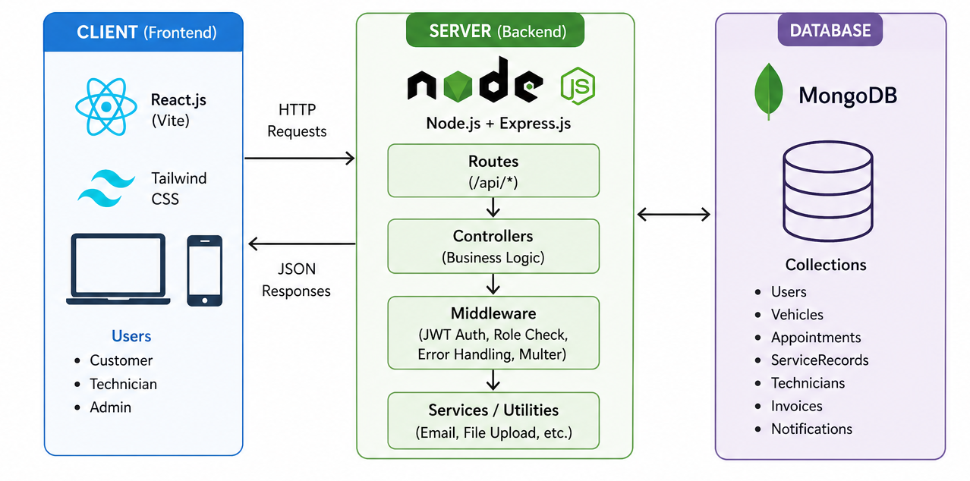

4.5 Folder Structure Representation
The backend is organized into a modular folder structure for better scalability:
- config/ → Database connection setup
- controllers/ → Business logic implementation
- models/ → Mongoose schemas
- routes/ → API endpoint definitions
- middleware/ → Authentication, error handling, file uploads
- utils/ → Helper functions (JWT, invoice generation)
- uploads/ → Stores uploaded files
- app.js → Express configuration
- server.js → Entry point of the application

4.6 Key Architectural Features
- Scalability: Modular structure allows easy addition of new features
- Separation of Concerns: Clear distinction between frontend, backend, and database
- Security: JWT-based authentication and role-based access control
- Maintainability: Organized MVC structure simplifies debugging and updates
- Flexibility: RESTful APIs allow integration with other platforms if needed
The architecture of the Vehicle Service Management System is designed to be robust, scalable, and efficient. By combining the MERN stack with the MVC design pattern, the system ensures a clean separation of responsibilities and smooth interaction between components. This structured approach not only improves performance but also makes the system easier to maintain and extend in the future.

5. ER Diagram
The Entity–Relationship (ER) diagram represents the logical structure of the Vehicle Service Management System by illustrating the entities involved, their attributes, and the relationships between them. It provides a clear understanding of how data is organized and how different components of the system interact with each other.

5.1 Overview
The system consists of multiple entities such as User, Vehicle, Appointment, Service Record, Invoice, Technician, and Notification. These entities are interconnected to support the complete workflow of vehicle servicing, from booking appointments to generating invoices and sending notifications.

5.2 Entities and Attributes
The main entities and their key attributes are described below:
1. User
- userId (Primary Key)
- name
- email
- password
- role (customer / technician / admin)
2. Vehicle
- vehicleId (Primary Key)
- userId (Foreign Key)
- vehicleNumber
- model
- fuelType
- purchaseYear
3. Appointment
- appointmentId (Primary Key)
- vehicleId (Foreign Key)
- serviceType
- appointmentDate
- status
4. ServiceRecord
- serviceId (Primary Key)
- vehicleId (Foreign Key)
- technicianId (Foreign Key)
- repairDetails
- serviceStatus

5. Invoice
- invoiceId (Primary Key)
- vehicleId (Foreign Key)
- totalAmount
- paymentStatus
6. Technician
- technicianId (Primary Key)
- name
- specialization (optional)
7. Notification
- notificationId (Primary Key)
- userId (Foreign Key)
- message
- status (read/unread)

5.3 Relationships Between Entities
The relationships define how entities are connected within the system:
- User → Vehicle
One user can own multiple vehicles (1 : Many)
- Vehicle → Appointment
One vehicle can have multiple service appointments (1 : Many)
- Vehicle → ServiceRecord
One vehicle can have multiple service records (1 : Many)
- Technician → ServiceRecord
One technician can handle multiple service records (1 : Many)
- Vehicle → Invoice
One vehicle can have multiple invoices (1 : Many)

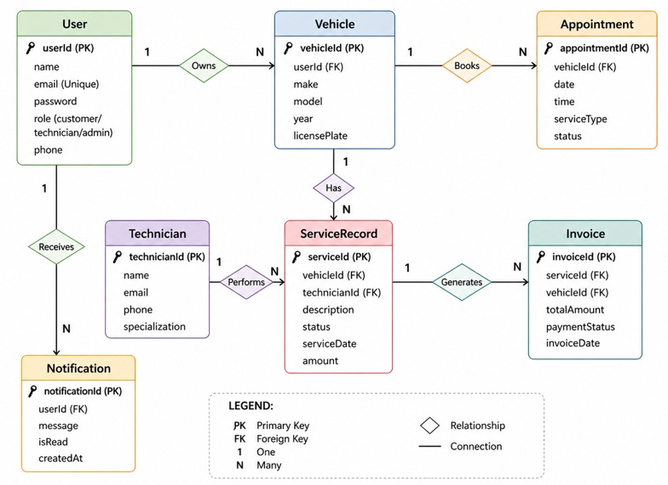
5.4 ER Diagram Representation

5.5 Tabular Representation of Relationships
Entity 1 | Relationship | Entity 2 | Cardinality
User | Owns | Vehicle | 1 : Many
Vehicle | Books | Appointment | 1 : Many
Vehicle | Has | ServiceRecord | 1 : Many
Technician | Handles | ServiceRecord | 1 : Many
Vehicle | Generates | Invoice | 1 : Many
User | Receives | Notification | 1 : Many
The ER diagram provides a clear visualization of how data flows within the Vehicle Service Management System. By defining entities, attributes, and relationships, it helps in designing an efficient database structure. This structured approach ensures data consistency, reduces redundancy, and supports smooth system operations.

6. Key Features
The Vehicle Service Management System is designed to provide a comprehensive and efficient solution for managing vehicle servicing operations. It incorporates several advanced features that enhance usability, security, and overall system performance. These features ensure smooth interaction between customers, technicians, and administrators while automating critical processes.

6.1 User Authentication and Role-Based Access Control
The system implements a secure authentication mechanism using JSON Web Tokens (JWT). Users must log in to access system functionalities, ensuring data privacy and security.
- Supports three roles: Customer, Technician, and Admin
- Restricts access based on user roles
- Ensures secure password storage using encryption techniques
- Prevents unauthorized access to sensitive data

6.2 Vehicle Management
Customers can efficiently manage their vehicles within the system.
- Add, update, and delete vehicle details
- Store important information such as vehicle number, model, and fuel type
- Maintain a digital record of all registered vehicles
This feature eliminates the need for manual record-keeping.

6.3 Appointment Scheduling System
The system allows customers to book service appointments easily.
- Select preferred date and type of service
- Track appointment status (Booked, In Progress, Completed, Cancelled)
- Avoid scheduling conflicts through structured booking
This improves convenience and reduces waiting time at service centers.

6.4 Service Record Management
Technicians can manage and update service details effectively.
- Record repair details and service activities
- Update service status dynamically
- Maintain complete service history for each vehicle
This ensures transparency and accurate tracking of work performed.

6.5 Automated Invoice Generation
The system automatically generates invoices after service completion.
- Calculates total cost based on service details
- Assigns payment status (Pending, Paid, Failed)
- Maintains a record of all financial transactions
This reduces manual billing errors and improves efficiency

6.6 Notification System
The platform includes a notification mechanism to keep users informed.
- Alerts customers about appointment updates
- Notifies users when services are completed
- Sends invoice-related updates
This enhances communication between the system and users.

6.7 File Upload Management
The system supports file uploads using middleware.
- Upload images or documents related to vehicles or services
- Store files securely in the server directory
- Organize files efficiently for easy access

6.8 Admin Dashboard and Analytics
Administrators have access to system-wide insights and controls.
- Monitor users, appointments, and services
- Track revenue and system activity
- Manage technicians and overall operations
This helps in better decision-making and system management.

6.9 Error Handling and Data Validation
The system ensures reliability through proper error handling.
- Centralized error handling mechanism
- Validates input data before processing
- Returns consistent and meaningful error responses

The key features of the Vehicle Service Management System focus on automation, security, and user convenience. By integrating modern technologies and efficient workflows, the system significantly improves the traditional vehicle servicing process and provides a reliable and scalable solution.

7. Roles and Responsibilities

7.1 Customer
- Register and log in to the platform
- Add, view, update, and delete own vehicles
- Book service appointments for own vehicles
- View own service records and invoices
- Receive and read notifications

7.2 Technician
- View all vehicles and appointments
- Create and manage service records
- Update appointment status
- View all technician profiles
- Send notifications to users

7.3 Admin
- Full access to all platform resources
- Create technician profiles
- Generate and manage invoices
- Access system-wide metrics and revenue data
- Manage all users
- All technician and customer capabilities

8. USER FLOW
The User Flow of the Vehicle Service Management System describes how different users interact with the system step-by-step to complete tasks. It represents the journey from login to final actions such as service completion and payment. A well-defined user flow ensures smooth navigation, better user experience, and efficient system operation.

8.1 Overview
The system supports three main user flows based on roles:
- Customer Flow
- Technician Flow
- Administrator Flow
Each flow is designed to guide the user through a logical sequence of actions while maintaining security and role-based access.

8.2 Customer User Flow
The customer flow focuses on booking and tracking vehicle services.
Flow Steps:
- User Registration / Login
- Add Vehicle Details
- Book Service Appointment
- Track Service Status
- Receive Notification
- View Invoice
- Make Payment

Customer Flow Representation
Login/Register → Add Vehicle → Book Appointment → Service in Progress → Service Completed → Invoice Generated → Payment Done

8.3 Technician User Flow
The technician flow handles service execution and updates.
Flow Steps:
- Login to System
- View Assigned Appointments
- Start Service
- Update Repair Details
- Mark Service as Completed
Technician Flow Representation
Login → View Tasks → Start Service → Update Records → Complete Service

8.4 Administrator User Flow
The administrator flow focuses on system monitoring and management.
Flow Steps:
- Login to Admin Dashboard
- Manage Users (Customers & Technicians)
- Monitor Appointments and Services
- Track Revenue and Invoices
- View Reports and Analytics
Admin Flow Representation
Login → Dashboard → Manage Users → Monitor System → Analyze Reports

8.5 Combined System Workflow Table
Step | User Role | Action | Outcome
1 | Customer | Registers / Logs in | Access granted
2 | Customer | Adds vehicle | Vehicle stored
3 | Customer | Books appointment | Appointment created
4 | Technician | Starts service | Status = In Progress
5 | Technician | Completes service | Status = Completed
6 | System | Generates invoice | Payment = Pending
7 | Customer | Makes payment | Payment = Paid
8 | Admin | Monitors system | Reports updated
The user flow clearly defines how different roles interact with the system in a structured manner. By organizing the steps logically, the system ensures a seamless experience for customers, efficient task management for technicians, and effective control for administrators. This structured flow enhances usability, reduces confusion, and improves overall system performance.

9. MVC Pattern
The Vehicle Service Management System follows the Model–View–Controller (MVC) architectural pattern for organizing the backend structure. MVC is a widely used design pattern that separates an application into three interconnected components—Model, View, and Controller—thereby improving code maintainability, scalability, and clarity.

9.1 Overview
The MVC pattern divides the application into logical layers, each with a specific responsibility:
- Model → Manages data and database interactions
- View → Handles the user interface
- Controller → Processes requests and contains business logic
This separation ensures that changes in one component do not directly affect others, making the system easier to develop and maintain.

9.2 Components of MVC
1. Model
The Model represents the data layer of the application. It defines the structure of the data and manages interactions with the database.
- Implemented using Mongoose schemas
- Represents entities such as User, Vehicle, Appointment, ServiceRecord, Invoice, etc.
- Handles data validation and schema definitions
- Communicates directly with the MongoDB database
Example:
The User model defines fields like name, email, password, and role.
2. View
The View represents the presentation layer of the system.
- In this project, the View is handled by the React frontend
- Responsible for displaying data to users
- Provides UI components for interaction (forms, dashboards, pages)
- Receives data from the backend in JSON format
Example:
Customer dashboard showing vehicle details and appointment status.
3. Controller
The Controller acts as the intermediary between the Model and the View.
- Handles incoming HTTP requests from the frontend
- Processes business logic
- Interacts with Models to fetch or update data
- Sends responses back to the frontend
Example:
When a user books an appointment, the controller:
- Receives request
- Validates data
- Stores appointment in database
- Sends confirmation response

9.3 MVC Flow in the System
The working of MVC in this system follows a structured flow:
- User interacts with the frontend (View)
- Frontend sends request to backend API
- Controller receives and processes the request
- Controller interacts with Model for database operations
- Model communicates with MongoDB
- Controller sends response back to View
- View updates UI accordingly

9.4 MVC Flow Representation
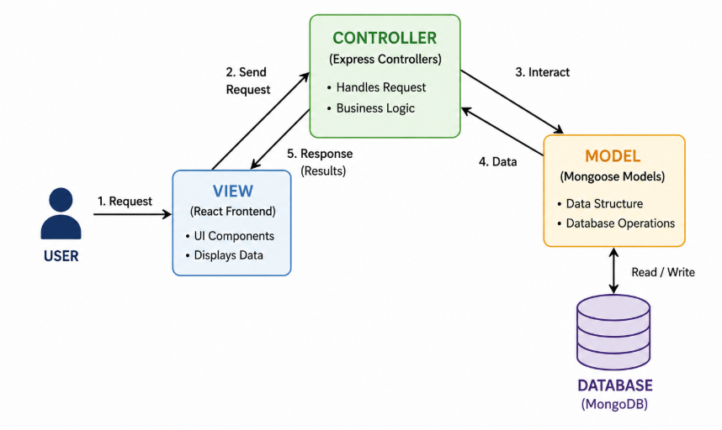

9.5 Mapping MVC to Project Structure
The project follows MVC through its folder organization:
- models/ → Contains all database schemas (Model)
- controllers/ → Contains business logic (Controller)
- routes/ → Defines API endpoints (connects View to Controller)
- frontend (React) → Acts as the View
Additional supporting layers:
- middleware/ → Handles authentication, validation, errors
- utils/ → Helper functions
The MVC pattern plays a crucial role in structuring the backend of the Vehicle Service Management System. By separating data handling, business logic, and presentation, the system becomes more organized, scalable, and easier to manage.

10. Project Setup and Configuration

10.1 Environment Variables
Variable | Value
PORT | 5000
MONGO_URI | mongodb://localhost:27017/vehicle_service_db
JWT_SECRET | yoursupersecretjwtkey
NODE_ENV | development

10.2 Client Setup
- cd client
- npm install
- npm run dev (starts Vite dev server — typically localhost:5173)

10.3 Server Setup
- cd server
- cp .env.example .env (configure MONGO_URI and JWT_SECRET)
- npm install
- npm run dev (starts nodemon — localhost:5000)

11. Backend Development
The backend is designed following a modular and scalable approach using the MVC (Model–View–Controller) architecture. It processes client requests, performs necessary operations, and returns structured JSON responses. The system ensures secure communication, efficient data handling, and smooth integration with the frontend.

11.1 Backend Architecture Components
The backend consists of several key components working together:
1. Server and Application Setup
- server.js initializes the server and connects to the database
- app.js configures middleware, routes, and API handling
- Uses Express.js to handle HTTP requests and routing

2. Models (Data Layer)
Models define the structure of the database using Mongoose schemas.
- Represent entities such as User, Vehicle, Appointment, ServiceRecord, Invoice, Technician, and Notification
- Define field types, validations, and relationships
- Ensure consistency and integrity of stored data
Example: User model includes name, email, password, and role.
3. Controllers (Business Logic Layer)
Controllers handle the main logic of the application.
- Process incoming requests from routes
- Perform operations such as create, read, update, delete (CRUD)
- Interact with models to fetch or store data
- Send appropriate responses back to the client
Example: Appointment controller handles booking, updating, and canceling appointments.
4. Routes (API Layer)
Routes define the API endpoints exposed by the backend.
- Map HTTP requests to controller functions
- Follow RESTful conventions:
  - GET → Retrieve data
  - POST → Create data
  - PUT → Update data
  - DELETE → Remove data
Example endpoints:
- /api/auth → Authentication
- /api/vehicles → Vehicle management
- /api/appointments → Appointment handling
5. Middleware (Supporting Layer)
Middleware functions enhance request processing and system security.
- Authentication Middleware: Verifies JWT tokens
- Authorization Middleware: Restricts access based on roles
- Error Handling Middleware: Captures and formats errors
- File Upload Middleware: Handles uploads using Multer

11.2 Key Backend Functionalities
The backend supports several important operations:
- User Authentication: Secure login and registration using JWT
- Role-Based Access Control: Different permissions for customers, technicians, and admins
- CRUD Operations: Manage vehicles, appointments, services, and invoices
- File Handling: Upload and store images/documents
- Notification Handling: Send updates to users
- Data Validation: Ensure correct and safe input data
- Pagination: Efficient handling of large datasets

11.3 Request–Response Lifecycle
The backend processes requests through a structured flow:
- Client sends HTTP request
- Request reaches the route
- Middleware validates request (auth, data)
- Controller processes logic
- Model interacts with database
- Response is sent back in JSON format

12. Database Development

12.1 MongoDB Configuration
The connectDB utility in config/db.js establishes a Mongoose connection using the MONGO_URI environment variable. On failure, the process exits with code 1, preventing the API from serving requests against an unavailable database.

12.2 Schemas and Models
Schema | Required Fields | Special Constraints
User | name, email, password, role | email unique + regex; password select:false; bcrypt hook
Vehicle | userId, vehicleNumber, model, fuelType, purchaseYear | vehicleNumber unique
Appointment | vehicleId, serviceType, appointmentDate | status enum; default Booked
ServiceRecord | vehicleId, technicianId, repairDetails | serviceStatus enum; default Pending
Invoice | vehicleId, totalAmount | paymentStatus enum; default Pending
Notification | userId, title, message | isRead default false; type enum
Technician | name, specialization, experience | All required

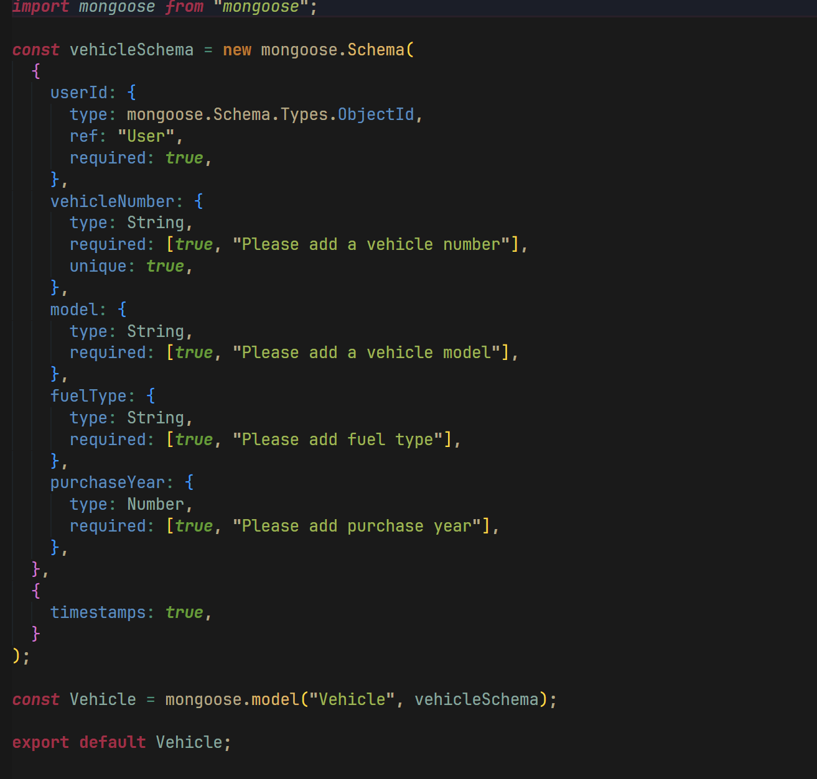
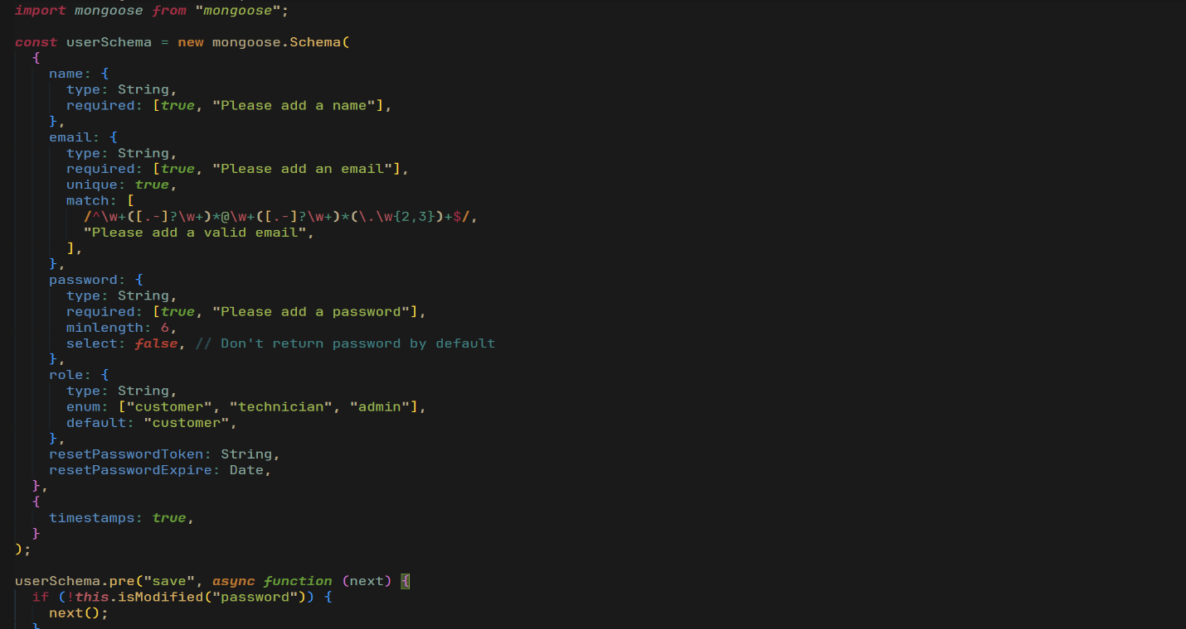
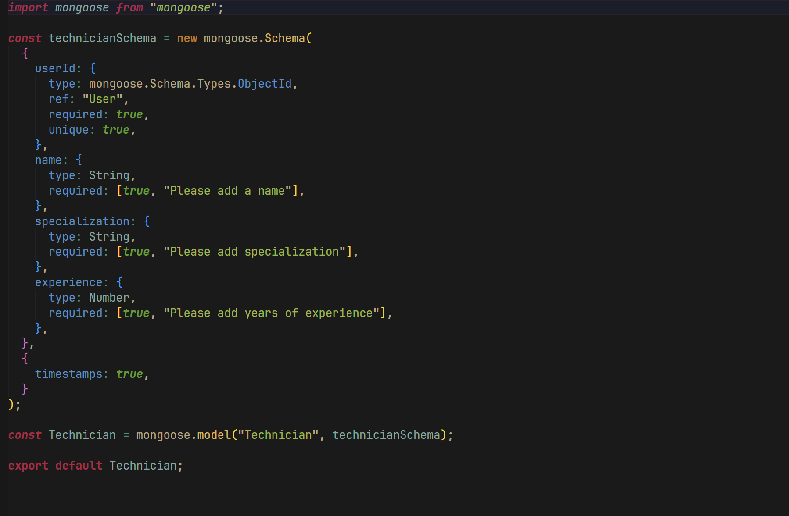

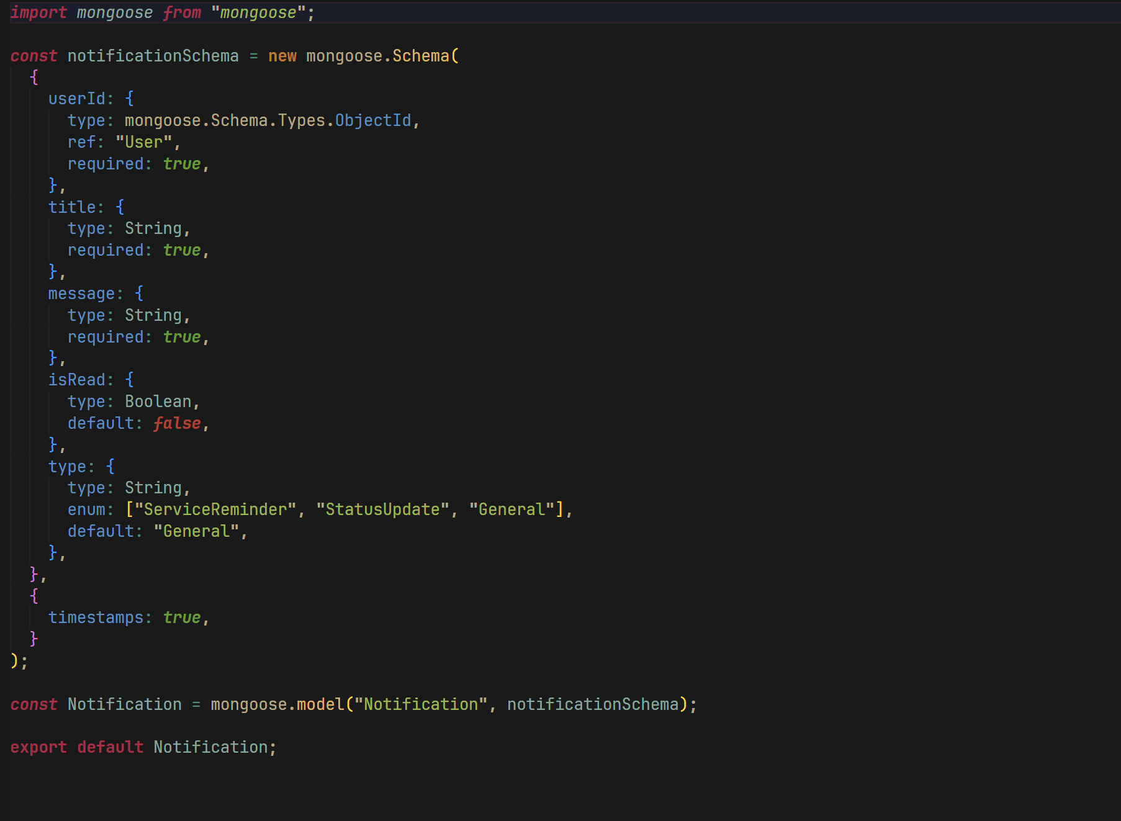

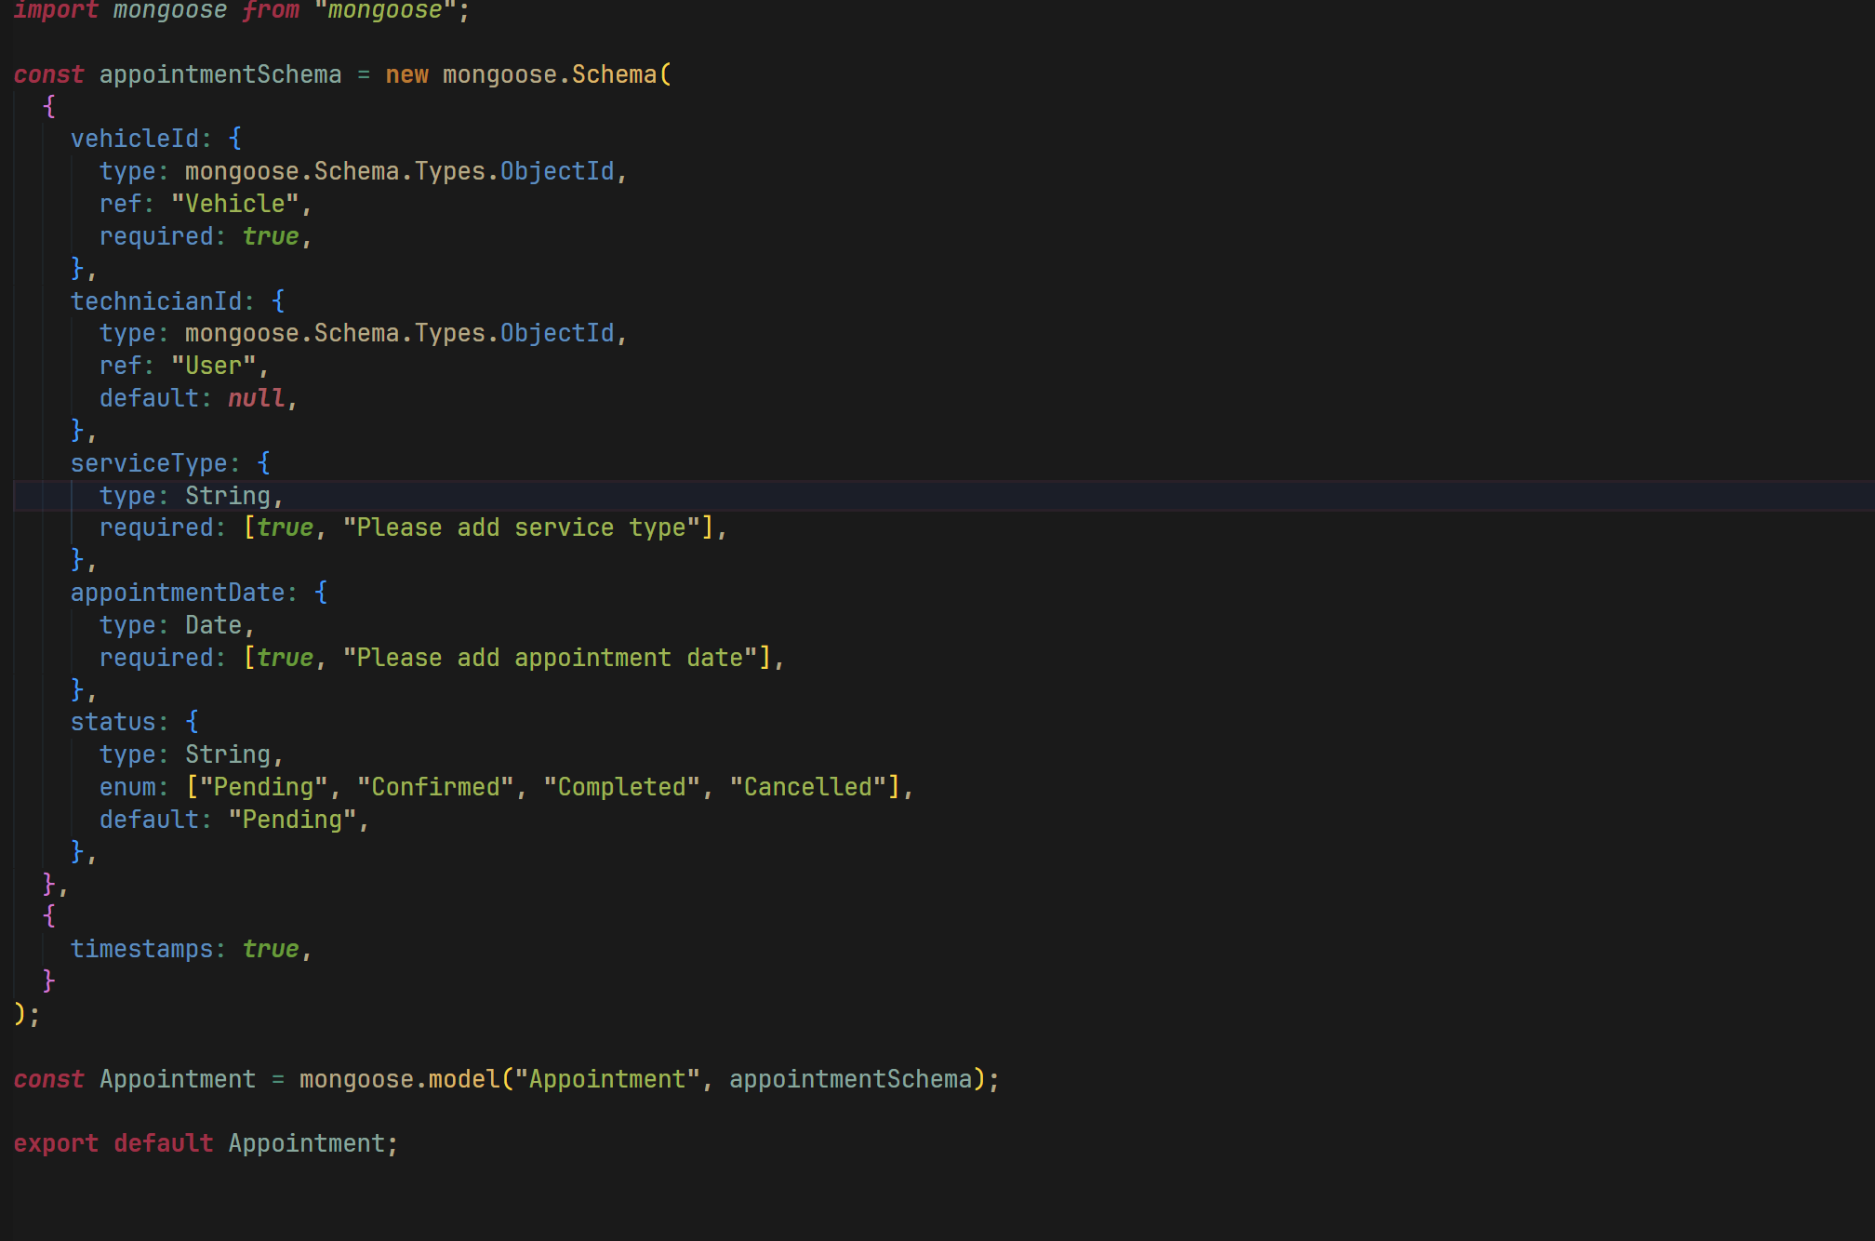

13. Frontend Development

13.1 Technology Stack
Technology | Role
React 19 | Component-based UI framework
Vite 6 | Fast build tool and dev server
Tailwind CSS 3 | Utility-first CSS framework
ESLint | Code quality enforcement

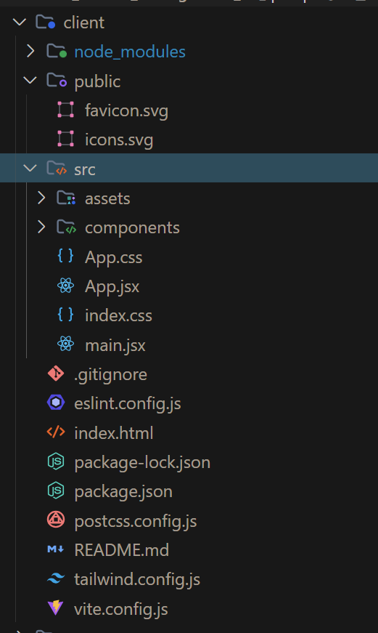

13.2 Admin Module
The Admin Module provides access to system metrics, user management, technician creation, invoice generation, and appointment status control. Admin routes are guarded by JWT + admin role middleware.
- Dashboard: live user count, vehicle count, appointment count, total revenue
- User list: all registered users (passwords excluded)
- Technician management: add specialists with name, specialization, experience
- Invoice management: create invoices and view payment statuses

13.3 User Module
The User Module delivers a vehicle-centric experience for customers.
- Vehicle registration and profile management
- Appointment booking with date and service type selection
- Service record visibility filtered to own vehicles
- Invoice viewing filtered to own vehicles
- Notification centre with read/unread management13.4 Components
- App.jsx — Root component with routing scaffold
- main.jsx — StrictMode React DOM entry
- index.css — Tailwind base / components / utilities import

14. Output Screenshots

Landing / Home Page
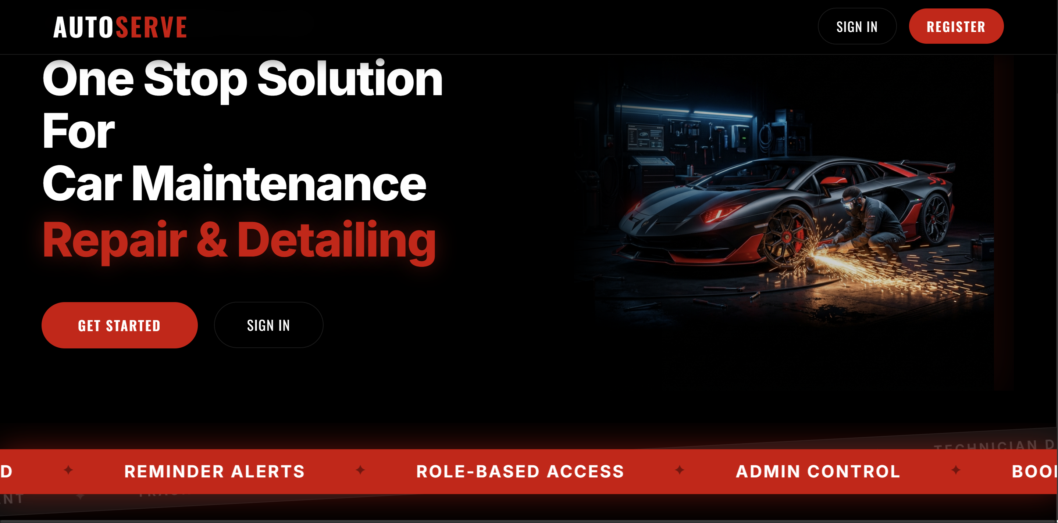

User Registration & Login Forms
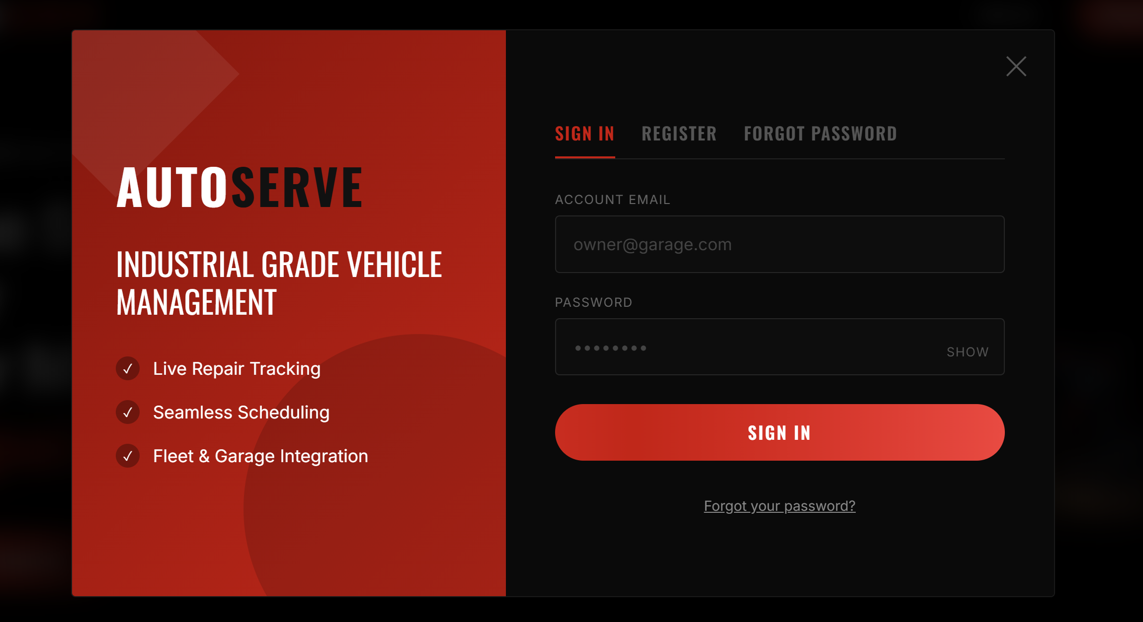

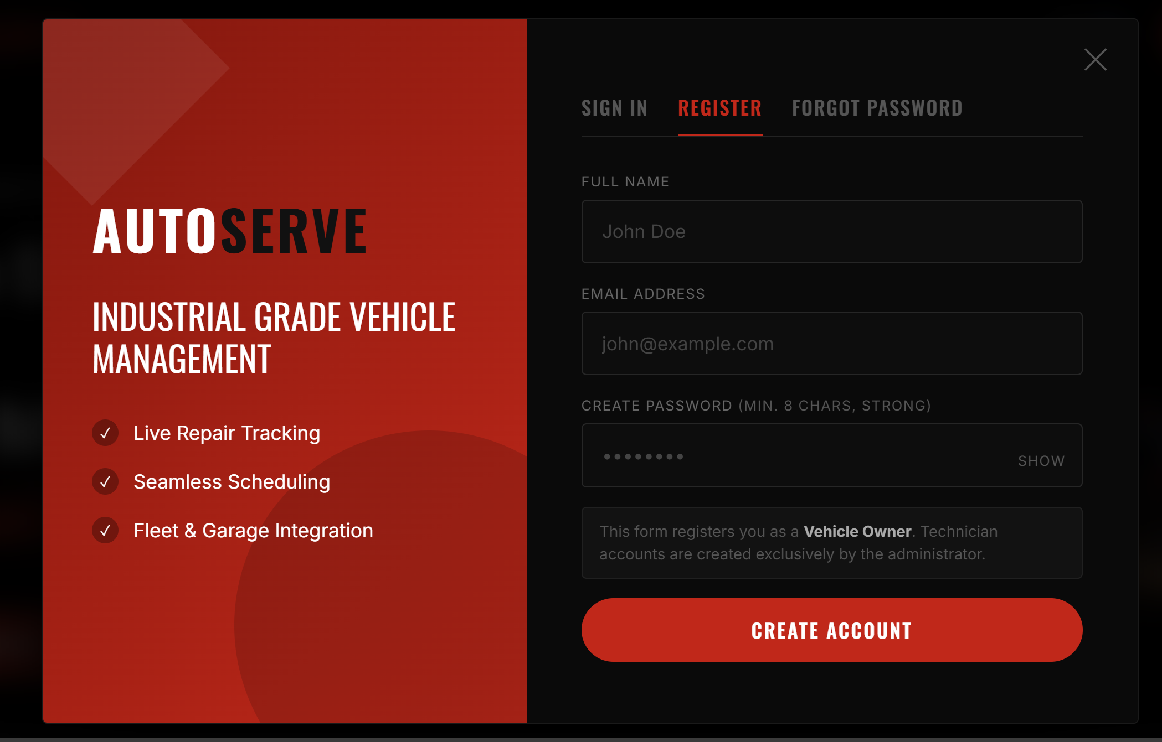

Vehicle Registration Form & Vehicle List
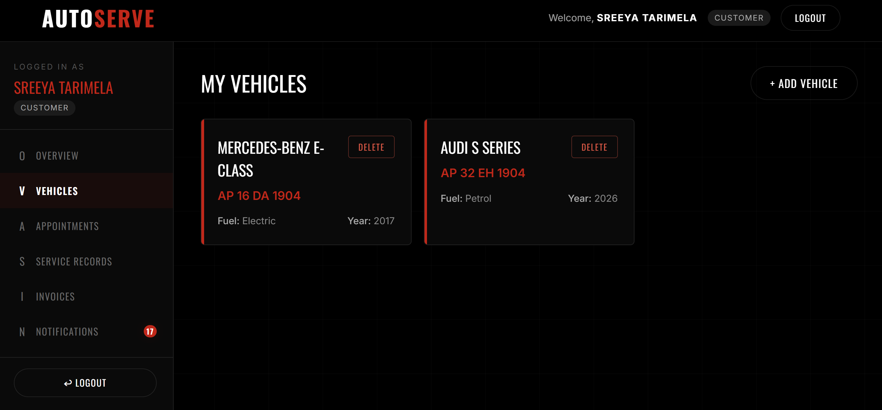

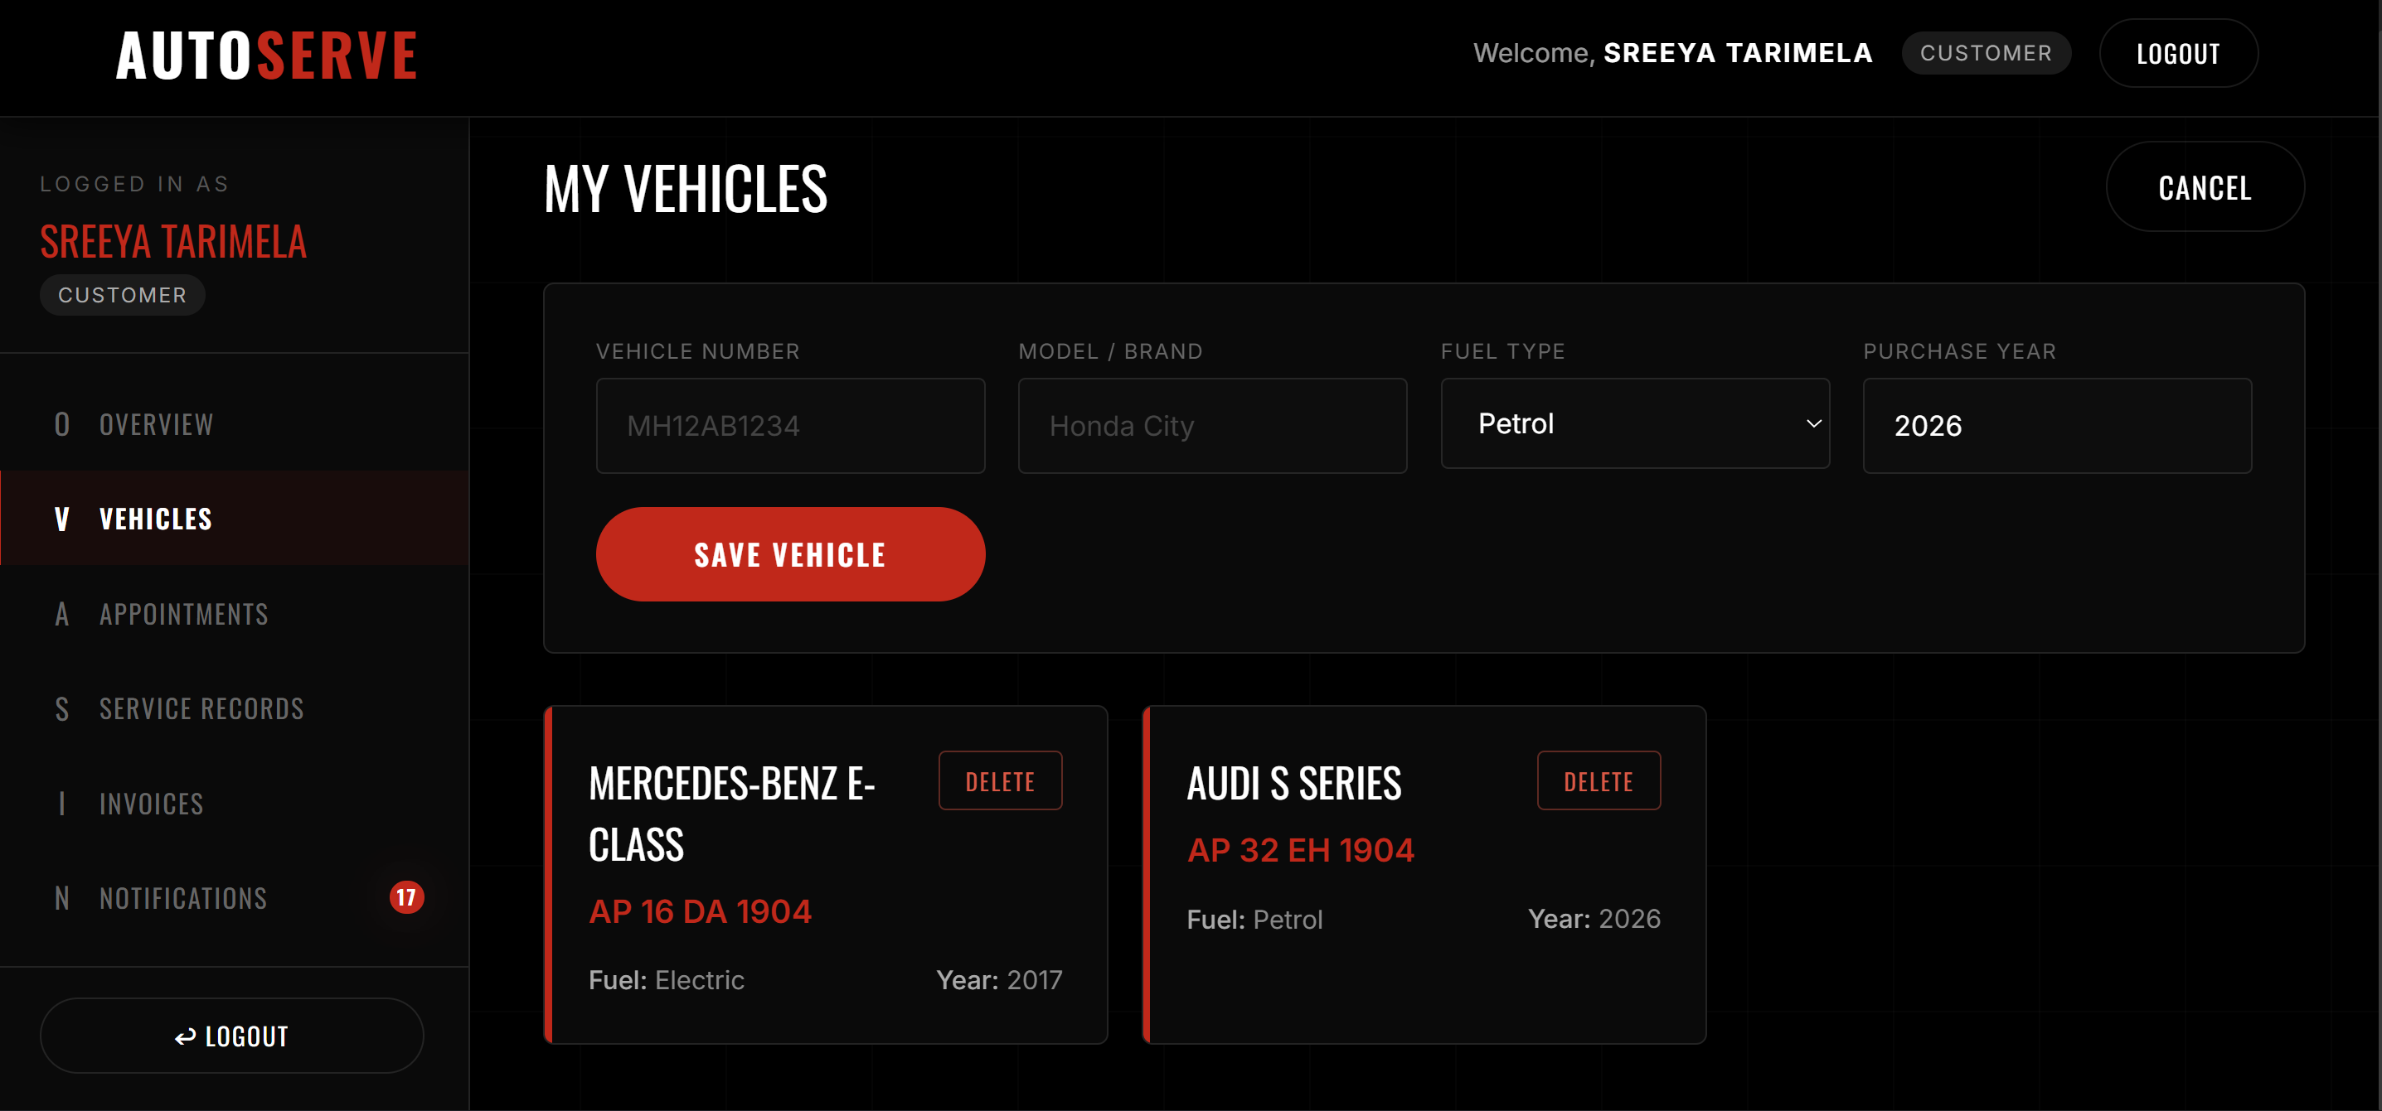

Appointment Booking Page
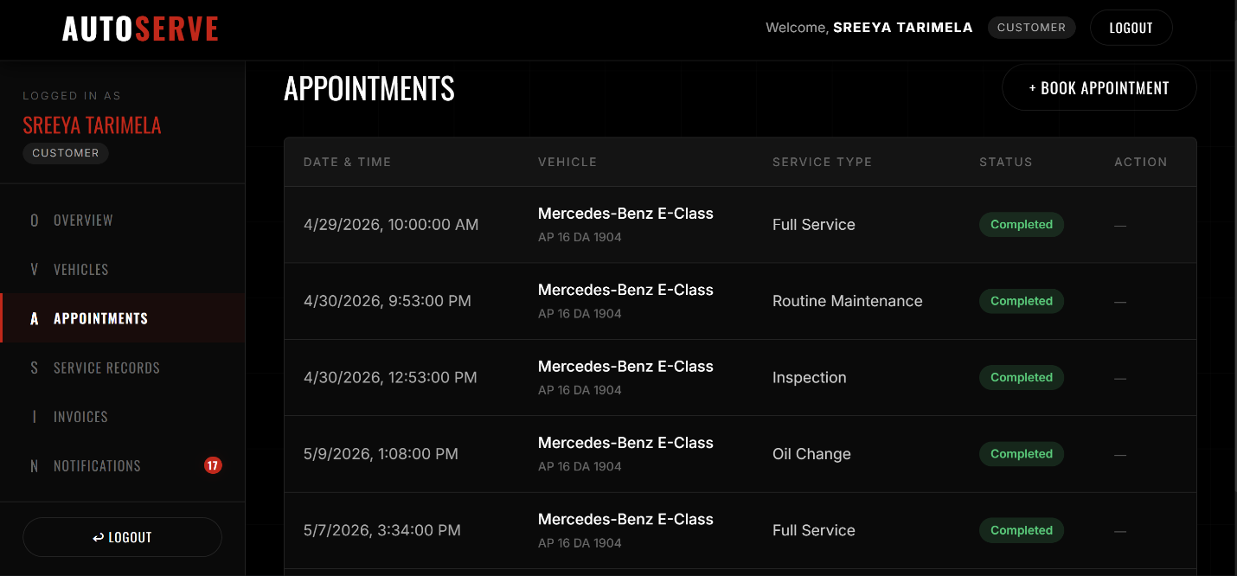

Admin Dashboard — Metrics Panel
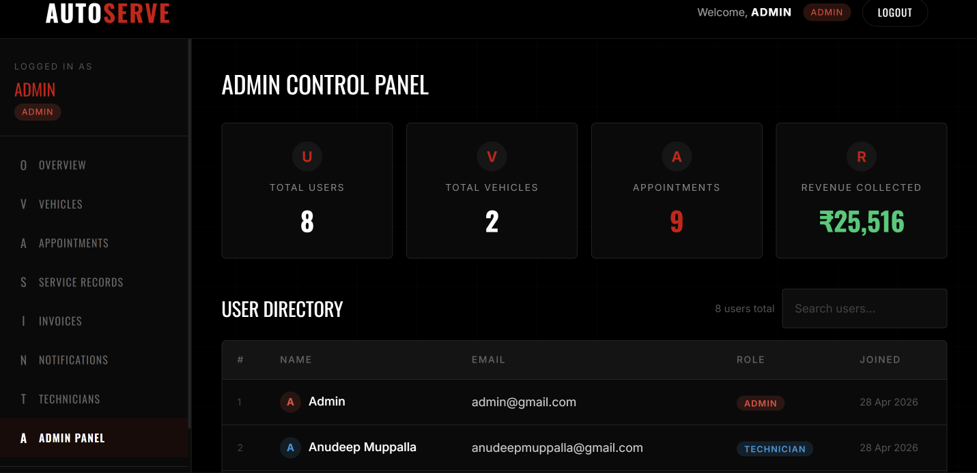

Service Record Detail View
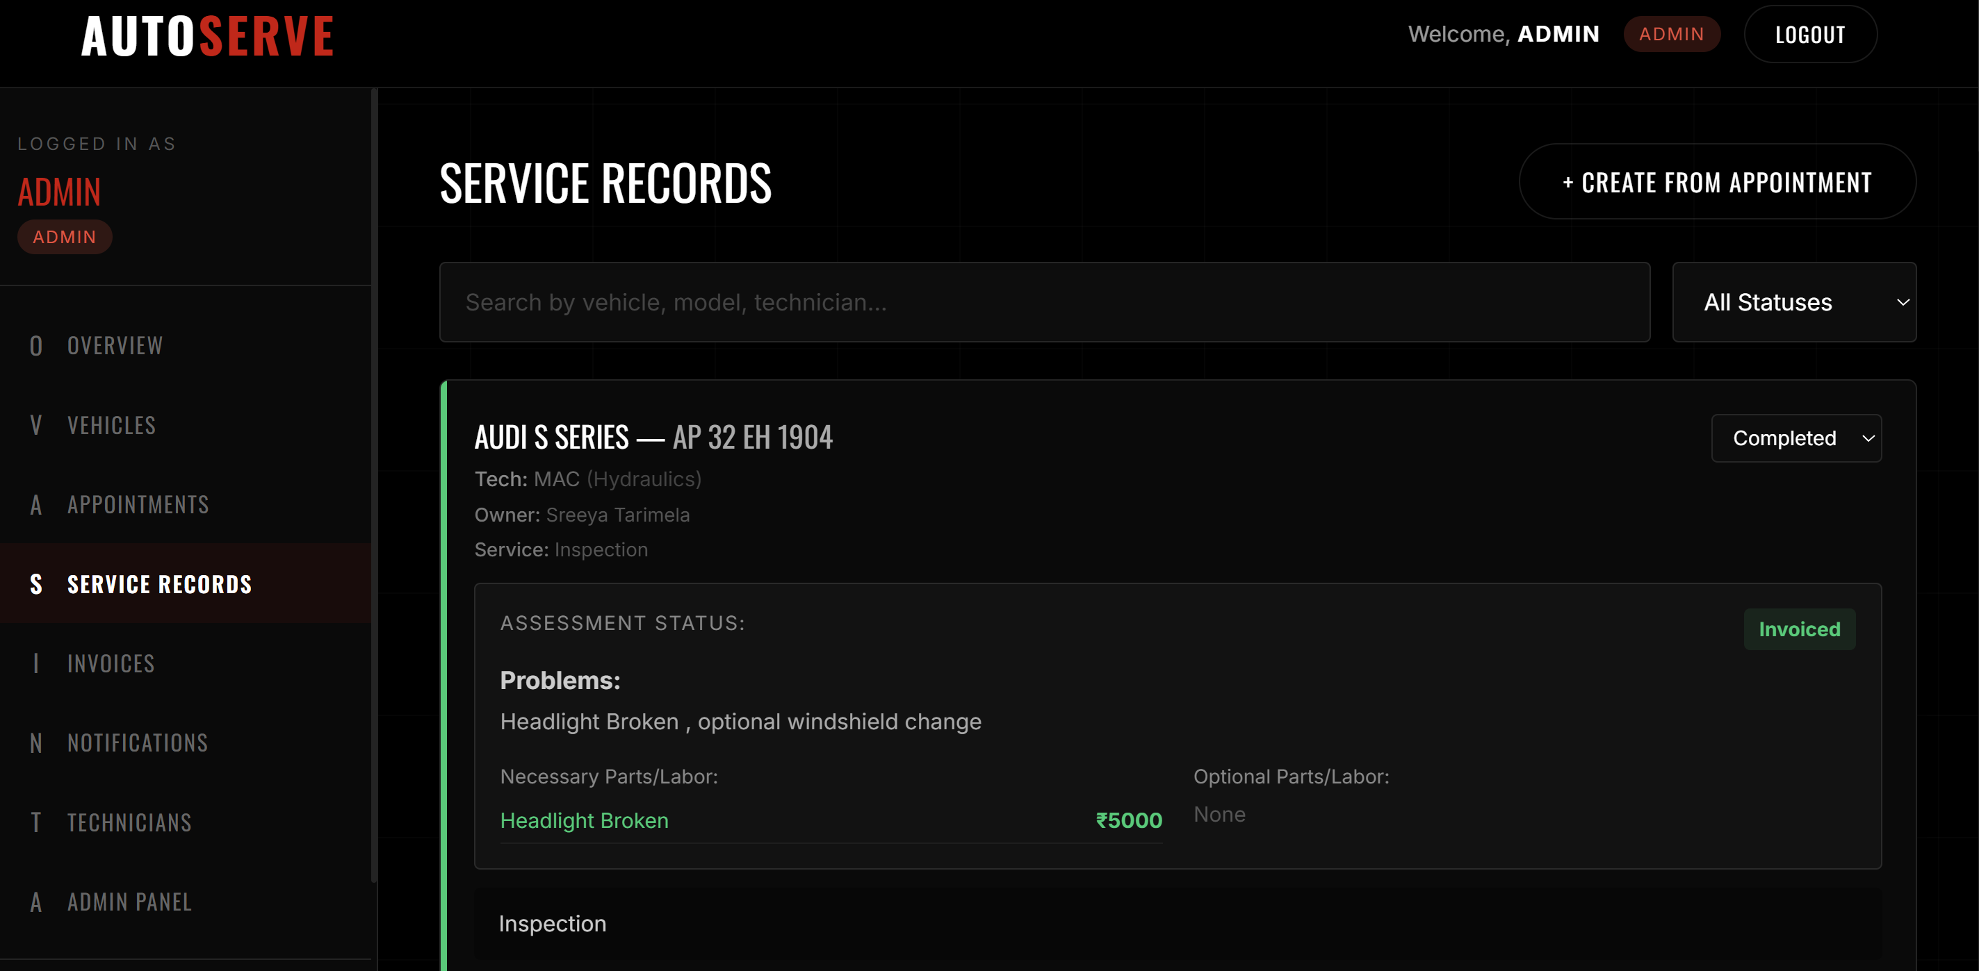

Invoice List with Payment Status
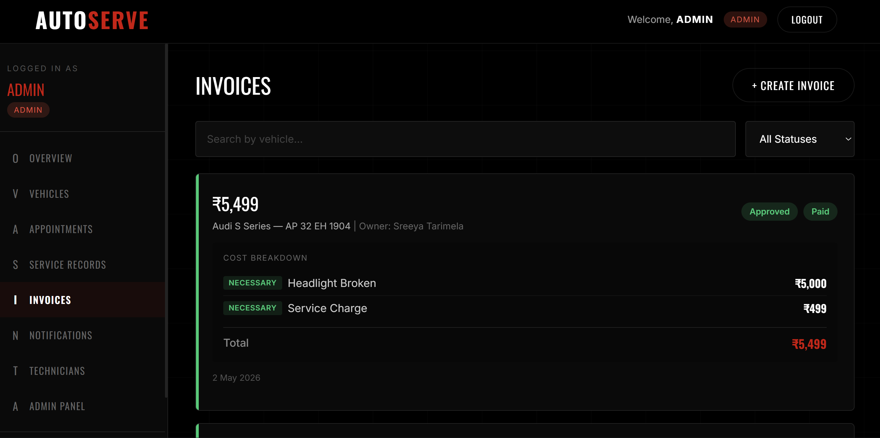

Notification Centre
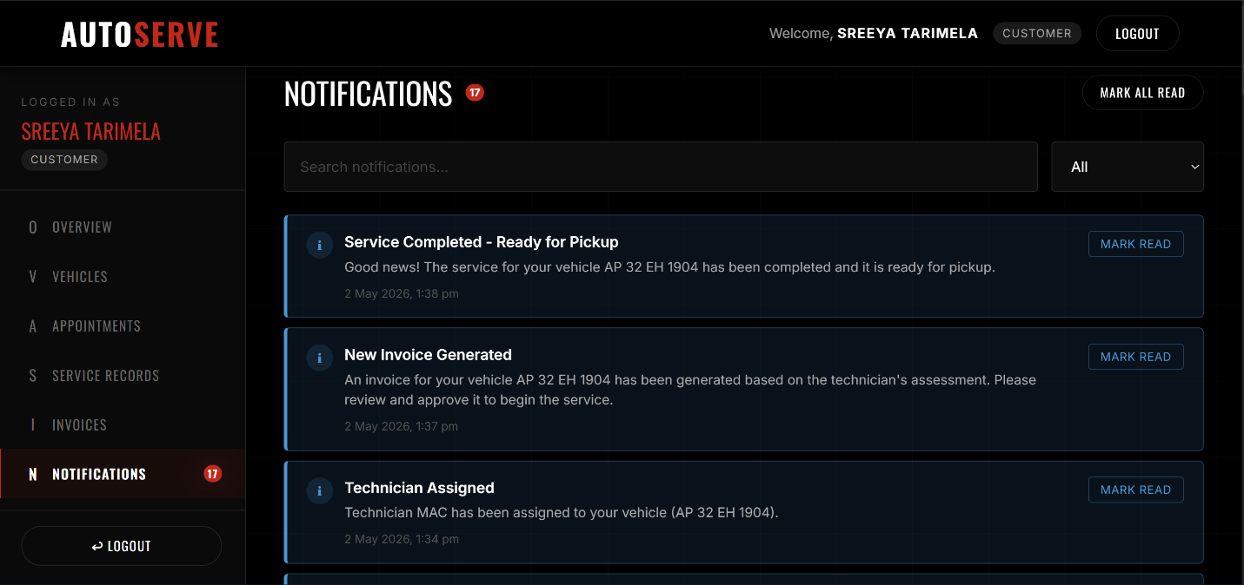

15. Demo and Code Links
Resource | Link
GitHub Repository | https://github.com/lalithmadhav11/Vehicle_Service_Management_System
Video Walkthrough | https://drive.google.com/file/d/1V6UGoizMfvUYzqBg9BYD716tIaqAEkN6/view?usp=sharing
Code Demo | https://drive.google.com/file/d/1JFz15rcefPh6WdWAFXW85zcd1q90lK7P/view?usp=sharing

