
Final Internship Report
Project Management Office (PMO) Tracker
Development & Implementation

Contributed by:
Lalith Siddardh Tulasi
Guided by :
Sri Harshavardhan V
Mohan
Index
S. No. | Contents
1. | Fundamentals of Project Management Systems
2. | Overview of PMO Features & Modules
3. | Overview of Technology Stack & Architecture
4. | Backend Development Using Spring Boot
5. | Frontend Development Using React & Vite
6. | Database Design & Schema Implementation
7. | Role-Based Access Control (RBAC) Implementation
8. | Feature Implementation – Change PM with Audit Trail
9. | Feature Implementation – Duplicate Project Prevention
10. | Feature Implementation – Portfolio Health Chart
11. | API Development & Testing
12. | Document Management & File Storage System
13. | Import & Export Functionalities
14. | Security Implementation – JWT Authentication
15. | Bug Fixing & Code Quality Enforcement
16. | Conclusion and Summary of Learnings

Abstract
This report presents the comprehensive learning experience and practical exposure gained during a development internship focused on designing, building, and deploying a full-stack Project Management Office (PMO) Tracker application. The internship covered foundational project management principles, an in-depth review of modern web application architecture, and hands-on implementation of both backend and frontend systems.
Through practical lab-style development activities, various features were implemented using industry-standard tools and frameworks such as Spring Boot 3.2, React 19, MySQL, and Vite. These included role-based authentication, project CRUD operations, PM change audit trails, duplicate project detection, portfolio health dashboards, document management with versioning, CSV/XLSX bulk import, and server-side PDF report generation.
Each feature was followed by focused testing and code quality enforcement using ESLint, Maven compilation, and systematic bug fixing. This internship provided both theoretical understanding and practical skills essential for building secure, scalable, and maintainable enterprise web applications.

1. Fundamentals of Project Management Systems
What I Did:
Studied the essential principles of project management systems, focusing on resource allocation, task tracking, portfolio management, and access control. Explored common project management challenges such as resource conflicts, duplicate entries, lack of audit trails, and visibility gaps. Also examined various user roles in an organization (Administrators, Project Managers, Team Members) and how software systems can streamline project oversight, deliverable tracking, and reporting.
Additionally Covered:
I studied the core components that make up a project management system:
- Project Lifecycle Management: Tracking projects from initiation through planning, execution, monitoring, and closure.
- Resource Allocation: Assigning Project Managers and team members to projects with role-based permissions.
- Portfolio Management: Grouping projects by Business Unit (BU) and providing aggregated health views.
- Audit Trail: Maintaining a complete history of changes for compliance and accountability.
I also explored key design patterns used in enterprise applications:
- Three-Tier Architecture
  - Presentation Layer (Frontend): React components handling UI and user interaction.
  - Business Logic Layer (Backend): Spring Boot services implementing business rules and validation.
  - Data Access Layer (Repository): JPA/Hibernate repositories managing database persistence.
- RESTful API Design
  - Stateless communication via HTTP methods (GET, POST, PATCH, PUT, DELETE).
  - JSON request/response format for data exchange.
  - Resource-oriented endpoints following REST conventions.
- Authentication & Authorization
  - JWT (JSON Web Token): Stateless token-based authentication.
  - RBAC (Role-Based Access Control): Granular permission management based on user roles.
  - Password Hashing: BCrypt for secure credential storage.
What I Learned:
Understood the basic architecture of enterprise web applications and the importance of a multi-layered design. Learned how to analyze requirements, design database schemas, implement REST APIs, and build responsive user interfaces. Gained awareness of how different user roles interact with the system and how proper design choices can prevent data inconsistencies and security breaches.

2. Overview of PMO Features & Modules
What I Did:
Analyzed the complete feature set of the PMO Tracker application. Reviewed key modules including: Project Management, Deliverable Tracking, Document Management, Portfolio View, Risk Register, Incident Tracking, Vulnerability Management, Security Task Board, Compliance Tracking, User Management, Notification System, and PDF Report Generation.
What I Learned:
Learned how these modules interact with each other and how they can be combined to provide a comprehensive project oversight platform. Gained the ability to identify feature dependencies, design database relationships, and recommend appropriate implementation approaches.
Module | Purpose | Key Features
Project Management | Core project CRUD | Create, read, update, delete with duplicate prevention
Deliverable Tracking | Recurring task management | Frequency-based scheduling, overdue detection
Document Management | File storage with versioning | Upload, preview, version history, audit logs
Portfolio View | BU-grouped project insights | Aggregated stats, health charts
Risk Register | Risk identification & tracking | Impact/probability matrix, mitigation plans
Security Tasks | Kanban board | To-do, in-progress, done columns
Reports | PDF generation | Server-side 3-page PDF reports
User Management | User lifecycle | Registration, approval, role assignment
Notifications | In-app alerts | Real-time updates, read/unread tracking

3. Overview of Technology Stack & Architecture
What I Did:
Explored the principles and tools used in building modern full-stack web applications. Studied the Spring Boot framework for backend development, React for frontend development, MySQL for database management, and Vite as the build tool. Analyzed how these technologies work together through REST APIs, JWT authentication, and proxy-based development setup.
Technology Stack Overview:
Layer | Technology | Version | Purpose
Backend Framework | Spring Boot | 3.2.0 | Application framework with embedded server
Backend Language | Java | 17 | Compiled, type-safe programming language
ORM | Hibernate / JPA | (via Spring) | Object-relational mapping
Database | MySQL | 8.0 | Relational database
Authentication | JWT (jjwt) | 0.12.3 | Stateless token auth
Frontend Framework | React | 19.2.6 | Component-based UI library
Build Tool | Vite | 8.0.12 | Fast dev server and bundler
Styling | Tailwind CSS | 4.3.1 | Utility-first CSS framework
Charts | Recharts | 3.8.1 | Declarative chart components
HTTP Client | Axios | 1.18.0 | Promise-based HTTP client
Excel Parsing | Apache POI | 5.2.5 | XLSX file processing
PDF Generation | OpenPDF | 1.3.30 | Server-side PDF rendering
Build Tool (Backend) | Maven | — | Dependency and build management
Architecture Overview:
Frontend (React 19)
Pages (16) | Components (13) | Context (AuthCtx) | Axios (JWT interceptor)
|
Proxy /api
v
Backend (Spring Boot)
Controllers (18 REST) | Services (9) | Repositories (16 JPA)
Security Layer (JWT + Spring Security) | Global Exception Handler
|
v
MySQL DB: fluentgrid_pmo (14 tables)
What I Learned:
Gained an understanding of how to design and build a full-stack web application from scratch. Learned how proper separation of concerns, middleware configuration, and security practices contribute to a robust system. Also developed knowledge of how the development proxy works and how frontend and backend communicate during development and production.

4. Backend Development Using Spring Boot
What I Did:
Developed the entire backend of the PMO Tracker using Spring Boot 3.2 with Java 17. Created 18 REST controllers, 9 service classes, 16 repository interfaces, and 16 JPA entity models. Configured Spring Security with JWT-based stateless authentication, CORS policies, and global exception handling.
Key Components Developed:
Configuration Layer:
- SecurityConfig.java: Configured Spring Security with stateless sessions, CORS enabled, CSRF disabled. Only /api/auth/** endpoints are public; all others require authentication. Added JWT filter before UsernamePasswordAuthenticationFilter. Provided BCryptPasswordEncoder and AuthenticationManager beans.
- CorsConfig.java: Global CORS configuration allowing all origin patterns, all headers, and all HTTP methods with credentials enabled.
Security Layer:
- JwtUtil.java: JWT token generation and validation using HMAC-SHA key. Token contains claims for email, role, and userId with 24-hour expiration.
- JwtAuthFilter.java: Per-request filter that extracts Bearer token, validates it, and sets authentication in the SecurityContext. Returns 401 JSON on invalid tokens.
- UserDetailsServiceImpl.java: Implements Spring Security's UserDetailsService for loading users by email during login authentication.
Exception Handling:
- GlobalExceptionHandler.java: Centralized handler using @RestControllerAdvice, mapping exceptions to HTTP status codes — 404 for not-found, 401 for bad credentials, 400 for validation errors, 403 for access denied, and 500 for generic exceptions.
Model Layer (16 Entities): Created JPA entities for User, Project, Deliverable, Notification, Risk, Incident, Vulnerability, SecurityTask, ComplianceItem, FileDocument, AuditLog, RegistrationRequest, DeleteProjectRequest, ProjectAssignment, UserProjectAssignment, and ProjectAssignmentHistory.
Service Layer (9 Classes):
- AuthService: Handles login authentication and user registration workflow.
- ProjectService: Core project business logic including duplicate validation, role-based listing, and PM change workflow.
- UserService: User management including registration approval and project assignment.
- DeliverableService: CRUD with computed status logic (overdue/due-soon/valid) and renew functionality.
- ReportService: Generates server-side PDF reports using OpenPDF with 3-page structure.
- FileDocumentService: Document lifecycle management with versioning and role-based access.
- FileStorageService: Physical file storage in organized directory structure with type validation and path traversal protection.
- NotificationService: CRUD for in-app notifications.
- VirusScanService: Placeholder service for future antivirus integration.
Key Code Snippet — Security Configuration:
@Configuration
@EnableWebSecurity
@EnableMethodSecurity
public class SecurityConfig {
@Bean
public SecurityFilterChain filterChain(HttpSecurity http) throws Exception {
http
.cors(cors -> {})
.csrf(csrf -> csrf.disable())
.sessionManagement(session -> session.sessionCreationPolicy(SessionCreationPolicy.STATELESS))
.authorizeHttpRequests(auth -> auth
.requestMatchers("/api/auth/**").permitAll()
.anyRequest().authenticated()
)
.userDetailsService(userDetailsService)
.addFilterBefore(jwtAuthFilter, UsernamePasswordAuthenticationFilter.class);
return http.build();
}
}
What I Learned:
Developed a strong understanding of Spring Boot application architecture, dependency injection, JPA entity relationships, and REST API design. Learned how to configure Spring Security for stateless JWT authentication and how to implement role-based access control. Gained practical experience in writing clean, layered code with proper separation of concerns.

5. Frontend Development Using React & Vite
What I Did:
Built the entire frontend using React 19 with Vite 8 as the build tool and Tailwind CSS 4 for styling. Created 16 page components, 13 reusable components, and supporting utilities. Implemented lazy loading for code splitting, JWT-based authentication flow with Axios interceptors, and responsive layouts with light/dark theme support.
Key Components Developed:
Core Setup:
- main.jsx: Application entry point with StrictMode.
- App.jsx: React Router setup with lazy-loaded routes, AuthProvider context wrapper, and ProtectedRoute guards for role-based access.
- index.css: Global CSS with Tailwind imports and CSS custom properties for theming (light/dark mode).
Authentication Flow:
- AuthContext.jsx: React Context providing login, register, and logout functions. Stores JWT in localStorage (fg_token) and user object (fg_user). Provides isAuthenticated and user values to all child components.
- api/axios.js: Axios instance with request interceptor adding Bearer token and response interceptor redirecting to login on 401.
Layout & Navigation:
- Layout.jsx: Collapsible sidebar with role-filtered navigation (12 items for admin, 6 for PM, 2 for user). Top bar with global search (debounced 200ms), notification bell, theme toggle, and user profile.
- ProtectedRoute.jsx: Route guard supporting adminOnly, pmOnly, and adminOrPm props. Redirects unauthenticated users to /login and unauthorized users to /dashboard.
Pages Developed (16 total):
Page | Route | Access | Description
Login | /login | Public | Email/password login form
Register | /register | Public | User registration form
Dashboard | /dashboard | All | Role-aware KPI cards, charts, activity timeline
Projects | /projects | Admin/PM | Project table with CRUD, Gantt toggle
ProjectDetails | /projects/:id | All | Detailed view with tabs, PM change modal
Deliverables | /deliverables | Admin/PM | Table/Kanban/Timeline views
TaskBoard | /board | Admin/PM | Kanban board for security tasks
Risk | /risk | Admin/PM | Risk register with severity matrix
Reports | /reports | Admin/PM | PDF/Excel/CSV report generation
OrgSecurity | /org-security | Admin/PM | Security dashboard with tabs
Portfolio | /portfolio | Admin | BU-grouped project view
UserManagement | /users | Admin | User list, role management
Registrations | /registrations | PM/Admin | Pending approvals
Import | /import | Admin/PM | CSV/XLSX bulk import
Documents | /documents | Admin/PM | Document repository
Team | /team | Admin | Team directory with metrics
Key Code Snippet — Axios JWT Interceptor:
import axios from 'axios';
const api = axios.create({ baseURL: '/api' });
api.interceptors.request.use(config => {
const token = localStorage.getItem('fg_token');
if (token) config.headers.Authorization = `Bearer ${token}`;
return config;
});
api.interceptors.response.use(
res => res,
err => {
if (err.response?.status === 401) {
localStorage.clear();
window.location.href = '/login';
}
return Promise.reject(err);
}
);
What I Learned:
Gained practical experience in building a single-page application with modern React, including hooks (useState, useEffect, useCallback, useMemo, useRef), context API for state management, lazy loading for performance optimization, and Tailwind CSS for rapid styling. Learned how to structure a frontend project with proper separation between pages, components, utilities, and API clients.

6. Database Design & Schema Implementation
What I Did:
Designed and implemented the MySQL database schema for the PMO Tracker. Created 14 tables with proper relationships, foreign key constraints, indexes, and seed data. Used Hibernate's ddl-auto=validate mode to ensure schema consistency between code and database.
Database Schema Overview:
users ---- registration_requests
| delete_project_requests
| project_assignment_history
| notifications
|
|--< project_assignments (pm_id)
|--< user_project_assignments (user_id)
|
projects --< project_assignments
| < user_project_assignments
| < project_assignment_history
| < delete_project_requests
| < deliverables
| < security_tasks
| < file_documents
| < audit_logs
|
+--< risks, incidents, vulnerabilities, compliance_items
Key Tables:
users — System user accounts with role-based access:
Column | Type | Constraints
id | BIGINT | PK
email | VARCHAR(255) | UNIQUE, NOT NULL
password_hash | VARCHAR(255) | NOT NULL (BCrypt)
role | ENUM(10 roles) | NOT NULL
status | ENUM(4 statuses) | DEFAULT PENDING_APPROVAL
assigned_pm_id | BIGINT | FK -> users(id)
projects — Core project entities:
Column | Type | Constraints
id | BIGINT | PK
name | VARCHAR(255) | NOT NULL
bu | VARCHAR(100) | NOT NULL
type | VARCHAR(100) | NOT NULL
status | ENUM(6 statuses) | DEFAULT ontrack
budget | DECIMAL(12,2) | DEFAULT 0
UNIQUE(name, bu) | — | Prevents duplicates
deliverables — Recurring cybersecurity deliverables:
- Fields: projectId, name, category, frequency, lastDate, nextDate, reminderDays, status
- Computed field (getComputedStatus()): Returns "overdue", "due_soon", or "valid" based on nextDate and reminderDays
project_assignment_history — PM change audit trail:
Column | Type | Purpose
project_id | BIGINT | FK -> projects
old_pm_id | BIGINT | Previous PM
new_pm_id | BIGINT | New PM
changed_by | BIGINT | Who made the change
changed_at | TIMESTAMP | When the change occurred
Seed Data:
- 5 users: SUPER_ADMIN, ADMIN, and 3 PMs with BCrypt-hashed password demo1234
- 37 projects: Across 3 Business Units — CIS (9), AMI (26), ACT (4) — with mixed statuses and budgets ranging from 25–200 Lakhs
- 3 sample deliverables: External VAPT (overdue), Internal VAPT (due soon), Patch Management (valid)
What I Learned:
Developed skills in relational database design, including proper normalization, foreign key relationships, and constraint management. Learned how to write effective SQL for creating tables, inserting seed data, and migrating schema changes. Understood the importance of UNIQUE constraints for data integrity at the database level.

7. Role-Based Access Control (RBAC) Implementation
What I Did:
Designed and implemented a comprehensive role-based access control system supporting 10 user roles with hierarchical permissions. Configured Spring Security for endpoint-level authorization and implemented frontend route guards for UI-level access control.
Role Hierarchy:
SUPER_ADMIN (Full Access)
|-- Can directly delete projects
|-- Can change PM on any project
|-- Can view audit logs
|-- Approve/reject delete requests
ADMIN (Operational Management)
|-- Create/edit projects (except delete)
|-- Manage users & assignments
|-- Upload/manage documents
|-- Assign PM only when project has no PM
PM (Project Manager)
|-- Manage assigned projects only
|-- Manage deliverables & security tasks
|-- Request project deletion (needs approval)
|-- Approve user registrations
TEAM MEMBER (DEVELOPER, TESTER, BA, QA, DEVOPS, DESIGNER, OTHER)
+-- Read-only access to assigned projects
Implementation:
Backend (Spring Security):
- JWT token contains a role claim (e.g., "ROLE_ADMIN")
- JwtAuthFilter creates a UsernamePasswordAuthenticationToken with SimpleGrantedAuthority(ROLE_{role})
- SecurityConfig.authorizeHttpRequests() gates endpoints at the HTTP method level
- Service-layer checks filter data based on user role (e.g., PMs only see assigned projects)
Frontend (React):
- ProtectedRoute.jsx supports adminOnly, pmOnly, adminOrPm props
- AuthContext.user.role determines which navigation items appear in the sidebar
- UI elements conditionally render based on role (e.g., "Add Project" button only for ADMIN/SUPER_ADMIN)
What I Learned:
Understood how to implement RBAC in a full-stack application with both backend and frontend enforcement. Learned that security must be applied at both layers — the backend as the authoritative source and the frontend for user experience. Gained practical experience in JWT claim customization and Spring Security's authority model.

8. Feature Implementation – Change PM with Audit Trail
What I Did:
Implemented a feature allowing SUPER_ADMIN to reassign Project Managers with a complete audit trail, and allowing ADMIN to assign a PM only when the project has no current PM.
Backend Implementation:
Endpoint: PUT /api/projects/{projectId}/change-pm
Access Control:
- SUPER_ADMIN: Can change any project's PM regardless of current assignment
- ADMIN: Can only assign when currentPmId is null (no existing PM)
Service Logic (ProjectService.changePm()):
- Fetch the project and validate it exists
- Check the requesting user's role and current PM assignment
- Update the ProjectAssignment table with the new PM
- Create a ProjectAssignmentHistory record with projectId, oldPmId, newPmId, changedBy, changedAt
- Send in-app notifications to the new PM and relevant admins
Frontend Implementation (ProjectDetails.jsx):
- Current PM Display: PM name shown in the project header, fetched via fetchPms()
- Two-Step Modal: Step 1 — searchable dropdown filtering users by name or email; Step 2 — confirmation dialog displaying "Previous PM → New PM"
- State Management: confirmPmChange, selectedPmName, pmSearchQuery, currentPmName
- Error Handling: Clears errors on modal open, displays API errors inline
- Refresh: Calls fetchProject() on success to update the entire view
Audit Trail Table (project_assignment_history):
Column | Type | Purpose
id | BIGINT | Primary key
project_id | BIGINT | The project affected
old_pm_id | BIGINT | Previous PM (nullable for first assignment)
new_pm_id | BIGINT | Newly assigned PM
changed_by | BIGINT | User who performed the change
changed_at | TIMESTAMP | Auto-recorded timestamp
What I Learned:
Learned how to implement an audit trail system for tracking important state changes. Understood the importance of recording who changed what and when for compliance and accountability. Gained experience in designing modals with multi-step workflows and search functionality.

9. Feature Implementation – Duplicate Project Prevention
What I Did:
Implemented a comprehensive duplicate detection system that prevents projects with the same name within the same Business Unit from being created. Fixed a null-BU comparison bug and eliminated race conditions with a database-level unique constraint.
Problem Analysis:
- Null-BU Asymmetry Bug: When no BU was specified, the check matched any project with the same name regardless of BU. When a BU was specified, it failed to match existing projects with null BU.
- Race Condition: The check loaded all projects into memory using findAll(), so two concurrent requests could both pass the check before either one saved.
Implementation:
Normalization Function (ProjectService.normalizeName()):
- Trims leading and trailing whitespace
- Collapses multiple internal spaces into one
- Converts to lowercase for case-insensitive comparison
Repository Query (ProjectRepository.findByNameNormalized()):
@Query("SELECT p FROM Project p WHERE LOWER(TRIM(p.name)) = LOWER(TRIM(:name))")
List<Project> findByNameNormalized(@Param("name") String name);
Duplicate Check Logic (ProjectService.isDuplicateNameAndBu()):
- Normalize input name and BU using normalizeName()
- Query database for projects with matching normalized name
- Filter by exclude ID (for updates)
- Compare BU with proper null handling: null BU matches only null BU; non-null BU matches only the same normalized BU
Database-Level Protection (Project.java):
@Table(name = "projects", uniqueConstraints = {
@UniqueConstraint(columnNames = {"name", "bu"})
})
All Import Paths Updated:
- CSV text import → projectService.createProject()
- CSV file upload → projectService.createProject()
- XLSX file upload → projectService.createProject()
- All catch and report duplicate errors per-row in the import results
Frontend Validation (ProjectWorkspaceDrawer.jsx):
- checkNameDuplicate() accepts a bu parameter
- Calls GET /api/projects/check-name?name=...&bu=...
- Displays: "Project already exists in this Business Unit."
- Handles HTTP 409 error on save
- Re-checks when the BU field changes
What I Learned:
Learned the importance of defensive programming — never assume data integrity is guaranteed at only one layer. Understood how race conditions can occur in concurrent systems and how database-level constraints serve as the ultimate safeguard. Gained experience in writing case-insensitive, whitespace-insensitive comparisons for real-world input validation.

10. Feature Implementation – Portfolio Health Chart
What I Did:
Revamped the Dashboard's portfolio health chart to aggregate project statuses into meaningful categories, clean up chart labels, and round BU values for a professional presentation.
Implementation:
Status Aggregation Function (aggregateProjectStatus()) — maps individual project statuses to 5 portfolio health categories:
Portfolio Category | Mapped Statuses
On Track | ontrack
Delayed | delayed
At Risk | atrisk
On Hold | onhold
Completed | done, pending
Doughnut Chart:
- Renders using aggregated category counts instead of raw statuses
- Custom center label displays the total number of projects
- Uses PORTFOLIO_CATEGORIES and PORTFOLIO_COLORS constants for consistent styling
Horizontal Bar Chart (BU-wise):
- Values rounded to whole numbers via Math.round() in the data preparation step
- tickFormatter ensures Y-axis labels display rounded values
- Cleaned up axis labels and tooltips for better readability
Bug Fix — Temporal Dead Zone (TDZ):
- portfolioHealthData was computed before the projects state was declared
- Fix: Moved the projects state declaration above portfolioHealthData (line 173 instead of 179)
Recharts Implementation:
import { PieChart, Pie, Cell, BarChart, Bar, XAxis, YAxis, Tooltip, ResponsiveContainer } from 'recharts';
const PORTFOLIO_COLORS = {
'On Track': '#22c55e',
'Delayed': '#eab308',
'At Risk': '#ef4444',
'On Hold': '#f97316',
'Completed': '#3b82f6',
};
What I Learned:
Gained experience in data visualization using Recharts, including pie charts with custom center labels and horizontal bar charts with formatted values. Understood the importance of data aggregation for making raw data more meaningful. Learned about the Temporal Dead Zone (TDZ) in JavaScript and how hoisting affects variable declarations in different scopes.

11. API Development & Testing
What I Did:
Developed 68 REST API endpoints across 18 controllers, covering the complete feature set of the PMO Tracker. Tested endpoints using browser developer tools and verified responses at each stage of development.
API Endpoint Categories:
Category | Endpoints | Description
Authentication | 2 | Login, Register
Projects | 14 | CRUD, PM change, duplicate check, delete request
Users | 7 | User management, registration approval
Dashboard | 1 | Role-aware KPIs and distributions
Portfolio | 1 | BU-grouped project data
Deliverables | 8 | CRUD, mark-done, renew
Security | 16 | Risks, incidents, vulns, tasks, compliance
Documents | 12 | Upload, download, preview, versioning, audit
Notifications | 4 | List, unread, mark-read, delete
Import | 2 | CSV text, file upload
Reports | 1 | Server-side PDF generation
Search | 1 | Cross-entity search
Team | 1 | User directory
State | 1 | Global project snapshot
Example API Request/Response:
Request: PUT /api/projects/3/change-pm
{
"newPmId": 5
}
Response: 200 OK
{
"message": "PM updated successfully",
"previousPm": { "id": 3, "name": "Harsha V." },
"newPm": { "id": 5, "name": "Murali Baggam" }
}
What I Learned:
Developed a systematic approach to API design following REST conventions. Learned how to structure endpoints with consistent naming, use appropriate HTTP methods and status codes, and design request/response formats for clarity and ease of frontend consumption.

12. Document Management & File Storage System
What I Did:
Implemented a complete document management system with file upload, versioning, preview, download, rename, and delete functionality. Built a secure file storage layer with path traversal protection and organized directory structure.
Storage Architecture:
- Physical Storage Path: filestorage/{yyyy}/{MM}/{UUID}.{ext}
- Supported File Types: pdf, doc, docx, xls, xlsx, csv, ppt, pptx, txt, png, jpg, jpeg, zip
- Size Limit: 50MB per file
Lifecycle:
- Upload: File is scanned (placeholder), stored on disk, metadata recorded in the file_documents table with version number, audit log created
- Access: Role-based permission check → download/preview as inline content
- Versioning: Uploading a new version increments versionNumber, old version preserved
- Delete: Removes file from disk and database record (with permission check)
Database Table (file_documents):
Column | Purpose
original_filename | User-friendly filename
stored_filename | UUID-based storage name
file_type | Extension type
file_size | Size in bytes
version_number | Auto-incrementing version
storage_path | Full path on disk
uploaded_by | User who uploaded
project_id | Associated project
access_scope | Scope (default: PROJECT)
What I Learned:
Understood the challenges of file management in web applications, including storage organization, version control, path traversal prevention, and role-based access to files. Gained experience in implementing secure file upload with type validation, size limits, and audit logging.

13. Import & Export Functionalities
What I Did:
Implemented bulk import functionality supporting CSV text paste and file upload (CSV + XLSX formats, up to 5MB). Also implemented client-side and server-side report export capabilities.
Import System (ImportController.java):
Supported Formats:
- CSV text: Pasted directly into a text area in the browser
- CSV file: Uploaded .csv files
- XLSX file: Uploaded Excel files (parsed via Apache POI)
Row Types Parsed:
- PROJECT rows: Full project data with all fields (name, BU, type, infraManagedBy, status, dates, budget, etc.)
- DELIVERABLE rows: Deliverable data with project reference, category, frequency, dates
- Default (simple): Name, BU, Type, Infra Managed By, SPOC, Status
Duplicate Handling:
- Each row is processed through projectService.createProject(), which includes duplicate name+BU validation
- Errors are caught per-row and reported in the import results
- Import summary shows: projects created, deliverables created, error count
Export System:
Client-Side (reportExport.js):
- CSV export using Blob download
- Excel (XLSX) export using SheetJS library
- PDF export using jsPDF with auto-table plugin
Server-Side (ReportService.java):
- Generates a professional 3-page PDF using OpenPDF
- Page 1: Project overview with KPIs, progress bar, pie chart
- Page 2: Team members, deliverables, documents, risks tables
- Page 3: Activity/audit log timeline
- Color-coded sections, header/footer, styled with fonts
What I Learned:
Gained experience in handling file uploads, parsing multiple formats (CSV, XLSX), and implementing robust error reporting. Learned about server-side PDF generation with graphics (progress bars, pie charts drawn via PdfContentByte) and client-side export using modern JavaScript libraries.

14. Security Implementation – JWT Authentication
What I Did:
Implemented stateless JWT-based authentication with secure token handling, password hashing, and request filtering.
Authentication Flow:
1. User submits login form (email + password)
|
v
2. AuthController.login() receives credentials
|
v
3. AuthService authenticates via AuthenticationManager
|
v
4. JwtUtil.generateToken() creates JWT with:
- Subject: email
- Claims: role, userId
- Expiration: 24 hours
|
v
5. Response returns { token, email, role, userId, name }
|
v
6. Frontend stores token in localStorage (fg_token)
|
v
7. Subsequent requests include Authorization: Bearer {token}
|
v
8. JwtAuthFilter validates token, sets SecurityContext
Security Measures:
Measure | Implementation
Password Hashing | BCryptPasswordEncoder (Spring Security)
Token Signing | HMAC-SHA256 with Base64-decoded secret key
Token Expiry | 24 hours (configurable via jwt.expiration)
Stateless Sessions | No HTTP sessions; each request authenticated independently
CORS | Allow all origins, methods, headers with credentials
CSRF Protection | Disabled (stateless JWT auth doesn't use cookies)
Input Validation | @Valid / @NotBlank / @Email annotations on DTOs
Error Handling | GlobalExceptionHandler returns structured JSON errors
Key Security Code — JWT Filter:
@Component
public class JwtAuthFilter extends OncePerRequestFilter {
@Override
protected void doFilterInternal(HttpServletRequest request,
HttpServletResponse response, FilterChain filterChain) {
String authHeader = request.getHeader("Authorization");
if (authHeader == null || !authHeader.startsWith("Bearer ")) {
filterChain.doFilter(request, response);
return;
}
String token = authHeader.substring(7);
Claims claims = jwtUtil.validateToken(token);
String email = claims.getSubject();
String role = claims.get("role", String.class);
Long userId = claims.get("userId", Long.class);
List<SimpleGrantedAuthority> authorities =
List.of(new SimpleGrantedAuthority("ROLE_" + role));
UsernamePasswordAuthenticationToken authentication =
new UsernamePasswordAuthenticationToken(email, userId, authorities);
SecurityContextHolder.getContext().setAuthentication(authentication);
filterChain.doFilter(request, response);
}
}
What I Learned:
Gained a deep understanding of JWT-based authentication, including token structure (header, payload, signature), claim customization, and secure token storage. Learned how Spring Security's filter chain works and how to integrate custom authentication filters. Understood the importance of stateless session management for scalable REST APIs.

15. Bug Fixing & Code Quality Enforcement
What I Did:
Systematically fixed 128 ESLint errors across the frontend codebase and ensured both backend and frontend build successfully. Enforced code quality standards through linting and compilation checks.
ESLint Error Resolution Breakdown:
Error Category | Count | Severity | Fix Applied
no-undef (runtime crash) | 1 | Critical | Fixed missing user variable in ProjectWorkspaceDrawer.jsx
react-hooks/refs | 15 | High | Suppressed for valid event-handler ref access
react-hooks/static-components | 5 | High | Moved SortButton outside render in Team.jsx
react-hooks/purity | 3 | High | Suppressed Date.now() and Math.random() in render
no-unused-vars | 30 | Medium | Removed unused imports and variables
no-empty (empty catch) | 10 | Medium | Added proper error handling
react-hooks/set-state-in-effect | 34 | Low | Suppressed for standard data-fetching patterns
Build Verification:
Check | Status
mvn compile (Backend) | BUILD SUCCESS
npm run build (Frontend) | BUILD SUCCESS
npx eslint src/ (Lint) | 0 errors, 3 warnings
Critical Bug Fixed — null-BU Asymmetry:
The isDuplicateNameAndBu() method had a logic error where checking with a null BU matched any project with the same name regardless of BU (too broad), while checking with a specific BU didn't match existing projects with a null BU (too narrow).
Fix: Rewrote the method with explicit null-equality logic:
if (normalizedBu == null && existingBu == null) return true;
if (normalizedBu == null || existingBu == null) return false;
return normalizedBu.equals(existingBu);
Critical Bug Fixed — Temporal Dead Zone:
In Dashboard.jsx, portfolioHealthData was referenced before the projects state was declared, causing a runtime error. Fix: Reordered declarations so projects comes before portfolioHealthData.
Dashboard
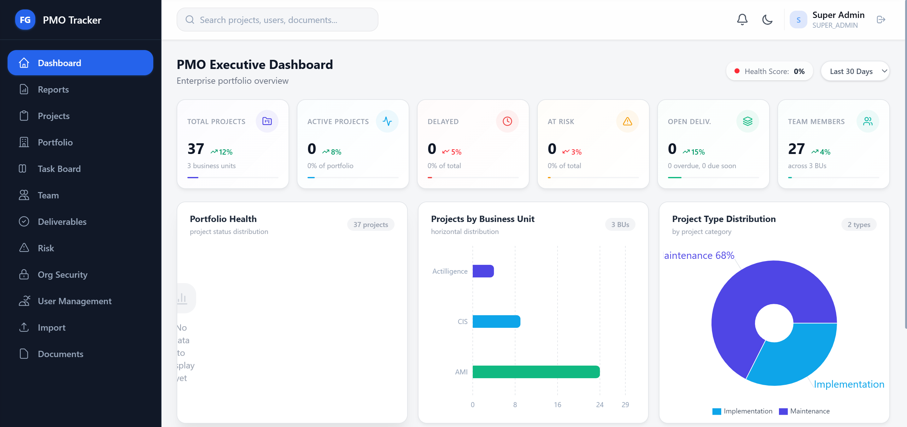

Team
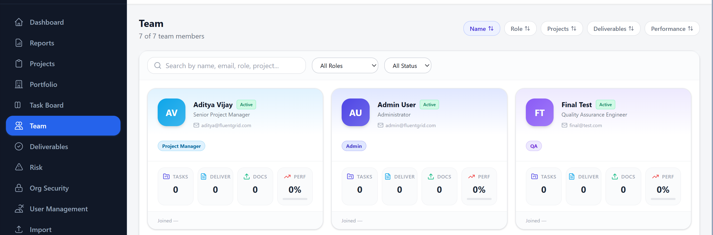

User Management
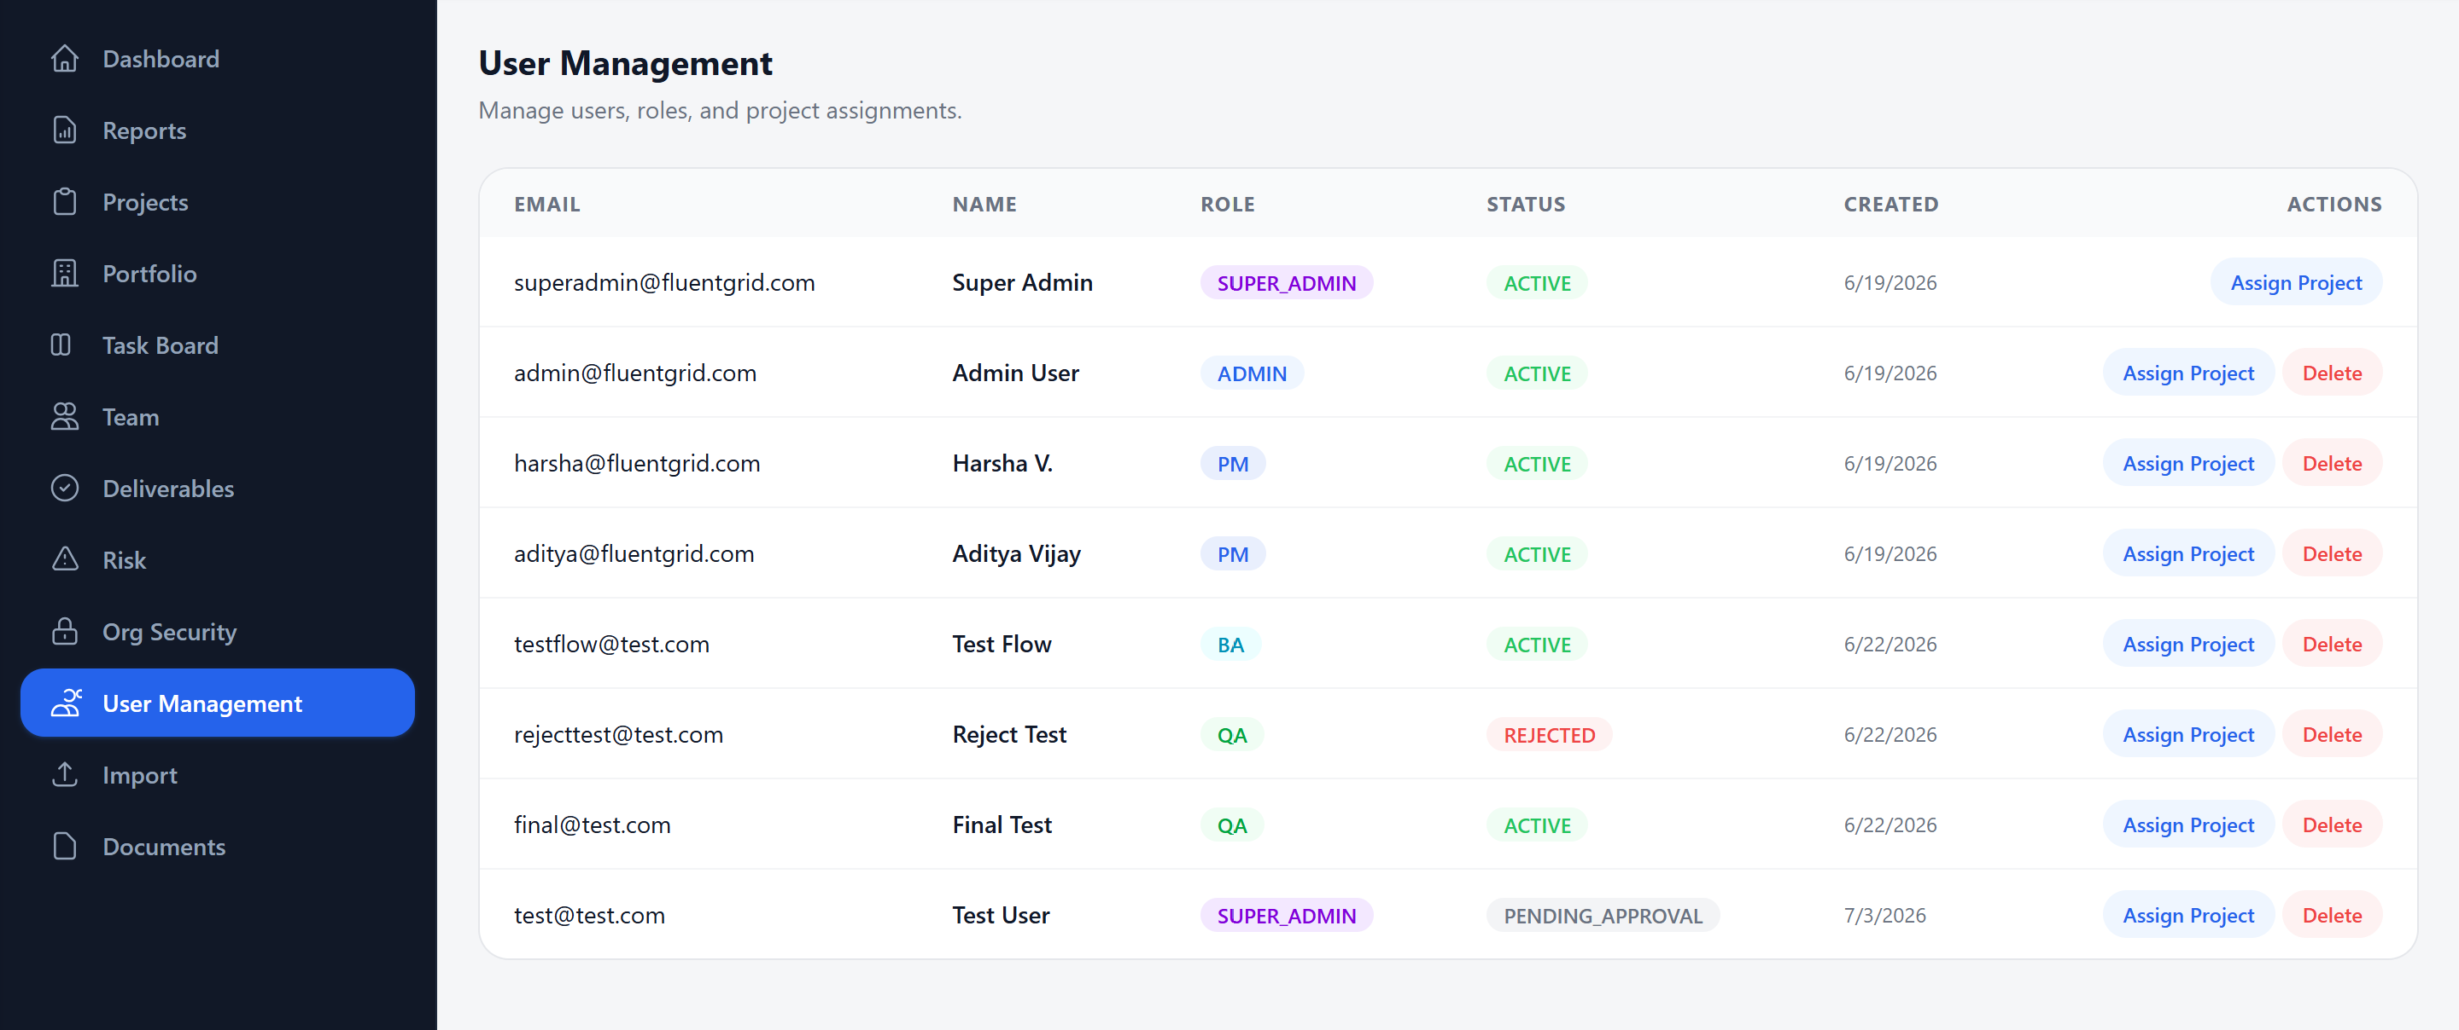

Import Functionality
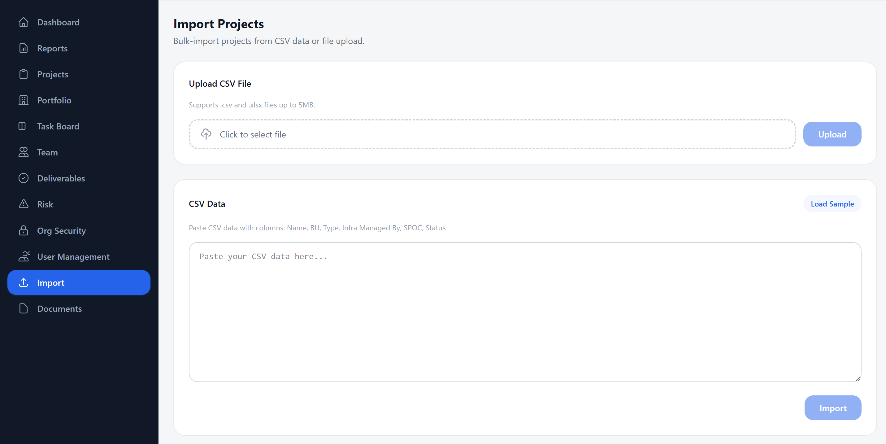
What I Learned:
Learned the importance of code quality tools like ESLint for catching potential bugs early. Developed systematic debugging skills — reading error messages, tracing through code, and applying targeted fixes. Understood that even seemingly simple bugs (like null comparisons) can have significant impact on system behavior.

16. Conclusion and Summary of Learnings
Throughout the internship, I acquired both practical skills and theoretical understanding in the field of full-stack web application development. I gained hands-on experience with industry-standard tools and frameworks such as Spring Boot, React, MySQL, and Vite, applying them in real-time to design, build, and deploy a comprehensive Project Management Office Tracker.
I developed a strong grasp of multiple development areas, including:
- Backend Development: REST API design, Spring Security, JPA/Hibernate ORM, JWT authentication, layered architecture
- Frontend Development: React hooks, component design, state management, routing, Tailwind CSS, Recharts visualization
- Database Design: Schema design, constraint management, foreign key relationships, seed data
- Security Implementation: Role-based access control, password hashing, token-based auth, CORS configuration
- Feature Development: PM change audit trail, duplicate prevention, portfolio health charts, document management, bulk import/export
- Code Quality: ESLint enforcement, build verification, systematic bug fixing
- Version Control & Project Management: Organized project structure, comprehensive reporting
This internship not only enhanced my technical proficiency but also improved my ability to:
- Analyze requirements and design appropriate solutions
- Implement features following industry best practices
- Debug and fix issues systematically
- Document work for future reference and reporting
- Work with a full technology stack end-to-end
Overall, it has strengthened my foundation in software engineering principles, prepared me for real-world development challenges, and motivated me to pursue advanced roles in full-stack development and enterprise application architecture.

