# Introduction

This functional requirement specification contains the description of the behavior of the System Access Subsystem, Manage Orders Subsystem. It includes a set of use cases that describes the interactions that user will have with the software. In addition to the use cases, this contains functional requirements, which defines the internal workings of the software as well as non-functional requirements, which impose constraints on design or implementation.

## Purpose and of the document

* Functional requirements specification helps to define the functionality of a system or one of its subsystems.
* Along with requirement analysis, it helps to identify missing requirements.
* They help clearly define the expected system service and behaviour.

## 1.2 Intended audience and Intended use

This FRS is intended for different types of users such as developers, testers, project managers, marketing staffs, users and documentation writers.

## Product Description

This software product is for a client of Microgenesis company, by this module he/she can log into the order processing system, placing and cancelling an orders.

## Product Scope

This is the sample module for National Widgets company, which comprises of 2 modules: System Access Subsystem, Manage Orders Subsystem.

## Glossary of terms

|  |  |
| --- | --- |
| Abbreviation | Acronym |
| HR | Human Resource |
| Dept. | Department |

## References

1. Business requirement document
2. Software requirement specification document

# System Overview

In this system, there are two modules namely System Access Subsystem, Manage Orders Subsystem.

**System Access Subsystem:**

* In this module, the authorized user can login to the National widgets order processing system by entering the user name and password.
* If in case he/she has forgotten the password, module has a feature called forgotten password where, the user can get new password and continue to login.
* After successful login, the user can go through the National Widgets ordering system.

**Manage Orders Subsystem:**

* In this module, the authorized user can place and cancel the order by entering the required details such as Shipping Name, Shipping Address, City, State and Zip, Product Information, Credit card Number, Expiration Date, Order Id, Cancel and Submit.

After entering all the above, employee can submit/cancel his/her order.

## Product features

### System Access Subsystem’s Login Screen

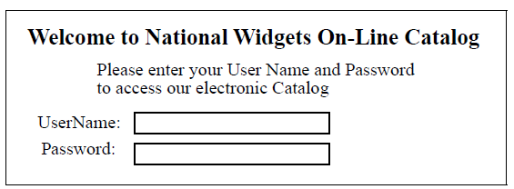

#### User name

* System shall provide user name module.
* This process allows the authorized users to enter their user name.

#### Enter password

* System shall provide enter password module.
* This process allows the authorized users to enter their password so, they can access the portal.

#### Login

* System shall provide login module.
* This process allows authorized users to access the portal.

#### Forgot password

* System shall provide forgot password module.
* This process allows the authorized users to obtain new password on forgetting the older one.

### Manage Orders Subsystem’s Place Order Screen

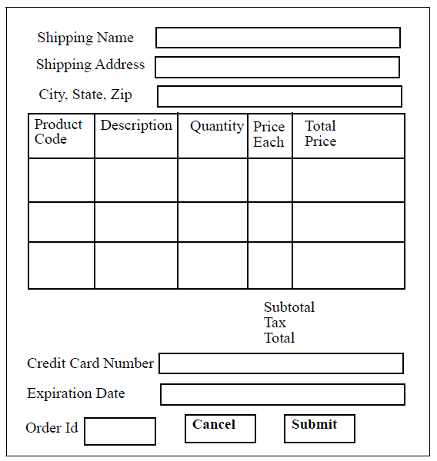

#### Shipping Name

* System shall provide Shipping name module.
* This process allows the authorized users to enter their Shipping name.

#### Shipping Address

* System shall provide Shipping Address module.
* This process allows the authorized users to enter their Shipping Address.

#### City, State and Zip

* System shall provide City, State and Zip code.
* This process allows the authorized users to enter their City, State and Zip code.

#### Product Information

* System shall provide Product Information module.
* This process will allow the authorized users to enter their product Information like product code, Description, Quantity, Price of each and Total price.

#### Credit card Number

* System shall provide Credit card Number module.
* This process will allow the authorized users to enter their credit card number.

#### Expiration Date

* System shall provide Expiration Date module.
* This process will allow the authorized users to enter their credit card expiration date.

#### Order Id

* System shall provide Order Id module.
* This process will allow the authorized users to enter their Order Id.

#### Cancel

* System shall provide Cancel module.
* This process will allow the authorized users to cancel their Order.

#### Submit

* System shall provide Submit module.
* This process will allow the authorized users to Submit their Order.

### Design and Implementation Constraints

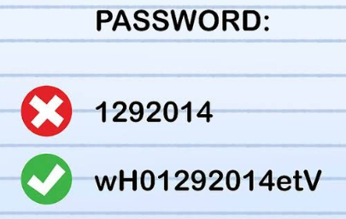

1. Password should consist of one uppercase alphabet, one lowercase alphabet and special character ($, *, _)
2. User name should be at least eight characters or long.
3. User name should be alphanumeric and do not contain any special characters.
4. Password should be at least eight characters.
5. From date should be selected from calendar.
6. Shipping name should be in upper case letters
7. Shipping Address should be alphanumeric and any special characters.
8. City, State and Zip should be alphanumeric.
9. Product Information should be alphanumeric.
10. Credit card Number should be numeric only.
11. Expiration Date should be selected from calendar.
12. Order ID should be numeric only.
13. Cancel may have direct link or mail ID (IT department).
14. Submit have direct link or mail ID (IT department).

## 2.3 Use Case

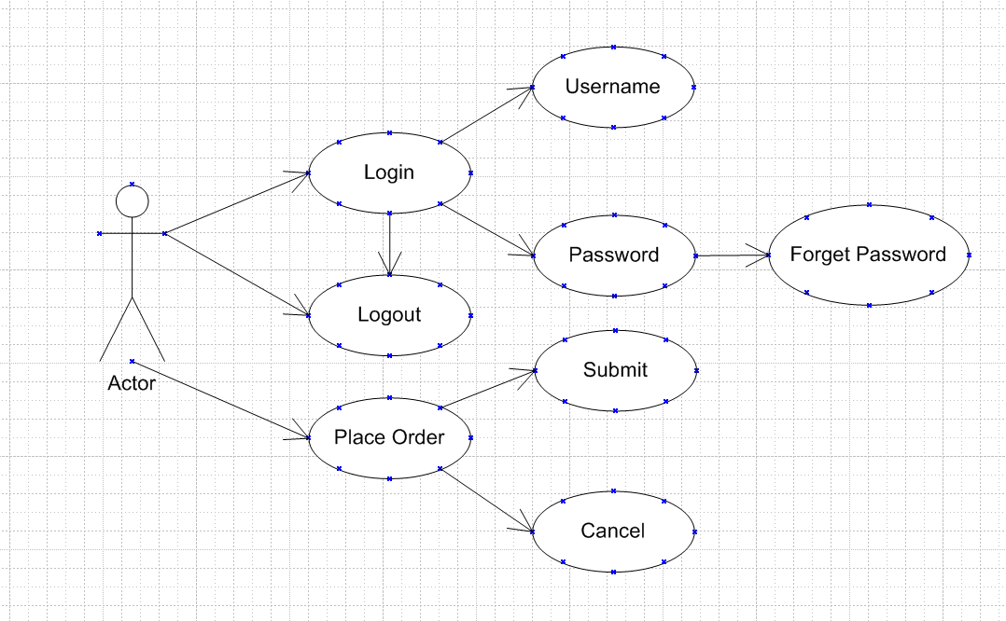

## Risks

* **Lack of intruder lockout:** This enables attackers to attempt to crack passwords using any number of automated tools or manual processes.
* **Descriptive error messages:** These error messages are displayed when incorrect application login credentials are entered.
* **Weak password requirements:** Some web applications still allow passwords such as 111111 and abc123. According to security studies that come out every year and we shall see that weak passwords are a top contributor to security incidents and breaches.
* **Password complexity:** In order to have secured credentials, user may forget their passwords by providing complex passwords.