Shipping Platform — Phase 1
Customer + Shipment Centric Data Model & AI Journey Summary Chat
A deliberately lean, limited-scope design — package, customs, pickup and delivery-appointment details are folded into the shipment record; drivers, vehicles, facilities, pricing and full AI governance are deferred to later phases.
Companion files: 01_phase1_schema.sql · 02_phase1_agentic_schema.json

Table of Contents
1. Phase 1 Scope & Rationale 3
2. Data Model 4
2.1 Entity Field Dictionary 5
3. Shipment Journey 8
4. AI Shipment Journey Summary Chat 9
5. Issue & Delay Taxonomy 11
6. Phase 2+ Roadmap (Deferred Scope) 11
7. Companion Deliverables 12

1. Phase 1 Scope & Rationale
Phase 1 deliberately limits the data model to two primary entities — customers (the organization/account holder) and shipments (the tracking-ID-centric shipment record) — plus the minimum supporting tables needed to power an AI 'Shipment Journey Summary' chat feature. This keeps the first release small, shippable, and directly focused on answering the two questions customers ask most: "where is my package" and "why is it late."

1.1 What Changed From the Full Design
Full-scope concept | Phase 1 treatment
Separate packages / package_items tables | Folded into shipments (package_type, package_desc, package_size, package_weight_kg) — order line-item detail is assumed to live in the external order system.
Separate customs_declarations table | Folded into shipments (is_international, customs_status). Full duty/incoterm/broker fields deferred.
Separate pickup_requests table | Folded into shipments (pickup_date, pickup_window_start/end).
Separate delivery_appointments table | Folded into shipments (delivery_window_start/end, failed_delivery_attempts, last_delivery_attempt_at).
drivers / vehicles / facilities / route_legs | Removed entirely for Phase 1 — no fleet or hub-routing operations UI in this release.
carriers / service_types / rate_cards / shipment_charges | Removed entirely — pricing engine and multi-carrier support are a later phase.
eligibility_checks / delivery_predictions / shipment_risk_scores / agent_action_log | Replaced by a single, focused shipment_chat_log audit table supporting the Phase 1 chat feature only.
shipment_exceptions (full RCA ledger) | Replaced by a lighter shipment_issues table — same purpose (delay/failure/RCA), fewer fields.
Net result: 28 tables in the full design collapse to 5 tables in Phase 1, all directly serving the two named entities and the chat feature.

2. Data Model
Five tables: customers and shipments as the two primary entities, plus tracking_events, shipment_issues, and shipment_chat_log as minimum support for the AI chat. tracking_id (not a UUID) is the shipment primary key since it is the stable, externally-visible identifier customers and the chat agent both key off of.
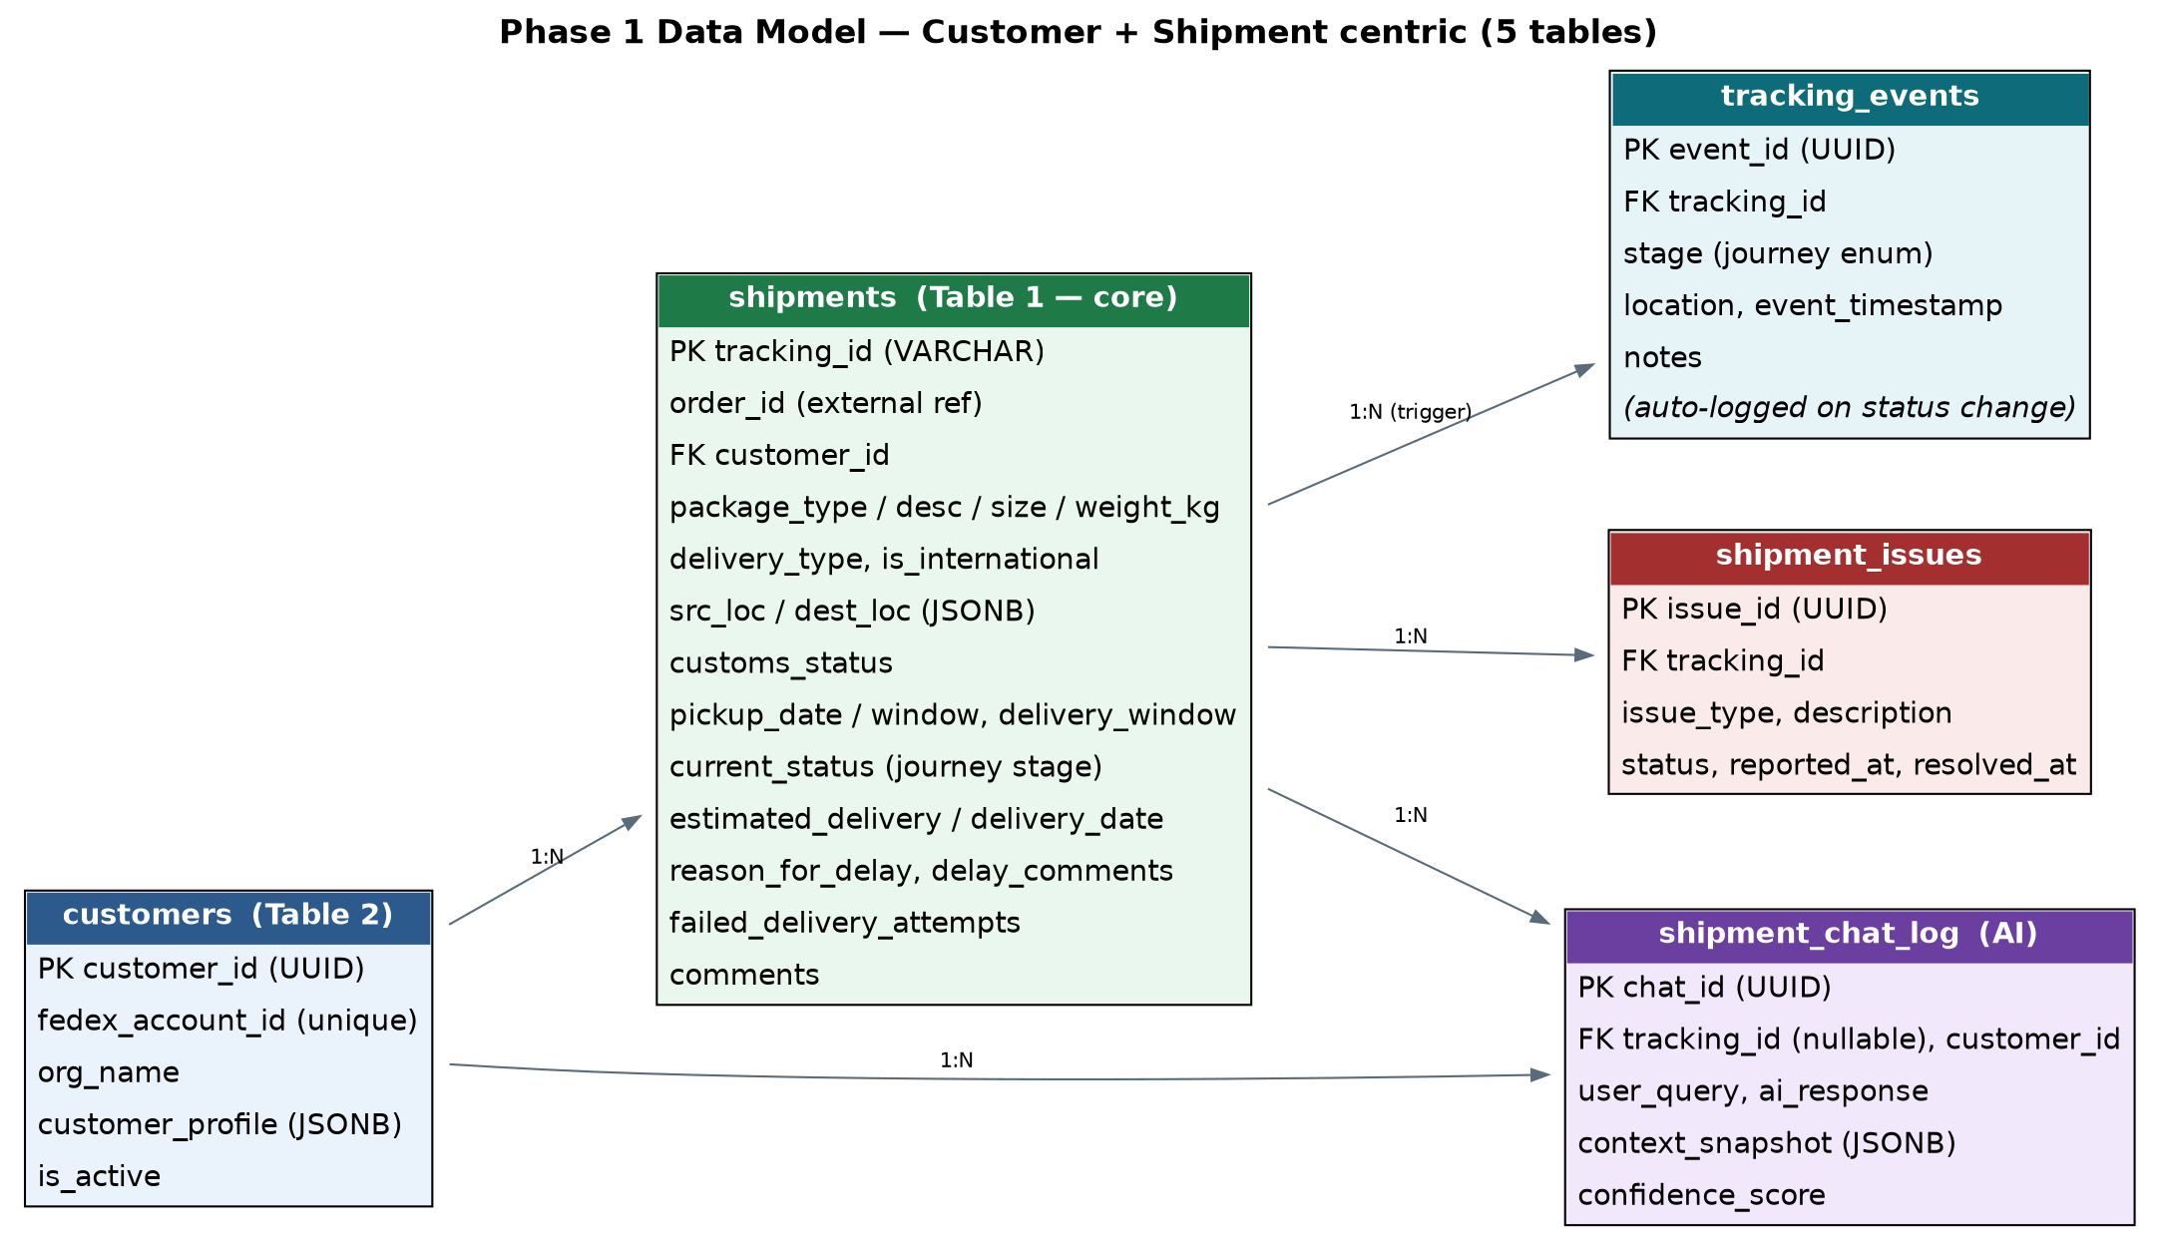
Figure 1 — Phase 1 entity-relationship diagram: customers (blue) and shipments (green) are the two primary entities; tracking_events (teal), shipment_issues (red), and shipment_chat_log (violet) are minimal AI-chat support tables.

2.1 Entity Field Dictionary

Customer (table: customers) — Table 2 (Phase 1 spec)
The organization/account holder. customer_profile is a flexible JSONB field so Phase 1 does not need a rigid, fully-normalized profile schema.
Field | Datatype | Notes / Allowed Values | Sample Value
customer_id | UUID | PK | 11111111-...-111111111111
fedex_account_id | VARCHAR(30) | Carrier billing/loyalty account #, unique | ACCT-88213
org_name | VARCHAR(200) | Organization display name | Acme Corp
customer_profile | JSONB | contact_name, email, phone, tier, etc. | {"tier":"GOLD", "email":"jane@acme.com"}
is_active | BOOLEAN | Account active flag | TRUE
created_at / updated_at | TIMESTAMPTZ | Auto-managed | 2025-01-10T09:00:00Z

Shipment (core entity) (table: shipments) — Table 1 (Phase 1 spec)
Tracking-ID-centric shipment record. Package, customs, pickup, and delivery-appointment details are folded directly into this table to minimize joins for the chat agent's context query.
Field | Datatype | Notes / Allowed Values | Sample Value
tracking_id | VARCHAR(40) | PK — public tracking number | 794658312457
order_id | VARCHAR(50) | External order-system reference (order mgmt out of scope) | ORD-2026-0000001
customer_id | UUID | FK to customers | 11111111-...
package_type | ENUM | BOX/ENVELOPE/TUBE/CRATE/PALLET/CUSTOM | BOX
package_desc | VARCHAR(255) | Human description | Wireless headphones
package_size | ENUM | SMALL/MEDIUM/LARGE/EXTRA_LARGE/PALLET_SIZED | SMALL
package_weight_kg | NUMERIC(10,3) | Nullable | 2.5
delivery_type | ENUM | STANDARD/EXPRESS/OVERNIGHT/ECONOMY/INTERNATIONAL_PRIORITY | INTERNATIONAL_PRIORITY
is_international | BOOLEAN | Drives customs sub-stages | TRUE
src_loc / dest_loc | JSONB | {address, city, country_code} | {"city":"San Francisco","country_code":"US"}
customs_status | ENUM | NOT_REQUIRED/PENDING/HELD/CLEARED/REJECTED | PENDING
pickup_date / pickup_window_start / end | DATE / TIME | Folded-in pickup scheduling | 2026-07-17 / 09:00 / 17:00
delivery_window_start / end | TIMESTAMPTZ | Folded-in delivery appointment window | nullable
current_status | ENUM | 13 happy-path + 4 terminal-failure states (Table below) | CUSTOMS_HOLD
estimated_delivery / delivery_date | TIMESTAMPTZ | ETA / actual (null until delivered) | 2026-07-19T18:00:00Z
reason_for_delay | ENUM | NONE/CUSTOMS/WEATHER/CIVIL_UNREST/LOST_PACKAGE/MECHANICAL_ISSUE/ADDRESS_ISSUE/OTHER | CUSTOMS
delay_comments | TEXT | Free-text explanation, nullable | Missing HS code; awaiting broker resubmission.
failed_delivery_attempts | SMALLINT | Attempt count | 0
last_delivery_attempt_at | TIMESTAMPTZ | Nullable | —
comments | TEXT | General free-text notes, nullable | —

Tracking Event (table: tracking_events)
Append-only journey log — one row per stage transition. Auto-logged by a database trigger whenever shipments.current_status changes; this is the primary context source for the AI chat.
Field | Datatype | Notes / Allowed Values | Sample Value
event_id | UUID | PK | 7a7a7a7a-...
tracking_id | VARCHAR(40) | FK to shipments | 794658312457
stage | ENUM | Same journey-stage enum as shipments.current_status | AT_CONNECTING_HUB
location | VARCHAR(200) | Nullable | Frankfurt Hub, DE
event_timestamp | TIMESTAMPTZ | When it occurred | 2026-07-18T04:00:00Z
notes | TEXT | Nullable | Auto-logged on status change

Shipment Issue (table: shipment_issues)
One row per delay/failed-delivery/RCA incident — the 'check existing issue details' requirement. Looked up by the AI chat agent and by ops before opening a duplicate.
Field | Datatype | Notes / Allowed Values | Sample Value
issue_id | UUID | PK | 9c9c9c9c-...
tracking_id | VARCHAR(40) | FK to shipments | 794658312457
issue_type | ENUM | CUSTOMS_HOLD/WEATHER_DELAY/CIVIL_UNREST/LOST_PACKAGE/FAILED_DELIVERY_ATTEMPT/ADDRESS_ISSUE/OTHER | CUSTOMS_HOLD
description | TEXT | What happened | Missing HS code on declaration; awaiting broker resubmission.
status | ENUM | OPEN/INVESTIGATING/RESOLVED/CLOSED | OPEN
reported_at / resolved_at | TIMESTAMPTZ | resolved_at nullable | 2026-07-18T04:05:00Z

Shipment Chat Log (AI) (table: shipment_chat_log)
Audit log of every AI chat interaction — question, grounded context used, generated answer, and confidence score — enabling QA review of the journey-summary chat feature.
Field | Datatype | Notes / Allowed Values | Sample Value
chat_id | UUID | PK | cdcd1111-...
tracking_id | VARCHAR(40) | FK, nullable for general queries | 794658312457
customer_id | UUID | FK, nullable | 11111111-...
user_query / ai_response | TEXT | The question and the generated answer | "Why is my package delayed?" / "Held at customs..."
context_snapshot | JSONB | Full grounded context from v_shipment_journey_summary | { "current_status": "CUSTOMS_HOLD", ... }
confidence_score | NUMERIC(5,4) | Nullable | 0.91
created_at | TIMESTAMPTZ | When the interaction occurred | 2026-07-18T09:15:00Z

3. Shipment Journey
shipments.current_status is the authoritative journey stage. Every change is auto-logged to tracking_events via a database trigger, so the AI chat always has a complete timeline to narrate — even if an external scan feed lags.
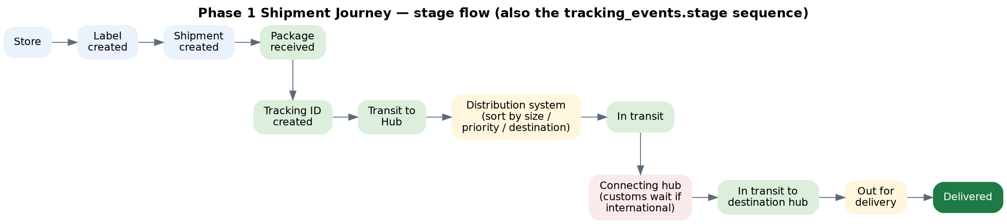
Figure 2 — Phase 1 shipment journey stage flow (also the tracking_events.stage sequence). CUSTOMS_HOLD / CUSTOMS_CLEARED apply only when is_international = true, as a sub-stage of the connecting hub.

3.1 Stage Reference
Stage | Meaning
LABEL_CREATED | Shipping label generated at store/origin
SHIPMENT_CREATED | Shipment record created in the system
PACKAGE_RECEIVED | Physical package received from customer
TRACKING_ID_ISSUED | Public tracking number issued
IN_TRANSIT_TO_ORIGIN_HUB | En route to the first sorting hub
AT_DISTRIBUTION_HUB | Sorted by size, priority, and destination
IN_TRANSIT | Line-haul between hubs
AT_CONNECTING_HUB | At an intermediate/connecting hub
CUSTOMS_HOLD | International only — held for customs review
CUSTOMS_CLEARED | International only — cleared, duties settled
IN_TRANSIT_TO_DESTINATION_HUB | En route to the final-mile hub
OUT_FOR_DELIVERY | Loaded on delivery vehicle
DELIVERED | Terminal success
DELIVERY_FAILED | Attempted, unsuccessful — may retry
RETURNED_TO_SENDER | Terminal failure — sent back
LOST | Terminal failure — untraceable
CANCELLED | Terminal — cancelled before delivery

4. AI Shipment Journey Summary Chat
The Phase 1 chat feature answers natural-language questions about a shipment using a single grounded context query — the v_shipment_journey_summary view — rather than a multi-agent pipeline. This keeps the first release simple, fast, and easy to audit.
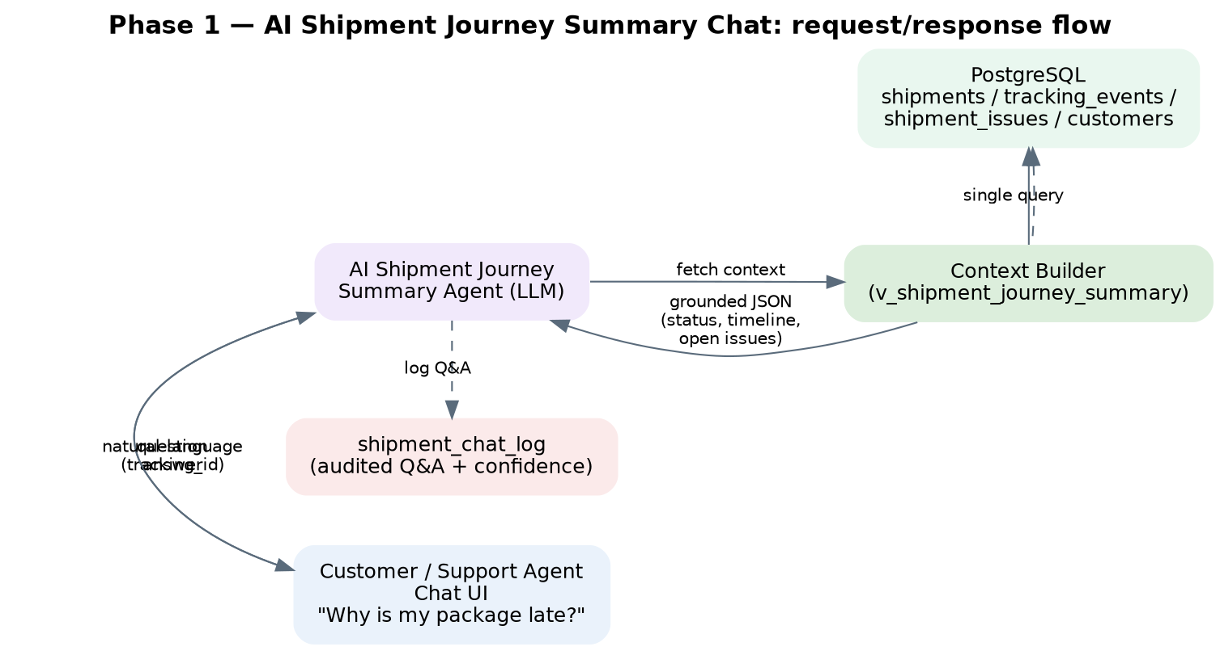
Figure 3 — AI Shipment Journey Summary chat: request/response flow.

4.1 How It Works
- The customer or support agent asks a question referencing a tracking_id (e.g., "Why is my package delayed?").
- The shipment-journey-summary-agent calls v_shipment_journey_summary once, receiving current status, customs status, ETA, delay reason, open issue count, and the full ordered journey timeline as a single JSON payload.
- The agent grounds its natural-language answer entirely in that payload — no free-floating claims.
- The question, the exact context used, the generated answer, and a confidence score are written to shipment_chat_log for QA review.
- Confidence below 0.75 should be flagged for human support review (a lightweight precursor to the fuller agent-governance layer planned for a later phase).

4.2 Worked Example
Field | Value
User query | "Why is my package delayed?"
tracking_id | 794658312457
Grounded context (from view) | current_status = CUSTOMS_HOLD; is_international = true; customs_status = PENDING; reason_for_delay = CUSTOMS; open_issue_count = 1; journey_timeline = 7 stages ending at AT_CONNECTING_HUB / CUSTOMS_HOLD
AI response | "Your package is currently held at customs in Frankfurt due to a missing HS code on the declaration. The broker has been notified and it should clear within 24 hours. Estimated delivery is now July 19, 6:00 PM local time, pending clearance."
Confidence score | 0.91

5. Issue & Delay Taxonomy
Both shipments.reason_for_delay and shipment_issues.issue_type share the same core categories, so the chat agent's explanation always matches what ops sees in the issue log.
Category | Example | Chat Answer Pattern
CUSTOMS | Missing HS code, under-declared value at an international border | "Held at customs in [location] due to [reason]; expected to clear by [time]."
WEATHER | Storm grounding flights/trucks at a hub | "Delayed by weather conditions affecting the [hub] hub; new ETA is [date]."
CIVIL_UNREST | Riots/civil disturbance blocking a route | "Delayed due to regional safety conditions along the route; monitoring for the next safe transit window."
LOST_PACKAGE | No scan for an extended period | "We're investigating a gap in tracking; a resolution/replacement update will follow within [SLA]."
FAILED_DELIVERY_ATTEMPT | Recipient not home, no safe location | "Delivery was attempted on [date] but unsuccessful; next attempt is scheduled for [date]."

6. Phase 2+ Roadmap (Deferred Scope)
Phase | Scope Addition | Why Deferred
2 | Split packages/package_items and customs_declarations into dedicated tables | Needed once multi-item customs valuation and HS-code-level reporting are required
2 | Dedicated pickup_requests / delivery_appointments tables with driver/vehicle assignment | Needed once fleet operations and route optimization are in scope
2 | carriers / service_types / rate_cards / shipment_charges (pricing engine) | Needed once the platform quotes and bills, not just tracks
3 | eligibility_checks (compliance automation), restricted_items, embargo lists | Needed before accepting live international shipments at scale
3 | delivery_predictions / shipment_risk_scores (ML ETA + proactive risk alerts) | Needed once historical journey data volume supports model training
3 | Full agent_action_log governance ledger across multiple specialized agents | Needed once more than one AI agent acts autonomously on the data

7. Companion Deliverables
File | Purpose
01_phase1_schema.sql | Full PostgreSQL 15+ DDL for the 5-table Phase 1 model — enums, triggers (auto journey-stage logging, updated_at), indexes, and the v_shipment_journey_summary view. Verified against a live PostgreSQL 16 instance, including a simulated end-to-end shipment journey.
02_phase1_agentic_schema.json | Machine-readable data dictionary for the 5 Phase 1 entities plus the context view: field-level detail, relationships, chat query-intent mapping, and one fully linked sample shipment (order → customs hold → chat Q&A) for agent grounding/testing.
This document | Phase 1 scope rationale, data model, shipment journey, AI chat design, issue taxonomy, and the Phase 2+ roadmap for everything intentionally deferred.

