**Stock Market Prediction Using Technical Indicators**

1. **Reasons for choosing HDFC as a stock for training:**

I chose HDFC Bank Stocks for my model training for several reasons. First, I selected 2016-2019 data to ensure robust training data and avoid major disruptions from the COVID-19 pandemic which started in 2020. This period gives our model a lot of historical data to learn from.

Secondly, HDFC Bank is significantly represented in the Nifty50 index, India's benchmark index of fifty of the country's leading stocks. As one of the largest constituents of the Nifty50 index, the performance of HDFC Bank significantly influences the movement of the index and reflects broader trends in the Indian equity market. Its weight in the market capitalization of the index underlines its importance, making it a strategic choice for model training.

In addition, HDFC Bank has high liquidity characterized by significant daily trading volumes. This liquidity ensures ease of buying and selling HDFC Bank shares, facilitating effective trading strategies and model testing. This is clearly explained by the graph below.

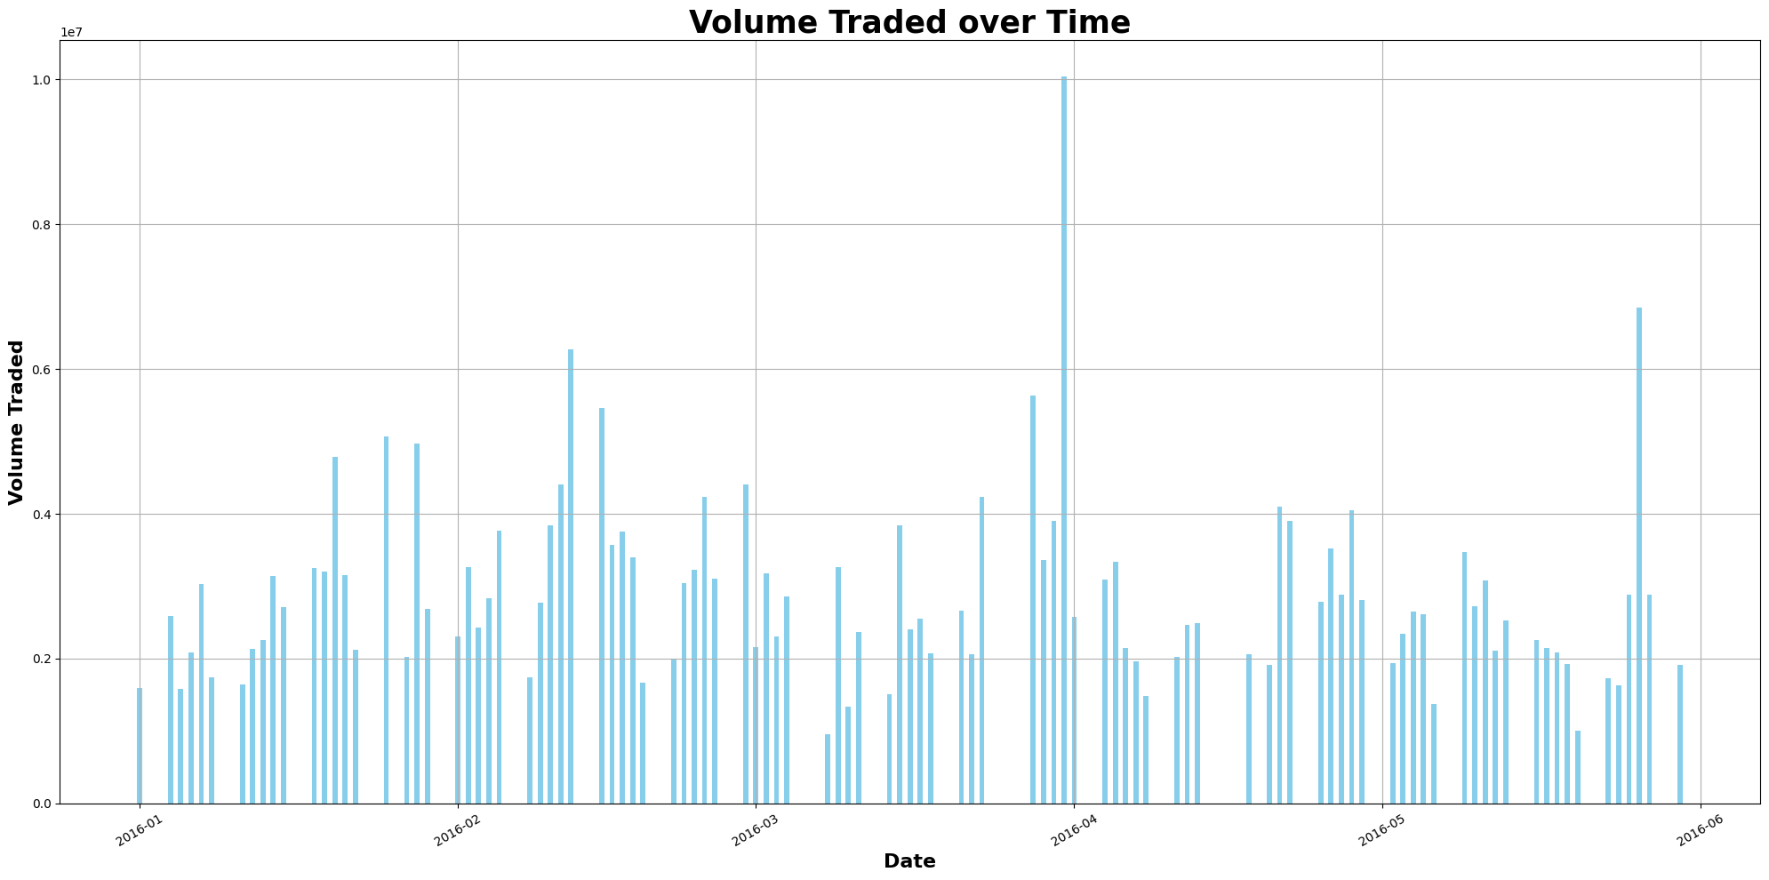

In addition, an analysis of HDFC Bank's historical share prices revealed a compelling balance between stability and volatility. Although stocks fluctuate over time, these fluctuations remain within reasonable limits, providing fertile ground for technical analysis and model development. This was made clear using the graph below (Histogram of daily Price changes).

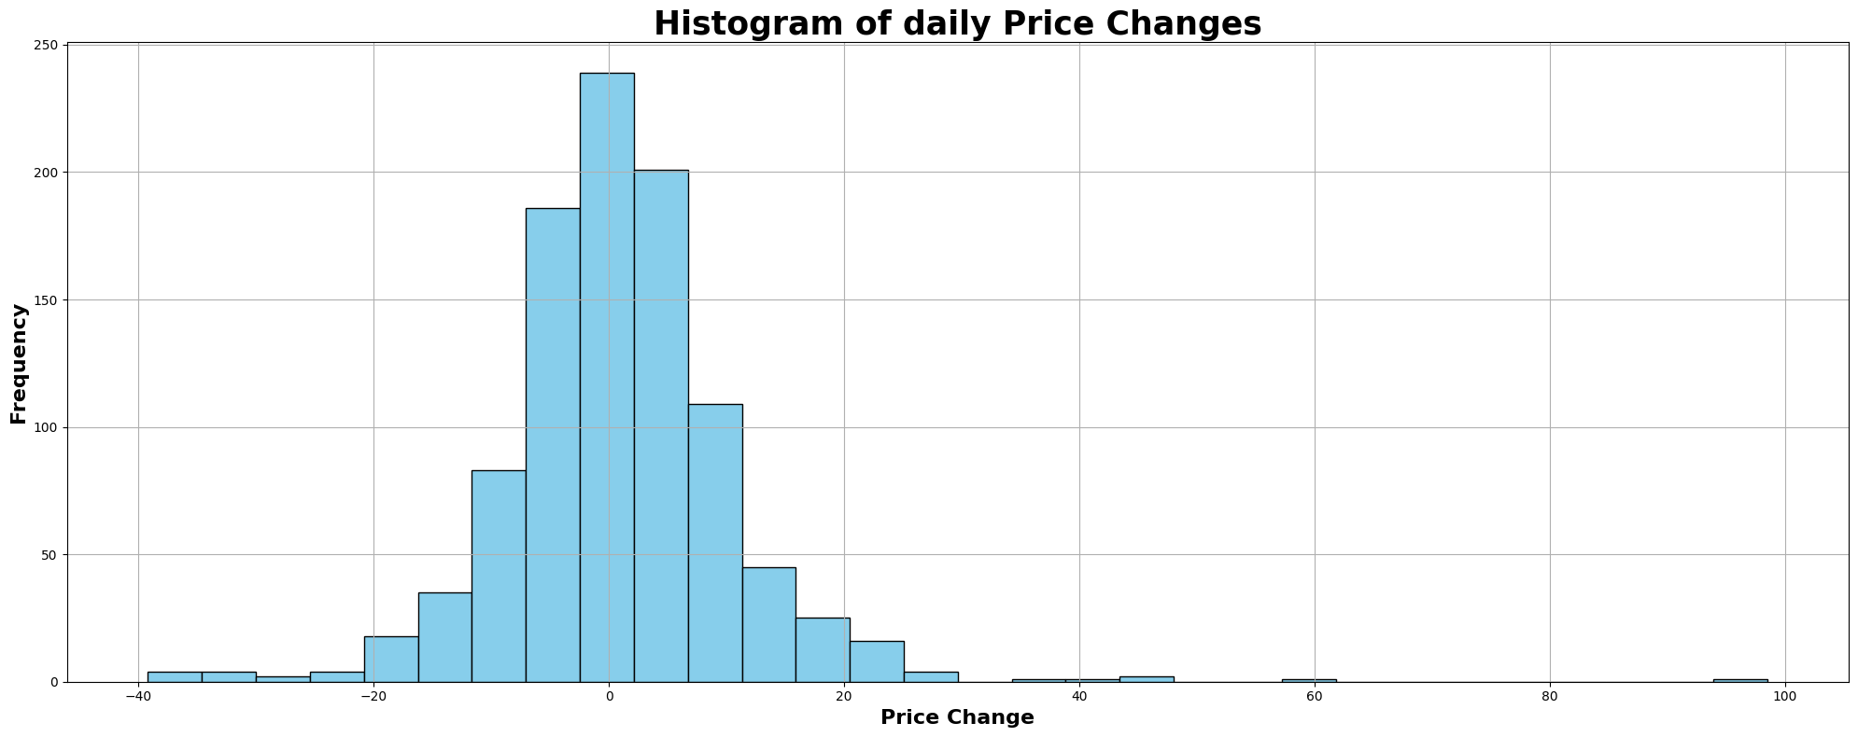

In addition, HDFC Bank's leading position in the Indian banking sector increases its attractiveness for model training. HDFC Bank has a strong reputation and a proven financial track record.

1. **How I labelled (predicted buy/sell/hold) my dataset:**

So the idea was to buy at a lower point of trending time, this was done by comparing the closing price of subsequent two days and if it is increasing I will buy at that point. For selling there are multiple conditions to be satisfied. First of all there is a condition to check if the stock has already been bought and if it is satisfied the next condition is to check 1. If the price has crossed a minimum price (which I will say how I calculated following this) from the buying price along with if there is a small reversion in trend (i.e, the price changes its direction from upper to lower trend) or the other condition is 2. To check if the stop loss has been breached. If one of these conditions is satisfied it is labelled as sell. The other else condition handles the holding part.

To find the minimum price for stop loss and minimum profit price I used a method from varsity module ([Volatility Applications](https://zerodha.com/varsity/chapter/volatility-applications/)). I have calculated the log of price differences of consecutive days (np.log (today’s closing price/previous day’s closing price)) and then I am finding the standard deviation of that line from the initial day till the current day (i.e, day 1 to the current day) this gives me the daily standard deviation now I am multiplying the square root of 7 with it (7 days).

1. **Features that I chose:**

* Moving Average Convergence Divergence (MACD) (Momentum Strength)
* Bollinger Bands (Volatility Indicator)
* Accumulation/ Distribution (A/D) (Volume based)
* Average Directional Index (ADX) (Trend Strength Indicator)
* Relative Strength Index (RSI) (Overbought/ Oversold)
* EMA Crossovers (Trend Indicator)

**Moving Average Convergence Divergence (MACD):** MACD is a powerful momentum indicator that helps identify changes in trend direction, momentum strength and potential entry/exit points. Its calculation involves the difference between two moving averages, for which I chose 7-day (fast) and 14-day (slow) exponential moving averages (EMA), and the signal line (9-day EMA). MACD crossovers and divergences provide valuable signals about trend reversals and momentum.

**Bollinger Bands:** Bollinger Bands consist of a simple moving average (SMA) surrounded by upper and lower bands (2*moving Standard Deviations) representing standard deviations. SMA. Bollinger Bands help identify overbought and oversold conditions, potential trend reversals and bursts of volatility, making them important for assessing price volatility and market sentiment. I have used a window size of 14 days.

**Accumulation/Distribution (A/D):** A/D is a volume-based indicator which measures the flow of money into or out of a security over a period of time. It considers both price and volume data to assess the strength of buying or selling pressure. A rising A/D line indicates accumulation (buying pressure), while a falling A/D line indicates distribution (selling pressure).

**Average Directional Index (ADX):** ADX quantifies the strength of a trend regardless of its direction by measuring the difference between a price rise and fall. A rising ADX indicates a strengthening trend, while a falling ADX indicates a weakening trend or consolidation. I have used a window size of 14 days for this too.

**Relative Strength Index (RSI):** RSI is an impulse oscillator that measures the speed and change of price movement, indicating overbought or oversold conditions in the market. RSI values ​​range from 0 to 100, with values ​​above 70 indicating overbought conditions and below 30 indicating oversold conditions. I have used a window size of 14 days for this too.

**EMA Crossovers:** Short-term crossovers associated with an exponential moving average crossover and long-term EMAs for which I used 7-day (fast) and 14-day (slow). Bullish crossovers occur when the short-term EMA crosses the long-term EMA, signalling bullish momentum and potential buying opportunities. Conversely, declines occur when the short-term EMA crosses the long-term EMA, indicating a bearish moment and potential selling opportunities.

At first I considered using OBV (Balance Volume) indicator instead of A/D indicator. However, upon closer analysis, I chose the A/D indicator over the OBV because I had a nuanced understanding of the principles behind them.

While the OBV attributes uptrends only to buyer activity, the A/D indicator offers more balanced perspective considering the interaction of buyers and sellers in influencing trend changes. Unlike OBV, which relies only on changes in volume to determine the strength of buying or selling pressure, the A/D indicator considers both price movement and volume. This nuanced approach provides a deeper understanding of market dynamics and trend behaviour.

The [video resource](https://www.youtube.com/watch?v=Thi9RW-VkKA) that explained the conceptual differences between OBV and A/D indicators was a key factor in my decision making process. This resource deepened my understanding of how each indicator interprets market action and highlighted the subtle but important differences that make the A/D indicator a primary choice in my analytical framework.

1. **Features that I constructed:**

Feature_1: I computed the two differences, closing prices and 30-day EMA and the difference between MACD line and the signal line. Finally, I multiplied both the difference. I got this idea by referring to this [video](https://www.youtube.com/watch?v=rf_EQvubKlk&t=305s). The usefulness of this feature lies in its ability to identify moments of convergence or divergence between price trends and momentum indicators.

Feature_2: I scaled down the RSI to the range [-1, 1] and now I multiplied the Volumes with it. RSI indicates the direction of price movement over a period of time, while volumes reflect the level of market participation or activity. Multiplying them together creates a composite metric that takes into account both overbought/oversold conditions and volume at the same time.

1. **Model Training and Results:**

I used TensorFlow to encode categorical data, such as converting categories to numeric values. To evaluate model performance, I relied on scikit-learn to calculate key metrics such as ROC-AUC score and F1 score. In addition, scikit-learn helped me standardize the dataset, ensuring that all data points were on the same scale for accurate analysis. I used softmax as activation function and categorical cross entropy as loss function after understanding the mathematics and logic behind it and coding it from scratch. After careful review, these collaborative efforts yielded encouraging results, as reflected in the final evaluation metrics.

