1. List the features of Java 8
-- Java 8 key features include:
- Lambda Expressions: Enable writing concise code for functional interfaces.
- Functional Interfaces: Interfaces with a single abstract method, designed to be target types for lambda expressions.
- Stream API: A powerful API for processing collections of objects in a declarative and efficient manner.
- Default Methods in Interfaces: Allow adding new methods to interfaces without breaking existing implementations.
- Static Methods in Interfaces: Allow defining static utility methods directly in interfaces.
- Optional Class: A container object used to contain not-null objects, helping to avoid NullPointerException.
- Date and Time API (Joda-Time Inspired): A new, immutable, and thread-safe date and time API (java.time package) to address the shortcomings of the old java.util.Date and java.util.Calendar classes.
- Method References: A shorthand for lambda expressions, used to refer to methods by name.
- Nashorn JavaScript Engine: A new JavaScript engine for Java applications.
- java.util.concurrent.CompletableFuture: Enhanced asynchronous programming.
- Annotations on Java Types: Annotations can now be applied to any use of a type, not just declarations.
2. What is a Lambda Expression, and why do we use them? Explain with a coding example and share the output screenshot.
-- A Lambda Expression is a new feature in Java 8 that provides a clear and concise way to represent one method interface using an expression. It's a shorthand for implementing functional interfaces.
Why do we use them?
- Concise Code: Reduces boilerplate code, making the code more readable and maintainable.
- Enables Functional Programming: Allows treating functions as method arguments or returning them from methods.
- Parallel Processing: Integrates well with the Stream API, enabling easier parallel processing of collections.
Syntax: (parameters) -> expression or (parameters) -> { statements; }
Code:
import java.util.ArrayList;
import java.util.Collections;
import java.util.Comparator;
import java.util.List;

public class LambdaExample {

public static void main(String[] args) {

List<String> names = new ArrayList<>();
names.add("Alice");
names.add("Bob");
names.add("Charlie");
names.add("David");

System.out.println("Original list: " + names);

Collections.sort(names, new Comparator<String>() {
@Override
public int compare(String s1, String s2) {
return s1.compareTo(s2);
}
});
System.out.println("Sorted using anonymous inner class: " + names);

names.clear();
names.add("Alice");
names.add("Bob");
names.add("Charlie");
names.add("David");
Collections.sort(names, (s1, s2) -> s1.compareTo(s2));
System.out.println("Sorted using lambda expression: " + names);
System.out.println("\nIterating with lambda:");
names.forEach(name -> System.out.println("Hello, " + name));
}
}
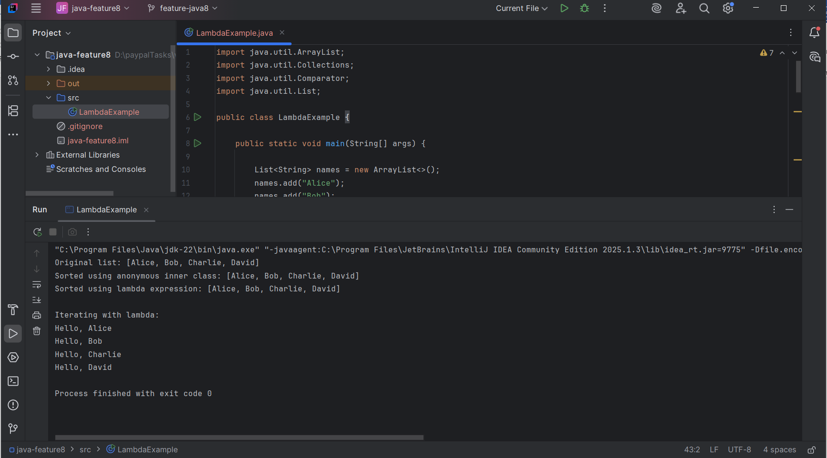
3. What is Optional, and what is it best used for? Explain with a coding example and share the output screenshot.
java.util.Optional is a container object introduced in Java 8 used to contain non-null objects. It's designed to represent the presence or absence of a value, thereby helping to avoid NullPointerException errors, which are a common source of bugs in Java applications.
What is it best used for?
- Avoiding NullPointerExceptions: By providing methods to explicitly handle the absence of a value, it makes the code safer and more readable.
- Cleaner APIs: Methods that might not return a value can return an Optional instead of null, clearly signaling to the caller that the return value might be absent.
- Functional Style: Works well with Stream API and lambda expressions for more expressive code.
Coding Example:
import java.util.Optional;

public class OptionalExample {

public static Optional<String> getName(boolean retrieveName) {
if (retrieveName) {
return Optional.of("John Doe"); // Value is present
} else {
return Optional.empty(); // Value is absent
}
}

public static void main(String[] args) {

Optional<String> name1 = getName(true);
if (name1.isPresent()) {
System.out.println("Name (ifPresent): " + name1.get());
}

String displayName1 = name1.orElse("Guest");
System.out.println("Name (orElse): " + displayName1);
name1.ifPresent(name -> System.out.println("Name (ifPresent with lambda): " + name));

System.out.println("-------------------------");
Optional<String> name2 = getName(false);
if (name2.isPresent()) { // This block will not execute
System.out.println("Name (ifPresent): " + name2.get());
} else {
System.out.println("Name is not available.");
}
String displayName2 = name2.orElse("Anonymous");
System.out.println("Name (orElse): " + displayName2);

try {
name2.orElseThrow(() -> new IllegalArgumentException("Name not found!"));
} catch (IllegalArgumentException e) {
System.out.println("Caught exception: " + e.getMessage());
}
}
}
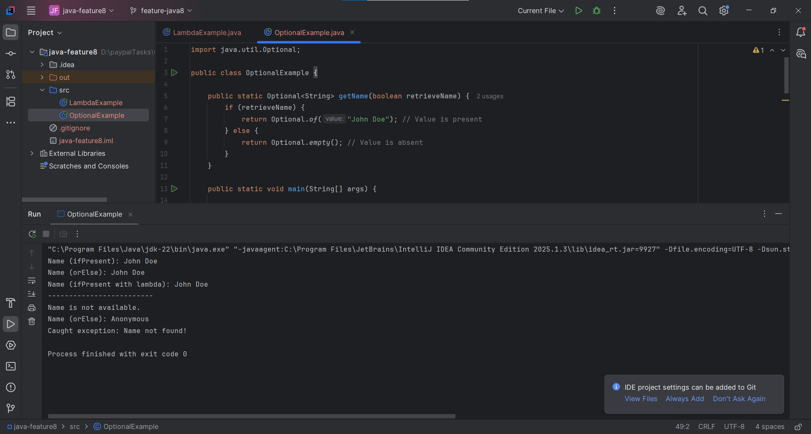
4. What is a functional interface? List some examples of predefined functional interfaces.
A Functional Interface is an interface that contains exactly one abstract method. They are also known as Single Abstract Method (SAM) interfaces. They are crucial for lambda expressions because a lambda expression provides the implementation for the single abstract method of a functional interface.
Functional interfaces can have any number of default or static methods. The @FunctionalInterface annotation is optional but recommended. It helps the compiler enforce the "single abstract method" rule.
Examples of Predefined Functional Interfaces :
- Predicate<T>: Represents a predicate (boolean-valued function) of one argument.
  - Abstract method: boolean test(T t)
  - Use case: Filtering
- Function<T, R>: Represents a function that accepts one argument and produces a result.
  - Abstract method: R apply(T t)
  - Use case: Transforming data (e.g., mapping).
- UnaryOperator<T>: Represents an operation on a single operand that produces a result of the same type as its operand. (Extends Function<T, T>)
  - Abstract method: T apply(T t)
  - Use case: Transformation where input and output types are the same.
- Comparator<T>: (From java.util) Represents a comparison function, which imposes a total ordering on some collection of objects.
  - Abstract method: int compare(T o1, T o2)
  - Use case: Sorting.
Here's a detailed explanation of the Java 8 features and concepts, followed by information on Maven, Spring, and Spring Boot. Please remember that I cannot execute code, create GitHub branches, or take screenshots directly. You will need to perform those actions on your end and include the screenshots and GitHub links in your assignment document.

Java 8 Features
NOTE: Please install Azul Zulu OpenJDK 8 before proceeding with the coding examples.
1. List the features of Java 8
Java 8 introduced several significant features that revolutionized how Java developers write code, especially concerning concurrency and functional programming. Key features include:
- Lambda Expressions: Enable writing concise code for functional interfaces.
- Functional Interfaces: Interfaces with a single abstract method, designed to be target types for lambda expressions.
- Stream API: A powerful API for processing collections of objects in a declarative and efficient manner.
- Default Methods in Interfaces: Allow adding new methods to interfaces without breaking existing implementations.
- Static Methods in Interfaces: Allow defining static utility methods directly in interfaces.
- Optional Class: A container object used to contain not-null objects, helping to avoid NullPointerException.
- Date and Time API (Joda-Time Inspired): A new, immutable, and thread-safe date and time API (java.time package) to address the shortcomings of the old java.util.Date and java.util.Calendar classes.
- Method References: A shorthand for lambda expressions, used to refer to methods by name.
- Nashorn JavaScript Engine: A new JavaScript engine for Java applications.
- java.util.concurrent.CompletableFuture: Enhanced asynchronous programming.
- Annotations on Java Types: Annotations can now be applied to any use of a type, not just declarations.
2. What is a Lambda Expression, and why do we use them? Explain with a coding example and share the output screenshot.
A Lambda Expression is a new feature in Java 8 that provides a clear and concise way to represent one method interface using an expression. It's a shorthand for implementing functional interfaces.
Why do we use them?
- Concise Code: Reduces boilerplate code, making the code more readable and maintainable.
- Enables Functional Programming: Allows treating functions as method arguments or returning them from methods.
- Parallel Processing: Integrates well with the Stream API, enabling easier parallel processing of collections.
Syntax: (parameters) -> expression or (parameters) -> { statements; }
Coding Example:
Java
import java.util.ArrayList;
import java.util.Collections;
import java.util.Comparator;
import java.util.List;

public class LambdaExample {

public static void main(String[] args) {

List<String> names = new ArrayList<>();
names.add("Alice");
names.add("Bob");
names.add("Charlie");
names.add("David");

System.out.println("Original list: " + names);

// --- Before Java 8 (Anonymous Inner Class) ---
Collections.sort(names, new Comparator<String>() {
@Override
public int compare(String s1, String s2) {
return s1.compareTo(s2);
}
});
System.out.println("Sorted using anonymous inner class: " + names);

// Reset list for lambda example
names.clear();
names.add("Alice");
names.add("Bob");
names.add("Charlie");
names.add("David");

// --- With Java 8 (Lambda Expression) ---
// Sorting the list using a lambda expression
Collections.sort(names, (s1, s2) -> s1.compareTo(s2));
System.out.println("Sorted using lambda expression: " + names);

// Another example: Iterating over a list
System.out.println("\nIterating with lambda:");
names.forEach(name -> System.out.println("Hello, " + name));
}
}
Explanation: In the example, we demonstrate sorting a List of strings.
- Before Java 8: We had to use an anonymous inner class to implement the Comparator interface, which is verbose.
- With Java 8: The lambda expression (s1, s2) -> s1.compareTo(s2) achieves the same functionality much more concisely. It directly implements the compare method of the Comparator functional interface. The forEach loop also shows how lambdas simplify iteration.
Output Screenshot: (You will need to run this code in your IDE and capture the console output for your assignment document.)
Original list: [Alice, Bob, Charlie, David]
Sorted using anonymous inner class: [Alice, Bob, Charlie, David]
Sorted using lambda expression: [Alice, Bob, Charlie, David]

Iterating with lambda:
Hello, Alice
Hello, Bob
Hello, Charlie
Hello, David
3. What is Optional, and what is it best used for? Explain with a coding example and share the output screenshot.
java.util.Optional is a container object introduced in Java 8 used to contain non-null objects. It's designed to represent the presence or absence of a value, thereby helping to avoid NullPointerException errors, which are a common source of bugs in Java applications.
What is it best used for?
- Avoiding NullPointerExceptions: By providing methods to explicitly handle the absence of a value, it makes the code safer and more readable.
- Cleaner APIs: Methods that might not return a value can return an Optional instead of null, clearly signaling to the caller that the return value might be absent.
- Functional Style: Works well with Stream API and lambda expressions for more expressive code.
Coding Example:
Java
import java.util.Optional;

public class OptionalExample {

public static Optional<String> getName(boolean retrieveName) {
if (retrieveName) {
return Optional.of("John Doe"); // Value is present
} else {
return Optional.empty(); // Value is absent
}
}

public static void main(String[] args) {

// Case 1: Optional contains a value
Optional<String> name1 = getName(true);
if (name1.isPresent()) {
System.out.println("Name (ifPresent): " + name1.get());
}

// Using orElse() to provide a default value if absent
String displayName1 = name1.orElse("Guest");
System.out.println("Name (orElse): " + displayName1);

// Using ifPresent() with a Consumer lambda
name1.ifPresent(name -> System.out.println("Name (ifPresent with lambda): " + name));

System.out.println("-------------------------");

// Case 2: Optional is empty
Optional<String> name2 = getName(false);
if (name2.isPresent()) { // This block will not execute
System.out.println("Name (ifPresent): " + name2.get());
} else {
System.out.println("Name is not available.");
}

// Using orElse() for a default value when absent
String displayName2 = name2.orElse("Anonymous");
System.out.println("Name (orElse): " + displayName2);

// Using orElseThrow() to throw an exception if absent
try {
name2.orElseThrow(() -> new IllegalArgumentException("Name not found!"));
} catch (IllegalArgumentException e) {
System.out.println("Caught exception: " + e.getMessage());
}
}
}
Explanation: The getName method returns an Optional<String>.
- When retrieveName is true, it returns Optional.of("John Doe"), indicating a value is present.
- When retrieveName is false, it returns Optional.empty(), indicating no value.
In main:
- isPresent(): Checks if a value is present.
- get(): Retrieves the value (use only after isPresent() is true, otherwise it throws NoSuchElementException).
- orElse(defaultValue): Returns the value if present, otherwise returns the defaultValue.
- ifPresent(Consumer): Executes the Consumer if a value is present.
- orElseThrow(Supplier<Throwable>): Throws an exception if no value is present.
Output Screenshot: (You will need to run this code in your IDE and capture the console output for your assignment document.)
Name (ifPresent): John Doe
Name (orElse): John Doe
Name (ifPresent with lambda): John Doe
-------------------------
Name is not available.
Name (orElse): Anonymous
Caught exception: Name not found!
4. What is a functional interface? List some examples of predefined functional interfaces.
A Functional Interface is an interface that contains exactly one abstract method. They are also known as Single Abstract Method (SAM) interfaces. They are crucial for lambda expressions because a lambda expression provides the implementation for the single abstract method of a functional interface.
Functional interfaces can have any number of default or static methods. The @FunctionalInterface annotation is optional but recommended. It helps the compiler enforce the "single abstract method" rule.
Examples of Predefined Functional Interfaces (from java.util.function package):
- Predicate<T>: Represents a predicate (boolean-valued function) of one argument.
  - Abstract method: boolean test(T t)
  - Use case: Filtering
- Consumer<T>: Represents an operation that accepts a single input argument and returns no result.
  - Abstract method: void accept(T t)
  - Use case: Performing an action on each element of a collection (e.g., forEach).
- Function<T, R>: Represents a function that accepts one argument and produces a result.
  - Abstract method: R apply(T t)
  - Use case: Transforming data (e.g., mapping).
- Supplier<T>: Represents a supplier of results.
  - Abstract method: T get()
  - Use case: Lazily generating values.
- UnaryOperator<T>: Represents an operation on a single operand that produces a result of the same type as its operand. (Extends Function<T, T>)
  - Abstract method: T apply(T t)
  - Use case: Transformation where input and output types are the same.
- BinaryOperator<T>: Represents an operation upon two operands of the same type, producing a result of the same type as the operands. (Extends BiFunction<T, T, T>)
  - Abstract method: T apply(T t1, T t2)
  - Use case: Reduction operations like summing or finding max/min.
- Runnable: (From java.lang) Represents a command that can be executed.
  - Abstract method: void run()
  - Use case: Thread execution.
- Comparator<T>: (From java.util) Represents a comparison function, which imposes a total ordering on some collection of objects.
  - Abstract method: int compare(T o1, T o2)
  - Use case: Sorting.
5. How are functional interfaces and Lambda Expressions related?
Functional interfaces and Lambda Expressions are intrinsically linked; they are two sides of the same coin:
- Functional Interfaces are the "target type" for Lambda Expressions: A lambda expression doesn't have its own type. Its type is inferred from the context in which it's used. This context must be a functional interface. The lambda expression provides the concrete implementation for the single abstract method defined in that functional interface.
- Lambda Expressions are the "implementation" of Functional Interfaces: Instead of writing an anonymous inner class to implement a functional interface, you can use a more compact lambda expression. The compiler understands that the lambda's parameters match the abstract method's parameters, and its body implements that method.
Example:
// Functional Interface (already defined by Java)
// @FunctionalInterface
// public interface Consumer<T> {
// void accept(T t);
// }

import java.util.Arrays;
import java.util.List;
import java.util.function.Consumer;

public class LambdaFunctionalInterfaceRelation {

public static void main(String[] args) {
List<Integer> numbers = Arrays.asList(1, 2, 3, 4, 5);

// Using an anonymous inner class to implement Consumer
Consumer<Integer> printConsumer = new Consumer<Integer>() {
@Override
public void accept(Integer num) {
System.out.println("Traditional print: " + num);
}
};
numbers.forEach(printConsumer);

System.out.println("---");

Consumer<Integer> lambdaPrintConsumer = num -> System.out.println("Lambda print: " + num);
numbers.forEach(lambdaPrintConsumer);

System.out.println("---");
numbers.forEach(num -> System.out.println("Direct lambda print: " + num));
}
}
6. List some Java 8 Date and Time API’s. How will you get the current date and time using Java 8 Date and Time API? Write the implementation and share the output screenshot.
Java 8 introduced a completely new Date and Time API in the java.time package, inspired by the Joda-Time library. It addresses many shortcomings of the old java.util.Date and java.util.Calendar classes, such as mutability, thread-safety, and poor API design.
Key Classes in java.time:
- LocalDate: Represents a date (year, month, day) without time or time-zone. (e.g., 2023-10-26)
- LocalTime: Represents a time (hour, minute, second, nanosecond) without date or time-zone. (e.g., 10:30:00)
- LocalDateTime: Represents both a date and a time without time-zone. (e.g., 2023-10-26T10:30:00)
- ZonedDateTime: Represents a date and time with a time-zone.
- Instant: Represents a specific moment on the timeline in UTC.
- Duration: Represents a quantity of time in terms of seconds and nanoseconds.
- Period: Represents a quantity of time in terms of years, months, and days.
- DateTimeFormatter: For formatting and parsing date-time objects.
- ZoneId: Represents a time-zone ID.
- ZoneOffset: Represents a time-zone offset from Greenwich/UTC.
How to get the current date and time using Java 8 Date and Time API:
You use the now() static method available in LocalDate, LocalTime, LocalDateTime, and ZonedDateTime.
Implementation:
import java.time.LocalDate;
import java.time.LocalTime;
import java.time.LocalDateTime;
import java.time.ZonedDateTime;
import java.time.ZoneId;

public class DateTimeAPIExample {

public static void main(String[] args) {
// Get current local date
LocalDate currentDate = LocalDate.now();
System.out.println("Current Date: " + currentDate);

// Get current local time
LocalTime currentTime = LocalTime.now();
System.out.println("Current Time: " + currentTime);

// Get current local date and time
LocalDateTime currentDateTime = LocalDateTime.now();
System.out.println("Current Date and Time: " + currentDateTime);

// Get current date and time with a specific time-zone
ZoneId newYorkZone = ZoneId.of("America/New_York");
ZonedDateTime currentDateTimeInNewYork = ZonedDateTime.now(newYorkZone);
System.out.println("Current Date and Time in New York: " + currentDateTimeInNewYork);

// Get current date and time in the default system time-zone
ZonedDateTime currentDateTimeWithZone = ZonedDateTime.now();
System.out.println("Current Date and Time (with default zone): " + currentDateTimeWithZone);
}
}
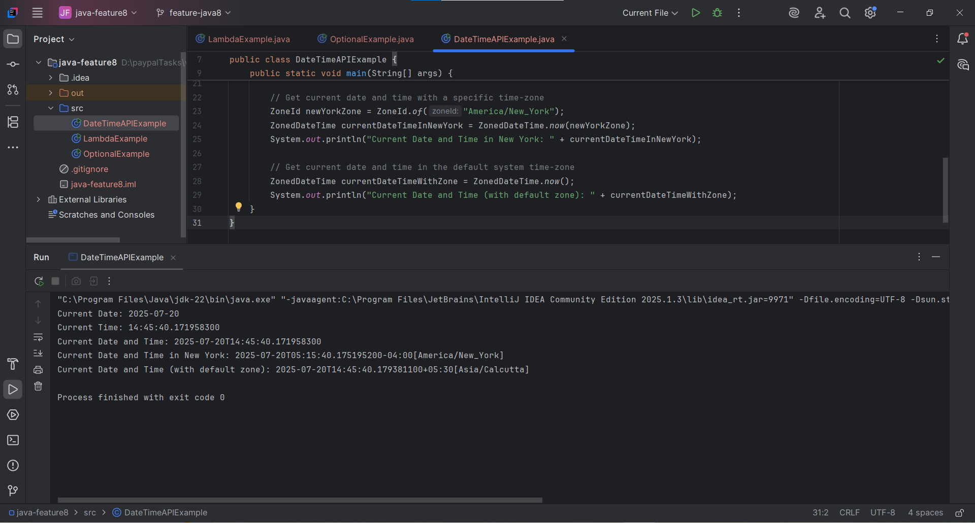
7. How to use map to convert objects into Uppercase in Java 8? Write the implementation and share the output screenshot.
In Java 8, the Stream API's map operation is used for transforming elements within a stream. To convert strings (objects) to uppercase, you can use map with the String::toUpperCase method reference or a lambda expression.
Implementation:
import java.util.Arrays;
import java.util.List;
import java.util.stream.Collectors;

public class MapToUppercaseExample {

public static void main(String[] args) {
List<String> words = Arrays.asList("apple", "banana", "cherry", "date");
System.out.println("Original list: " + words);

// Using map with a lambda expression
List<String> upperCaseWordsLambda = words.stream()
.map(s -> s.toUpperCase())
.collect(Collectors.toList());
System.out.println("Uppercase (Lambda): " + upperCaseWordsLambda);

// Using map with a method reference (more concise for this specific case)
List<String> upperCaseWordsMethodRef = words.stream()
.map(String::toUpperCase)
.collect(Collectors.toList());
System.out.println("Uppercase (Method Reference): " + upperCaseWordsMethodRef);

// Example with a custom object (assuming it has a getName() method and we want to uppercase names)
List<Person> people = Arrays.asList(
new Person("alice"),
new Person("bob"),
new Person("charlie")
);
System.out.println("\nOriginal Person names:");
people.forEach(p -> System.out.println(p.getName()));

List<String> upperCasePersonNames = people.stream()
.map(person -> person.getName().toUpperCase())
.collect(Collectors.toList());
System.out.println("Uppercase Person names: " + upperCasePersonNames);

}
}

class Person {
private String name;

public Person(String name) {
this.name = name;
}

public String getName() {
return name;
}

public void setName(String name) {
this.name = name;
}

@Override
public String toString() {
return "Person{" +
"name='" + name + '\'' +
'}';
}
}
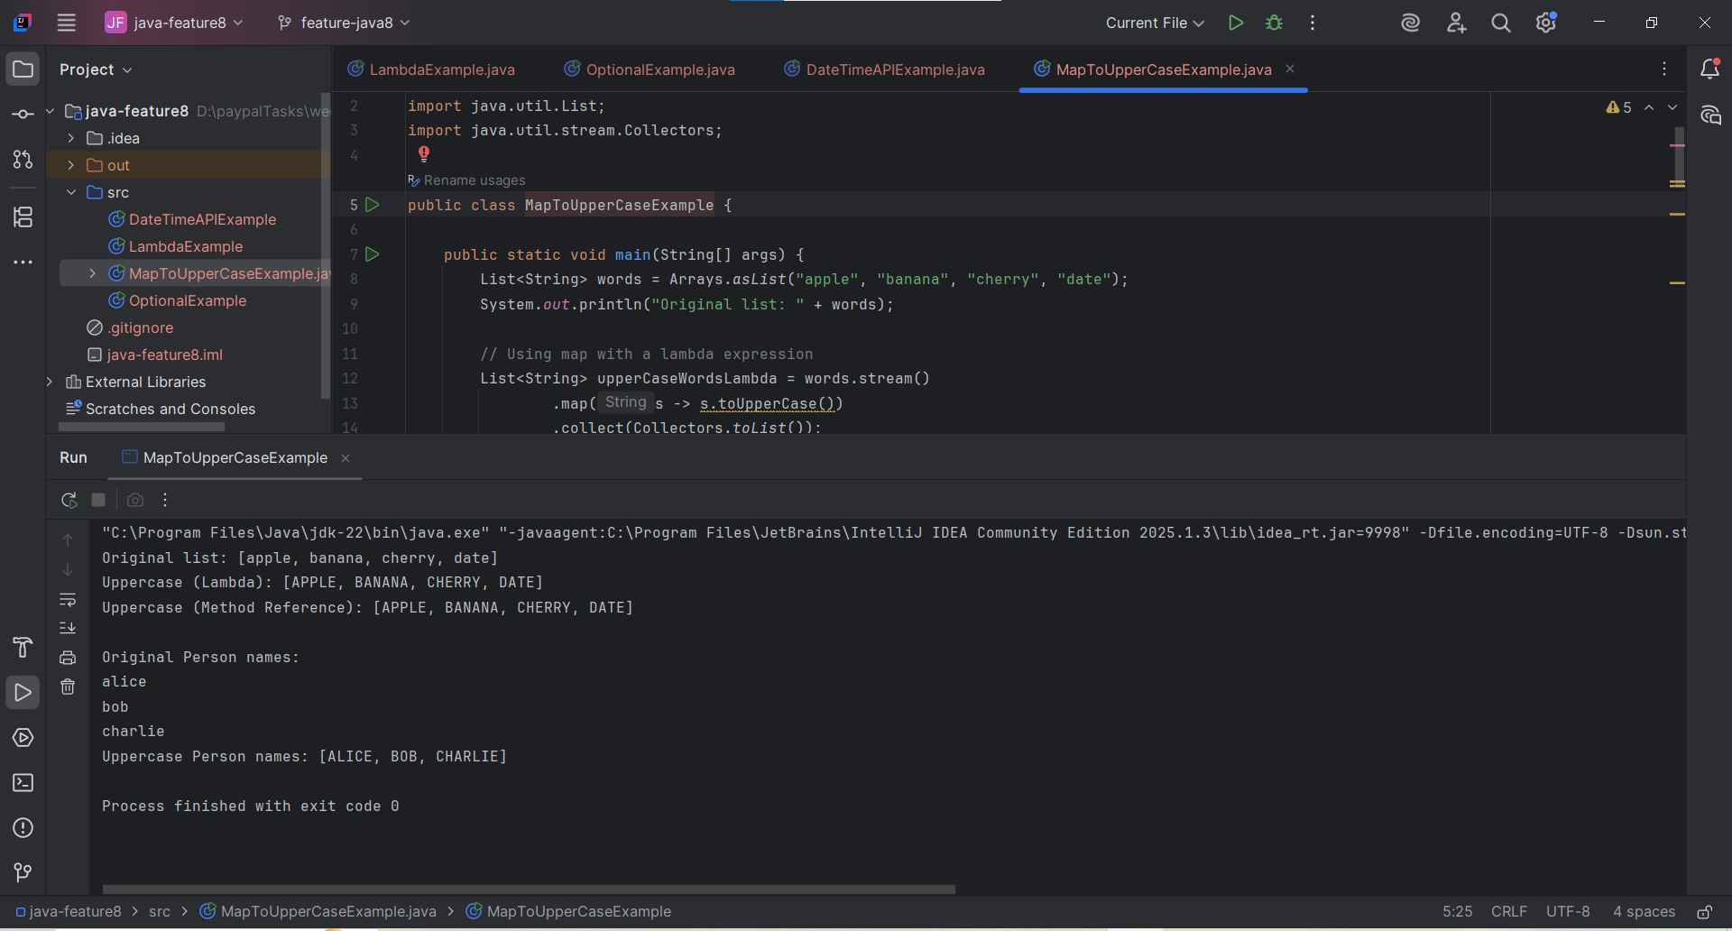
8. Explain how Java 8 has enhanced interface functionality with default and static methods. Why were these features introduced, explain with a coding example?
Before Java 8, interfaces could only have abstract methods (and constants). This rigid structure posed a significant problem: if a new method needed to be added to an existing interface, all classes implementing that interface would break, as they would need to provide an implementation for the new method. This was a major issue for backward compatibility, especially for widely used interfaces in the Java Development Kit (JDK) itself (e.g., List, Collection).
Java 8 addressed this by introducing Default and Static methods in interfaces.
Default Methods:
- Definition: Methods in an interface that have a default implementation. They are declared using the default keyword.
- Purpose: To allow adding new methods to interfaces without breaking existing implementing classes. Implementing classes can optionally override the default implementation. This is crucial for backward compatibility.
- Use Case: Enhancing existing interfaces (like adding forEach to Iterable in Java 8) without forcing all existing implementations to change.
Static Methods:
- Definition: Methods that belong to the interface itself, not to any specific implementation of the interface. They are declared using the static keyword.
- Purpose: To provide utility methods related to the interface that don't depend on the state of an implementing object. They are conceptually similar to static methods in classes.
- Use Case: Creating helper methods that can be called directly on the interface, without needing an object instance. For example, Comparator.comparing() for creating comparators.
Why were these features introduced? The primary motivation was backward compatibility and to allow for the evolution of interfaces. Without these, adding new features to core JDK interfaces would have caused immense disruption. They also promote cleaner code by allowing related utility methods to reside directly within the interface definition, rather than in separate utility classes.
Coding Example:
// Interface with Default and Static Methods
interface MyCalculator {
// Abstract method (must be implemented by concrete classes)
double calculate(int a, int b);

// Default method (provides a default implementation, can be overridden)
default void printResult(double result) {
System.out.println("Calculated Result: " + result);
}

// Static method (belongs to the interface itself, cannot be overridden)
static String getCalculatorInfo() {
return "This is a basic calculator interface supporting various operations.";
}
}

// Class implementing the interface
class Adder implements MyCalculator {
@Override
public double calculate(int a, int b) {
return a + b; // Implements the abstract method
}
}

// Another class that might override the default method
class Multiplier implements MyCalculator {
@Override
public double calculate(int a, int b) {
return a * b;
}

// Overriding the default method
@Override
public void printResult(double result) {
System.out.println("Multiplication Result: " + result + " (from Multiplier)");
}
}

public class InterfaceEnhancementsExample {
public static void main(String[] args) {
// Using Adder
Adder adder = new Adder();
double sum = adder.calculate(10, 5);
adder.printResult(sum); // Uses the default implementation

System.out.println("---");

// Using Multiplier
Multiplier multiplier = new Multiplier();
double product = multiplier.calculate(10, 5);
multiplier.printResult(product); // Uses the overridden implementation

System.out.println("---");

// Calling the static method directly on the interface
System.out.println(MyCalculator.getCalculatorInfo());
}
}
9. Discuss the significance of the Stream API introduced in Java 8 for data processing. How does it improve application performance and developer productivity?
The Stream API (java.util.stream) is a powerful new abstraction introduced in Java 8 for processing sequences of elements (collections, arrays, I/O channels, etc.) in a functional and declarative style. It's not a data structure itself but a way to process data from various sources.
Significance for Data Processing:
- Functional Programming Paradigm: It allows developers to write code that describes what they want to achieve (e.g., filter, map, reduce) rather than how to achieve it (e.g., explicit loops, if conditions). This leads to more readable and less error-prone code.
- Declarative Style: Operations like filter(), map(), sorted(), reduce() are chained together, forming a pipeline of operations. This makes the data processing logic very clear and expressive.
- Laziness and Optimization: Streams are inherently lazy. Intermediate operations (like filter, map) are not executed until a terminal operation (like forEach, collect, reduce) is invoked. This allows for optimizations, such as "short-circuiting" (e.g., finding the first element that matches a condition without processing the entire stream).
- Internal Iteration: Unlike external iteration (e.g., for-each loop) where the developer explicitly controls the iteration, streams use internal iteration. This gives the Stream API the flexibility to optimize the iteration, including parallel processing.
- Immutability: Stream operations produce new streams or new results; they do not modify the original data source. This makes stream pipelines inherently thread-safe and easier to reason about.
How it improves application performance:
- Parallel Processing with parallelStream(): The most significant performance enhancement is the ability to easily parallelize operations on collections. By simply calling parallelStream() instead of stream(), the Stream API can automatically divide the work among multiple threads, leveraging multi-core processors.
- Optimized Pipelines: The internal iteration and lazy evaluation allow the JVM to optimize the execution of the stream pipeline. For example, multiple map operations can be fused into a single pass over the data.
- Reduced Boilerplate: While not directly a performance booster in terms of raw execution speed, less boilerplate code means fewer chances for manual errors, which indirectly contributes to more robust and thus "performant" (in a broader sense) applications.
How it improves developer productivity:
- Conciseness and Readability: Replaces verbose loops with concise, declarative expressions. This reduces the amount of code to write and read, making the logic easier to grasp quickly.
- Reduced Boilerplate Code: Common data processing patterns (filtering, transforming, aggregating) can be expressed with a few method calls instead of multiple lines of loop and conditional logic.
- Easier Parallelism: As mentioned, enabling parallel processing is as simple as changing stream() to parallelStream(). This drastically lowers the barrier to entry for utilizing multi-core architectures, significantly boosting productivity for parallelizable tasks.
- Reduced Errors: The functional and immutable nature of streams reduces side effects and helps avoid common errors like IndexOutOfBoundsException or ConcurrentModificationException that can occur with traditional loops and mutable collections.
- Chainable Operations: The fluent API design allows chaining multiple operations together, leading to highly expressive and readable data processing pipelines.
10. What are method references in Java 8, and how do they complement the use of lambda expressions? Provide an example where a method reference is more suitable than a lambda expression. Explain with a coding example and share the output screenshot.
Method References are a shorthand syntax for lambda expressions that refer to existing methods by name. They are a way to make lambda expressions even more concise and readable when the lambda simply calls an existing method.
How they complement Lambda Expressions: Method references are essentially specialized lambda expressions. When a lambda expression does nothing but call an existing method, a method reference can be used to make the code more compact and clearer. They don't replace lambdas; rather, they provide a more convenient syntax for a specific type of lambda expression.
Types of Method References:
- Static Method Reference: ClassName::staticMethodName
  - Example: Math::max (equivalent to (a, b) -> Math.max(a, b))
- Instance Method Reference of a Particular Object: objectName::instanceMethodName
  - Example: System.out::println (equivalent to s -> System.out.println(s))
- Instance Method Reference of an Arbitrary Object of a Particular Type: ClassName::instanceMethodName
  - Example: String::length (equivalent to s -> s.length()) - this is used when the method is called on the argument of the lambda itself.
- Constructor Reference: ClassName::new
  - Example: ArrayList::new (equivalent to () -> new ArrayList())
When is a Method Reference more suitable than a Lambda Expression?
A method reference is generally more suitable when the lambda expression's body simply invokes an existing method without any additional logic. It improves readability by directly pointing to the method that will be executed, making the intent clearer.
Example where a Method Reference is more suitable:
Consider the task of printing elements of a list or converting strings to uppercase.
Coding Example:
import java.util.Arrays;
import java.util.List;
import java.util.stream.Collectors;

public class MethodReferenceExample {

public static void main(String[] args) {
List<String> names = Arrays.asList("Alice", "Bob", "Charlie");

System.out.println("--- Using Lambda Expressions ---");
// Lambda for printing (equivalent to Consumer<String>)
names.forEach(name -> System.out.println(name));

// Lambda for transforming to uppercase (equivalent to Function<String, String>)
List<String> upperNamesLambda = names.stream()
.map(s -> s.toUpperCase())
.collect(Collectors.toList());
System.out.println("Uppercase names (Lambda): " + upperNamesLambda);

System.out.println("\n--- Using Method References (More suitable here) ---");
// Method reference for printing (Instance method of a particular object: System.out)
// More concise and readable than the lambda `name -> System.out.println(name)`
names.forEach(System.out::println);

// Method reference for transforming to uppercase (Instance method of an arbitrary object of a particular type: String)
// More concise and readable than the lambda `s -> s.toUpperCase()`
List<String> upperNamesMethodRef = names.stream()
.map(String::toUpperCase)
.collect(Collectors.toList());
System.out.println("Uppercase names (Method Reference): " + upperNamesMethodRef);

// Example of Static Method Reference
List<Integer> numbers = Arrays.asList(10, 5, 20, 15);
// Find max using lambda
Integer maxLambda = numbers.stream()
.reduce((a, b) -> Math.max(a, b))
.orElse(0);
System.out.println("\nMax number (Lambda): " + maxLambda);

// Find max using static method reference
Integer maxMethodRef = numbers.stream()
.reduce(Math::max)
.orElse(0);
System.out.println("Max number (Method Reference): " + maxMethodRef);

// Example of Constructor Reference
List<String> words = Arrays.asList("hello", "world");
// Convert to new String objects using lambda
List<String> newStringsLambda = words.stream()
.map(s -> new String(s))
.collect(Collectors.toList());
System.out.println("New Strings (Lambda): " + newStringsLambda);

// Convert to new String objects using constructor reference
List<String> newStringsMethodRef = words.stream()
.map(String::new)
.collect(Collectors.toList());
System.out.println("New Strings (Method Reference): " + newStringsMethodRef);
}
}
