**Contents**

***HTML Task:- 1***

***List Example 1***

***Table Example 2***

***Navigation Example 3***

***Form Example 4***

***CSS Task:- 5***

***Header styles 5***

***Main Content Styles 5***

***Form Input Styles 5***

***Footer Style 6***

***Enhanced Task 6***

***CSS Task Output:- 7***

***Git and IntelliJ: 7***

**GitHub: https://github.com/lalitkishor9/PayPal-rg-assignments/tree/main/task1**

# HTML Task:-

## List Example

* 1. **Code**

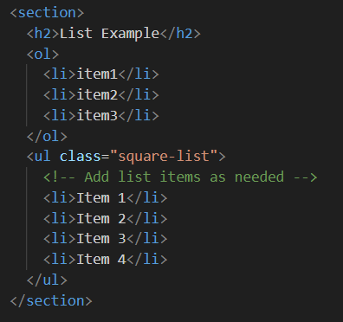

* 1. **Output**

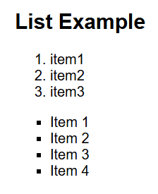

## Table Example

* 1. **Code**

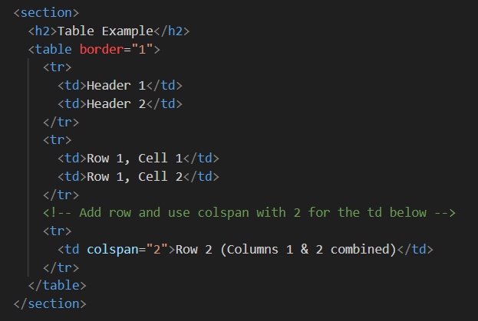

* 1. **Output**

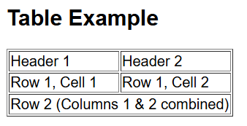

## Navigation Example

* 1. **Code**

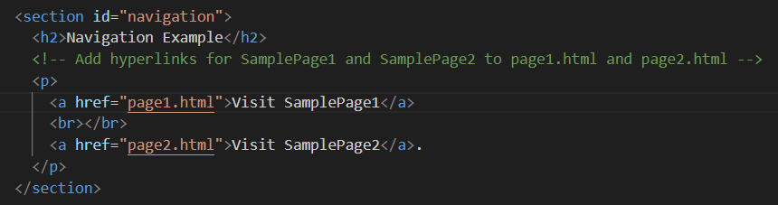

* 1. **Output**

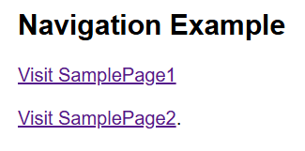

## Form Example

* 1. **Code**

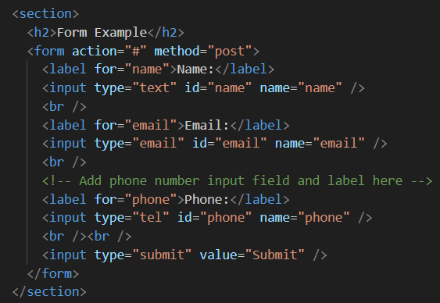

* 1. **Output**

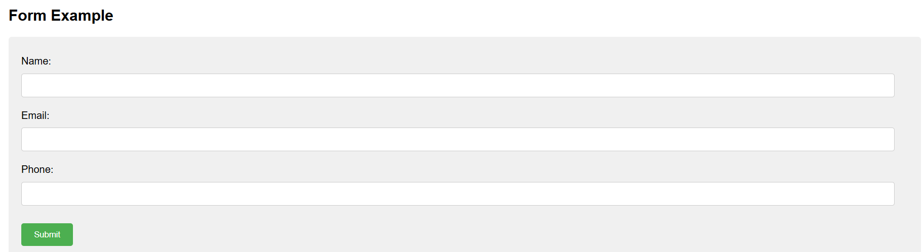

# CSS Task:-

## Header styles

* 1. **Code**

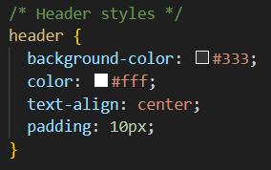

## Main Content Styles

* 1. **Code**

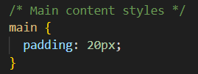

## Form Input Styles

* 1. **Code**

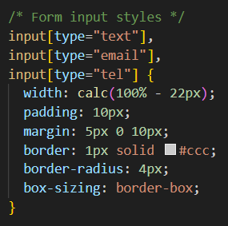

## Footer Style

* 1. **Code**

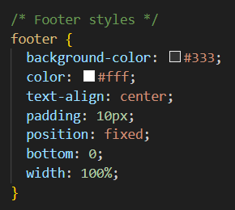

## Enhanced Task

* 1. **Uncommented Code**

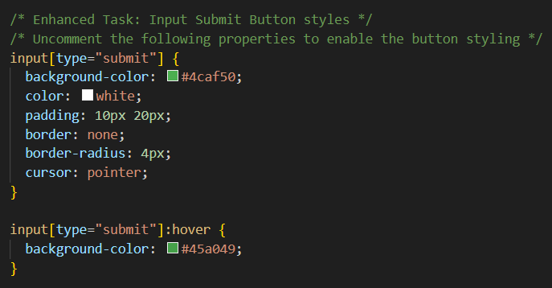

## CSS Task Output:-

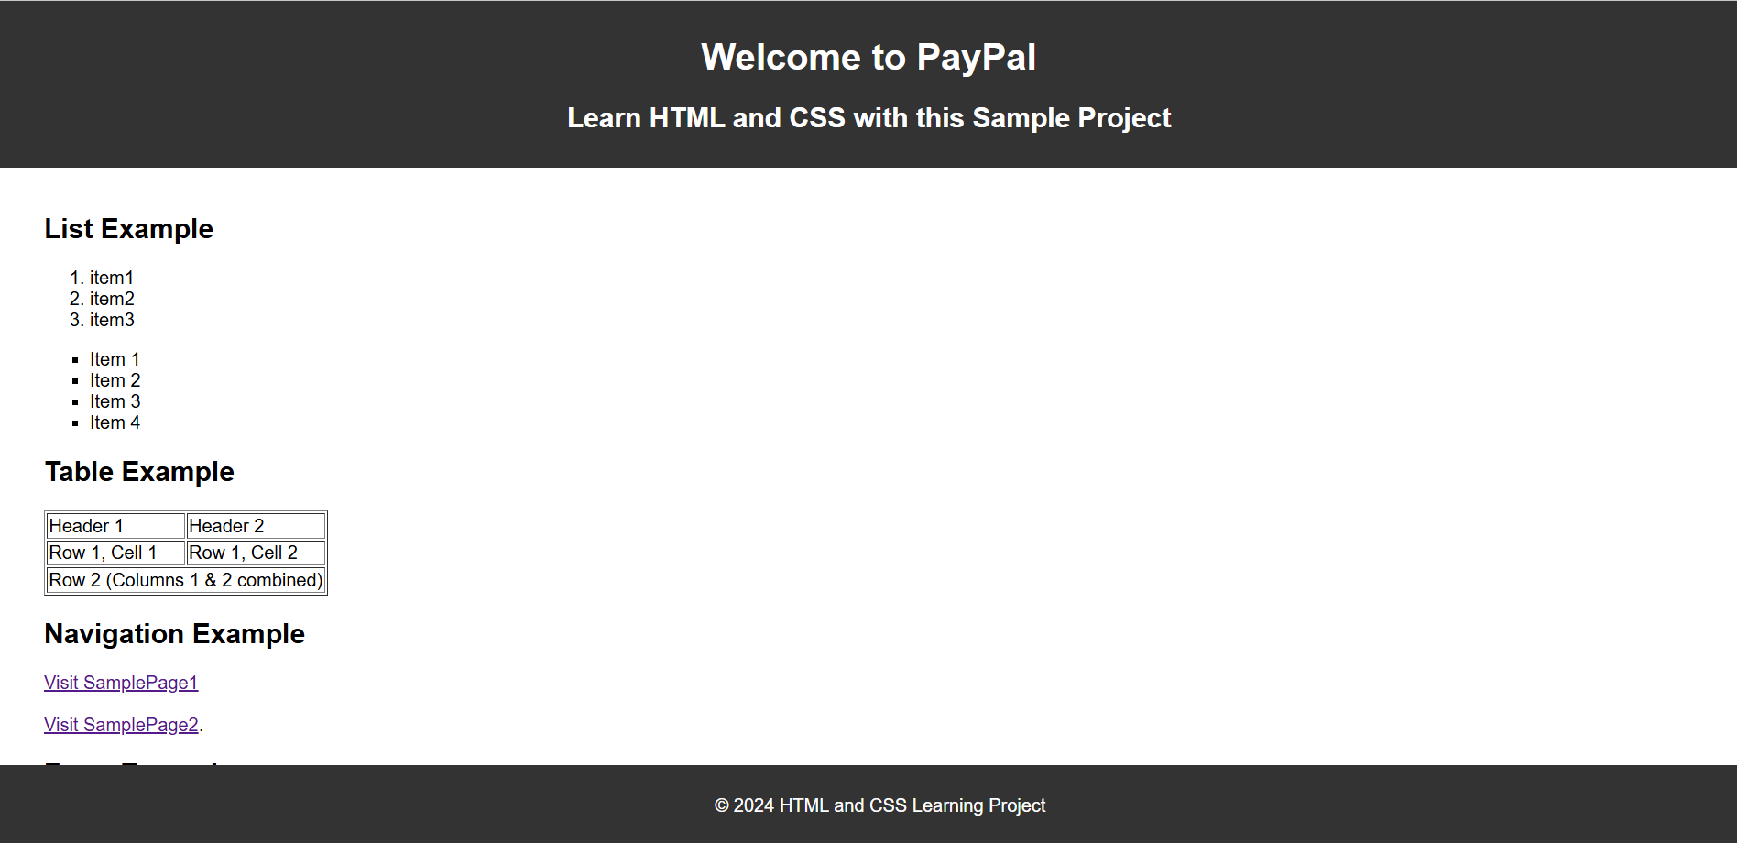

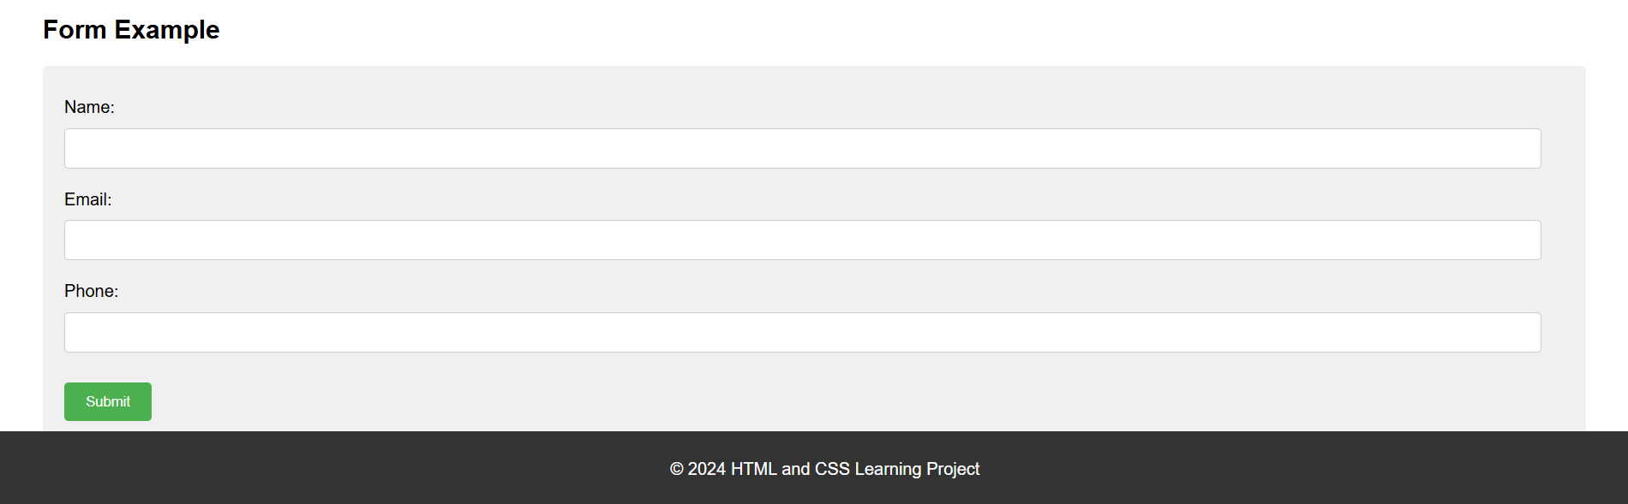

# Git and IntelliJ:

**1. What is the use of the git add command?**

-- The git add command stages changes, meaning it adds modified or new files to the Git staging area. This prepares them to be included in the next commit.

**2. Write the command to create a branch “feature-group”.**

--git branch feature-group

**3. What is a pull request? Write the steps involved in creating a pull request.**

-- A pull request is a way to propose changes from one branch to another, usually to merge feature work into the main branch.  
Steps: Push your branch to GitHub → Go to the repository → Click “Compare & pull request” → Add a title and description → Click “Create pull request”.

**4. How do you add collaborators?**

Go to your GitHub repository → Click on **Settings → Collaborators**.  
Then search the GitHub username or email and click **Add** to invite them.

**5. What is the command used to commit our changes in GitHub repo?**

-- git commit -m "Your commit message"

**6. Install IntelliJ IDE. Create a simple Java project displaying “Hello World!!” and share the screenshot.**

