**MBD Project**

**WEEK 3**

**MATLAB & Simulink Implementation of a complex Automotive suspension System**

**P Lalit Kishore**

**2005670**

**ABSTRACT**

The suspension system is designed to provide the comfort of driving. Vibrations are not transferred from the tire to the passenger if the suspension is strong. Depending on the road profile, the vibrations are transmitted via the suspension strut to the chassis (unsprung mass) to the seat and the rider. The most important factor in this case is the vertical acceleration produced by the spring mass. So, reducing the vertical acceleration gives you better ride comfort. The suspension study is therefore to be conducted for vertical acceleration. This paper focuses on the effect of suspension parameters i.e. spring mass, unwrapped mass, damping value, suspension and tire stiffness on acceleration.

The basic quarter car model is considered for research purposes. The equation of motion is obtained in a differential form. These motion equations are the basis of the Simulink model in MATLAB. This simulation will help to simulate suspension parameters. Thus, vertical accelerations are obtained under various working conditions and maximum acceleration values are obtained. The same values are tried on Simulink.

A good automotive suspension system should have satisfactory road holding ability, while still providing comfort when riding over bumps and holes in the road. When the vehicle is experiencing any road disturbance (i.e. pot holes, cracks, and uneven pavement), the vehicle body should not have large oscillations, and the oscillations should dissipate quickly. This must be visible in the Simulink output graphs.

**INTRODUCTION**

Vehicle suspensions are mainly classified into three types i.e., passive, semi active and active suspensions, which depend on the operation mode to improve vehicle ride comfort, vehicle safety, road damage minimization and the overall performance. Normally, passive suspension is an older conventional system having non-controlled springs and shock observing dampers with fixed parameters and no online feedback action is used

Passive suspension design performance is used for specific operating conditions .On contrary, active suspensions can have a wide range of operation condition and can adapt to the system variations based on online changes of the actuating force. Therefore, active suspensions have been extensively studied since 1960s and various approaches have been proposed.

However active suspensions normally require large power supply, which is the main drawback that prevents this technique from being used extensively in practice. From 1970s, semi-active suspensions have received much attention since they can achieve desirable performance than passive suspensions and consume much less power than active suspensions. Especially some controllable dampers are available in practice that is electrorheological (ER) dampers and magneto-rheological (MR) dampers.

Semi-active suspensions are more practical than ever in engineering realization. Semi-active control with MR dampers for vehicles suspensions have been studied by many researchers.

The modelling and simulation are carried in Simulink environment and further a sophisticated controller is implemented.

Simulink is a versatile interface which can handle various types of controllers easily –Lai et al. (2002) and Herren et al. (2008).

The present work tries to analyse the performance of semi active suspension control in the application of two-degree freedom vehicle suspension. Dynamic response with road disturbances is simulated with fixed parameter of the system.

The primary role of the suspension system is to separate from the passengers the road excitement experienced by the wheels. The simplest and most complex models are seen in the following situations. Mathematical models are capable of translating the system into mathematical equations so that equations can be resolved and some rigid conclusions can be drawn for proper and optimized results.

The optimization functions are obtained using these models, which contain various parameters that need to be optimized. The numerical simulation results show that the design criteria are substantially improved by optimizing the selected design variables. The effect of vehicle speed and road irregularity on design variables to improve vehicle driving efficiency has been investigated.

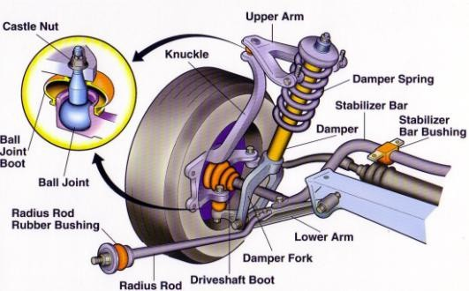

Figure 1: Two Degrees of Freedom (DOF) Quarter-Vehicle Model

Figure 2 shows a simplified 2 degrees of freedom (DOF) quarter-vehicle model. It consists of a sprung mass (m2) supported by a primary suspension, which in turn is connected to the unsprung mass (m1).

The tire is represented as a simple spring, although the damper is also used to represent a small amount of damping inherent to the visco-elastic nature of the tire The irregularity of the road is represented by q, while m1, m2, Kt, K and C are the mass of the tire, sprung weight, suspension stiffness, suspension damping coefficient and tire stiffness, respectively. This is a very popular model that can be considered when evaluating the various suspension parameters. In this model single suspension is considered for analysis purpose. The tire has been replaced with its equivalent stiffness and tire damping is neglected. The suspension, tire, passenger seat is modelled by linear springs with dampers.

The parameters are

* q=road irregularity (m)
* Kt = tire stiffness
* m1=unsprung mass (kg)
* m2=sprung mass (kg)
* K=sprung mass stiffness (N/ m)
* C=Damping coefficient (N/m/s)
* z1=displacement of unsprung mass (m)
* z2=displacement of sprung mass (m)

For study, a complete car model with eight degrees of freedom is considered. Figure 1 shows a complete car (8DOF) model consisting of a passenger seat and a spring mass referring to the part of the car that is supported by the springs and the unwrapped mass which refers to the mass of the wheel assembly. The rubber has been replaced with its corresponding hardness and the tire damping has been ignored. The suspension, the tire, the passenger seat is formed by longitudinal springs parallel to the dampers. In the vehicle model sprung mass is considered to have 3DOF i.e. bounce, pitch and roll while passenger seat and four unsprung mass have 1DOF each.

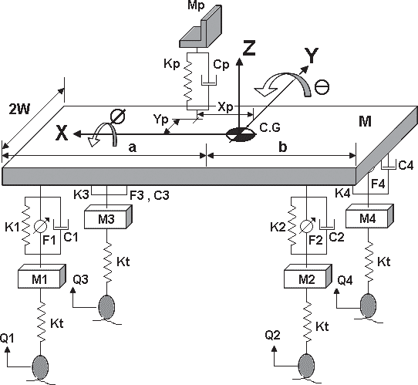

Figure: Eight DOF Model

1. Mp: Passenger seat mass (kg) M: Sprung mass (kg)
2. M1 & M3: Front left and front right side un- sprung mass respectively (kg)
3. M2 & M4: Rear left and rear right side un- sprung mass respectively (kg)
4. Kp: Passenger Seat Stiffness (N/m)
5. K1 & K3: Front left and front right-side spring stiffness respectively (N/m)
6. K2 & K4: Rear left and rear right side spring stiffness respectively (N/m)
7. Kt: Tyre stiffness (N/m)
8. Cp: Passenger seat damping coefficient (Ns/ m)
9. C1 & C3: Front left and front right side
10. suspension damping co-eff. respectively (Ns/ m)
11. C2 & C4: Rear left and rear right side
12. Suspension damping co-eff. respectively (Ns/ m)
13. F1 & F3: Front left and front right-side actuator force respectively (N)
14. F2 & F4: Rear left and rear right side actuator force respectively (N)
15. a & b:C.G location from front and rear axle respectively (m)
16. 2W: Wheel track (m)
17. Xp & Yp: Distance of seat position from CG of sprung mass (m)
18. Ix: Mass moment of inertia for roll (kg-m2)
19. Iy: Mass moment of inertia for roll (kg-m2)
20. Q1 & Q3: Road input at front left and front right side respectively.
21. Q2 & Q4: Road input at rear left and rear right side respectively.

Also, this model shows how to model a simplified half-car model that includes an independent front and rear vertical suspension. The model also includes body pitch and bounce degrees of freedom. The example provides a description of the model to show how simulation can be used to investigate ride characteristics.

**Equations of Motion for 2 DOF System and Simulink Model**

From Free body diagram of the system following equations of motions can be derived.



With Simulink, one can move beyond idealized linear models to explore more realistic nonlinear models, factoring in friction, air resistance, gear slippage, hard stops, and the other things that describe real-world phenomena. Simulink turns your computer into a laboratory for modeling and analyzing systems that would not be possible or practical otherwise.

After you define a model, you can simulate it, using a choice of mathematical integration methods, either from the Simulink menus or by entering commands in the MATLAB® Command Window. The menus are convenient for interactive work, while the command line is useful for running a batch of simulations. Simulink provides a graphical user interface (GUI) for building models as block diagrams, allowing you to draw models as you would with pencil and paper. Simulink also includes a comprehensive block library of sinks, sources, linear and nonlinear components, and connectors. If these blocks do not meet your needs, however, you can also create your own blocks. The interactive graphical environment simplifies the modeling process, eliminating the need to formulate differential and difference equations in a language or program.

Models are hierarchical, so you can build models using both top-down and bottom-up approaches. You can view the system at a high level, then double-click blocks to see increasing levels of model detail. This approach provides insight into how a model is organized and how its parts interact.

Using scopes and other display blocks, you can see the simulation results while the simulation runs. You can then change many parameters and see what happens for "what if" exploration. The simulation results can be put in the MATLAB workspace for post processing and visualization.

**The default conditions used in the model are detailed below.**

Lf = 0.9; % front hub displacement from body gravity centre (m)

Lr = 1.2; % rear hub displacement from body gravity centre (m)

Mb = 1200; % body mass (kg)

Iyy = 2100; % body moment of inertia about y-axis in (kg m^2)

kf = 28000; % front suspension stiffness in (N/m)

kr = 21000; % rear suspension stiffness in (N/m)

cf = 2500; % front suspension damping in (N sec/m)

cr = 2000; % rear suspension damping in (N sec/m)

**SIMULINK model and variables used**

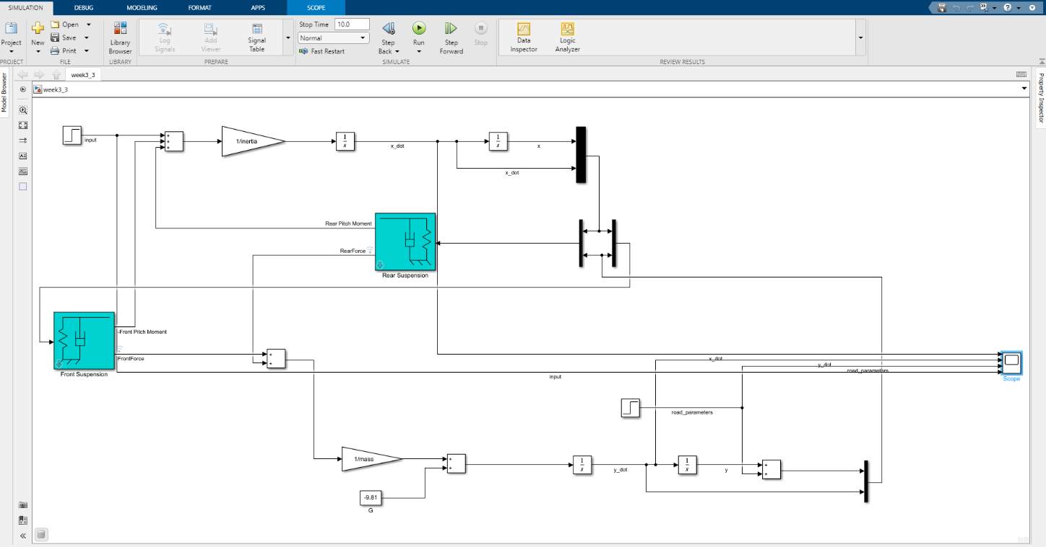

Model in SIMULINK

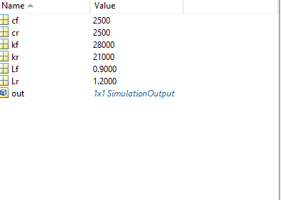

Variables used

**Data Inspector in the SIMULINK model**

You will use the Simulation Data Inspector to simulate the data you generate during the design process. Simulation data that you log on to the Simulation Data Inspector in the Simulink® Model Logs. You may also import test data and other reported data to the Simulation Data Inspector to review and analyse it alongside logged simulation data. The Simulation Data Inspector provides many types of plots that help you to quickly construct complex visualizations of your data.

**View Logged Data**

Logged signals as well as outputs and states logged using the Dataset format automatically log to the Simulation Data Inspector when you simulate a model. You can also record other kinds of simulation data so the data appears in the Simulation Data Inspector at the end of the simulation. To see states and output data logged using a format other than Dataset in the Simulation Data Inspector, in the Model Configuration Parameters Data Import/Export pane, select the Record logged workspace data in Simulation Data Inspector option.

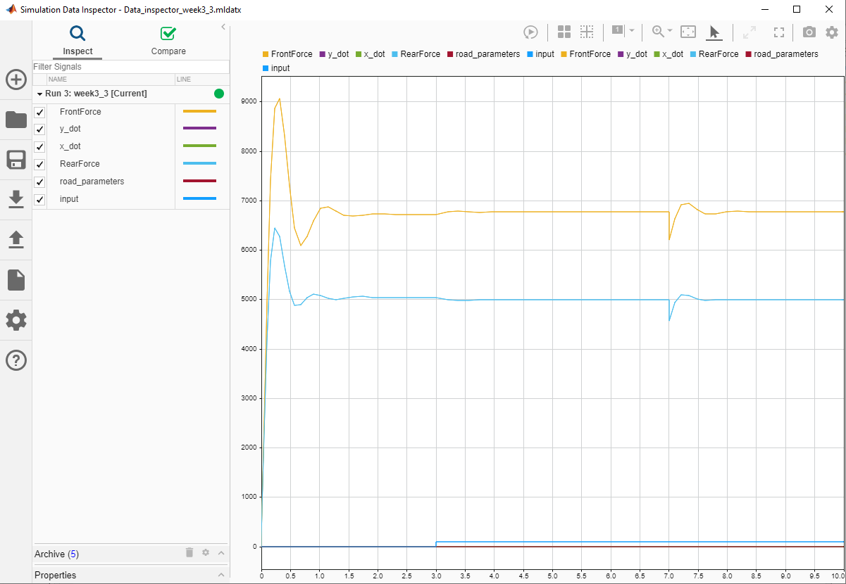

Data Inspector output in SIMULINK

**Solver Selection Strategy**

ODE23 and ODE45 are MATLAB's ordinary differential equation solver functions.

ODE23 is based on the integration method, Runge Kutta23, and ODE45 is based on the integration method, Runge Kutta45. The way that ODE23 and ODE45 utilize these methods is by selecting a point, taking the derivative of the function at that point, checking to see if the value is greater than or less than the tolerance, and altering the step size accordingly.

This integration approaches do not lend themselves to set phase sizes. Using an algorithm that uses a fixed phase size is risky, since you may skip points where the frequency of the signal is greater than the frequency of the solver. Using a variable step means that a broad step size is used for low frequencies and that a small step size is used for high frequencies. ODE23/ODE45 was designed for variable phase, run faster with variable step duration, and the results are obviously more reliable.

If one wishes to obtain only those values at a certain fixed increment, do the following:

* Use ODE45 to solve the differential equation.
* Better to use with variable step solver

For this simulation, ODE45 is chosen.

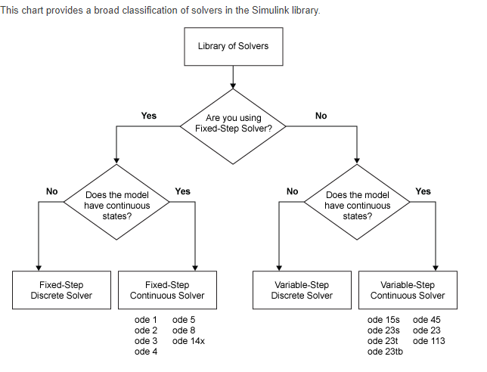

**Signal Builder**

Signal builders are used for creating tests in Simulink. Let’s say you’ve created a low-pass filter and want to make sure that you didn’t make any mistakes while developing it. You may want to input a signal to your low-pass filter such as different kind of sine waves with different frequencies and look at your filter’s behaviour.

A Signal Builder also allows you to construct different kinds of test cases so that you are running all of them to study your model’s behaviours.

You can find Simulink blocks in the Simulink library at “Simulink/Sources.”  Here’s what the Signal Builder block looks like:

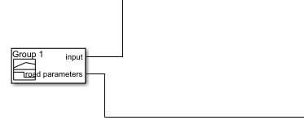

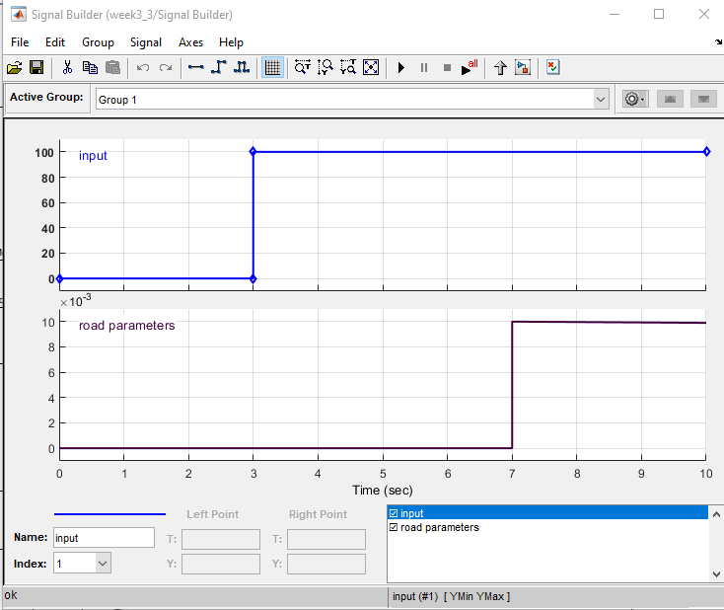

**Conclusion**

This model allows you to simulate the effects of changing the suspension damping and stiffness, thereby investigating the trade-off between comfort and performance.

In general, racing cars have very stiff springs with a high damping factor, whereas passenger vehicles have softer springs and a more oscillatory response.

1. Effect of Change in Sprung Mass: from the result of simulation it is clear that initially the less amount of sprung mass causes the large vertical acceleration. But as sprung mass goes on increasing then vertical acceleration sharply decreases. But sprung mass can’t be increased beyond 175Kg otherwise the high dynamic forces strikes the shaker. Thus, high sprung mass gives comfort but striking of sprung and unsprung mass should not takes place. The simulation result shows that we have extended the mass up to the 250 kg. But actually, we take it up to 175 kg for safety purpose.
2. Change in Suspension Spring Stiffness: simulation shows that as suspension spring stiffness increases the vertical acceleration increases. From results it can be proved that 18.63% change in the stiffness changes vertical acceleration only by 3.64%. It does not mean that we should use less stiffness spring. That causes increase in flexibility. Thus, it should be such that it will reduce vertical acceleration as well as should give the stability. In suspension spring we take five different values but we are having the two struts thus experimental and simulation values are compared for those two values only.
3. Change in the damping coefficient: the damping coefficient damps the amplitude suddenly and brings system to the mean position. The vertical acceleration increases by 3.2% while an increase in the damping coefficient is increased by 13.5%.
4. Tire stiffness is dependent of the pressure in the tire. The minimum pressure in the tire should be maintained. At that air pressure the particular stiffness should be considered. As tire air pressure increases the rigidity of tire and transfers the vibrations. Thus, tire pressure increases the stiffness increases and vertical acceleration also goes on increasing.