**MINI PROJECT REPORT**

**ON**

**Wheather Forecast Application**

**BY**

**1.Lalit Mali**

**Course: MCA I Sem.: III**

**Roll No.: 20699**

**PRATIBHA INSTITUTE OF BUSINESS MANAGEMENT**

**CHINCHWAD, PUNE-411019**

**2022-2023**

**DECLARATION**

**PRATIBHA INSTITUTE OF BUSINESS MANAGEMENT**

**CHINCHWAD, PUNE-411019**

**2022-2023**

**Master in Computer Application**

This is certify that Mr. Lalit Mali(20699)

have successfully completed Project titled

“Wheather Forecast Application”

for MCA (Computer

Application) Sem-II in academic year 2022-2023.

**Project Guide Head of Department**

**Mr.Shubham Nagure (Master In Comp.Application)**

**External Examiner Internal Examiner**

**ACKNOWLEDGEMENT**

Words fall insufficient to describe the efforts taken by all the staff member and colleagues for their encouragement and willing co-operation for the completion of this project. We would like to place our sincere gratitude their worthy suggestions and timely cooperation “Defeat is not when you fall down; it is when you refuse to get up”. We faced many difficulties during our project tenure, right from the requirements Gathering to implementation. We cannot retain our self from according heartfelt thanks to **Mr.Shubham Nagure** our project guide cum mentor for sailing us through various odds at various stages of this project without his guidance this project wouldn’t have reached this stage. Apart from the efforts of me, the success of any project depends largely on the encouragement and guidelines of many others. I take this opportunity to express my gratitude to the people who have been instrumental in the successful completion of this project. Last but not least; we are thankful our friends for their innovation suggestions which helped us in completing this project.

**INDEX**

|  |  |  |
| --- | --- | --- |
| **Sr. no.** | **topic name** | **page no.** |
| **1** | **CHAPTER 1: INTRODUCTION**  1.1 Introduction  1.2 Existing System and need for System  1.3 Limitations of existing system |  |
| **2** | **CHAPTER 2: PROPOSED SYSTEM**  2.1 Problem statement/s  2.2 Objectives of proposed system  2.3 Scope of the system  2.4 Module specifications  2.5 Detail Description of Technology Used  2.6 Operating environment |  |
| **3** | **CHAPTER 3: SYSTEM ANALYSIS & DESIGN**  3.1 E-R Diagram  3.2 Use Case Diagrams  3.3 Sequence Diagram  3.4 Class Diagram  3.5 Activity Diagram  3.6 FlowChart Diagram |  |
| **4** | **CHAPTER 4 : Implementation**  4.1 : user interface screens  4.2 :output reports with data (if any) |  |
| **5** | **Chapter 5 : Drawbacks and Limitations** |  |
| **6** | **Chapter 6 : Conclusion** |  |
| **7** | **Chapter 7 : Bibliography** |  |

**Chapter 1 :INTRODUCTION**

**1.Introduction**

Weather forecasting is the application of science and technology to predict the conditions of the atmosphere for a given location and time. Weather forecasts are made by collecting quantitative data about the current state of the atmosphere at a given place and using meteorology to project how the atmosphere will change. The role of Technology has been remarkable in the field of weather forecasting. Weather data is not only necessary for researchers or scientists, ordinary people can be benefitted from it as well. People nowadays are feeling the necessity of weather data as well.There are a variety of weather mobile apps in Google Play and the App store. Those apps have great features and functionalities to satisfy users. However, only a few of them have friendly user interface and human centered interactions, which means that a lot of them might be difficult to be navigated even though they provide enough functionalities. It is not convenient for new users. Therefore, we would like to do improvements on weather mobile apps. It is basically for Android smart phones and tablets.

**1.2 Existing System and Need for System**

Nowadays we face a huge problem that knowing real weather status instantly in such place we need to know. It is a complex and often challenging skill that involves observing and processing vast amounts of data. Weather systems can range from small, short lived thunderstorms only a few miles in diameter that last a couple of hours to large scale rain and wind up to a thousand miles in a diameter, and lasting for days. So most of the times we cannot get the real weather forecast and face to lot of troubles. We have another problem in weather forecasting.

The aim of this project is to make a software application that can be downloaded and used in an android device to get to know about real-time weather updates in a particular place that we need to know and inform others about the current weather status in our location, and also to make an application for different weather stations of Meteorology Department to submit their weather synopsis to the system for every three hours either using the computer at the station or using the specified mobile application only for them.

**1.3 Limitations of existing system**

* Unpaid APIs provide incomplete services Many details cannot be fetched.
* Often,tuples of upcoming days remain empty once again due to free APIs
* The GMS API ( Google Manual Search) is actually keyword based that might only provide data of few discrete locations.The data might not be precise and continous.
* Language diversity could have been implemented.Multilingual apps make it easy for users worldwide

**CHAPTER 2: PROPOSED SYSTEM**

**2.1Problem statements**

Human activity is influenced by weather conditions, monitoring of weather conditions can help in controlling the activity. It is important to monitor and study the pattern of weather at surrounding. Limited way for user to know about weather such as temperature, humidity and wind speed. Without weather station, user can’t be alerted of the strong winds, heat waves or any other weather-related emergency. Furthermore, difficulty in making weather forecasts without data. When user use weather station, user can view the history of information as well. User can figure out the trends in the measurements. This will allow user to analyze the trends in a more effective way. A weather station is a device that collects data related to the weather and environment using many different sensors. Weather station is also a facility that can use for measuring atmospheric conditions to provide information for weather forecasts and to study the weather and climate. The measurements taken include temperature, atmospheric pressure, humidity, wind speed, wind direction, and precipitation amounts. Weather stations are also called weather centers, personal weather stations, professional weather stations, home weather station and weather forecaster.

**2.2 Objectives of proposed system**

Weather forecasting is the application of science and technology to predict the conditions of the atmosphere for a given location and time. Weather forecasting is the application design in a such way that real-time weather station that can help user to access data anywhere in real-time Weather forecasts are made by collecting quantitative data about the current state of the atmosphere at a given place and using meteorology to project how the atmosphere will change. The role of Technology has been remarkable in the field of weather forecasting. Weather data is not only necessary for researchers or scientists, ordinary people can be benefitted from it as well. People nowadays are feeling the necessity of weather data as well.There are a variety of weather mobile apps in Google Play and the App store. Those apps have great features and functionalities to satisfy users. However, only a few of them have friendly user interface and human centered interactions, which means that a lot of them might be difficult to be navigated even though they provide enough functionalities. It is not convenient for new users. Therefore, we would like to do improvements on weather mobile apps. It is basically for Apple smart phones and tablets. To test the capabilities and effectiveness of the Weather Station and generate the data to the user.

**2.3 Scope of the system**

The app allows the users to check the weather for every three hours for the next three days. The users can view several details such as temperature,pressure, humidity, weather conditions, and so on. The users can get theweather for any location and they can get the temperature in Celsius as well asFahrenheit. The users can also share the weather through messaging apps.Weather Report project application is a web based application through whichyou will able to get all the reports related to weather forecasting of any locations. Its geographical locator which will be received through your browsersetting and server configuration will automatically identify the location and ableto present its weather details such as temperature, direction of wind, rains,humidity etc. To change the location you will just have to select the options provided below to get its details. Its new avatars and feed burner will also allow its users to get the weather reports directly to their mail, when they were not able to access this particular domain or even when the server is down.Its weather watch gadgets in animated form will able to notify about weather forparticular date and time also. It will also able to focus on critical weathercondition for a particular gadgets through this gadgets. So with one weathersolutions, its users can get weather reports by getting information directly fromsatellite and radar via proper communication medium using java servlet coding.Its calculations and details are so accurate, that you can even check and match itfrom news channel. Its user's friendly tools are so simple to use, that even achild can handle it and get information on particular geographical area.

**CHAPTER 3: SYSTEM ANALYSIS & DESIGN**

**3.1 E-R Diagrams**

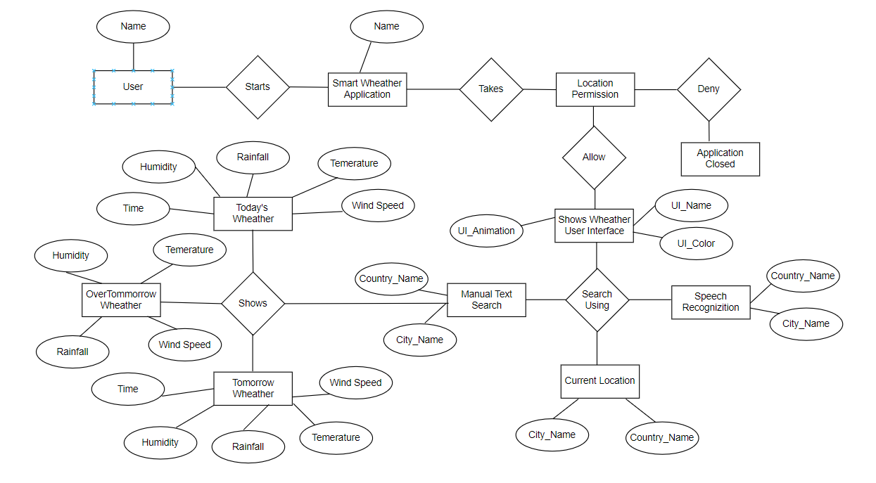

**3.2 Use Case Diagrams**

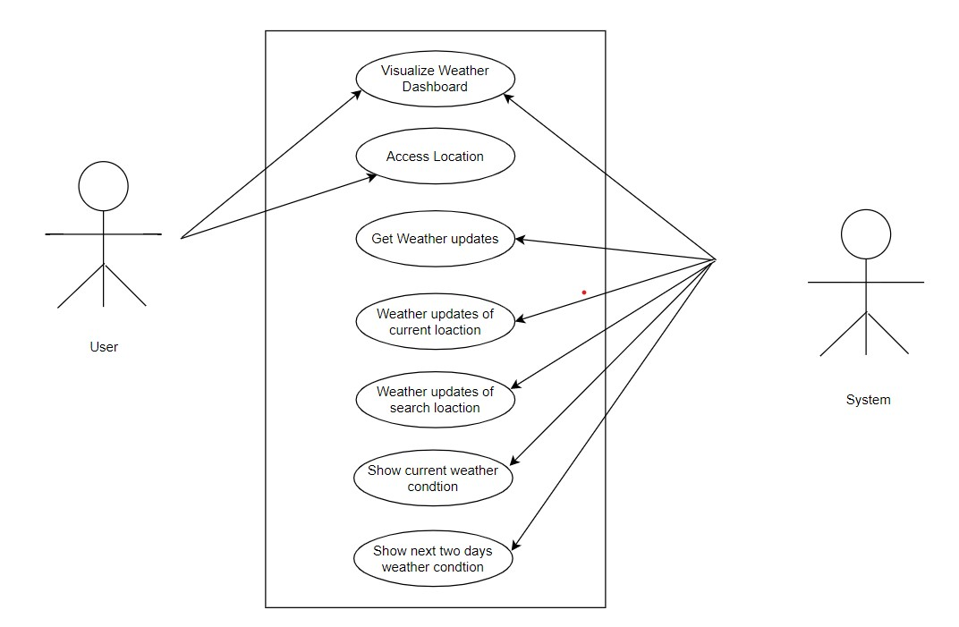

**3.3 Sequence Diagram**

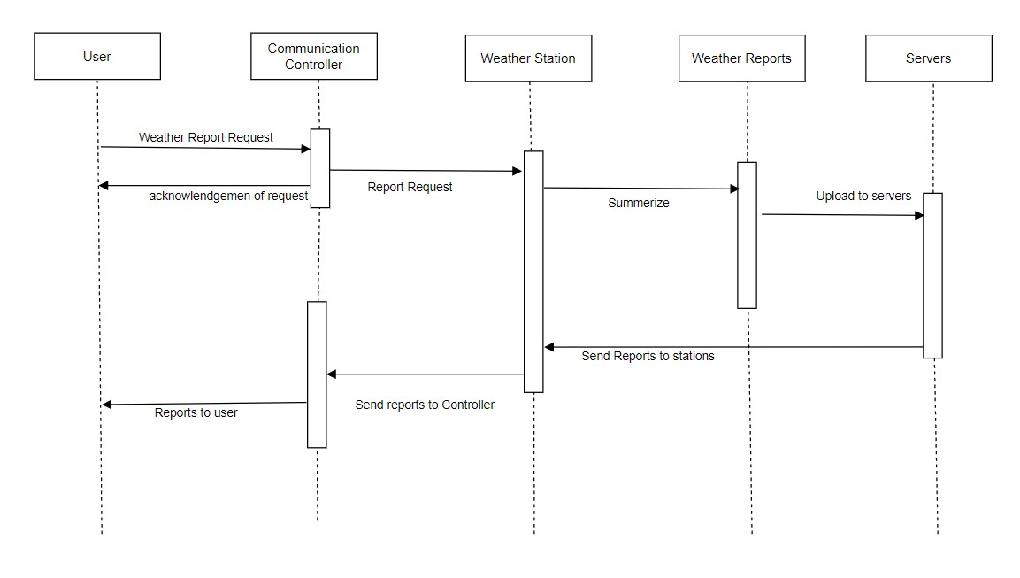

**3.4 Class Diagram**

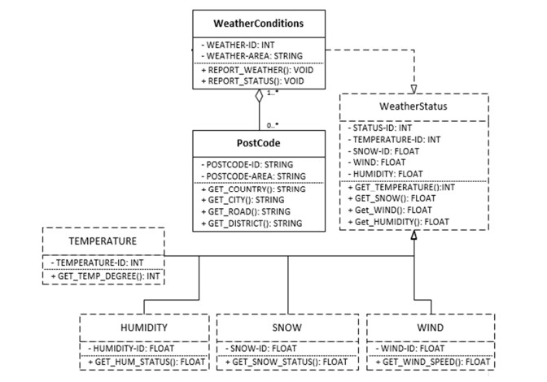

**3.5 Activity Diagram**

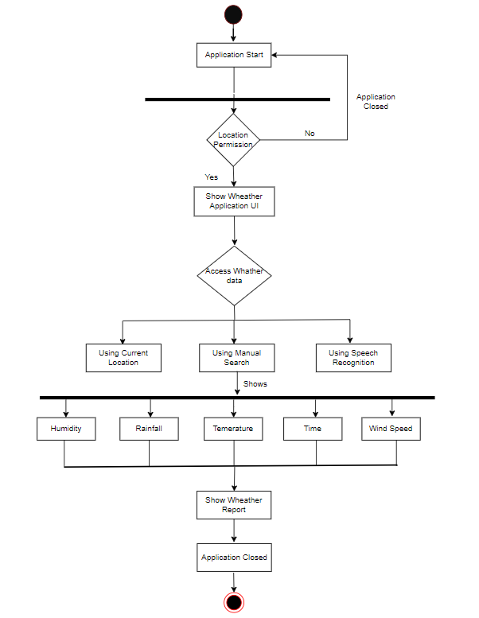

**3.6 FlowChart Diagram**

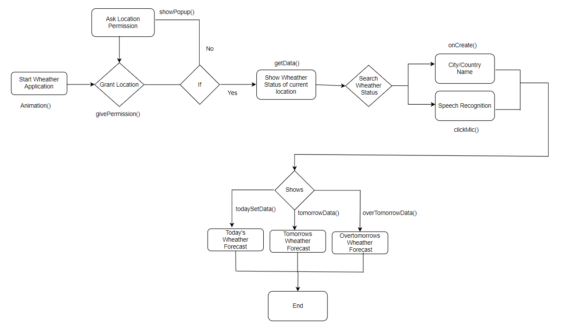

**3.7 User Interface Screens with Data(Input/Output)**

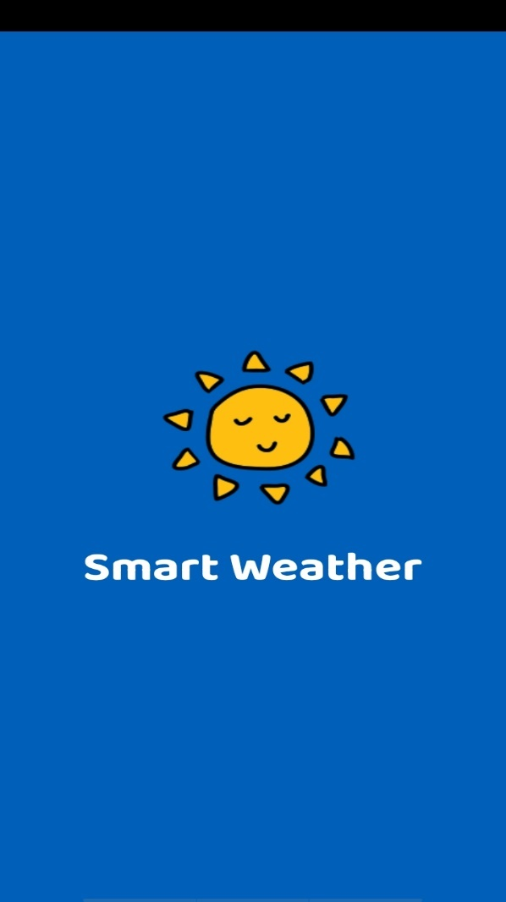

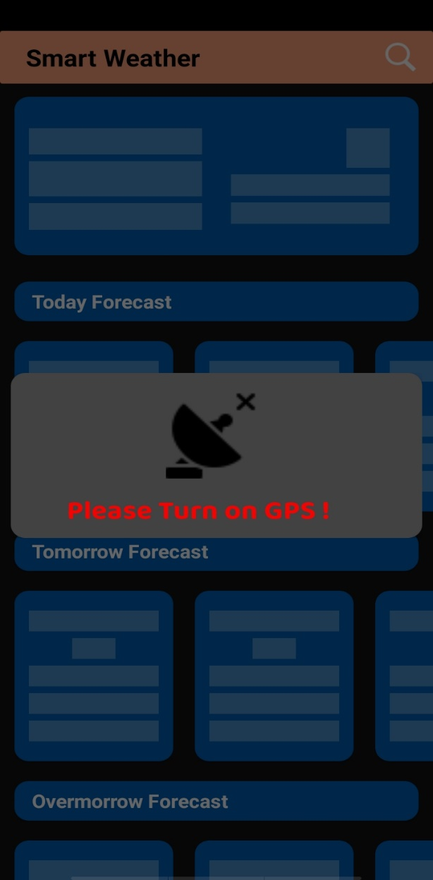

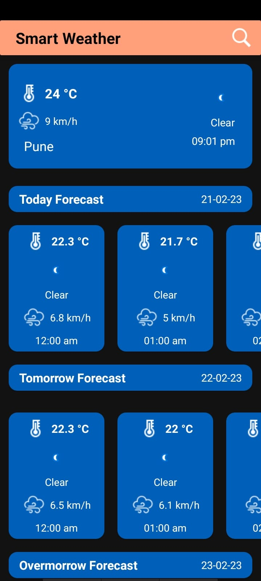

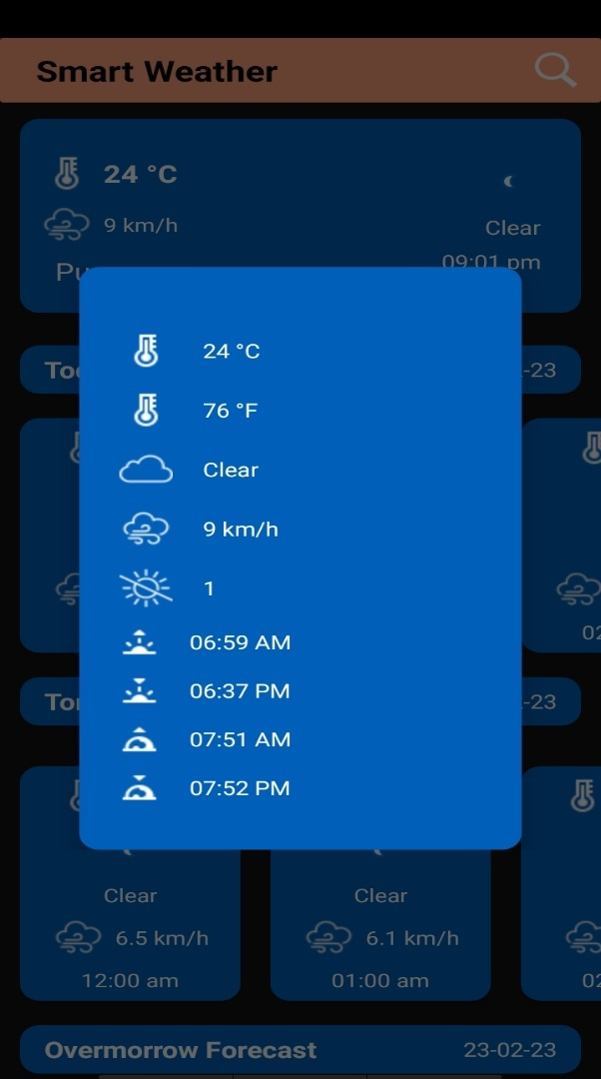

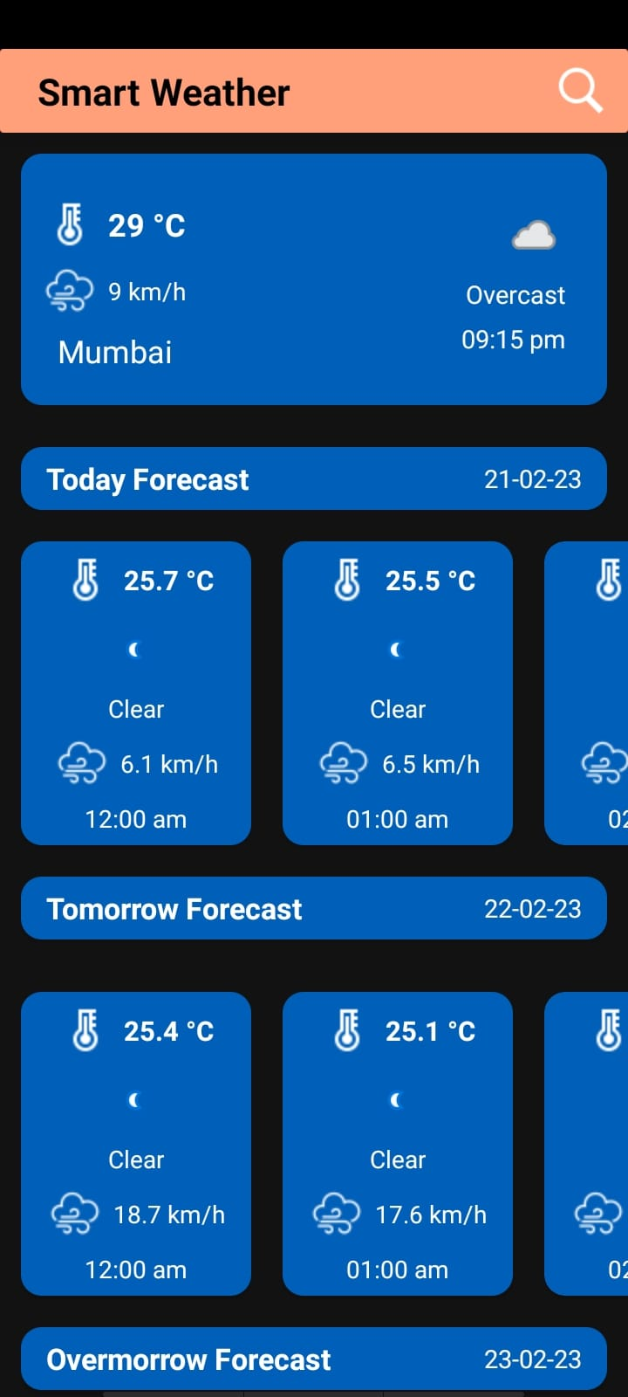

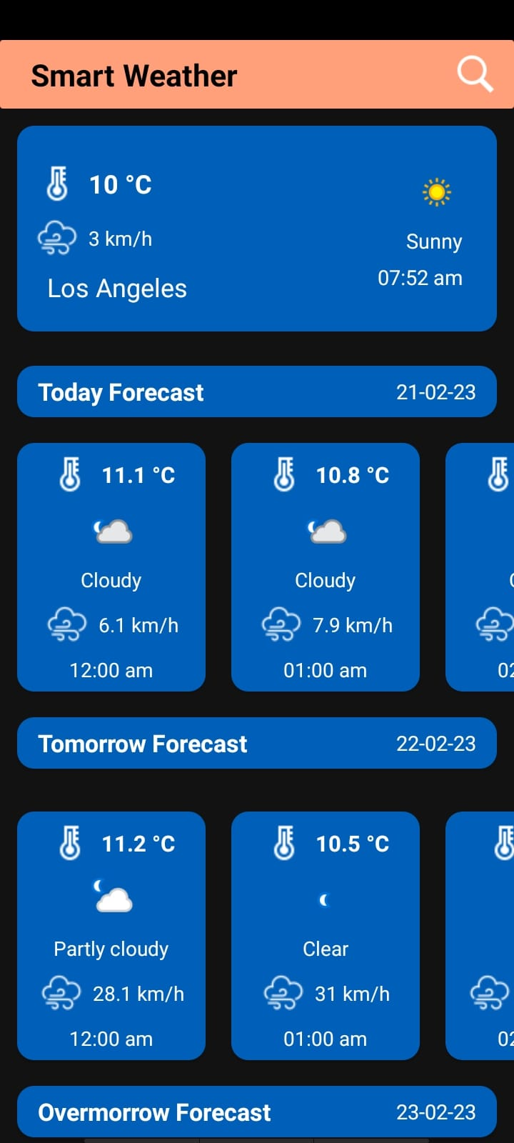

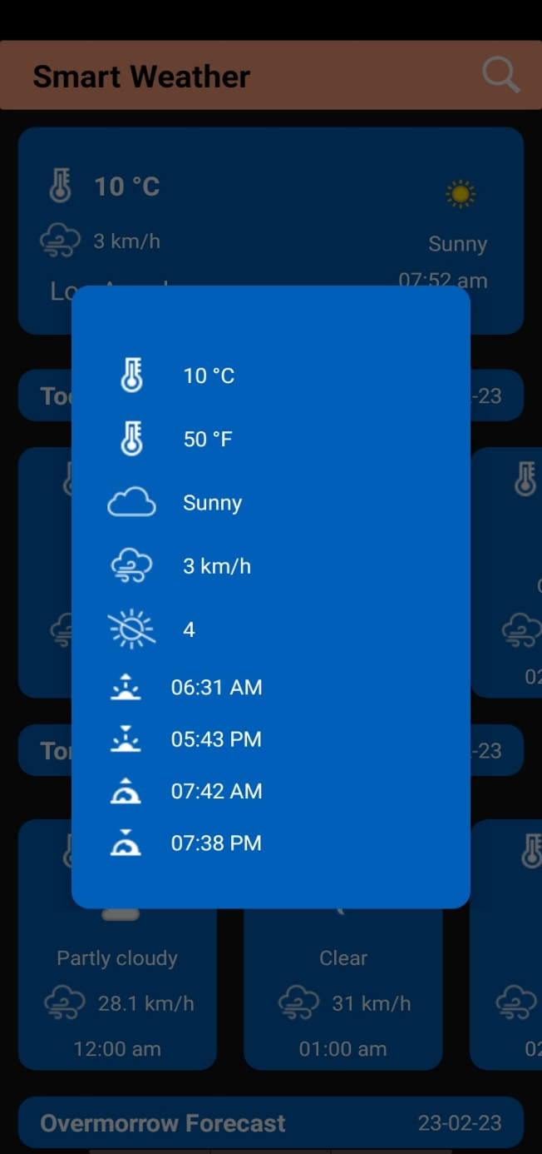

**Drawbacks and Limitations**

* We intend to provide more detailed tips based on the age,gender,region and health conditions(Dust allergy,heatstroke tendency etc.) of the user.
* FAQ section based on detailed datamight be quite handy.It will save the user’s efforts and make it more convenient.
* Using paid APIs to fetch more details might make the application more comprehensive and appealing.For example wind speed,precipitation & sea level values can be used to provide more intellectual tips.
* Mobility of the traveler,their start & end points of the journey,their route of traveling(road,waterway,aerial) shall be strongly focused.The application needs to be an aid for traveling users.
* Recording User inputs to understand the user preferences and providing them necessary notifications needs to be kept in mind
* Maybe someday in the near future,we will use AIs for more precision and accuracy.

**Conclusion**

Weather forecasting and prediction involves formulating and disseminating information about future weather conditions based upon the collection and analysis of meteorological observations. Numerical weather prediction is the prediction of weather phenomena by the numerical solution of the equations governing the motion and changes of condition of the atmosphere. Weather analysis and forecasting involves collecting global meteorological surface and upper-air observations, preparing global surface and upper air pressure, temperature, moisture, and wind analyses at frequent time intervals based upon these observations, solving a closed set of highly nonlinear equations governing atmospheric dynamical motions, and applying statistical procedures to the atmospheric simulations to predict a wide variety of weather elements of interest to potential users. Nowcasting is a form of very short-range weather forecasting; that is, the current weather along with forecasts up to about two hours ahead. Forecasts in which the lead time for the prediction is more than two weeks, are termed long-range or extended-range climate predictions.

**Bibliography**

We are taken references from these following website to build our project and ideas only for study material purpose.

https://youtube.com

https://wikipedia.com