BDM Project Presentation

1. The student needs to collect the data pertaining to a business problem. It could be any business- organized or unorganized sector. E.g.: Manufacturing, automobile, IT sectors, supermarkets, laundry, vegetable vendors, restaurants, service businesses etc. Kindly note that only “**primary data**” is to be collected. **Do not collect** data from online sources like Kaggle, GitHub etc, as they constitute the secondary data sources.
2. Clearly explain the process of data collection.
3. Prepare field notes describing the meeting between the two parties (Student and the business, the people involved etc). Mention in brief, how many meetings were done and what was discussed?
4. Understanding of the business (Type of Business-B2B, B2C or both) and nature of problem(s) the businesses encounter.
5. How do businesses solve the problems they encounter? Are these problems recurring or one-time?
6. How did the student narrow down to the problem?
7. How was the data collection done? Time period of data collection (Days/ Months/Years etc).
8. Tangible evidence (People, Processes (say an organization chart) or any form of physical evidence)
9. Details about the various variables collected as a part of data collection. Importance of these variables and its relevance.
10. Cleaning of the data – Describe the process in brief and how it was done?
11. Analysis of the data- While the students can use the case studies taught in BDM course as cues to conduct the analysis, the rationale for the same needs to be mentioned. We also encourage students to go through newspapers, journals, reference books, use learnings from other courses etc, and explore newer ways of conducting analysis.
12. Provide the insights from the analysis conducted to the businesses.
13. What should businesses do? (Continue doing and start doing)
14. What is that, they need to avoid?
15. In what ways does your solution(s) address the business problem(s)?

Kindly note these insights should be novel, as something that adds value to the decision maker. The insights should be derived from the analysis you conduct. So, better the data, richer the insights!

Flow of Project

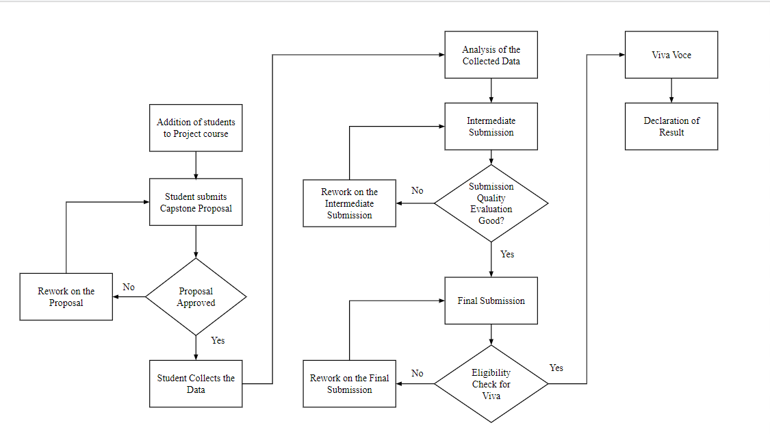

Submission Phases and Evaluation criteria

1. Proposal submission
2. Mid-term Submission (Explanation of Data collection and cleaning)
3. Final Submission with Analysis/Interpretation of data
4. Viva Voce

Maximum completion time - 30-Apr-2023, Else they have to re-register in May-2023

Timeline for September-2022 term

**(These are tentative dates, it may vary based on student submission)**

|  |  |  |  |  |
| --- | --- | --- | --- | --- |
| Project Proposal Start (Google Form) | 16-Nov | 16-Dec | 16-Jan | 16-Feb |
| Proposal for Project final date | 20-Nov | 20-Dec | 20-Jan | 20-Feb |
| Proposal Approval Deadline | 28-Nov | 28-Dec | 28-Jan | 28-Feb |
| Data Collection | After approval of the proposal | | After approval of the proposal | |
| Mid-term Submission Start (Google Form) | 28-Nov | 28-Dec | 28-Jan | 28-Feb |
| Mid-term Submission End | 30-Nov | 30-Dec | 30-Jan | 2-Mar |
| Feedback on Mid-term submission (Last date) | 10-Dec | 10-Jan | 10-Feb | 12-Mar |
| Enable payment for eligible in Midterm,  Final submission (Analysis and Interpretation) start date | 10-Dec | 10-Jan | 10-Feb | 12-Mar |
| Final Submission (Analysis and Interpretation) End Date | 20-Dec | 20-Jan | 20-Feb | 22-Mar |
| Feedback on Final submission (Last Date) | 30-Dec | 30-Jan | 2-Mar | 2-Ap |
| Viva Slot Booking Starts | 1-Jan | 1-Feb | 3-Mar | 3-Apr |
| Stop Viva Slot Booking | 5-Jan | 5-Feb | 7-Mar | 7-Apr |
| Max Viva date(Tentative) | 20-Jan to  24-Jan | 20-Feb to  24-Feb | 20-Mar to  24-Mar | 20-Apr to  24-Apr |

Project Proposal

* Proposal must be about four – five pages long
* Proposal is evaluated for 100 marks and scaled down to 20
* A pass mark of at least 50/100 is needed for the proposal to be approved
* At least 2 objectives (problem objectives) must be identified in the proposal
* Only one firm should be picked for the study

|  |  |  |
| --- | --- | --- |
| 1 | Does the Proposal discuss a business problem? | Yes/No |
| 2 | If Answer to Q1 is No | Reject Proposal |
|  | **Expected Contents** | **Weightage** |
| 3 | * Executive Summary and Title (200 Words) | 15 |
| 4 | * Organization Background (150 Words)- Name of the firm, photo and location, brief description of firm, key stakeholders. You need not disguise info as it will only be with us and will not be shared with anyone else. | 10 |
| 5 | * Problem Statement (Listed as objectives) (50-75 Words) | 10 |
| 6 | * Background of the Problem (200 Words) | 10 |
| 7 | * Problem Solving Approach (400 Words) | 45 |
| 7a | * Details about the methods used with Justification |  |
| 7b | * Details about the intended data collection with Justification |  |
| 7c | * Details about the analysis tools with Justification |  |
| 8 | * Expected Timeline | 5 |
| 9 | * Expected Outcome | 5 |

Mid-term Submission

* Submission must be about 8 – 10 pages long
* Submission is evaluated for 100 marks and scaled down to 20

|  |  |  |
| --- | --- | --- |
| 1 | Is the plagiarism % of the document is less than 20% | Yes |
| 2 | If Answer to Q1 is No | Reject Submission |
|  | **Expected Contents** | **Weightage** |
| 3 | * Executive Summary and Title (200 Words) | 15 |
| 4 | * Proof of originality of the Data (Primary Data - survey link, photograph, letter from organization, etc) and Short video of interaction with the business person (3-5 mins) | 20 |
| 5 | * Metadata and Descriptive Statistics | 40 |
| 6 | * Detailed Explanation of Analysis Process/Method | 25 |
| 7 | * Results and Findings (Graphs and other Pictorial Representation Preferred and with words) (Bonus) | 10 |

Final Submission

* Submission must be about 18 – 20 pages long
* Submission is evaluated for 100 marks and scaled down to 40
* A cumulative score of 40/80 is needed to be eligible for viva voce.

|  |  |  |
| --- | --- | --- |
| 1 | Is the plagiarism % of the document is less than 20% | Yes |
| 2 | If Answer to Q1 is No | Reject Submission |
|  | **Expected Contents** | **Weightage** |
| 3 | * Executive Summary and Title (200 Words) | 15 |
| 4 | * Detailed Explanation of Analysis Process/Method | 15 |
| 5 | * Results and Findings (Graphs and other Pictorial Representation Preferred and with words) | 40 |
| 6 | * Interpretation of Results and Recommendation | 20 |
|  | * Presentation and legibility of the report | 10 |

* Students are free to use any analysis tool including Excel, R, Python

**V**iva Voce

* Student should present the project using google slides of powerpoint – Max 10 slides
* Submission is evaluated for 100 marks and scaled down to 20
* A cumulative of 50/100 marks is needed to pass BDM capstone project course

|  |  |  |
| --- | --- | --- |
|  | **Evaluation Criteria** | **Weightage** |
| 1 | * Presentation Content | 30 |
| 2 | * Presentation Quality | 10 |
| 3 | * Presentation Flow | 10 |
| 4 | * Presenter Communication Skills | 20 |
| 5 | * Presenter ability to answer questions | 20 |
| 6 | * Presenter’s preparedness and confidence | 10 |

**Reference Textbooks**

1. Malhotra, N., & Dash, S. (2019). *Marketing research: An applied approach*. Pearson.
2. Newbold, P. (2013). *Statistics for business and economics*. Pearson.
3. Wirtz, J., & Lovelock, C. (2021). *Services marketing: People, technology, strategy*. World Scientific.
4. Operations Management: Processes and supply chain | Twelfth Edition by Lee J Krajewski and others