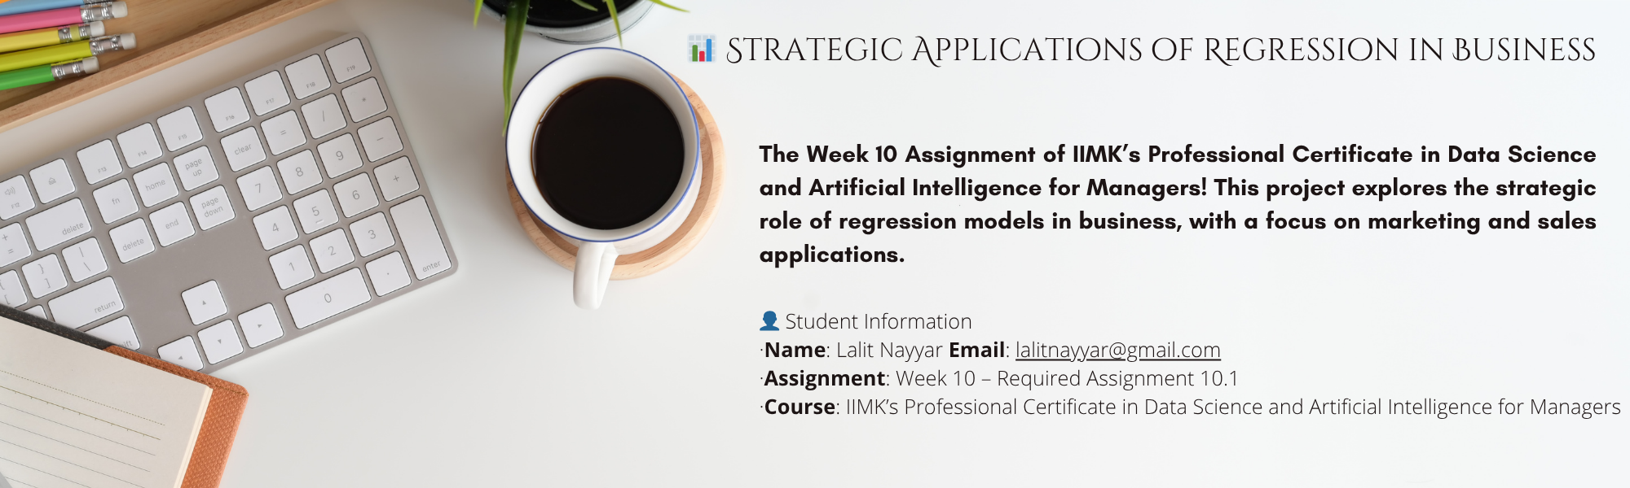

**📊 Strategic Applications of Regression in Business**

This document is part of the Week 10 Assignment for IIMK’s Professional Certificate in Data Science and Artificial Intelligence for Managers. It delves into the strategic role of regression models in business, with a particular focus on marketing and sales applications.

**🎯 Learning Outcomes**

* Enumerate the different types and uses of regression models.
* Differentiate between linear and non-linear regression models.
* Differentiate between classification and regression techniques.
* Describe how to decipher the outputs of regression models.

**📝 Objective**

The objective of this assignment is to evaluate the strategic role of regression models in business environments—especially in marketing and sales. By analyzing different regression techniques, interpreting their outputs, and managing model risks (such as overfitting or multicollinearity), we aim to develop practical data-driven frameworks for business decision-making.

**1️⃣ Business Decisions Influenced by Regression Analysis Results**

Regression analysis provides powerful insights that influence various business areas such as marketing, finance, and strategic planning. In data-driven organizations, regression is a critical enabler of decision intelligence.

**Key Business Decisions Informed by Regression Analysis:**

* **Optimized Marketing Budget Allocation:** Identify how individual marketing channels contribute to sales and revenue. Example: A 10% increase in Instagram ads leads to a 7% increase in sales, whereas print ads may have negligible or negative returns.
* **Revenue Forecasting:** Forecast expected sales based on advertising spend, product discounts, or seasonal trends. This assists executives in setting targets and planning operations.
* **Campaign Performance Analysis:** Assess how specific marketing initiatives perform across segments (e.g., campaign type, demographic group, region) for smarter A/B testing and refinement.
* **Cross-functional Alignment:** Forecasted demand influences inventory, staffing, procurement, and finance, connecting marketing to broader operations.
* **Scenario Planning & Sensitivity Analysis:** Simulate “what-if” scenarios (e.g., impact of cutting TV spend by 30%) for risk mitigation and strategic planning.
* **Strategic Investment Decisions:** Guide investments into emerging channels (e.g., influencer marketing, programmatic ads) based on model outcomes.

**

*Example:* A retail firm uses multiple regression to assess ad spend across channels. It finds Google Ads (β = 0.65, p < 0.01) drives more incremental sales than TV (β = 0.12, p = 0.4). The firm reallocates 20% of its TV budget to digital, resulting in a 6% year-over-year sales increase.

**2️⃣ Strategic Implications of Underfitting and Overfitting**

Model fit is crucial in machine learning and statistics. Inappropriate complexity leads to underfitting or overfitting, each with significant business consequences.

**🔵 Underfitting: Definition & Implications**

* **Definition:** The model is too simplistic to capture underlying patterns (e.g., using linear regression for non-linear problems).
* **Implications:**
  + Missed insights and hidden drivers
  + Low forecast accuracy
  + Reduced business confidence in analytics
* **Solutions:**
  + Add explanatory variables
  + Use non-linear models if needed
  + Apply residual analysis

**🟠 Overfitting: Definition & Implications**

* **Definition:** The model is too complex, capturing noise instead of signal (too many variables/interactions).
* **Implications:**
  + Misleading insights
  + High variance in predictions
  + Wasted resources
* **Solutions:**
  + Cross-validation
  + Regularization (Lasso, Ridge)
  + Feature pruning

*Business Analogy:* A bank forecasts loan defaults using 100+ features. Overfitting may wrongly indicate irrelevant features as predictive, while underfitting may miss critical predictors. Both can have large financial consequences.



**3️⃣ Handling Multicollinearity to Ensure Actionable Insights**

Multicollinearity occurs when two or more independent variables are highly correlated. While it may not always reduce model accuracy, it destabilizes coefficient interpretation and can mislead business decisions.

**🔍 What is Multicollinearity?**

* **Definition:** Highly correlated predictors cause unstable, hard-to-interpret coefficients.

**🚩 Strategic Implications**

* Lack of interpretability
* Incorrect attribution of results
* Increased risk of overfitting

**🛠️ Solutions for Multicollinearity**

1. **Variance Inflation Factor (VIF):** Remove variables with VIF > 10.
2. **Feature Engineering:** Merge correlated variables into composite indicators.
3. **Dimensionality Reduction (PCA):** Create uncorrelated components.
4. **Domain-Driven Feature Elimination:** Choose predictors with clear business impact.
5. **Model Substitution:** Use models like Ridge Regression that handle multicollinearity.

*Illustration:* A telecom firm predicts churn and finds high correlation between “total call minutes” and “international minutes.” Removing one improves model stability and enables clearer segmentation strategies.



**🏁 Conclusion**

Regression analysis, when strategically implemented, is foundational for intelligent decision-making in modern enterprises. It empowers leadership to simulate outcomes, measure channel performance, allocate budgets efficiently, and foster a culture of data-driven experimentation.

For maximum value, regression models must be well-fitted, interpretable, and generalizable. Business leaders must guard against underfitting, overfitting, and multicollinearity to ensure reliable insights.

As managers in the AI-driven economy, understanding and acting on regression models enables us to translate complex data into concrete value for customers, employees, and shareholders alike.

**📬 Contact**

For questions, reach out to lalitnayyar@gmail.com.