*[Font/size: DejaVu Sans Mono/12] [ ForCode Font/size: Consolas/11] Date: 25/2/2025 (Day-1)*

**Summary of CoreJava:**

1. Java Programming Components (Java Alphabets)

2. Java Programming Concepts

3. Object Oriented Programming features

**1. Java Programming Components (Java Alphabets)**

(a) Variables

(b) Methods

(c) Constructors

(d) Blocks

(e) Class

(f) Interface

(g) Abstract Class

**2.Java Programming Concepts**

(a) Object Oriented Programming

(b) Exception Handling Process

(c) Java Collection Framework

(d) Multi-Threading Concept

(e) File Storage in Java

(f) Networking in Java

**3.Object Oriented Programming features**

(a) Class

(b) Object

(c) Abstraction

(d) Encapsulation

(e) Polymorphism

(f) Inheritance

**Note:**

* Using CoreJava Components, Concepts and Construction rules we can develop
* NonServer-Applications (which means Stand-Alone-Applications)

**Define Stand-Alone-Application?**

* The Application which is installed in one Computer and performs actions in the same computer, is known as Stand-Alone-Application or NonServer-Application.

FAQ

**Define Server based Applications?**

* The Applications which are executed in server-environment are known as Server based Applications.
* These Server based applications are categorized into two types:

*1. Web Applications*

*2. Enterprise Applications*

**1. Web Applications:**

* The Applications which are constructed using AdvJava technologies like JDBC, Servlet and JSP are known as Web Applications.
* These Web Applications are available in 3-tier Architecture.

***Diagram:***

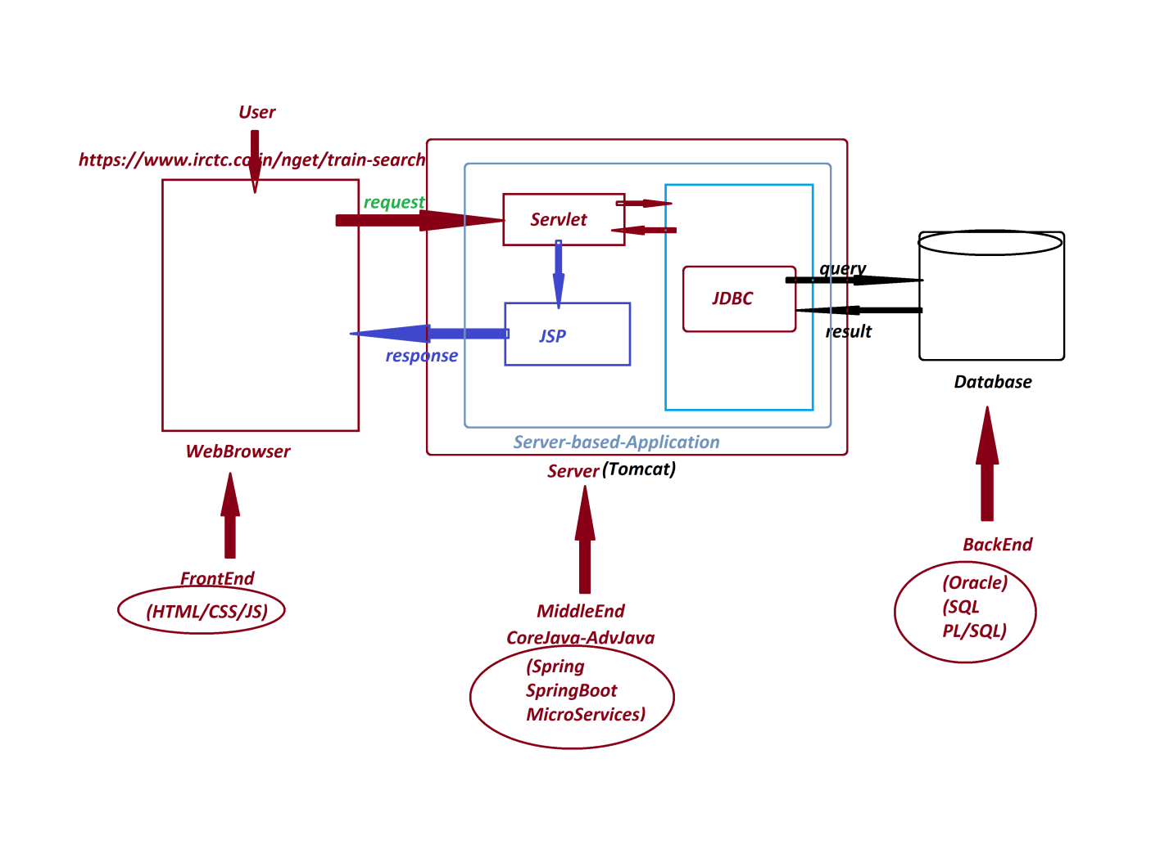

**2. Enterprise Applications:**

* The Applications which are executed in distributed environment and depending on the features like "Security", "Load Balancing" and "Clustering" are known as Enterprise Applications or Enterprise Distributed Applications.
* Enterprise Applications are available in n-tier Architecture

*Ex: Java-Frameworks*

Java-Tools

-----

***\*imp***

**JDBC:(Part-1)**

* JDBC stands for ***'Java DataBase Connectivity***' and which is used to interact with database product.

-----

FAQ

##### Define Storage?

* The memory location where the data is available for access is known as Storage.

-----

**Types of Storages:**

* According to Java Application development, the storages are categorized into four types:

***1. Field Storage***

***2. Object Storage***

***3. File Storage***

***4. Database Storage***

**1. Field Storage:**

* The memory generated to hold single data value is known as Field Storage.
* When we use Primitive datatypes like byte, short, int, long, float, double, char and boolean will generate Field Storages.

**2. Object Storage:**

* The memory generated to hold group values is known as Object-Storage.
* when we use Non- Primitive datatypes like Class, Interface, Array and Enum will generate Object Storage.

*Date: 26/2/2025 (Day-2)*

Example

|  |
| --- |
| class Addition  {  static int a;      int b;      void add()      {         int c = a+b:        Sop(c);      }  }  Addition ad = new Addition();  ad.a = 12;  ad.b = 13;  ad.add();  Addition ob2 = ad; |
| Diagram |

FAQ

**What is the difference b/w**

**(i) Object**

**(ii) Object reference**

**(iii) Object reference Variable**

**(i) Object:**

* The memory generated to hold instance members of Class is known as Object. It is created using the new keyword.

|  |
| --- |
| class Book {  String title;  double price;  }  public class ObjectExample {  public static void main(String[] args) {  Book b1 = new Book(); // Object creation  }  }  ------------------------------------------------------  -> Here, **new Book();** creates an **object** in memory. |

**(ii) Object reference:**

* The address location where the Object is created is known as Object reference.

|  |
| --- |
| class Book {  String title;  double price;  }  public class ObjectReferenceExample {  public static void main(String[] args) {  Book b1 = new Book(); // 'b1' holds the reference of the object  System.out.println(b1); // Prints memory address (hashcode) of the object  }  }  -> Here, b1 is storing the **reference** (memory location) of the object. |

**(iii) Object reference Variable:**

* The Nonprimitive-data-type variable which is holding Object reference is known as Object reference Variable or Object name.

|  |
| --- |
| class Book {  String title;  double price;  }  public class ObjectReferenceVariableExample {  public static void main(String[] args) {  Book b1 = new Book(); // 'b1' is an Object Reference Variable  Book b2; // Declaring an Object Reference Variable without initializing  b2 = b1; // Assigning reference of 'b1' to 'b2'    System.out.println("b1 reference: " + b1);  System.out.println("b2 reference: " + b2);  }  }  /** OUTPUT  b1 reference: Book@5e91993f  b2 reference: Book@5e91993f  */  -> Here, b1 and b2 are **Object Reference Variables** that hold the same **Object Reference**. |

-----

***\*imp***

**List of Objects generated from CoreJava:**

1. User defined Class Objects

2. String-Objects

3. WrapperClass-Objects

4. Array-Objects

5. Collection<E>-Objects

6. Map<K, V>-Objects

7. Enum<E>-Objects

-----

***Note:***

* The Field and Object Storages which are generated part of JVM while Application execution will be destroyed automatically when JVM Shutdowns.
* when we want to have permanent storage for Applications, then we have to take the support of any one of the following:
* File Storage
* Database Storage

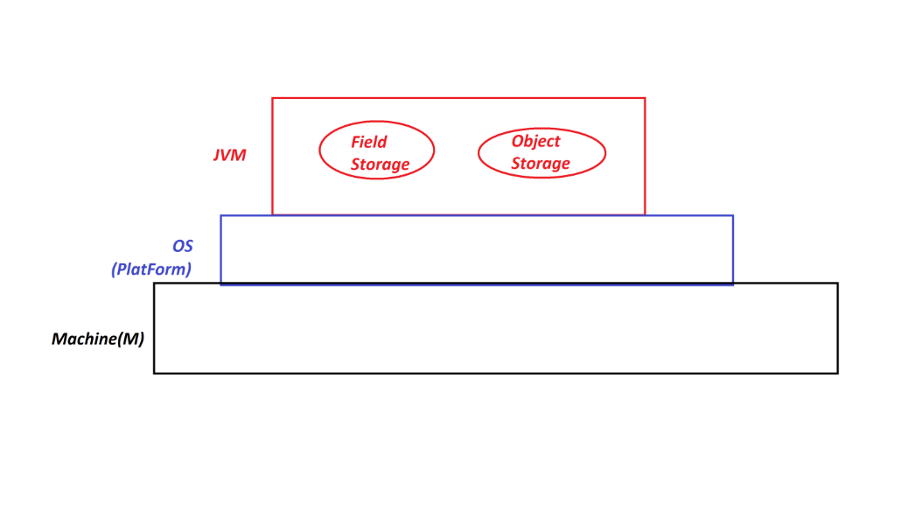

*Date: 27/02/2025 (Day-2)*

**3. File Storage:**

* The smallest permanent storage of Computer System which is 'controlled and managed' by the Operating System is known as File Storage.
* In the process of establishing communication b/w Java-Program and File-Storage, the Java-Program must be Constructed using 'Classes and Interfaces' available from 'java.io' package (IO Streams and File API)

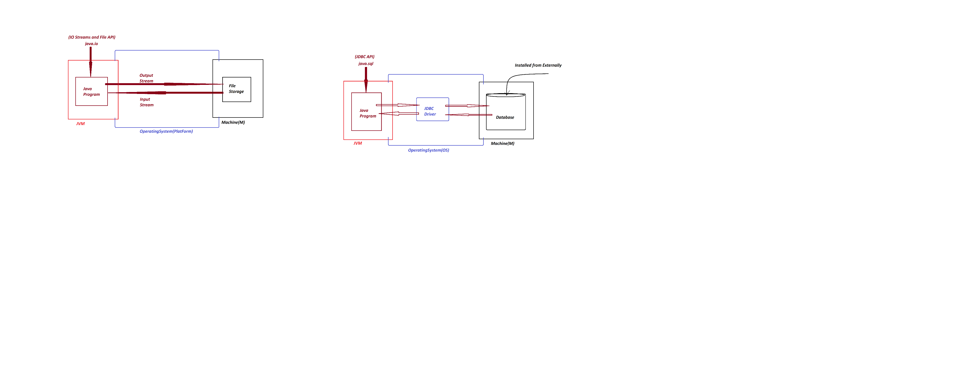

**Disadvantages of File Storage:**

(a) Data redundancy

(b) Data Inconsistency

(c) Difficulty in accessing data

(d) Limited data sharing

(e) File System corruption

(f) Security Problems

-----

*(a) Data redundancy:*

* Same information will be duplicated in different files known as Data redundancy. (data duplication)

-----

*(b) Data Inconsistency:*

* data can be inconsistent due to data redundancy

-----

*(c) Difficulty in accessing data:*

* Difficulty in accessing data, because the data is available in scattered form and there is no quering process.

-----

*(d) Limited data sharing:*

* Limited data sharing because data in scattered form.

-----

*(e) File System corruption:*

* File System can be Corrupted due to fragmentation or metadata corruption.

------

*(f)Security Problems:*

* File System will have Security Problems.

------

***Note***

* Because of disadvantages in File-Storage, the File-Storage cannot be taken as major backend for Java-Applications.
* To Overcome all disadvantages of File-Storage, we use Database Storage.

=====

***\*imp***

**4. Database Storage:**

* The largest permanent storage of Computer System, which is installed from externally is known as Database Storage.
* In the process of establishing Communication b/w Java-Program and Database-Product, the Java-Program must be constructed using 'Classes and Interfaces' from 'java.sql' package (JDBC API) and the Java-Program must take the support of JDBC-Driver

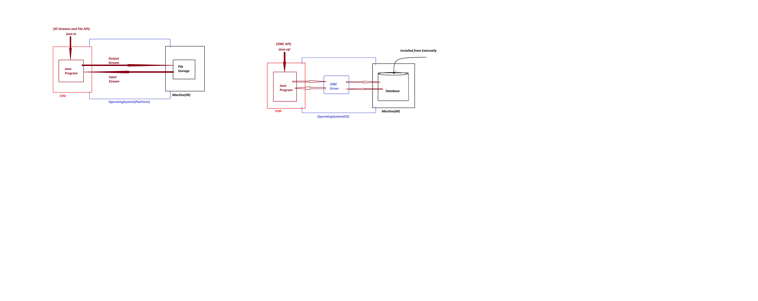

------

FAQ

#### Define 'driver'?

* The small s/w program which is used to establish communication b/w two end-points is known as 'driver'.
* *Ex: Audio drivers, Video drivers, N/W drivers*

-----

***FAQ***

#### Define JDBC driver?

* The driver which is used to establish communication b/w Java-Program and DB-Product is known as JDBC driver.

**Types of drivers:**

* According Vendor the JDBC drivers are categorized into four types:

*1. JDBC-ODBC bridge driver (Type-1 driver)*

*2. Native API driver (Type-2 driver)*

*3. Network Protocol driver (Type-3 driver)*

*4. Thin driver (Type-4 driver)*

-----

***Note***

* According to realtime application development, we use only 'Thin driver'

*Date: 28/02/2025 (Day-4)*

***\*imp***

**Creating System Environment ready to execute JDBC Applications:**

***step-1*** : Download and Install Database Product(Oracle)

***step-2*** : Perform Login process to Database Product

* DB UserName : system
* DB Password : tiger

***step-3*** : Create table with name Customer72

(phno, cid, name, city, mid) Primary Key : phno

*SQL> create table Customer72(*

*phno number(15),*

*cid varchar2(15),*

*name varchar2(15),*

*city varchar2(15),*

*mid varchar2(25),*

*primary key(phno)*

*);*

-----

***step-4*** : Insert min 5 Customer details from SQL-Command-Line

insert into Customer72 values(9898981234,'HM9898981234','Alex','Hyd','a@gmail.com');

insert into Customer72 values(7676761234,'HM7676761234','Raj','Hyd','rj@gmail.com');

insert into Customer72 values(8686861234,'HM8686861234','Ram','Hyd','rm@gmail.com');

-----

*SQL> Select * from Customer72;*

*PHNO CID NAME CITY MID*

*---------------------------------------------------------------------------------*

*9898981234 HM9898981234 Alex Hyd a@gmail.com*

*7676761234 HM7676761234 Raj Hyd rj@gmail.com*

*8686861234 HM8686861234 Ram Hyd rm@gmail.com*

-----

***step-5***  :

* Copy DB-Jar file from "lib" folder of Oracle to User defined folder(on Desktop)

**C:\oraclexe\app\oracle\product\11.2.0\server\jdbc\lib**

ojdbc6.jar - Oarcle11

FAQ

#### Define JAR?

#### JAR stands for 'Java Archive' and which is compressed format of more number of Class files.

***Note***

* This DB-Jar file will provide JDBC drivers.

-----

***step-6*** : Find the PortNo and ServiceName of Database Product(Oracle) PortNo and ServiceName is available from 'tnsnames.ora' file of 'Admin' folder of network

**C:\oraclexe\app\oracle\product\11.2.0\server\network\ADMIN**

*PortNo : 1521*

*ServiceName : XE (Express Edition)*

------

***\*imp***

***Steps used to establish communication to Database product:***

*step-1* : Loader driver

*step-2* : Creating Connection to Database Product

*step-3* : preparing JDBC-statement

*step-4* : Executing the query

*step-5* : Closing the connection from Database

-----

***\*imp***

**JDBC API:**

* 'java.sql' package is known as JDBC-API and which provide 'classes and Interfaces' to Construct JDBC-Applications.
* 'Connection' is a Normal interface from java.sql package and which is root of JDBC API.
* The following are some important methods of 'Connection' interface:

1. createStatement()

2. prepareStatement()

3. prepareCall()

4. getAutoCommit()

5. setAutoCommit()

6. setSavepoint()

7. releaseSavepoint()

8. commit()

9. rollback()

10. close()

---------------------------------------------------------------------

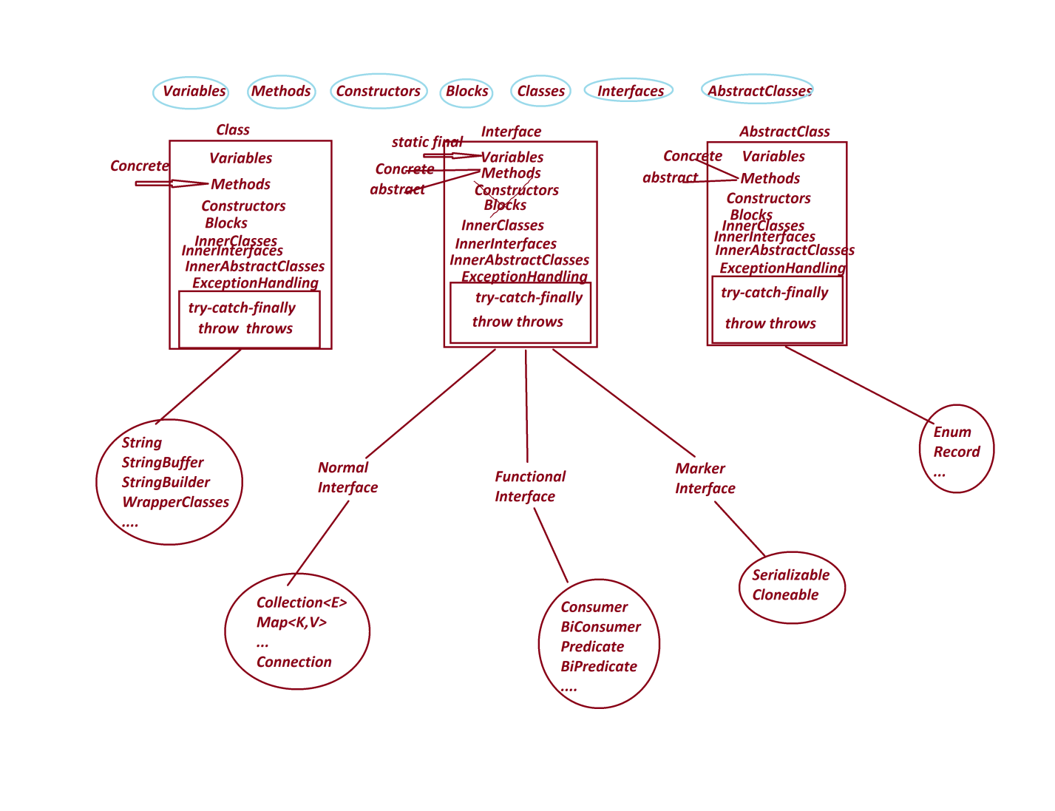

*Date: 03/03/2025 (Day-5)*

**\*imp**

**Application Development design Models:**

**Model-1 : Interface with Implementation class with name.**

#### Model-2 : Interface without Implementation Class_Name

**(Anonymous InnerClass as Implementation)**

**------**

**Model-1 : Interface with Implementation class with name.**

***Diagram:***

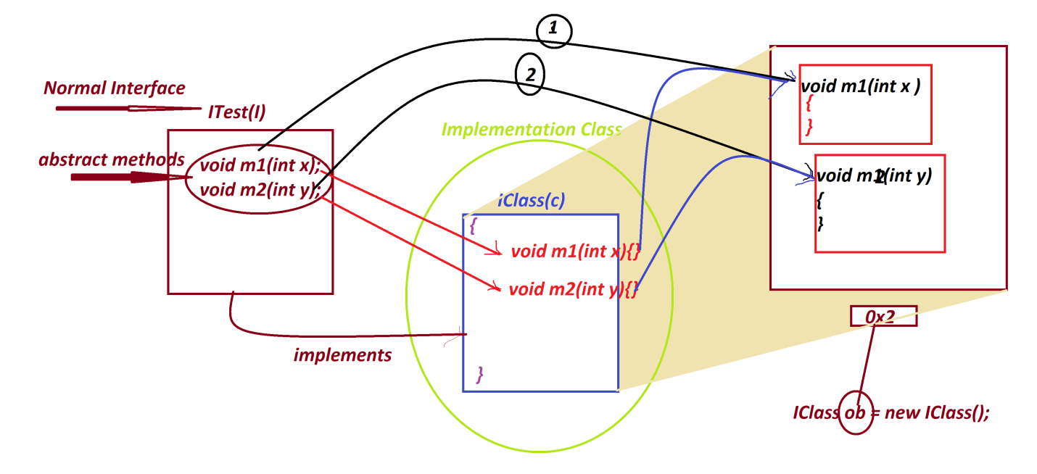

***ProjectName : CoreJava_Model_1***

|  |
| --- |
| ***//P1 : ITest.java***  **package p1;**  **public interface ITest**  **{**  **public abstract void m1(int x);**  **public abstract void m2(int y);**  **}**  ***//p1 : IClass.java***  **package p1;**  **public class IClass implements ITest**  **{**  **public void m1(int x)**  **{**  **System.out.println("*****Implemented m1(x)******");**  **System.out.println("The value x:"+x);**  **}**    **public void m2(int y)**  **{**  **System.out.println("*****Implemented m2(xy******");**  **System.out.println("The value y:"+y);**  **}**  **}** |

***p2 : DemoModel1.java(MainClass)***

|  |
| --- |
| **package p2;**  **import p1.*;**  **public class DemoModel1**  **{**  **public static void main(String[] args)**  **{**  **IClass ob = new IClass();//Implementation Object**  **ob.m1(11);**  **ob.m2(23);**  **}**  **}** |
| ***o/P:***  ***\*\*\*\*\*Implemented m1(x)\*\*\*\*\*\****  ***The value x:11***  ***\*\*\*\*\*Implemented m2(xy\*\*\*\*\*\****  ***The value y:23*** |

***\*imp***

***Model-2 : Interface without Implementation Class_Name***

***(Anonymous InnerClass as Implementation)***

Diagram

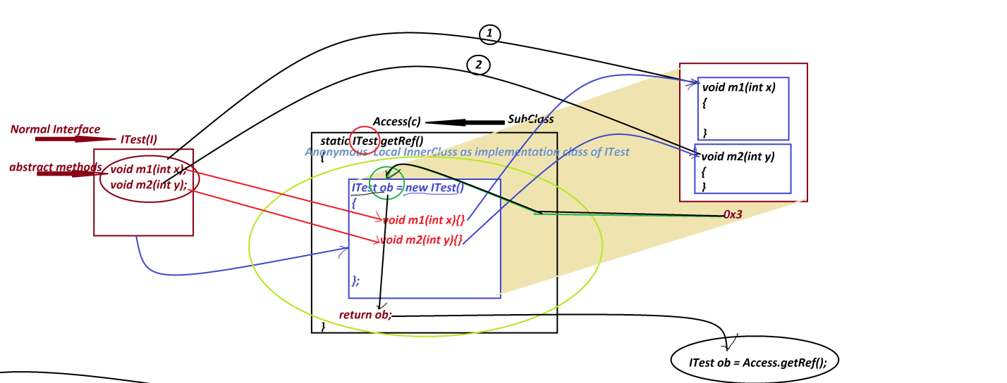

***ProjectName : CoreJava_Model_2***

|  |
| --- |
| ***p1 : ITest.java***  **package p1;**  **public interface ITest**  **{**  **public abstract void m1(int x);**  **public abstract void m2(int y);**  **}**  ***p1 : Access.java***  **package p1;**  **public class Access**  **{**  **public static ITest getRef()**  **{**  **ITest ob = new ITest()**  **{**  **public void m1(int x)**  **{**  **System.out.println("*****Implemented m1(x)*****");**  **System.out.println("The value x:"+x);**  **}**  **public void m2(int y)**  **{**  **System.out.println("*****Implemented m2(y)*****");**  **System.out.println("The value y:"+y);**  **}**  **};**  **return ob;**  **}//OuterClass static method**  **}//OuterClass** |
| ***p2 : DemoModel2.java(MainClass)***  ***package p2;***  ***import p1.*;***  ***public class DemoModel2***  ***{***  ***public static void main(String[] args)***  ***{***  ***ITest ob = Access.getRef();//Creating and Accessing Implementation Object***  ***ob.m1(11);***  ***ob.m2(12);***  ***}***  ***}*** |
| ***o/p:***  ***\*\*\*\*\*Implemented m1(x)\*\*\*\*\****  ***The value x:11***  ***\*\*\*\*\*Implemented m2(y)\*\*\*\*\****  ***The value y:12*** |

***Diagram representing generating 'Connection' implementation Object:***

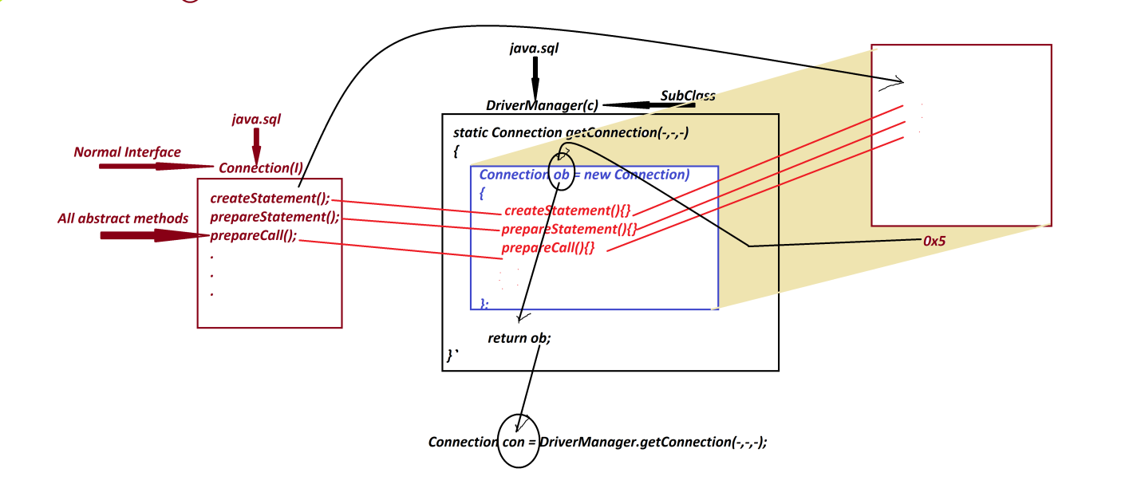

*Date: 04/03/2025 (Day-6)*

***Note***

* we use **getConnection()** - method is from 'DriverManager' to create implementation Object for 'Connection' interface, because **getConnection()**- method internally holding 'Anonymous Local InnerClass as implementation class of Connection interface' and which generate Connection-Implementation Object.

------

**Method Signature of getConnection():**

**public static java.sql.Connection getConnection**

**(java.lang.String, java.lang.String, java.lang.String)**

**throws java.sql.SQLException;**

-----

Syntax

**Connection con = DriverManager.getConnection("DB-URL","DB-UName","DB-PWord");**

*DB-URL => jdbc:oracle:thin:@localhost:1521:XE*

*DB-UName => system*

*DB-PWord => tiger*

**Connection con = DriverManager.getConnection**

**("jdbc:oracle:thin:@localhost:1521:xe","system","tiger");**

-----

***\*imp***

**JDBC statements:**

* JDBC statements will specify the type of operation to be performed on DB Product.
* These JDBC statements are categorized into three types:

**1. Statement**

**2. PreparedStatement**

**3. CallableStatement**

**1.1 Statement**

* 'Statement' is an interface from java.sql package and which is used to execute normal queries without IN-Parameters.

(Normal queries means Create, Insert, Select, Update and delete)

* we use **createStatement()**-method from 'Connection' interface to create implementation object for 'Statement' interface, because this **createStatement()** -method internally holding 'Anonymous Local InnerClass as implementation class of Statement-Interface' and which generate Statement-Object.

**Method Signature of createStatement();**

**public abstract java.sql.Statement createStatement() throws java.sql.SQLException;**

***Syntax***

**Statement stm = con.createStatement();**

* The following are two important methods of 'Statement' interface:

(a) **executeQuery()**

(b) **executeUpdate()**

**(a) executeQuery():**

* executeQuery()- method is used to execute select-queries Method
* **Signature of** **executeQuery()**:

**public abstract java.sql.ResultSet executeQuery(java.lang.String)**

**throws java.sql.SQLException;**

***Syntax***

**ResultSet rs = stm.executeQuery("select-query");**

**(b)** **executeUpdate():**

* executeUpdate()-method is used to execute NonSelect-Queries.\
* ***Method Signature of*** **executeUpdate**:

public abstract int executeUpdate(java.lang.String) throws java.sql.SQLException;

* *Syntax*

**int k = stm.executeUpdate("NonSelect-Query");**

**======**

***\*imp***

**Creating JDBC Application Using IDE Eclipse:**

-----

**step-1** : Open IDE Eclipse, while opening name the WorkSpace and click 'Launch'

-----

**step-2** : Create Java Project

-----

**step-3** : Add DB-Jar file to Java-Project through 'Build path' RightClick on Project-> Build Path -> Configure Build Path -> Libraries -> select 'Classpath' and click 'Add External JARs' -> Browse and select DB-Jar file from user defined folder-> Open-> Apply -> Apply and Close.

-----

**step-4** : Create package in 'src'

-----

**step-5** : Create class(JDBC Program) in package and write JDBC-code to display all Customer details.

**======**

|  |
| --- |
| DBCon1.java -----------  package test;  import java.sql.*;  public class DBCon1  {  public static void main(String[] args)  {  try  {  //step-1 : Loader driver  Class.forName("oracle.jdbc.driver.OracleDriver");  //step-2 : Creating Connection to Database Product  Connection con = DriverManager.getConnection  ("jdbc:oracle:thin:@localhost:1521:xe",  "system","tiger");  //step-3 : preparing JDBC-statement  Statement stm = con.createStatement();  //step-4 : Executing the query  ResultSet rs = stm.executeQuery("select * from Customer72");  while(rs.next())  {  System.out.println(rs.getLong(1)+"\t"  +rs.getString(2)+"\t"+  rs.getString(3)+"\t"+  rs.getString(4)+"\t"+  rs.getString(5));  }//end of loop  //step-5 : Closing the connection from Database  con.close();  }//end of try  catch(Exception e)  {  e.printStackTrace();  }  }  } |

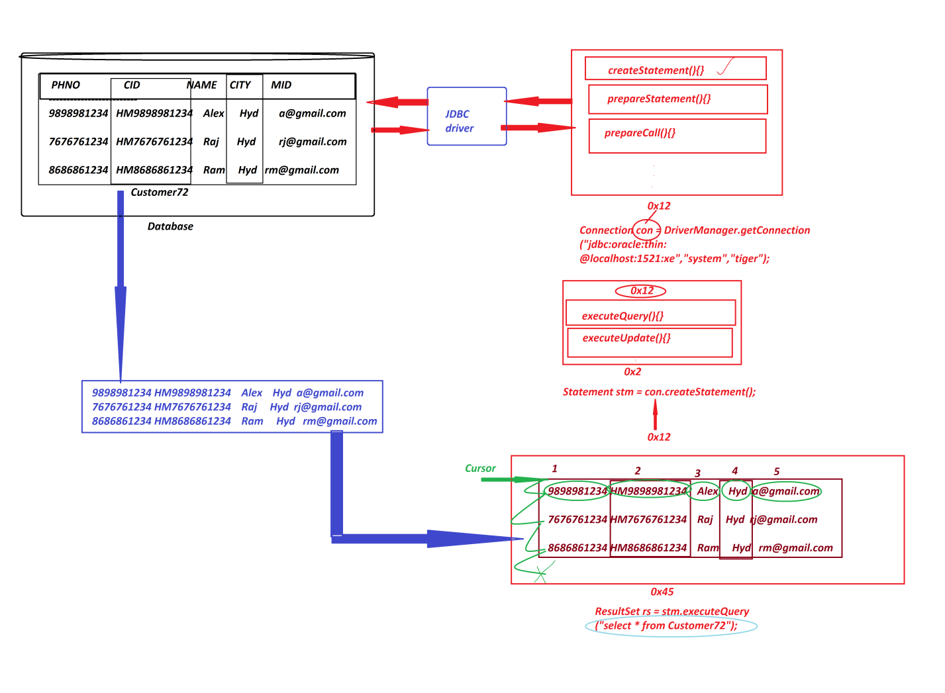

*Date: 05/03/2025 (Day-7)*

***Note***

1. **'forName()'** method is from java.lang.Class and which is used to load the class at runtime or execution time, in this process the class is not identified by the Compiler at compilation stage.
2. **executeQuery()** -method will create implementation object for 'ResultSet-Interface' and the object will hold the result generated from select-queries,and the method also generate one cursor pointing before the first row.
3. we use **'next()'** method to move the cursor on ResultSet-object and which generate boolean result***.***

-----

Example

Q. Construct JDBC Application to display Customer details based on PhoneNo.

*Diagram*

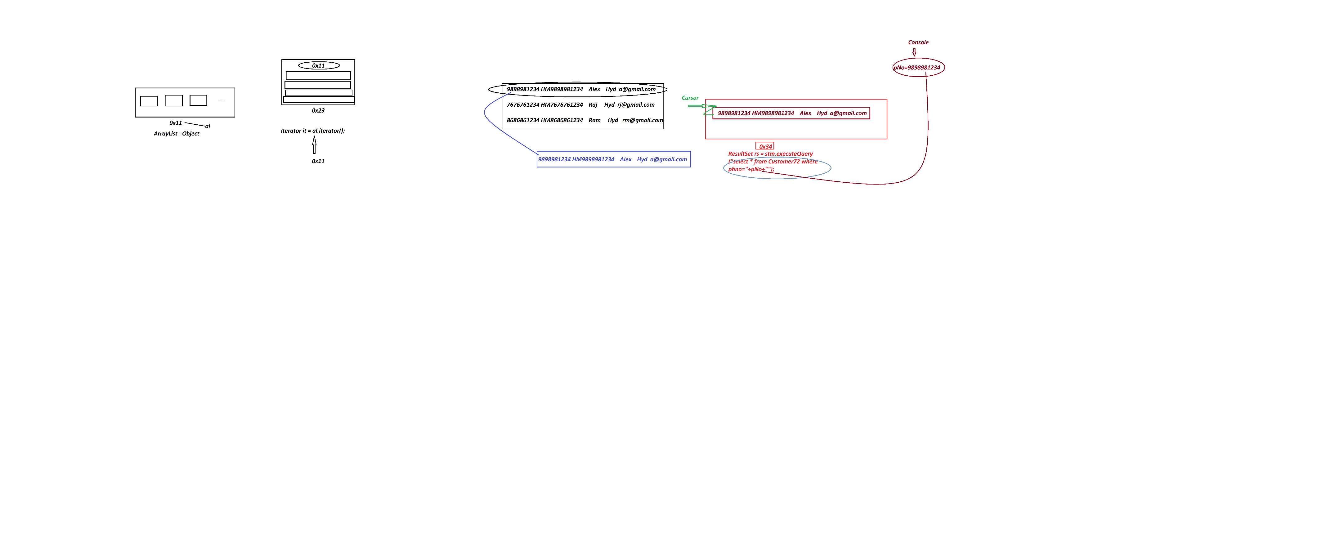

***Program-* DBCon2.java**

|  |
| --- |
| package test;  import java.sql.*;  import java.util.*;;  public class DBCon2  {  public static void main(String[] args)  {          Scanner s = new Scanner(System.in);          try(s;)          {           Class.forName("oracle.jdbc.driver.OracleDriver");           Connection con = DriverManager.getConnection           ("jdbc:oracle:thin:@localhost:1521:xe","system","tiger");           Statement stm = con.createStatement();           System.out.println("Enter the Cust-PhoneNo to display details:");           long pNo = s.nextLong();           ResultSet rs = stm.executeQuery           ("select * from Customer72 where phno="+pNo+"");           if(rs.next()) {           System.out.println(rs.getLong(1)+"\t"           +rs.getString(2)+"\t"           +rs.getString(3)+"\t"           +rs.getString(4)+"\t"           +rs.getString(5));           }else {           System.out.println("Invalud Cust-PhNo....");           }           con.close();          }//end of try          catch(Exception e)          {           e.printStackTrace();          }  }  } |
| o/P:  **Enter the Cust-PhoneNo to display details: 9898981234**  **9898981234 HM9898981234 Alex Hyd a@gmail.com** |

Example

Q. Construct JDBC Application to read Customer details from Console and insert into Customer72

Table (Insert Operation)

#### Program : DBCon3.java

|  |
| --- |
| package test;  import java.sql.*;  import java.util.*;  public class DBCon3 {  public static void main(String[] args) {         Scanner s = new Scanner(System.in);         try(s;){         Class.forName("oracle.jdbc.driver.OracleDriver");          Connection con = DriverManager.getConnection          ("jdbc:oracle:thin:@localhost:1521:xe","system","tiger");          Statement stm = con.createStatement();          System.out.println("Enter the Cust-PhoneNO:");          long phNo = Long.parseLong(s.nextLine());          String custId = "HM"+phNo;          System.out.println("Enter the Cust-Name:");          String name = s.nextLine();          System.out.println("Enter the Cust-City:");          String city = s.nextLine();          System.out.println("Enter the Cust-MailId:");          String mId = s.nextLine();          int k = stm.executeUpdate          ("insert into Customer72 values("+phNo+",'"+custId+"','"+name+"','"+city+"','"+mId+"')");          if(k>0) {          System.out.println("Customer details added Successfully...");          }          con.close();         }catch(Exception e) {         e.printStackTrace();         }  }  } |
| o/p:  Enter the Cust-PhoneNO: 4545451234  Enter the Cust-Name: RTER  Enter the Cust-City: Hyd  Enter the Cust-MailId: r@gmail.com  Customer details added Successfully... |

----

***Assignment***

*DB Table : BookDetails72*

*(bcode,bname,bauthor,bprice,bqty)*

*primary key : bcode*

*program-1 : Construct JDBC Application to insert 5 book details*

Program-2 : Construct JDBC Application to display all book details

*program-3 : Construct JDBC Application to display book details based on bookCode*

[[**View Program**](https://github.com/lalitpatil891/Code-with-AdvanceJava/tree/main/PracticePrograms/BookTrack72_JDBC_app_1/src/test)]

*Date: 06/03/2025 (Day-8)*

Example

Construct JDBC Application to perform Update and Delete Operations on Customer table.

(based Customer PhoneNo) 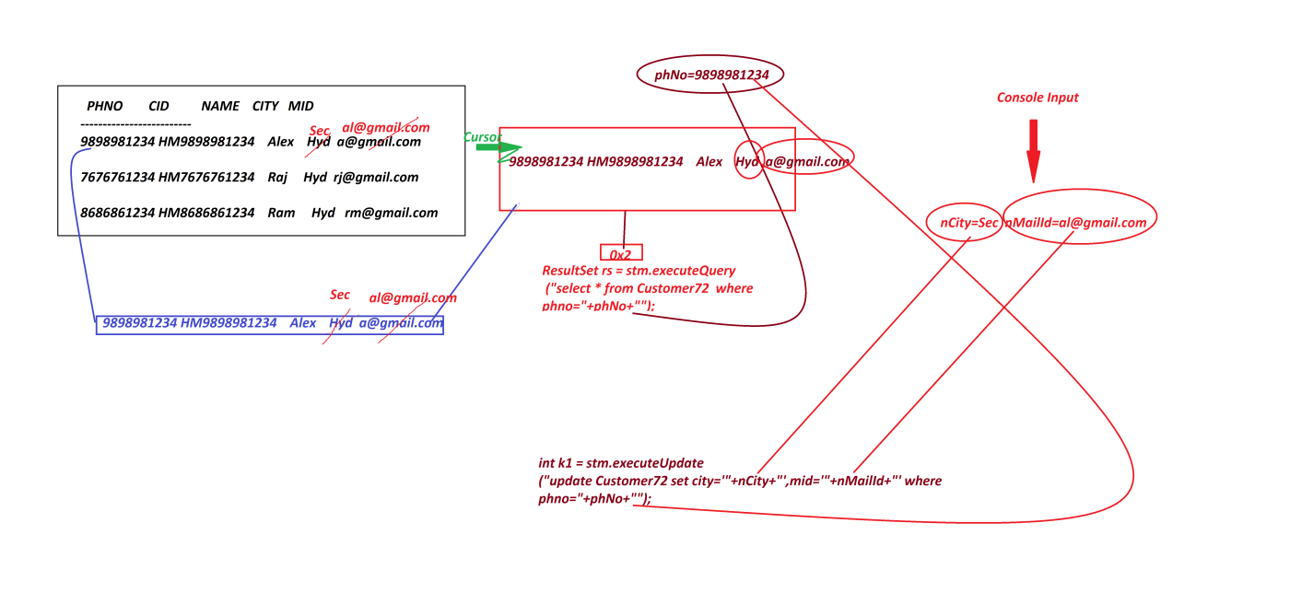

[[View Program](https://github.com/lalitpatil891/Code-with-AdvanceJava/blob/main/PracticePrograms/JDBC_app_5/src/test/DBcon5.java)]

----------------------------------------------------------------------------------

Example

#### Construct JDBC Application to perform the following operations

1.create

2.insert

3.update

4.delete

##### Program : DBCon5.java

package test;

import java.sql.*;

import java.util.*;

public class DBCon5 {

public static void main(String[] args) {

Scanner s = new Scanner(System.in);

try(s;){

Class.forName("oracle.jdbc.driver.OracleDriver");

Connection con = DriverManager.getConnection

("jdbc:oracle:thin:@localhost:1521:xe","system","tiger");

Statement stm = con.createStatement();

System.out.println("Enter the query(create/insert/update/delete)");

String qry = s.nextLine();

int k = stm.executeUpdate(qry);

System.out.println("The value in k:"+k);

if(k>=0) {

System.out.println("Query executed Successfully...");

}

con.close();

}catch(SQLSyntaxErrorException sqe) {

System.out.println(sqe.getMessage());

System.out.println("Error Code:"+sqe.getErrorCode());

}catch(SQLIntegrityConstraintViolationException sie) {

System.out.println(sie.getMessage());

System.out.println("Error Code:"+sie.getErrorCode());

}catch(Exception e) {

e.printStackTrace();

}

}

}

o/p:(Create)

Enter the query(create/insert/update/delete)

create table emp72(id varchar2(10),name varchar2(15),desg varchar2(10),primary key(id))

The value in k:0

Query executed Successfully...

o/p:(Insert)

Enter the query(create/insert/update/delete)

insert into Emp72 values('A11','Alex','SE')

The value in k:1

Query executed Successfully...

o/p:(Update)

Enter the query(create/insert/update/delete)

update Emp72 set desg='ME' where id='A11'

The value in k:1

Query executed Successfully...

o/p:(Delete)

Enter the query(create/insert/update/delete)

delete from Emp72 where id='A21'

The value in k:1

Query executed Successfully...

o/p:

Enter the query(create/insert/update/delete)

create table Emp72(id varchar2(10),name varchar2(15),desg varchar2(10),primary key(id))

Table already avilable...

Error Code:955

955 - Create

001 – Insert

-------------------------------------------------------------------------------------

Assignment

*DB Table : Product72(code,name,price,qty)*

*Primary key : code*

*Construct JDBC Application to perform the following operations based on User Choice:*

*1.AddProduct*

*2.ViewAllProducts*

*3.ViewProductByCode*

*4.UpdateProductByCode(price-qty)*

*5.DeleteProductByCode*

*6.Exit*

*Note:*

*=>repeat the above choice(operations) until we perform exit-operation*

**[**[**View Program**](https://github.com/lalitpatil891/Code-with-AdvanceJava/blob/main/PracticePrograms/JDBC_Inventory_App/src/test/InventoryAppDBcon.java)**]**

--------------------------------------------------------------------------------

*Date: 07/03/2025 (Day-9)*

***\*imp***

**1.2 PreparedStatement**

* 'PreparedStatement' is an interface from java.sql package and which is used to execute normal queries with IN-Parameters.
* we use parepareStatement() -method from 'Connection' interface to create implementation Object for 'PreparedStatement' interface, becuase the prepareStatement()-method internally holding 'Anonymous Local innerclass as implementation class of preparedStatement Interface and which generate PreparedStatement-Object
* Method signature of **prepareStatement()**

**public abstract java.sql.PreparedStatement prepareStatement(java.lang.String) throws java.sql.SQLException;**

***Syntax***

**PreparedStatement ps = con.prepareStatement("query-structure");**

* The following are two important methods of PreparedStatement:

**(a)** **executeQuery()**

**(b)** **executeUpdate()**

**(a) executeQuery()**

* *executeQuery()* - method is used to execute select-queries.
* Method Signature of ***executeQuery()*:**

**public abstract java.sql.ResultSet executeQuery() throws java.sql.SQLException;**

* ***syntax***

**ResultSet rs = ps.executeQuery();**

**(b) executeUpdate()**

* **executeUpdate()** -method is used to execute NonSelect queries.
* Method signature of **executeUpdate()**
* **public abstract int executeUpdate() throws java.sql.SQLException;**
* ***syntax***

**int k = ps.executeUpdate();**

-----

***Note***

***executeQuery()*** *and* ***executeUpdate()*** *methods are with parameter in 'Statement' and without parameter in 'preparedStatement'.*

------

***Example :***

***(Demonstrating PreparedStatement)***

DBTable : BankCustomer72(accno,cid,cname,balance,acctype)

primary key : accno

*create table BankCustomer72(*

*accno number(15),*

*cid varchar2(15),*

*cname varchar2(15),*

*balance number(10,2),*

*acctype varchar2(15),*

*primary key(accno));*

-----

***Construct JDBC Application to perform the following operations based on Choice:***

***1.AddBankCustomer***

***2.ViewAllBankCustomers***

***3.Exit***

***Note: repeat the process until we perform exit operation***

***Program*** DBCon6.java

|  |
| --- |
| package test;  import java.sql.*;  import java.util.*;  public class DBCon6  {  public static void main(String[] args)  {  Scanner s = new Scanner(System.in);  try(s;){  Class.forName("oracle.jdbc.driver.OracleDriver");  Connection con = DriverManager.getConnection  ("jdbc:oracle:thin:@localhost:1521:xe","system","tiger");  PreparedStatement ps1 = con.prepareStatement  ("insert into BankCustomer72 values(?,?,?,?,?)");  //Compilation process  PreparedStatement ps2 = con.prepareStatement  ("select * from BankCustomer72");//Compilation Process  while(true) {  System.out.println("******Operations Choice******");  System.out.println("\t1.AddBankCustomer"  + "\n\t2.ViewAllBankCustomers"  + "\n\t3.Exit");  System.out.println("Enter Your Choice:");  int choice = Integer.parseInt(s.nextLine());  switch(choice) {  case 1:  //read data from console into Local variables  System.out.println("Enter the CustAccNo:");  long accNo = Long.parseLong(s.nextLine());  String cId = "SB"+accNo;  System.out.println("Enter the CustName:");  String cName = s.nextLine();  System.out.println("Enter the Cust-Balance:");  float balance = Float.parseFloat(s.nextLine());  System.out.println("Enter the Cust-AccType:");  String accType = s.nextLine();    //Load data to PreparedStatement Object using Setter methods  ps1.setLong(1, accNo);  ps1.setString(2, cId);  ps1.setString(3, cName);  ps1.setFloat(4, balance);  ps1.setString(5, accType);    int k = ps1.executeUpdate();//Execution Process  if(k>0) {  System.out.println("BankCustomer Added Successfully...");  }    break;  case 2:  ResultSet rs = ps2.executeQuery();//Execution process  while(rs.next()) {  System.out.println(rs.getLong(1)+"\t"  +rs.getString(2)+"\t"  +rs.getString(3)+"\t"  +rs.getFloat(4)+"\t"  +rs.getString(5));  }//end of loop  break;  case 3:  System.out.println("Operations Stopped...");  System.exit(0);  default:  System.out.println("Invalid Choice....");  }//end of switch  }//end of while  }catch(Exception e) {  e.printStackTrace();  }  }  } |
| *o/p:*  *\*\*\*\*\*\*Operations Choice\*\*\*\*\*\**  *1.AddBankCustomer*  *2.ViewAllBankCustomers*  *3.Exit*  *Enter Your Choice:*  *2*  *6123456 SB6123456 Alex 12000.0 Savings*  *454541234 SB454541234 Ram 16000.0 Savings*  *\*\*\*\*\*\*Operations Choice\*\*\*\*\*\**  *1.AddBankCustomer*  *2.ViewAllBankCustomers*  *3.Exit*  *Enter Your Choice:*  *3*  *Operations Stopped...* |

***Diagram***

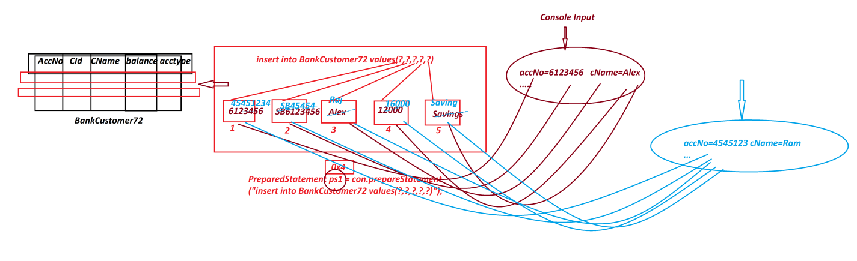

*Date: 08/03/2025 (Day-10)*

***Example***

*Construct JDBC Application to perform the following operations on Choice based on AccNo*

*1.UpdateBankCustomer*

*2.DeleteBankCustomer*

***Program*** *DBCon7.java*

|  |
| --- |
| package test;  import java.util.*;  import java.sql.*;  public class DBCon7 {  public static void main(String[] args) {  Scanner s = new Scanner(System.in);  try(s;){  Class.forName("oracle.jdbc.driver.OracleDriver");  Connection con = DriverManager.getConnection  ("jdbc:oracle:thin:@localhost:1521:xe","system","tiger");  PreparedStatement ps1 = con.prepareStatement  ("select * from BankCustomer72 where accno=?");  //Compilation process  PreparedStatement ps2 = con.prepareStatement  ("update BankCustomer72 set balance=? where accno=?");  //Compilation Process  PreparedStatement ps3 = con.prepareStatement  ("delete from BankCustomer72 where accno=?");  //Compilation Process  System.out.println("Enter the Cust-AccNo to perform Update/Delete operation:");  long accNo = s.nextLong();  ps1.setLong(1, accNo);  ResultSet rs = ps1.executeQuery();  if(rs.next()) {  System.out.println("*******Operation Choice*****");  System.out.println("\t1.UpdateBankCustomer"  + "\n\t2.DeleteBankCustomer");  System.out.println("Enter your Choice:");  int choice = s.nextInt();  switch(choice) {  case 1:  System.out.println("Existing balance:"+rs.getFloat(4));  System.out.println("Enter the new balance:");  float nBal = s.nextFloat();  ps2.setFloat(1, nBal);  ps2.setLong(2,accNo);  int k1 = ps2.executeUpdate();  if(k1>0) {  System.out.println("Customer Updated Successfully...");  }  break;  case 2:  ps3.setLong(1, accNo);  int k2 = ps3.executeUpdate();  if(k2>0) {  System.out.println("Customer deleted Successfully....");  }  break;  default:  System.out.println("Invalid Choice....");  }//end of switch  }else {  System.out.println("Invalid accNo....");  }  con.close();  }catch(Exception e) {  e.printStackTrace();  }  }  } |
| o/p:(Update)  Enter the Cust-AccNo to perform Update/Delete operation:  454541234  *******Operation Choice*****  1.UpdateBankCustomer  2.DeleteBankCustomer  Enter your Choice:  1  Existing balance:16000.0  Enter the new balance:  20000  Customer Updated Successfully...  o/p:(Delete)  Enter the Cust-AccNo to perform Update/Delete operation:  454541234  *******Operation Choice*****  1.UpdateBankCustomer  2.DeleteBankCustomer  Enter your Choice:  2  Customer deleted Successfully.... |
| ***Diagram*** |

**'ResultSet' in JDBC *\*imp***

* 'ResultSet' is an interface from java.sql package and which is instantiated to holdthe result generated from select-queries.
* 'ResultSet' Objects are categorized into two types:

*1.NonScrollable ResultSet Objects*

*2.Scrollable ResultSet Objects*

***1. NonScrollable ResultSet Objects:***

* In NonScrollable ResultSet Objects the cursor can be moved only in one direction, from top-of-table-data to bottom-of-table-data, which means only in forward direction.
* we use the following syntax to create NonScrollable ResultSet Object:

**Syntax-1** **:** Using 'Statement'

**Statement stm = con.createStatement();**

**ResultSet rs = stm.executeQuery("select-query");**

**Syntax-2 :** Using 'PreparedStatement'

**PreparedStatement ps = con.prepareStatement("select-query-structure");**

**ResultSet rs = ps.executeQuery();**

***2. Scrollable ResultSet Objects***

* In Scrollable ResultSet Objects the cursor can be moved in both directions,which means can be moved in foward and backward directions.
* we use the following syntax to create Scrollable ResultSet Object:

***syntax-1*** : Using 'Statement'

**Statement stm = con.createStatement(type, mode);**

**ResultSet rs = stm.executeQuery("select-query");**

***syntax-2*** : Using 'PreparedStatement'

**PreparedStatement ps =**

**con.prepareStatement(type, mode,"select-query-structure");**

**ResultSet rs = ps.executeQuery();**

*Date: 10/03/2025 (Day-11)*

**Define "type"?**

* "type" specifies the direction of Cursor on ResultSet Object.
* The following fields from ResultSet-Interface will specify the "type"

**public static final int TYPE_FORWARD_ONLY;**

**public static final int TYPE_SCROLL_INSENSITIVE;**

**public static final int TYPE_SCROLL_SENSITIVE;**

-----

**Define "mode"?**

* "mode" specifies the action to be performed on ResultSet Object.
* The following fields from ResultSet-Interface will specify the "mode":

**public static final int CONCUR_READ_ONLY;**

**public static final int CONCUR_UPDATABLE;**

---------------------------------------------------------------

***Note***

* we use the following some important methods to control cursor on ResultSet Object:

**1. afterLast()**

**2. beforeFirst()**

**3. first()**

**4. last()**

**5. previous()**

**6. next()**

**7. absolute(int)**

**8. relative(int)**

**1. afterLast()**

* afterLast() - method will make the cursor point after the last row in ResultSet Object.

**2. beforeFirst()**

* beforeFirst() - method will make the cursor point before the first row in ResultSet Object.

**3. first()**

* first() - method will make the cursor point to the first row of ResultSet Object.

**4. last()**

* last() - method will make the cursor point to the last row of ResultSet Object.

**5. previous()**

* previous() - method is used to move the cursor in backward direction.

**6. next()**

* next() - method is used to move the cursor in forward direction.

**7. absolute(int)**

* absolute(int) - method is used to move the cursor to specified row number.

**8.relative(int)**

* relative(int) - method is used to take incre/decre value as parameter and move the cursor in forward or backward direction from current cursor position.

***Example***

|  |
| --- |
| ***Program: DBCon8.java***  package test;  import java.sql.*;  public class DBCon8 {  public static void main(String[] args) {  try {  Class.forName("oracle.jdbc.driver.OracleDriver");  Connection con = DriverManager.getConnection  ("jdbc:oracle:thin:@localhost:1521:xe","system","tiger");  System.out.println("*******Statement******");  Statement stm = con.createStatement  (ResultSet.TYPE_SCROLL_INSENSITIVE,  ResultSet.CONCUR_READ_ONLY);  ResultSet rs1 = stm.executeQuery("select * from Customer72");  System.out.println("------3rd row------");  rs1.absolute(3);  System.out.println(rs1.getLong(1)+"\t"  +rs1.getString(2)+"\t"  +rs1.getString(3)+"\t"  +rs1.getString(4)+"\t"  +rs1.getString(5));  System.out.println("------relative(-2)------");  rs1.relative(-2);  System.out.println(rs1.getLong(1)+"\t"  +rs1.getString(2)+"\t"  +rs1.getString(3)+"\t"  +rs1.getString(4)+"\t"  +rs1.getString(5));  System.out.println("------last row------");  rs1.last();  System.out.println(rs1.getLong(1)+"\t"  +rs1.getString(2)+"\t"  +rs1.getString(3)+"\t"  +rs1.getString(4)+"\t"  +rs1.getString(5));  System.out.println("------first row------");  rs1.first();  System.out.println(rs1.getLong(1)+"\t"  +rs1.getString(2)+"\t"  +rs1.getString(3)+"\t"  +rs1.getString(4)+"\t"  +rs1.getString(5));  System.out.println("*****PreparedStatement******");  PreparedStatement ps = con.prepareStatement(  "select * from BankCustomer72",  ResultSet.TYPE_SCROLL_INSENSITIVE,  ResultSet.CONCUR_READ_ONLY);  ResultSet rs2 = ps.executeQuery();  System.out.println("------reverse-----");  rs2.afterLast();  while(rs2.previous()) {  System.out.println(rs2.getLong(1)+"\t"  +rs2.getString(2)+"\t"  +rs2.getString(3)+"\t"  +rs2.getString(4)+"\t"  +rs2.getString(5));  }//end of loop  }catch(Exception e) {  e.printStackTrace();  }  }  } |
| o/p:  *******Statement******  ------3rd row------  4545451234 HM4545451234 RTER Hyd r@gmail.com  ------relative(-2)------  9898981234 HM9898981234 Alex Sec al@gmail.com  ------last row------  4545451234 HM4545451234 RTER Hyd r@gmail.com  ------first row------  9898981234 HM9898981234 Alex Sec al@gmail.com  *****PreparedStatement******  ------reverse-----  321321 SB321321 Raj 10000 Savings  6123456 SB6123456 Alex 12000 Savings |

***Assignment***

*DB Table: Employee72(eid,ename,edesg,bsal,hra,da,totsal)*

*Primary Key : eid*

*Construct JDBC Application to perform the following Operations based on Choice:*

*1.AddEmployee*

*2.ViewAllEmployees*

*3.ViewEmployeeByCode*

*4.UpdateEmployeeById(bSal)*

*5.DeleteEmployeeById*

*6.Exit*

*Calcutions:*

*hra = 91% of bSal*

*da = 63% of bSal*

*totSal = bSal+hra+da*

*Exception: Min bSal must be 12000/-,else raise the exception*

**[**[**View Program**](https://github.com/lalitpatil891/Code-with-AdvanceJava/tree/main/PracticePrograms/JDBC_app_Employee72/src/test)**]**

*Date: 11/03/2025 (Day-12)*

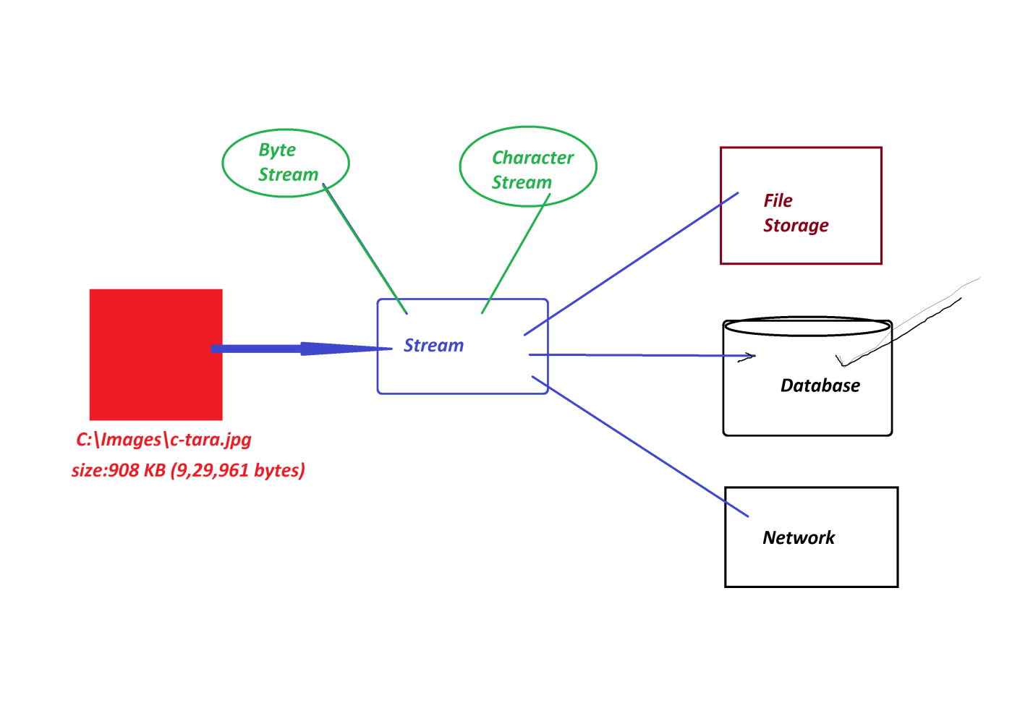

***\*imp***

***Streams with Database product***

**Define stream? (Normal definition)**

* The continuous flow of data is known as stream.

***Types of streams***

* Java language support two types of streams:

**1.Byte Stream (Binary Stream)**

**2.Character Stream**

**1. Byte Stream(Binary Stream)**

* The continuous flow of data in the form of 8-bits is known as Byte Stream or Binary Stream.
* Through Byte Stream we can send all Multi-Media data formats,which means Text, Audio, Video, Image and Animation.

**2. Character Stream**

* The Continuous flow of data in the form of 16-bits is known as Character Stream or Text Stream.
* Character Stream is preferable for Text data,and which is not preferable for Audio, Video,Image and Animation data.

------

* We use the following SQL-Types to store Stream data:

***(a)BLOB***

***(b)CLOB***

**(a)BLOB**

* BLOB stands for 'Binary Large OBjects' and which is used to store Byte Stream data.

**(b)CLOB**

* CLOB stands for 'Character Large OBjects' and which is used to store Character Stream data.

-------------------------------------------------------------------------------

***\*imp***

**Storing Stream data to Database product**

**Step-1 :**

Create DB Table with name StreamTab72(id, name, mfile)

create table StreamTab72(id varchar2(10), name varchar2(15), mfile BLOB, primary key(id));

**Step-2 :** Construct JDBC Application to store Image to Database product

|  |
| --- |
| **Program : DBCon9.java**  package test;  import java.util.*;  import java.io.*;  import java.sql.*;  public class DBCon9  {  public static void main(String[] args)  {  Scanner s = new Scanner(System.in);  try(s;){  Class.forName("oracle.jdbc.driver.OracleDriver");  Connection con = DriverManager.getConnection  ("jdbc:oracle:thin:@localhost:1521:xe","system","tiger");  PreparedStatement ps = con.prepareStatement  ("insert into StreamTab72 values(?,?,?)");  System.out.println("Enter the User-Id:");  String id = s.nextLine();  System.out.println("Enter the User-Name:");  String name = s.nextLine();  System.out.println("Enter the Location(fPath&fName) of User-Image(Source)");  String path = s.nextLine();  File f = new File(path);  if(f.exists()) {  FileInputStream fis = new FileInputStream(path);  ps.setString(1,id);  ps.setString(2,name);  ps.setBinaryStream(3, fis, f.length());  int k = ps.executeUpdate();  if(k>0) {  System.out.println("Image Stored Successfully...");  }  fis.close();  }else {  System.out.println("Invalid fPath or fName....");  }  con.close();  }catch(Exception e) {  e.printStackTrace();  }  }  } |
| ***o/p:***  Enter the User-Id:  A121  Enter the User-Name:  Alex  Enter the Location(fPath&fName) of User-Image(Source)  C:\Images\c-tara.jpg  Image Stored Successfully... |
| ***Diagram*** |

*Date: 12/03/2025 (Day-13)*

***Retrieving Stream(Image) from Database Product***

|  |
| --- |
| **Program : DBCon10.java**  package test;  import java.util.*;  import java.io.*;  import java.sql.*;  public class DBCon10 {  public static void main(String[] args) {  Scanner s = new Scanner(System.in);  try(s;){  Class.forName("oracle.jdbc.driver.OracleDriver");  Connection con = DriverManager.getConnection  ("jdbc:oracle:thin:@localhost:1521:xe","system","tiger");  PreparedStatement ps = con.prepareStatement  ("select * from StreamTab72 where id=?");  System.out.println("Enter the User-Id to retrive details:");  String id = s.nextLine();  ps.setString(1, id);  ResultSet rs = ps.executeQuery();  if(rs.next()) {  Blob b = rs.getBlob(3);  byte by[] = b.getBytes(1, (int)b.length());  System.out.println("User-Id:"+rs.getString(1));  System.out.println("User-Name:"+rs.getString(2));  System.out.println("Enter the lacation(fPath&fName-destination) to store Stream: ");  String path = s.nextLine();  FileOutputStream fos = new FileOutputStream(path);  fos.write(by);  System.out.println("Stream stored to specified location....");  fos.close();  }else {  System.out.println("Invalid User Id....");  }  }catch(Exception e) {  e.printStackTrace();  }  }  } |
| o/p:  Enter the User-Id to retrive details:  A121  User-Id:A121  User-Name:Alex  Enter the lacation(fPath&fName-destination) to store Stream:  E:\Images\XYZ.jpg  Stream stored to specified location.... |
| ***Diagram*** |

***FAQ***

**Define** **'FileInputStream'?**

* ‘FileInputStream' is a class from java.io package and which is instantiated to link(open) the file to read Byte-Stream data.
* ***Syntax***

**FileInputStream fis = new FileInputStream("fPath&fName");**

------

***FAQ***

**Define 'FileOutputStream'?**

* 'FileOutputStream' is a class from java.io package and which is instantiated to create a new file with 0KB and links(opens) the file to write Byte-stream data.
* ***Syntax***

**FileOutputStream fos = new FileOutputStream("fPath&fName");**

------

***FAQ***

**Define setBinaryStream() method?**

* setBinaryStream()-method belongs to PreparedStatement and which links stream to parameter-index-field of PreparedStatement Object.
* Through this method we must specify para-index-no,location-of-stream and length-of-stream.
* ***Syntax***

**ps.setBinaryStream(3, fis, f.length());**

------

***FAQ***

**define getBlob() method?**

* getBlob()-method is from ResultSet and which is used to instantiate Blob-Interface and this Blob-Object internally linked to Stream-column of ResultSet.
* ***Syntax***

**Blob b = rs.getBlob(3);**

**-------**

***FAQ*** ***\*imp***

**Define getBytes() method?**

* getBytes()-method is from Blob,and which is used to convert stream into byte-Array.
* ***Syntax***

**byte by[] = b.getBytes(1, (int)b.length());**

**------**

***\*imp***

**CallableStatement**

* 'CallableStatement' is an interface from java.sql package and which is used to execute Procedures and Functions on Database product.
* we use prepareCall()-method from 'Connection-interface' to create implementation Object for 'CallableStatement Interface',because the prepareCall()-method internally holding 'Anonymous Local InnerClass as implementation class of CallableStatement' and generate CallableStatement Object.
* Method Signature of **prepareCall():**

public abstract java.sql.CallableStatement prepareCall(java.lang.String) throws java.sql.SQLException;

* ***Syntax***

**CallableStatement cs = con.prepareCall("{call Proce_name/Func_name}");**

**-----**

*Date: 12/03/2025 (Day-13)*

***What is the difference***

***(i)function***

***(ii)member function***

***(iii)method***

**(i) function**

* The part of program which is executed outof main()-program is known as 'function' in C-Lang.

**(ii) member function**

* The functions which are declared as members of class in C++ are known as member functions.
* These member functions can be declared inside the class or Outside the class with class reference.

**(iii) method**

* The functions which are declared only inside the class in Java are known as Methods.

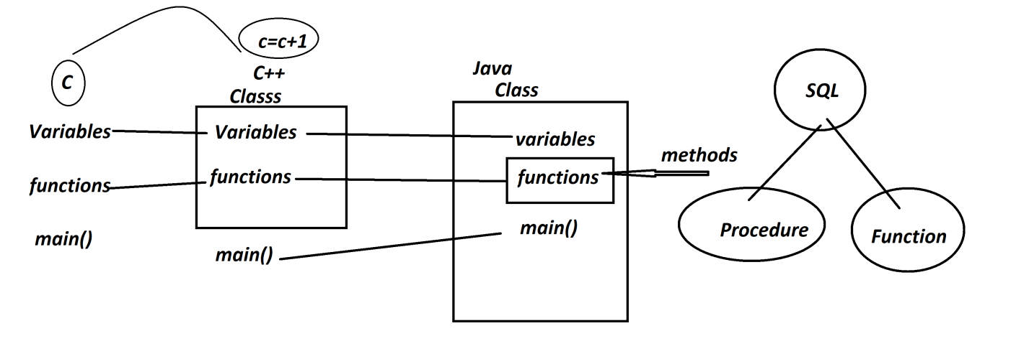

-----

***FAQ***

**Define 'Procedure'?**

* Procedure is a set-of-queries executed on Database product at-a-time, and after execution Procedure will not return any value.

(Procedure means NonReturn_type)

*Structure of Procedure:*

|  |
| --- |
| **create or replace procedure Procedure_name**  **(para_list) is**  **begin**  **query-1**  **query-2**  **...**  **end;**  **/** |

**Types of Procedures**

* According to JDBC,Procedures are categorized into three types:

***(a) IN-Parameter Procedure***

***(b) OUT-Parameter Procedure***

***(c) IN-OUT-Parameter Procedure***

**(a) IN-Parameter Procedure**

* The Procedures which take the data from Java-Program and sent to database product are known as IN-Parameter Procedures.

**(b)** **OUT-Parameter Procedure**

* The Procedures which take the data from database product and sent to Java-Program are known as OUT-Parameter Procedures.

**(c) IN-OUT-Parameter Procedure**

* The procedures which perform both operations are known as IN-OUT-Parameter Procedures.

***FAQ***

**Define 'Function'?**

* Function is a set-of-queries executed on Database product at-a-time,and after execution it will return the value.
* we use 'return' statement to return the value from Function.

*Stucture of Function*

|  |
| --- |
| **create or replace Function Function_name**  **(para_list) return data_type as var data_type;**  **begin**  **queries**  **return var;**  **end;**  **/** |

------

***\*imp***

**Construct Application to demonstrate Procedure**

**Step-1 :** *Create the following tables*

EmpData72(eid,ename,edesg);

EmpAddress72(eid,hno,sname,city,state,pincode);

EmpContact72(eid,mid,phno);

EmpSalary72(eid,bsal,hra,da,totsal);

-----

create table EmpData72(eid varchar2(10),ename varchar2(15),edesg varchar2(10), primary key(eid));

-----

create table EmpAddress72(eid varchar2(10), hno varchar2(15), sname varchar2(15), city varchar2(15), state varchar2(15), pincode number(10), primary key(eid));

-----

create table EmpContact72(eid varchar2(10), mid varchar2(25), phno number(15), primary key(eid));

-----

create table EmpSalary72(eid varchar2(10), bsal number(10), hra number(10,2), da number(10,2), totsal number(10,2), primary key(eid));

-----

**Step-2 :** *Construct Procedure to perform Insert operation to Employee tables*

create or replace procedure InsertEmployee72

(id varchar2, en varchar2, ed varchar2, hn varchar2, sn varchar2, cty varchar2, st varchar2, pcode number, md varchar2, pno number, bs number, h number, d number, ts number) is

begin

insert into EmpData72 values(id, en, ed);

insert into EmpAddress72 values(id, hn, sn, cty, st, pcode);

insert into EmpContact72 values(id, md, pno);

insert into EmpSalary72 values(id, bs, h, d, ts);

end;

/

------

**Step-3 :** *Construct JDBC Application to execute Procedure*

|  |
| --- |
| ***Program: DBCon11.java***  package test;  import java.util.*;  import java.sql.*;  public class DBCon11 {  public static void main(String[] args) {  Scanner s = new Scanner(System.in);  try(s;){  Class.forName("oracle.jdbc.driver.OracleDriver");  Connection con = DriverManager.getConnection  ("jdbc:oracle:thin:@localhost:1521:xe","system","tiger");  CallableStatement cs = con.prepareCall  ("{call InsertEmployee72(?,?,?,?,?,?,?,?,?,?,?,?,?,?)}");  System.out.println("Enter the Emp-Id:");  String eId = s.nextLine();  System.out.println("Enter the Emp-Name:");  String eName = s.nextLine();  System.out.println("Enter the Emp-Desg:");  String eDesg = s.nextLine();  System.out.println("Enter the Emp-HNo:");  String hNo = s.nextLine();  System.out.println("Enter the Emp-SName:");  String sName = s.nextLine();  System.out.println("Enter the Emp-City:");  String city = s.nextLine();  System.out.println("Enter the Emp-State:");  String state = s.nextLine();  System.out.println("Enter the Emp-PinCode:");  int pinCode = Integer.parseInt(s.nextLine());  System.out.println("Enter the Emp-MailId:");  String mId = s.nextLine();  System.out.println("Enter the Emp-PhNo:");  long phNo = s.nextLong();  System.out.println("Enter the Emp-bSal:");  int bSal = s.nextInt();  float hra = 0.93F*bSal;  float da = 0.61F*bSal;  float totSal = bSal+hra+da;  cs.setString(1, eId);  cs.setString(2, eName);  cs.setString(3, eDesg);  cs.setString(4, hNo);  cs.setString(5, sName);  cs.setString(6, city);  cs.setString(7, state);  cs.setInt(8, pinCode);  cs.setString(9, mId);  cs.setLong(10, phNo);  cs.setInt(11, bSal);  cs.setFloat(12, hra);  cs.setFloat(13, da);  cs.setFloat(14, totSal);  cs.execute();//Execute Procedure  System.out.println("Employee added Successsfully....");  con.close();  }catch(Exception e) {  e.printStackTrace();  }  }  }  ***o/p***  Enter the Emp-Id:  T121  Enter the Emp-Name:  Alex  Enter the Emp-Desg:  TE  Enter the Emp-HNo:  12-34/h  Enter the Emp-SName:  SRN  Enter the Emp-City:  Hyd  Enter the Emp-State:  TG  Enter the Emp-PinCode:  506112  Enter the Emp-MailId:  alex@gmail.com  Enter the Emp-PhNo:  9898981234  Enter the Emp-bSal:  45000  Employee added Successsfully.... |
| Diagram: |

*Date: 15/03/2025 (Day-15)*

**Construct Application to retrieve all details of Employee using Procedure:**

**step-1:** *Construct the Procedure to retrive Employee details based on Emp-Id*

create or replace procedure RetrieveEmployee72

(id varchar2, en OUT varchar2, ed OUT varchar2, hn OUT varchar2, sn OUT varchar2,

cty OUT varchar2, st OUT varchar2, pcode OUT number, md OUT varchar2, pno OUT number,

bs OUT number, h OUT number, d OUT number, ts OUT number) is

begin

select ename,edesg into en,ed from EmpData72 where eid=id;

select hno,sname,city,state,pincode into hn,sn,cty,st,pcode from EmpAddress72 where eid=id;

select mid,phno into md,pno from EmpContact72 where eid=id;

select bsal,hra,da,totsal into bs,h,d,ts from EmpSalary72 where eid=id;

end;

/

**Step-2 :** *Construct JDBC Application to execute Procedure*

|  |
| --- |
| Program : DBCon12.java  package test;  import java.util.*;  import java.sql.*;  public class DBCon12 {  public static void main(String[] args) {  Scanner s = new Scanner(System.in);  try(s;){  Class.forName("oracle.jdbc.driver.OracleDriver");  Connection con = DriverManager.getConnection  ("jdbc:oracle:thin:@localhost:1521:xe","system","tiger");  CallableStatement cs = con.prepareCall  ("{Call RetrieveEmployee72(?,?,?,?,?,?,?,?,?,?,?,?,?,?)}");  System.out.println("Enter the Emp-Id to retrieve details:");  String eId = s.nextLine();  cs.setString(1, eId);  cs.registerOutParameter(2, Types.VARCHAR);  cs.registerOutParameter(3, Types.VARCHAR);  cs.registerOutParameter(4, Types.VARCHAR);  cs.registerOutParameter(5, Types.VARCHAR);  cs.registerOutParameter(6, Types.VARCHAR);  cs.registerOutParameter(7, Types.VARCHAR);  cs.registerOutParameter(8, Types.INTEGER);  cs.registerOutParameter(9, Types.VARCHAR);  cs.registerOutParameter(10, Types.BIGINT);  cs.registerOutParameter(11, Types.INTEGER);  cs.registerOutParameter(12, Types.FLOAT);  cs.registerOutParameter(13, Types.FLOAT);  cs.registerOutParameter(14, Types.FLOAT);  cs.execute();  System.out.println("******Details******");  System.out.println("Emp-Id:"+eId);  System.out.println("Emp-Name:"+cs.getString(2));  System.out.println("Emp-Desg:"+cs.getString(3));  System.out.println("Emp-HNo:"+cs.getString(4));  System.out.println("Emp-SName:"+cs.getString(5));  System.out.println("Emp-City:"+cs.getString(6));  System.out.println("Emp-State:"+cs.getString(7));  System.out.println("Emp-PinCode:"+cs.getInt(8));  System.out.println("Emp-MailId:"+cs.getString(9));  System.out.println("Emp-PhoneNo:"+cs.getLong(10));  System.out.println("Emp-BSal:"+cs.getInt(11));  System.out.println("Emp-HRA:"+cs.getFloat(12));  System.out.println("Emp-DA:"+cs.getFloat(13));  System.out.println("Emp-TotSal:"+cs.getFloat(14));  con.close();  }catch(Exception e) {  e.printStackTrace();  }  }  } |
| o/p:  Enter the Emp-Id to retrieve details:  T121  ******Details******  Emp-Id:T121  Emp-Name:Alex  Emp-Desg:TE  Emp-HNo:12-34/h  Emp-SName:SRN  Emp-City:Hyd  Emp-State:TG  Emp-PinCode:506112  Emp-MailId:alex@gmail.com  Emp-PhoneNo:9898981234  Emp-BSal:45000  Emp-HRA:41850.0  Emp-DA:27450.0  Emp-TotSal:114300.0 |

------

***Assignment:***

*DT Tables:*

*StudentData72(rollno,name,branch)*

*StudentAddress72(rollno,hno,sname,city,state,pincode)*

*StudentContact72(rollno,mid,phno)*

*StudentMarks72(rollno,t,h,e,m,s,so)*

*StudentResult72(rollno,totmarks,per,grade)*

*Application-1:*

*Step-1 : Construct Procedure to insert student deatails to DB Tables*

*Step-2 : Construct JDBC Application to execute Procedure*

*Application-2 :*

*Step-1 : Construct Procedure to retrieve student details based on rollNo*

*Step-2 : Construct JDBC Application to execute Procedure*

#pending

*------*

*Date: 17/03/2025 (Day-16)*

**Construct Application demonstrating Function in JDBC**

**step-1:** *Construct Function to retrieve Employee TotSal based in emp-Id*

create or replace Function RetrieveTotSal72

(id varchar2) return number as ts number;

begin

select totsal into ts from EmpSalary72 where eid=id;

return ts;

end;

/

**step-2:** *Construct JDBC Application to execute function.*

|  |
| --- |
| **Program : DBCon13.java**  package test;  import java.util.*;  import java.sql.*;  public class DBCon13 {  public static void main(String[] args) {  Scanner s = new Scanner(System.in);  try(s;){  Class.forName("oracle.jdbc.driver.OracleDriver");  Connection con = DriverManager.getConnection  ("jdbc:oracle:thin:@localhost:1521:xe","system","tiger");  CallableStatement cs = con.prepareCall  ("{call ?:=RetrieveTotSal72(?)}");  System.out.println("Enter the Emp-Id to retrieve TotSal:");  String eId = s.nextLine();  cs.setString(2, eId);  cs.registerOutParameter(1, Types.FLOAT);  cs.execute();  System.out.println("******Details******");  System.out.println("Emp-Id:"+eId);  System.out.println("TotSal:"+cs.getFloat(1));  con.close();  }catch(Exception e) {  e.printStackTrace();  }  }  } |
| o/p:  Enter the Emp-Id to retrieve TotSal:  T121  ******Details******  Emp-Id: T121  TotSal:114300.0 |

-----------------------------------------------------------------------------------***Assignment***

Construct and Execute Function to retrieve Student Percentage based on RollNo. #pending

-----------------------------------------------------------------------------------

***FAQ***

**Define registerOutParameter()-method?**

* registerOutParameter()-method is from 'CallableStatement' and which specify the type of data recored(loaded) to the Parameter-Index-field of CallableStatement-Object.
* ***syntax***

**cs.registerOutParameter( 1, Types.FLOAT);**

***Note***

"Types" in JDBC is a class from java.sql package and which specify the SQL-TYPE used in registerOutParameter()-method.

------

***\*imp***

**Transaction Management in JDBC:**

**Define Transaction?**

* The set-of-statements which are executed on a single resource or multiple resources using ACID properties is known as Transaction.

***A - Atomicity***

***C - Consistency***

***I - Isolation***

***D - Durability***

***A - Atomicity***

* The process in which the statements in Tranasction are executed at-a-time or not-at-all,is known as Atomicity.

***C – Consistency***

* The process in which the selected state of resources remain same until the Transaction is complemented,is known as Consistency.

***I – Isolation***

* The process in which multiple users are executed independently is known as Isolation.

***D – Durability***

* The process in which recording the state of transaction and making it available for Customers,is known as Durability

-------

*Date: 18/03/2025 (Day-17)*

***FAQ***

**Define Transaction Management?**

* The process of controlling the Transaction from starting to ending is known as Transaction Management.
* We use the following methods in Transaction Management:

***(a) getAutoCommit()***

***(b) setAutoCommit()***

***(c) setSavepoint()***

***(d) releaseSavepoint()***

***(e) commit()***

***(f) rollback()***

---

**(a) getAutoCommit()**

* getAutoCommit() - method is used to know the status of Commit-Operation.
* ***Syntax***

**boolean b = con.getAutoCommit();**

---

**(b) setAutoCommit()**

* setAutoCommit() - method is used to stop the commit-operation.
* ***Syntax***

**con.setAutoCommit(false);**

---

**(c) setSavepoint()**

* setSavepoint() - method is used to take one savepoint to perform rollback operation.
* ***Syntax***

**Savepoint sp = con.setSavepoint();**

---

**(d) releaseSavepoint()**

* releaseSavepoint() - method is used to delete the savepoint.
* ***Syntax***

**con.releaseSavepoint(sp);**

---

**(e) commit()**

* commit() - method is used to save the data permanently to Database.
* ***Syntax***

**con.commit();**

---

**(f) rollback()**

* rollback() - method will reset the buffers and moves the control to savepoint, when the transaction is failed.
* ***Syntax***

**con.rollback();**

----------------------------------------------------------------------------------

***Example***

*DB Table : Bank72(accNo,name,bal,accType)*

*Primary Key:accNo*

*create table Bank72(accno number(15),name varchar2(15),bal number(10,2),accType varchar2(15),*

*primary key(accno));*

*insert into Bank72 values(6123456,'Alex',12000,'Savings');*

*insert into Bank72 values(313131,'Ram',500,'Savings');*

*ACCNO NAME BAL ACCTYPE*

*---------- --------------- ---------- ---------------*

*6123456 Alex 12000 Savings*

*313131 Ram 500 Savings*

*Transaction : Transfer amt:5000/- from accNo:6123456 to accNo:313131*

*Statement-1 : Subtract amt:5000/- from accNo:6123456*

*Statement-2 : Add amt:5000/- to accNo:313131*

***Layout***

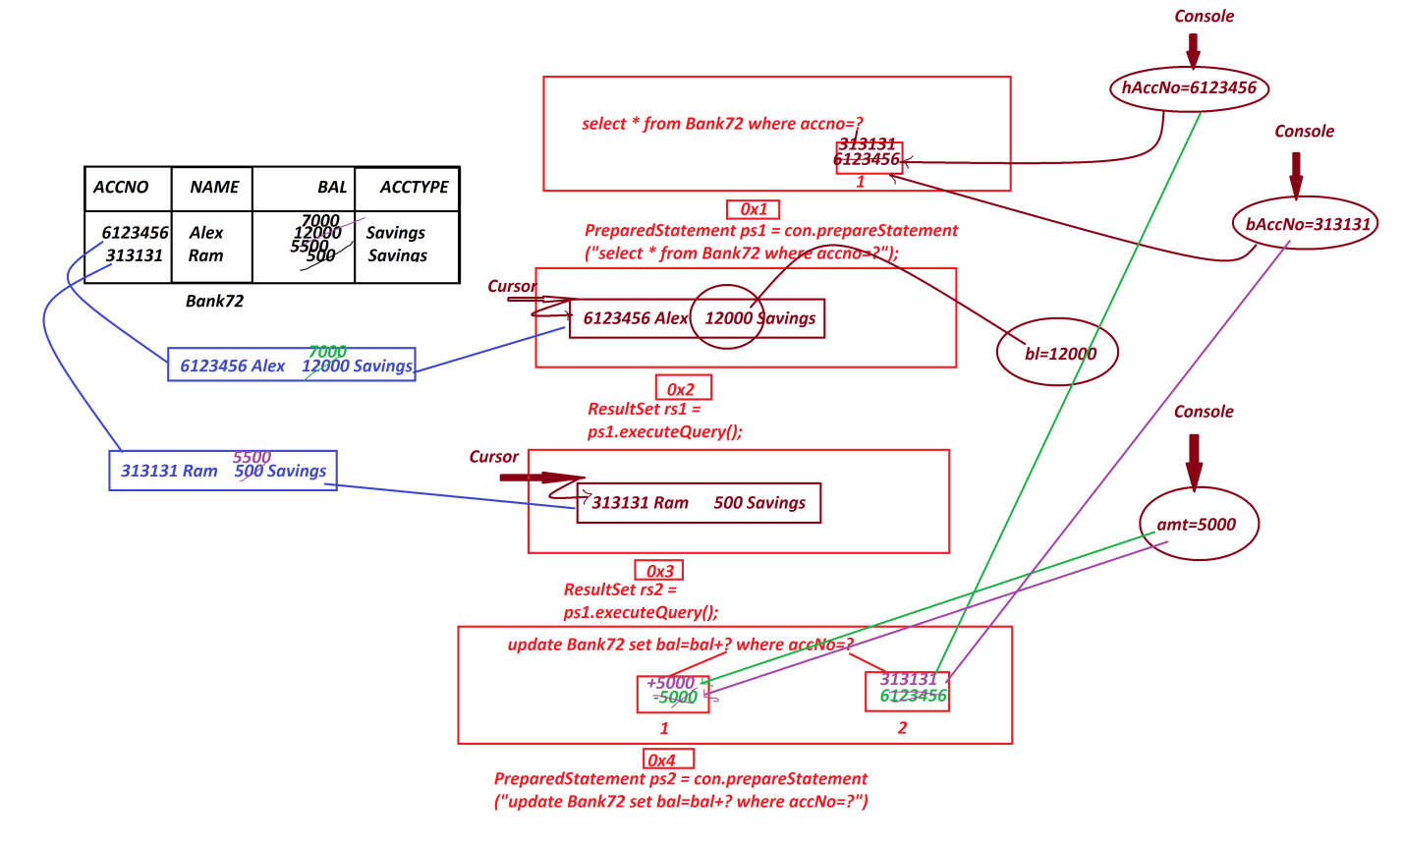

|  |
| --- |
| **Program: DBCon14.java**  package test;  import java.util.*;  import java.sql.*;;  public class DBCon14 {  public static void main(String[] args) {  Scanner s = new Scanner(System.in);  try(s;){  Class.forName("oracle.jdbc.driver.OracleDriver");  Connection con = DriverManager.getConnection  ("jdbc:oracle:thin:@localhost:1521:xe","system","tiger");  PreparedStatement ps1 = con.prepareStatement  ("select * from Bank72 where accno=?");  PreparedStatement ps2 = con.prepareStatement  ("update Bank72 set bal=bal+? where accNo=?");  System.out.println("Commit-Status : "+con.getAutoCommit());  con.setAutoCommit(false);//Auto-Commit-Operation-Stopped  System.out.println("Commit-Status : "+con.getAutoCommit());  System.out.println("Enter the Home-AccNo:");  long hAccNo = s.nextLong();  ps1.setLong(1, hAccNo);  ResultSet rs1 = ps1.executeQuery();  if(rs1.next()) {  float bl = rs1.getFloat(3);  System.out.println("Enter the benificieryAccNo:");  long bAccNo = s.nextLong();  ps1.setLong(1, bAccNo);  ResultSet rs2 = ps1.executeQuery();  if(rs2.next()) {  System.out.println("Enter the Amount to be Transferred:");  float amt = s.nextFloat();  if(amt<=bl) {  //Statement-1 : Subtract amt:5000/- from accNo:6123456  ps2.setFloat(1, -amt);  ps2.setLong(2, hAccNo);  int p = ps2.executeUpdate();//Updated in Buffer    //Statement-2 : Add amt:5000/- to accNo:313131  ps2.setFloat(1, +amt);  ps2.setLong(2, bAccNo);  int q = ps2.executeUpdate();//Updated in Buffer    if(p==1 && q==1) {  System.out.println("Transaction Successfull...");  con.commit();  }else {  System.out.println("Transaction failed....");  con.rollback();  }  }else {  System.out.println("InSufficient Fund...");  }  }else {  System.out.println("Invalid bAccNo...");  }  }else {  System.out.println("Invalid HomeAccNo...");  }  con.close();  }catch(Exception e) {  e.printStackTrace();  }  }  } |
| **o/p**  Commit-Status : true  Commit-Status : false  Enter the Home-AccNo:  6123456  Enter the benificieryAccNo:  313131  Enter the Amount to be Transferred:  5000  Transaction Successfull...  ------------------------------------------------------  ACCNO NAME BAL ACCTYPE  ---------- --------------- ---------- ---------------  6123456 Alex 7000 Savings  313131 Ram 5500 Savings |

*Date: 19/03/2025 (Day-18)*

##### Batch Processing in JDBC

* The process of collecting multiple queries as batch and executing on Database product at-a-time, is known as Batch Processing.
* Batch Processing Support only NonSelect queries, and which is also known as Batch Update processing.
* In real time, the Batch Processing is performed using 'Statement'.
* The following are some important methods related to barch processing:

***(a) addBatch()***

***(b) executeBatch()***

***(c) clearBatch()***

---

**(a) addBatch()**

* addBatch() - method is used to add NonSelect-query to a batch.
* *Method Signature*

public abstract void addBatch(java.lang.String) throws java.sql.SQLException;

* ***syntax***

**stm.addBatch("NonSelect-Query");**

**---**

**(b) executeBatch()**

* executeBatch()-method is used to execute all queries from the batch at-a-time.
* *Method Signature*

**public abstract int[] executeBatch() throws java.sql.SQLException;**

* ***syntax***

**int k[] = stm.executeBatch();**

---

**(c) clearBatch()**

* clearBatch()-method will delete all queries from the batch and destroys the batch.
* *Method Signature*

**public abstract void clearBatch() throws java.sql.SQLException;**

* ***syntax***

**stm.clearBatch();**

***Example***

|  |
| --- |
| **Program : DBCon15.java**  package test;  import java.util.*;  import java.sql.*;  public class DBCon15 {  public static void main(String[] args) {  Scanner s = new Scanner(System.in);  try(s;){  Class.forName("oracle.jdbc.driver.OracleDriver");  Connection con = DriverManager.getConnection  ("jdbc:oracle:thin:@localhost:1521:xe","system","tiger");  Statement stm = con.createStatement();  System.out.println("******Insert on Bank72******");  System.out.println("Enter the AccNo:");  long accNo = Long.parseLong(s.nextLine());  System.out.println("Enter the Name:");  String name = s.nextLine();  System.out.println("Enter the Balance:");  float bal = Float.parseFloat(s.nextLine());  System.out.println("Enter the AccType:");  String accType = s.nextLine();  stm.addBatch  ("insert into Bank72 values("+accNo+",'"+name+"',"+bal+",'"+accType+"')");    System.out.println("*****delete on Customer72*****");  System.out.println("Enter the Cust-PhoneNo to delete the details:");  long pNo = Long.parseLong(s.nextLine());  stm.addBatch  ("delete from Customer72 where phno="+pNo+"");    int k[] = stm.executeBatch();  for(int i : k)  {  System.out.println("query executed : "+i);  }//end of loop  stm.clearBatch();  }catch(Exception e) {  e.printStackTrace();  }  }  } |
| o/p:  ******Insert on Bank72******  Enter the AccNo:  434343123  Enter the Name:  RTE  Enter the Balance:  1200  Enter the AccType:  Savings  *****delete on Customer72*****  Enter the Cust-PhoneNo to delete the details:  9898981234  query executed : 1  query executed : 1 |

***FAQ***

**What is the difference b/w**

**(i) Batch Processing**

**(ii) Procedures**

* Batch Processing will execute only NonSelect-Queries,but using Procedures we can execute both 'Select and NonSelect Queries'
* when we use Batch Processing the execution load is on Server,but when we use Procedures then execution load is on Database.

-----

***FAQ***

**Define MetaData?**

* The data which is holding information about other data is known as MetaData.
* JDBC will provide the following MetaData components:

***1. DatabaseMetaData***

***2. ParameterMetaData***

***3. ResultSetMetaData***

**1. DatabaseMetaData**

* DatabaseMetaData is an interface from java.sql package and which is instantiated to hold information about Connection-Object.
* ***Syntax***

**DatabaseMetaData dmd = con.getMetaData();**

**2. ParameterMetaData**

* ParameterMetaData is an interface from java.sql package and which is instantiated to hold information about PreparedStatement-Object.
* ***Synatax***

**ParameterMetaData pmd = ps.getParameterMetaData();**

**3. ResultSetMetaData**

* ResultSetMetaData is an interface from java.sql package and which is instantiated to hold information about ResultSet-Object.

***Syntax***

**ResultSetMetaData rsmd = rs.getMetaData();**

Diagram

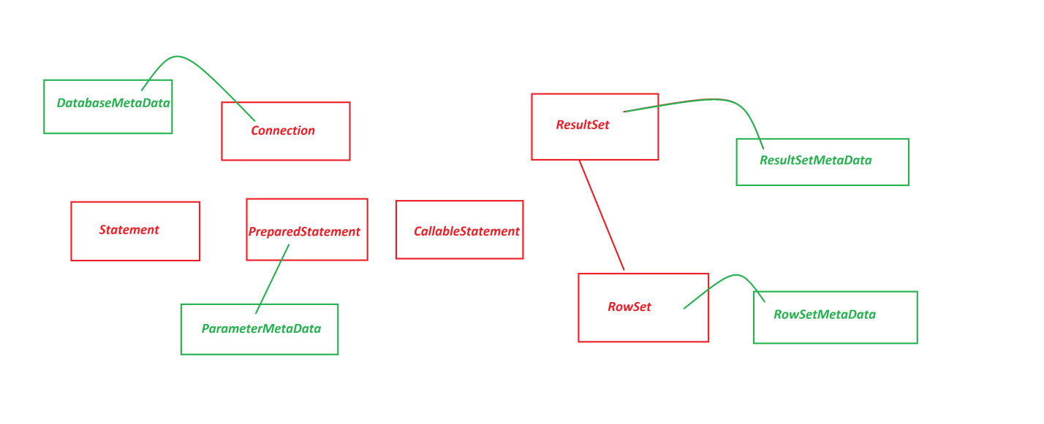

Date: 20/03/2025 (Day-19)

***Example***

|  |
| --- |
| Program : DBCon16.java  package test;  import java.sql.*;  public class DBCon16 {  public static void main(String[] args) {  try {  Class.forName("oracle.jdbc.driver.OracleDriver");  Connection con = DriverManager.getConnection  ("jdbc:oracle:thin:@localhost:1521:xe","system","tiger");  System.out.println("******DatabaseMetaData*****");  DatabaseMetaData dmd = con.getMetaData();  System.out.println("Driver Name:"+dmd.getDriverName());  System.out.println("Driver Version:"+dmd.getDriverMajorVersion());  System.out.println("*****ParameterMetaData******");  PreparedStatement ps = con.prepareStatement  ("update Customer72 set city=? where phno=?");  ParameterMetaData pmd = ps.getParameterMetaData();  System.out.println("Para Count:"+pmd.getParameterCount());  System.out.println("*****ResultSetMetaData*******");  PreparedStatement ps2 = con.prepareStatement  ("select phno,city,mid from Customer72");  ResultSet rs = ps2.executeQuery();  while(rs.next()) {  System.out.println(rs.getLong(1)+"\t"  +rs.getString(2)+"\t"  +rs.getString(3));  }//end of loop  ResultSetMetaData rsmd = rs.getMetaData();  System.out.println("Col-Count:"+rsmd.getColumnCount());  System.out.println("2nd Col-Name:"+rsmd.getColumnName(2));  }catch(Exception e) {  e.printStackTrace();  }  }  } |
| o/p:  ******DatabaseMetaData*****  Driver Name:Oracle JDBC driver  Driver Version:11  *****ParameterMetaData******  Para Count:2  *****ResultSetMetaData*******  8686861234 Hyd rm@gmail.com  4545451234 Hyd r@gmail.com  Col-Count:3  2nd Col-Name:CITY |

**Summary of CoreJava Objects:**

1.User defined Class Objects

2.String-Objects

3.WrapperClass-Objects

4.Array-Objects

5.Collection<E>-Objects

6.Map<K,V>-Objects

7.Enum<E>-Objects

**Summary of JDBC Objects:**

1.Connection Object

2.Statement Object

3.PreparedStatement Object

4.CallableStatement Object

5.ResultSet Object

(i)Scrollable ResultSet Object

(ii)NonScrollable ResultSet Object

6.DatabaseMetaData Object

7.ParameterMetaData Object

8.ResultMetaData Object

9.RowSet Object

(a)JdbcRowSet Object

(b)CachedRowSet Object

10.RowSetMetaData Object

------

**Hierarchy of JDBC API**

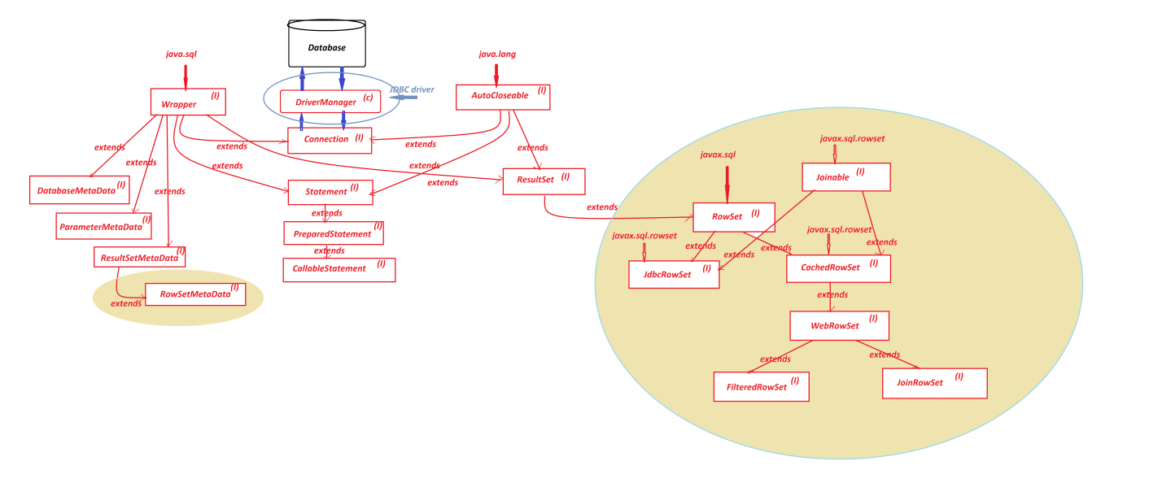

Date: 20/03/2025 (Day-19)